Appendix A

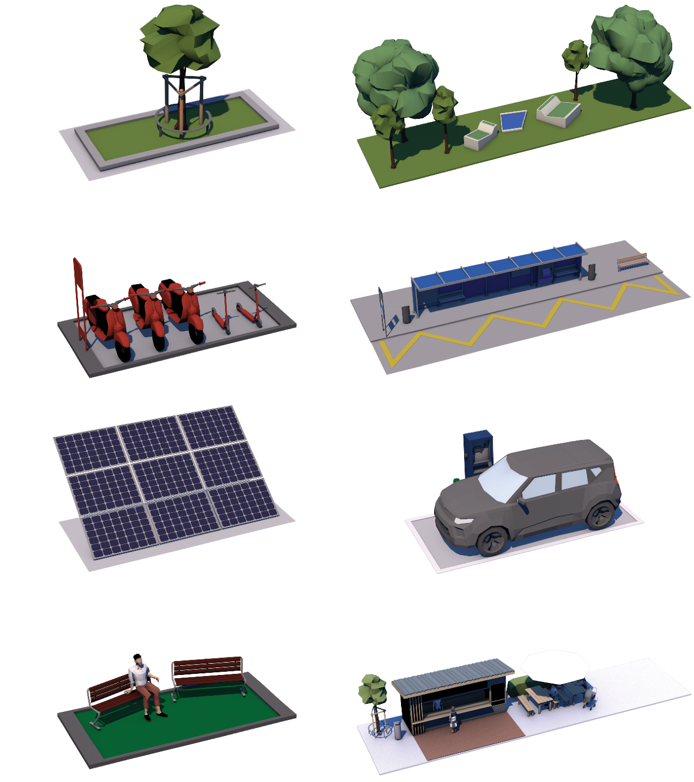
Fig. 12 List of placeable elements in the VR-Game. From top left to bottom right: Green space small, green space large, public transport small, public transport large, solar panels, EV charging station, social space small, social space large

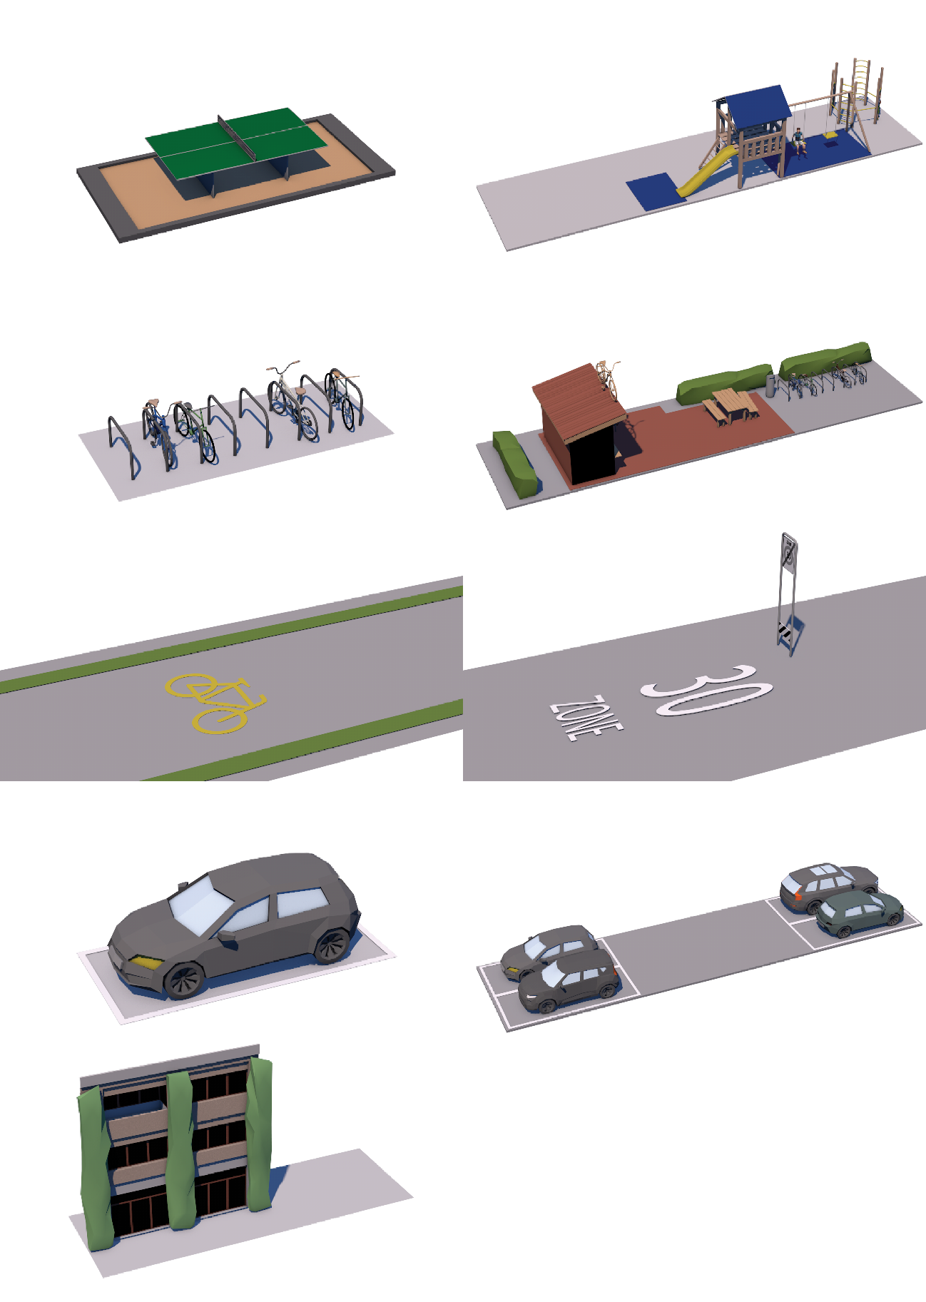
Fig. 13 List of placeable elements in the VR-Game. From top left to bottom right: Play area small, play area large, bike area small, bike area large, bike path, 30km/h zone, parking space small, parking space large, facade greening

Appendix B
Table 2 List of constructs with their items and Cronbach's alpha
Construct | Item | Cronbach's alpha
 |  | Pre-survey (n = 162) | Post-survey (n = 162) | Follow-up survey (n = 51)
Attitudes | Private cars are indispensable in the city. (recoded) | 0.695 | 0.737 | 0.691
Attitudes | A city should establish many more 20 km/h and 30 km/h zones. | 0.695 | 0.737 | 0.691
Attitudes | Above all, a city should create space for pedestrians and cyclists. | 0.695 | 0.737 | 0.691
Attitudes | Roof areas should be used for photovoltaics (solar power systems) wherever possible. | 0.695 | 0.737 | 0.691
Attitudes | The city/state should legally require building owners to install photovoltaic systems at suitable private locations. | 0.695 | 0.737 | 0.691
Attitudes | The city should convert more road space into green areas (e.g. trees, hedges, meadows). | 0.695 | 0.737 | 0.691
Affinity for Technology Interaction | I like to occupy myself in greater detail with technical systems. | 0.788 | NA | NA
Affinity for Technology Interaction | I like testing the functions of new technical systems. | 0.788 | NA | NA
Affinity for Technology Interaction | It is enough for me that a technical system works; I don’t care how or why. | 0.788 | NA | NA
Affinity for Technology Interaction | It is enough for me to know the basic functions of a technical system. | 0.788 | NA | NA
Satisfaction | ‘Design Zurich’ was exciting. | NA | 0.827 | NA
Satisfaction | ‘Design Zurich’ was graphically appealing. | NA | 0.827 | NA
Satisfaction | ‘Design Zurich’ was educational. | NA | 0.827 | NA
Satisfaction | Overall, I really liked ‘Design Zurich’. | NA | 0.827 | NA
Attention | I have focused my full attention on ‘Design Zurich’. | NA | 0.806 | NA
Attention | My attention was almost automatically drawn to ‘Design Zurich’. | NA | 0.806 | NA
Attention | I have devoted myself entirely to ‘Design Zurich’. | NA | 0.806 | NA
Presence | I felt as if I were physically present in the environment depicted. | NA | 0.905 | NA
Presence | It was as if my actual location had shifted to the environment depicted. | NA | 0.905 | NA
Presence | It felt as if I had actually participated in the events depicted. | NA | 0.905 | NA
Usefulness | Visualisations such as those used in ‘Design Zurich’ should be used more frequently to involve citizens in redesign projects. | NA | 0.870 | NA
Usefulness | The use of ‘Design Zurich’ makes it more appealing to participate in discussions about redesigns. | NA | 0.870 | NA
Usefulness | If ‘Design Zurich’ is used at a public event on redesigns, I am more inclined to attend. | NA | 0.870 | NA
Usefulness | Presenting a construction project with ‘Design Zurich’ helps me to understand more precisely what is being discussed. | NA | 0.870 | NA
Usefulness | All in all, I find the presentation of an urban redesign with ‘Design Zurich’ to be meaningful. | NA | 0.870 | NA
Behavioral change | I pay more attention to cycle paths or cycle routes. | NA | NA | 0.825
Behavioral change | I pay more attention to parking spaces. | NA | NA | 0.825
Behavioral change | I pay more attention to greenery such as trees and hedges. | NA | NA | 0.825
Behavioral change | I pay more attention to solar power systems on roofs or facades. | NA | NA | 0.825
Behavioral change | I pay more attention to elements that enliven the city, such as cafés, playgrounds or benches. | NA | NA | 0.825

