Supplementary material
Appendix 1: Quality assessment of the included studies with JBI tools
Table 1 Quality assessment of the included studies on risk factors associated with high occurrence of HAIs among paediatric hospitalized patients with JBI checklist for cross-sectional study
Questions/Study ID/Author (Year) |  | 1. Were the criteria for inclusion in the sample clearly defined? |  |  |  | 2. Were the study subjects and the setting described in detail? |  |  |  | 3. Was the exposure measured in a valid and reliable way? |  |  |  | 4. Were objective, standard criteria used for measurement of the condition?
 |  | Yes | Unclear | No | Not applicable | Yes | Unclear | No | Not applicable | Yes | Unclear | No | Not applicable | Yes | Unclear | No | Not applicable
1 | Chen (2017) | √ |  |  |  |  |  | √ |  |  |  | √ |  |  |  | √
2 | Zhou (2018) | √ |  |  |  |  |  | √ |  |  | √ |  |  |  | √
4 | Wei (2013) | √ |  |  |  |  |  | √ |  |  | √ |  |  |  | √
6 | Tang (2010) | √ |  |  |  |  |  | √ |  |  | √ |  |  |  | √
7 | Chen (2005) | √ |  |  |  |  |  | √ |  |  | √ |  |  |  | √
8 | Zhao (2009) | √ |  |  |  |  |  | √ |  |  | √ |  |  |  | √
9 | Huang et al. (2008) | √ |  |  |  |  |  | √ |  |  | √ |  |  |  | √
10 | Sun et al. (2012) | √ |  |  |  |  |  | √ |  |  | √ |  |  |  | √
11 | Tan (2009) | √ |  |  |  |  |  | √ |  |  | √ |  |  |  | √
13 | Zheng et al. (2014) | √ |  |  |  |  |  | √ |  |  | √ |  |  |  | √
14 | Yang et al. (2016) | √ |  |  |  |  |  | √ |  |  |  | √ |  | √
15 | Jiang (2020) | √ |  |  |  |  |  | √ |  |  |  | √ |  | √

Table 1 (Continued) Quality assessment of the included studies on risk factors associated with high occurrence of HAIs among paediatric hospitalized patients with JBI checklist for cross-sectional study
Questions/ Study ID/ Author (Year) |  | 5. Were confounding factors identified? |  |  |  | 6. Were strategies to deal with confounding factors stated? |  |  |  | 7. Were the outcomes measured in a valid and reliable way? |  |  |  | 8. Was appropriate statistical analysis used?
 |  | Yes | Unclear | No | Not applicable | Yes | Unclear | No | Not applicable | Yes | Unclear | No | Not applicable | Yes | Unclear | No | Not applicable
1 | Chen (2017) |  |  | √ |  |  |  | √ |  | √ |  |  |  | √
2 | Zhou (2018) |  |  | √ |  |  |  | √ |  | √ |  |  |  |  | √
4 | Wei (2013) |  |  | √ |  |  |  | √ |  | √ |  |  |  | √
6 | Tang (2010) |  |  | √ |  |  |  | √ |  | √ |  |  |  |  |  |  | √
7 | Chen (2005) | √ |  |  |  |  |  | √ |  | √ |  |  |  | √
8 | Zhao (2009) | √ |  |  |  |  |  | √ |  | √ |  |  |  | √
9 | Huang et al. (2008) | √ |  |  |  |  |  | √ |  | √ |  |  |  | √
10 | Sun et al. (2012) | √ |  |  |  |  |  | √ |  | √ |  |  |  | √
11 | Tan (2009) | √ |  |  |  |  |  | √ |  | √ |  |  |  | √
13 | Zheng et al. (2014) | √ |  |  |  |  |  | √ |  | √ |  |  |  | √
14 | Yang et al. (2016) | √ |  |  |  | √ |  |  |  | √ |  |  |  | √
15 | Jiang (2020) | √ |  |  |  |  |  | √ |  | √ |  |  |  | √

Table 2 Quality assessment of the included studies on risk factors associated with high occurrence of HAIs among paediatric hospitalized patients with JBI checklist for case-control study
Questions/ Study ID/Author (Year) |  | 1. Were the groups comparable other than the presence of disease in cases or the absence of disease in controls? |  |  |  | 2. Were cases and controls matched appropriately? |  |  |  | 3. Were the same criteria used for identification of cases and controls? |  |  |  | 4. Was exposure measured in a standard, valid and reliable way? |  |  |  | 5. Was exposure measured in the same way for cases and controls?
 |  | Yes | Unclear | No | Not applicable | Yes | Unclear | No | Not applicable | Yes | Unclear | No | Not applicable | Yes | Unclear | No | Not applicable | Yes | Unclear | No | Not applicable
3 | Xu (2018) | √ |  |  |  | √ |  |  |  | √ |  |  |  |  | √ |  |  |  | √
12 | Wang (2008) | √ |  |  |  | √ |  |  |  | √ |  |  |  |  | √ |  |  |  | √

Table 2 (continued) Quality assessment of the included studies on risk factors associated with high occurrence of HAIs among paediatric hospitalized patients with JBI checklist for case-control study
Questions/ Study ID/Author (Year) |  | 6. Were confounding factors identified? |  |  |  | 7. Were strategies to deal with confounding factors stated? |  |  |  | 8. Were outcomes assessed in a standard, valid and reliable way for cases and controls? |  |  |  | 9. Was the exposure period of interest long enough to be meaningful? |  |  |  | 10. Was appropriate statistical analysis used?
 |  | Yes | Unclear | No | Not applicable | Yes | Unclear | No | Not applicable | Yes | Unclear | No | Not applicable | Yes | Unclear | No | Not applicable | Yes | Unclear | No | Not applicable
3 | Xu (2018) | √ |  |  |  |  | √ |  |  | √ |  |  |  | √ |  |  |  | √
12 | Wang (2008) | √ |  |  |  | √ |  |  |  | √ |  |  |  | √ |  |  |  | √

Table 3 Quality assessment of the included studies on risk factors associated with high occurrence of HAIs among paediatric hospitalized patients with JBI checklist for cohort study
Questions/ Study ID/Author (Year) |  | 1. Were the two groups similar and recruited from the same population? |  |  |  | 2. Were the exposures measured similarly to assign people to both exposed and unexposed groups? |  |  |  | 3. Was the exposure measured in a valid and reliable way? |  |  |  | 4. Were confounding factors identified? |  |  |  | 5. Were strategies to deal with confounding factors stated?
 |  | Yes | Unclear | No | Not applicable | Yes | Unclear | No | Not applicable | Yes | Unclear | No | Not applicable | Yes | Unclear | No | Not applicable | Yes | Unclear | No | Not applicable
5 | Yu et al. (2006) | √ |  |  |  |  | √ |  |  |  | √ |  |  |  |  | √ |  |  |  | √

Table 3 (continuted) Quality assessment of the included studies on risk factors associated with high occurrence of HAIs among hospitalized paediatric patients with JBI checklist for cohort study
Questions/ Study ID/Author (Year) |  | 6. Were the groups/participants free of the outcomes at the start of the study (or at the moment of exposure)? |  |  |  | 7. Were the outcomes measured in a valid and reliable way? |  |  |  | 8. Was the follow up time reported and sufficient to be long enough for outcomes to occur? |  |  |  | 9. Was follow up complete, and if not, were the reasons to loss to follow up described and explored? |  |  |  | 10. Were strategies to address incomplete follow up utilized? |  |  |  | 11. Was appropriate statistical analysis used?
 |  | Yes | Unclear | No | Not applicable | Yes | Unclear | No | Not applicable | Yes | Unclear | No | Not applicable | Yes | Unclear | No | Not applicable | Yes | Unclear | No | Not applicable | Yes | Unclear | No | Not applicable
5 | Yu et al. (2006) |  | √ |  |  | √ |  |  |  |  | √ |  |  |  | √ |  |  |  | √ |  |  | √

Appendix 2: Forest plots of the risk factors in the meta-analyses
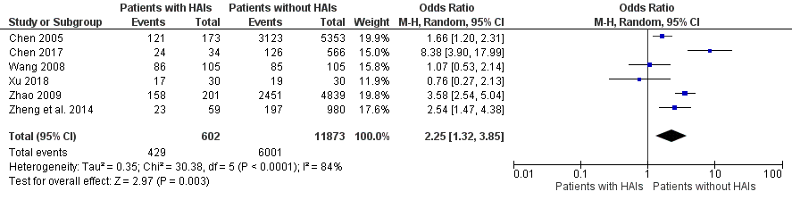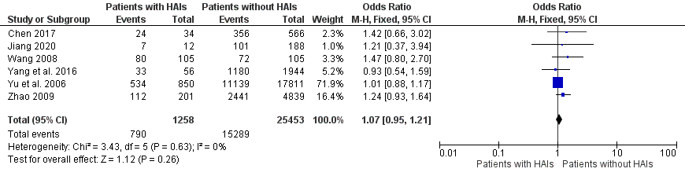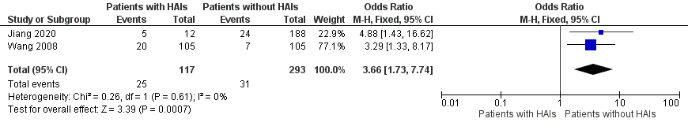
Figure 1-1 Age (≤ 1 year vs. > 1 year) Figure 1-2 Gender (Male vs. Female) Figure 1-3 Hormone (Yes vs. No)
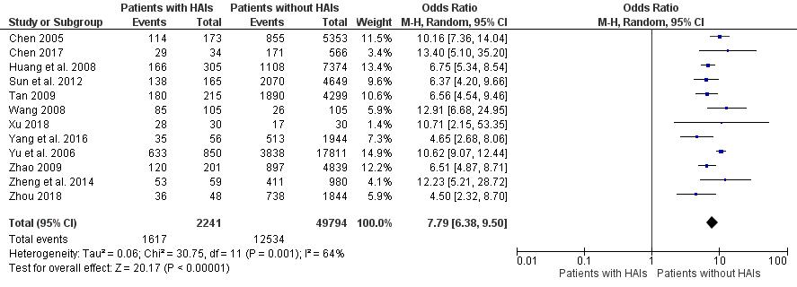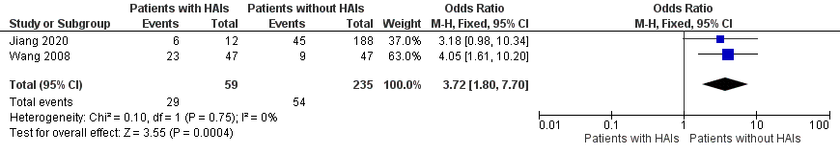
Figure 1-4 Invasive procedure (Yes vs. No) Figure 1-5 Length of hospitalization ((> 7 days vs. ≤ 7 days) Figure 1-6 Malnutrition (Yes vs. No)

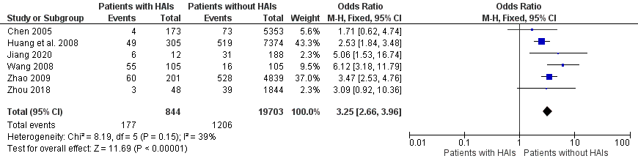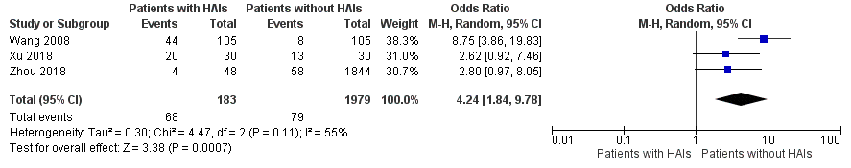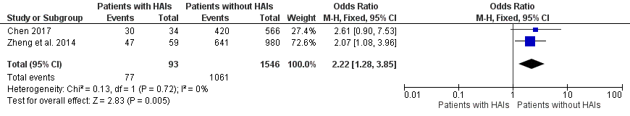
Figure 1-7 Number of kinds of antibiotics (> 3 vs. ≤ 3) Figure 1-8 Number of underlying disease (> 3 vs. ≤ 3) Figure 1-9 Room size (Large vs. ≤ Small)

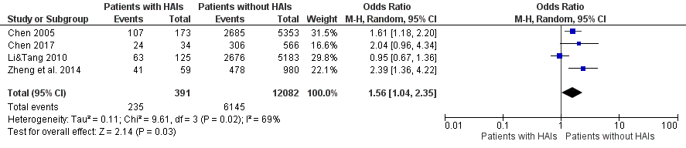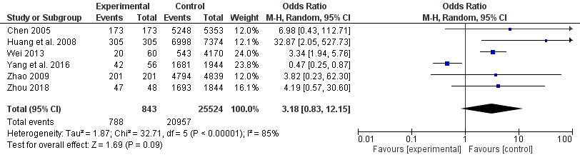
Figure 1-10 Seasons (Autumn + Winter vs. Spring + Summer) Figure 1-11 Use of antibiotics (Yes vs. No)

