Supplementary information
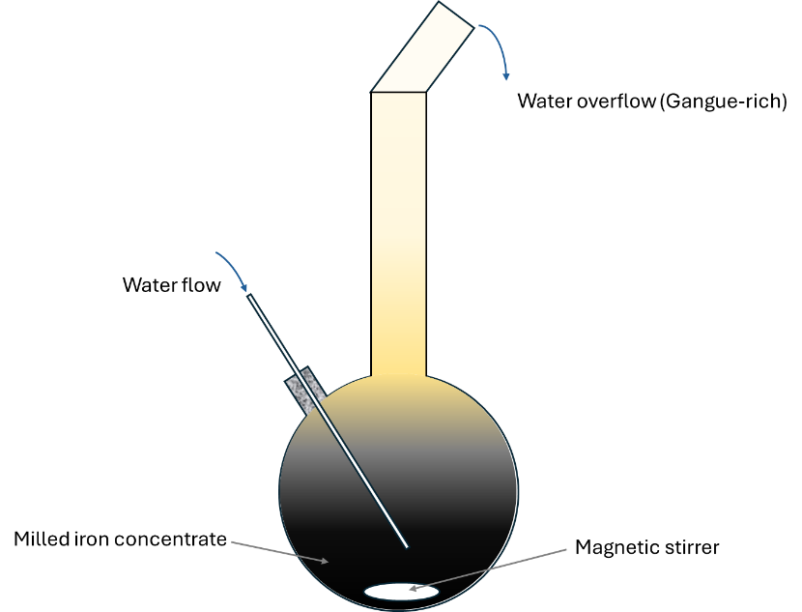
Supplementary Fig. 1 | Hydro-separation apparatus.
Schematic of the hydro-separation apparatus used for removing gangue particles from the milled concentrate.
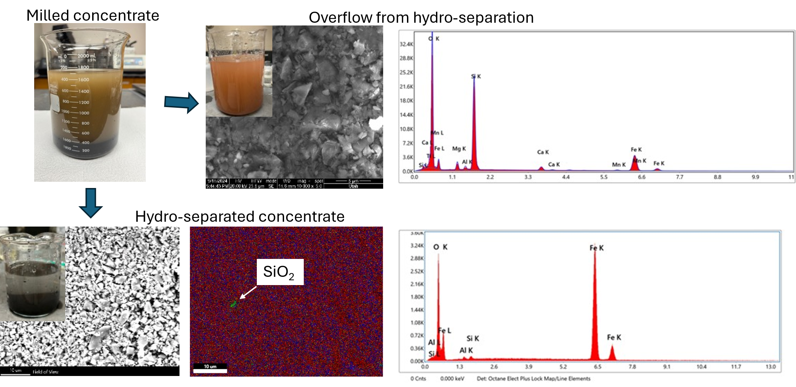
Supplementary Fig. 2 | The concentrate before and after hydro-separation.
The overflow from hydro-separation contains fine particles rich in Si, Mg, Al, and Ca. Small silica particles can still be found in the hydro-separated concentrate.
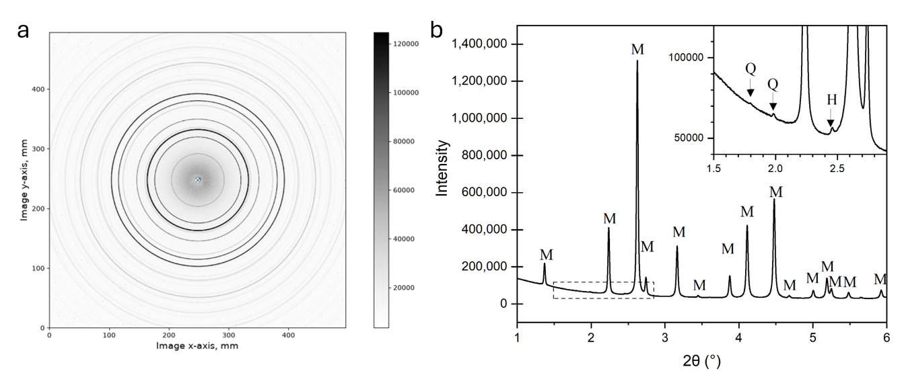
Supplementary Fig. 3 | Synchrotron X-ray Diffraction of hydro-separated concentrate.
a, Two-dimensional synchrotron X-ray diffraction pattern of the hydro-separated concentrate. b, One-dimensional diffraction pattern integrated from the two-dimensional diffraction rings. The hydro-separated concentrate is dominated by magnetite, labelled M, with weak peaks from residual quartz, Q, and hematite, H, visible in the low-angle region, as shown in the inset.

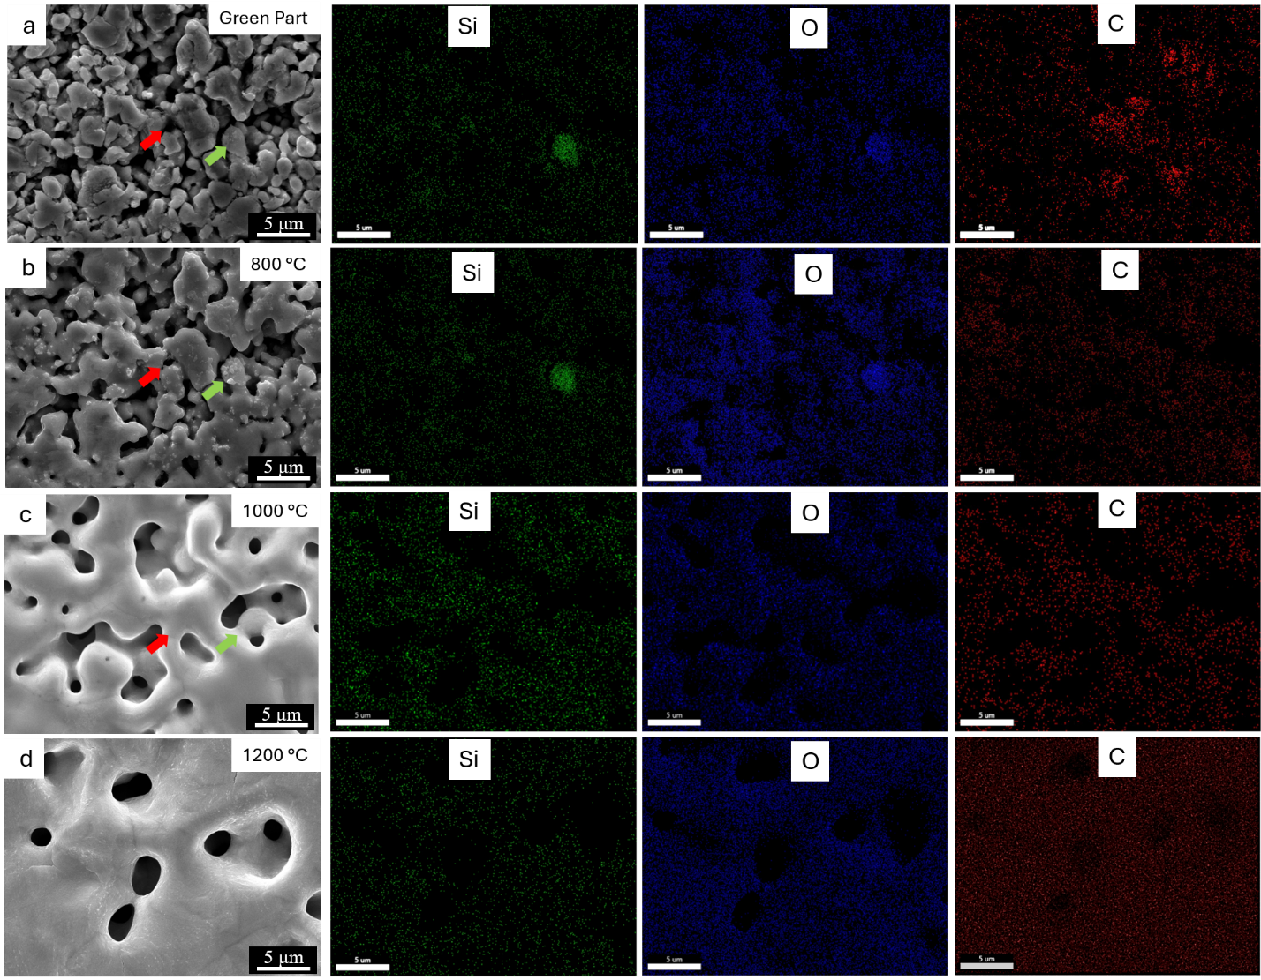
Supplementary Fig. 4 | SEM images and EDS element maps showing the stepwise reduction of a silica inclusion by dissolved carbon.
a, The green compact (die-pressed powder with 1 wt% graphite) before heating. b, After heating at 800 °C for 2 h: the graphite particles (indicated by the green arrow) have fully dissolved into the iron matrix, while the silica particle (red arrow) remains. c, After heating at 1000 °C for 2 h: the silica particle has been completely reduced and is no longer visible; its silicon is now dissolved in the iron matrix. d, After heating at 1200 °C for 2 h: the previously porous region has densified into a continuous alloy matrix with no trace of the original graphite or silica.

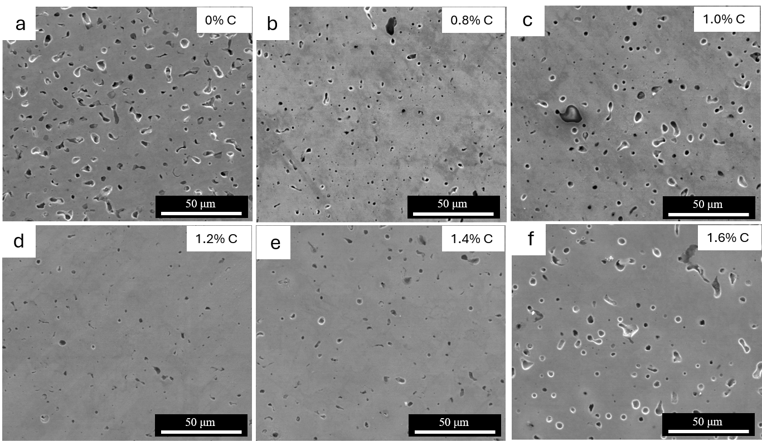
Supplementary Fig. 5 | Effect of graphite addition on residual porosity after sintering.
SEM micrographs of samples sintered with nominal graphite additions of a, 0 wt%; b, 0.8 wt%; c, 1.0 wt%; d, 1.2 wt%; e, 1.4 wt%; and f, 1.6 wt%. Residual porosity is lowest near the optimum graphite addition and increases at higher carbon contents, consistent with the decrease in sintered density above 1.2 wt% C.
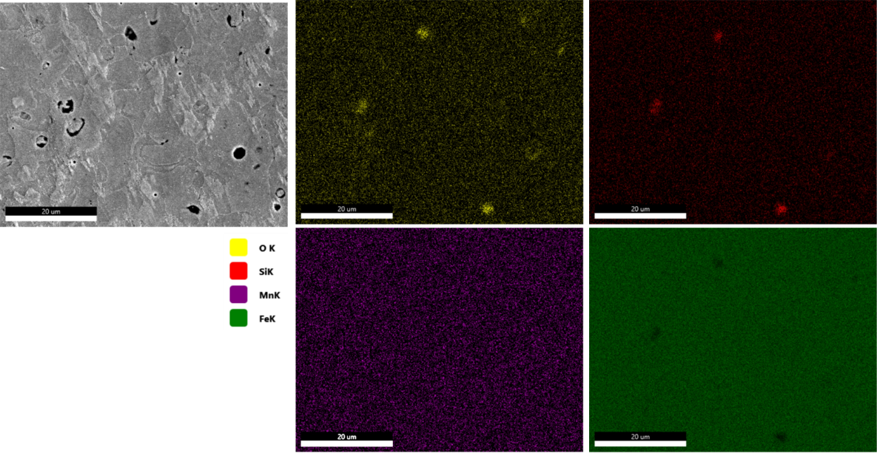
Supplementary Fig. 6 | Elemental distribution in as-sintered Fe-2Mn-0.8Si-0.2C steel.
SEM image and corresponding EDS elemental maps of an as-sintered Fe-2Mn-0.8Si-0.2C sample. Mn and Si are distributed throughout the Fe matrix, consistent with reduction of MnO₂ and SiO₂ during sintering and incorporation of Mn and Si into the steel matrix.
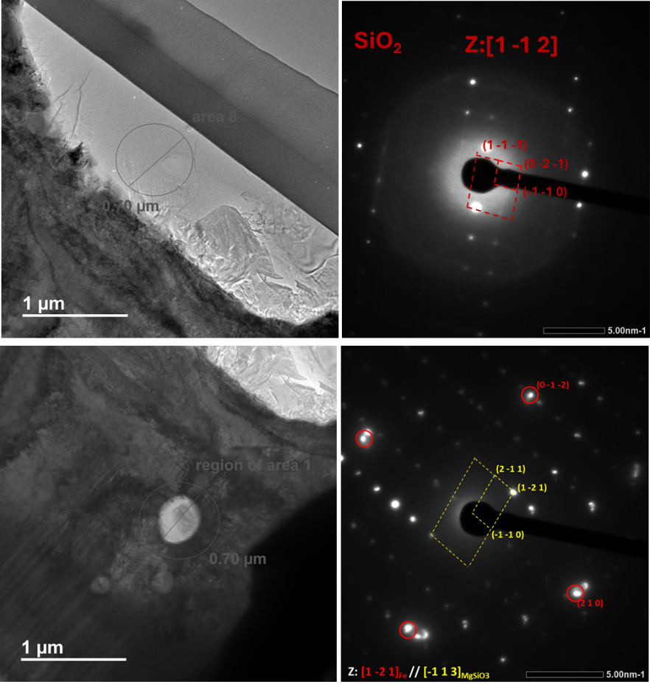
Supplementary Fig. 7 | Residual oxide inclusions after sintering.
TEM images and diffraction analyses showing residual SiO₂ and MgSiO₃ inclusions in the Fe matrix after sintering. These observations confirm that a small fraction of impurity oxides can remain unreduced, particularly where gas transport is limited by pore closure.

Thermodynamic modeling with Thermo-Calc
The calculations were run under two conditions: (1) at a constant temperature of 1000 °C (matching the holding temperature) while varying carbon content and P_{CO} (Supplementary Fig. 8a), and (2) at a constant P_{CO} of 5 Pa (matching the vacuum level for sintering) while varying temperature and carbon content (Supplementary Fig. 8b). The activity of solid SiO₂ was assumed to be 1. The calculations confirm that at 1000 °C and 0.70 wt% C, SiO₂ is thermodynamically stable at P_{CO} > 10⁴ Pa but is fully reduced at P_{CO} < 10³Pa. In other words, at the sintering temperature (1200 °C) and vacuum pressure (5 Pa), any carbon added above the stoichiometric requirement should drive the silica reduction to completion.
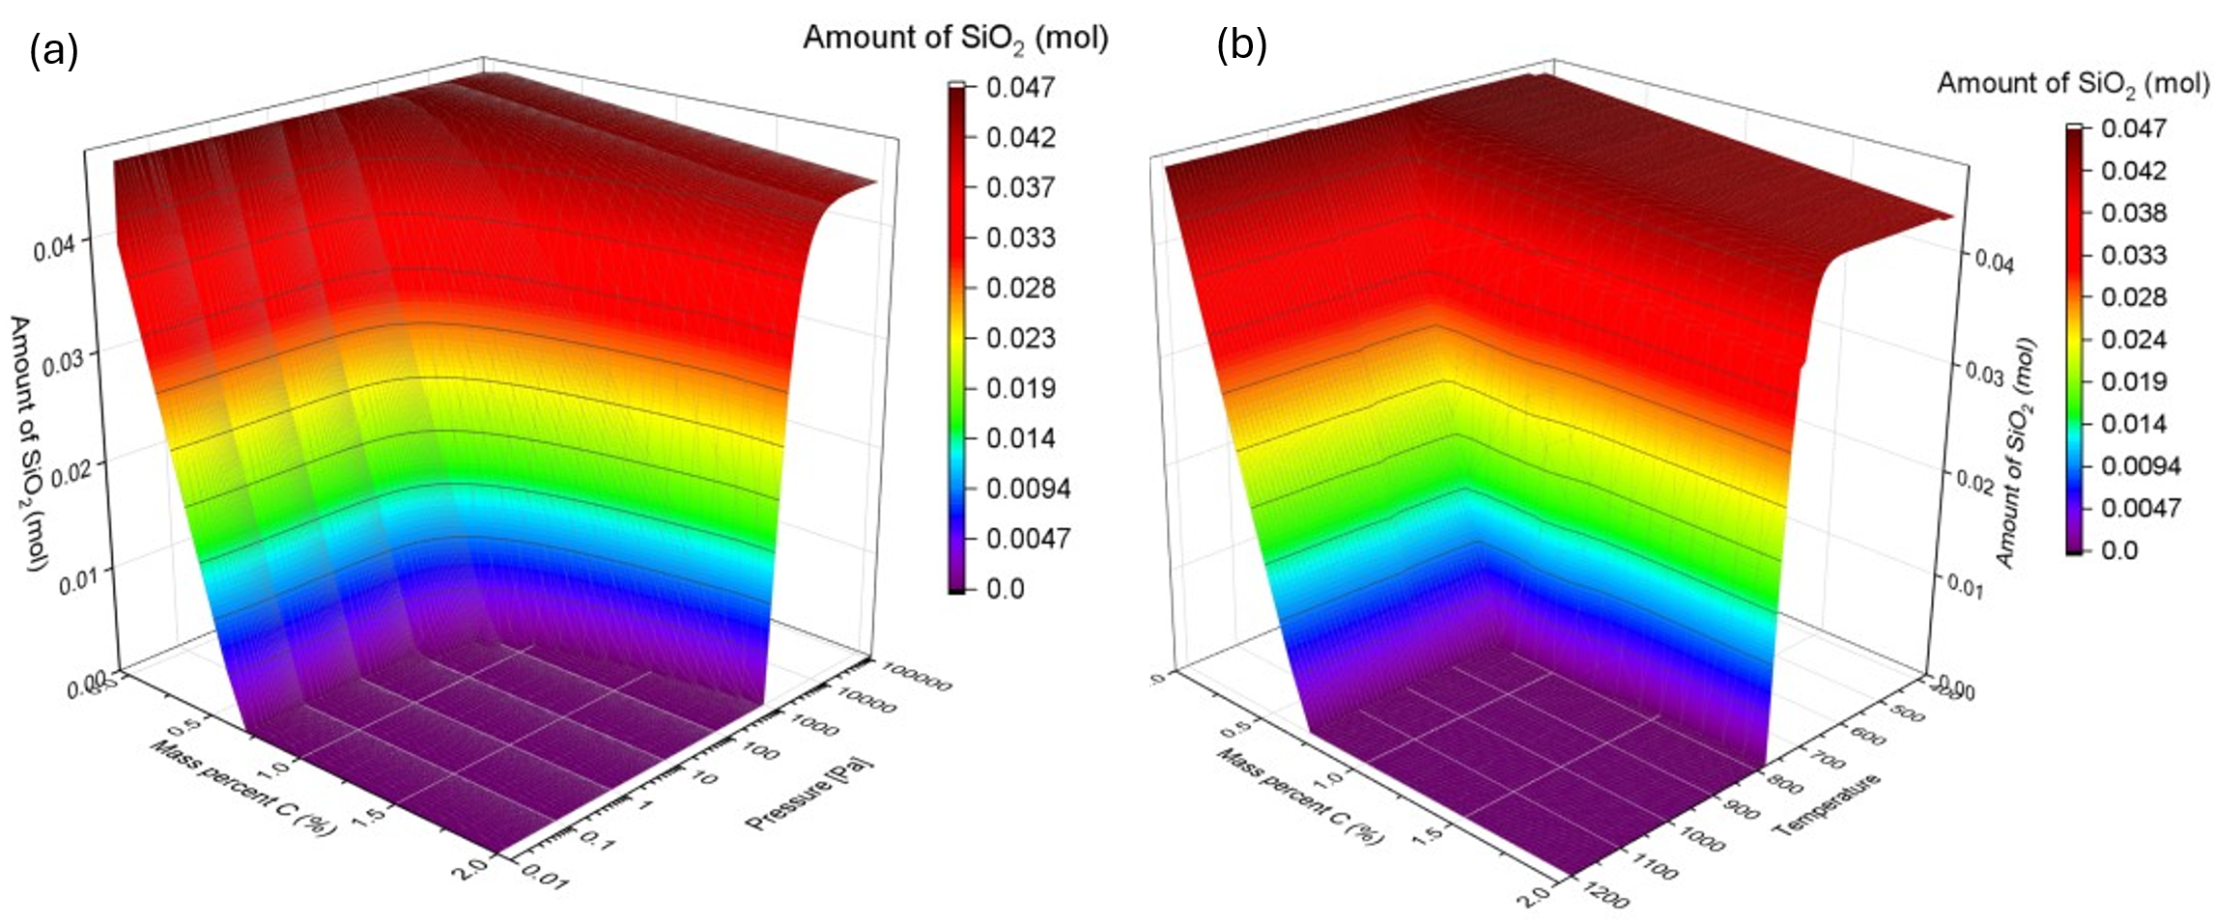
Supplementary Fig. 8 | Thermo-Calc predictions for SiO₂ reduction.
a, Equilibrium amount of residual SiO₂ as a function of carbon content and CO partial pressure at 1000 °C. b, Equilibrium amount of residual SiO₂ as a function of temperature and carbon content at fixed P_{CO}=5 Pa. The activity of solid SiO₂ was assumed to be unity. These calculations show that low P_{CO} and sufficient dissolved carbon favor SiO₂ reduction, whereas elevated P_{CO} stabilizes SiO₂.
Activities of carbon and silicon in FCC-Fe (γ-Fe)
Activity as a function of steel composition and temperature was calculated as:
$$a_{i}=e^{\left(\frac{µ_{i}-G_{i}^{0}}{RT}\right)}$$
Where $G_{i}^{0}$ is the Gibbs energy of component $i$ in its standard state and $µ_{i}$ is the chemical potential of component $i$ in the state of interest (in this case, FCC Fe). Treating the mole fraction of Fe as a dependent variable via:
$$X_{Fe}=1-X_{C}-X_{Si}$$
The chemical potential of C and Si is calculated as a function of composition and temperature via:
$$µ_{C}={\overline{G}}_{FCC_A1}-X_{Si}\frac{∂{\overline{G}}_{FCC_A1}}{∂X_{Si}}+(1-X_{C})\frac{∂{\overline{G}}_{FCC_A1}}{∂X_{C}}$$
$$µ_{Si}={\overline{G}}_{FCC_A1}+(1-X_{Si})\frac{∂{\overline{G}}_{FCC_A1}}{∂X_{Si}}-X_{C}\frac{∂{\overline{G}}_{FCC_A1}}{∂X_{C}}$$
Where ${\overline{G}}_{FCC_A1}$ is the molar Gibbs energy of the FCC_A1 phase. The molar Gibbs energy of this phase was calculated using the 1998 assessment of Miettinen. (Miettinen, J. Reassessed thermodynamic solution phase data for ternary Fe-Si-C system. Calphad 22, 231-256 (1998).)
Supplementary Table 1 | Concentrations of major impurity elements at various stages of the HRMLES process, determined by ICP.
Element (wt%) | As-received | Hydro-separated | Hydrogen-reduced | Sintered
Si | 1.54 | 0.38 | 0.75 | 0.81
Al | 0.019 | 0.005 | 0.018 | 0.019
Ca | 0.096 | 0.010 | 0.024 | 0.031
Mg | 0.10 | 0.024 | 0.032 | 0.020
Mn | 0.051 | 0.027 | 0.054 | 0.057

Supplementary Table 2 | Effect of graphite addition on final oxygen content and sintered density.
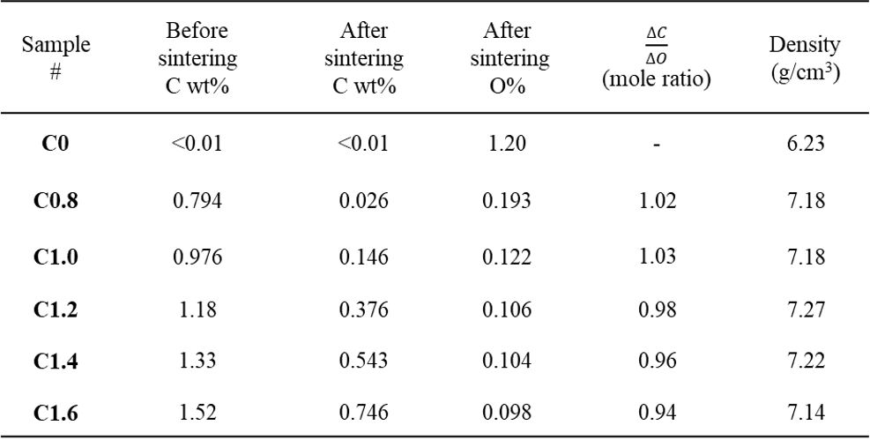
Supplementary Table 3 | Tensile properties of HRMLES steels compared with representative wrought and powder-metallurgy steels.
The HRMLES steels are compared with typical values or property ranges for as-hot-rolled low-carbon steel, as-hot-rolled high-strength C–Mn steel, and widely used powder-metallurgy steels FC-0208 and FN-0205.
