Supplementary Information

Mesolithic Hunter-Gatherer Adaptations to Small Mediterranean Island Ecosystems

Mario Mata-González^{1,2*}, Mathew Stewart^{3*}, James A. Blinkhorn^{2,4}, Alexander F. Blackwood^{2,5,6}, Jop van Dijen^{7,8}, Carli Peters⁹, Ethel Allué^{10,11}, Aitor Burguet-Coca^{10,11}, Andrés Currás², Huw S. Groucutt^{1,12}, Nicholas C. Vella¹, Eleanor M. L. Scerri^{1,2,12*}

¹Department of Classics and Archaeology, University of Malta, Msida, Malta
²Human Palaeosystems Group, Max Planck Institute of Geoanthropology (MPI-GEA), Jena, Germany
³Australian Research Centre for Human Evolution, Griffith University, Brisbane, Australia
⁴Department of Archaeology, Classics, and Egyptology, University of Liverpool, Liverpool, UK
⁵Palaeoscience Labs, Department of Archaeology and History, La Trobe University Melbourne Campus, Bundoora, Victoria, Australia
⁶Human Evolution Research Institute (HERI), Department of Geological Sciences, University of Cape Town, Cape Town, South Africa
⁷Earth, Life, Time, Naturalis Biodiversity Center, Leiden, The Netherlands
⁸Institute of Biology Leiden, Leiden University, Leiden, The Netherlands
⁹The Interdisciplinary Center for Archaeology and Evolution of Human Behaviour (ICArEHB), Universidade do Algarve, Faro, Portugal
¹⁰Institut Català de Paleoecologia Humana i Evolució Social (IPHES-CERCA), Tarragona, Spain
¹¹Universitat Rovira i Virgili (URV), Departament d’Història i Història de l’Art, Tarragona, Spain
¹²Institute of Prehistoric Archaeology, University of Cologne, Cologne, Germany
*Corresponding authors
mario.mata-gonzalez@um.edu.mt
mathew.stewart@griffith.edu.au
scerri@gea.mpg.de

Table of Contents

Supplementary Data 1: Spatial Analysis 4
  - Detailed results 5
1.1.1. Mammals 5
1.1.2. Birds 6
1.1.3. Burning 6
1.1.4. Calcitic crusts 7
1.2. Refit Results 7

Supplementary Figures
Supplementary Fig. 1. Counts of piece plotted and sieved finds by excavation square 8

Supplementary Fig. 2. Results of spatial analysis on the Mammals and Aves datasets, showing the spatial data in plan and profile view, kernel density estimates, and the results of the likelihood ratio tests 9

Supplementary Fig. 3. Results of spatial structure tests (Inhomogeneous K and L functions) on the Mammals and Aves datasets 10

Supplementary Fig. 4. NISP counts and relative proportions (%) of unburnt and burnt (charred/calcined) bones for each taxonomic or body size group 11

Supplementary Fig. 5. Results of spatial analysis on the Burnt (and Unburnt datasets, showing the spatial data in plan and profile view, kernel density estimates, and the results of the likelihood ratio tests 12

Supplementary Fig. 6. Results of spatial structure tests (Inhomogeneous K and L functions) on the Burnt and Unburnt datasets 13

Supplementary Fig. 7. Faunal remains with natural and postdepositional modifications 14

Supplementary Fig. 8. Results of spatial analysis on the Crusts and No Crusts datasets, showing the spatial data in plan and profile view, kernel density estimates, and the results of the likelihood ratio tests 15

Supplementary Fig. 9. Results of spatial structure tests (Inhomogeneous K and L functions) on the Crusts and No Crusts datasets 16

Supplementary Fig. 10. Map showing refitting sets in the Latnija Phase V fauna, and summarising mean and maximum horizontal (hz) and vertical (z) distances 17

Supplementary Tables
Supplementary Table 1. K & L Function Test Results: Mammals 18

Supplementary Table 2. K & L Function Test Results: Aves 18

Supplementary Table 3. Quadrat count chi-square tests at different grid resolutions:
Mammals 18

Supplementary Table 4. Quadrat count chi-square tests at different grid resolutions:
Aves 18

Supplementary Table 5. K & L Function Test Results: Burnt Bone 18

Supplementary Table 6. K & L Function Test Results: Unburnt Bone 18

Supplementary Table 7. Quadrat count chi-square tests at different grid resolutions:
Burnt Bone 18

Supplementary Table 8. Quadrat count chi-square tests at different grid resolutions:
Unburnt Bone 18

Supplementary Table 9. Frequencies of bone surface modifications and readability 19

Supplementary Table 10. Absolute and relative frequencies of fracture attributes on mammalian long bones 21

Supplementary Table 11. K & L Function Test Results: Crusts 22

Supplementary Table 12. K & L Function Test Results: No Crusts 22

Supplementary Table 13. Quadrat count chi-square tests at different grid resolutions:
Crusts 22

Supplementary Table 14. Quadrat count chi-square tests at different grid resolutions:
No Crusts 22

Supplementary Table 15. Summary of refitting sets from Phase V, showing mean distance between refitting points, total distance (sum of distances between all refitting points), mean vertical distance, and maximum vertical distance 23

Supplementary Table 16. NISP, observed MNE, MNEs for a standard deer skeleton (ST deer), MAU and %MAU for cervids/ungulates by element 24

Supplementary Table 17. Results of log-normal family generalized linear models 25

Supplementary Table 18. NISP, MNE, MAU and %MAU for Cervidae/ungulates by element, alongside MNEs for a standard deer skeleton (ST deer), and utility indices 26

Supplementary Table 19. NISP, NNE, and the wing-to-leg and proximal-to-distal element ratios for all birds combined, along with MNE for a standard (ST) bird skeleton 27

Supplementary Table 20. Survivorship values for cervids/ungulates 28

Supplementary Table 21. Counts and relative proportions of fused and unfused elements for cervids/ungulates 30

Supplementary Table 22. Linear measurements for cervid/ungulate specimens 31

Supplementary Table 23. Standard sample for the Size Variation Index (SVI) 34

References 35

Supplementary Data 1: Spatial Analysis
* H₀: The observed point pattern is consistent with the null model (Complete Spatial Randomness; CSR) generated using an inhomogeneous Poisson process for the Kinhom and Lscaled functions.
H₁: The observed summary function (Kinhom or Lscaled) shows significant global deviation from Complete Spatial Randomness, due to clustering, inhibition/spatial regularity, or other interaction effects.
**H₀: Points are distributed according to a homogeneous Poisson process (Complete Spatial Randomness); i.e., intensity is constant across the study area, and any variation in quadrat counts is due to chance.
H₁: The point pattern does not follow a homogeneous Poisson process, and the intensity varies spatially (hotspots or gradients) or that there is non-random structure such as clustering or regularity.

Spatial analysis of the Phase V faunal remains (Supplementary Fig. 1-3; Supplementary Tables 1-4) reveals that the two main taxonomic classes (mammals and aves) both exhibit non-random distributions, with strong evidence for a departure from complete spatial randomness for both populations. The Aves subset clusters strongly in grid square L2, with the kernel smoothed intensity surfaces revealing two clusters tightly constrained with this square, and a very limited distribution outside of these two clusters. The mammals dataset exhibits a much wider distribution, with clustering observed in squares N3-4, and to a lesser extent M3. Both populations mostly occur within the present-day dripline. There is some overlap between populations, however, with mammals also occurring in square L2, and the pairwise cross correlation functions did not show strong evidence for spatial dispersion between the avian and mammal remains (Supplementary Fig. 3).
The faunal dataset was then separated based on burnt and unburned remains, regardless of taxonomic category (Supplementary Fig. 5-6, Supplementary Tables 5-8), with the highest counts of burned bones observed in grid squares N3 and M3. When only the piece-plotted material is assessed, burnt bones strongly cluster in square M3, and to a lesser extent in N3-2, broadly following the pattern exhibited by bones with crusts. In contrast, unburnt bones occur in the greatest numbers in grid square L2, and cluster strongly in L2/L3, following a similar pattern to the distribution of avian remains. Both burnt and unburnt bones were found to exhibit non-random distributions, with strong evidence for clustering. As with the calcitic crusts, spatial analysis also detected dispersion between the clusters of burnt and unburnt bones, meaning that these two populations are more spatially separated from each other than would be expected under random conditions, and likely reflects some underlying processes or behaviours that lead to spatial separation.
A broadly similar distribution was observed for the presence or absence of calcitic crusts (crusts) covering cortical surfaces, regardless of taxonomic category (Supplementary Fig. 8-9; Supplementary Tables 11-14). Both populations (bones with calcitic crust, and those without) exhibit non-random distributions and form spatially separate clusters. Of note, bones with no crusts cluster strongly in grid square L2, which is associated with most of the Aves remains, and very few mammals. Bones with no crusts were also identified in lower numbers across all other grid squares, with the second highest distribution in N2, although no other clusters were identified. In contrast, bones with crusts cluster most strongly in N4, and to a lesser extent in N3, M3, and L3, and were also found across all the Phase V grid squares. Pairwise analysis of these two populations showed they are negatively correlated, suggesting they are spatially dispersed. Interestingly, the greatest number of bones with no crusts are found in grid squares adjacent to the cave wall, while bones with crusts occur in the highest densities in the grid squares immediately within and closest to the dripline. The hot-spot likelihood ratio tests also confirm the presence of a weak cluster of bones with no crusts in N4-5, immediately outside of the cave dripline.
While the patterning of bones with calcitic crusts may suggest that water-related taphonomic processes were more active nearer the dripline, the substantial overlap between burnt bones and bones with calcitic crusts suggests that burning may be closely associated with the formation of the crusts. This interpretation is further supported by the high concentrations of unburnt bones and avian remains in grid square L2, near the cave wall, suggesting different accumulation agents and taphonomic pathways for these remains. In contrast, the spatial concentration of burnt mammal remains inside of the dripline along the central grid squares likely reflects a higher degree of anthropogenic activity, including burning, in these areas.

1.1. Detailed results
1.1.1. Mammals (Supplementary Fig. 1-3; Supplementary Tables 1-4)
There is strong evidence for clustering of mammals, after adjustment for spatial inhomogeneity (Kinhom; DCLF: p = 0.01, MAD: p= 0.01). The observed inhomogeneous K-function rises well above the global simulation envelope across all spatial scales, indicating a pattern of inter-point attraction rather than an artefact of uneven deposit density. The Lscaled function for mammals exhibits a similar result (Lscaled; DCLF: p = 0.01, MAD: p= 0.01), with a sustained and substantial departure from the global simulation envelope across all spatial scales, indicating persistent clustering after variance stabilisation. Unlike the K-function, the Lscaled test standardises both scale and variance, meaning this result reflects a multi-scale clustering structure rather than an artefact of point density. When considered alongside the inhomogeneous K-function results, these findings demonstrate that the mammal remains form strongly aggregated spatial concentrations independent of broader intensity gradients in the deposit. These results demonstrate that mammal remains were deposited in non-random, spatially cohesive clusters independent of broader intensity gradients within the excavation area, suggesting tightly structured concentrations consistent with discrete depositional events or spatially focused activity areas. χ2 tests confirm that the distribution of points is non-random.

1.1.2. Birds (Supplementary Fig. 1-3; Supplementary Tables 1-4)
As with the Mammals dataset, the spatial distribution of avian remains provides strong evidence for a departure from complete spatial randomness. The observed Kinhom and Lscaled functions exceed the expected distribution for complete spatial randomness at some spatial scales, with the observed curve intersecting and exceeding the upper simulation envelope at multiple distances. Both the DCLF and MAD tests indicate strong global and localized clustering for the Kinhom (DCLF: p = 0.01; MAD: p = 0.02) and Lscaled (DCLF: p = 0.01; MAD: p = 0.03) functions, although the results of the MAD test are weaker, potentially related to the smaller sample size of this dataset. Nevertheless, the observed pattern demonstrates that avian remains are spatially aggregated beyond what would be expected from spatial variation in recovery intensity alone, suggesting repeated deposition in grid square L2. χ2 tests confirm that the distribution of points is non-random.

1.1.3. Burning (Supplementary Fig. 5-6; Supplementary Tables 5-8)
There is strong evidence for clustering of both burnt and unburnt bones, with both populations, after adjustment for spatial inhomogeneity (Kinhom; DCLF: p = 0.01, MAD: p= 0.01). The observed K-function indicates inter-point attraction, and the Lscaled function exhibited a similar result (Lscaled; DCLF: p = 0.01, MAD: p= 0.01), with a substantial departure from the global simulation envelope across all spatial scales. These results indicate persistent clustering after variance stabilisation. When considered alongside the inhomogeneous K-function results, these findings demonstrate that both burnt and unburnt remains form strongly aggregated spatial concentrations independent of broader intensity gradients in the deposit. These results demonstrate that distribution of burnt and unburnt remains is non-random, and they form spatially cohesive clusters. The pairwise cross functions indicate a negative correlation at scales above 0.4 m, and provide evidence that the two populations are spatially separated and cluster in different areas. χ2 tests confirm the non-random distribution of points.

1.1.4. Calcitic crusts (Supplementary Fig. 8-9; Supplementary Tables 11-14)
DCLF and MAD tests provide strong evidence for departure from CSR for both populations, indicating they are spatially aggregated beyond what would be expected from spatial variation in recovery intensity alone. Pairwise K-cross and L-cross functions showed a negative correlation (i.e., spatially dispersed) between both populations at scales above ~0.3 m, suggesting a spatially discrete taphonomic process is producing calcitic crusts on some specimens. χ2 tests confirm the non-random distribution of points.

1.2. Refit Results
Twenty separate refitting sets were identified in the Phase V faunal material (Supplementary Fig. 10), consisting of 2 sets with 4 refits, 2 sets with 3 refits, and 16 sets with 2 refits. Three of the refit sets with 2 components were identified as Aves, while the remaining 17 sets were Mammals. A summary of the mean horizontal and vertical distance, total horizontal distance, and maximum vertical distance for each refitting set are provided in Extended Data Table 8. Across all the refitting sets, the mean horizontal distance was 0.107 m, while the maximum distance between any two refitting specimens was 0.341 m. Vertical displacement was found to be minimal, with a mean vertical distance of 0.015 m across all sets, while the maximum vertical distance was 0.0462 m.

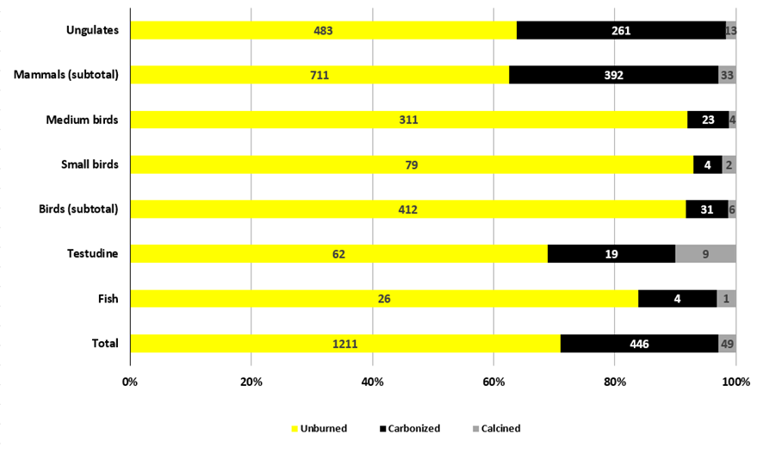
Supplementary Fig. 4. Latnija Cave – Phase V. NISP counts and relative proportions (%) of unburnt and burnt (charred/calcined) bones for each taxonomic or body size group. Specimens completely covered by calcitic crusts and those darkened or whitened but most likely due to geochemical/post-depositional processes (e.g., oxide and/or manganese staining) are excluded.

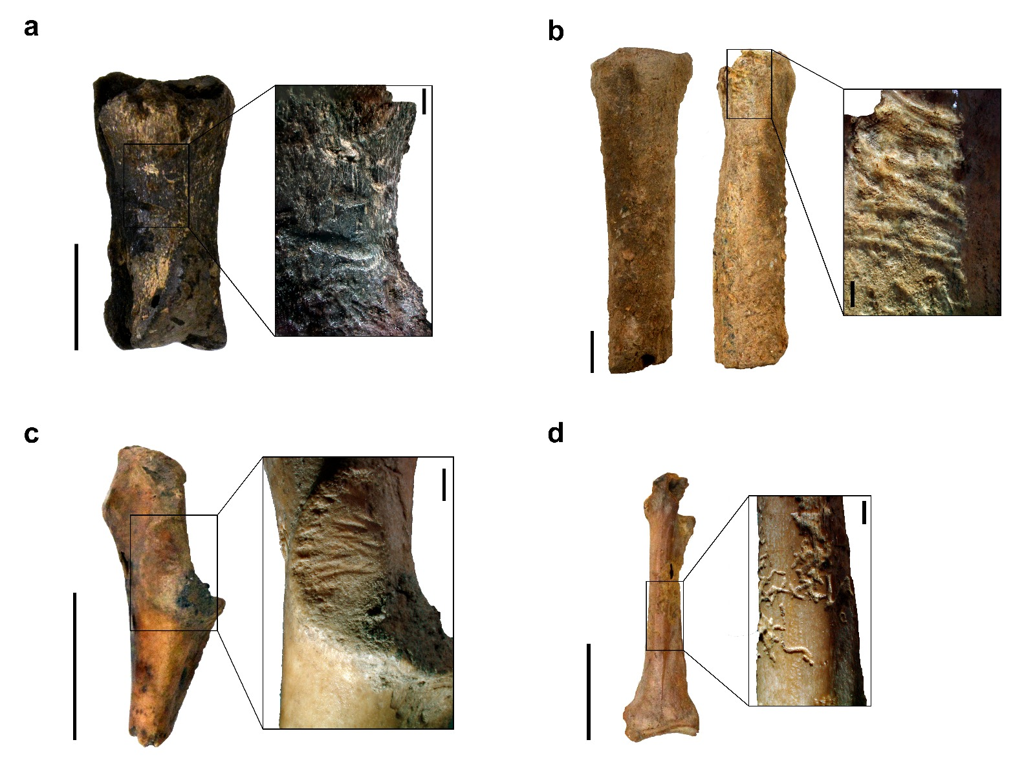
Supplementary Fig. 7. Latnija Cave - Phase V. Faunal remains with natural and postdepositional modifications: a) Second phalanx of a deer (LAT23.29.122.M3) with carnivore bite marks; b) Deer metacarpal (LAT.24.24.306.N5) and c) Shearwater/petrel coracoid (LAT21.FL.09.20.L2) with rodent gnawing; and d) medium-sized bird coracoid (LAT.21.5.38.L2) with chemical weathering/corrosion. Scale: general view = 10 mm; close-up view = 1 mm.

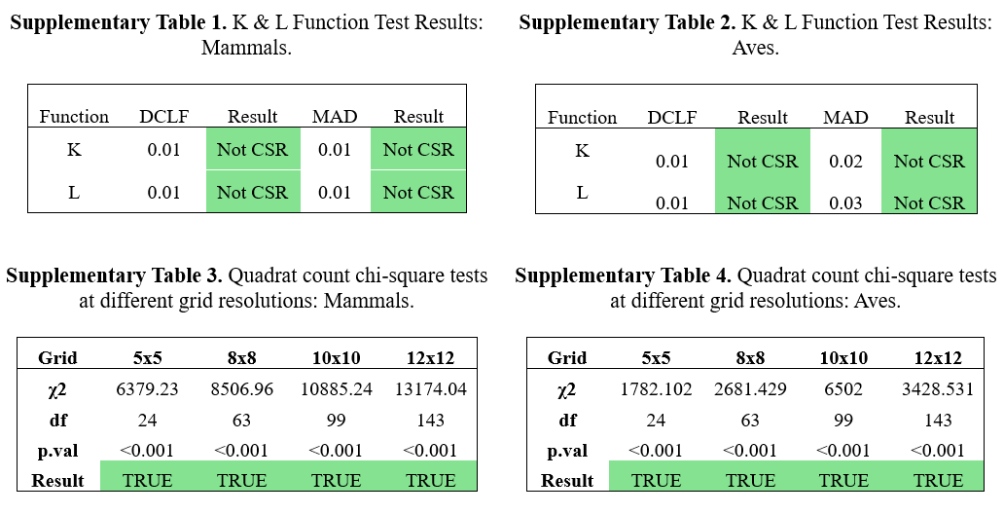

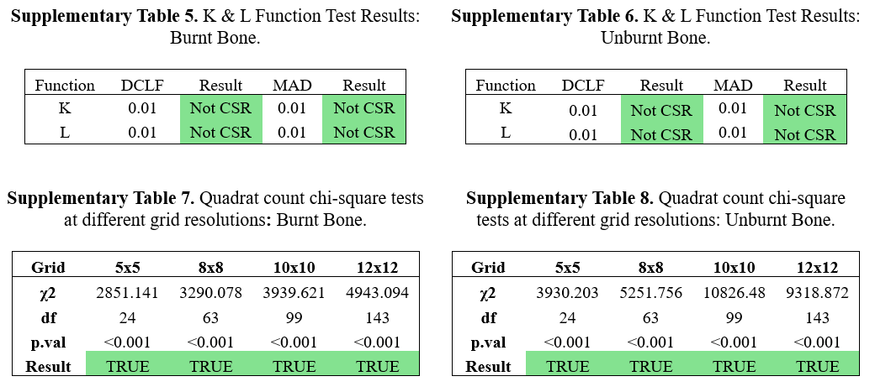

Supplementary Table 9. Latnija Cave - Phase V. Frequencies of bone surface modifications and readability.
 | NISP | %
Calcitic crusts
None | 540 | 28.2
Partly or completely covered | 1374 | 71.8
Surface readability 1 (<50%) | 832 | 43.5
Surface readability 2 (50–75%) | 262 | 13.7
Surface readability 3 (>75%) | 820 | 42.8
Surface Modifications*
Non-anthropogenic
Weathering Stage 0 | 899 | 90.9
Weathering Stage 1 | 74 | 7.5
Weathering Stage 2 | 6 | 0.6
Weathering Stage 3 | 1 | 0.1
Weathering Stage 4 | 1 | 0.1
Exfoliation | 24 | 2.4
Chemical weathering/corrosion | 942 | 95.3
Rounding (chemical) | 42 | 4.3
Trampling | 3 | 0.3
Carnivore bite marks | 3 | 0.3
Potential carnivore bite marks | 5 | 0.5
Rodent gnawing | 7 | 0.7
Potential rodent gnawing | 1 | 0.1
Anthropogenic
Percussion impact | 2 | 0.2
Potential percussion impact | 2 | 0.2
Potential cut marks | 8 | 0.8
Peeling** | 11 | 2.5
*In this analysis, we excluded specimens covered by calcitic crusts for which cortical readability is less than 50% (surface readability 1), alongside teeth and tooth fragments.
**Only on bird specimens.

Supplementary Table 10. Latnija Cave – Phase V. Absolute and relative frequencies of fracture attributes on mammalian long bones. Specimens with recent fractures, edges covered by calcitic crusts, or ambiguous characteristics were not recorded. Fracture patterns described by¹ are also included here for comparative purposes: Frontbrégoua (assemblage with bones broken for marrow extraction), Sarrians (collective burial affected by sediment compaction), and Bezouce (desiccated/sub-fossilized bones broken during the excavation as results of “dynamic forces”). Attribute states with the highest frequencies for each assemblage are highlighted in bold.
Sites |  | Latnija |  | Frontbrégoua |  | Sarrians |  | Bezouce
Attributes | States | N | % | N | % | N | % | N | %
Fracture angle | Oblique | 85 | 16.3 | 114 | 65.5 | 22 | 8.2 | 27 | 10.7
 | Right | 229 | 43.5 | 47 | 27.0 | 176 | 65.4 | 174 | 68.8
 | Oblique and right | 212 | 40.3 | 13 | 7.5 | 71 | 26.4 | 52 | 20.6
Fracture outline | Transverse | 245 | 45.1 | 92 | 35.3 | 193 | 53.9 | 144 | 50.2
 | Curved (spiral/V-shaped) | 124 | 22.8 | 134 | 51.3 | 106 | 29.6 | 82 | 28.6
 | Intermediate | 174 | 32.0 | 35 | 13.4 | 59 | 16.5 | 61 | 21.3
Fracture edge | Smooth | 253 | 51.0 | 163 | 62.5 | 111 | 31.0 | 158 | 55.1
 | Jagged | 243 | 49.0 | 98 | 37.6 | 247 | 69.0 | 129 | 45.0
Shaft circumference | Less than half | 304 | 77.4 | 115 | 76.2 | 16 | 7.1 | 33 | 35.5
 | More than half | 15 | 3.8 | 23 | 17.2 | 10 | 4.4 | 0 | 0.0
 | Complete | 74 | 18.8 | 13 | 8.6 | 200 | 88.5 | 60 | 64.5

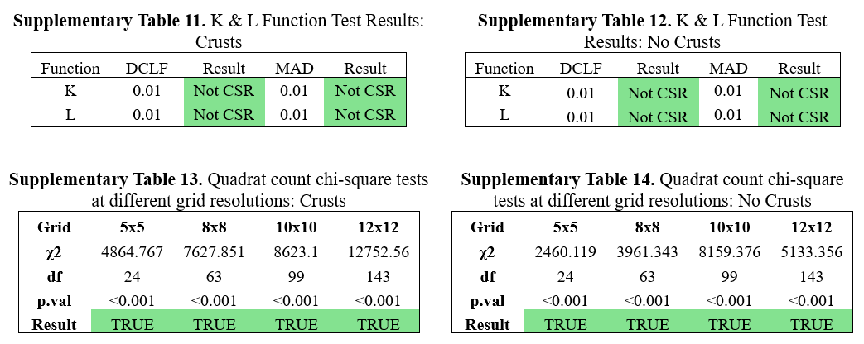

Supplementary Table 15. Latnija Cave - Phase V. Summary of refitting sets from Phase V, showing mean distance between refitting points, total distance (sum of distances between all refitting points), mean vertical distance, and maximum vertical distance.
Refit Set | Number of Points | Mean Horizontal Distance (m) | Total Horizontal Distance (m) | Mean Vertical Distance (m) | Max Vertical Distance (m)
1 | 4 | 0.182 | 1.092 | 0.02 | 0.038
2 | 2 | 0.054 | 0.054 | 0.005 | 0.005
3 | 4 | 0.112 | 0.671 | 0.045 | 0.086
4 | 2 | 0.089 | 0.089 | 0.018 | 0.018
5 | 2 | 0.096 | 0.096 | 0.02 | 0.02
7 | 2 | 0.077 | 0.077 | 0.007 | 0.007
8 | 3 | 0.045 | 0.136 | 0.012 | 0.017
9 | 2 | 0.254 | 0.254 | 0.046 | 0.046
10 | 3 | 0.045 | 0.134 | 0.004 | 0.006
11 | 2 | 0.037 | 0.037 | 0.01 | 0.01
12 | 2 | 0.341 | 0.341 | 0.006 | 0.006
13 | 2 | 0.097 | 0.097 | 0.002 | 0.002
14 | 2 | 0.24 | 0.24 | 0.027 | 0.027
15 | 2 | 0.048 | 0.048 | 0.01 | 0.01
16 | 2 | 0.063 | 0.063 | 0.004 | 0.004
17 | 2 | 0.044 | 0.044 | 0.001 | 0.001
18 | 2 | 0.056 | 0.056 | 0.012 | 0.012
19 | 2 | 0.033 | 0.033 | 0.006 | 0.006
20 | 2 | 0.127 | 0.127 | 0.03 | 0.03
21 | 2 | 0.103 | 0.103 | 0.019 | 0.019

Supplementary Table 16. Latnija Cave - Phase V. NISP, observed MNE, MNEs for a standard deer skeleton (ST deer), MAU and %MAU for cervids/ungulates by element. Selected elements and their specific order for the Bayesian analysis follows².
Elements | NISP | Observed MNE | MNE ST deer | MAU | %MAU
Mandible | 58 | 11 | 2 | 5.50 | 100.00
Atlas | 5 | 3 | 1 | 3.00 | 54.55
Axis | 3 | 1 | 1 | 1.00 | 18.18
Cervical vertebrae | 37 | 9 | 5 | 1.80 | 32.73
Thoracic vertebrae | 29 | 16 | 13 | 1.23 | 22.38
Lumbar vertebrae | 27 | 12 | 7 | 1.71 | 31.17
Ribs | 73 | 24 | 26 | 0.92 | 16.78
Sacrum | 8 | 3 | 1 | 3.00 | 54.55
Pelvis | 12 | 4 | 2 | 2.00 | 36.36
Scapula | 17 | 6 | 2 | 3.00 | 54.55
Humerus | 31 | 9 | 2 | 4.50 | 81.82
Radius-ulna | 35 | 7 | 2 | 3.50 | 63.64
Metacarpal | 22 | 8 | 2 | 4.00 | 72.73
Femur | 32 | 10 | 2 | 5.00 | 90.91
Tibia | 34 | 8 | 2 | 4.00 | 36.37
Metatarsal | 31 | 9 | 2 | 4.50 | 81.82
Total | 485 | 134 | 72

Supplementary Table 17. Latnija Cave - Phase V. Results of log-normal family generalized linear models for percent survivorship (%MAU, Supplementary Table 20) as a function of bone mineral density^{3,4}, and %MAU (Supplementary Table 18) as a function of different utility indices, including the Modified General Utility Index (MGUI)⁵, Simplified Meat Utility Index (SMUI)⁶, Food Utility Index (FUI)⁶, Corrected Food Utility Index (CFUI)⁷, and Unsaturated Marrow Index (UMI)⁸.
 | N | X² | df | P | D²
Bone mineral density | 75 | 17.497 | 1 | < 0.001* | 0.211
MGUI | 26 | 0.004 | 1 | 0.948 | < 0.001
SMUI | 26 | 1.381 | 1 | 0.240 | 0.052
FUI | 27 | 0.013 | 1 | 0.909 | < 0.001
CFUI | 25 | 0.124 | 1 | 0.725 | 0.005
UMI | 13 | 3.324 | 1 | 0.068 | 0.226
*Asterisks indicate statistically significant results.

Supplementary Table 18. Latnija Cave - Phase V. NISP, MNE, MAU and %MAU for Cervidae/ungulates by element, alongside MNEs for a standard deer skeleton (ST deer), the Modified General Utility Index (MGUI)⁵, Simplified Meat Utility Index (SMUI)⁶, Food Utility Index (FUI)⁶, Corrected Food Utility Index (CFUI)⁷, and Unsaturated Marrow Index (UMI)⁸.
Elements | NISP | MNE | MNE ST deer | MAU | %MAU | MGUI* | SMUI | FUI | CFUI | UMI
Antler | 35 | 1 | 2 | 0.50 | 8.16 | 1.02 | NA | 1.0 | NA | NA
Cranium | 36 | 10 | 2 | 5.00 | 81.63 | 8.74 | 18.2 | 9.1 | 469.0 | NA
Mandible | 58 | 11 | 2 | 5.50 | 89.80 | 13.89 | 11.5 | 11.5 | 590.0 | NA
Atlas | 5 | 3 | 1 | 3.00 | 48.98 | 9.79 | 10.2 | 10.2 | 524.0 | NA
Axis | 3 | 1 | 1 | 1.00 | 16.33 | 9.79 | 10.2 | 10.2 | 524.0 | NA
Cervical | 37 | 9 | 5 | 1.80 | 29.39 | 35.71 | 37.1 | 37.1 | 1905.0 | NA
Thoracic | 29 | 16 | 13 | 1.23 | 20.08 | 45.53 | 47.3 | 47.3 | 2433.0 | NA
Lumbar | 27 | 12 | 7 | 1.71 | 27.92 | 32.05 | 33.2 | 33.2 | 1706.0 | NA
Sacrum | 8 | 3 | 1 | 3.00 | 48.98 | NA** | 49.3 | 49.3 | 2531.0 | NA
Rib | 73 | 24 | 26 | 0.92 | 15.02 | 49.77 | 51.6 | 51.6 | 2650.0 | NA
Sternum | 3 | 1 | 1 | 0.50 | 8.16 | 64.13 | 66.6 | 66.6 | NA | NA
Pelvis | 12 | 4 | 2 | 2.00 | 32.65 | 47.89 | 49.3 | 49.3 | 2531.0 | NA
Scapula | 17 | 6 | 2 | 3.00 | 48.98 | 43.47 | 44.7 | 44.7 | 2295.0 | NA
Humerus | 31 | 9 | 2 | 4.50 | 73.47 | 40.00 | 28.9 | 36.8 | 2093.0 | 22.8
Radius | 20 | 7 | 2 | 3.50 | 57.14 | 24.44 | 14.7 | 25.8 | 1181.0 | 26.3
Ulna | 15 | 6 | 2 | 3.00 | 48.98 | 24.44 | 14.7 | 25.8 | 1181.0 | NA
Metacarpal | 22 | 8 | 2 | 4.00 | 65.31 | 11.34 | 5.2 | 5.2 | 413.0 | 19.6
Carpals | 20 | 20 | 12 | 1.67 | 27.27 | 15.53 | 5.2 | 5.2 | 653.0 | 0.9
Femur | 32 | 10 | 2 | 5.00 | 81.63 | 100.0 | 100.0 | 100.0 | 5139.0 | 34.0
Patella | 5 | 5 | 2 | 2.50 | 40.82 | NA | NA | NA | NA | NA
Tibia | 34 | 8 | 2 | 4.00 | 65.31 | 55.91 | 25.5 | 62.8 | 2746.0 | 51.1
Astragalus | 6 | 4 | 2 | 2.00 | 32.65 | 31.66 | 25.5 | 62.8 | 1424.0 | 0.9
Calcaneum | 14 | 8 | 2 | 4.00 | 65.31 | 31.66 | 25.5 | 62.8 | 1424.0 | 2.6
Metatarsal | 31 | 9 | 2 | 4.50 | 73.47 | 26.93 | 11.3 | 37.0 | 897.0 | 46.5
Tarsals | 15 | 14 | 8 | 1.75 | 28.57 | 31.66 | 25.5 | 62.8 | 1424.0 | 0.9
Phalanx 1 | 55 | 49 | 8 | 6.13 | 100.00 | 13.72 | 1.8 | 19.4 | 99.6 | 3.7
Phalanx 2 | 26 | 23 | 8 | 2.88 | 47.02 | 13.72 | 1.8 | 19.4 | 77.5 | 1.8
Phalanx 3 | 19 | 16 | 8 | 2.00 | 32.65 | 13.72 | 1.8 | 19.4 | 44.3 | 0.9
*We consider long bones as whole elements, so the utility values shown here for long bones are the average between the distal and medial epiphyses.
**NA (Not Applicable).

Supplementary Table 19. Latnija Cave – Phase V. NISP, NNE, and the wing-to-leg and proximal-to-distal element ratios for all birds combined, along with MNE for a standard (ST) bird skeleton.
 | Medium birds |  | All birds |  | ST Bird
Element | NISP | MNE | NISP | MNE | MNE
Coracoid | 52 | 36 | 59 | 40 | 2
Scapula | 30 | 30 | 33 | 33 | 2
Humerus | 31 | 18 | 41 | 24 | 2
Radius | 26 | 18 | 26 | 18 | 2
Ulna | 21 | 13 | 27 | 15 | 2
Carpometacarpus | 26 | 17 | 34 | 20 | 2
Femur | 19 | 8 | 25 | 11 | 2
Tibiotarsus | 22 | 9 | 29 | 13 | 2
Tarsometatarsus | 41 | 20 | 48 | 25 | 2
Wings (total)¹ | 104 | 66 | 128 | 77 | 8
Legs (total)² | 82 | 37 | 102 | 49 | 6
Proximal (total)³ | 154 | 101 | 187 | 121 | 10
Distal (total)⁴ | 114 | 68 | 135 | 78 | 8
Wing-to-leg ratio |  | 1.8 |  | 1.6 | 1.3
Proximal-to-distal ratio |  | 1.5 |  | 1.6 | 1.3
¹Wings: humerus, radius, ulna, and carpometacarpus,
²Legs: femur, tibiotarsus, and tarsometatarsus.
³Proximal: coracoid, scapula, humerus, femur, and tibiotarsus.
⁴Distal: radius, ulna, carpometacarpus, and tarsometatarsus.

Supplementary Table 20. Latnija Cave – Phase V. Survivorship values for cervids/ungulates. Density values from^{3,4} for American deer (Odocoileus spp.).
 | Scan site | Density | MNE Observed | MNE Expected | MAU | MNI | Survivorship (%MAU)
 | AC1 | 0.27 | 4 | 2 | 2.00 | 8 | 25.00
 | AS1 | 0.47 | 3 | 2 | 2.00 | 8 | 25.00
 | AS2 | 0.59 | 5 | 2 | 2.50 | 8 | 31.25
 | AS3 | 0.61 | 3 | 2 | 1.50 | 8 | 18.75
 | AT1 | 0.13 | 2 | 1 | 2.00 | 8 | 25.00
 | AT2 | 0.15 | 3 | 1 | 3.00 | 8 | 37.50
 | AT3 | 0.26 | 5 | 2 | 2.50 | 8 | 31.25
 | AX1 | 0.16 | 3 | 1 | 3.00 | 8 | 37.50
 | AX2 | 0.10 | 0 | 1 | 0.00 | 8 | 0.00
 | AX3 | 0.16 | 0 | 1 | 0.00 | 8 | 0.00
 | CA1 | 0.41 | 3 | 2 | 1.50 | 8 | 18.75
 | CA2 | 0.64 | 8 | 2 | 4.00 | 8 | 50.00
 | CA3 | 0.57 | 10 | 2 | 5.00 | 8 | 62.50
 | CA4 | 0.33 | 8 | 2 | 4.00 | 8 | 50.00
 | CE1 | 0.19 | 21 | 5 | 4.20 | 8 | 52.50
 | CE2 | 0.15 | 13 | 5 | 2.60 | 8 | 32.50
 | DN1 | 0.55 | 7 | 2 | 3.50 | 8 | 43.75
 | DN2 | 0.57 | 9 | 2 | 4.50 | 8 | 56.25
 | DN3 | 0.55 | 8 | 2 | 4.00 | 8 | 50.00
 | DN5 | 0.57 | 10 | 2 | 5.00 | 8 | 62.50
 | DN6 | 0.31 | 9 | 2 | 4.50 | 8 | 56.25
 | DN7 | 0.36 | 9 | 2 | 4.50 | 8 | 56.25
 | DN8 | 0.61 | 5 | 2 | 2.50 | 8 | 31.35
 | FE1 | 0.41 | 2 | 2 | 1.00 | 8 | 12,50
 | FE2 | 0.36 | 3 | 2 | 1.50 | 8 | 18.75
 | FE3 | 0.33 | 4 | 2 | 2.00 | 8 | 25.00
 | FE5 | 0.37 | 5 | 2 | 2.50 | 8 | 31.25
 | FE6 | 0.28 | 12 | 2 | 6.00 | 8 | 75.00
 | HU1 | 0.24 | 5 | 2 | 2.50 | 8 | 31.25
 | HU2 | 0.25 | 2 | 2 | 1.00 | 8 | 12.50
 | HU4 | 0.63 | 10 | 2 | 5.00 | 8 | 62,50
 | HU5 | 0.39 | 11 | 2 | 5.50 | 8 | 68.75
 | IL1 | 0.20 | 0 | 2 | 0.00 | 8 | 0.00
 | IL2 | 0.49 | 1 | 2 | 0.5 | 8 | 6.25
 | IS1 | 0.41 | 2 | 2 | 1.00 | 8 | 12.50
 | IS2 | 0.16 | 0 | 2 | 0.00 | 8 | 0.00
 | LU1 | 0.29 | 16 | 7 | 2.29 | 8 | 28.57
 | LU2 | 0.30 | 17 | 7 | 2.43 | 8 | 30.36
 | LU3 | 0.29 | 6 | 14 | 0.43 | 8 | 5.36
 | MC1 | 0.56 | 11 | 2 | 5.50 | 8 | 68.75
 | MC2 | 0.69 | 11 | 2 | 5.50 | 8 | 68.75
 | MC4 | 0.58 | 8 | 2 | 4.00 | 8 | 50.00
 | MC5 | 0.49 | 5 | 2 | 2.50 | 8 | 31.25
 | MC6 | 0.51 | 4 | 2 | 2.00 | 8 | 25.00
 | MR1 | 0.55 | 16 | 2 | 8.00 | 8 | 100.00
 | MR2 | 0.65 | 15 | 2 | 7.50 | 8 | 93.75
 | MR4 | 0.57 | 9 | 2 | 4.50 | 8 | 56.25
 | MR5 | 0.46 | 5 | 2 | 2.50 | 8 | 31.25
 | Supplementary Table 20. Continued.
 | Scan site | Density | MNE Observed | MNE Expected | MAU | MNI | Survivorship (%MAU)
 | MR6 | 0.50 | 3 | 2 | 1.50 | 8 | 18.75
 | P11 | 0.36 | 33 | 8 | 4.13 | 8 | 51.56
 | P12 | 0.42 | 49 | 8 | 6.13 | 8 | 76.56
 | P13 | 0.57 | 47 | 8 | 5.88 | 8 | 73.44
 | P21 | 0.28 | 21 | 8 | 2.63 | 8 | 32.81
 | P22 | 0.25 | 25 | 8 | 3.13 | 8 | 39.06
 | P23 | 0.35 | 25 | 8 | 3.13 | 8 | 39.06
 | P31 | 0.25 | 17 | 8 | 2.13 | 8 | 26.56
 | PA1 | 0.31 | 5 | 2 | 2.50 | 8 | 31.25
 | PU1 | 0.46 | 3 | 2 | 1.50 | 8 | 18.75
 | PU2 | 0.24 | 0 | 2 | 0.00 | 8 | 0.00
 | RA1 | 0.42 | 9 | 2 | 4.50 | 8 | 46.25
 | RA2 | 0.62 | 8 | 2 | 4.00 | 8 | 50.00
 | RA4 | 0.38 | 5 | 2 | 2.50 | 8 | 31.25
 | RA5 | 0.43 | 5 | 2 | 2.50 | 8 | 31.25
 | RI1 | 0.26 | 21 | 26 | 0.81 | 8 | 10.10
 | RI2 | 0.25 | 29 | 26 | 1.12 | 8 | 13.94
 | RI3 | 0.40 | 16 | 26 | 0.62 | 8 | 7.69
 | RI5 | 0.14 | 3 | 26 | 0.12 | 8 | 1.44
 | SC1 | 0.19 | 3 | 1 | 3.00 | 8 | 37.50
 | SC2 | 0.16 | 0 | 1 | 0.00 | 8 | 0.00
 | SP1 | 0.36 | 6 | 2 | 3.00 | 8 | 27.50
 | SP2 | 0.49 | 4 | 2 | 2.00 | 8 | 25.00
 | SP3 | 0.23 | 0 | 2 | 0.00 | 8 | 0.00
 | SP4 | 0.34 | 0 | 2 | 0.00 | 8 | 0.00
 | SP5 | 0.28 | 0 | 2 | 0.00 | 8 | 0.00
 | TH1 | 0.24 | 18 | 13 | 1.38 | 8 | 17.31
 | TH2 | 0.27 | 13 | 13 | 1.00 | 8 | 12.50
 | TI1 | 0.30 | 7 | 2 | 3.50 | 8 | 43.75
 | TI2 | 0.32 | 4 | 2 | 2.00 | 8 | 25.00
TI4 |  | 0.51 | 9 | 2 | 4.50 | 8 | 56.25
 | TI5 | 0.50 | 8 | 2 | 4.00 | 8 | 50.00
 | UL1 | 0.30 | 2 | 2 | 1.00 | 8 | 12.50
 | UL2 | 0.45 | 4 | 2 | 2.00 | 8 | 25.00
 | UL3 | 0.44 | 2 | 2 | 1.00 | 8 | 12.50

Supplementary Table 21. Latnija Cave – Phase V. Counts and relative proportions of fused and unfused elements for cervids/ungulates. P = proximal, and D = distal epiphyses.
Element | MNE  (total) | MNE (%) fused | MNE (%) unfused
P Phalanx 1 | 34 | 30 (88.2) | 4 (11.8)
P Phalanx 2 | 22 | 21 (95.5) | 1 (4.5)
D Tibia | 7* | 5 (85.7) | 1 (14.3)
D Metapodial | 11* | 9 (81.8) | 2 (18.2)
D Calcaneus | 5* | 3 (60.0) | 2 (40.0)
P Femur | 3* | 2 (66.7) | 1 (33.3)
D Radius | 5* | 5 (100.0) | 0 (0.0)
*Asterisks represent small sample sizes.

Supplementary Table 22. Latnija Cave - Phase V. Linear measurements for cervid/ungulate specimens (after⁹). In bold, values included in our metric analysis.
ID | Element | Measurement abbreviations*
 |  | GLP | LG | BG | SLC
12.155.L3 | Scapula | 37.2 | - | 24.3 | 25.0
24.143.M3 | Scapula | 39.0 | 30.0 | - | -
1.173.N3 | Scapula | - | - | - | 19.0
6.118.L3 | Scapula | - | - | ~24.0 | -
 |  | Bd | BT
Fl.02.146.L3 | Humerus | - | ~32.0
11.114.L3 | Humerus | 33.7 | 32.6
79.48.L2 | Humerus | 38.1 | 34.2
 |  | Bp | BFp | Bd | BFd | GL | SD
31.143.M3 | Radius | ~37.0 | 35.0 | - | - | - | -
35.143.N3 | Radius | ~36.0 | ~35.0 | - | - | - | -
16.1.118.L3 | Radius | 35.5 | 33.9 | 30.2 | 29.2 | ~162.0 | 16.6
1.111.N4 | Radius | 37.5 | 35.2 | - | - | - | -
69.48.L2 | Radius | - | - | 33.1 | - | - | -
18.1.306.N5 | Radius | 35.0 | 33.3 | - | - | - | -
18.2.306.N5 | Radius | - | - | ~30.8 | 26.5 | - | -
73.281.N4 | Radius | - | - | 31.8 | 27.8 | - | -
 |  | SDO | DPA | BPC
53.113.N3 | Ulna | 25.7 | - | -
61.281.N4 | Ulna | - | 36.2 | 22.1
44.281.N4 | Ulna | - | 28.9 | 18.5
 |  | Bp | Bd | GL | SD
3.155.L3 | Metacarpal | - | 28.0 | ~156.0 | -
10.120.M3 | Metacarpal | 26.0 | - | - | -
1.113.N3 | Metacarpal | - | 28.7 | - | -
13.111.N3 | Metacarpal | 27.3 | - | - | -
1.1.306.N5 | Metacarpal | ~24.9 | - | - | 14.1
1.2.306.N5 | Metacarpal | - | 26.8 | - | -
24.306.N5 | Metacarpal | ~24.6 | - | - | -
1.302.N4 | Metacarpal | - | - | - | 12.7
 |  | Bp | DC | SD
14.118.L3 | Femur | 59.0 | 25.0 | -
34.111.M3 | Femur | - | - | 14.6
Fl.75.41.L2 | Femur | - | 21.4 | -
 |  | Bd
43.1.43.N3 | Tibia | 30.0
29.115.N3 | Tibia | 30.0
45.114.L3 | Tibia | 28.0
 |  | GLl | GLm | Dl
24.115.N3 | Astragalus | - | 32.0 | -
3.136.L3 | Astragalus | 31.0 | 29.0 | -
23.284.N4 | Astragalus | 36.7 | 33.4 | 19.5
 |  | GB
40.281.N4 | Calcaneus | 22.3
 |  | Bp | Bd
22.143.M3 | Metatarsus | 21.0 | -
40.114.L3 | Metatarsus | 20.0 | -
2.118.L3 | Metatarsus | - | 24
48.113.N3 | Metatarsus | - | 26.2
24.291.N4 | Metatarsus | 24.6 | -
10.302.N4 | Metatarsus | 25.6 | -
 |  | Bp | Bd | GL | SD
6.143.M3 | 1st phalanx | - | 11.0 | - | 10.0
17.115.N3 | 1st phalanx | 14.0 | 14.0 | 38.0 | 11.0
22.115.N3 | 1st phalanx | 15.0 | 13.0 | 34.0 | 11.0
49.115.N3 | 1st phalanx | 16.0 | 14.0 | 35.0 | 12.0
25.115.N3 | 1st phalanx | 12.0 | 12.0 | 30.0 | 10.0
16.142.M3 | 1st phalanx | ~13.0 | 13.0 | - | -
Supplementary Table 22. Latnija Cave - Phase V. Continued.

ID | Element | Measurement abbreviations*
 |  | Bp | Bd | GL | SD
30.114.M3 | 1st phalanx | - | 13.0 | 37.0 | 11.0
1.139.M3 | 1st phalanx | 13.0 | 12.0 | 31.0 | 10.0
6.153.L3 | 1st phalanx | 14.0 | 12.0 | 31.0 | 11.0
1.162.M3 | 1st phalanx | - | - | - | 11.0
21.114.M3 | 1st phalanx | ~13.0 | 12.0 | 34.0 | 11.0
6.146.L3 | 1st phalanx | - | 14.0 | 35.0 | 12.0
1.146.L3 | 1st phalanx | - | 13.0 | 33.0 | 12.0
2.122.M3 | 1st phalanx | 15.0 | ~14.0 | 35.0 | 12.0
Fl.28.40.N2 | 1st phalanx | 10.0 | - | - | -
Fl.19.48.N2 | 1st phalanx | 12.0 | 11.0 | 33.0 | 10.0
Fl.152.48.L2 | 1st phalanx | - | 14.0 | - | -
Fl.59.48.L2 | 1st phalanx | 10.2 | - | - | -
Fl.139.48.L2 | 1st phalanx | ~10.5 | - | - | -
Fl.05.45.L2 | 1st phalanx | 12.0 | 10.7 | 28.9 | 9.3
2.114.N3 | 1st phalanx | - | 13.8 | - | -
3.114.N3 | 1st phalanx | - | 12.2 | - | 9.9
45.113.N3 | 1st phalanx | 12.9 | 12.2 | 32.7 | 10.1
16.111.N3 | 1st phalanx | 11.3 | - | - | 8.3
38.48.L2 | 1st phalanx | 14.8 | 13.3 | 35.4 | 11.3
23.1.40.N2 | 1st phalanx | - | 12.3 | 32.8 | -
23.4.40.N2 | 1st phalanx | 13.4 | - | - | -
23.48.L2 | 1st phalanx | - | 11.9 | - | -
20.110.N3 | 1st phalanx | - | 13.7 | - | -
24.40.N2 | 1st phalanx | ~13.2 | ~13.3 | 34.3 | 10.8
17.113.N3 | 1st phalanx | 14.8 | 13.1 | 35.4 | -
4.110.N3 | 1st phalanx | - | 11.1 | - | 9.1
8.36.L2 | 1st phalanx | - | ~14.3 | - | -
4.41.L2 | 1st phalanx | 14.7 | 13.3 | 34.7 | -
SR.09 | 1st phalanx | - | ~9.3 | - | 8.1
14.306.N5 | 1st phalanx | - | - | - | 9.6
10.281.N4 | 1st phalanx | 13.1 | 12.4 | 36.0 | 10.0
26.291.N4 | 1st phalanx | 12.9 | 12.5 | 32.9 | 10.1
34.281.N4 | 1st phalanx | 12.6 | 11.1 | 32.8 | 9.4
30.286.N4 | 1st phalanx | 12.2 | 11.6 | 30.5 | ~9.7
Fl.27.110.N3 | 1st phalanx | - | ~12.6 | - | 10.8
21.281.N4 | 1st phalanx | 13.3 | 12.7 | 35.4 | 10.0
49.281.N4 | 1st phalanx | 13.8 | 13.9 | 37.1 | 10.8
28.298.N4 | 1st phalanx | - | - | - | 10.5
24.286.N4 | 1st phalanx | 15.0 | 14.6 | 33.6 | 12.1
14.43.N2 | 1st phalanx | - | ~9.2 | - | 7.2
 |  | Bp | Bd | GL | SD
11.143.L3 | 2nd phalanx | 13.0 | 11.0 | 25.0 | -
32.143.N3 | 2nd phalanx | 14.0 | 11.0 | 27.0 | 11.0
19.115.N3 | 2nd phalanx | 12.0 | 11.0 | 23.0 | 9.0
1.120.M3 | 2nd phalanx | 13.0 | 11.0 | 27.0 | 10.0
26.142.M3 | 2nd phalanx | 13.0 | ~11.0 | 26.0 | 10.0
19.122.M3 | 2nd phalanx | 13.0 | ~10.0 | 25.0 | 9.0
18.118.L3 | 2nd phalanx | 11.0 | ~10.0 | 24.0 | 8.0
4.158.N3 | 2nd phalanx | ~12.0 | - | - | 9.0
Fl.10.115.N3 | 2nd phalanx | - | ~9.0 | - | -
Fl.24.36.L2 | 2nd phalanx | - | 9.8 | - | -
22.111.N3 | 2nd phalanx | 12.7 | ~10.9 | 25.1 | 9.9
28.111.N3 | 2nd phalanx | 13.5 | 11.4 | 26.8 | 10.3
7.107.N3 | 2nd phalanx | - | ~9.8 | - | 9.1
10.48.L2 | 2nd phalanx | 13.5 | 11.3 | 26.0 | 10.3
11.30.L2 | 2nd phalanx | 15.5 | 13.1 | 27.3 | 12.1
23.5.40.N2 | 2nd phalanx | - | 10.7 | - | -
12.110.N3 | 2nd phalanx | - | ~9.1 | - | -
26.111.N3 | 2nd phalanx | 12.3 | 10.4 | 26.2 | -
4.47.N2 | 2nd phalanx | - | 10.4 | 27.4 | 9.5
SR.01.163.LM3 | 2nd phalanx | 10.9 | - | - | -
10.281.N4 | 2nd phalanx | - | - | - | 8.9
Supplementary Table 22. Latnija Cave - Phase V. Continued.

ID | Element | Measurement abbreviations*
 |  | Bp | Bd | GL | SD
Fl.02.40.N2 | 2nd phalanx | 13.6 | 11.4 | ~27.2 | -
 |  | Ld | DLS | MBS
Fl.07.142.M3 | 3rd phalanx | 28.0 | 31.0 | 8.0
Fl.08142.M3 | 3rd phalanx | 23.0 | 25.0 | 7.0
Fl.88.48.L2 | 3rd phalanx | 19.8 | 21.6 | -
Fl.26.40.N2 | 3rd phalanx | 27.7 | 29.2 | 8.5
5.114.N3 | 3rd phalanx | 27.2 | 30.4 | 7.8
40.113.N3 | 3rd phalanx | ~30.6 | 32.4 | -
5.40.N2 | 3rd phalanx | ~25.4 | ~28.5 | -
23.3.40.N2 | 3rd phalanx | 26.7 | 28.1 | 8.6
44.48.L2 | 3rd phalanx | 26.0 | 29.4 | 8.0
76.48.L2 | 3rd phalanx | 28.6 | 31.6 | 9.1
33.111.M3 | 3rd phalanx | 23.8 | 25.1 | 7.8
16.43N2 | 3rd phalanx | ~25.3 | ~28.7 | ~7.4
*Measurement abbreviations from⁹: GLP (greatest length of the glenoid process), LG (length of the glenoid cavity), BG (breadth of the glenoid cavity), SLC (smallest length of the neck of the scapula), Bd (greatest breadth of the distal epiphysis), BT (greatest breadth of the trochlea), Bp (greatest breadth of the proximal epiphysis), BFp (greatest breadth of the humeral articular surface), GL (greatest length), SD (smallest breadth of the diaphysis); SDO (smallest depth of the olecranon), DPA (depth across the anconeal process), BPC (greatest breadth across the coronoid process), DC (greatest depth of the femoral head), GLl (greatest length of the lateral half), GLm (greatest length of the medial half), Dl (greatest depth of the medial half), GB (greatest breadth), Ld (length of the dorsal surface, (DLS (greatest diagonal length of the sole); and MBS (middle breadth of the sole).

Supplementary Table 23. Standard sample for the Size Variation Index (SVI). Data obtained from¹⁰.
Element | Measurement abbreviations* | n | Mean | Standard deviation
Humerus | Bd | 18 | 43.81 | 2.78
Radius | Bp | 13 | 42.08 | 1.67
Metacarpal | Bp | 9 | 31.64 | 2.07
Femur | Bp | 3 | 55.67 | 16.20
Tibia | Bd | 16 | 36.47 | 4.07
Astragalus | GLl | 19 | 44.47 | 2.10
Metatarsal | Bp | 18 | 28.66 | 2.25
1st phalanx | GL | 23 | 48.30 | 3.10
2nd phalanx | GL | 11 | 35.13 | 1.61
3rd phalanx | DLS | 5 | 39.52 | 2.11
*Measurement abbreviations from⁹, along with equivalences to the terminology used by¹⁰: Bd (greatest breadth of the distal epiphysis = transverse diameter of the distal epiphysis), Bp (greatest breadth of the proximal epiphysis = transverse diameter of the proximal epiphysis), GL (greatest length = length), GLl (greatest length of the lateral half = length), DLS (greatest diagonal length of the sole = length of the plantar surface).

References
1. Villa, P. & Mahieu, E. Breakage patterns of human long bones. J. Hum. Evol. 21, 27–48 (1991).
2. Marín-Arroyo, A.B., Ocio, D., Vidal-Cordasco, M., Vettese, D., 2024. BaSkePro: Bayesian model to archaeological faunal skeletal profiles. R Package Version 1.1.1. https://cran.r-project.org/web/packages/BaSkePro/index.html (2024).
3. Lyman, R. L. Bone density and differential survivorship of fossil classes. J. Anthropol. Archaeol. 3, 259–299 (1984).
4. Lyman, R. L. Vertebrate Taphonomy (Cambridge Univ. Press, 1994).
5. Binford, L. R. Nunamiut Ethnoarchaeology (Academic press, 1978).
6. Metcalfe, D. & Jones, K. T. A Reconsideration of Animal Body-Part Utility Indices. Am. Antiq. 53, 486–504 (1988).
7. Morin, E. & Ready, E. Foraging goals and transport decisions in Western Europe during the Paleolithic and Early Holocene in Zooarchaeology and Modern Human Origins. Human Hunting Behavior during the Later Pleistocene (eds. Clark, J. K. & Speth, J. D.) 227–269 (Springer, 2013).
8. Morin, E. Fat composition and Nunamiut decision-making: A new look at the marrow and bone grease indices. J. Archaeol. Sci. 34, 69–82 (2007).
9. von den Driesch, A. A Guide to the Measurement of Animals Bones from Archaeological Sites. Peabody Museum of Archaeology and Ethnology (Peabody Museum of Archaeology and Ethnology, Harvard Univ., 1976).
10. Gliozzi, E., Malatesta, A. & Scalone, E. Revision of Cervus elaphus siciliae Pohlig, 1983, Late Pleistocene endemic deer of the Siculo-Maltese District. Geol. Rom. 24, 307–353 (1993).

