Supplementary materials

Table (1): Demographic and Clinical Characteristics of the Studied Groups:
 |  |  | HD cases  (N=42) |  | Controls  (N=42) |  | Test value | p- value
 |  |  | N | % | N | % | Test value | p- value
Gender: | Female |  | 24 | 57.1% | 22 | 52.4% | 0.192 | 0.661‡
Gender: | Male |  | 18 | 42.9% | 20 | 47.6% | 0.192 | 0.661‡
Age (years): | Mean± SD  Min.–Max. |  | 10.41± 3.29  3.3- 16 |  | 9.52± 2.83  3- 15 |  | 1.315 | 0.192#
Socioeconomics | High |  | 2 | 4.8% | 1 | 2.4% | 0.354 | >0.999^{MC‡}
Socioeconomics | Low |  | 24 | 57.1% | 25 | 59.5% | 0.354 | >0.999^{MC‡}
Socioeconomics | Moderate |  | 16 | 38.1% | 16 | 38.1% | 0.354 | >0.999^{MC‡}
Primary diagnosis | Atypical HUS |  | 4 | 9.5% | - |  | - | -
Primary diagnosis | Bartter syndrome |  | 1 | 2.4% |  |  | - | -
Primary diagnosis | Prune belly syndrome |  | 1 | 2.4% |  |  | - | -
Primary diagnosis | Chronic interstitial nephritis |  | 2 | 4.8% |  |  | - | -
Primary diagnosis | CKD recurrent stones |  | 1 | 2.4% |  |  | - | -
Primary diagnosis | Congenital atrophic kidneys |  | 1 | 2.4% |  |  | - | -
Primary diagnosis | Glomerulopathy Nephrotic syndrome |  | 8 | 19% |  |  | - | -
Primary diagnosis | Nephrocalcinosis |  | 1 | 2.4% |  |  | - | -
Primary diagnosis | Neurogenic bladder |  | 6 | 14.3% |  |  | - | -
Primary diagnosis | Obstructive uropathy |  | 3 | 7.1% |  |  | - | -
Primary diagnosis | Polycystic kidney |  | 1 | 2.4% |  |  | - | -
Primary diagnosis | SLE |  | 3 | 7.1% |  |  | - | -
Primary diagnosis | Unexplained renal failure |  | 10 | 23.8% |  |  | - | -
Dialysis duration (years): | Median (IQR)  Min.–Max. |  | 2.0 (1.0–5.0)  6 months- 12 years |  | - |  | - | -
KT/V | Median (IQR)  Min.–Max. |  | 1.1 (0.9–1.3)  0.7- 1.7 |  | - |  | - | -
Weight (Kg) |  | Mean± SD | 30.84± 11.6 |  | 41.57± 12.26 |  | 4.121 | <0.001#
 |  | Min.–Max. | 11.0–56.0 |  | 18–75.0 |  | 4.121 | <0.001#
Height (cm) |  | Median (IQR) | 130.75 (120–142) |  | 137 (131.0–148.0) |  | 2.466 | 0.014╪
 |  | Min.–Max. | 90–165 |  | 100.0–155.0 |  | 2.466 | 0.014╪
BMI (Kg/m²) |  | Median (IQR) | 17.0 (15.6–19.0) |  | 21.35 (19.5–24.0) |  | 4.963 | <0.001╪
 |  | Min.–Max. | 11.0–31.8 |  | 15.0–33.0 |  | 4.963 | <0.001╪
MAC (cm) |  | Median (IQR) | 19 (18–24) |  | 27.0 (23.0–35.0) |  | 5.545 | <0.001╪
 |  | Min.–Max. | 10.0–31.0 |  | 15.0–35.0 |  | 5.545 | <0.001╪
SFC (mm) |  | Mean± SD | 19.38± 6.57 |  | 24.79± 5.42 |  | 4.113 | <0.001#
 |  | Min.–Max. | 9.0–30.0 |  | 13.0–35.0 |  | 4.113 | <0.001#
WC (cm) |  | Median (IQR) | 62.0 (57.0–69.0) |  | 62.0 (55.0–66.0) |  | 7.193 | 0.427╪
 |  | Min.–Max. | 20.0–95.0 |  | 48.0–71.0 |  | 7.193 | 0.427╪
p>0.05 is non-significant; p≤0.05 is significant. #Student T test, , ╪ Mann- Whitney U test, ‡Chi-square test, BMI: Body Mass Index.
MAC: Mid-Arm Circumference, SFC: Subcutaneous Fat Caliper, WC: Waist Circumference

Correlation of Muscle with Clinical, Nutritional, and Laboratory Parameters in Children on Hemodialysis

As shown in Table 5, association analysis illustrated that total caloric intake was positively related to muscle thickness, including rectus femoris (r = 0.573, p < 0.001), vastus intermedius (r = 0.486, p = 0.001), vastus medialis (r = 0.422, p = 0.006), and vastus lateralis (r = 0.290, p = 0.066). In addition, protein intake showed significant positive correlations with rectus femoris (r = 0.427, p = 0.005), vastus intermedius (r = 0.444, p = 0.004), vastus medialis (r = 0.514, p = 0.001), and vastus lateralis (r = 0.354, p = 0.023).

Renal function markers, particularly creatinine, were positively correlated with all muscle thickness measurements: rectus femoris (r = 0.604, p < 0.001), vastus intermedius (r = 0.480, p = 0.001), vastus medialis (r = 0.526, p < 0.001), and vastus lateralis (r = 0.467, p = 0.002). Other laboratory parameters, including total protein, albumin, calcium, phosphorus, UA, and lipid profile, showed no significant correlations with muscle thickness.
Table (5): Correlation of muscle thickness with clinical, nutritional, and laboratory parameters in hemodialysis children.
 | Rectus femoris thickness (mm) |  | Vastus intermedius (mm) |  | Vastus medialis (mm) |  |  | Vastus lateralis (mm)
 | r | P-value | r | P-value | r | P-value | r |  | P-value
Age (years) | 0.048 | 0.767 | -0.011 | 0.945 | 0.063 | 0.696 | 0.049 |  | 0.760
Dialysis duration (years) | 0.106 | 0.510 | -0.030 | 0.852 | -0.099 | 0.540 | -0.153 |  | 0.339
BMI | 0.073 | 0.647 | 0.164 | 0.299 | 0.052 | 0.744 | 0.159 |  | 0.314
KT/V | 0.098 | 0.536 | -0.187 | 0.236 | -0.070 | 0.661 | -0.128 |  | 0.420
Total calories | 0.573 | <0.001 | 0.486 | 0.001 | 0.422 | 0.006 | 0.290 |  | 0.066
Protein intake | 0.427 | 0.005 | 0.444 | 0.004 | 0.514 | 0.001 | 0.354 |  | 0.023
Fat intake | -0.208 | 0.191 | -0.191 | 0.231 | -0.099 | 0.540 | -0.187 |  | 0.242
Creatinine (mg/dL) | 0.604 | <0.001 | 0.480 | 0.001 | 0.526 | <0.001 | 0.467 |  | 0.002
BUN (mg/dL) | 0.008 | 0.960 | 0.260 | 0.096 | 0.130 | 0.411 | 0.198 |  | 0.210
HB (g/dL) | 0.070 | 0.661 | -0.145 | 0.360 | -0.024 | 0.882 | -0.157 |  | 0.321
Total protein (g/dL) | 0.202 | 0.200 | 0.110 | 0.489 | 0.195 | 0.215 | 0.032 |  | 0.839
Albumin (g/dL) | 0.226 | 0.149 | 0.212 | 0.178 | 0.134 | 0.399 | 0.231 |  | 0.141
Ca (mg/dL) | -0.160 | 0.318 | -0.091 | 0.573 | -0.133 | 0.408 | -0.220 |  | 0.166
Ph. (mg/dL) | 0.084 | 0.602 | 0.255 | 0.108 | 0.003 | 0.987 | 0.165 |  | 0.303
Uric acid (mg/dL) | 0.091 | 0.687 | -0.158 | 0.482 | -0.201 | 0.369 | -0.086 |  | 0.704
Cholesterol (mg/dL) | -0.078 | 0.697 | -0.092 | 0.648 | -0.037 | 0.856 | -0.097 |  | 0.630
p>0.05 is non-significant, *p≤0.05 is significant, **p≤0.01 is highly significant,r: Spearman correlation coefficient

Table (8): Validity (AUC, sensitivity, specificity) of Muscle in detection of malnutrition.
 | Best cut off | Sensitivity | Specificity | PPV | NPV | AUC | P-value
Rectus femoris thickness (mm) | 10.4 | 100% | 48% | 18.8% | 100% | 0.731 | <0.001
Vastus intermedius (mm) | 8.3 | 88.9% | 61.3% | 21.6% | 97.9% | 0.705 | 0.012
Vastus medialis (mm) | 14.4 | 77.8% | 61.3% | 19.4% | 95.8% | 0.678 | 0.032
Vastus lateralis (mm) | 20.6 | 100% | 52% | 20% | 100% | 0.736 | 0.001
ROC: Receiver operating characteristic, AUC: Area Under a Curve, NPV: Negative predictive value,
PPV: Positive predictive value

Figures

Figure 2:Ultrasound image of right thigh muscle thickness measurement in hemodualysis patient
Transverse ultrasound image of right mid thigh in hemodialysis patient shows 1.sub cutaneous fat thickness 2.Rectus femoris thickness 3.Vastus intermedius thickness 4.Vastus lateralis thickness

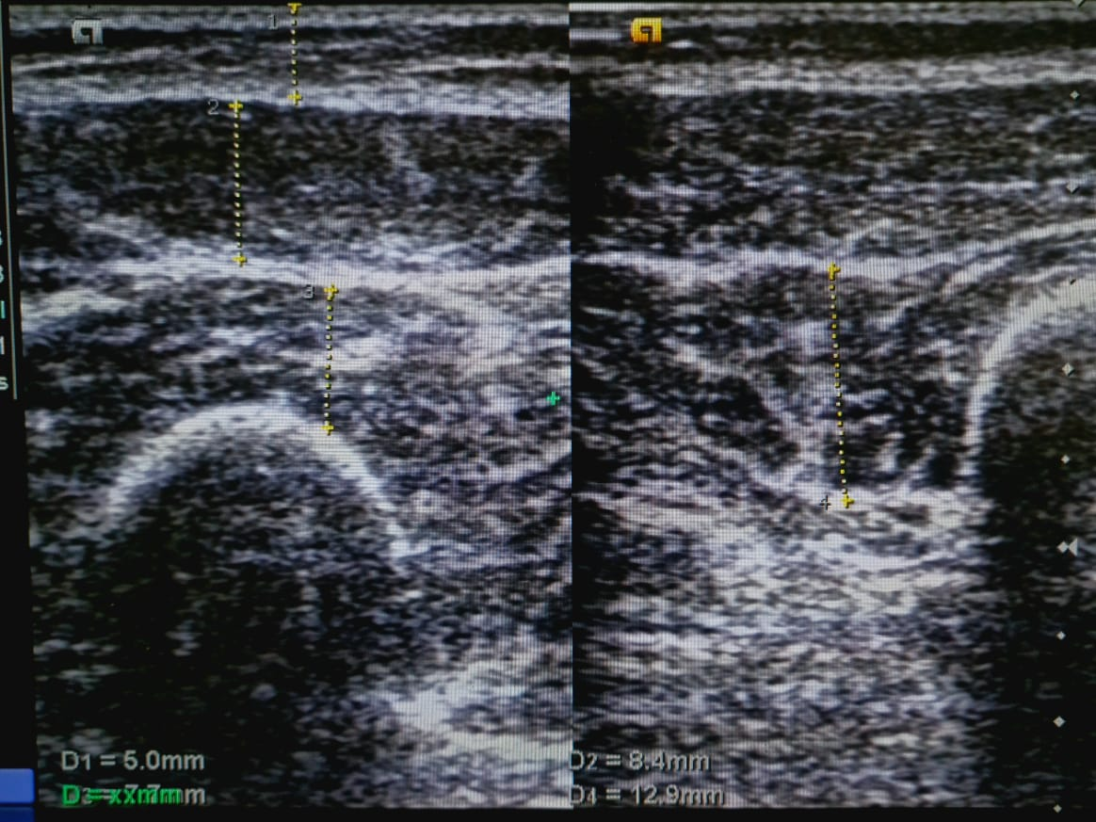

Figure 3:Right thigh quadriceps muscle thickness and fat thickness in control

Transverse ultrasound image of right mid thigh in control subject shows 1.sub cutaneous fat thickness 2.Rectus femoris thickness 3.Vastus intermedius thickness 4.Vastus lateralis thickness
