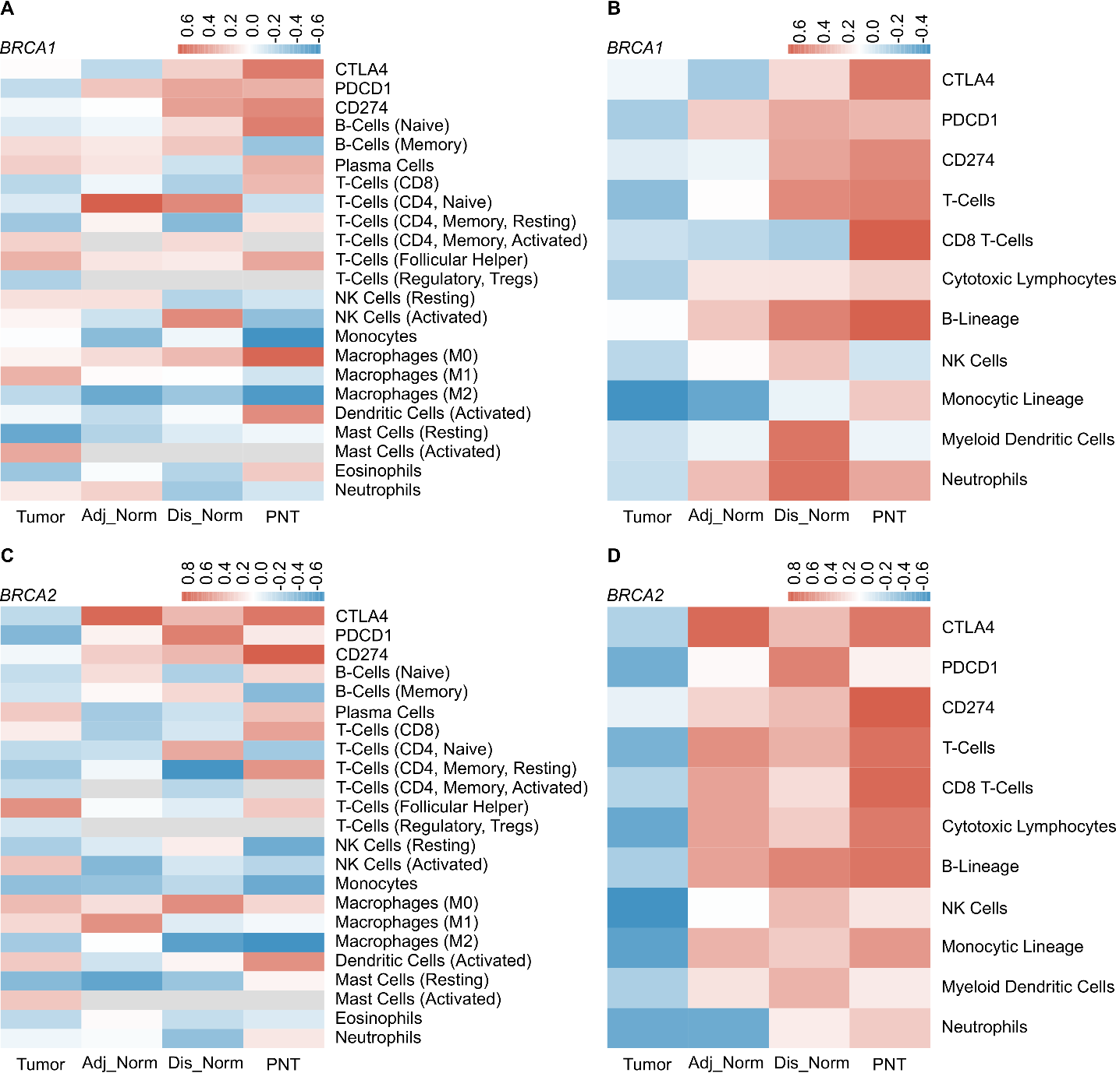
Sup Figure 1. Detailed Correlation of BRCA1 and BRCA2 with the Immune Microenvironment. Heatmap showing the correlation of BRCA1 transcript levels with immune cells estimated using the (A) CIBERSORT deconvolution algorithm or (B) the MCPcounter abundance scoring method. Heatmap showing the correlation of BRCA2 transcript levels with immune cells estimated using the (C) CIBERSORT deconvolution algorithm or (D) the MCPcounter abundance scoring method.

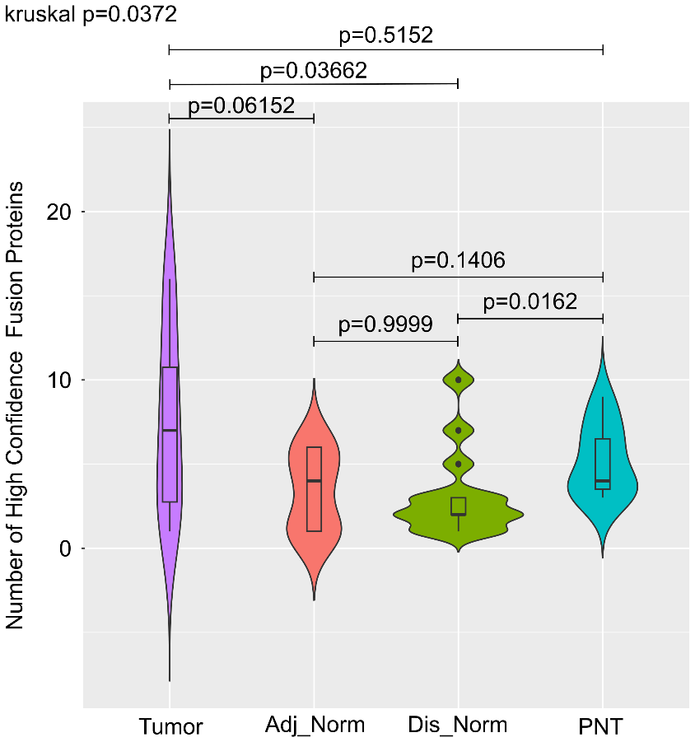
Sup Figure 2. Fusion Protein Landscape Across Breast Tissue Cohorts. Box plots showing the number of high-confidence fusion proteins predicted to generate neoantigens detected across Tumor, Adjacent Normal (Adj_Norm), Distant Normal (Dis_Norm), and prophylactic normal breast (PNT) tissue samples. The box represents the interquartile range (IQR), the line within the box is the median, and whiskers extend to 1.5 times the IQR. Dots represent outliers. Overall differences were evaluated by Kruskal–Wallis test. Paired Wilcoxon signed-rank tests were used for post-hoc pairwise comparisons (p-values shown without multiple test correction).

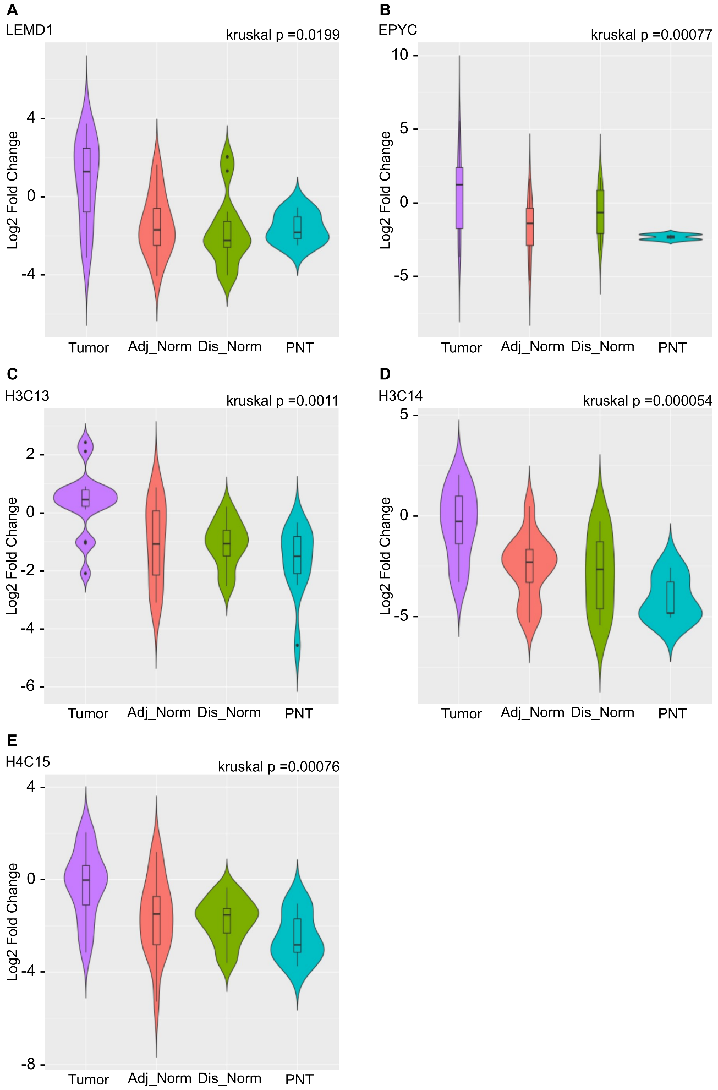
Supplementary Figure 3. Tumor-Specific Upregulation of Top 5 Lead Candidate Antigens. Violin plots demonstrating the expression (Log2 Fold Change) of the five prioritized lead candidate genes (A) LEMD1, (B) EPYC, (C) H3C13, (D) H3C14, and (E) H4C15 across the four breast tissue cohorts: Tumor, Adjacent Normal (Adj_Norm), Distant Normal (Dis_Norm), and Prophylactic normal breast tissue (PNT). P-values represent the Kruskal-Wallis test for differences across all four groups. The box represents the interquartile range (IQR), the line within the box is the median, and whiskers extend to 1.5 times the interquartile range (IQR).

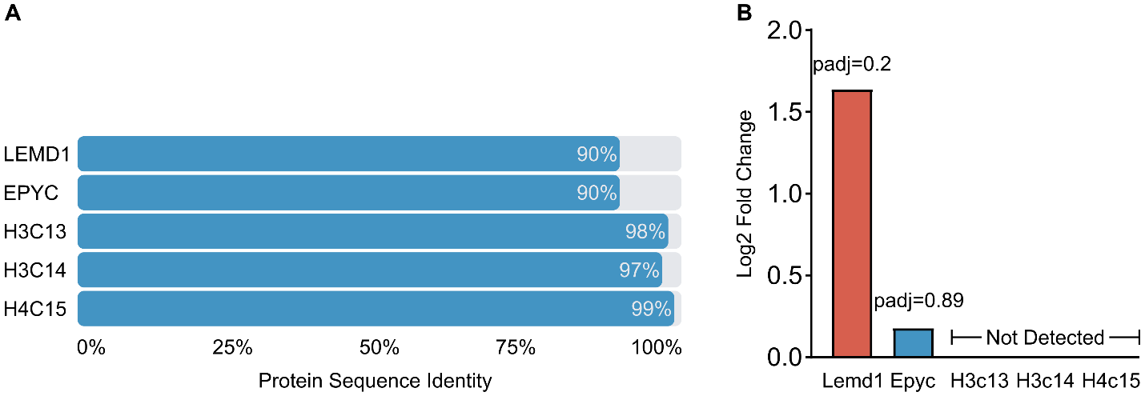
Supplementary Figure 4. Preclinical Validation of Lead Candidate Genes in a Brca1-Deficient Mouse Model. (A) Bar chart illustrating the high protein sequence identity (conservation) between the human and mouse homologs for the five prioritized lead candidates: LEMD1, EPYC, H3C13, H3C14, and H4C15.(B) Bar chart showing the differential gene expression (Log2 Fold Change) of the five mouse homologs in Brca1-deficient tumors relative to Brca1-proficient control tumors.

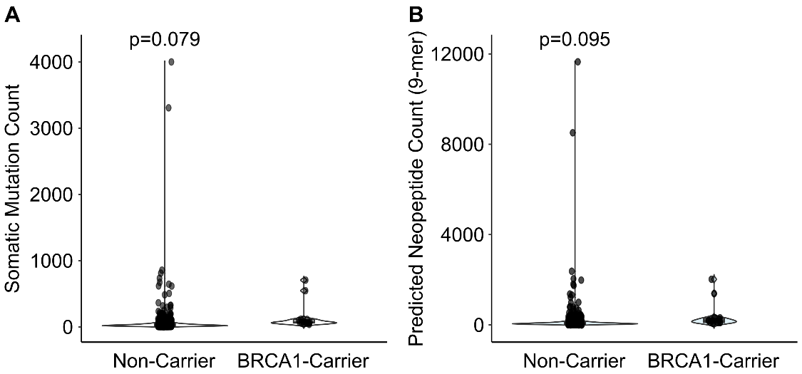
Supplementary Figure 5. Somatic Mutation and Neoantigen Burden in the TCGA BRCA1-Carrier Cohort. Violin plots comparing tumors from BRCA1 germline mutation carriers to non-carrier tumors from the TCGA breast cancer cohort. (A) Comparison of the total somatic mutation count. (B) Comparison of the predicted neoepitope count (9-mer). Each dot represents an individual tumor sample. The violin plot shows the density distribution of the data, and the p-value is from a two-sample t-test.

