Phytochemical Characterization and Biofilm-Inhibitory Activity of Sphaerostephanos unitus (L.) Holttum
Shivangi Borkotoky ª, Supriyo Sen ^{a,b}, Vedant Vikrom Borahª*

ª Department of Bio-Sciences, School of Life Sciences, Assam Don Bosco University,
Tapesia, Sonapur - 784802, Assam, India
^{b} School of Agriculture, The Royal Global University, Guwahati – Assam, India
*Corresponding Author
Email: vedant.borah@dbuniversity.ac.in ORCID: 0000-0002-5116-2072

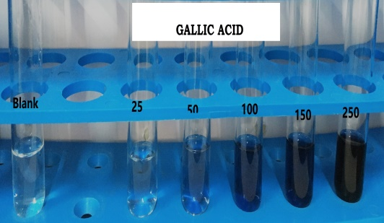Supplementary Fig 1. Standard curve of gallic acid for the estimation of total phenolic and tannin content

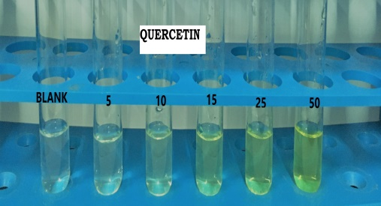Supplementary Fig 2. Standard curve of quercitin for the estimation of total flavonoid content
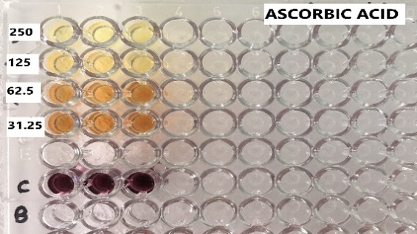 Supplementary Fig 3. Standard curve of different concentrations (µg/ml) of ascorbic acid and their respective optical density at 517nm for DPPH free radical scavenging activity
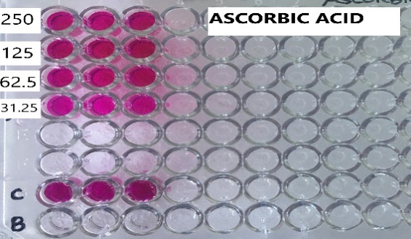
Supplementary Fig 4. Standard curve of different concentrations (µg/ml) of ascorbic acid and their respective optical density at 570nm for nitric oxide scavenging activity

Supplementary Fig 5. Standard curve of different concentrations (µg/ml) of podophyllotoxin and the percent (%) mortality after 24hours of brine shrimp (Artemia salina) lethality assay
Supplementary Data. Biofilm forming capability of the organisms
Test organism | OD_{AVG} | Mean | OD_{CUT} | Inference
S. epidermidis ATCC 35984 | 0.17 | 0.02 | 0.09 | Weak Biofilm former
P. aeruginosa (Clinical isolate) | 0.42 | 0.11 | 0.09 | Strong biofilm former

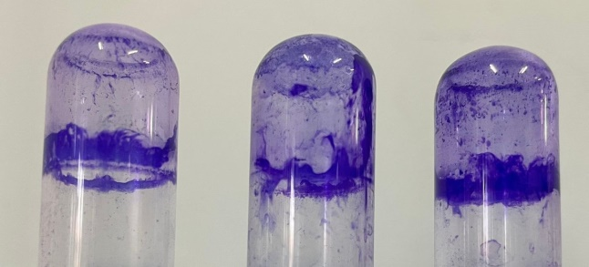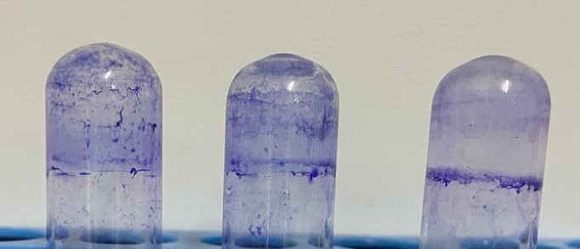
VS
Supplementary Fig 6. Strong biofilm formation by P. aeruginosa vs Weak biofilm former S. epidermidis ATCC 35984
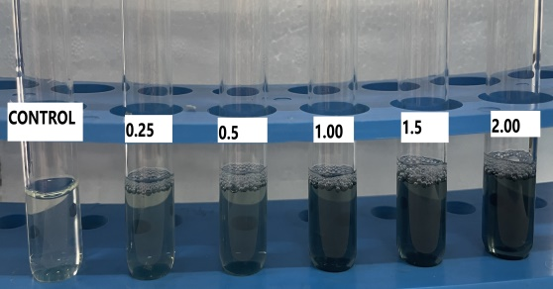
Supplementary Fig 7. Standard curve of different concentrations (µg/ml) of BSA and their respective optical density at 650nm for protein estimation
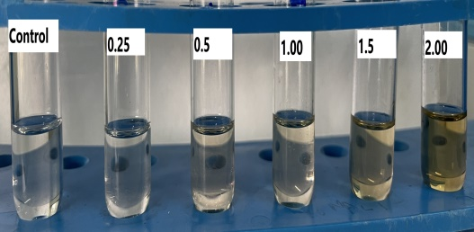
Supplementary Fig 8. Standard curve of different concentrations (µg/ml) of glucose and their respective optical density at 490 nm for carbohydrate estimation

Supplementary Table 1. Extraction yield and qualitative phytochemical composition of different solvent extracts of Sphaerostephanos unitus (L.) Holttum
Solvent extract | Yield Percentage (%) | Qualitative Phytochemical test
Solvent extract | Yield Percentage (%) | Alkaloid | Phenolics | Quinone | Tannins | Coumarins | Carboxylic acid | Saponins | Flavonoids | Terpenoids | Cardiac Glycosides
Methanol | 2.75 | + | + | - | + | - | - | + | + | + | +
Ethyl Acetate | 1.0 | + | + | - | + | - | - | + | + | + | +
Ethanol | 4.9 | + | + | - | + | - | - | + | + | + | +
Acetone | 1.2 | + | + | - | + | - | - | + | + | + | +
Fatty acid-rich fraction | 29.6 | nd
Note: “+” = present; “–” = absent; “nd” = not determined.
Extraction yield was calculated as (mass of dried extract / mass of starting material) × 100.

Supplementary Table 2. Major compounds identified in the fatty acid–rich fraction (Su-F) of Sphaerostephanos unitus by GC–MS
RT (min) | Compound | MW (Da) | Formula | Peak Area % (Σ) | Norm % (Σ) | Remarks
23.58 (range 22.465–24.661, apex 24.661) | N-Decanoic acid | 172 | C₁₀H₂₀O₂ | 1.444 | 14.88 | Two peaks merged; identical EI spectra.
26.832 | Tetradecanoic acid | 228 | C₁₄H₂₈O₂ | 3.037 | 31.28 | Single peak.
29.403 | 13-Methyltetradec-9-enoic acid, methyl ester | 254 | C₁₆H₃₀O₂ | 2.048 | 21.09 | Clear FAME ions (m/z 74, 87, 143).
30.769 | Dodecanoic acid | 200 | C₁₂H₂₄O₂ | 9.710 | 100.00 | Base peak (normalization reference).
32.42 (range 28.853–37.821, apex 32.654) | Oleic acid | 282 | C₁₈H₃₄O₂ | 3.702 | 38.12 | Six-peak cluster merged; same EI fingerprint across RTs.
31.059 | 3-N-Hexylthiolane, S,S-dioxide | 204 | C₁₀H₂₀O₂S₂ | 0.658 | 6.77 | Single peak; non-FA sulfur heterocycle.
Note: Compounds were identified by matching the electron ionization (EI) mass spectra with the NIST 17 MS library at ≥ 90 % similarity. Retention times correspond to a Perkin Elmer Clarus 680/600C GC-MS system (Elite-5 MS column, 60 m × 0.25 mm × 0.25 µm) operated under the conditions described in the main text.

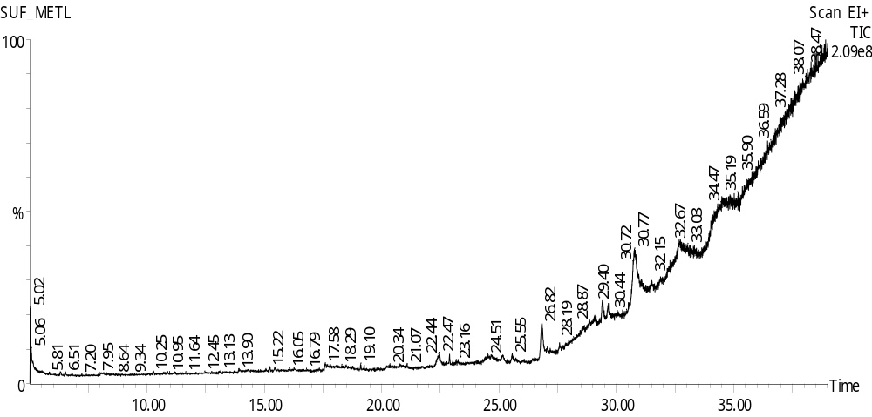
Supplementary Fig 9. GC–MS total ion chromatogram (TIC) of the fatty acid–rich fraction (Su-F) of Sphaerostephanos unitus (L.) Holttum.

