Supplementary information

Figure S1. Alignment of representative sequences of Trichoderma afroharzianum and other Trichoderma species of the RPB2 gene (A) for the real-time PCR and TEF1α gene (B) for the endpoint PCR. Primers and hydrolysis probe are flagged in blue for forward primer, in green for the reverse primer and in red for the probe.

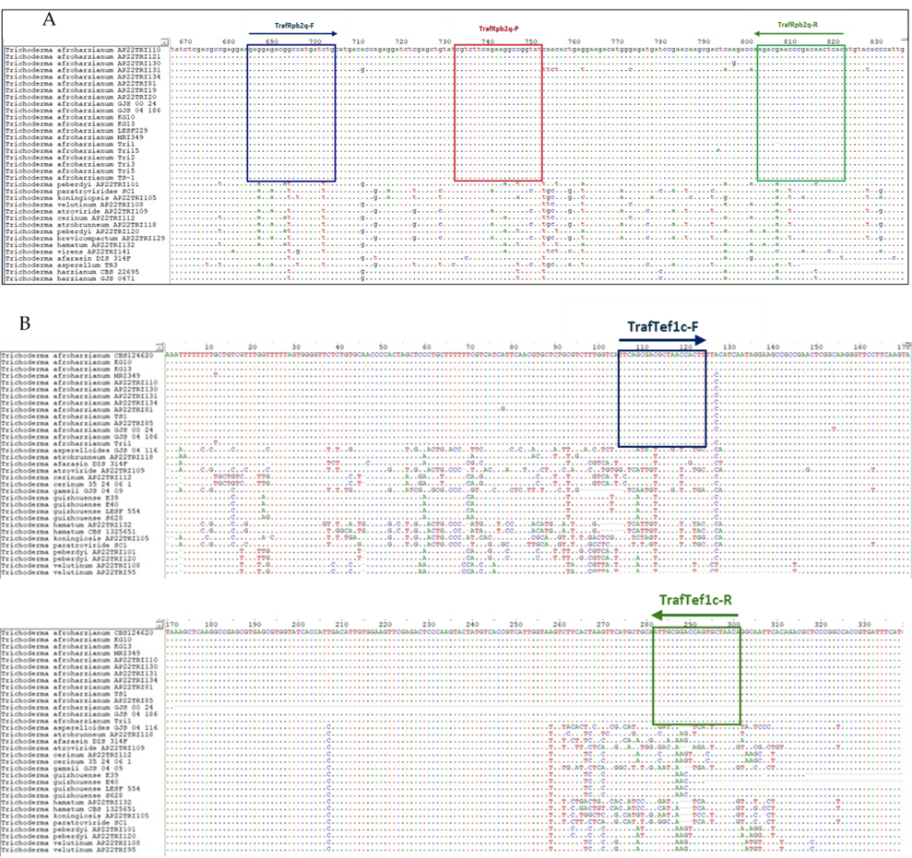

Table S1. Evaluation of the repeatability and reproducibility of the real-time PCR assay. Mean Ct values and standard deviations were obtained from 10 replicates for repeatability and 3 replicates for reproducibility

 | Repeatability |  | Reproducibility
DNA template | Mean Ct ± SD | CV (%) | Mean Ct±SD | CV (%)
target Plasmid DNA 100xLOD (1:10.000) | 26.54 ± 0,24 | 0,9 | 26.45 ± 0,19 | 0,72
target Plasmid DNA 10xLOD (1:100.000) | 30.53 ± 0,32 | 1,05 | 30.74 ± 0,15 | 0,49
T. afroharzianum CBS124620 (0,1 ng/µl) | 25.76 ± 0,45 | 1,74 | 24.84 ± 0,14 | 0,60
T. afroharzianum 159.1 (0,1 ng/µl) | 27.14 ± 0,35 | 1,30 | 27.19 ± 0,23 | 0,84
T. asperellum 1 ng/µl | >40 | - | >40 | -
T. brevicompactum 1 ng/µl | >40 | - | >40 | -

Table S2. Evaluation of the robustness of the real-time PCR assay. A set of templates was analysed with varying PCR reaction volume or annealing temperature. Mean Ct values and standard variations were obtained from 10 replicates

Hybridization temperature | 60°C | 64°C | 62°C | 62°C
Reaction volume | 12,5 µL | 12,5 µL | 11,25 µL | 13,75 µL
DNA template (concentration)
target Plasmid DNA 100xLOD (1:10.000) | 24.03±0.19 | 22.26±0.15 | 24.24±0.27 | 24.37±0.18
target Plasmid DNA 10xLOD (1:100.000) | 27.36±0.25 | 25.21±0.86 | 27.59±0.22 | 27.91±0.23
T. afroharzianum CBS124620 (0,1 ng/µl) | 26.10±0.21 | 24.17±0.08 | 25.73±0.14 | 26.11±0.09
T. afroharzianum 159 (0,1 ng/µl) | 26.59±0.26 | 24.47±0.25 | 26.72±0.11 | 27.02±0.24
T. asperellum 1 ng/µl | >40 | >40 | >40 | >40
T. brevicompactum 1 ng/µl | >40 | >40 | >40 | >40

Table S3. Evaluation of the transferability of the real-time PCR assay. A set of templates was analysed with different qPCR equipment and commercial qPCR master mixes. Mean Ct values and standard variations were obtained from 10 replicates.

 | Maxima Probe/ROX qPCR Master Mix + StepOnePlus |  | TaKaRa Premix Ex Taq Probe qPCR + StepOnePlus |  | TaqMan Universal Master Mix II (Applied Biosystems) + StepOnePlus |  | iTaq Universal Probes Supermix (Bio-Rad) + qTower³ thermocycler
DNA template | Mean Ct±SD | CV | Mean Ct±SD | CV | Mean Ct±SD | CV | Mean Ct ±SD | CV
target Plasmid DNA 100xLOD (1:10.000) | 24.59±0.43 | 1.75 | 25.71±0.23 | 0.89 | 26.50±0.25 | 0.94 | 29.24±0.83 | 2.83
target Plasmid DNA 10xLOD (1:100.000) | 28.49±0.62 | 2.18 | 29.96±0.19 | 0.63 | 30.88±0.60 | 1.94 | 33.77±0.98 | 2.90
T. afroharzianum CBS124620 (0,1 ng/µl) | 24.46±0.29 | 1.18 | 25.35±0.19 | 0.75 | 26.43±0.02 | 0.08 | 20.46±0.68 | 3,32
T. afroharzianum 159.1 (0,1 ng/µl) | 26.15±0.11 | 0.42 | 26.69±0.28 | 1.05 | 28.49±0.14 | 0.49 | 19.92±0.55 | 2.76
T. asperellum 1 ng/µl | >40 | - | >40 | - | >40 | - | >40 | -
T. brevicompactum 1 ng/µl | >40 | - | >40 | - | >40 | - | >40 | -

