Supplementary File

Wasti et al., 2025

Supplementary Table S1. Database(s)/Register(s)/Other Source(s) with Search Strings and Results (Searches re-run on August 28, 2025)

Database(s) | Search String | Results
PubMed | #1  (((((("Endoscopy"[Mesh]) OR (ESS)) OR (FESS)) OR (Endosco*)) OR ("Endoscopic Sinus Surgery")) OR ("Functional Endoscopic Sinus Surgery")) OR ("Functional ESS")  #2  (((((((((((((((((((("Dexmedetomidine"[Mesh]) OR (Dexmedetomidine)) OR (dexamedetomidine)) OR ("Dexmedetomidine Hydrochloride")) OR ("MPV-1440")) OR (MPV1440)) OR (Precedex)) OR (Igalmi)) OR (Sedadex)) OR (Sileo)) OR (Cepedex)) OR (Dexdor)) OR (Dexdomitor)) OR ("bxcl 501")) OR (bxcl501)) OR ("da 9501")) OR (da9501)) OR (delos)) OR (primadex)) OR ("tpu 006")) OR (tpu006)  #3  (((((((((((((("esmolol" [Supplementary Concept]) OR (Esmolol)) OR ("ASL-8052")) OR (Brevibloc)) OR ("esmolol hydrochloride")) OR ("asl 8052 001")) OR (asl8052)) OR ("asl8052-001")) OR (asl8052001)) OR ("brevibloc double strength")) OR (clol)) OR (galnobax)) OR (miniblock)) OR ("vld 02")) OR (vld02)  #4  #1 AND #2 AND #3 | 12
Embase | ('functional endoscopic sinus surgery' OR 'ess' OR 'fess' OR 'endoscopic sinus surgery' OR 'endoscopic sinus surgery'/exp OR 'functional ess') AND ('dexmedetomidine'/exp OR 'bxcl 501' OR 'bxcl501' OR 'cepedex' OR 'da 9501' OR 'da9501' OR 'delos' OR 'dexamedetomidine' OR 'dexdomitor' OR 'dexdor' OR 'dexmedetomidine' OR 'dexmedetomidine hydrochloride' OR 'igalmi' OR 'mpv 1440' OR 'mpv1440' OR 'precedex' OR 'primadex' OR 'sedadex' OR 'sileo' OR 'tpu 006' OR 'tpu006') AND ('esmolol'/exp OR '3 [4 (2 hydroxy 3 isopropylaminopropoxy) phenyl] propionic acid methyl ester' OR '3 [4 [ [2 hydroxy 3 (isopropylamino) propyl] oxy] phenyl] propanoic acid methyl ester' OR '3 [4 [ [2 hydroxy 3 (isopropylamino) propyl] oxy] phenyl] propionic acid methyl ester' OR '3 [4 [ [2 hydroxy 3 (propan 2 ylisopropylamino) propyl] oxy] phenyl] propanoic acid methyl ester' OR '3 [4 [ [2 hydroxy 3 (propan 2 ylisopropylamino) propyl] oxy] phenyl] propionic acid methyl ester' OR '3 [4 [ [2 hydroxy 3 [ (1 methylethyl) amino] propyl] oxy] phenyl] propanoic acid methyl ester' OR '3 [4 [ [2 hydroxy 3 [ (1 methylethyl) amino] propyl] oxy] phenyl] propionic acid methyl ester' OR '3 [4 [ [2 hydroxy 3 [ (2 propanyl) amino] propyl] oxy] phenyl] propanoic acid methyl ester' OR '3 [4 [ [2 hydroxy 3 [ (2 propanyl) amino] propyl] oxy] phenyl] propionic acid methyl ester' OR '3 [4 [ [2 hydroxy 3 [ (2 propyl) amino] propyl] oxy] phenyl] propanoic acid methyl ester' OR '3 [4 [ [2 hydroxy 3 [ (2 propyl) amino] propyl] oxy] phenyl] propionic acid methyl ester' OR '3 [4 [2 hydroxy 3 (isopropylamino) propoxy] phenyl] propanoic acid methyl ester' OR '3 [4 [2 hydroxy 3 (isopropylamino) propoxy] phenyl] propionic acid methyl ester' OR '3 [4 [2 hydroxy 3 (propan 2 ylisopropylamino) propoxy] phenyl] propanoic acid methyl ester' OR '3 [4 [2 hydroxy 3 (propan 2 ylisopropylamino) propoxy] phenyl] propionic acid methyl ester' OR '3 [4 [2 hydroxy 3 [ (1 methylethyl) amino] propoxy] phenyl] propanoic acid methyl ester' OR '3 [4 [2 hydroxy 3 [ (1 methylethyl) amino] propoxy] phenyl] propionic acid methyl ester' OR '3 [4 [2 hydroxy 3 [ (2 propanyl) amino] propoxy] phenyl] propanoic acid methyl ester' OR '3 [4 [2 hydroxy 3 [ (2 propanyl) amino] propoxy] phenyl] propionic acid methyl ester' OR '3 [4 [2 hydroxy 3 [ (2 propyl) amino] propoxy] phenyl] propanoic acid methyl ester' OR '3 [4 [2 hydroxy 3 [ (2 propyl) amino] propoxy] phenyl] propionic acid methyl ester' OR '4 (2 hydroxy 3 isopropylaminopropoxy) hydrocinnamic acid methyl ester' OR '4 [ [2 hydroxy 3 (isopropylamino) propyl] oxy] hydrocinnamic acid methyl ester' OR '4 [ [2 hydroxy 3 (propan 2 ylisopropylamino) propyl] oxy] hydrocinnamic acid methyl ester' OR '4 [ [2 hydroxy 3 [ (1 methylethyl) amino] propyl] oxy] hydrocinnamic acid methyl ester' OR '4 [ [2 hydroxy 3 [ (2 propanyl) amino] propyl] oxy] hydrocinnamic acid methyl ester' OR '4 [ [2 hydroxy 3 [ (2 propyl) amino] propyl] oxy] hydrocinnamic acid methyl ester' OR '4 [2 hydroxy 3 (isopropylamino) propoxy] hydrocinnamic acid methyl ester' OR '4 [2 hydroxy 3 (propan 2 ylisopropylamino) propoxy] hydrocinnamic acid methyl ester' OR '4 [2 hydroxy 3 [ (1 methylethyl) amino] propoxy] hydrocinnamic acid methyl ester' OR '4 [2 hydroxy 3 [ (2 propanyl) amino] propoxy] hydrocinnamic acid methyl ester' OR '4 [2 hydroxy 3 [ (2 propyl) amino] propoxy] hydrocinnamic acid methyl ester' OR 'asl 8052' OR 'asl 8052 001' OR 'asl 8052-001' OR 'asl8052' OR 'asl8052-001' OR 'asl8052001' OR 'brevibloc' OR 'brevibloc double strength' OR 'clol (drug)' OR 'esmolol' OR 'esmolol hydrochloride' OR 'galnobax' OR 'methyl 3 [4 [ [2 hydroxy 3 (isopropylamino) propyl] oxy] phenyl] propanoate' OR 'methyl 3 [4 [ [2 hydroxy 3 (propan 2 ylisopropylamino) propyl] oxy] phenyl] propanoate' OR 'methyl 3 [4 [ [2 hydroxy 3 [ (1 methylethyl) amino] propyl] oxy] phenyl] propanoate' OR 'methyl 3 [4 [ [2 hydroxy 3 [ (2 propanyl) amino] propyl] oxy] phenyl] propanoate' OR 'methyl 3 [4 [ [2 hydroxy 3 [ (2 propyl) amino] propyl] oxy] phenyl] propanoate' OR 'methyl 3 [4 [2 hydroxy 3 (isopropylamino) propoxy] phenyl] propanoate' OR 'methyl 3 [4 [2 hydroxy 3 (propan 2 ylamino) propoxy] phenyl] propanoate' OR 'methyl 3 [4 [2 hydroxy 3 [ (1 methylethyl) amino] propoxy] phenyl] propanoate' OR 'methyl 3 [4 [2 hydroxy 3 [ (2 propanyl) amino] propoxy] phenyl] propanoate' OR 'methyl 3 [4 [2 hydroxy 3 [ (2 propyl) amino] propoxy] phenyl] propanoate' OR 'methyl 4 [ [2 hydroxy 3 (isopropylamino) propyl] oxy] benzenepropanoate' OR 'methyl 4 [ [2 hydroxy 3 (isopropylamino) propyl] oxy] hydrocinnamate' OR 'methyl 4 [ [2 hydroxy 3 (propan 2 ylisopropylamino) propyl] oxy] benzenepropanoate' OR 'methyl 4 [ [2 hydroxy 3 (propan 2 ylisopropylamino) propyl] oxy] hydrocinnamate' OR 'methyl 4 [ [2 hydroxy 3 [ (1 methylethyl) amino] propyl] oxy] benzenepropanoate' OR 'methyl 4 [ [2 hydroxy 3 [ (1 methylethyl) amino] propyl] oxy] hydrocinnamate' OR 'methyl 4 [ [2 hydroxy 3 [ (2 propanyl) amino] propyl] oxy] benzenepropanoate' OR 'methyl 4 [ [2 hydroxy 3 [ (2 propanyl) amino] propyl] oxy] hydrocinnamate' OR 'methyl 4 [ [2 hydroxy 3 [ (2 propyl) amino] propyl] oxy] benzenepropanoate' OR 'methyl 4 [ [2 hydroxy 3 [ (2 propyl) amino] propyl] oxy] hydrocinnamate' OR 'methyl 4 [2 hydroxy 3 (isopropylamino) propoxy] benzenepropanoate' OR 'methyl 4 [2 hydroxy 3 (isopropylamino) propoxy] hydrocinnamate' OR 'methyl 4 [2 hydroxy 3 (propan 2 ylisopropylamino) propoxy] benzenepropanoate' OR 'methyl 4 [2 hydroxy 3 (propan 2 ylisopropylamino) propoxy] hydrocinnamate' OR 'methyl 4 [2 hydroxy 3 [ (1 methylethyl) amino] propoxy] benzenepropanoate' OR 'methyl 4 [2 hydroxy 3 [ (1 methylethyl) amino] propoxy] hydrocinnamate' OR 'methyl 4 [2 hydroxy 3 [ (2 propanyl) amino] propoxy] benzenepropanoate' OR 'methyl 4 [2 hydroxy 3 [ (2 propanyl) amino] propoxy] hydrocinnamate' OR 'methyl 4 [2 hydroxy 3 [ (2 propyl) amino] propoxy] benzenepropanoate' OR 'methyl 4 [2 hydroxy 3 [ (2 propyl) amino] propoxy] hydrocinnamate' OR 'methyl para [2 hydroxy 3 (isopropylamino) propoxy] hydrocinnamate' OR 'miniblock' OR 'para (2 hydroxy 3 isopropylaminopropoxy) hydrocinnamic acid methyl ester' OR 'vld 02' OR 'vld02') | 24
Scopus | #1  TITLE-ABS-KEY(endoscopy) OR TITLE-ABS-KEY(ESS) OR TITLE-ABS-KEY(FESS) OR TITLE-ABS-KEY(endosco*) OR TITLE-ABS-KEY("endoscopic sinus surgery") OR TITLE-ABS-KEY("functional endoscopic sinus surgery") OR TITLE-ABS-KEY("functional ESS")  #2  TITLE-ABS-KEY("Dexmedetomidine") OR TITLE-ABS-KEY(dexmedetomidine) OR TITLE-ABS-KEY(dexamedetomidine) OR TITLE-ABS-KEY("Dexmedetomidine Hydrochloride") OR TITLE-ABS-KEY("MPV-1440") OR TITLE-ABS-KEY(MPV1440) OR TITLE-ABS-KEY(Precedex) OR TITLE-ABS-KEY(Igalmi) OR TITLE-ABS-KEY(Sedadex) OR TITLE-ABS-KEY(Sileo) OR TITLE-ABS-KEY(Cepedex) OR TITLE-ABS-KEY(Dexdor) OR TITLE-ABS-KEY(Dexdomitor) OR TITLE-ABS-KEY("bxcl 501") OR TITLE-ABS-KEY(bxcl501) OR TITLE-ABS-KEY("da 9501") OR TITLE-ABS-KEY(da9501) OR TITLE-ABS-KEY(delos) OR TITLE-ABS-KEY(primadex) OR TITLE-ABS-KEY("tpu 006") OR TITLE-ABS-KEY(tpu006)  #3  TITLE-ABS-KEY(esmolol) OR TITLE-ABS-KEY("ASL-8052") OR TITLE-ABS-KEY(Brevibloc) OR TITLE-ABS-KEY("esmolol hydrochloride") OR TITLE-ABS-KEY("asl 8052 001") OR TITLE-ABS-KEY(asl8052) OR TITLE-ABS-KEY("asl8052-001") OR TITLE-ABS-KEY(asl8052001) OR TITLE-ABS-KEY("brevibloc double strength") OR TITLE-ABS-KEY(clol) OR TITLE-ABS-KEY(galnobax) OR TITLE-ABS-KEY(miniblock) OR TITLE-ABS-KEY("vld 02") OR TITLE-ABS-KEY(vld02)  #4  #1 AND #2 AND #3 | 22
Web of Science | #1  TS=(endoscopy) OR TS=(ESS) OR TS=(FESS) OR TS=(endosco*) OR TS=("endoscopic sinus surgery") OR TS=("functional endoscopic sinus surgery") OR TS=("functional ESS")  #2  TS=("Dexmedetomidine") OR TS=(dexmedetomidine) OR TS=(dexamedetomidine) OR TS=("Dexmedetomidine Hydrochloride") OR TS=("MPV-1440") OR TS=(MPV1440) OR TS=(Precedex) OR TS=(Igalmi) OR TS=(Sedadex) OR TS=(Sileo) OR TS=(Cepedex) OR TS=(Dexdor) OR TS=(Dexdomitor) OR TS=("bxcl 501") OR TS=(bxcl501) OR TS=("da 9501") OR TS=(da9501) OR TS=(delos) OR TS=(primadex) OR TS=("tpu 006") OR TS=(tpu006)  #3  TS=(esmolol) OR TS=("ASL-8052") OR TS=(Brevibloc) OR TS=("esmolol hydrochloride") OR TS=("asl 8052 001") OR TS=(asl8052) OR TS=("asl8052-001") OR TS=(asl8052001) OR TS=("brevibloc double strength") OR TS=(clol) OR TS=(galnobax) OR TS=(miniblock) OR TS=("vld 02") OR TS=(vld02)  #4  #1 AND #2 AND #3 | 24
Cochrane | ID Search Hits  #1 MeSH descriptor: [Endoscopy] explode all trees 26622  #2 (endoscopy OR ESS OR FESS OR endosco* OR "endoscopic sinus surgery" OR "functional endoscopic sinus surgery" OR "functional ESS"):ti,ab,kw 39923  #3 #1 OR #2 57579  #4 MeSH descriptor: [Dexmedetomidine] explode all trees 3190  #5 ("Dexmedetomidine" OR dexmedetomidine OR dexamedetomidine OR "Dexmedetomidine Hydrochloride" OR "MPV-1440" OR MPV1440 OR Precedex OR Igalmi OR Sedadex OR Sileo OR Cepedex OR Dexdor OR Dexdomitor OR "bxcl 501" OR bxcl501 OR "da 9501" OR da9501 OR delos OR primadex OR "tpu 006" OR tpu006):ti,ab,kw 11618  #6 #4 OR #5 11618  #7 (esmolol OR "ASL-8052" OR Brevibloc OR "esmolol hydrochloride" OR "asl 8052 001" OR asl8052 OR "asl8052-001" OR asl8052001 OR "brevibloc double strength" OR clol OR galnobax OR miniblock OR "vld 02" OR vld02):ti,ab,kw 1020  #8 #3 AND #6 AND #7 18 | 18
Register(s) | Search String | Results
ClinicalTrials.gov | (endoscopy OR ESS OR FESS OR "endoscopic sinus surgery" OR "functional endoscopic sinus surgery" OR "functional ESS") AND ("Dexmedetomidine" OR dexmedetomidine OR dexamedetomidine OR "Dexmedetomidine Hydrochloride" OR "MPV-1440" OR MPV1440 OR Precedex OR Igalmi OR Sedadex OR Sileo OR Cepedex OR Dexdor OR Dexdomitor OR "bxcl 501" OR bxcl501 OR "da 9501" OR da9501 OR delos OR primadex OR "tpu 006" OR tpu006) AND (esmolol OR "ASL-8052" OR Brevibloc OR "esmolol hydrochloride" OR "asl 8052 001" OR asl8052 OR "asl8052-001" OR asl8052001 OR "brevibloc double strength" OR clol OR galnobax OR miniblock OR "vld 02" OR vld02) | 2
All | Databases (n=100), Register (n=2) | 102
Other Sources | Search String | Results
Websites* | dexmedetomidine AND esmolol  *DOAJ.org; sagepub.com; scholar.google.com; springer.com; sciencedirect.com; onlinelibrary.wiley.com | 48
Citation Chaining | Done Through Google Scholar and Reference Lists | 61
All | Websites (n=48), Citation Chaining (n=61) | 109

Supplementary Figure SA1. Risk of bias assessment for intraoperative blood loss: ‘Traffic Light’ Plot
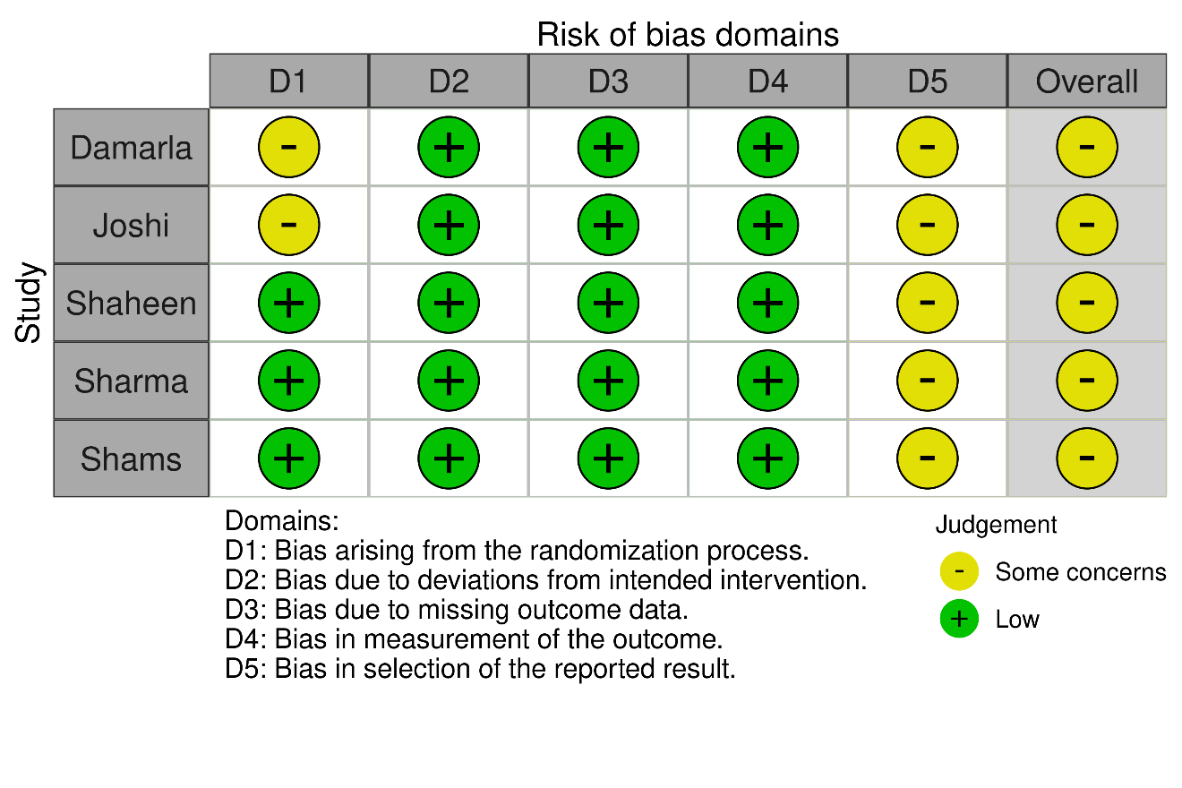

Supplementary Figure SA2. Risk of bias assessment for intraoperative blood loss: ‘Summary’ Plot
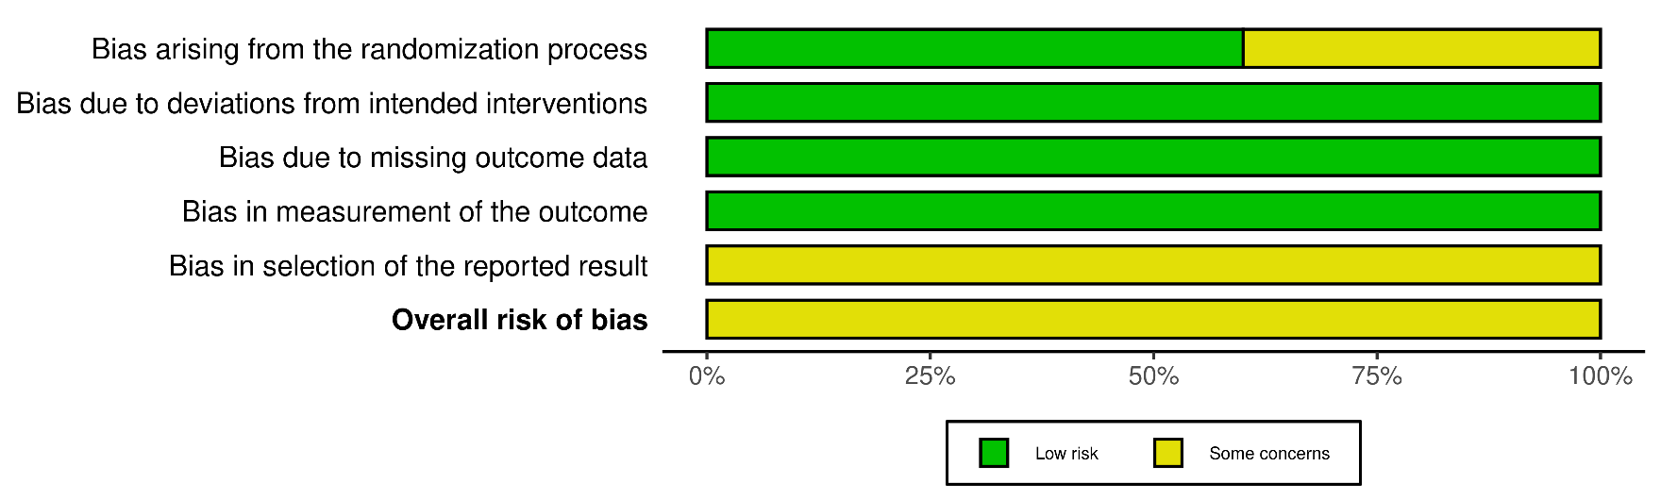

Supplementary Figure SA3. Risk of bias assessment for emergence time: ‘Traffic Light’ Plot
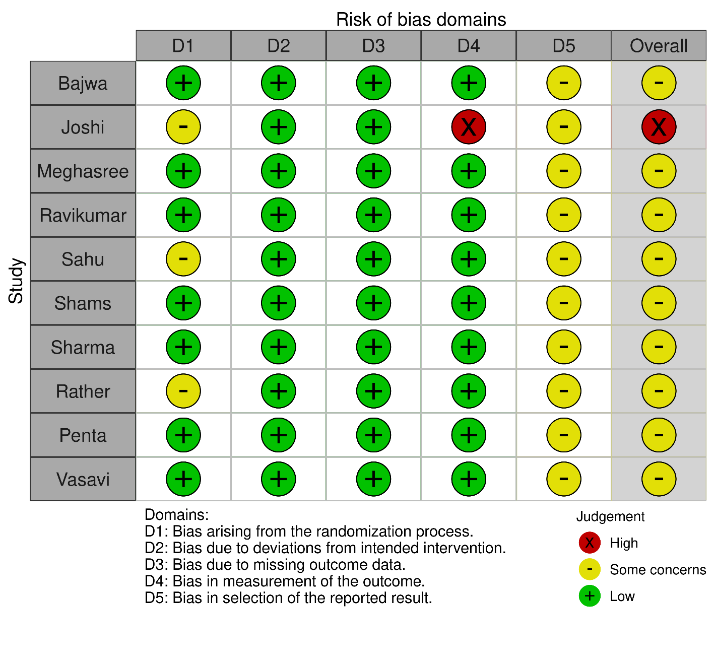
Supplementary Figure SA4. Risk of bias assessment for emergence time: ‘Summary’ Plot
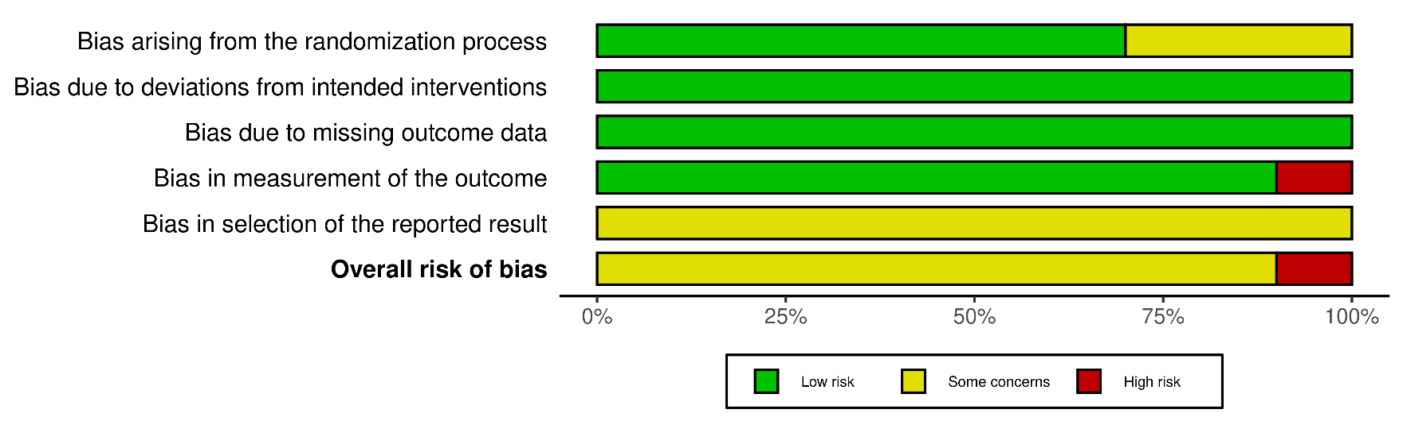

Supplementary Figure SA5. Risk of bias assessment for time to first rescue analgesia: ‘Traffic Light’ Plot
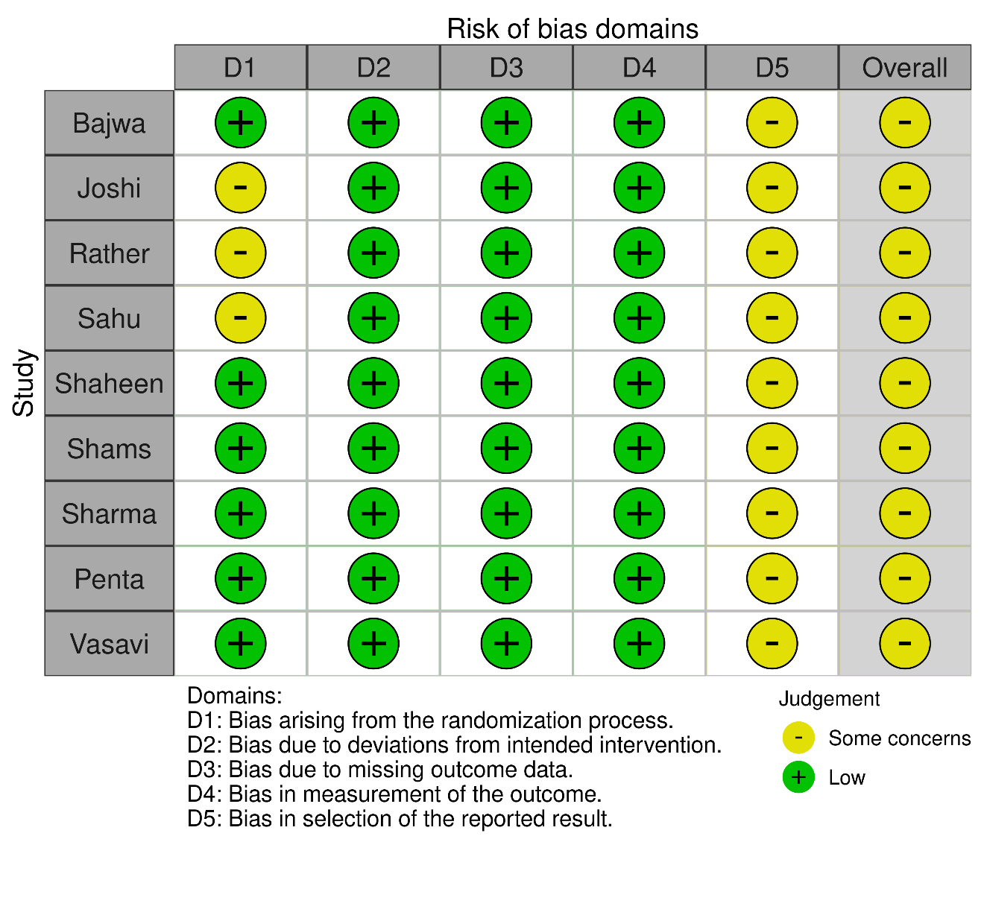

Supplementary Figure SA6. Risk of bias assessment for time to first rescue analgesia: ‘Summary’ Plot
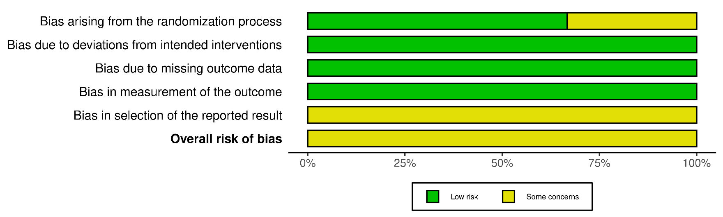

Supplementary Figure SA7. Risk of bias assessment for time to modified Aldrete score >9: ‘Traffic Light’ Plot
Supplementary Figure SA8. Risk of bias assessment for time to modified Aldrete score >9: ‘Summary’ Plot

Supplementary Figure SA9. Risk of bias assessment for incidence of hypotension: ‘Traffic Light’ Plot
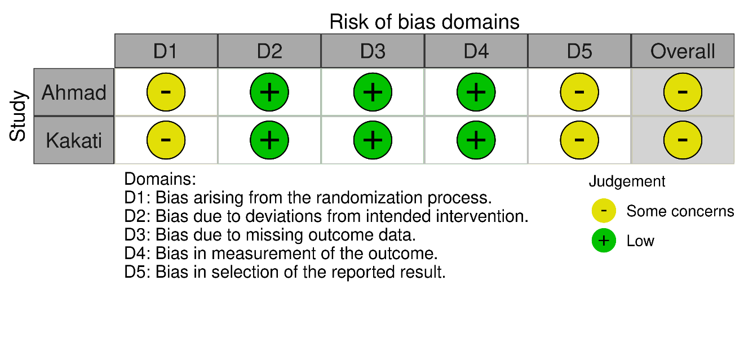

Supplementary Figure SA10. Risk of bias assessment for incidence of hypotension: ‘Summary’ Plot
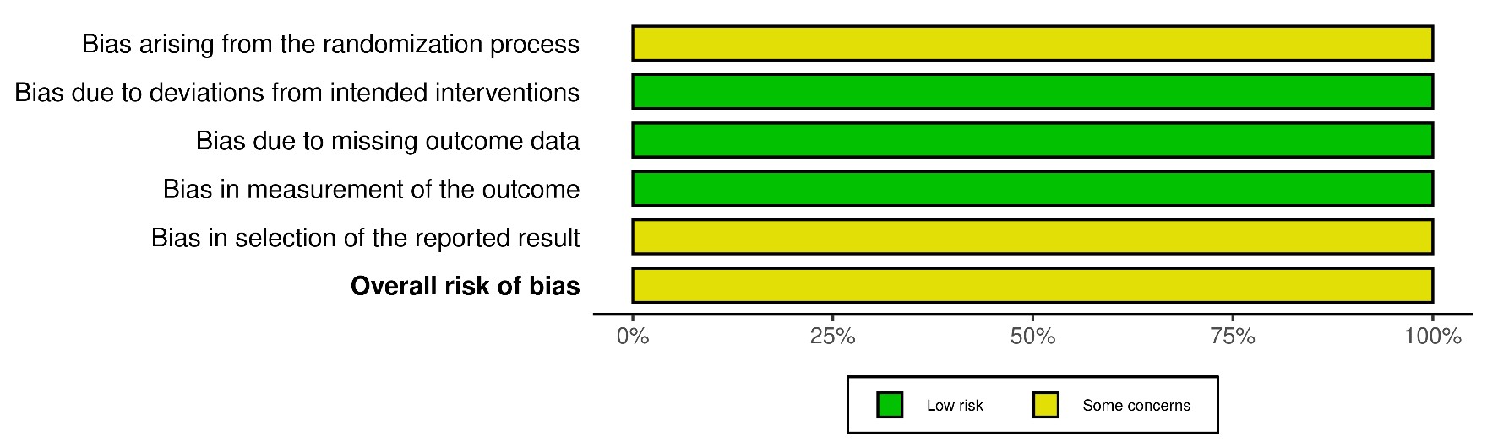

Supplementary Figure SA11. Risk of bias assessment for incidence of bradycardia: ‘Traffic Light’ Plot

Supplementary Figure SA12. Risk of bias assessment for incidence of bradycardia: ‘Summary’ Plot

Supplementary Figure SA13. Risk of bias assessment for incidence of postoperative nausea and vomiting: ‘Traffic Light’ Plot
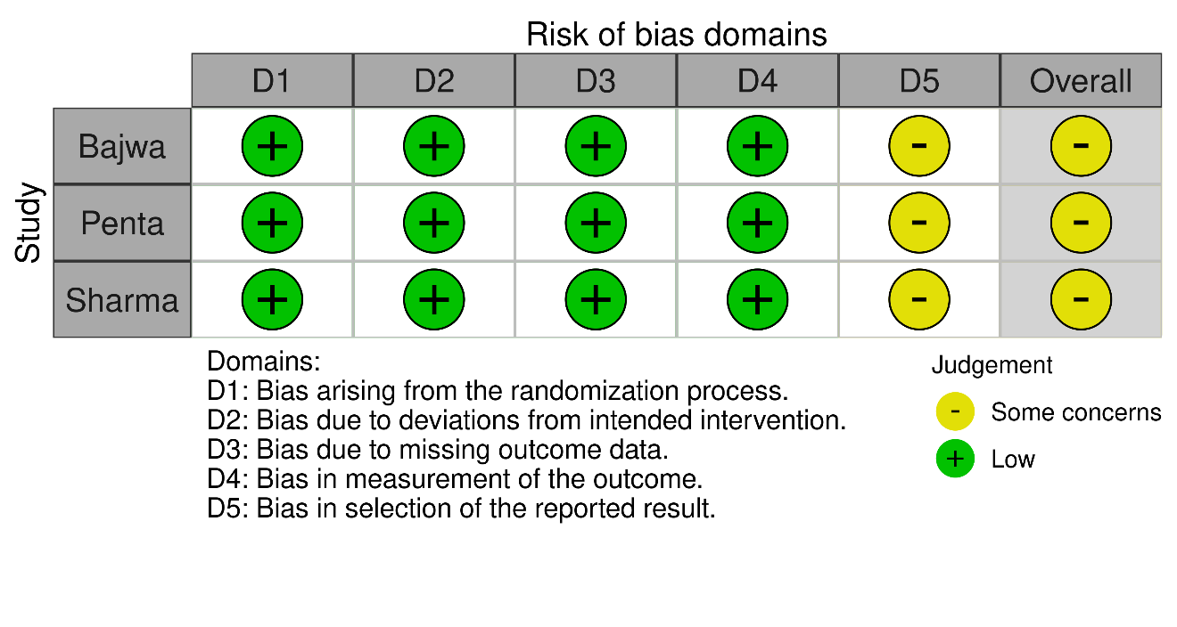

Supplementary Figure SA14. Risk of bias assessment for incidence of postoperative nausea and vomiting: ‘Summary’ Plot
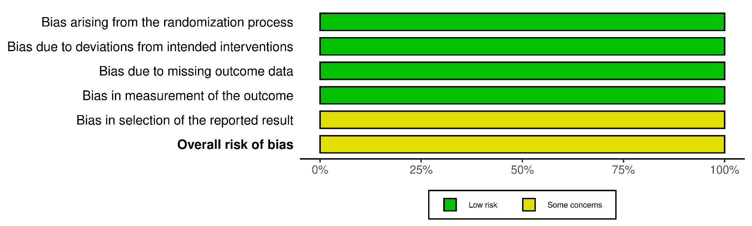
Authors’ Note on Handling Double-Zero Event Studies: In accordance with standard practices, studies with zero events in both intervention and comparator arms were excluded from the meta-analysis. This approach is mentioned in the Section 10.4.4.2 of the Cochrane Handbook for Systematic Reviews of Interventions, which also states that such studies provide no information on the direction or magnitude of the relative treatment effect and therefore do not contribute to pooled effect estimates based on odds ratios or risk ratios. To quote, “The standard practice in meta-analysis of odds ratios and risk ratios is to exclude studies from the meta-analysis where there are no events in both arms. This is because such studies do not provide any indication of either the direction or magnitude of the relative treatment effect.” At present, there is no established consensus in the methodological literature regarding the optimal handling of double-zero event studies. For this reason, the authors followed the current most-adopted approach exclusion of double-zero event studies in meta-analyses. Many alternative approaches have been proposed to handle double-zero event studies in current literature, but none have received formal validation, exploration and integration into current guidelines for conducting meta-analyses.

Supplementary Table S2. Leave-one-out analysis for duration of surgery
Leave-one-out meta-analysis

MD 95%-CI p-value tau^2 tau I^2 95%-PI
Omitting Bajwa, 2016 -2.4112 [-5.4550; 0.6326] 0.1205 16.2078 4.0259 69.0% [-12.0257; 7.2033]
Omitting Damarla, 2021 -3.3162 [-6.7943; 0.1620] 0.0617 21.9998 4.6904 73.1% [-14.4900; 7.8577]
Omitting Joshi, 2023 -3.1111 [-6.4987; 0.2765] 0.0719 20.7893 4.5595 73.0% [-13.9758; 7.7536]
Omitting Omara, 2025 -3.5283 [-6.8601; -0.1964] 0.0379 19.9871 4.4707 72.4% [-14.1854; 7.1289]
Omitting Rather, 2015 -3.2726 [-6.6138; 0.0686] 0.0549 20.4020 4.5169 73.1% [-14.0297; 7.4845]
Omitting Sahu, 2021 -3.6997 [-7.0515; -0.3480] 0.0305 19.7715 4.4465 71.1% [-14.3147; 6.9152]
Omitting Shaheen, 2018 -3.4117 [-6.9370; 0.1135] 0.0578 22.6910 4.7635 73.1% [-14.7569; 7.9334]
Omitting Shams, 2013 -3.1793 [-6.4993; 0.1408] 0.0605 20.2294 4.4977 73.1% [-13.8880; 7.5295]
Omitting Sharma, 2025 -3.5555 [-7.0821; -0.0288] 0.0482 22.6314 4.7572 72.7% [-14.8881; 7.7772]
Omitting Shivakumara, 2018 -0.8468 [-2.6465; 0.9530] 0.3564 1.4357 1.1982 16.0% [ -4.2104; 2.5168]
Omitting Penta, 2025 -2.6254 [-5.7270; 0.4761] 0.0971 17.5111 4.1846 70.8% [-12.5938; 7.3429]
Omitting Vasavi, 2024 -3.6534 [-7.4130; 0.1063] 0.0568 26.7029 5.1675 72.2% [-15.9349; 8.6282]

Random effects model -3.0428 [-6.1631; 0.0774] 0.0560 18.6744 4.3214 70.5% [-13.1790; 7.0934]

Supplementary Figure S2A. Meta-regression on duration of surgery with covariate year of publication
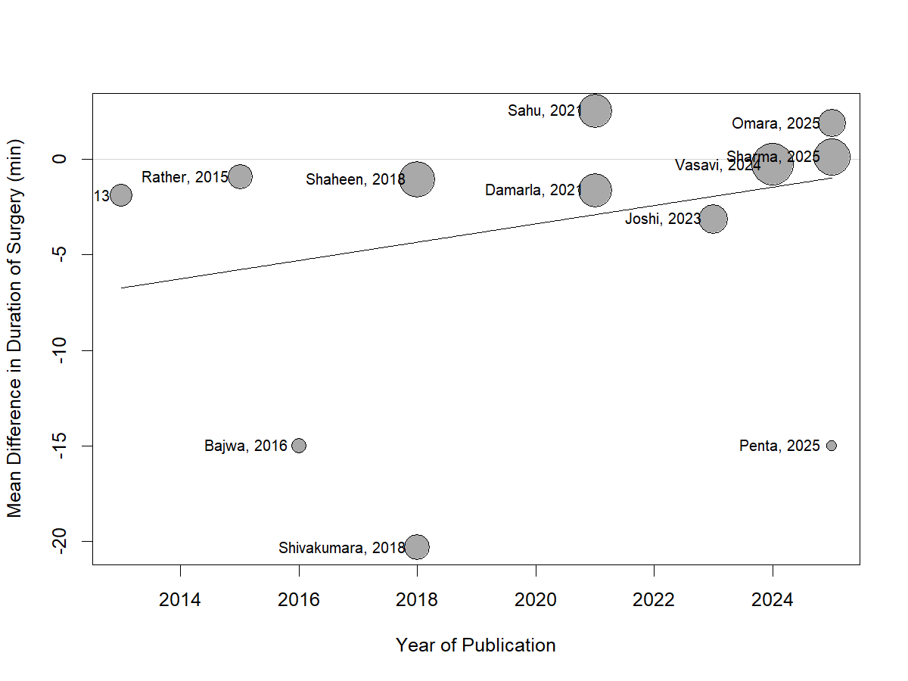

Supplementary Figure S2B. Meta-regression on duration of surgery with raw total sample size
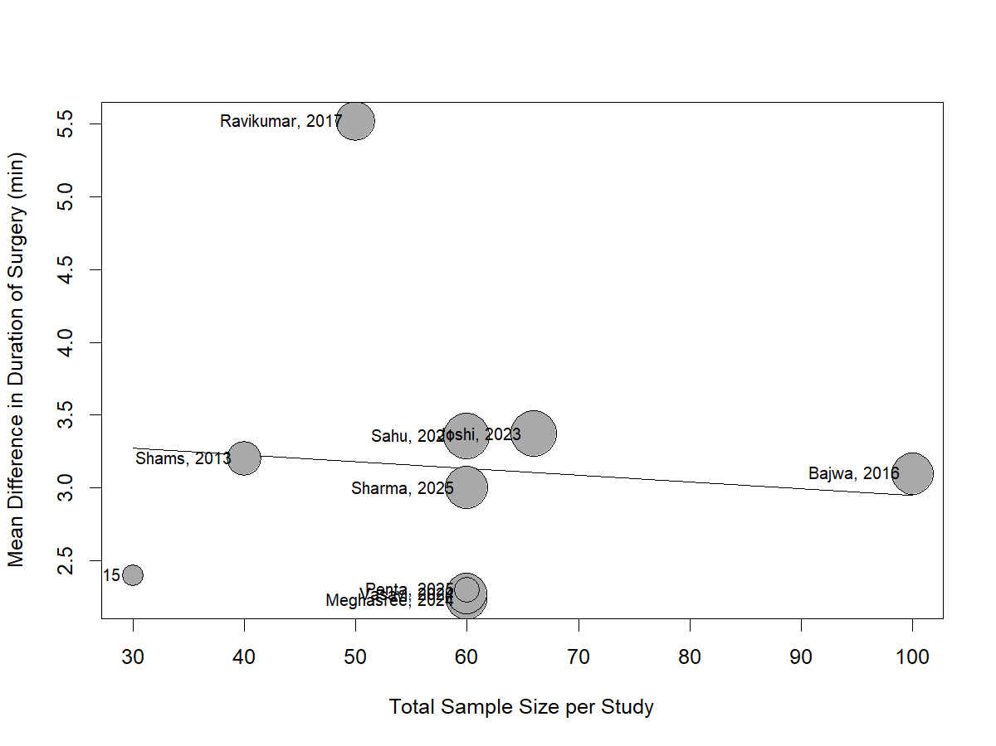

Supplementary Figure S2C. Meta-regression on duration of surgery with log sample size
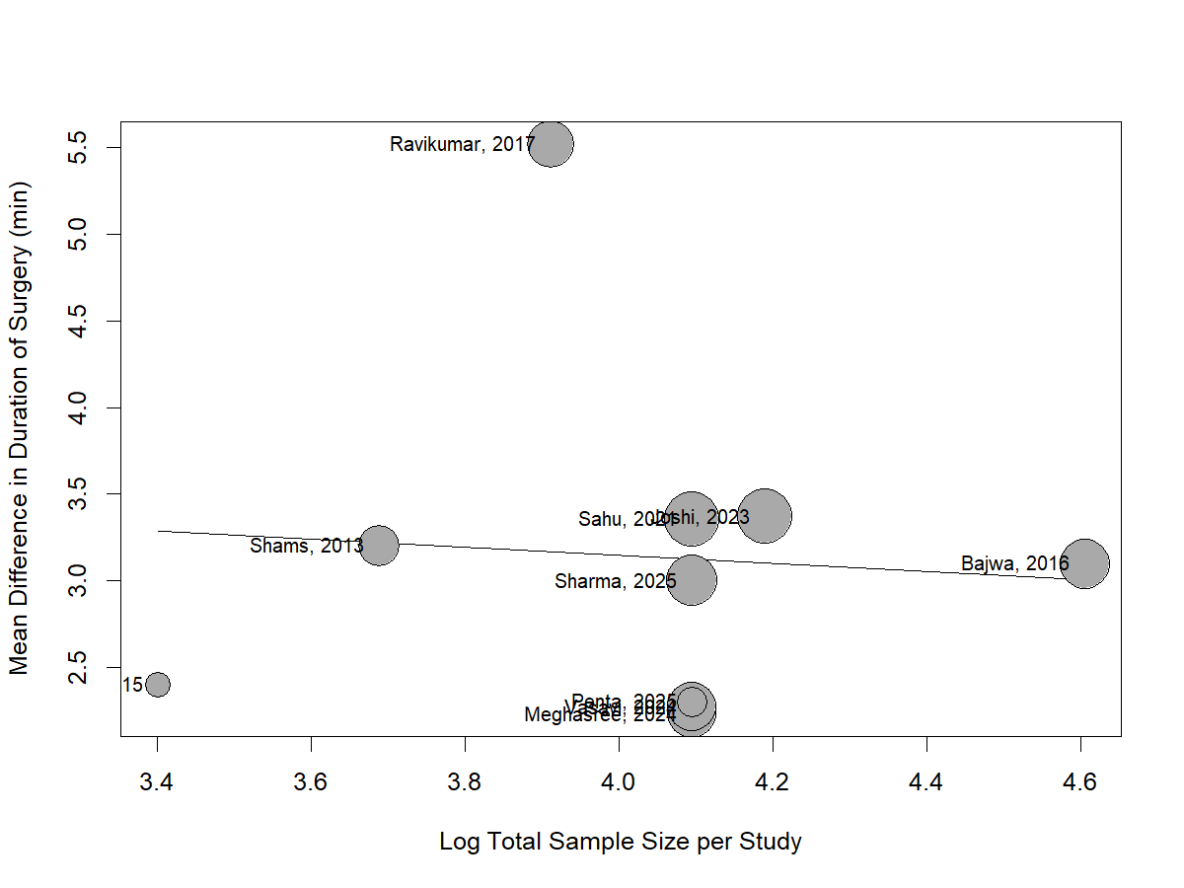

Supplementary Table S3. Leave-one-out analysis for emergence time
Leave-one-out meta-analysis (LOO)

MD 95%-CI p-value tau^2 tau I^2 95%-PI
Omitting Bajwa, 2016 3.1336 [2.5761; 3.6912] < 0.0001 0.5814 0.7625 89.0% [1.2570; 5.0103]
Omitting Joshi, 2023 3.0912 [2.4773; 3.7051] < 0.0001 0.7234 0.8505 88.9% [1.0011; 5.1813]
Omitting Meghasree, 2024 3.2480 [2.7417; 3.7543] < 0.0001 0.4607 0.6788 86.7% [1.5733; 4.9228]
Omitting Rather, 2015 3.1769 [2.6631; 3.6907] < 0.0001 0.5128 0.7161 88.9% [1.4184; 4.9355]
Omitting Ravikumar, 2017 2.9128 [2.5838; 3.2417] < 0.0001 0.1468 0.3832 68.3% [1.9482; 3.8774]
Omitting Sahu, 2021 3.0941 [2.4860; 3.7022] < 0.0001 0.7078 0.8413 88.9% [1.0262; 5.1619]
Omitting Shams, 2013 3.1253 [2.5906; 3.6600] < 0.0001 0.5388 0.7340 89.1% [1.3196; 4.9310]
Omitting Sharma, 2025 3.1460 [2.5859; 3.7061] < 0.0001 0.5865 0.7658 88.9% [1.2610; 5.0309]
Omitting Penta, 2025 3.1940 [2.6786; 3.7094] < 0.0001 0.5091 0.7135 88.8% [1.4405; 4.9476]
Omitting Vasavi, 2024 3.2409 [2.7293; 3.7525] < 0.0001 0.4736 0.6882 87.1% [1.5437; 4.9381]

Random effects model 3.1340 [2.6375; 3.6305] < 0.0001 0.5060 0.7113 87.7% [1.4259; 4.8421]

Supplementary Figure S2D. Analysis of emergence time, subgrouped by dexmedetomidine maintenance dose
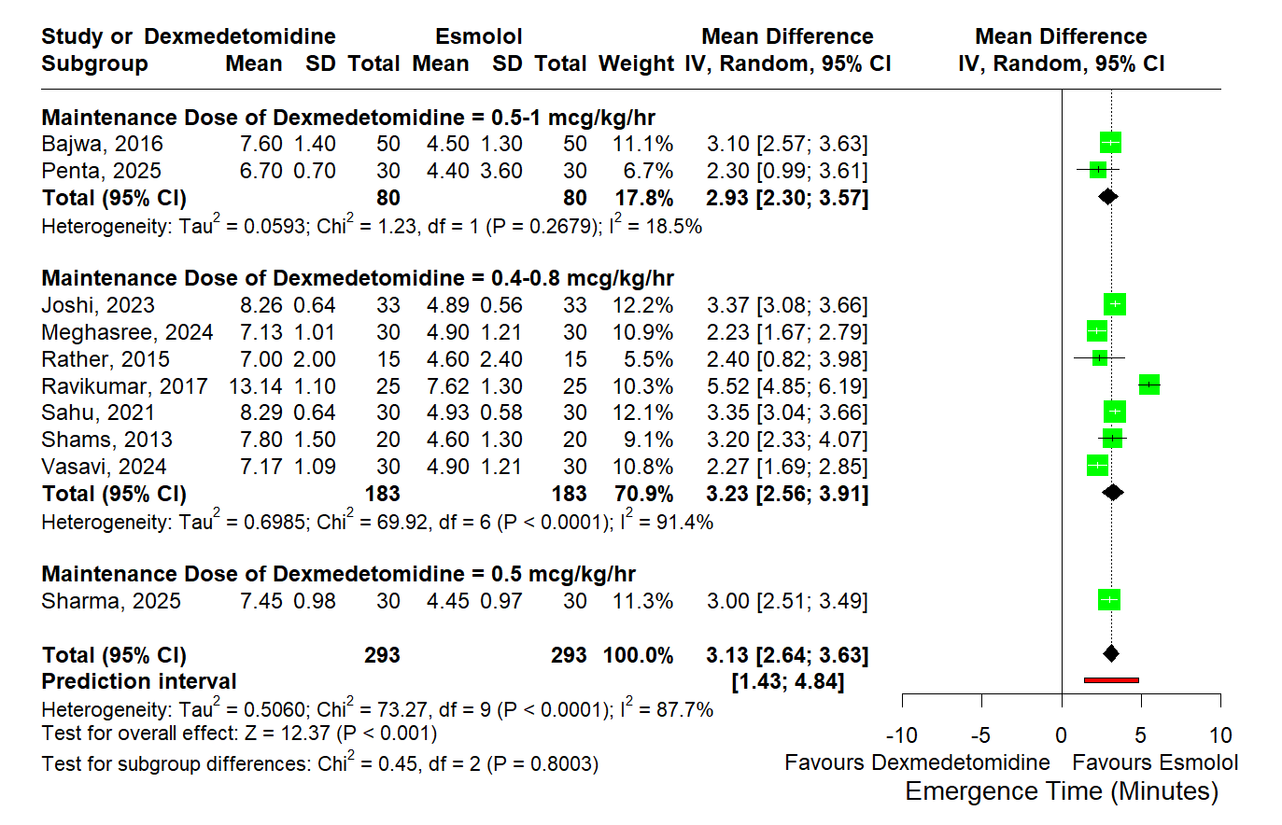

Supplementary Figure S2E. Analysis of emergence time, subgrouped by esmolol maintenance dose
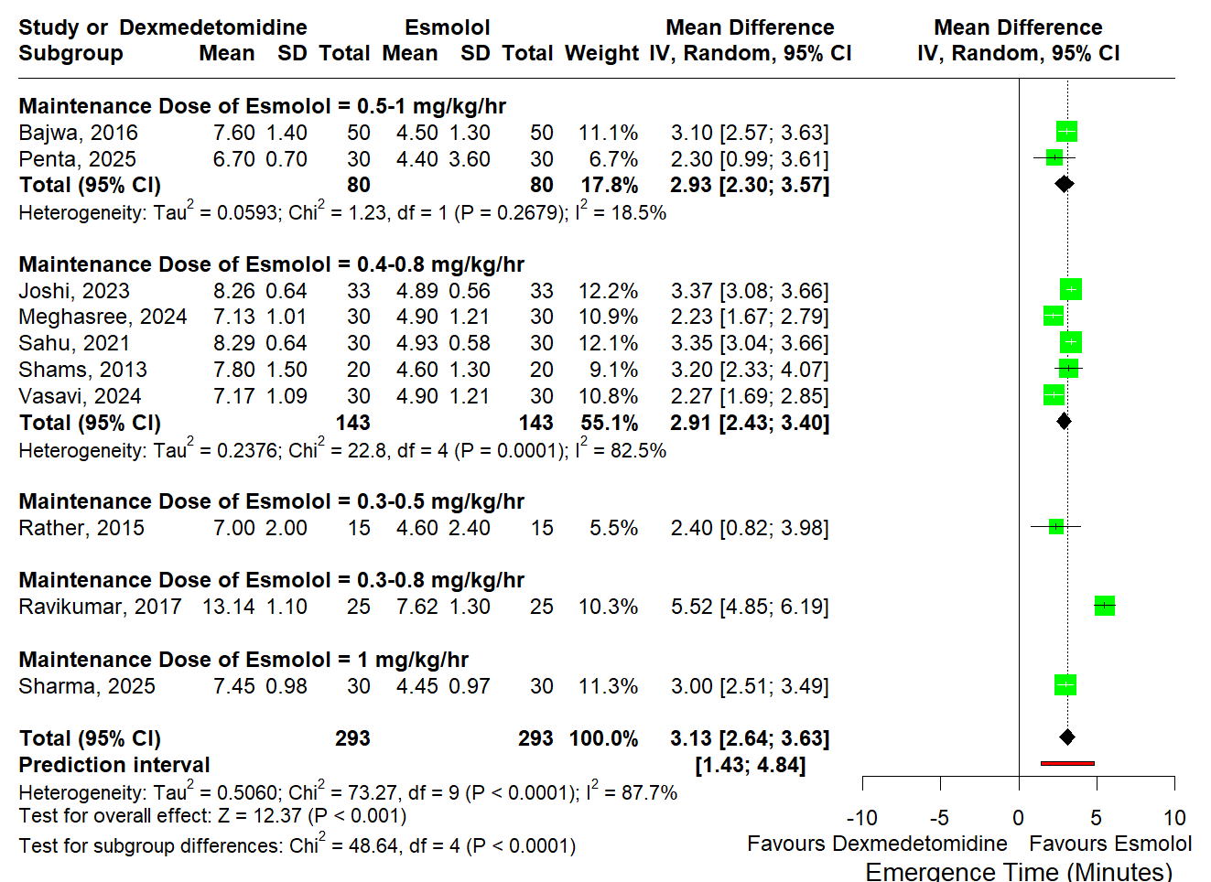

Supplementary Figure S2F. Meta-regression on emergence time with covariate year of publication
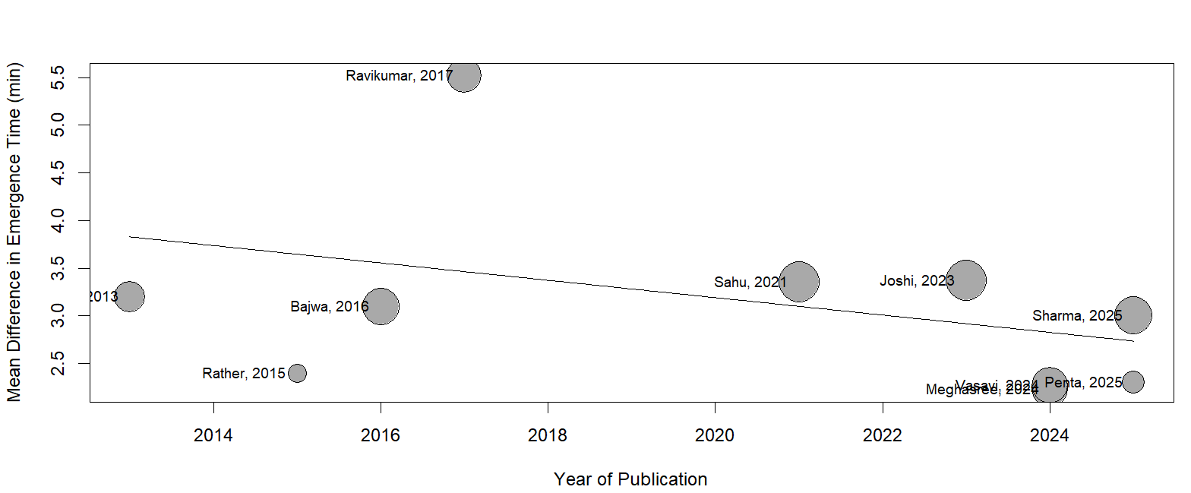

Supplementary Figure S2G. Meta-regression on emergence time with raw total sample size
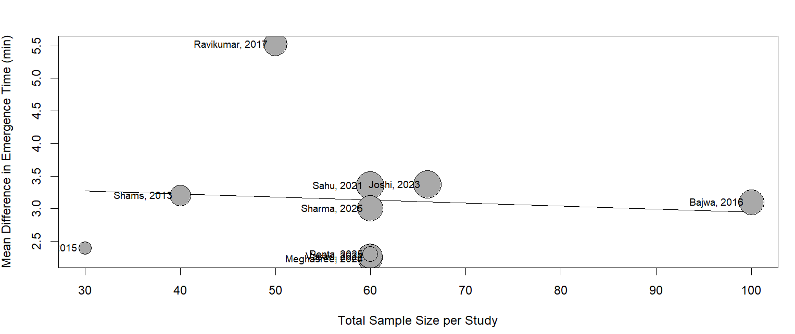

Supplementary Figure S2H. Meta-regression on emergence time with log sample size
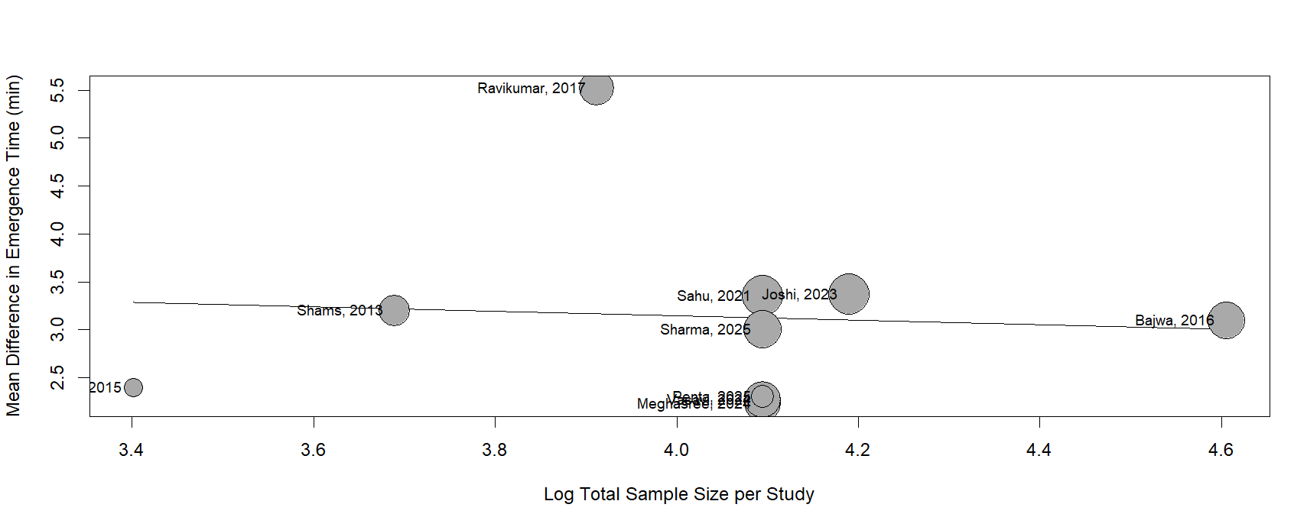

Supplementary Table S4. Leave-one-out analysis for time to first rescue analgesia
Leave-one-out meta-analysis

MD 95%-CI p-value tau^2 tau I^2 95%-PI
Omitting Bajwa, 2016 27.5342 [26.0186; 29.0499] < 0.0001 2.3129 1.5208 54.6% [23.4998; 31.5686]
Omitting Joshi, 2023 27.8873 [26.1588; 29.6158] < 0.0001 3.2951 1.8152 57.7% [23.1152; 32.6594]
Omitting Rather, 2015 27.9934 [26.5475; 29.4392] 0 2.2549 1.5016 56.4% [24.0372; 31.9495]
Omitting Sahu, 2021 27.5190 [25.9106; 29.1274] < 0.0001 2.5650 1.6016 52.1% [23.2637; 31.7743]
Omitting Shaheen, 2018 27.8588 [26.2796; 29.4380] < 0.0001 2.7584 1.6608 59.7% [23.4938; 32.2238]
Omitting Shams, 2013 27.8511 [26.3021; 29.4002] < 0.0001 2.6877 1.6394 59.8% [23.5475; 32.1547]
Omitting Sharma, 2025 27.6394 [26.0001; 29.2787] < 0.0001 2.9120 1.7065 58.7% [23.1456; 32.1332]
Omitting Penta, 2025 27.6314 [26.1214; 29.1415] < 0.0001 2.4570 1.5675 57.6% [23.5014; 31.7615]
Omitting Vasavi, 2024 28.4318 [27.5143; 29.3493] 0 0.0227 0.1506 1.2% [27.2690; 29.5946]

Random effects model 27.8315 [26.4074; 29.2557] 0 2.3068 1.5188 54.3% [23.9489; 31.7141]

Supplementary Figure S2I. Subgroup analysis for RSS at 15 min by maintenance dose of esmolol
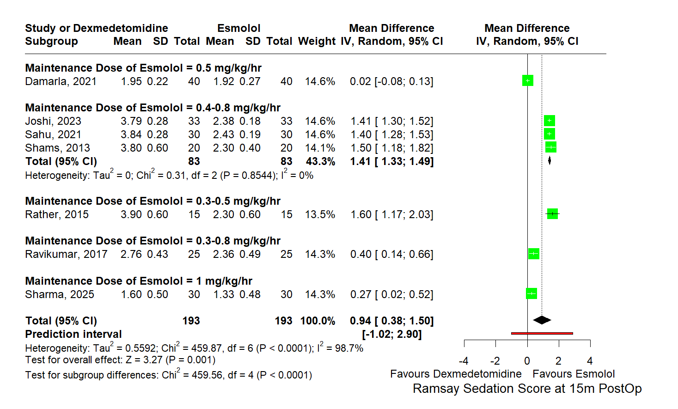

Supplementary Figure S2J. Subgroup analysis for RSS at 15 min by maintenance dose of dexmedetomidine
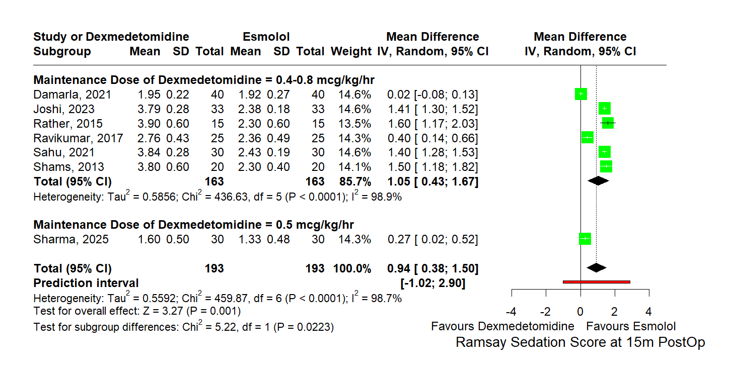

Supplementary Table S5. Leave-one-out analysis for RSS at 15 min
Leave-one-out meta-analysis

MD 95%-CI p-value tau^2 tau I^2 95%-PI
Omitting Damarla, 2021 1.0909 [0.6952; 1.4866] < 0.0001 0.2264 0.4758 95.9% [-0.2378; 2.4196]
Omitting Joshi, 2023 0.8580 [0.2160; 1.4999] 0.0088 0.6250 0.7906 98.5% [-1.3418; 3.0578]
Omitting Rather, 2015 0.8342 [0.2272; 1.4411] 0.0071 0.5639 0.7509 98.9% [-1.2539; 2.9222]
Omitting Ravikumar, 2017 1.0278 [0.4018; 1.6538] 0.0013 0.5957 0.7718 98.9% [-1.1194; 3.1750]
Omitting Sahu, 2021 0.8593 [0.2095; 1.5091] 0.0096 0.6410 0.8006 98.6% [-1.3683; 3.0868]
Omitting Shams, 2013 0.8461 [0.2324; 1.4597] 0.0069 0.5734 0.7572 98.9% [-1.2602; 2.9524]
Omitting Sharma, 2025 1.0496 [0.4287; 1.6704] 0.0009 0.5856 0.7652 98.9% [-1.0794; 3.1785]

Random effects model 0.9379 [0.3758; 1.4999] 0.0011 0.5592 0.7478 98.7% [-1.0219; 2.8976]

Supplementary Figure S2K. Subgroup analysis for RSS at 30 min by maintenance dose of dexmedetomidine
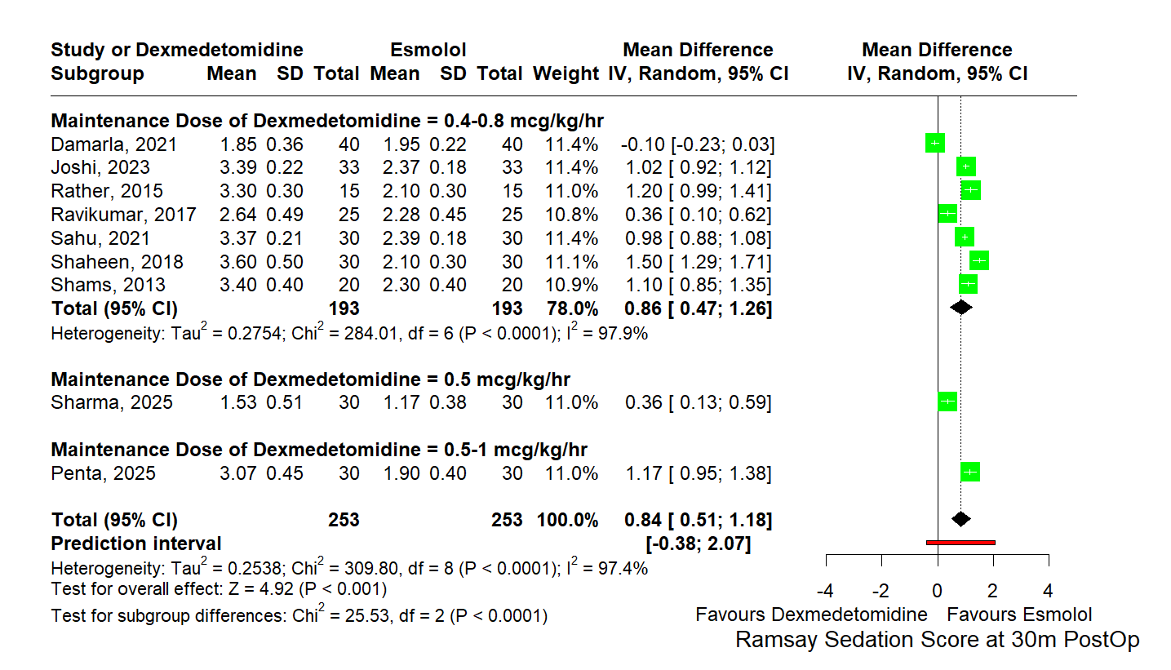

Supplementary Figure S2L. Subgroup analysis for RSS at 30 min by maintenance dose of esmolol
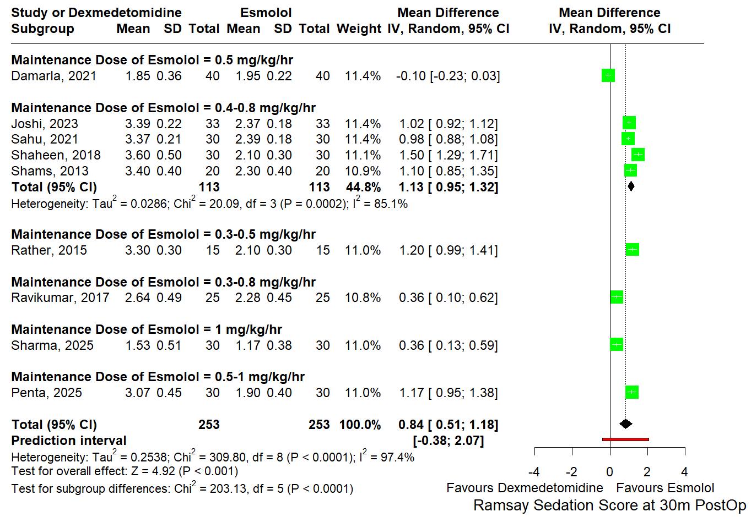

Supplementary Table S6. Leave-one-out analysis for RSS at 30 min
Leave-one-out meta-analysis

MD 95%-CI p-value tau^2 tau I^2 95%-PI
Omitting Damarla, 2021 0.9677 [0.7609; 1.1745] < 0.0001 0.0784 0.2800 91.5% [ 0.2601; 1.6753]
Omitting Joshi, 2023 0.8202 [0.4101; 1.2304] < 0.0001 0.3392 0.5824 97.6% [-0.6431; 2.2835]
Omitting Rather, 2015 0.7985 [0.4346; 1.1623] < 0.0001 0.2658 0.5155 97.6% [-0.4972; 2.0941]
Omitting Ravikumar, 2017 0.9013 [0.5432; 1.2593] < 0.0001 0.2578 0.5078 97.6% [-0.3747; 2.1773]
Omitting Sahu, 2021 0.8250 [0.4120; 1.2380] < 0.0001 0.3441 0.5866 97.7% [-0.6489; 2.2989]
Omitting Shaheen, 2018 0.7610 [0.4148; 1.1072] < 0.0001 0.2396 0.4895 97.4% [-0.4694; 1.9914]
Omitting Shams, 2013 0.8114 [0.4471; 1.1756] < 0.0001 0.2669 0.5166 97.7% [-0.4868; 2.1096]
Omitting Sharma, 2025 0.9023 [0.5434; 1.2612] < 0.0001 0.2585 0.5084 97.6% [-0.3755; 2.1801]
Omitting Penta, 2025 0.8026 [0.4376; 1.1675] < 0.0001 0.2675 0.5172 97.7% [-0.4972; 2.1024]

Random effects model 0.8428 [0.5071; 1.1784] < 0.0001 0.2538 0.5038 97.4% [-0.3844; 2.0699]

Supplementary Figure S2M. Subgroup analysis for RSS at 60 min by maintenance dose of dexmedetomidine
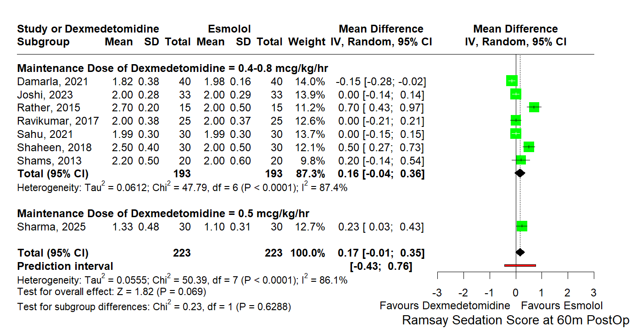

Supplementary Figure S2N. Subgroup analysis for RSS at 60 min by maintenance dose of esmolol
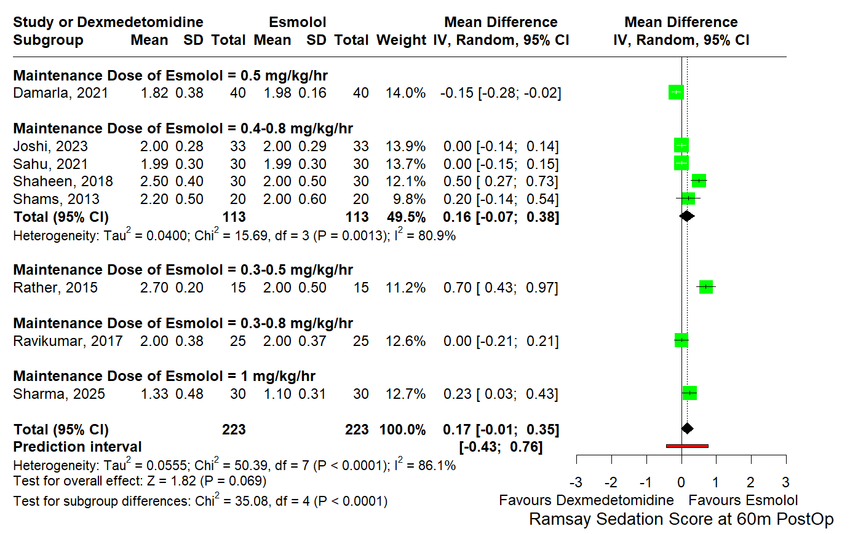

Supplementary Table S7. Leave-one-out analysis for RSS at 60 min
Leave-one-out meta-analysis

MD 95%-CI p-value tau^2 tau I^2 95%-PI
Omitting Damarla, 2021 0.2178 [ 0.0299; 0.4056] 0.0231 0.0514 0.2267 83.1% [-0.3846; 0.8201]
Omitting Joshi, 2023 0.1976 [-0.0196; 0.4147] 0.0745 0.0729 0.2700 87.8% [-0.5166; 0.9118]
Omitting Rather, 2015 0.0928 [-0.0584; 0.2440] 0.2290 0.0313 0.1770 79.1% [-0.3796; 0.5652]
Omitting Ravikumar, 2017 0.1933 [-0.0108; 0.3974] 0.0634 0.0640 0.2530 88.0% [-0.4763; 0.8629]
Omitting Sahu, 2021 0.1967 [-0.0169; 0.4102] 0.0711 0.0703 0.2652 87.9% [-0.5048; 0.8982]
Omitting Shaheen, 2018 0.1164 [-0.0552; 0.2879] 0.1836 0.0424 0.2059 83.2% [-0.4310; 0.6637]
Omitting Shams, 2013 0.1643 [-0.0297; 0.3582] 0.0970 0.0589 0.2426 88.0% [-0.4769; 0.8054]
Omitting Sharma, 2025 0.1594 [-0.0409; 0.3597] 0.1188 0.0612 0.2474 87.4% [-0.4956; 0.8144]

Random effects model 0.1669 [-0.0127; 0.3466] 0.0686 0.0555 0.2356 86.1% [-0.4309; 0.7647]

Supplementary Figure S3A. Funnel plot for duration of surgery
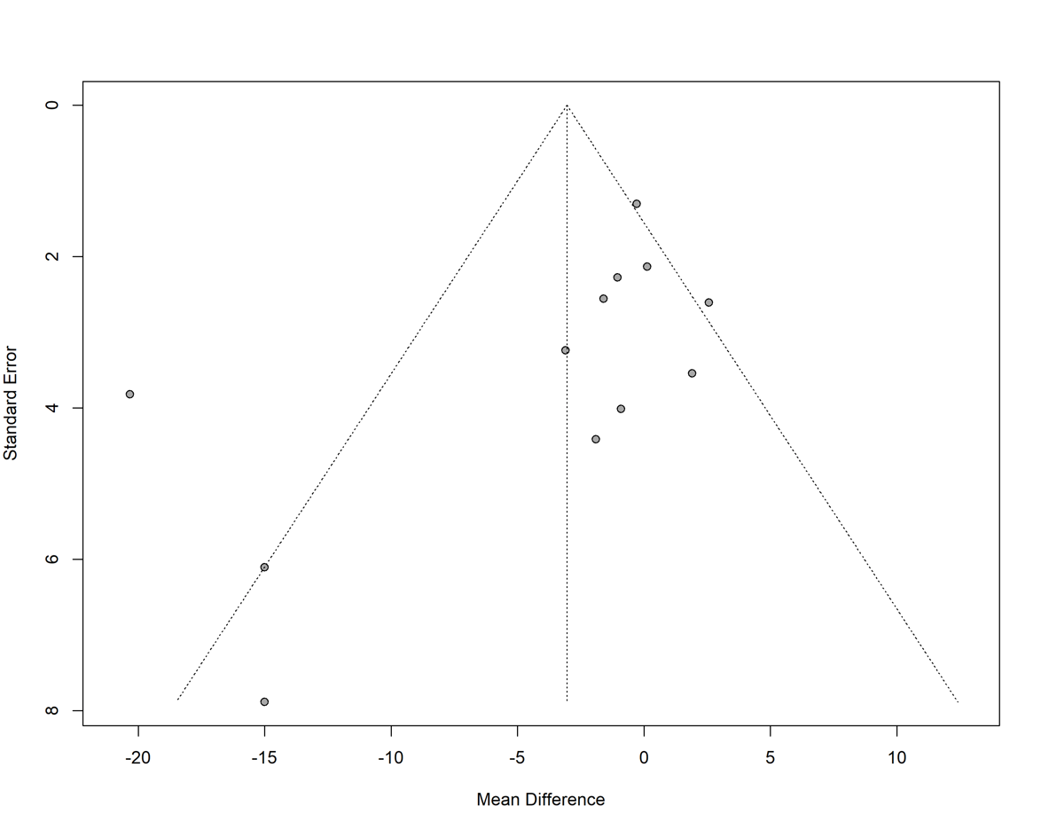
Supplementary Figure S3B. Funnel plot for emergence time
