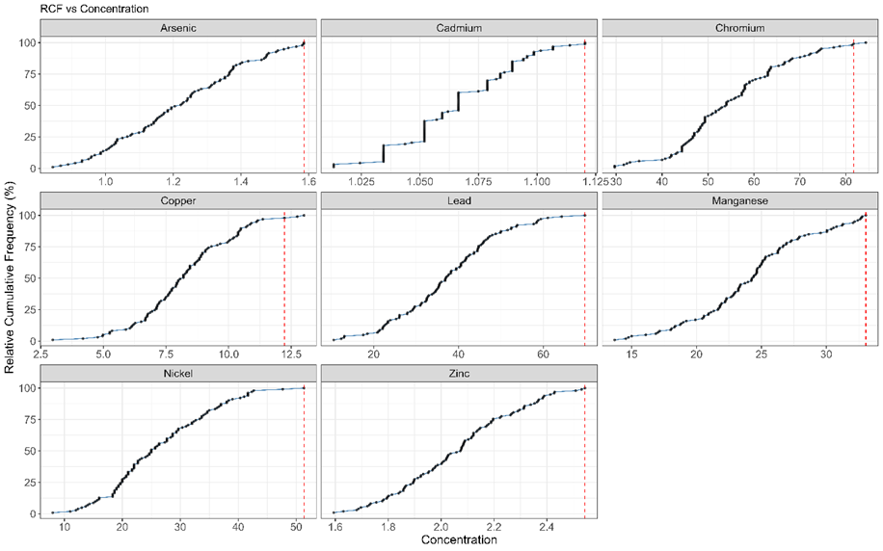
Supplementary Figures:
Figure S1: Relative cumulative frequency curve of eight heavy metals in soil (red line indicates the inflection point determined through consecutive linear fitting/maximum value removal).

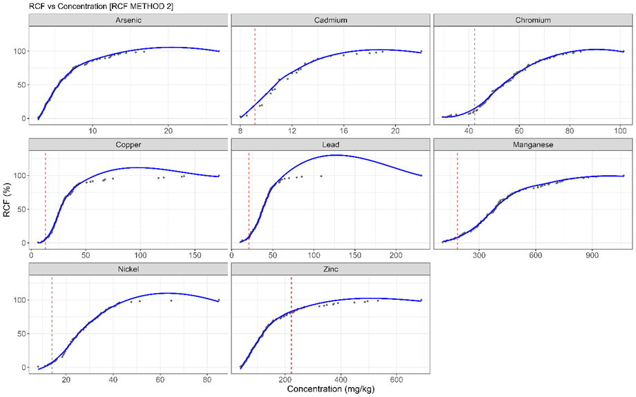
Figure S2: Relative cumulative frequency curve of eight heavy metals in soil; red line indicates the inflection point determined through Kneedle Algorithm)

Table S1: Heavy metal pollution values (mean with 95% confidence interval) using Geochemical Baseline Values (GBV) compared with UCC (Taylor & McLenan, 1995) and WSBV (Kabata-Pendias, 2011).
Elements |  |  | Igeo |  |  | EF |  |  | PI
 |  |  | UCC | WSBV | GBV | UCC | WSBV | GBV | UCC | WSBV | GBV
As | Mean |  | 1.40 | -0.79 | -0.58 | 2.30 | 0.71 | 0.59 | 4.43 | 0.97 | 1.12
As | 95% CI | Upper Limit | 1.52 | -0.66 | -0.46 | 2.67 | 0.82 | 0.68 | 4.91 | 1.08 | 1.24
 | 95% CI | Lower Limit | 1.27 | -0.92 | -0.71 | 1.94 | 0.60 | 0.49 | 3.96 | 0.87 | 1.00
Cd | Mean |  | 6.27 | 4.21 | -0.21 | 62.58 | 21.02 | 0.70 | 118.46 | 28.31 | 1.32
Cd | 95% CI | Upper Limit | 6.33 | 4.27 | -0.16 | 73.60 | 24.72 | 0.83 | 123.64 | 29.55 | 1.38
 | 95% CI | Lower Limit | 6.21 | 4.15 | -0.27 | 51.56 | 17.32 | 0.58 | 113.27 | 27.07 | 1.26
Cr | Mean |  | 0.04 | -0.73 | -0.01 | 0.75 | 0.62 | 0.74 | 1.58 | 0.93 | 1.53
Cr | 95% CI | Upper Limit | 0.10 | -0.66 | 0.06 | 0.81 | 0.67 | 0.79 | 1.65 | 0.97 | 1.60
 | 95% CI | Lower Limit | -0.02 | -0.79 | -0.07 | 0.70 | 0.58 | 0.68 | 1.51 | 0.89 | 1.46
Cu | Mean |  | -0.40 | -1.04 | 0.92 | 0.67 | 0.61 | 1.69 | 1.35 | 0.87 | 3.38
Cu | 95% CI | Upper Limit | -0.25 | -0.89 | 1.07 | 0.78 | 0.70 | 1.96 | 1.56 | 1.00 | 3.89
 | 95% CI | Lower Limit | -0.55 | -1.19 | 0.77 | 0.57 | 0.51 | 1.43 | 1.15 | 0.74 | 2.88
Pb | Mean |  | 0.30 | -0.14 | 0.70 | 1.05 | 1.10 | 1.40 | 2.04 | 1.51 | 2.69
Pb | 95% CI | Upper Limit | 0.41 | -0.02 | 0.82 | 1.23 | 1.28 | 1.64 | 2.26 | 1.68 | 2.99
 | 95% CI | Lower Limit | 0.18 | -0.26 | 0.58 | 0.88 | 0.91 | 1.17 | 1.81 | 1.34 | 2.39
Mn | Mean |  | -1.26 | -0.94 | 0.83 | 0.38 | 0.66 | 1.62 | 0.70 | 0.87 | 2.97
Mn | 95% CI | Upper Limit | -1.13 | -0.81 | 0.96 | 0.46 | 0.82 | 1.99 | 0.76 | 0.95 | 3.24
 | 95% CI | Lower Limit | -1.39 | -1.07 | 0.70 | 0.29 | 0.51 | 1.25 | 0.64 | 0.79 | 2.71
Ni | Mean |  | -0.23 | -0.77 | 0.54 | 0.68 | 0.66 | 1.18 | 1.37 | 0.95 | 2.35
Ni | 95% CI | Upper Limit | -0.13 | -0.66 | 0.65 | 0.75 | 0.73 | 1.30 | 1.48 | 1.02 | 2.53
 | 95% CI | Lower Limit | -0.34 | -0.88 | 0.44 | 0.61 | 0.59 | 1.06 | 1.26 | 0.87 | 2.17
Zn | Mean |  | 0.27 | 0.29 | -0.25 | 1.11 | 2.81 | 0.78 | 2.21 | 2.24 | 1.54
Zn | 95% CI | Upper Limit | 0.43 | 0.45 | -0.08 | 1.28 | 3.22 | 0.90 | 2.52 | 2.55 | 1.76
 | 95% CI | Lower Limit | 0.10 | 0.12 | -0.42 | 0.95 | 2.40 | 0.67 | 1.90 | 1.92 | 1.33

Table S2: Organic matter content of the eighty-five soil samples of Kathmandu Valley.
Sample ID | Soil Weight (gram) | Ferrous ammonium sulphate (FAS) value | Organic matter (%)
s1 | 0.50 | 13.6 | 3.08
s2 | 0.51 | 16.4 | 1.18
s3 | 0.51 | 10.3 | 5.15
s4 | 0.51 | 12.4 | 3.61
s6 | 0.51 | 14.6 | 2.38
s7 | 0.52 | 12.5 | 3.68
s8 | 0.51 | 13.8 | 2.91
s9 | 0.50 | 14.3 | 2.61
s10 | 0.50 | 10.8 | 4.94
s11 | 0.51 | 9.7 | 5.60
s12 | 0.52 | 11.3 | 4.46
s13 | 0.51 | 15.4 | 1.83
s14 | 0.52 | 13.6 | 2.99
s15 | 0.51 | 12.1 | 4.02
s16 | 0.50 | 10.5 | 5.12
s17 | 0.50 | 12.2 | 3.81
s18 | 0.51 | 12.8 | 3.54
s19 | 0.52 | 8.9 | 6.04
s20 | 0.51 | 15 | 2.12
s22 | 0.51 | 15 | 2.11
s23 | 0.51 | 13.7 | 2.93
s24 | 0.51 | 13.3 | 3.23
s26 | 0.50 | 16.7 | 1.00
s27 | 0.51 | 12 | 4.11
s28 | 0.50 | 14.5 | 2.47
s29 | 0.51 | 10.8 | 4.85
s30 | 0.50 | 13.3 | 3.26
s31 | 0.50 | 15.4 | 1.86
s32 | 0.51 | 13.5 | 3.10
s33 | 0.51 | 15 | 2.11
s34 | 0.51 | 15.3 | 1.92
s37 | 0.50 | 15.4 | 1.87
s38 | 0.51 | 15.7 | 1.65
s39 | 0.50 | 14.5 | 2.46
s40 | 0.50 | 14.4 | 2.53
s41 | 0.51 | 15.1 | 2.04
s43 | 0.50 | 14.3 | 2.60
s44 | 0.50 | 15.4 | 1.87
s45 | 0.50 | 14.4 | 2.53
s46 | 0.52 | 14.3 | 2.52
s47 | 0.51 | 15 | 2.12
s48 | 0.51 | 14.9 | 2.18
s49 | 0.51 | 13.8 | 2.90
s50 | 0.51 | 13.5 | 3.12
s52 | 0.52 | 12.8 | 3.49
s53 | 0.51 | 16.6 | 1.06
s56 | 0.50 | 14.4 | 2.54
s57 | 0.51 | 12.6 | 3.68
s58 | 0.51 | 13.4 | 3.17
s59 | 0.50 | 12.3 | 3.93
s60 | 0.51 | 14.3 | 2.35
s61 | 0.50 | 10.6 | 4.86
s62 | 0.50 | 9.5 | 5.59
s64 | 0.51 | 16.1 | 1.18
s66 | 0.51 | 14.3 | 2.38
s68 | 0.51 | 13.5 | 2.87
s69 | 0.51 | 14.6 | 2.17
s70 | 0.50 | 14.1 | 2.54
s71 | 0.51 | 11.4 | 4.27
s72 | 0.51 | 7.8 | 6.57
s74 | 0.51 | 12.8 | 3.37
s75 | 0.51 | 12.1 | 3.83
s76 | 0.52 | 13.2 | 3.05
s78 | 0.51 | 12.8 | 3.32
s79 | 0.51 | 14.2 | 2.43
s80 | 0.52 | 15.2 | 1.75
s82 | 0.52 | 12.7 | 3.38
s83 | 0.50 | 13.9 | 2.66
s84 | 0.51 | 9.9 | 5.26
s85 | 0.51 | 9.9 | 5.26
s87 | 0.51 | 12.3 | 3.68
s89 | 0.51 | 17.5 | 0.26
s90 | 0.51 | 14.2 | 2.45
s91 | 0.51 | 9 | 5.87
s93 | 0.51 | 14 | 2.55
s94 | 0.50 | 16 | 1.27
s95 | 0.51 | 16.6 | 0.86
s96 | 0.52 | 10 | 5.10
s97 | 0.52 | 12.1 | 3.74
s98 | 0.51 | 9.1 | 5.80
s101 | 0.51 | 16.3 | 1.05
s103 | 0.51 | 17.4 | 0.33
s104 | 0.51 | 15.2 | 1.79
s105 | 0.51 | 16 | 1.26
s107 | 0.50 | 14.6 | 2.20

