Supplementary Materials for

An environment transitional zone buffers peatlands carbon lose
Liangfeng Liu, Huai Chen, Jianqing Tian, Hongjun Wang, Dan Xue, Ning Wu, Meng Wang, Xingliang Xu, Changhui Peng, Yanfen Wang

This file includes:

Supplementary Figures. 1 to 12

Supplementary Figures. 1 to 12

Figure. 1
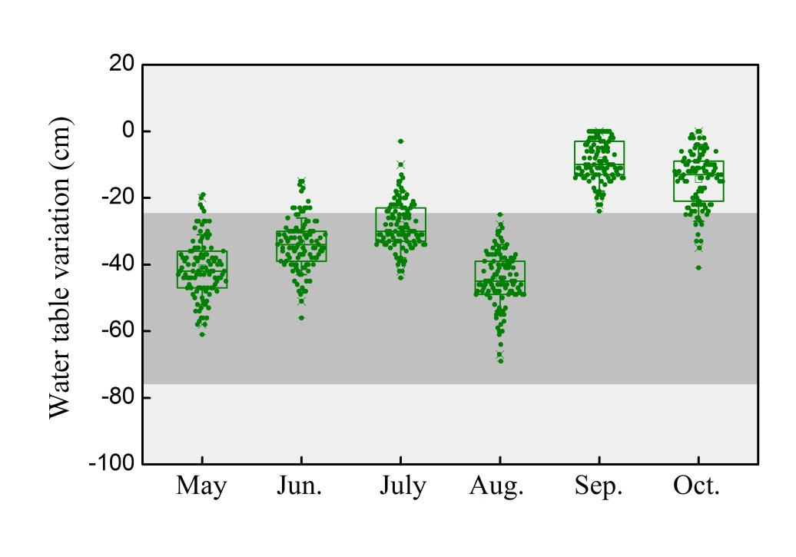
Supplementary Fig. 1 Water table fluctuation at the sampling site in growing season.

Figure. 2.

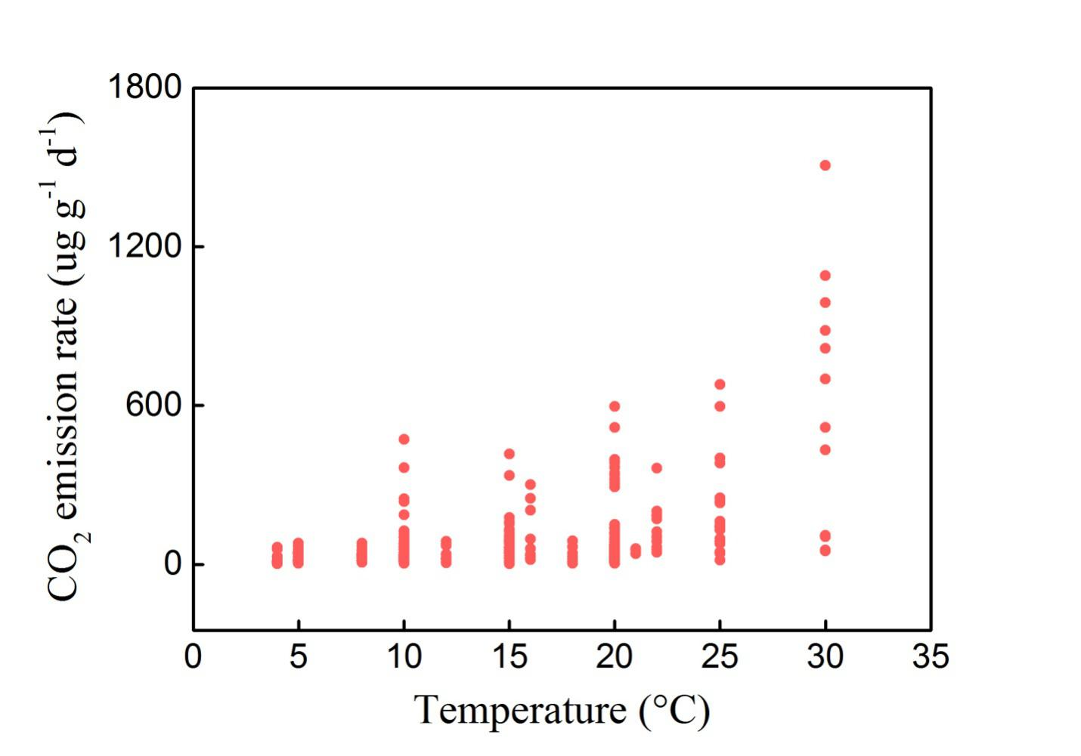

Supplementary Fig. 2 The soil CO₂ emission under different temperatures of global peatlands.

Figure 3

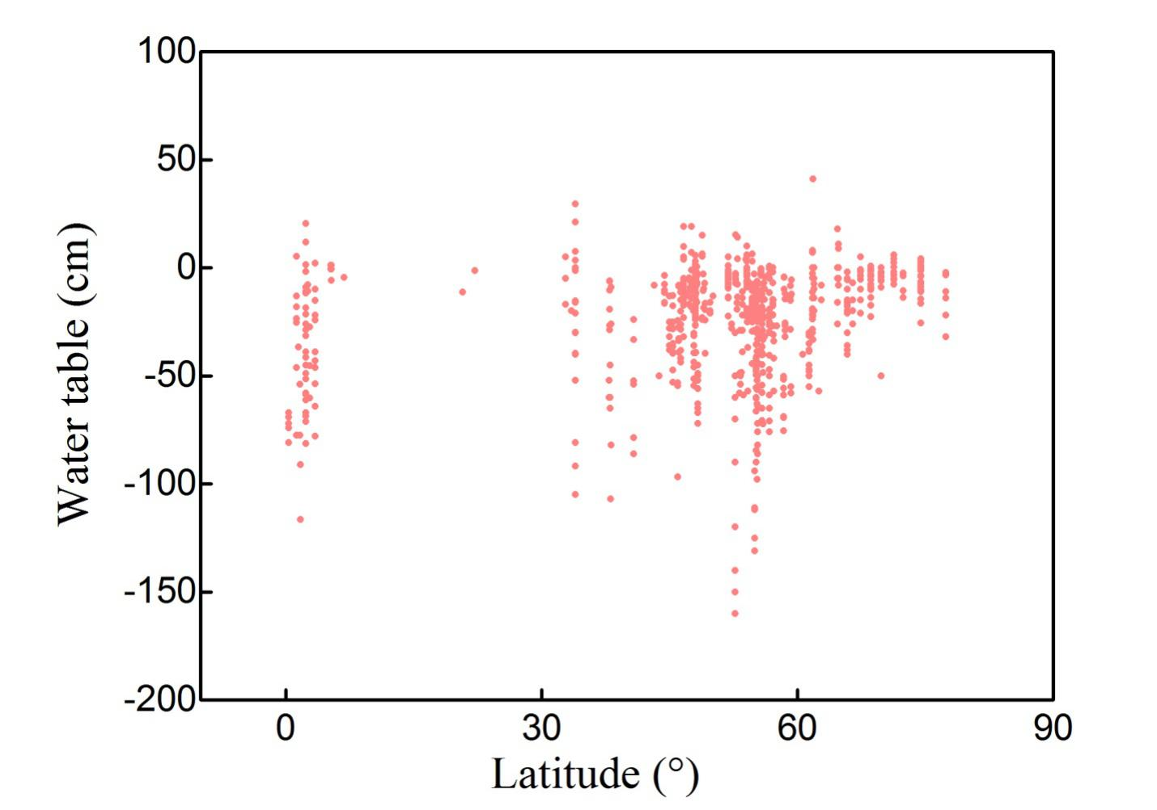

Supplementary Fig. 3 The fluctuation of water table of global peatlands.

Figure. 4.
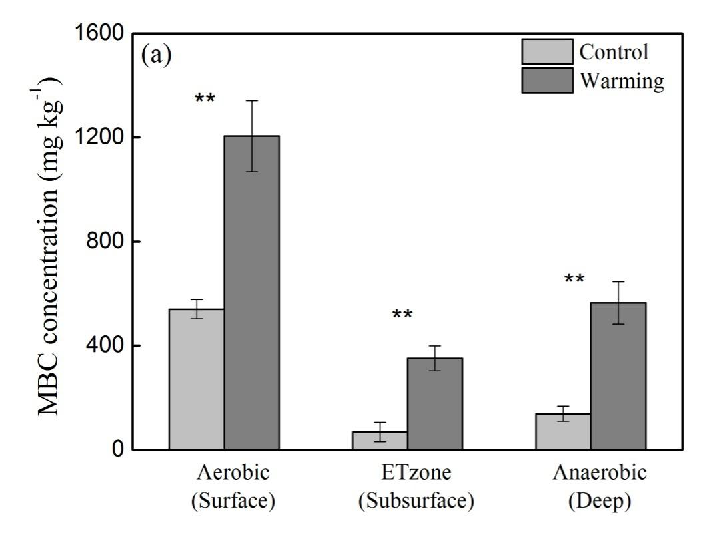
Supplementary Fig. 4 Soil microbial biomass carbon (MBC) distribution in soil of three layers under control and warming treatments (value ± SE, n = 3; t test, *: p < 0.05, **: p < 0.01).

Figure. 5.

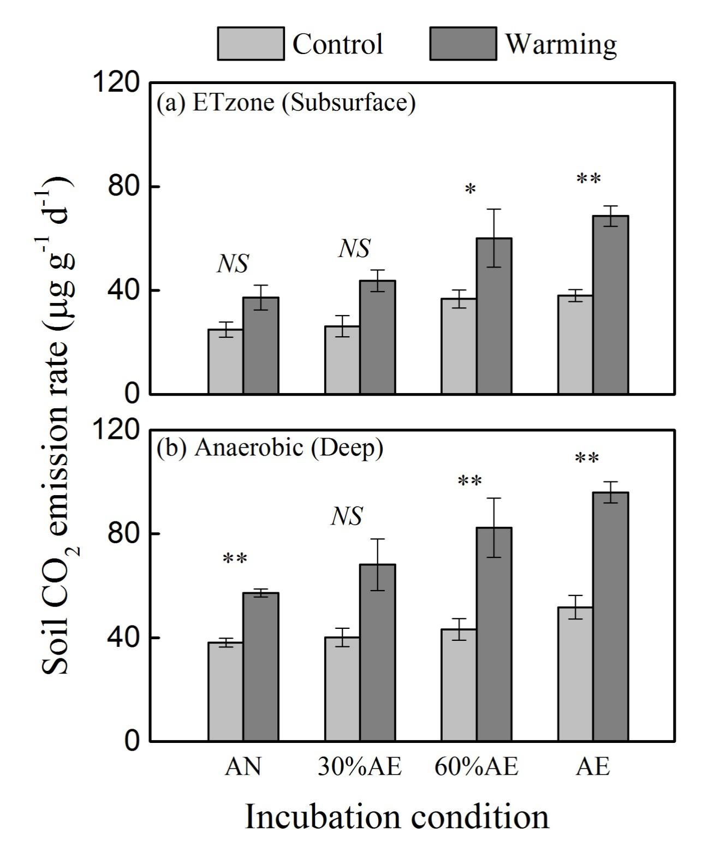
Supplementary Fig. 5 Variation in ETzone soil CO₂ emission with conditions shift from anaerobic to aerobic in both control and warming treatments (Value ± SE, n = 3; t test).

Figure. 6

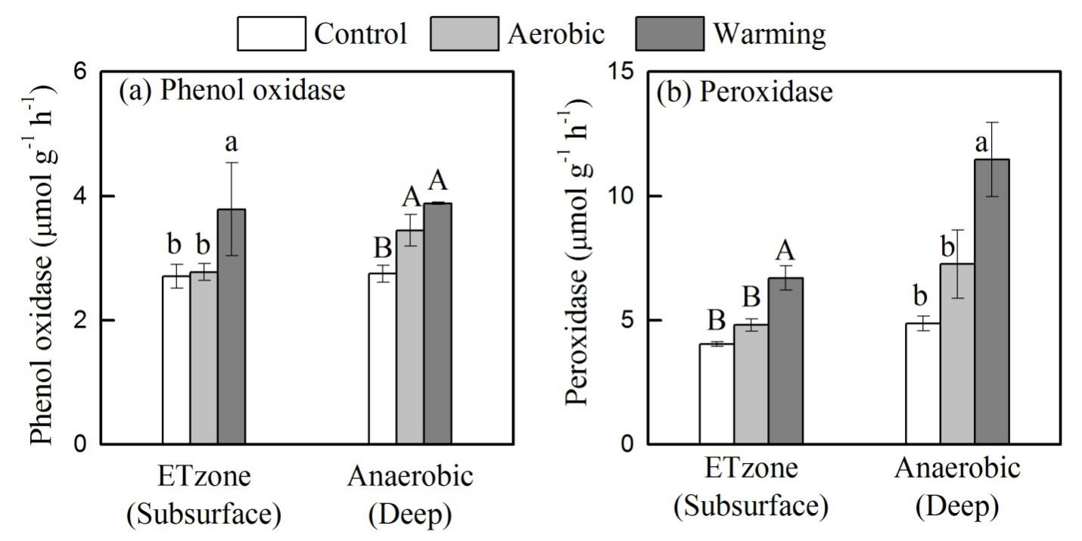
Supplementary Fig. 6 Soil phenol oxidase and peroxidase activity under control, aerobic and warming conditions (Value ± SE, n = 3; Duncan test, p < 0.05 for lowercase letters and p < 0.01 for uppercase letters).

Figure. 7

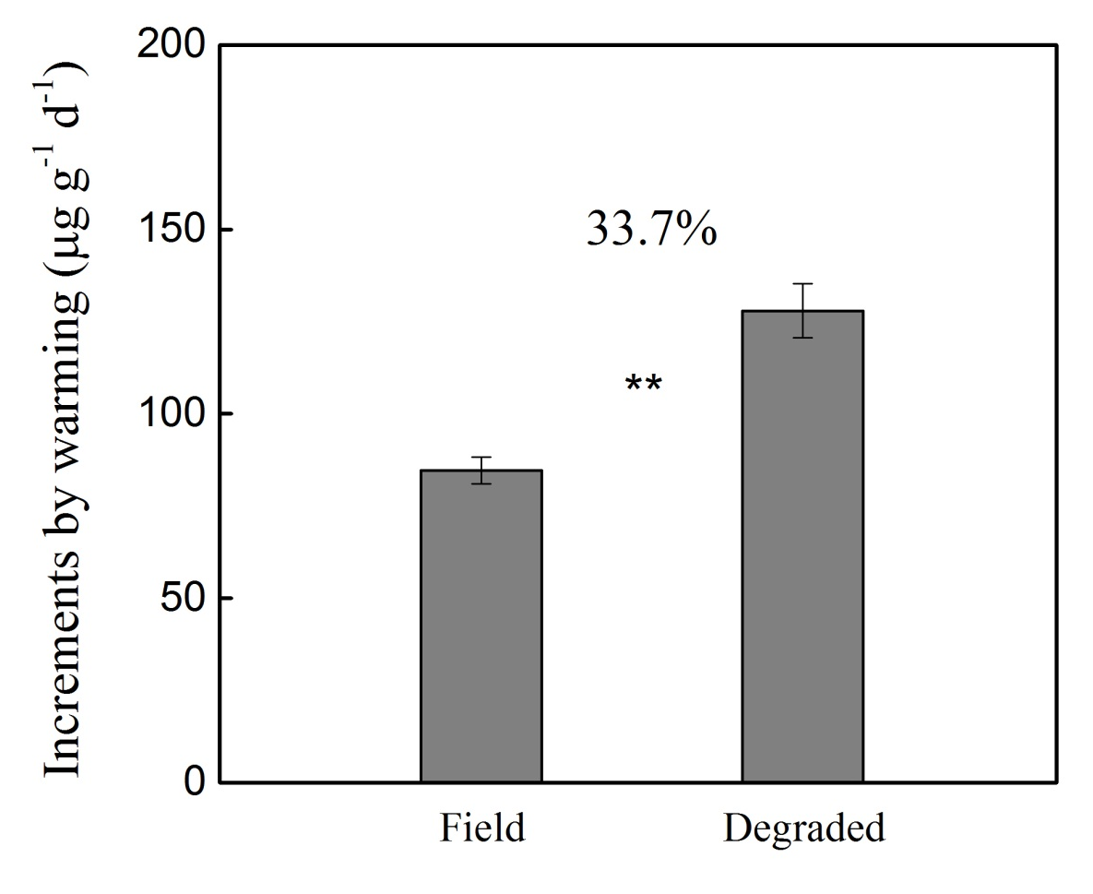
Supplementary Fig. 7 The increments of increased CO₂ emission caused by warming of 100 cm soil profile in both conditions of field and future degraded (Value ± SE, n = 3; t test, *: p < 0.05, **: p < 0.01).

Figure. 8
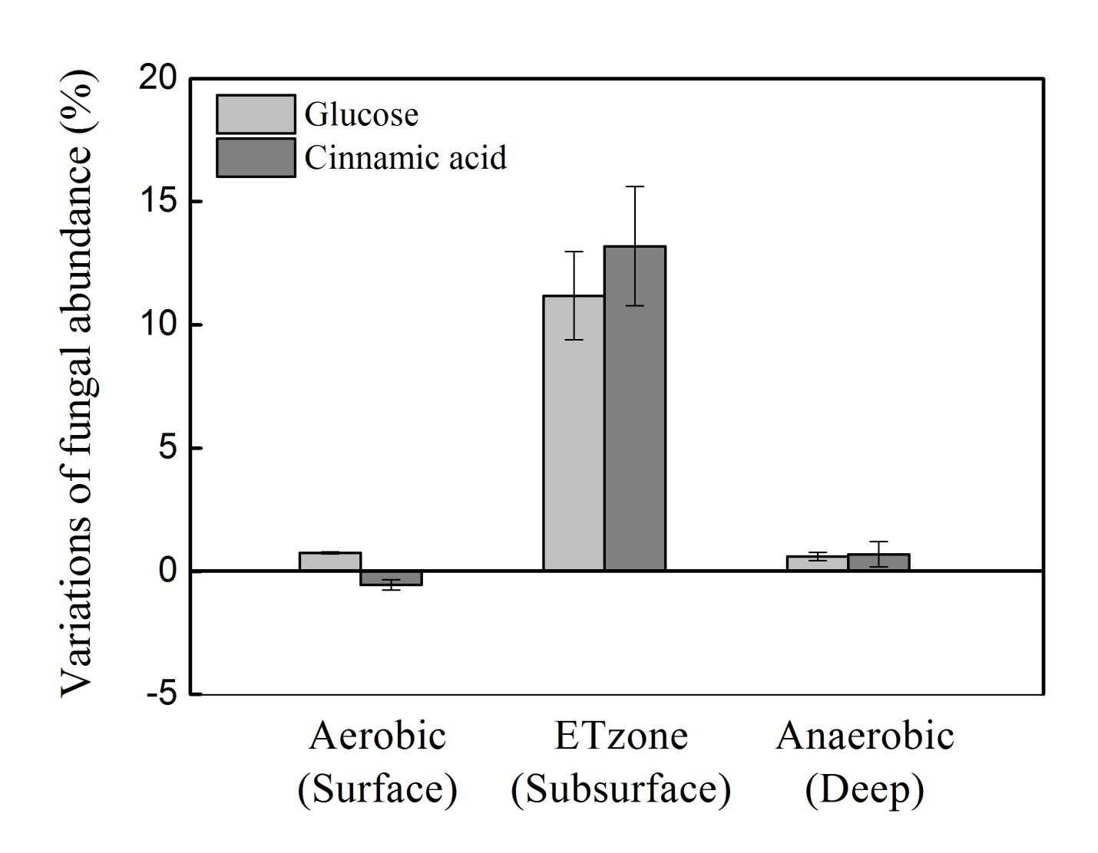
Supplementary Fig. 8 Variation in soil fungal abundance after substrate addition relative to control (Only data for soil treated with glucose and cinnamic acid are shown, the treated with oxalic acid was not analyzed) (Value ± SE, n = 3).

Figure. 9

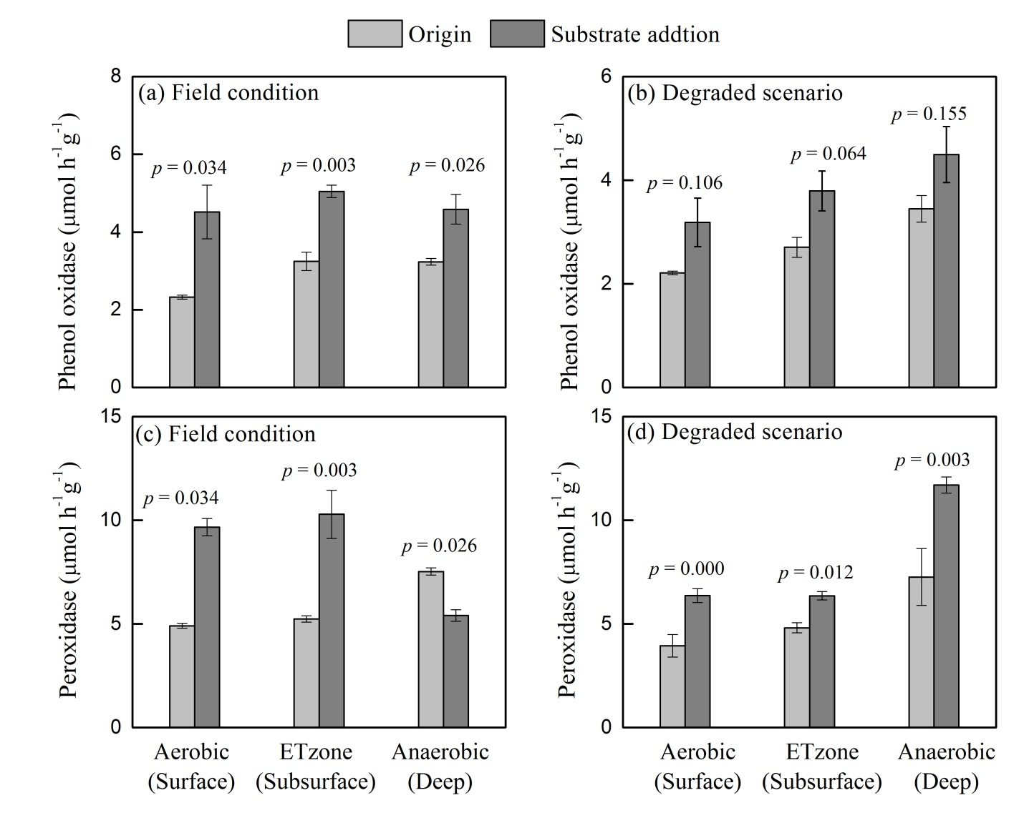
Supplementary Fig. 9 Variation in activity of soil phenol oxidase and peroxidase after substrate addition (a: phenol oxidase in anaerobic condition; b: phenol oxidase in aerobic condition; c: peroxidase in anaerobic condition; d: peroxidase in aerobic condition) (Value ± SE, n = 3; t test).

Figure. 10
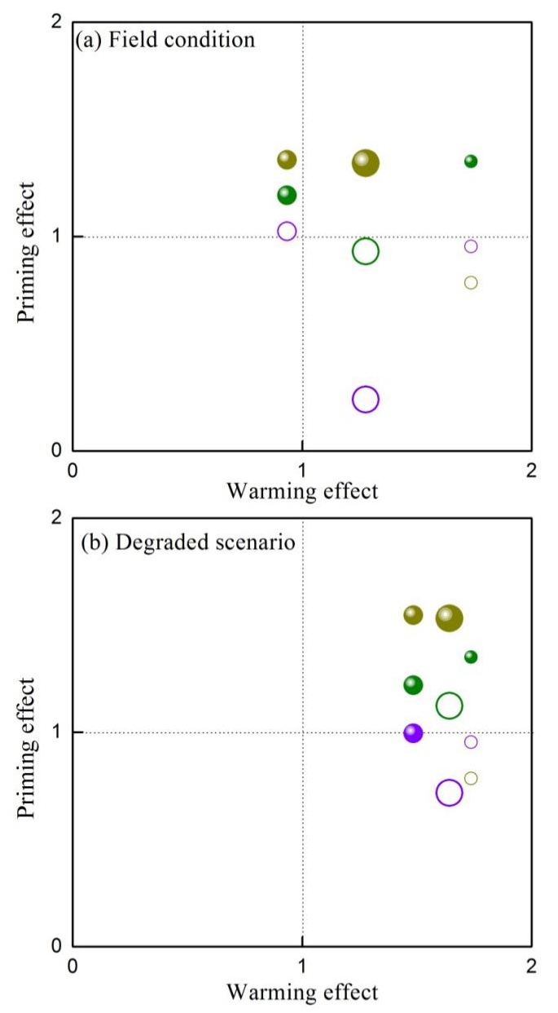
Supplementary Fig. 10 Ratios of the log value of the increased CO₂ emission for treatments of warming and substrate addition (oxalate, green; glucose, purple; cinnamic acid, dark yellow) under (a) field conditions and (b) degraded conditions. Values are provided as mean ± standard error (n =3). Small circles: surface soil; Intermediate circles: subsurface EnTraZon soil and large circles: deep soil. Solid circles indicate significant influence of substrate on CO₂ emission; hollow circles, no significant influence of substrate on CO₂ emission.

Figure. 11
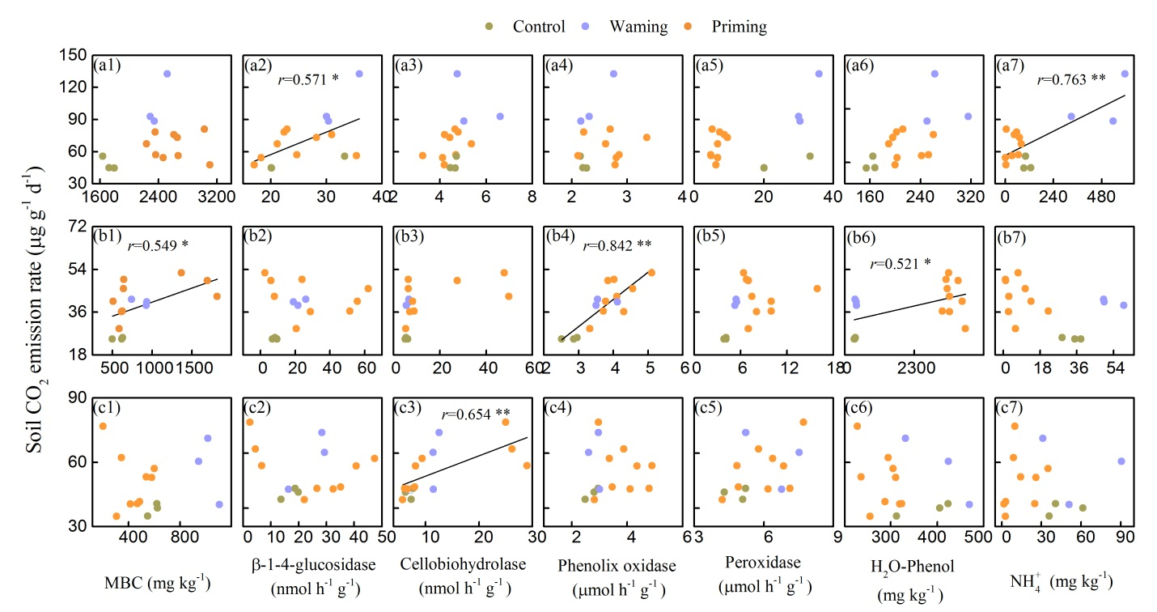
Supplementary Fig. 11 Soil variables variation and the correlation with soil CO₂ emission of three zones.

Figure. 12

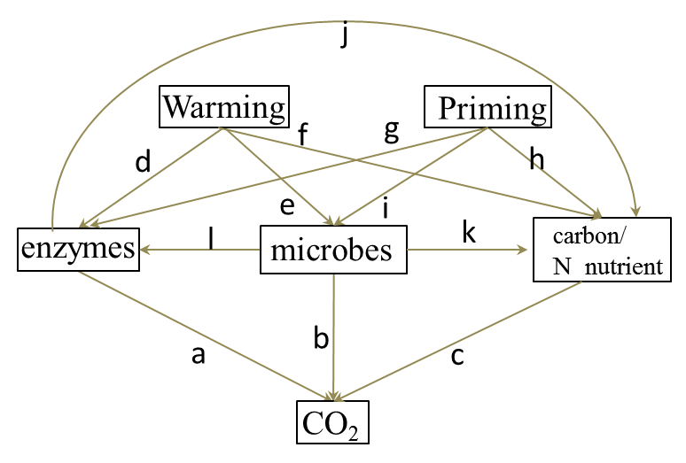

Supplementary Fig. 12 Hypothesized direct and indirect effects of warming, priming soil enzymes, microbes and soil carbon component/N nutrient on soil CO₂ emission. Previous researches have showed that warming and priming influence soil CO₂ emission through functioning on soil enzyme, microbes and N nutrient (a-l). microbes also influence soil CO₂ emission through soil enzyme functioning on soil carbon and nutrient (j-l).

