Supplementary Information for

Hall effect in gated single-wall carbon nanotube films

Yohei Yomogida,*¹ Kanako Horiuchi,¹ Ryotaro Okada,¹ Hideki Kawai,¹ Yota Ichinose,¹ Hiroyuki Nishidome,¹ Kan Ueji,¹ Natsumi Komatsu,² Weilu Gao,³ Junichiro Kono,^{2,4,5} and Kazuhiro Yanagi*¹
¹Department of Physics, Tokyo Metropolitan University, Hachioji, Tokyo 192-0397, Japan
²Department of Electrical and Computer Engineering, Rice University, Houston, Texas 77005, USA
³Department of Electrical and Computer Engineering, University of Utah, Salt Lake City, UT 84112, USA
⁴Department of Physics and Astronomy, Rice University, Houston, Texas 77005, USA
⁵Department of Materials Science and NanoEngineering, Rice University, Houston, Texas 77005, USA

E-mail: yomogida@tmu.ac.jp, yanagi-kazuhiro@tmu.ac.jp

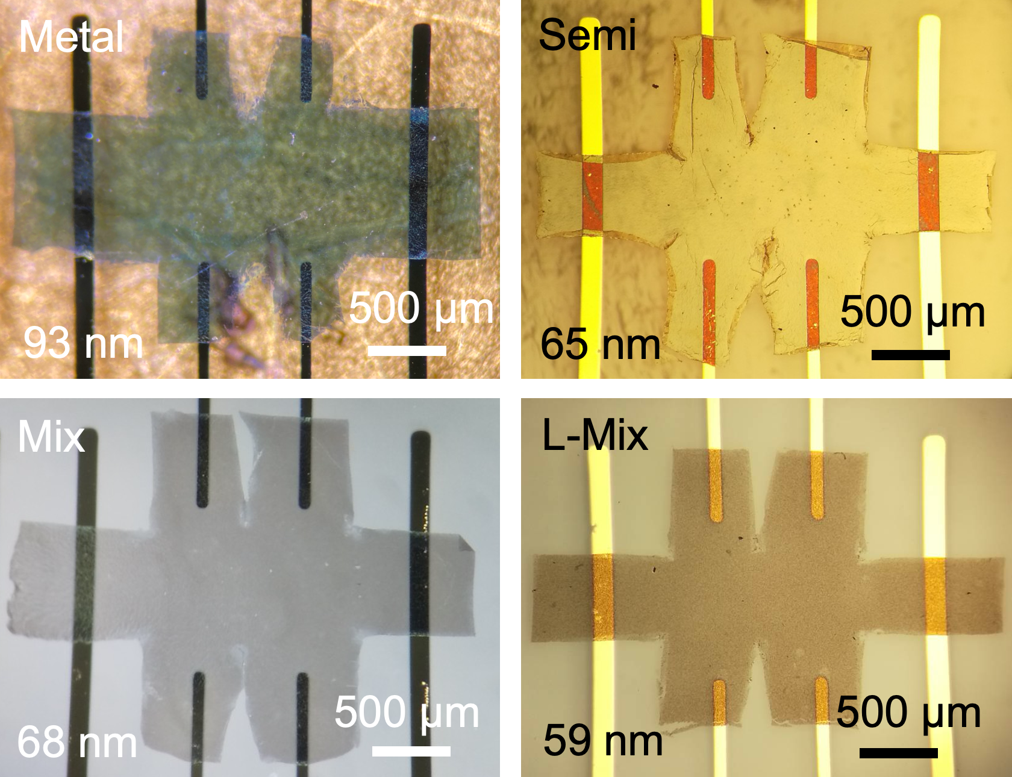
Fig. 1. Optical microscopy images of the various SWCNT thin film devices. The film thickness is also shown.

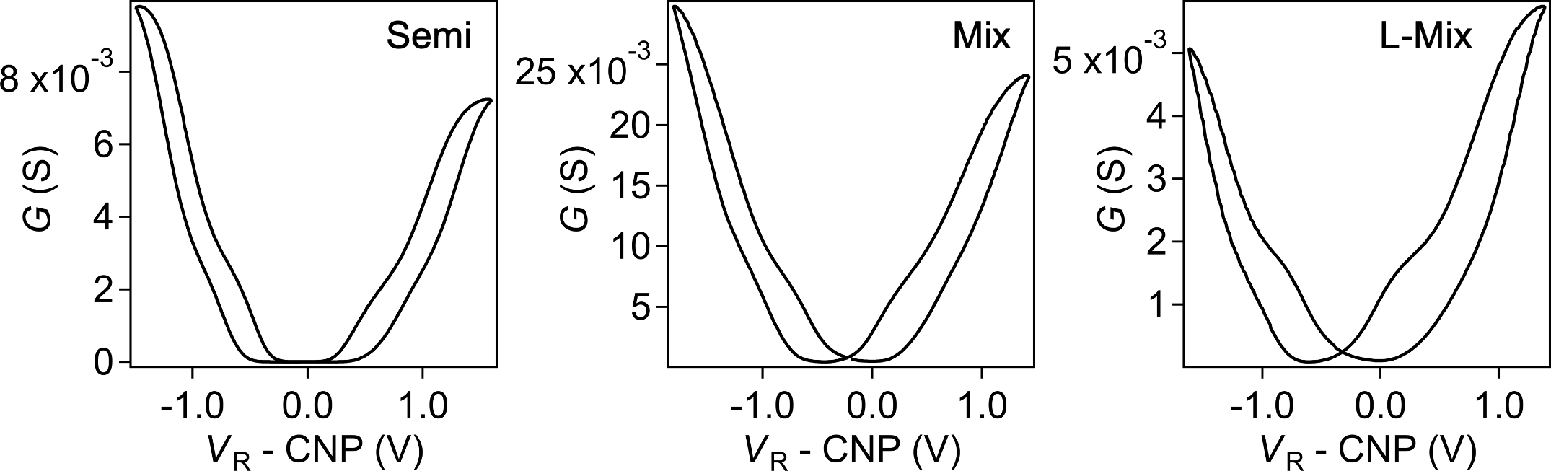
Fig. 2. Transfer characteristics of the various SWCNT thin film devices. Channel conductance (G) is plotted as a function of the reference voltage (V_{R}). Data for the Semi (left), Mix (center), L-Mix (right) samples are shown. The data were measured at room temperature.

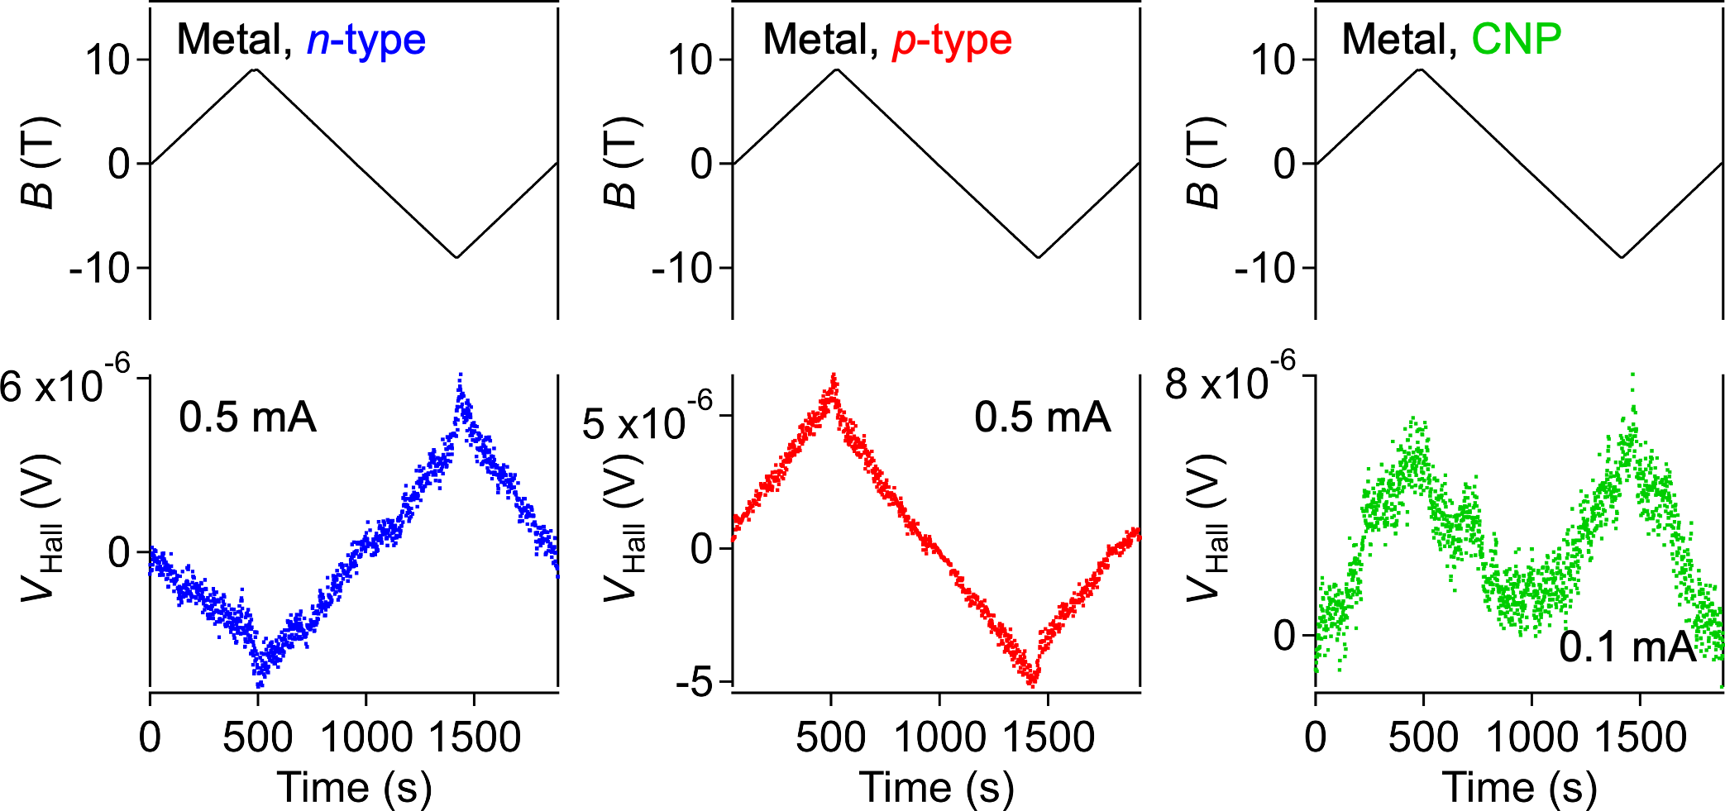
Fig. 3. Hall voltage (V_{Hall}) of the Metal sample, plotted as a function of the time. Data at 200 K in the n-type region (V_{R} - CNP = 1.65 V) (left), in the p-type region (V_{R} - CNP = -1.56 V) (center), and at the charge neutral point (CNP) (right) are shown along with the magnetic field profile (black line).

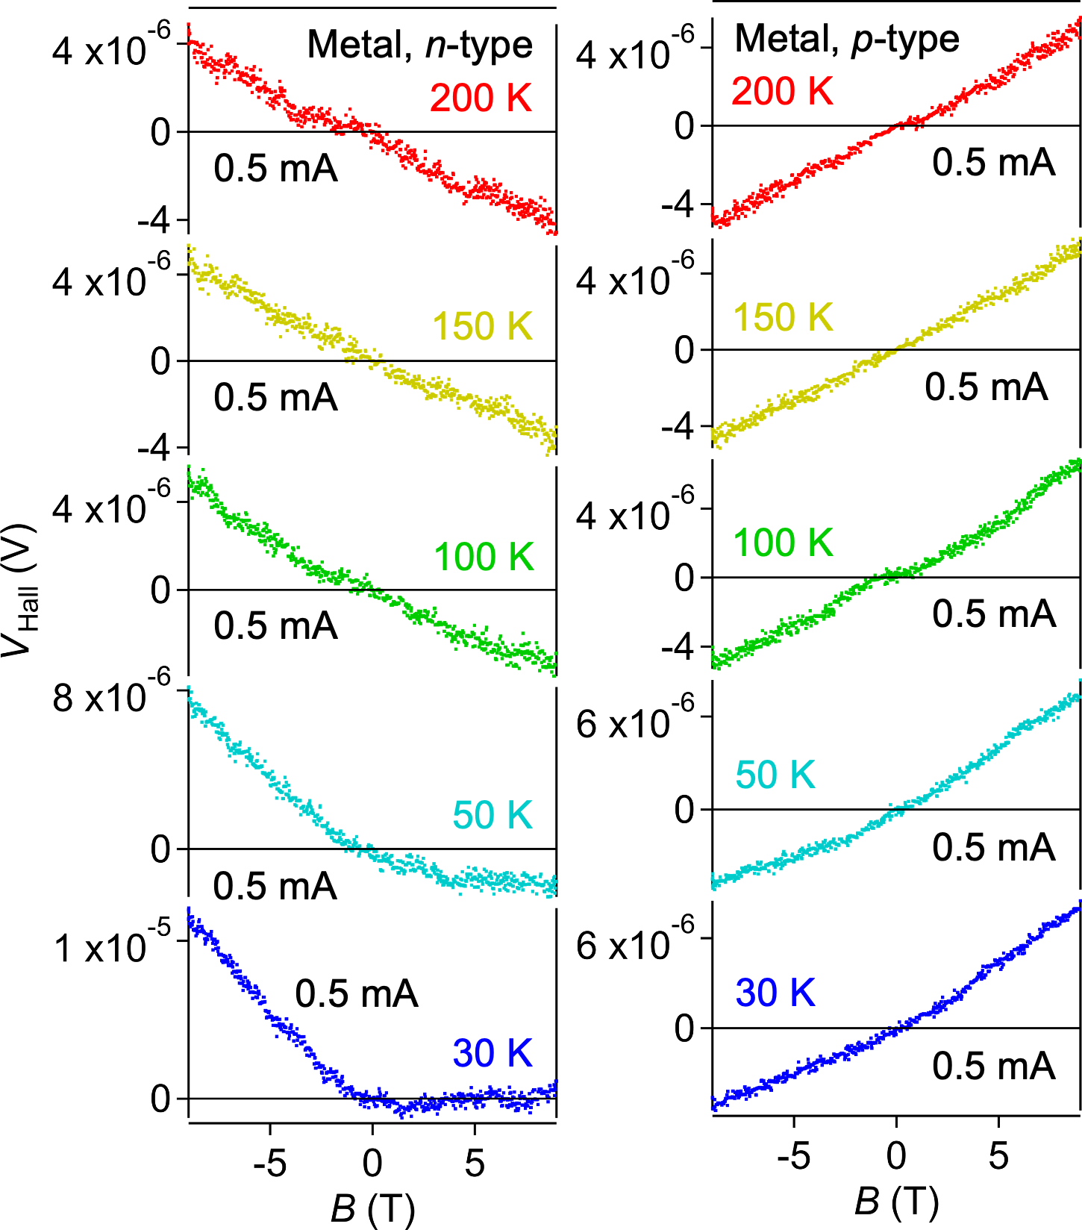
Fig. 4. Hall voltage (V_{Hall}) at different temperatures for the Metal devices, plotted as a function of the magnetic field (B). Data in the n-type region (V_{R} - CNP = 1.65 V) (left) and the p-type region (V_{R} - CNP = -1.56 V) (right) are shown.

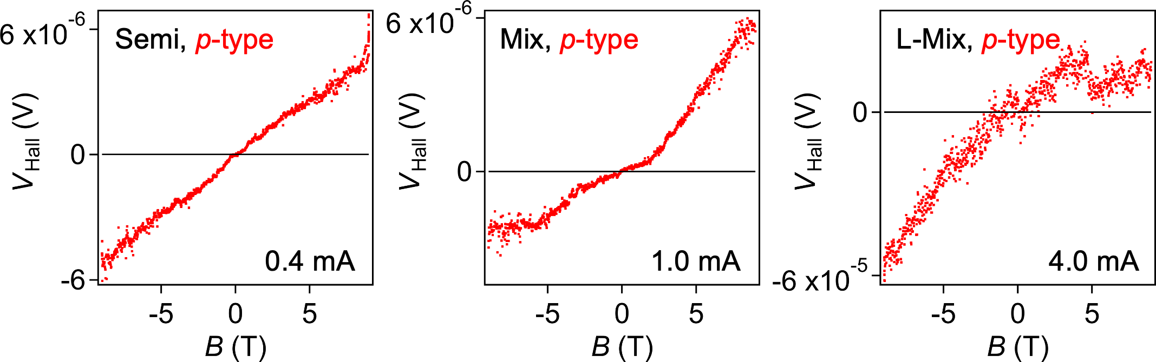
Fig. 5. Hall voltage (V_{Hall}) of the various SWCNT thin film devices in the p-type region, plotted as a function of the magnetic field (B). Data at 200 K for the Semi (V_{R} - CNP = -1.33 V) (left), Mix (V_{R} - CNP = -1.35 V) (center), L-Mix samples (V_{R} - CNP = -0.99 V) (right) are shown.

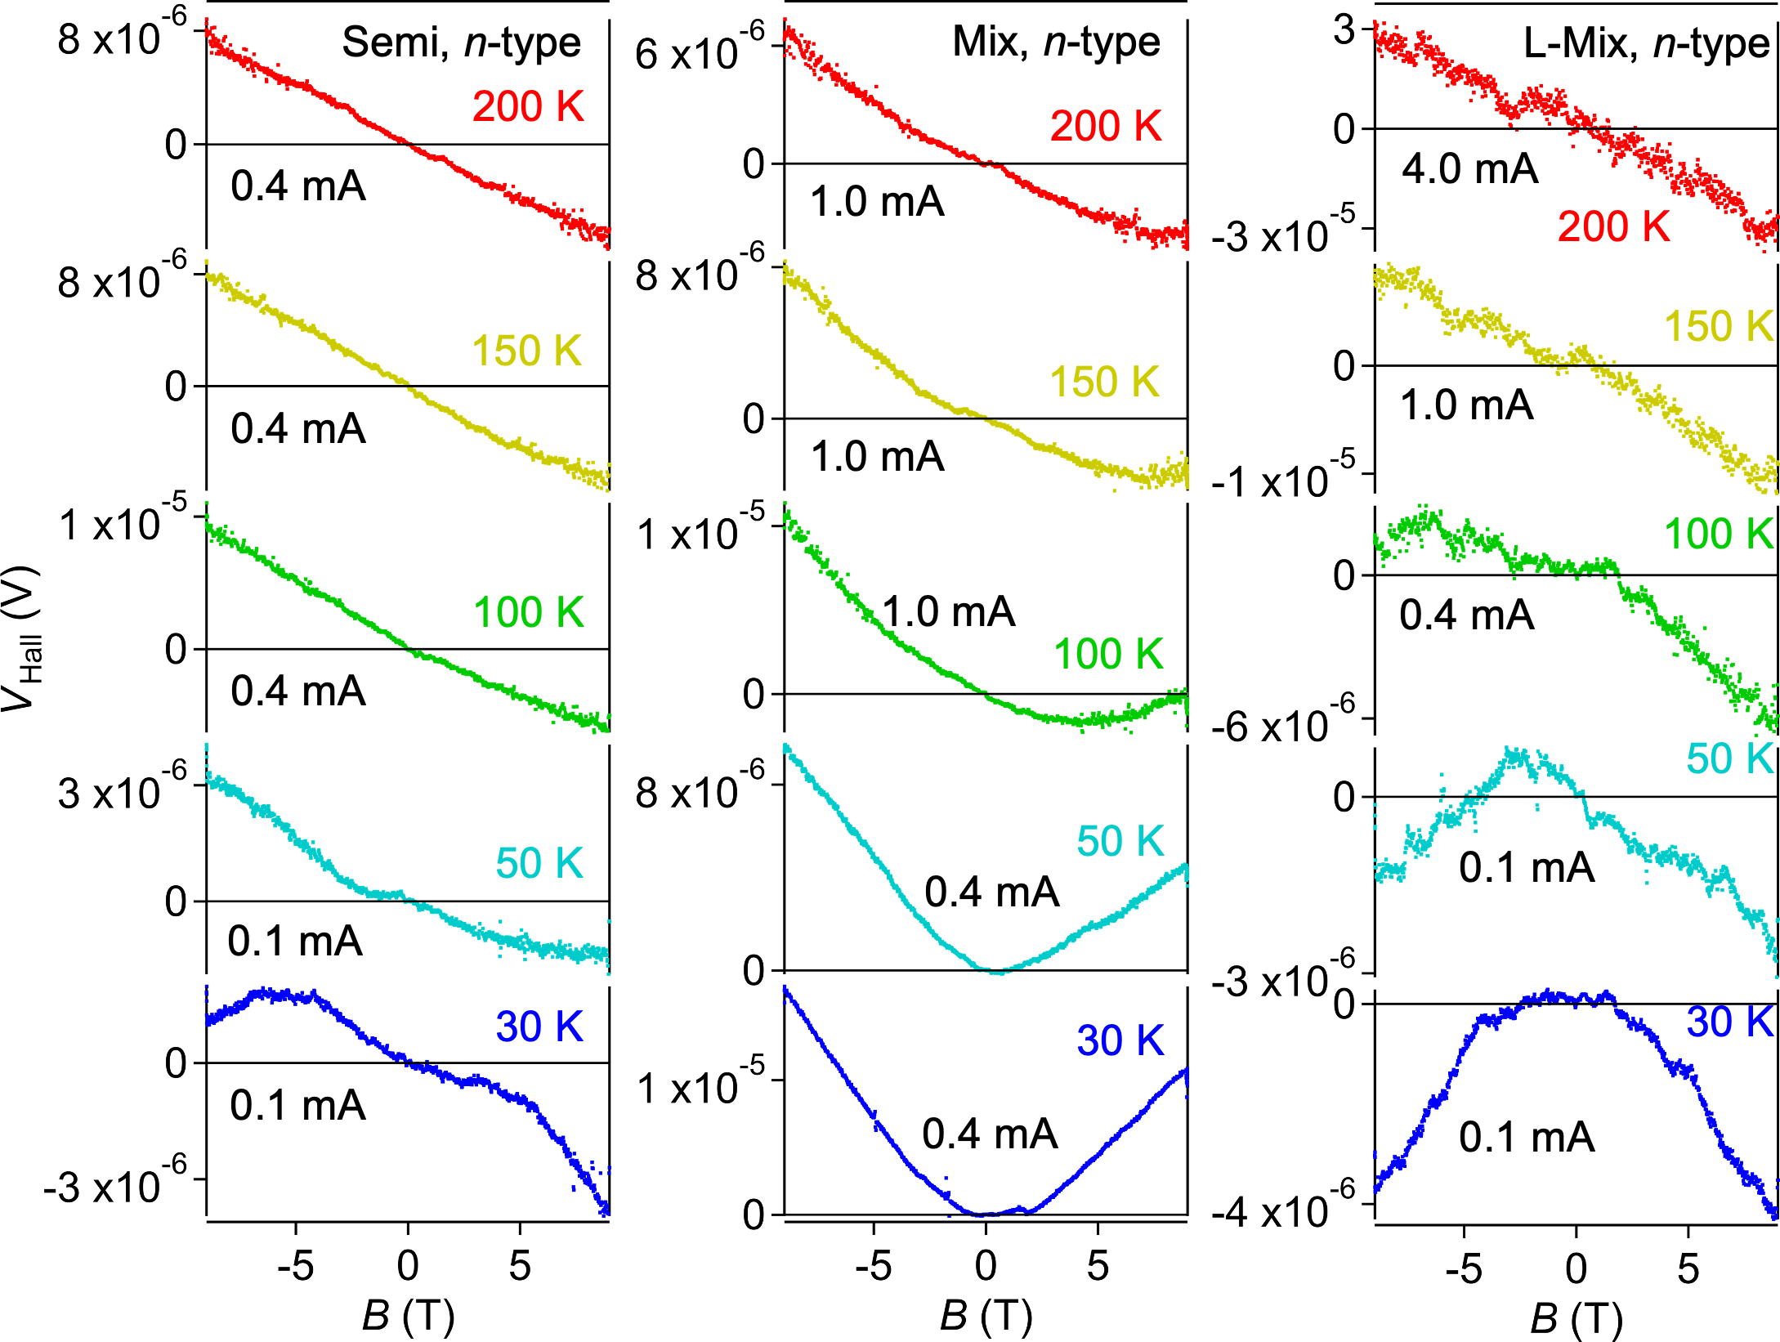
Fig. 6. Hall voltage (V_{Hall}) at different temperatures for the various SWCNT thin film devices, plotted as a function of the magnetic field (B). Data in the n-type region for the Semi (V_{R} - CNP = 1.60 V) (left), Mix (V_{R} - CNP = 1.43 V) (center), and L-Mix samples (V_{R} - CNP = 1.39 V) (right) are shown.

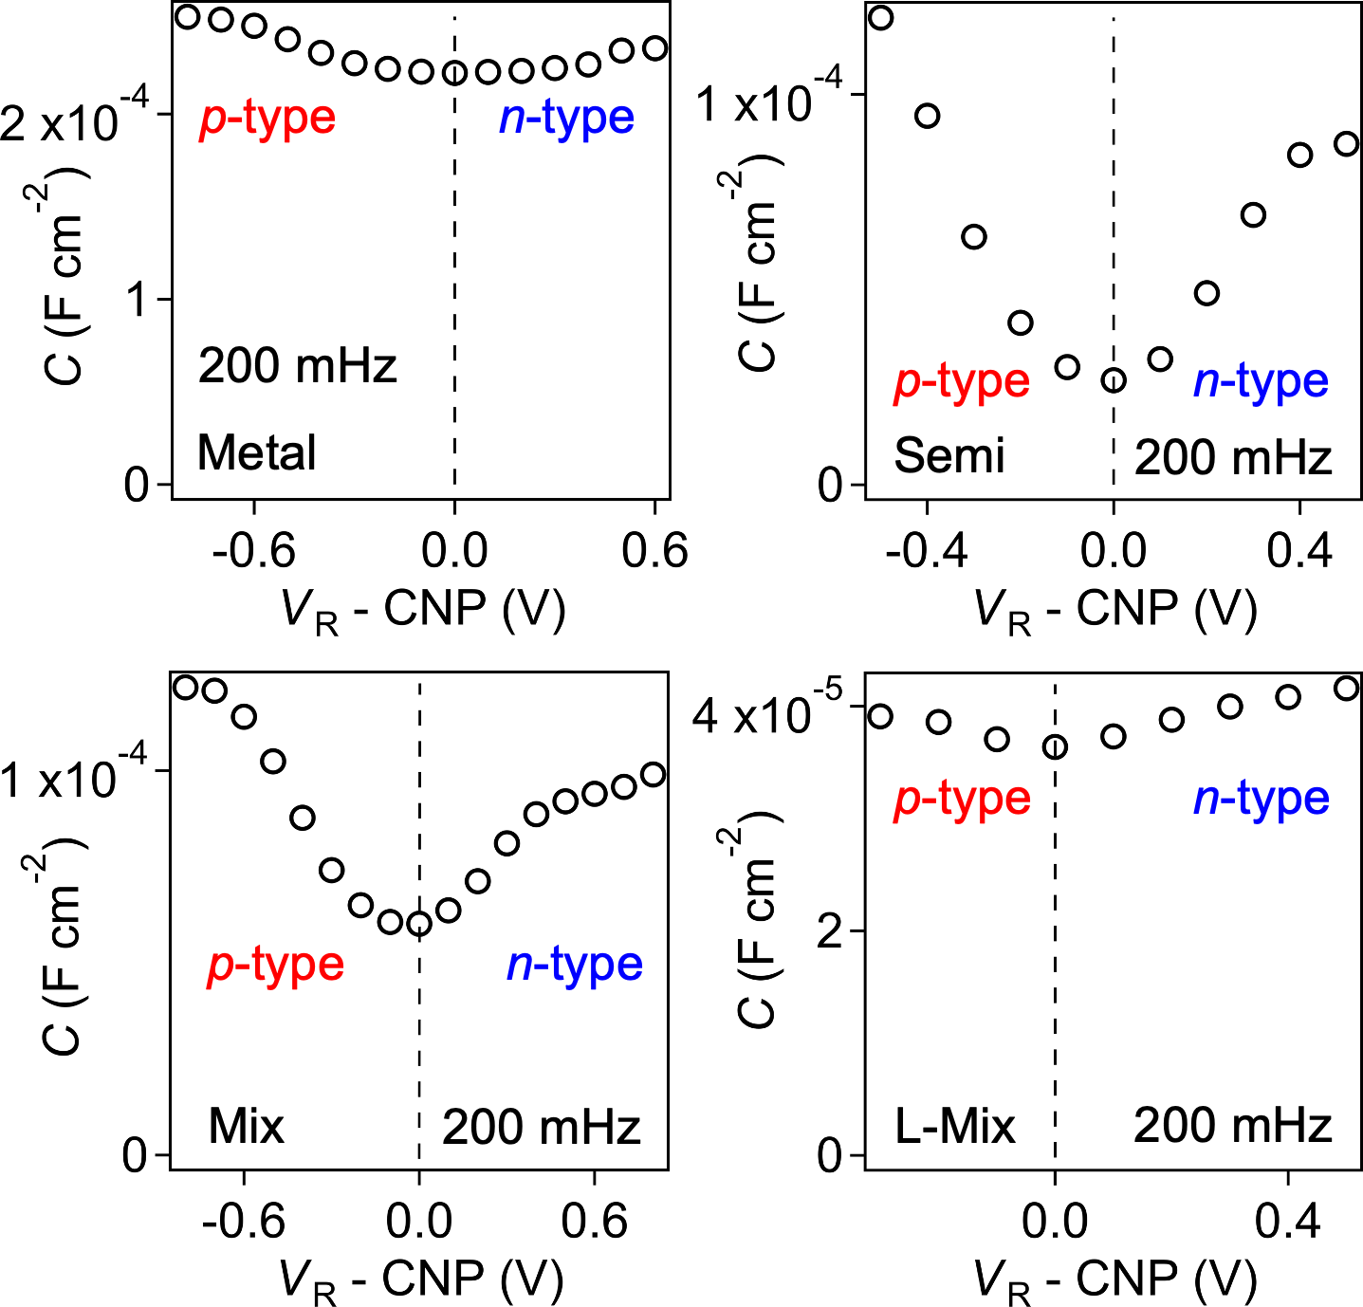
Fig. 7. Specific capacitance (c_{FET}) of the various SWCNT thin film devices, plotted as a function of the reference voltage (V_{R}). Data for the Metal (top, left), Semi (top, right), Mix (bottom, left), L-Mix samples (bottom, right) are shown. The frequency in the measurements is also shown.

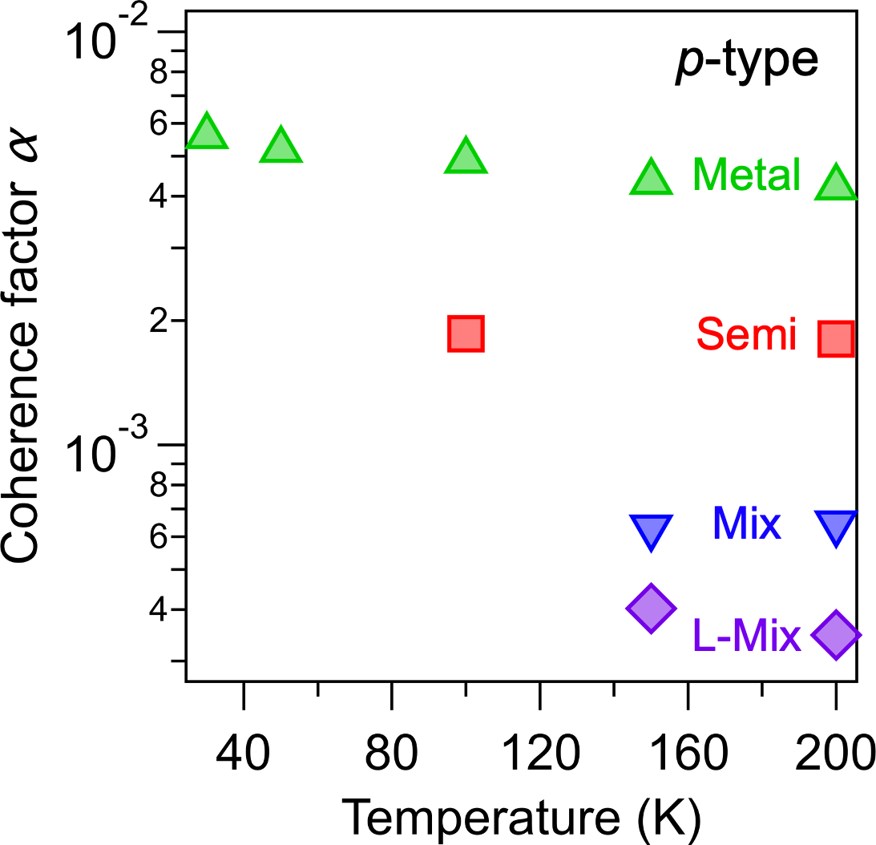
Fig. 8. Coherence factor (α) of the various SWCNT thin film devices in the p-type region, plotted as a function of the temperature. Data for the Metal (green), Semi (red), Mix (blue), and L-Mix samples (purple) are shown.

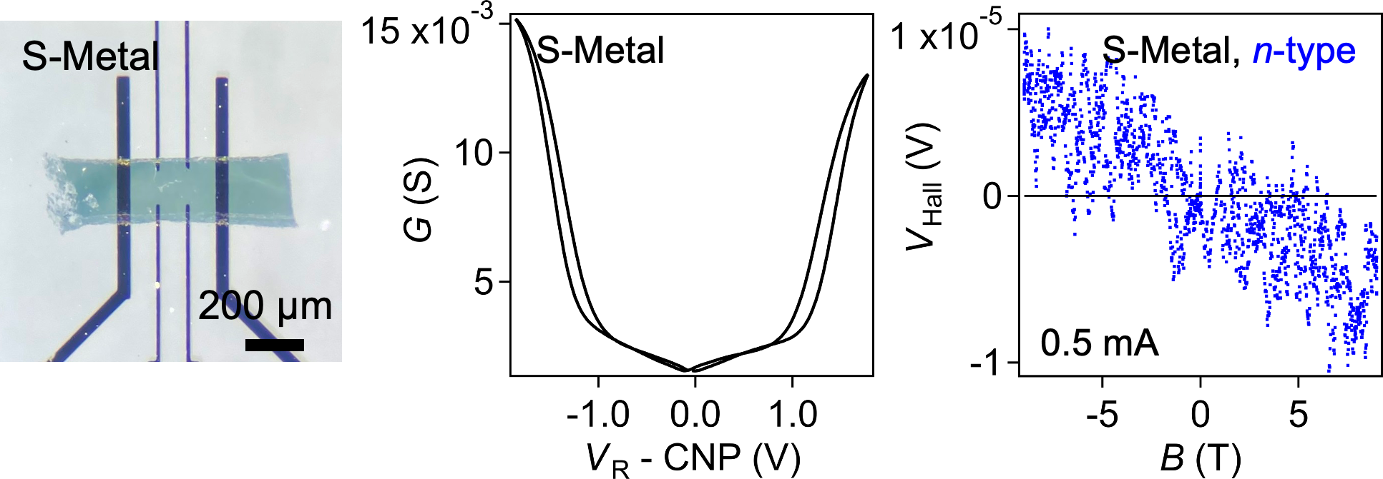
Fig. 9. Optical microscopy images of the Metal sample with small size (S-Metal) (left). Transfer characteristics of the S-Metal sample (center). Channel conductance (G) is plotted as a function of the reference voltage (V_{R}). Hall voltage (V_{Hall}) of the S-Metal sample (right), plotted as a function of the magnetic field (B). Data at 50 K in the n-type region (V_{R} - CNP = 1.52 V) are shown. The coherence factor is estimated to be 4.5 × 10⁻³, which is comparable to the value of 4.0 × 10⁻³ at 50 K for the Metal sample.

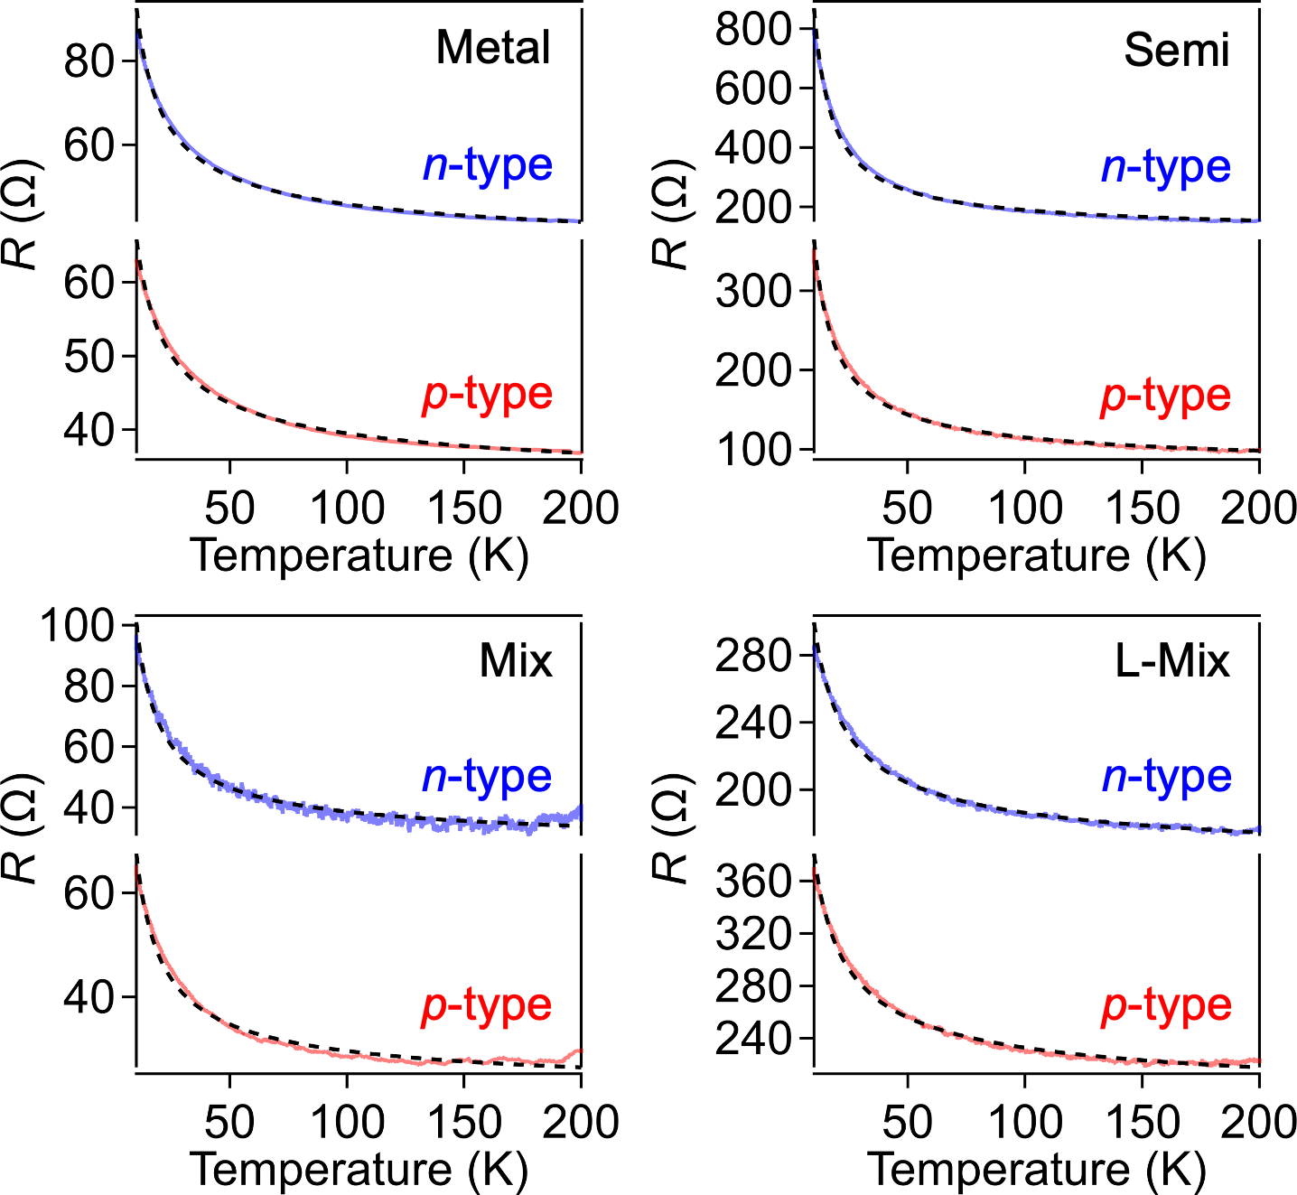
Fig. 10. Temperature dependence of channel resistance (R) of the various SWCNT thin film devices in the n-type region (blue) and the p-type region (red). Data for the Metal (V_{R} - CNP = 1.65 V, -1.56 V) (top, left), Semi (V_{R} - CNP = 1.60 V, -1.33 V) (top, right), Mix (V_{R} - CNP = 1.43 V, -1.35 V) (bottom, left), and L-Mix samples (V_{R} - CNP = 1.39 V, -0.99 V) (bottom, right) are shown. All data were analyzed using the following variable range hopping (VRH) model, $R=R_{0}\exp\left[-{\left({T_{0}}/T\right)}^{1/{\left(d+1\right)}}\right]$, where d is 1, 2, or 3. All data were well reproduced using the VRH model with d = 2 (dotted lines).

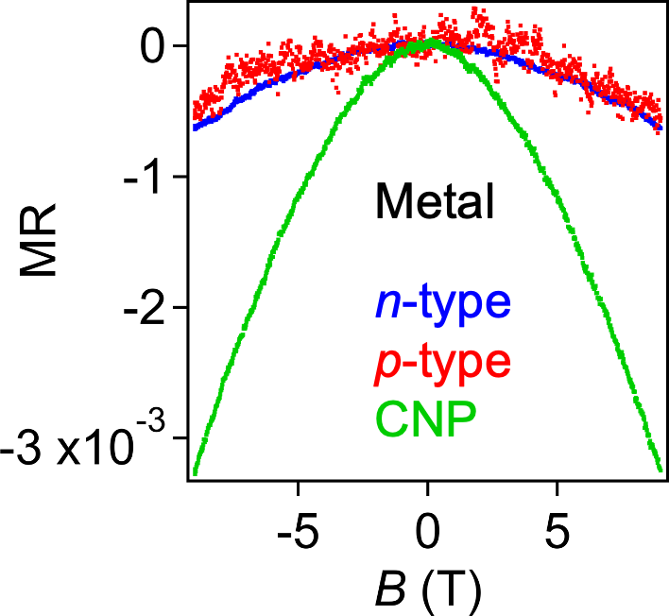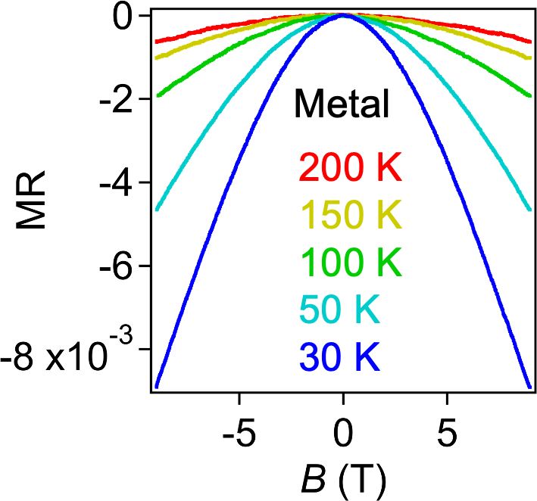
Fig. 11. Magnetoresistance ((R(B)-R(0))/R(0)) of the Metal sample in different carrier density regions (left) and different temperature regions (right). (left) Data at 200 K in the n-type region (V_{R} - CNP = 1.65 V) (blue), in the p-type region (V_{R} - CNP = -1.56 V) (red), and at the charge neutral point (CNP) (green) are shown. (right) Data in the n-type region (V_{R} - CNP = 1.65 V) are shown. All data show the negative magnetoresistance.

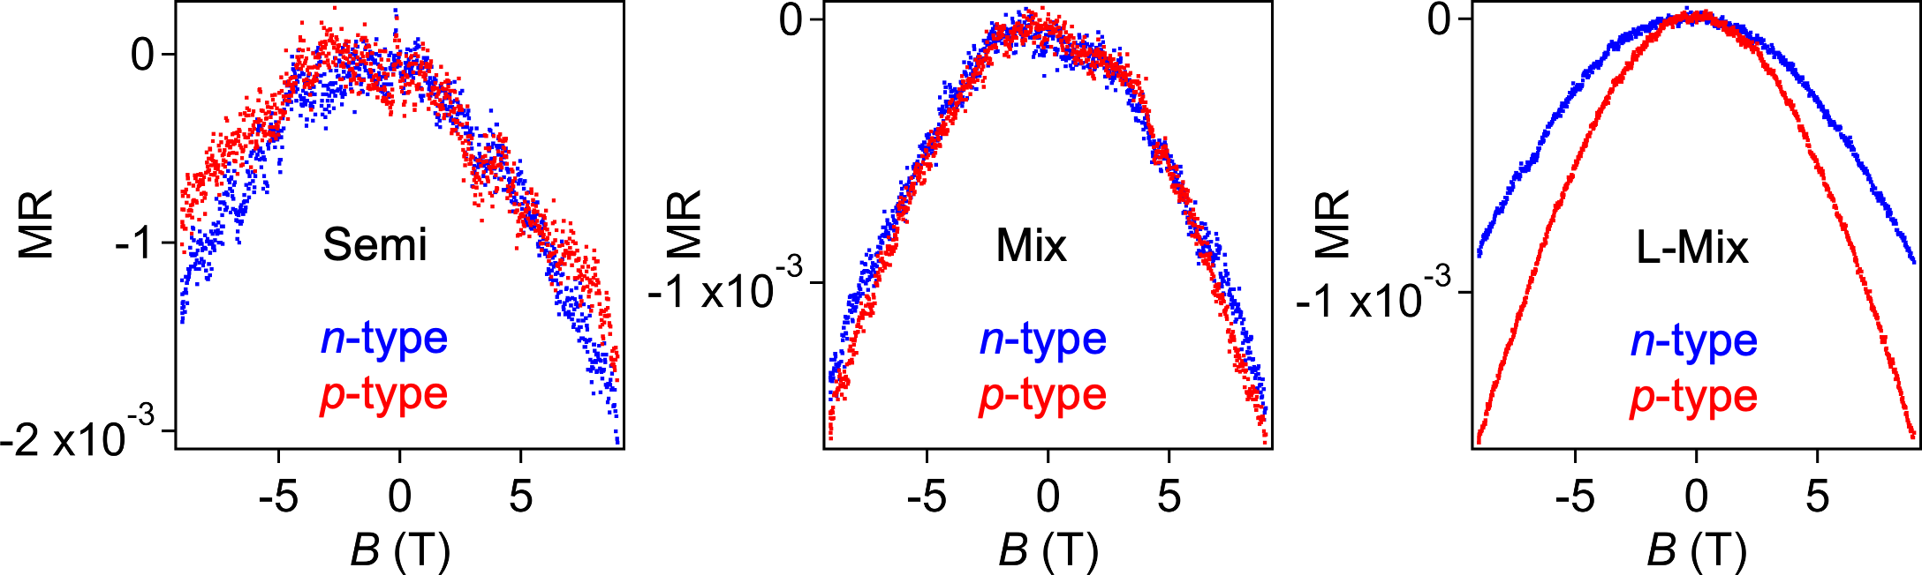
Fig. 12. Magnetoresistance ((R(B)-R(0))/R(0)) of the various SWCNT thin film devices in the n-type region (blue line) and the p-type region (red line). Data at 200 K for the Semi (V_{R} - CNP = 1.60 V, -1.33 V) (left), Mix (V_{R} - CNP = 1.43 V, -1.35 V) (center), and L-Mix samples (V_{R} - CNP = 1.39 V, -0.99 V) (right) are shown. All data show the negative magnetoresistance.

Table 1. Hall carrier density (n_{Hall}), FET carrier density (n_{FET}), and coherence factor (α) of the various SWCNT thin film devices. Data at 200 K are shown.
Types | Samples | V_{R} - CNP (V) | n_{FET} (cm⁻²) | n_{Hall} (cm⁻²) | α
n-type | Metal | 1.68 | 2.4 × 10¹⁵ | 7.0 × 10¹⁷ | 3.4 × 10⁻³
n-type | Semi | 1.60 | 7.8 × 10¹⁴ | 3.1 × 10¹⁷ | 2.5 × 10⁻³
n-type | Mix | 1.43 | 7.9 × 10¹⁴ | 1.1 × 10¹⁸ | 7.1 × 10⁻⁴
n-type | L-Mix | 1.39 | 3.5 × 10¹⁴ | 7.5 × 10¹⁷ | 4.7 × 10⁻⁴
p-type | Metal | -1.56 | 2.3 × 10¹⁵ | 5.6 × 10¹⁷ | 4.2 × 10⁻³
p-type | Semi | -1.33 | 7.8 × 10¹⁴ | 4.3 × 10¹⁷ | 1.8 × 10⁻³
p-type | Mix | -1.35 | 9.0 × 10¹⁴ | 1.4 × 10¹⁸ | 6.4 × 10⁻⁴
p-type | L-Mix | -0.99 | 2.4 × 10¹⁴ | 6.9 × 10¹⁷ | 3.4 × 10⁻⁴

