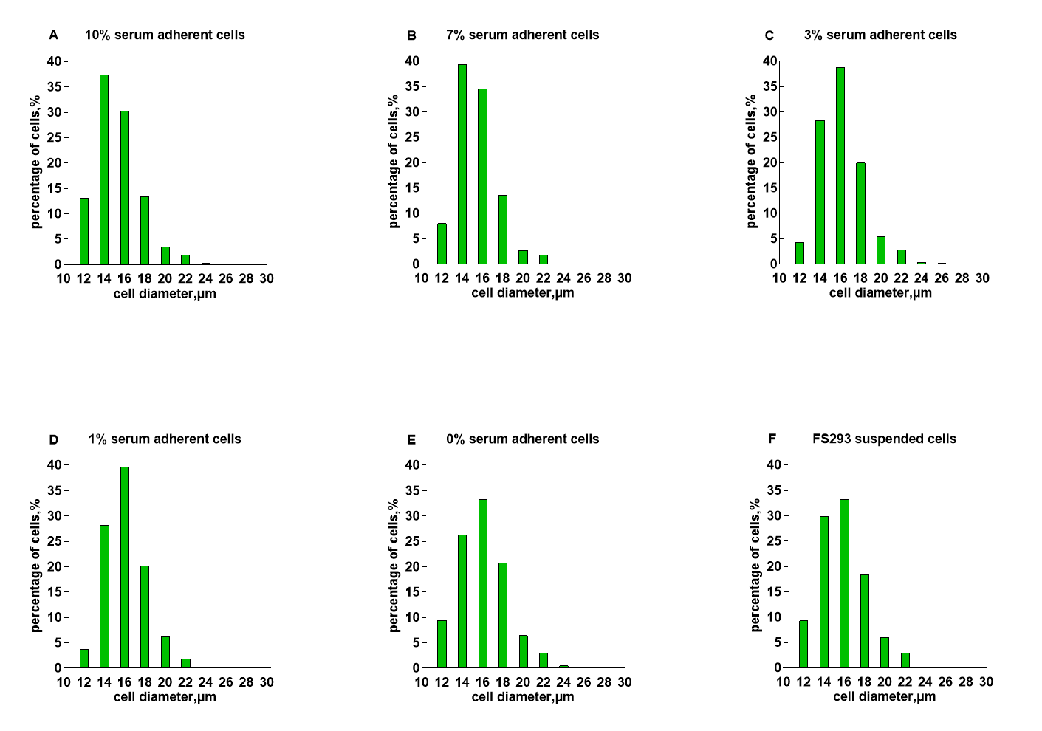
Supplementary Figure 1. Cell diameter distribution of different cells. All cells were collected and measured in the logistic growth phase. Fig.1A, adherent cells in complete DMEM containing 10% FBS. Fig.1B, adherent cells in 70% complete DMEM/30%SCM (7%FBS). Fig.1C, adherent cells in 30% complete DMEM/70%SCM (3%FBS). Fig.1D, adherent cells in 10% complete DMEM/90%SCM (1%FBS). Fig.1E, adherent cells in 1000%SCM (0%FBS). Fig.1F, suspension-adapted cells in serum-free SCM.

