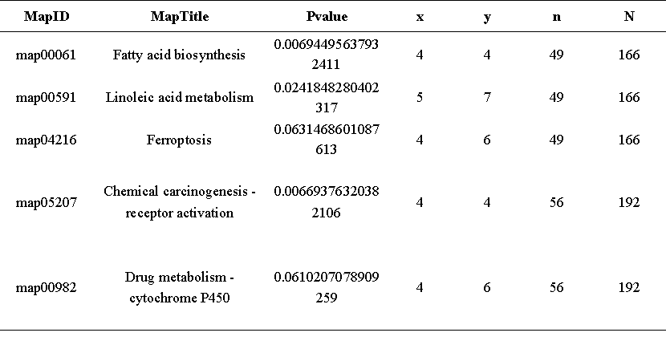
Table.1. Altered metabolic pathways between suspension-adapted cells and parental adherent cells by KEGG enrichment. MapID, the ID of the enriched KEGG pathway; MapTitle, the name of the enriched KEGG pathway; Pvalue, the P-value of the enrichment analysis; x, the number of differentially expressed metabolites associated with this pathway; y, the number of background (all) metabolites associated with this pathway; n, the number of KEGG-annotated differentially expressed metabolites; N, the number of KEGG-annotated background (all) metabolites.

