Table S1: Health risk assessment factors including reference values.
 |  |  | Unit | Adults |  | Children |  | References
Ingestion rate (IR) |  |  | L/day | 2 |  | 0.64 |  | Wang et al., (2017); Xiao et al., (2019); Siddique et al., (2021)
Exposure frequency (EF) |  |  | days/year | 350 |  | 350 |  | Xiao et al., (2019); Siddique et al., (2021)
Exposed skin area (SA) |  |  | cm² | 18000 |  | 6600 |  | Xiao et al., (2019); Siddique et al., (2021)
Exposure time (ET) |  |  | h/day | 0.58 |  | 1.0 |  | Wang et al., (2017); Siddique et al., (2021)
Exposure duration (ED) |  |  | years | 70 |  | 6 |  | USEPA, (2004); Xiao et al., (2019)
Body weight (BW) |  |  | kg | 70 |  | 15 |  | Saha et al., (2017); Siddique et al., (2021)
Average time for non-carcinogens (AT) |  |  | days | 25550 |  | 2190 |  | USEPA, (2004); Xiao et al., (2019)

Element | Gastrointestinal absorption factor (Abs_{g} in %) | References | Dermal permeability  coefficient (K_{p} in cm/h) | References
Cr | 3.8 | Wang et al., (2017); Xiao et al., (2019) | 3.00×10⁻³ | USEPA, (2004)
Mn | 6 | Wang et al., (2017); Xiao et al., (2019) | 1.00×10⁻³ | USEPA, (2004)
Fe | 1.4 | Wang et al., (2017); Xiao et al., (2019) | 1.00×10⁻³ | USEPA, (2004)
Co | 20 | Rodriguez-Proteau and Grant, (2005) | 4.00×10⁻³ | Zeng et al., (2015)
Ni | 4 | Wang et al., (2017); Xiao et al., (2019) | 4.00×10⁻³ | Zeng et al., (2015)
Cu | 57 | Wang et al., (2017); Xiao et al., (2019) | 1.00×10⁻³ | USEPA, (2004)
Zn | 20 | Wang et al., (2017); Xiao et al., (2019) | 6.00×10⁻⁴ | USEPA, (2004)
As | 95 | Wang et al., (2017); Xiao et al., (2019) | 1.00×10⁻³ | USEPA, (2004)
Cd | 5 | Wang et al., (2017); Xiao et al., (2019) | 1.00×10⁻³ | USEPA, (2004)
Hg | 7 | USEPA, (2004); Qu et al., (2018) | 1.00×10⁻³ | Qu et al., (2018)
Pb | 11.7 | Wang et al., (2017); Xiao et al., (2019) | 1.00×10⁻³ | Zeng et al., (2015)

 | R_{f}D_{ingestion} | R_{f}D_{dermal} | References |  |  |  | Oral cancer slope factor (SF) (µg/kg/day)⁻¹ |  |  | References
 | (µg.kg⁻¹.day⁻¹) | (µg.kg⁻¹.day⁻¹) |  |  |  |  | Ingestion | Dermal
Cr | 3 | 0.075 |  |  |  |  | 0.0005 |  |  | USEPA, 2011
Mn | 24 | 0.96
Fe | 700 | 140
Co | 0.3 | 0.06
Ni | 20 | 0.8 | Wang et al., (2017) |  |  |  | 0.00091 |  |  | CALEPA; Zeng et al., (2015)
Cu | 40 | 12
Zn | 300 | 60
As | 0.3 | 0.285 |  |  |  |  | 0.0015 | 0.00366 |  | Fakhri et al., (2018)
Cd | 0.5 | 0.025 |  |  |  |  | 0.0063 |  |  | Saha et al., 2017; USEPA, 2010
Hg | 0.3 | 0.021 | EPA (1993), Fakhri et al.,(2018)
Pb | 1.4 | 0.42 | Xiao et al., (2019) |  |  |  | 0.0085 |  |  | Fakhri et al., (2018); Luo et al., 2012

Table S2: Varimax rotated factor loadings and communalities of the analyzed chemical elements (strong loadings are in bold face).
Parameters | PC1 | PC2 | PC3 | PC4 | PC5 | Communalities
Cr | -0.124 | 0.830 | -0.046 | 0.084 | 0.140 | 0.733
Mn | 0.119 | -0.105 | 0.672 | -0.218 | 0.450 | 0.726
Fe | -0.366 | -0.129 | 0.717 | 0.023 | -0.093 | 0.674
Co | -0.264 | -0.347 | 0.123 | 0.082 | -0.678 | 0.671
Ni | -0.282 | 0.772 | -0.059 | -0.055 | -0.218 | 0.731
Cu | 0.100 | 0.015 | 0.077 | 0.837 | -0.003 | 0.717
Zn | -0.116 | -0.003 | -0.147 | 0.801 | 0.051 | 0.679
As | 0.719 | -0.195 | -0.015 | 0.022 | 0.079 | 0.562
Cd | -0.095 | -0.384 | 0.002 | 0.227 | 0.655 | 0.637
Hg | 0.858 | -0.129 | 0.019 | -0.044 | 0.023 | 0.755
Pb | 0.368 | 0.101 | 0.674 | 0.036 | -0.348 | 0.722
Eigenvalue | 2.187 | 1.623 | 1.463 | 1.208 | 1.125
% of total variance | 15.759 | 14.962 | 13.353 | 13.284 | 11.787
Cumulative % of variance | 15.759 | 30.721 | 44.074 | 57.358 | 69.145

Table S3: Varimax rotated factor loadings and communalities of sampling sites (strong loadings are in bold face).
Sampling Sites | PC1 | PC2 | Communalities | Sampling Sites | PC1 | PC2 | Communalities
W1 | 0.959 | 0.280 | 0.998 | W18 | 0.958 | 0.285 | 0.999
W2 | 0.955 | 0.296 | 0.999 | W19 | 0.962 | 0.270 | 0.999
W3 | 0.964 | 0.263 | 0.999 | W20 | 0.958 | 0.276 | 0.995
W4 | 0.938 | 0.333 | 0.991 | W21 | 0.953 | 0.303 | 0.999
W5 | 0.916 | 0.386 | 0.989 | W22 | 0.924 | 0.379 | 0.997
W6 | 0.904 | 0.426 | 0.997 | W23 | 0.946 | 0.323 | 0.998
W7 | 0.942 | 0.333 | 0.999 | W24 | 0.962 | 0.269 | 0.999
W8 | 0.919 | 0.391 | 0.998 | W25 | 0.959 | 0.282 | 1.000
W9 | 0.946 | 0.322 | 0.999 | W26 | 0.960 | 0.230 | 0.975
W10 | 0.961 | 0.274 | 0.999 | W27 | 0.076 | 0.996 | 0.998
W11 | 0.946 | 0.324 | 0.999 | W28 | 0.945 | 0.302 | 0.985
W12 | 0.887 | 0.449 | 0.988 | W29 | 0.935 | 0.348 | 0.996
W13 | 0.960 | 0.277 | 0.998 | W30 | 0.579 | 0.812 | 0.994
W14 | 0.945 | 0.323 | 0.998 | W31 | 0.917 | 0.399 | 1.000
W15 | 0.922 | 0.379 | 0.994 | W32 | 0.961 | 0.275 | 0.999
W16 | 0.740 | 0.672 | 0.999 | W33 | 0.960 | 0.277 | 0.999
W17 | 0.930 | 0.364 | 0.997 | W34 | 0.945 | 0.311 | 0.990
Eigenvalue | 32.472 | 1.391
% of total variance | 83.774 | 15.825
Cumulative % of variance | 83.774 | 99.599

Table S4: Pearson correlation matrix for the analyzed chemical elements.
Parameters | Cr | Mn | Fe | Co | Ni | Cu | Zn | As | Cd | Hg | Pb
Cr | 1
Mn | -0.096 | 1
Fe | -0.077 | 0.222 | 1
Co | -0.151 | -0.109 | 0.196 | 1
Ni | 0.526** | -0.232 | -0.012 | 0.011 | 1
Cu | -0.022 | -0.122 | 0.068 | -0.014 | -0.025 | 1
Zn | 0.103 | -0.155 | -0.117 | 0.050 | -0.078 | 0.390* | 1
As | -0.144 | 0.071 | -0.104 | -0.072 | -0.271 | 0.076 | -0.122 | 1
Cd | -0.112 | 0.153 | -0.004 | -0.089 | -0.269 | 0.110 | 0.135 | 0.145 | 1
Hg | -0.183 | 0.155 | -0.220 | -0.143 | -0.318 | 0.025 | -0.107 | 0.474** | 0.004 | 1
Pb | -0.076 | 0.244 | 0.208 | 0.137 | -0.022 | 0.010 | -0.075 | 0.100 | -0.159 | 0.223 | 1
**. Correlation is significant at the 0.01 level (2-tailed).
*. Correlation is significant at the 0.05 level (2-tailed).

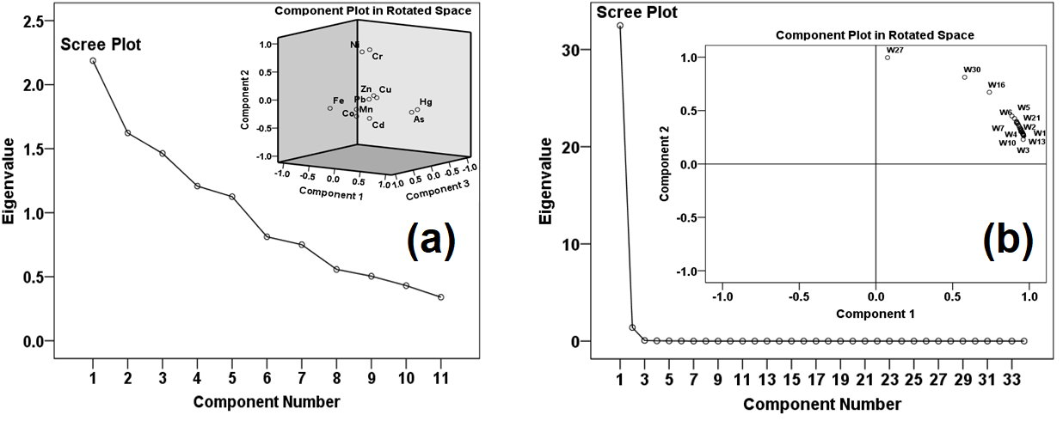

Fig. S1. (a) Principal component analysis (PCA) of the analyzed metal(oid)s by scree plot of the characteristic roots (eigenvalues) and component plot in rotated space and (b) PCA of the sampling sites by scree plot of the characteristic roots (eigenvalues) and component plot in rotated space.

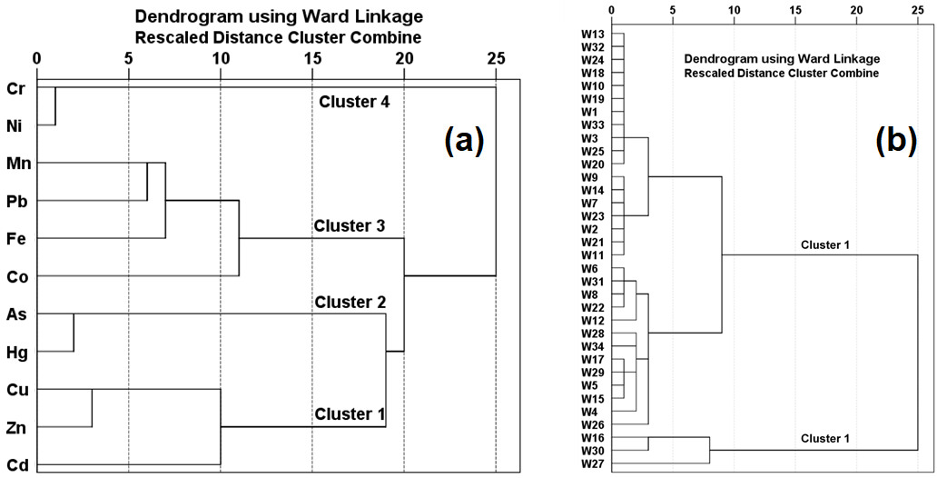

Fig. S2. (a) Dendrogram obtained by hierarchical clustering analysis for the analyzed chemical elements (R-mode) and (b) Dendrogram obtained by hierarchical clustering analysis for the sampling sites (Q-mode).

