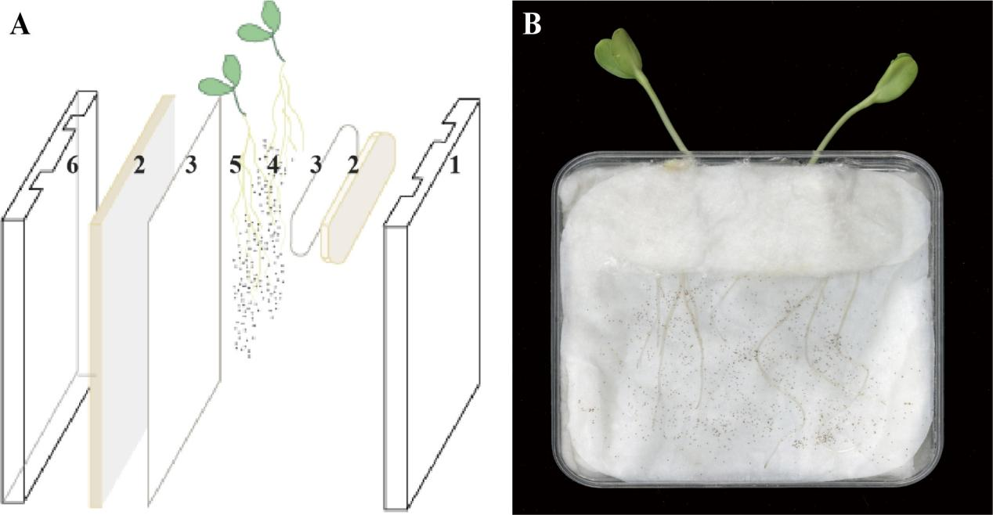
Supplementary Figure 1 Petri dish-filter paper system. (A) Establishment of Host-Nonhost Interaction System: (1) Cover of culture dish. (2) Defatted cotton. (3) Filter paper. (4) O. cumana seeds. (5) Sunflower seedlings. (6) Bottom of culture dish. (B) The interaction process between sunflower and O. cumana.
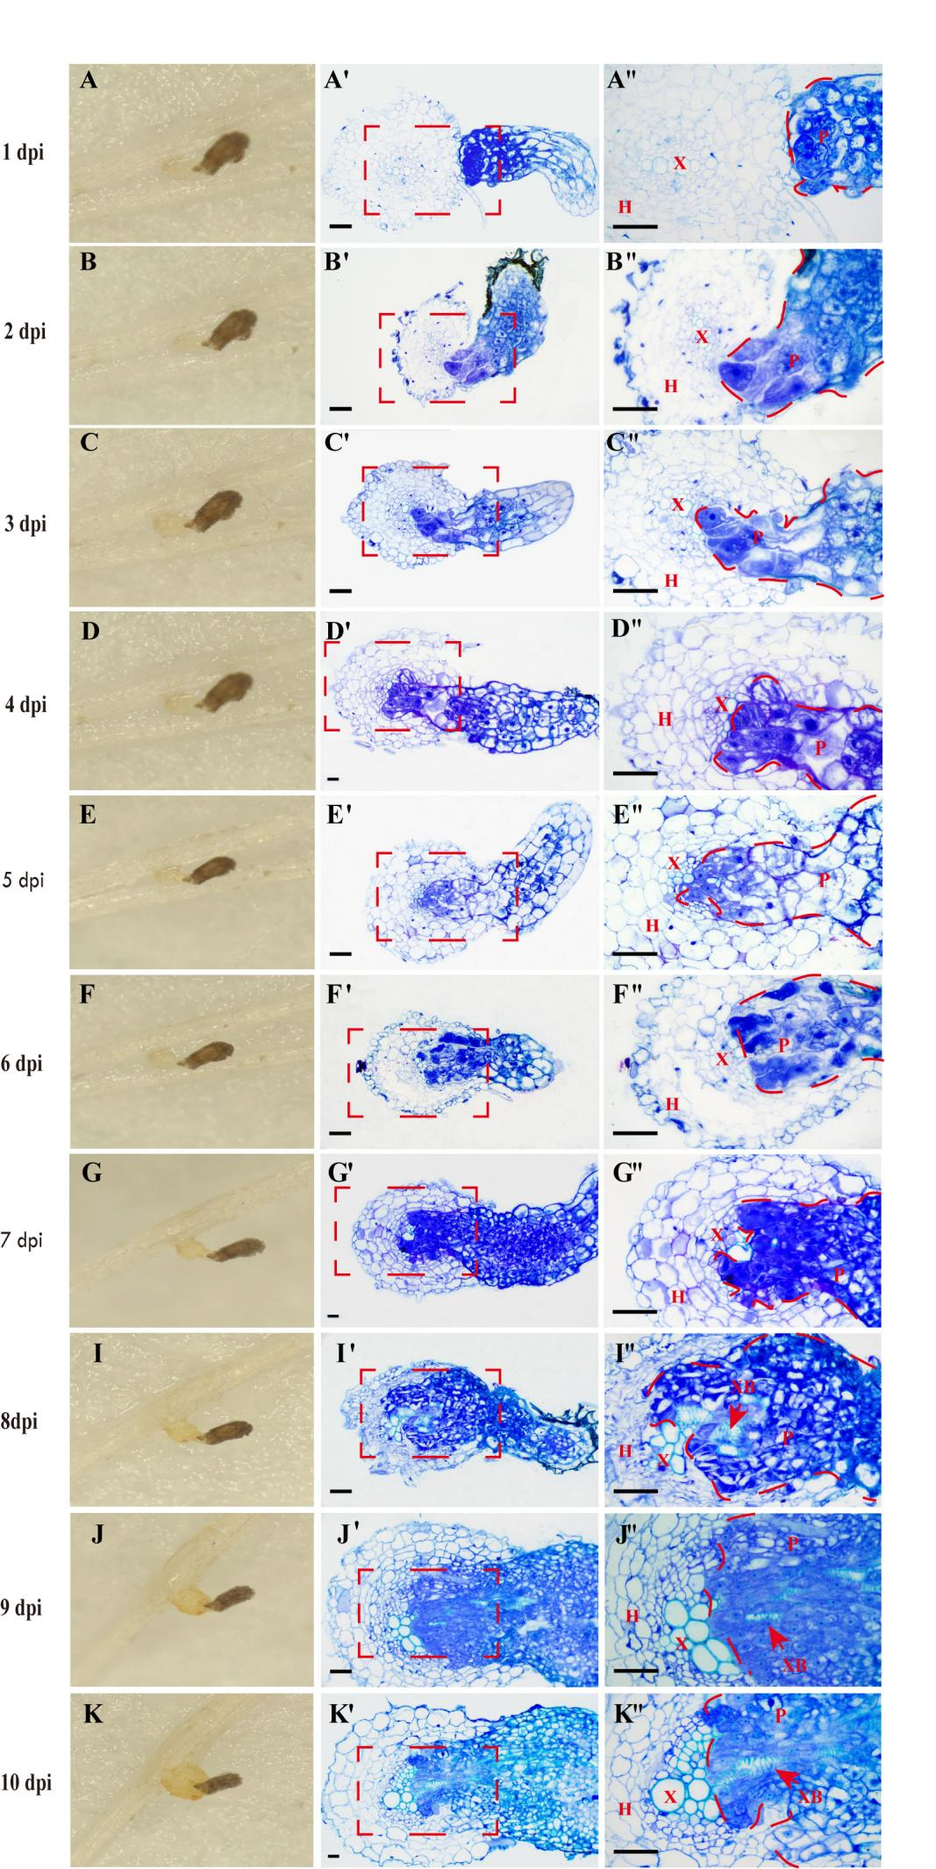
Supplementary Figure 2 Cytological Observation of Susceptible Host-Parasite Plant Interactions During Parasitization. Image panels: (A–K) Phenotypic images of the parasitic plant infecting the host plant. (A′–K′) 4× magnified semi-thin plastic sections. (A′′–K′′) 40× magnified views of red-oxed areas in (A′–K′). Staining: 0.05% toluidine blue. Labels: H, Host plant; P, Parasitic plant; X, Xylem; XB, Xylem bridge. All scale bars: 50 µm.

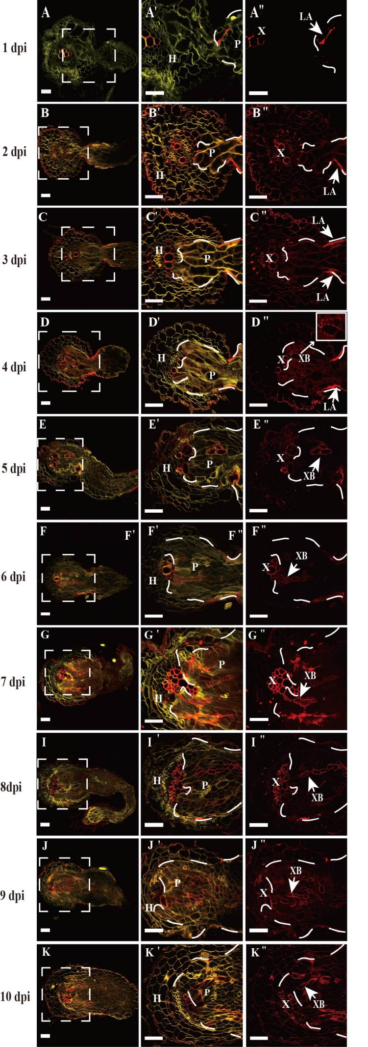
Supplementary Figure 3 Formation of Xylem Bridge During Parasitization of Susceptible Host-Nonhost. Staining: (A–K′) Direct Yellow for cell walls (yellow). (A–K′′) Basic Fuchsin for lignified xylem bridges (red). Image panels: (A–K) 4× confocal overlay images at different stages. (A′–K′) 40× confocal overlays of red-boxed areas in (A–K). (A′′–K′′) 40× Basic Fuchsin channel images of red-boxed areas. Abbreviations: H, Nonhost plant; P, Parasitic plant; LA, Lignin accumulation; X, Xylem; XB, Xylem bridge.
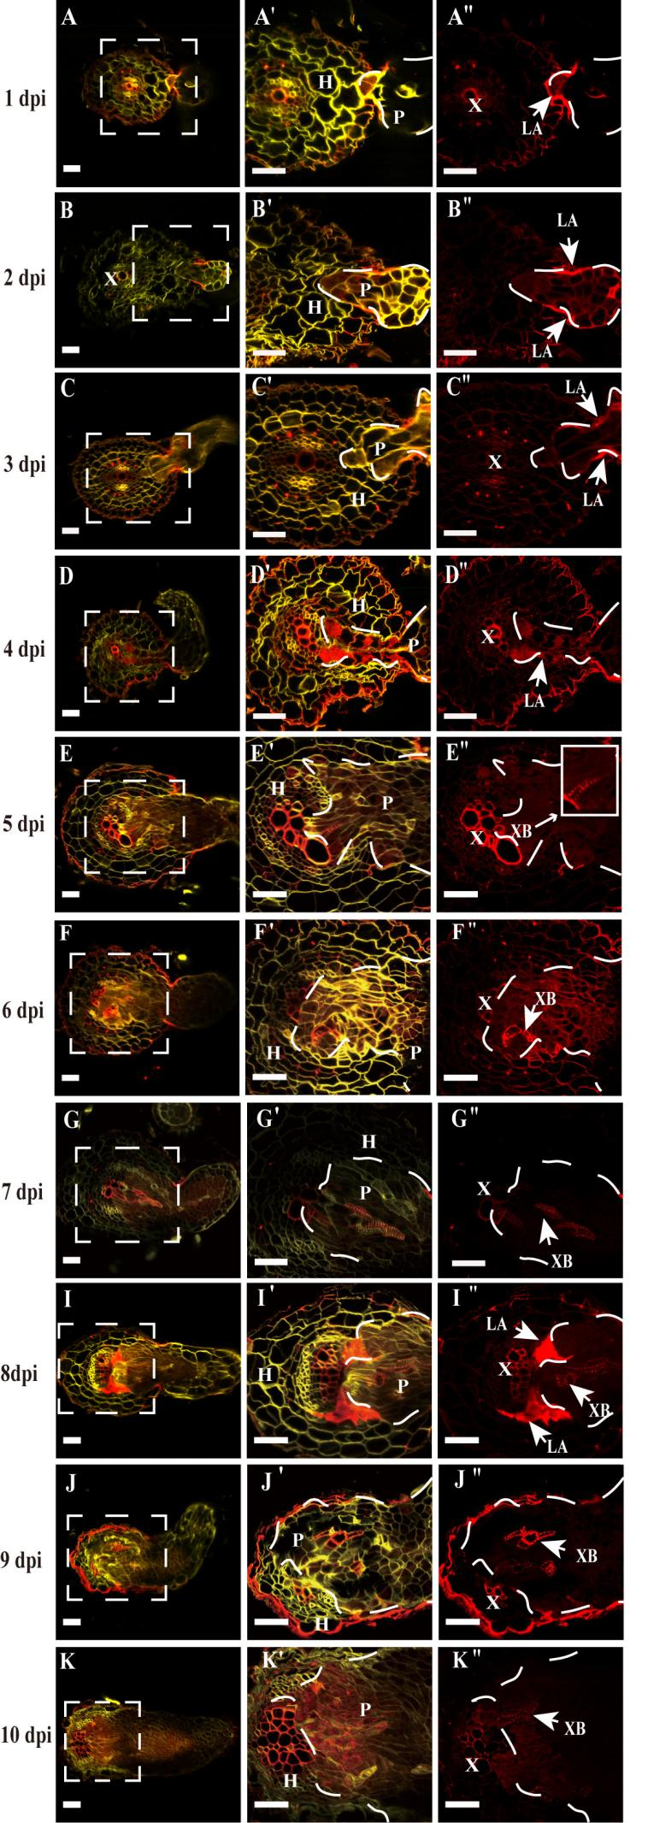
Supplementary Figure 4 Xylem Bridge Formation During Parasitization of Resistant Host-Nonhost Plants. Staining: (A–K′) show cell wall staining with Direct Yellow (yellow); (A–K′′) show lignified xylem bridge staining with Basic Fuchsin (red). Image panels: (A–K) 4× confocal overlay images at different time points. (A′–K′) 40× confocal overlays of white-boxed areas in (A–K). (A′′–K′′) 40× Basic Fuchsin channel images of white-boxed areas in (A–K). Abbreviations: X, Xylem; XB, Xylem bridge; LA, Lignin accumulation; H, Non-host plant; P, Parasitic plant. All scale bars: 50 μm.
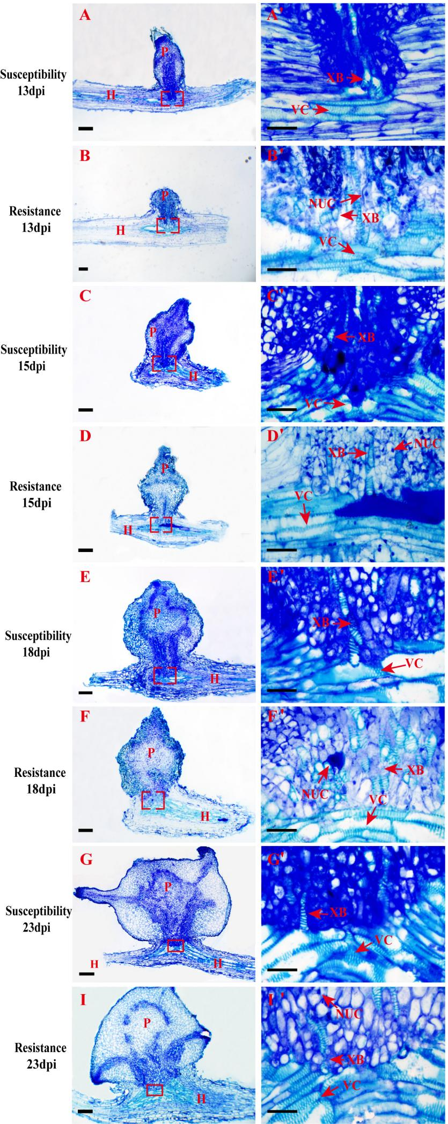
Supplementary Figure 5 Cytological and histological changes in resistant cultivar JK103 and susceptible cultivar LD5009 following O. cumana infection. (A–I) 4× magnified semi-thin plastic sections. (A′–I′) 40× magnified views of red-boxed areas in (A–I). Staining: 0.05% toluidine blue. Labels: XB, Xylem bridge; Nuc: Nucleus; VC: Vascular Connection (containing the xylem bridge and phloem bridge); H, Host plant; P, Parasitic plant; All scale bars: 50 µm.

