Supplementary Material For Review

Table of Contents
Tables………………………………………………………………………..……...1-7
Figures…………………………………………………………………………...…6-17

Table A1: Description of the Data Set
 | Obs. | Average | Std. Error | Max | Min
Type 1: Target dependent variable
Count of citizen who enter the USA and Canada by nationalities | 274678693 | 178362 | 446072.54 | 3585256 | 453
Count of citizen who enter the USA and Canada by continents | 309588100 | 690853 | 774529 | 3627292 | 3863

Table A2: Data Description of Dependent Variable by Nationalities
Region | Country | USA Avg (SE) | Canada Avg (SE)
Asia | India | 92,838 (30,291) | 18,866 (9,515)
 | Japan | 302,659 (38,962) | 25,378 (10,837)
 | South Korea | 162,860 (27,732) | 20,374 (10,022)
 | PRC (excl. HK) | 230,661 (71,267) | 50,255 (26,080)
 | Taiwan | 37,753 (7,831) | 7,739 (4,072)
South America | Argentina | 66,792 (11,784) | 1,820 (919)
 | Brazil | 155,986 (38,860) | 10,124 (3,964)
 | Columbia | 68,545 (18,496) | 2,434 (1,528)
North America | Canada | 1,682,519 (331,085) | -
 | Mexico | 1,517,435 (186,721) | 22,591 (12,127)
 | USA | - | 1,940,218 (790,189)
Europe | France | 138,894 (42,917) | 45,154 (24,290)
 | Germany | 175,117 (44,226) | 31,275 (18,800)
 | Ireland | 37,133 (8,250) | 5,119 (2,562)
 | Italy | 83,841 (27,138) | 11,318 (8,395)
 | Netherlands | 57,454 (19,603) | 11,143 (7,635)
 | Russia | 19,934 (4,143) | 1,877 (691)
 | Spain | 64,932 (18,055) | 7,268 (5,629)
 | Sweden | 46,002 (10,377) | 4,054 (1,304)
 | Switzerland | 40,038 (14,003) | 10,457 (6,883)
 | United Kingdom | 381,909 (91,229) | 67,215 (35,305)
Oceania | Australia | 114,421 (23,607) | 28,741 (14,183)

Table A3: Data Description of Dependent Variable by Continents
Continents | Average (Standard error) count of foreigners who enters USA | Average count (Standard error) of foreigners who enters Canada
Africa | 50,257 (31,720) | 10,123 (5,084)
Asia | 91,9671 (145,805) | 165,771 (75,966)
Middle East | 1,117,056(79,135) | 9,432 (5,400)
Latin America (Excluding Mexico) | 648,794 (104,836) | 37,110 (16,347)
Europe | 1,238,342 (266,315) | 237,560 (128,899)
Total Foreign | 7,177,746 (3,502,454) | 2,448,893 (1,047,850)

Table A4: Arithmetic Calculations of Raw Differences Between the United States and Canada in the Change in Foreigners Entering the United States Before and After the Election, Travel Ban, and Court Upholding Travel Ban (N=7,177,746)

Change in Entries After Event Minus Entries Before Event, Into Country | Total | Africa | Asia | Europe | Latin America (Excluding Mexico) | Middle East
Election, US | -1559338 | -32661 | -6093 | -61452 | -95627 | 1622
Election, Canada | 110467 | 767 | 15628 | 12602 | 6077 | 207
difference in difference (US minus Canada) | -1669806 | -33428 | -21721 | -74053 | -101704 | 1416
Obstructed Ban, US | -1070567 | -28642 | 19719 | 72437 | -123040 | -37322
Obstructed Ban, Canada | 595363 | 2656 | 52559 | 76500 | 12153 | 2034
Difference-in-difference (US minus Canada) | -1665930 | -31298 | -32840 | -4063 | -135193 | -39356
Court Uphold Ban, US | -204701 | -14193 | 151052 | 222666 | -55989 | -7125
Court Uphold Ban, Canada | 1659633 | 7971 | 126936 | 207834 | 27660 | 7260
Difference-in-difference (US minus Canada) | -1864334 | -22164 | 24116 | 14832 | -83649 | -14385

Table A5: Changes in Entries by Continent and Country, 12 Months Before and After the Event For US and Canada (N=7,177,746)
Change in Entries After Event Minus Entries Before Event, Into Country | Election US | Election Canada | DID | Ban, US | Ban, Canada | DID | Court Uphold Ban, US | Court Uphold Ban, Canada | DID
Argentina | -15130 | 265 | -15394 | -15085 | 762 | -15847 | -15570 | 1714 | -17284
Australia | -3967 | 3885 | -7852 | 402 | 7156 | -6754 | 21073 | 21518 | -446
Brazil | -19624 | 2250 | -21874 | -31917 | 3500 | -35417 | -16618 | 7540 | -24158
Canada | 63692 | NA | NA | 217601 | NA | NA | 339727 | NA | NA
Colombia | -7746 | 533 | -8279 | -12233 | 1081 | -13314 | -3380 | 2622 | -6002
France | -1363 | 2873 | -4236 | 21734 | 14275 | 7459 | 36765 | 39250 | -2485
Germany | -8879 | 2512 | -11391 | 16975 | 13292 | 3683 | 37299 | 32612 | 4687
India | -9128 | 3734 | -12863 | -346 | 8273 | -8619 | 7677 | 12875 | -5198
Ireland | 1472 | 647 | 826 | 3854 | 1893 | 1961 | 9084 | 4588 | 4496
Italy | 2541 | 91 | 2450 | 6065 | 3695 | 2370 | 27541 | 12874 | 14667
Japan | -2467 | -1280 | -1188 | 8672 | 3834 | 4838 | 30287 | 11566 | 18721
Mexico | -145385 | 12334 | -157720 | -211946 | 16633 | -228579 | -95153 | 24061 | -119214
Netherlands | -460 | 788 | -1248 | 8372 | 4834 | 3538 | 14777 | 11298 | 3479
PRC (Excluding HK) | -8610 | 6319 | -14929 | -4190 | 18012 | -22202 | 58538 | 46955 | 11582
Russia | -5618 | 122 | -5740 | -6887 | 285 | -7172 | -4219 | 988 | -5208
South Korea | 26735 | 2593 | 24142 | 24689 | 7702 | 16988 | 42449 | 17401 | 25048
Spain | 3080 | 748 | 2331 | 5458 | 3235 | 2223 | 21193 | 9091 | 12102
Sweden | -4825 | 200 | -5025 | -5880 | 561 | -6442 | -7121 | 1763 | -8883
Switzerland | -6244 | -205 | -6039 | 922 | 2867 | -1945 | 6644 | 9242 | -2598
Taiwan | 332 | 555 | -222 | 2389 | 2255 | 134 | 9247 | 6122 | 3125
USA | NA | 58876 | NA | NA | 426052 | NA | NA | 1238801 | NA
United Kingdom | -32647 | 1843 | -34490 | 15608 | 19115 | -3507 | 57348 | 53477 | 3871

Table A6: Results from Difference-in-Difference OLS Models For All Foreign Entries to the US, November 2014 to September 2017
Term | Coefficient | P-value | Lower CI | Upper CI
Model 1: Difference-in-Difference Two-Way Fixed Effects OLS Model of Trump’s 2016 Election on Logged Counts of Foreign Entries
Trump’s 2016 Election | -0.325 | 0.026 | -0.510 | -0.141
Model 2: Difference-in-Difference Two-Way Fixed Effects OLS Model of Blocked Travel Ban Executive Order on Logged Counts of Foreign Entries
Blocked Travel Ban EO | -0.472 | 0.005 | -0.640 | -0.305
Model 3: Difference-in-Difference Two-Way Fixed Effects OLS Model of Court Upholding Travel Ban on Logged Counts of Foreign Entries
Court Upholding Travel Ban | -0.687 | 0.000 | -0.757 | -0.617

Table A7: Results from Difference-in-Difference OLS Models For All Nationals From 21 Largest Sources of Tourist Revenue
Term | Coefficient | P-value | Lower CI | Upper CI
Model 1: Difference-in-Difference Two-Way Fixed Effects OLS Model of Trump’s 2016 Election on Logged Counts of Foreign Entries
Trump’s 2016 Election | -0.172 | 0.000 | -0.229 | -0.116

Model 2: Difference-in-Difference Two-Way Fixed Effects OLS Model of Blocked Travel Ban Executive Order on Logged Counts of Foreign Entries
 | Blocked Travel Ban EO | -0.347 | 0.001 | -0.506 | -0.187

Model 3: Difference-in-Difference Two-Way Fixed Effects OLS Model of Court Upholding Travel Ban on Logged Counts of Foreign Entrie
Court Upholding Travel Ban | -0.687 | 0.000 | -0.757 | -0.617

Model 4: Difference-in-Difference Two-Way Fixed Effects OLS Model of Trump’s 2016 Election on Logged Counts of Foreign Entries and Interaction With Needing a Visa
 |  | Trump’s 2016 Election | -0.346 | 0.019 | -0.593 | -0.098
 |  | Traveler Need A Visa Interacted With Trump’s 2016 Election | 0.495 | 0.066 | 0.019 | 0.970
 | Model 5: Difference-in-Difference Two-Way Fixed Effects OLS Model of Blocked Travel Ban Executive Order on Logged Counts of Foreign Entries and Interaction With Needing a Visa
 | Trump’s 2016 Election |  | -0.469 | 0.005 | -0.728 | -0.210
 | Traveler Need A Visa Interacted With Trump’s 2016 Election |  | 0.495 | 0.066 | 0.019 | 0.970
Model 6: Difference-in-Difference Two-Way Fixed Effects OLS Model of Court Upholding Travel Ban on Logged Counts of Foreign Entries and Interaction With Needing a Visa
Trump’s 2016 Election |  |  | -0.469 | 0.005 | -0.728 | -0.210
Traveler Need A Visa Interacted With Trump’s 2016 Election |  |  | 0.351 | 0.127 | -0.065 | 0.767

Table A8: Odds ratios for whether a text of potential traveler has
positive or negative attitude about traveling toward the US
term | coefficient | std.error | p.value | odds ratios | lci | uci
elected | -1.47 | 0.22 | 0.00 | 0.23 | 0.15 | 0.35
ban | -1.83 | 0.38 | 0.00 | 0.16 | 0.08 | 0.34
court_approve | -0.81 | 1.19 | 0.50 | 0.44 | 0.04 | 0.38

Figures
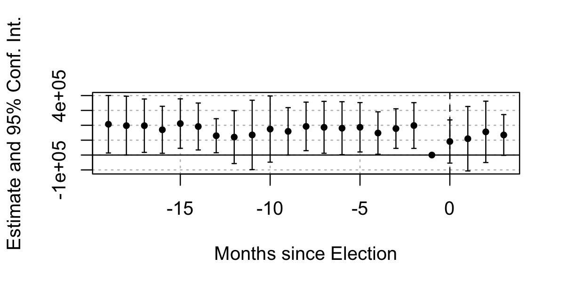
Figure A1: Event Study Testing Parallel Trends Before 2016 Election of Trump for US and Canada
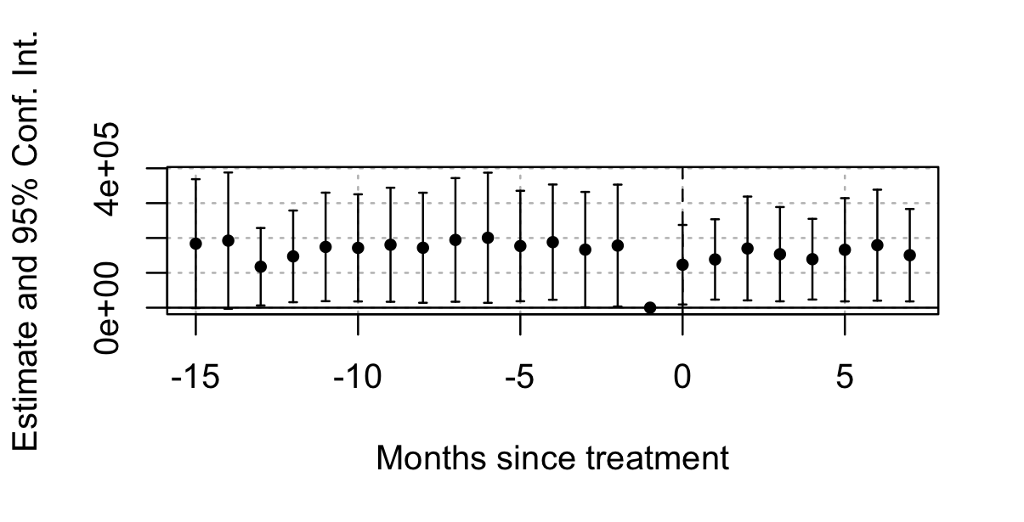
Figure A2: Event Study Testing Parallel Trends Before 2017 Travel Ban Proposal for US and Canada
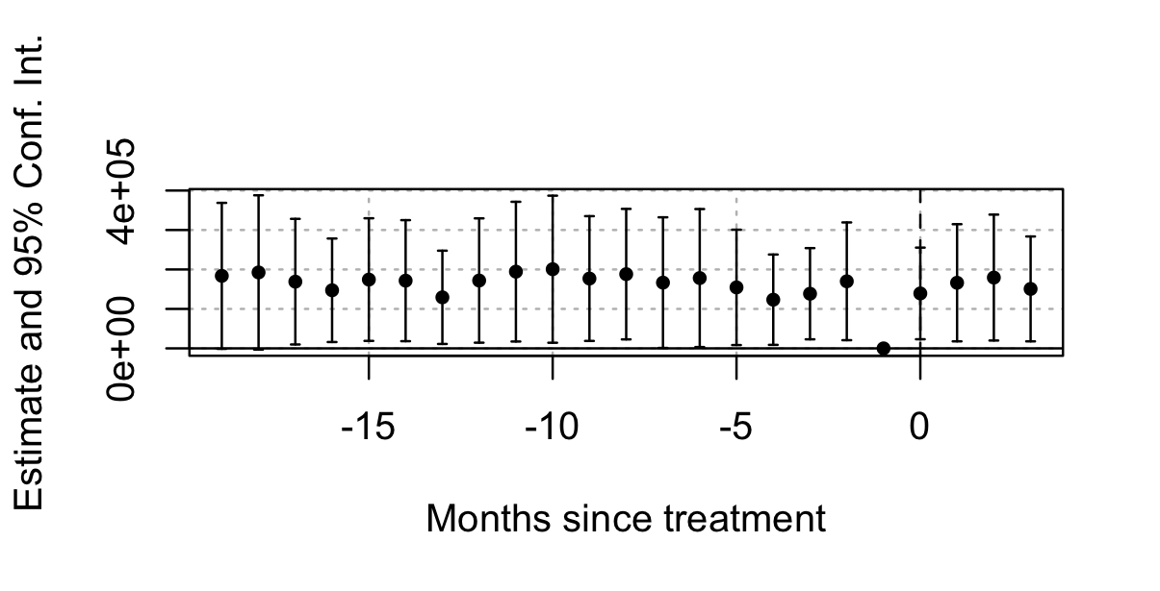
Figure A3: Event Study Testing Parallel Trends Before Court Uphold Ban for US and Canada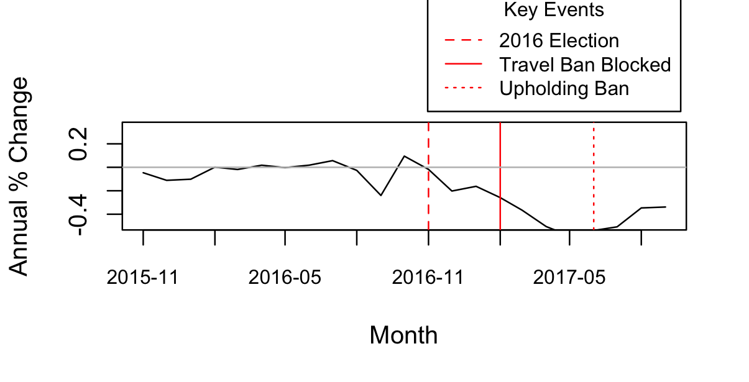
Figure A4: Annual % Change in Entries of Foreigners From Russia
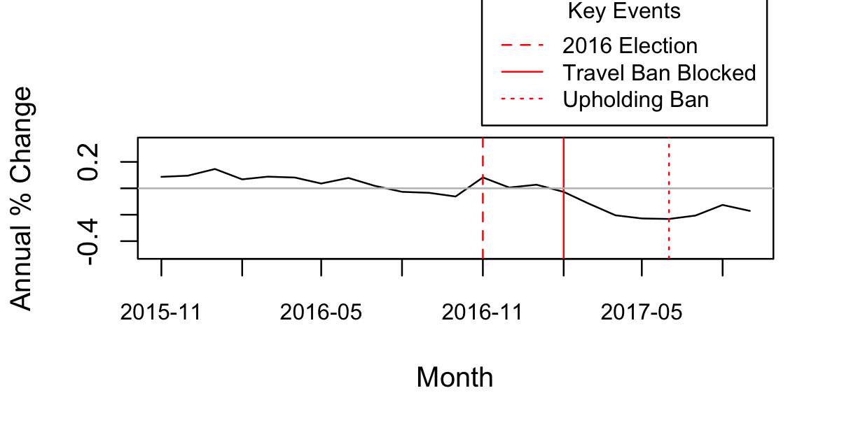
Figure A5: Annual % Change in Entries of Foreigners From India
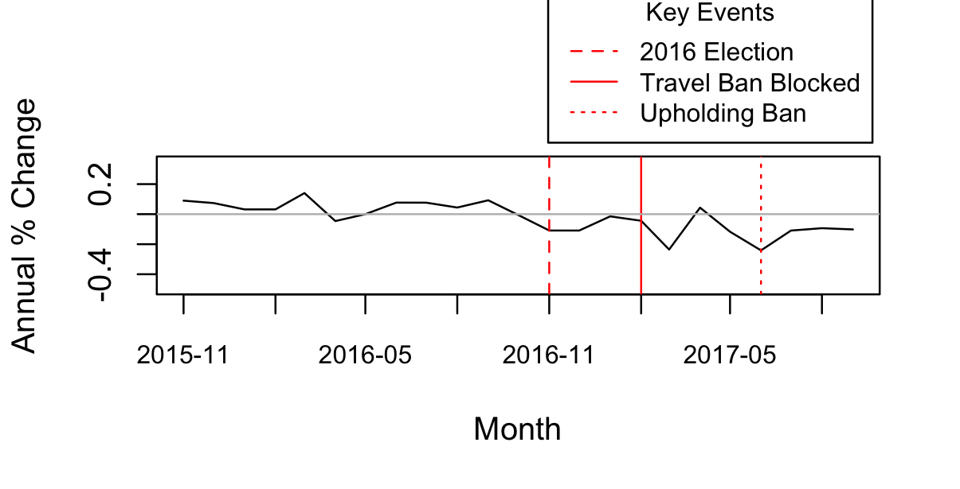
Figure A6: Annual % Change in Entries of Foreigners From Mexico

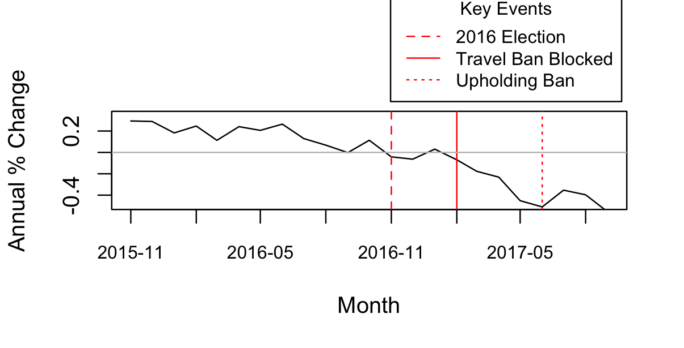
Figure A7: Annual % Change in Entries of Foreigners From Argentina

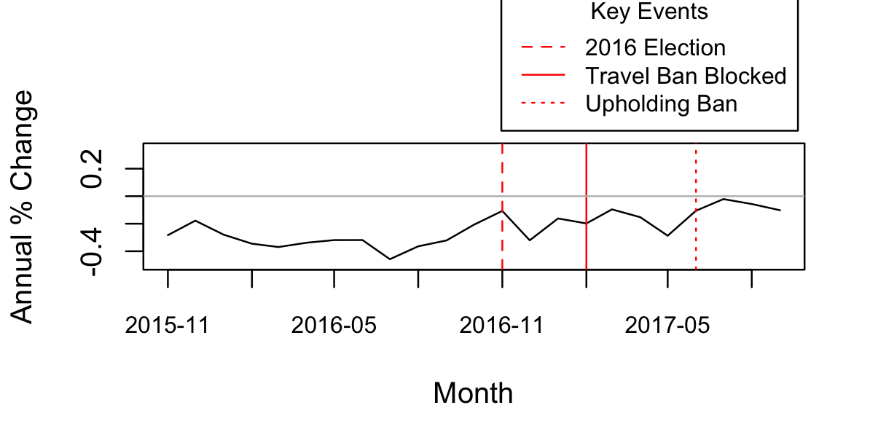
Figure A8: Annual % Change in Entries of Foreigners From Brazil

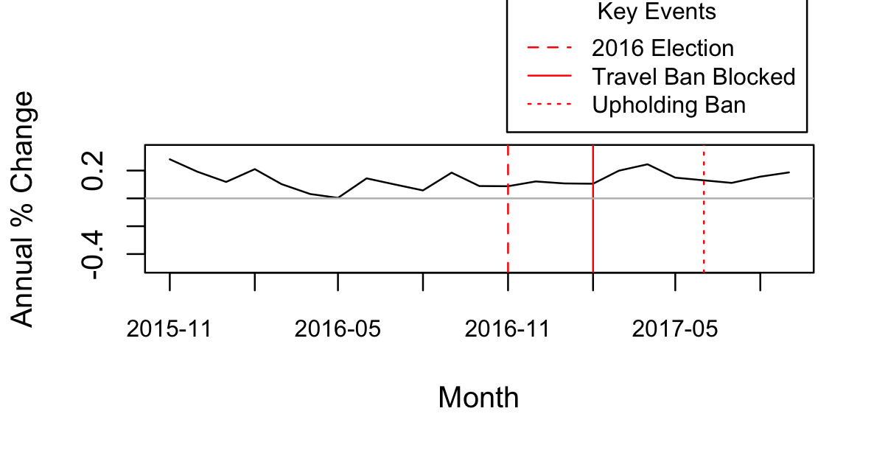
Figure A9: Annual % Change in Entries of Foreigners From South Korea

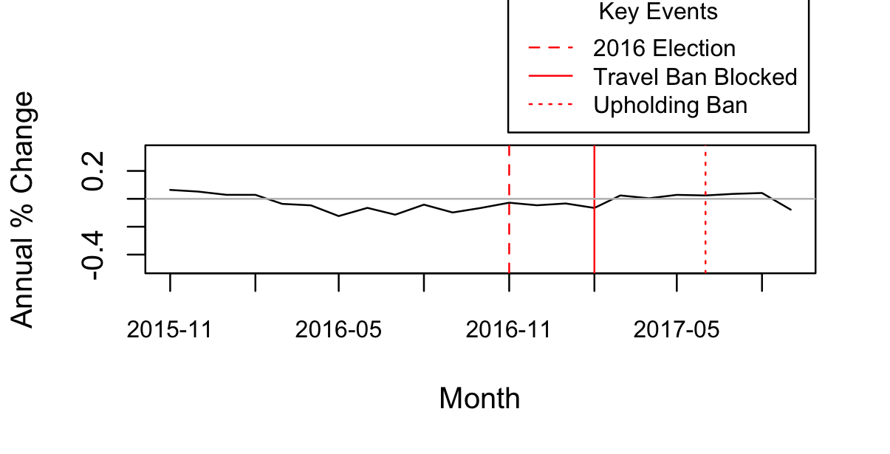
Figure A10: Annual % Change in Entries of Foreigners From Japan
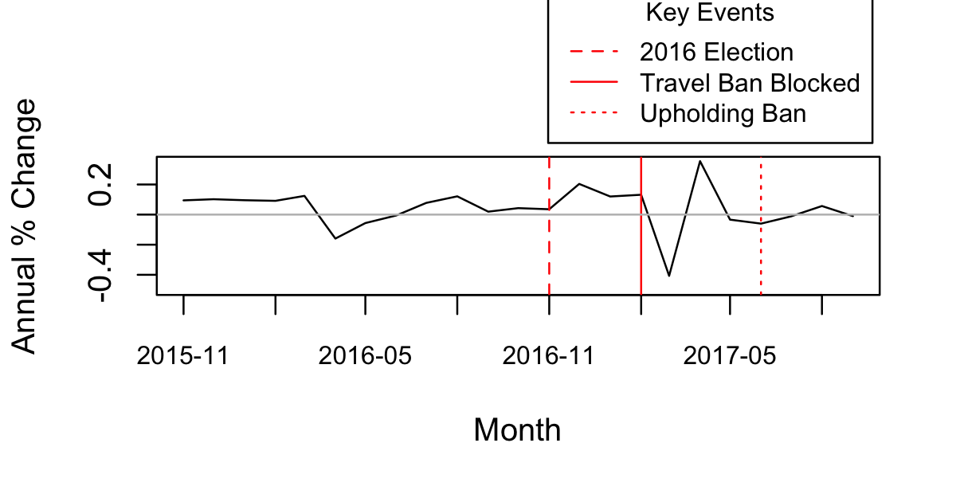
Figure A11: Annual % Change in Entries of Foreigners From Spain
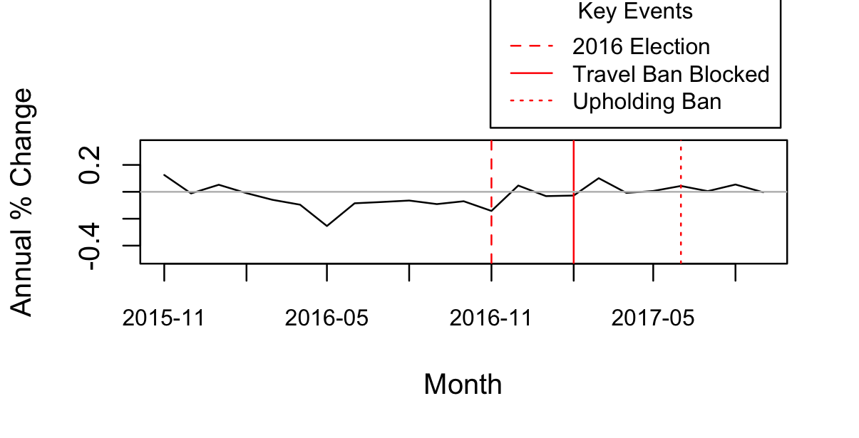
Figure A12: Annual % Change in Entries of Foreigners From France
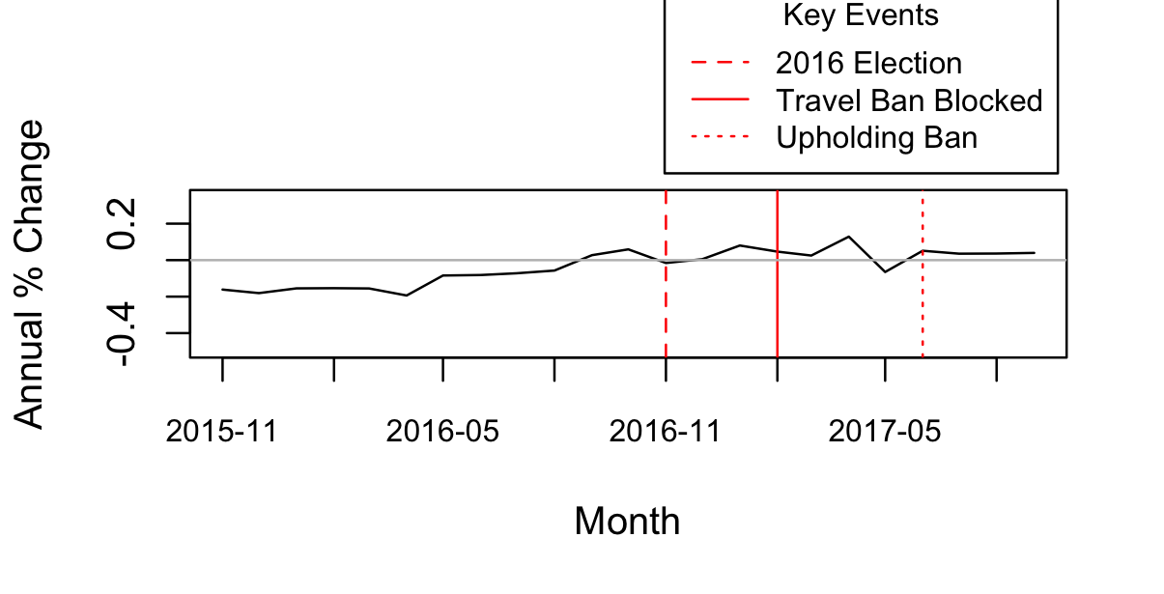
Figure A13: Annual % Change in Entries of Foreigners From Canada

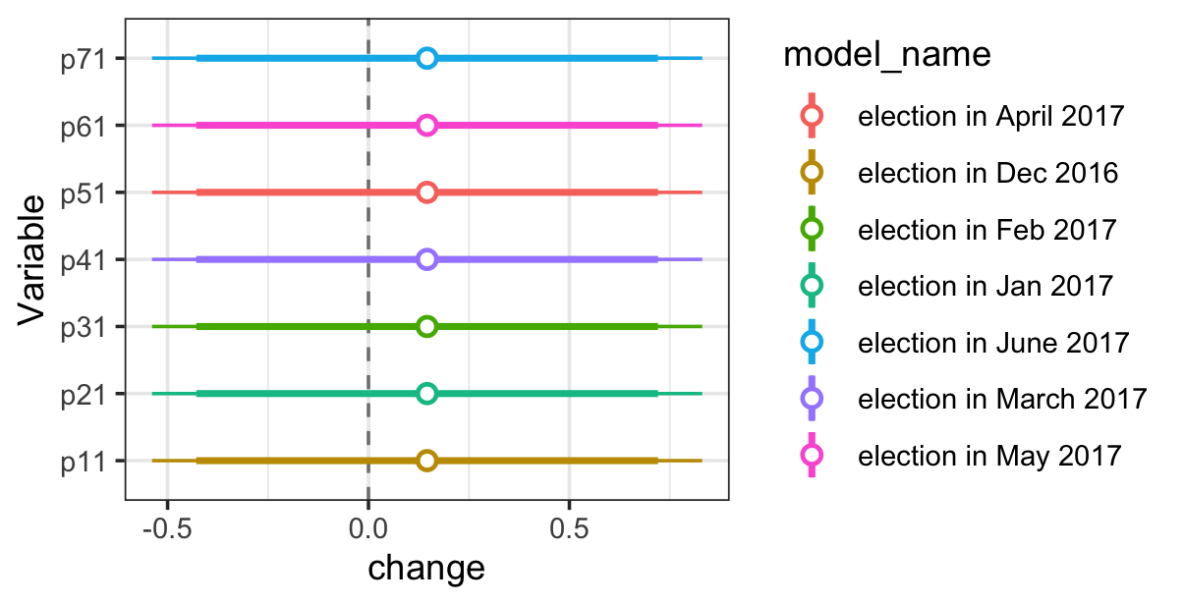
A14: Placebo OLS Regression Test of Estimated Impact of 2016 Election of Trump on Logged Counts of Foreign Entries If Implemented Another Month
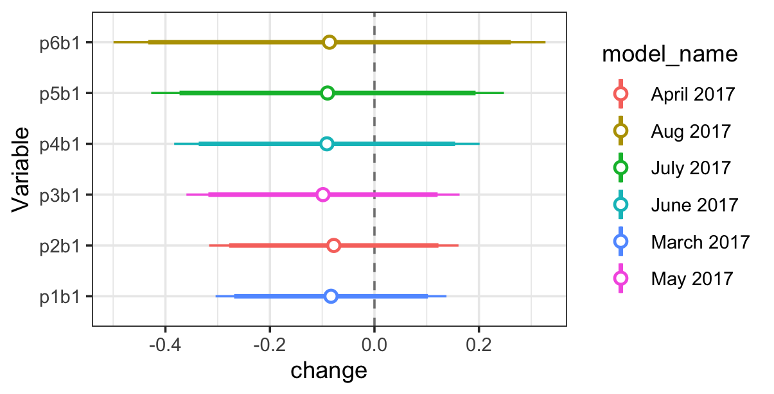
A15: Placebo OLS Regression Test of Estimated Impact of Blocked Travel Ban on Logged Counts of Foreign Entries If Implemented Another Month

Figure A16: reasons for not traveling after election, N=451

Figure A17: reasons for not traveling after travel ban, N=347

Figure A18: Relation of events to attitudes toward travel
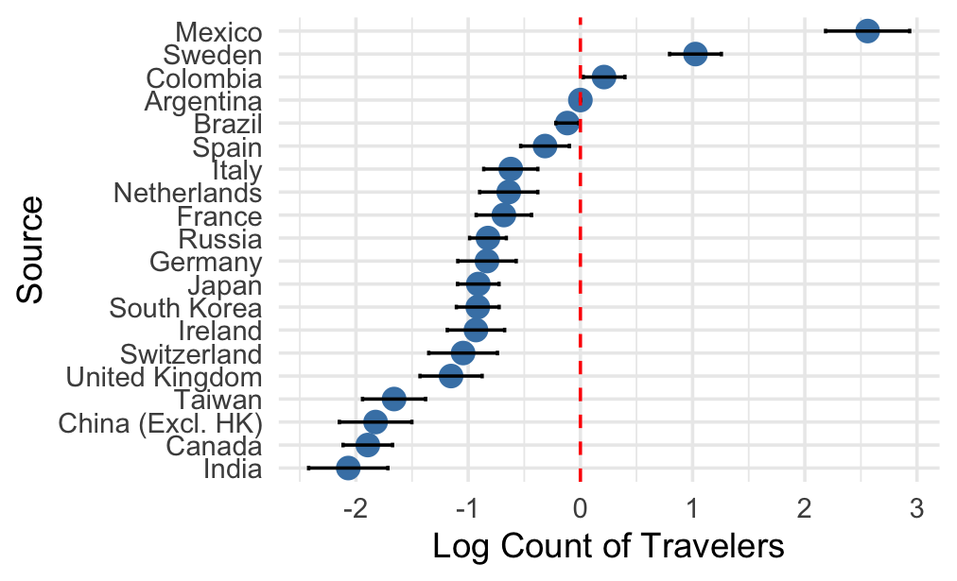

A19: Heterogeneous Impacts of the Election on Logged Counts of Foreigners Entering the US Rather Than Australia (by Country)

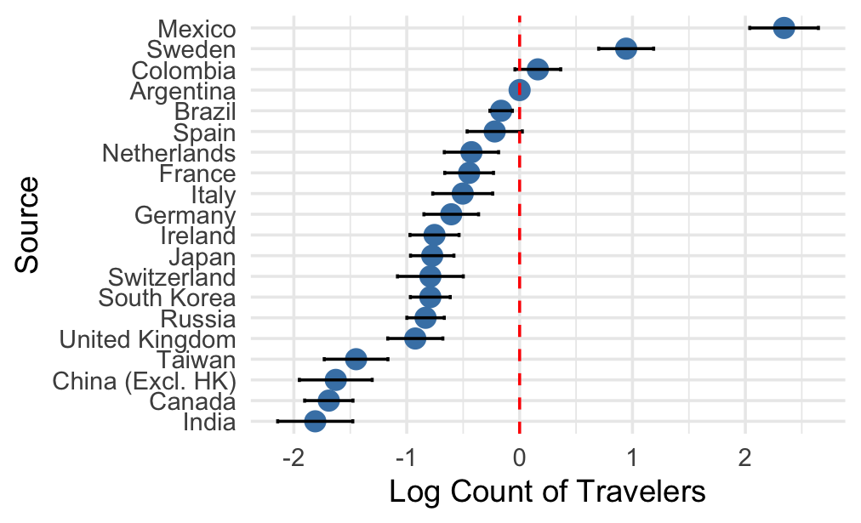
A20: Heterogeneous Impacts of the Travel Ban Proposal on Logged Counts of Foreigners Entering the US Rather Than Australia (by Country)

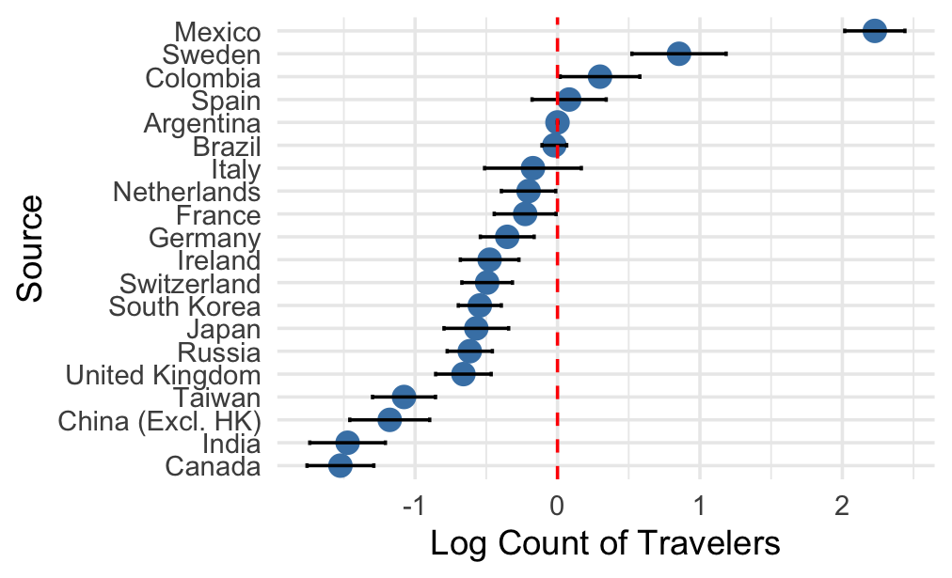
A21: Heterogeneous Impacts of the Court Upholding the Travel Ban on Logged Counts of Foreigners Entering the US Rather Than Australia (by Country)

