Supplementary materials
Urban trees: A Sustainable and Phyto-monitoring Tool for Cities and Societies
Rushikesh Kadam^{1,3} and Arun Kumar², and Indra Jeet Chaudhary^{3*}
¹Wildlife Institute of India, Dehradun, India; lycodon176@gmail.com (R. K.)
²Department of Zoology, BSNV PG College, University of Lucknow, Lucknow, 226001, India; arunkumar02071997@gmail.com (A. K.)
³Department of Environmental Science, Savitribai Phule Pune University (University of Pune), Ganeshkhind Road, Pune, Maharashtra, India; indrajeet.cug@gmail.com (I. J. C.)
*Corresponding author: indrajeet.cug@gmail.com

Sr. No | Sampling zone | Sampling sites
1. | SE (Shivaji road) | SE1(0.5 KM) | SE2 (1 KM) | SE3 (1.5 KM) | South east
2. | NW (Aundh road) | NW1 (0.5 KM) | NW2 (1 KM) | NW3 (1.5 KM) | North west
3. | W (Baner road) | W1 (0.5 KM) | W2 (1 KM) | W3 (1.5 KM) | West
4. | N (SPPU campus) | N1 (0.5 KM) | N2 (1 KM) | N3 (1.5 KM) | North
Table S1: Description of sites which were sampled during the study period along each road. Each site is 500 m away from each other and the main traffic signal.

Sr. No | Plant species | Common name | Family | Average height (m) | Leaf morphology
 | Azadirachta indica | Neem and Indian Lilac | Meliaceae | 15-40 | Opposite, pinnate leaves are 20-40 cm long, with 20-30 medium to dark green leaflets about 3-8 cm long; petioles are short.
 | Broussonetia papyrifera | Paper mulberry | Moraceae | 10-20 | The shape of the leaves varies even on the same plant, with some having lobed or unlobed blades, but typically they have serrated edges, a slightly hairy texture, pale undersides, and a rough feel. The leaves can grow up to 15-20 cm (5.9-7.9 in) in length.
 | Ficus religiosa | Bodhi, Pippala, Peepal tree | Moraceae | up to 30 | The leaves are characterised by a cordate shape and a unique elongated drip tip. They measure 10-17 cm in length and 8-12 cm in width, with a petiole that is approximately 6-10 cm long.
4.. | Polyalthia longifolia | Ashok | Annonaceae | 20 | Emerging leaves have a coppery brown pigmentation; as the leaves grow older, the colour becomes a light green and, finally, a dark green. The leaves are lanceolate and have wavy edges.
5. | Senna  siamea | kassod tree, cassod tree and cassia tree | Caesalpiniaceae | 18 m | The leaves are arranged alternately and are pinnately compound, consisting of a slender, green-reddish tinged axis and 6 to 12 pairs of leaflets with short stalks. The leaflets are rounded on both ends.
Table S2: Description of selected plant species including average height and their leaf characteristics.
Table S3: Evaluation of plants by Air Pollution Tolerance Index (APTI) and associated biological and socio-economic parameters (Prajapati & Tripathi, 2008).
Grading Characters Pattern of Assessment Grade Allotted
Tolerance APTI 7.0-8.0 +
8.1-10.0 + +
10.1-11.0 + + +
11.1-12.0 + + +
12.1-13.0 + + + + +
Morphological Plant habit Small -
Medium +
Large + +
Canopy structure Sparse/irregular/globular -
Spreading crown/open/semi dense +
Spreading dense + +
Type of plant Deciduous -
Evergreen +
Laminar structure Size Small -
Medium +
Large + +
Texture Smooth -
Coriaceous +
Hardness Delineate -
Hardy +
Socio-economic Economic value <3 uses -
3-4 uses +
5 or more uses + +

Grade | Score (%) | Assessment of plant species
0 | Up to 30 | Not recommended for plantation
1 | 31-40 | Very poor
2 | 41-50 | Poor
3 | 51-60 | Moderate
4 | 61-70 | Good
5 | 71-80 | Very good
6 | 81-90 | Excellent
7 | 91-100 | Best
Table S4: Criteria used for assessing the API percentage of plant species (Prajapati & Tripathi, 2008).
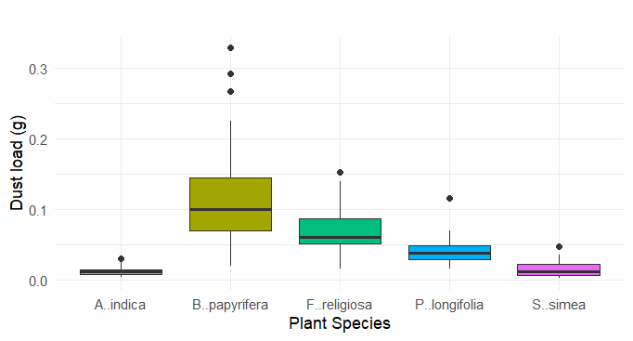
Fig. S1. Rate of dust deposition on different trees species. The vertical boxes represent the dust load, the central line showcases the median along with upper and lower limits showing the first and third quartile. The extreme values in the graph shown by dots.
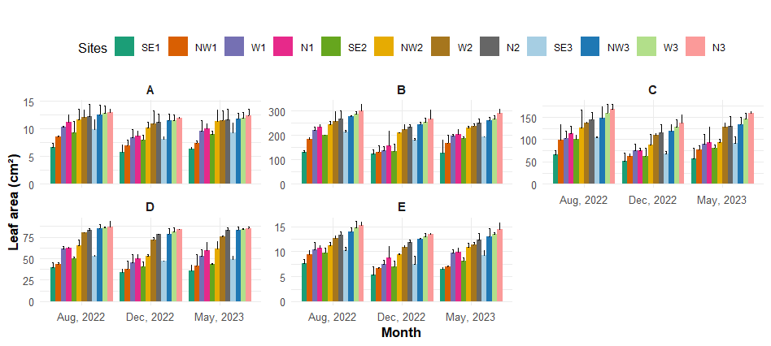Fig. S2. Effect of dust load on leaf area of (A) Azadirachta indica, (B) Broussonetia papyrifera, (C) Ficus religiosa, (D) Polyalthia longifolia, and (E) Senna siamea at different sites and season (Mean ± standard deviation of three replicates represented by thin vertical bars).
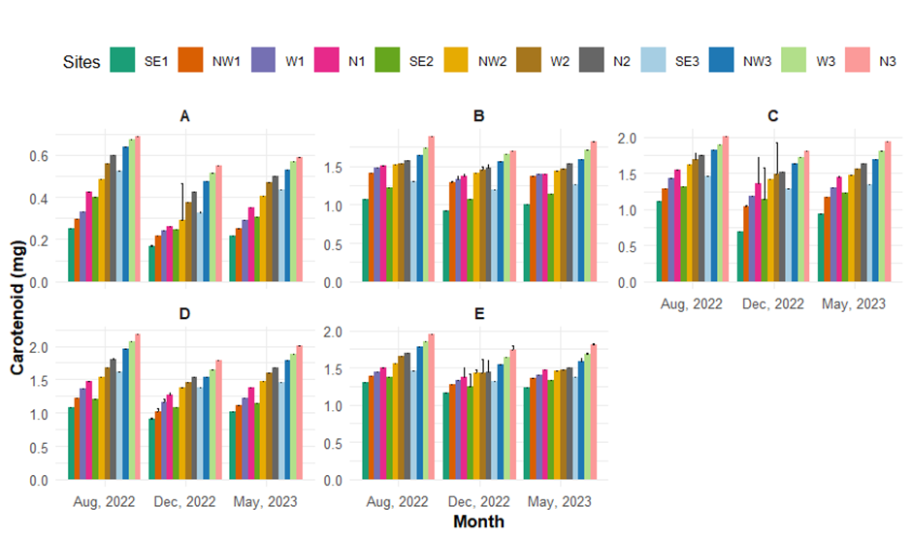
Fig. S3. Effect of dust load on carotenoid content of selected trees species (A) Azadirachta indica, (B) Broussonetia papyrifera, (C) Ficus religiosa, (D) Polyalthia longifolia, and (E) Senna siamea at different sites and seasons (Mean ± standard deviation of three replicates represented by thin vertical bars).

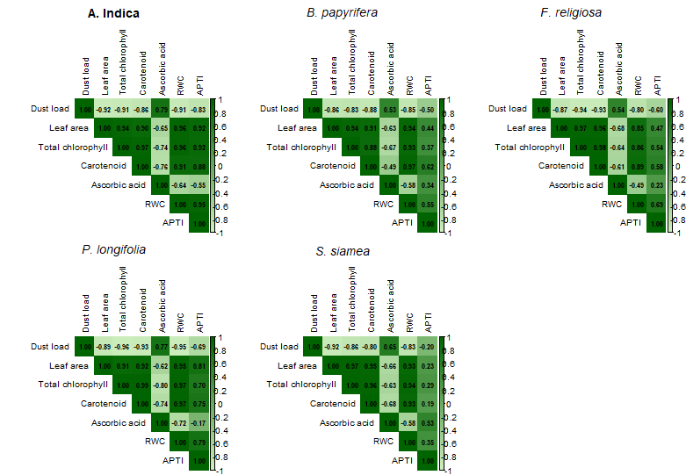

Fig. S4. Pearson’s correlation coefficient between variables including Dust load, Leaf area, Total chlorophyll, carotenoid, ascorbic acid, RWC, and APTI. Correlation is significant at 0.01 and 0.05 level.

