Supplementary material
Reverse Prediction of Carbohydrate Esterase Polysaccharide Targets
Kristian Barrett¹, Jesper Holck¹ and Anne S. Meyer¹*
¹ Department of Biotechnology and Biomedicine, Section for Protein and Enzyme Technology, Technical University of Denmark (DTU), Søltofts Plads 221, 2800, Kgs. Lyngby, Denmark
*Correspondence: Anne S. Meyer, e-mail: asme@dtu.dk
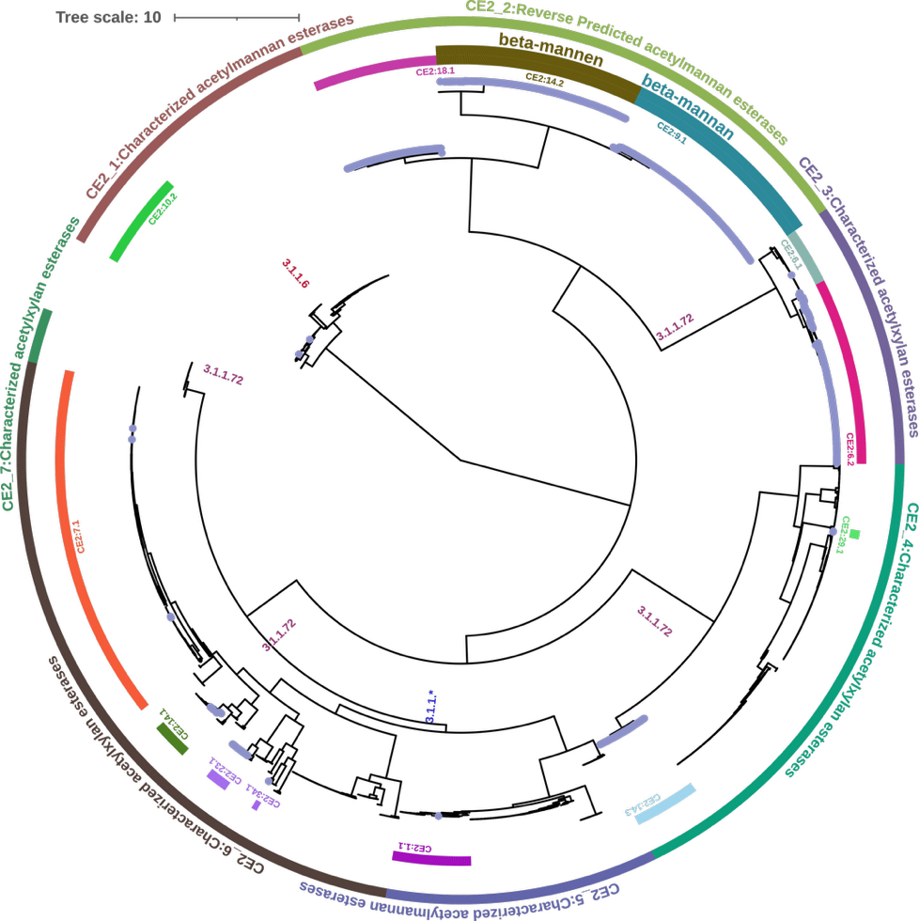
Fig. S1 Motif-based clustering dendrogram for the CE2 family. Blue dots on the tree leaves indicate members originating from the Bacteroidota phylum. EC numbers represent characterized enzymes within the family, including acetylxylan esterase (EC 3.1.1.72), acetylesterase (EC 3.1.1.6), acetylmannan esterase (EC 3.1.1.), and 6-O-glycoside deacetylase (EC 3.1.1.). Reverse prediction identified two motif groups within a single clade as likely to act on acetylated β-mannan. Based on characterized members and reverse predictions, the family is divided into seven major clades. The full tree with additional data labels can be viewed at: https://itol.embl.de/tree/1923814218153921750937516.
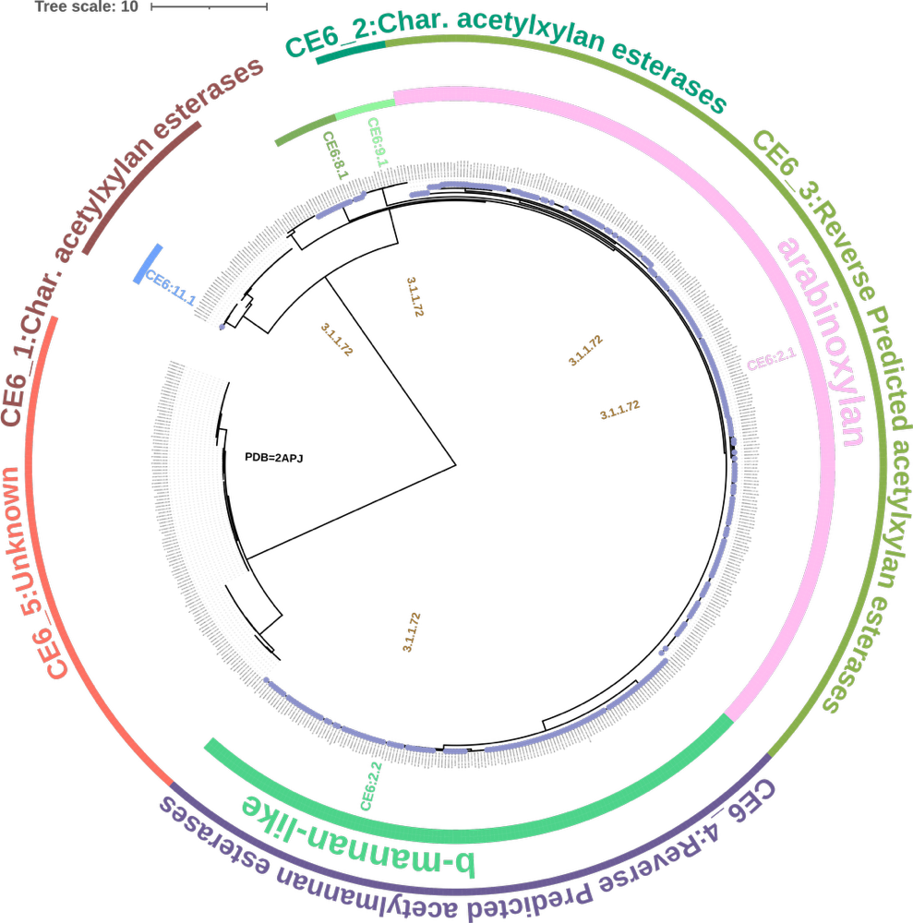
Fig. S2 Dendrogram by motif-based clustering for the CE6 family. Green dots on the leaves indicate members originating from the Bacteroidota phylum. EC numbers shown represent characterized enzymes, including acetylxylan esterase (EC 3.1.1.72). The label PDB=2APJ marks a motif group with a solved crystal structure. Five motif groups harboring Bacteroidota members are included with their group names. Two of these groups have been reverse predicted to act on arabinoxylan or a β-mannan-like substrate while one remains unknown. Based on the combined insight from characterized members and reverse predicted substrates, the family has been divided into five major clades. The tree with additional data labels can be viewed at: https://itol.embl.de/tree/1923814218198281750945149.
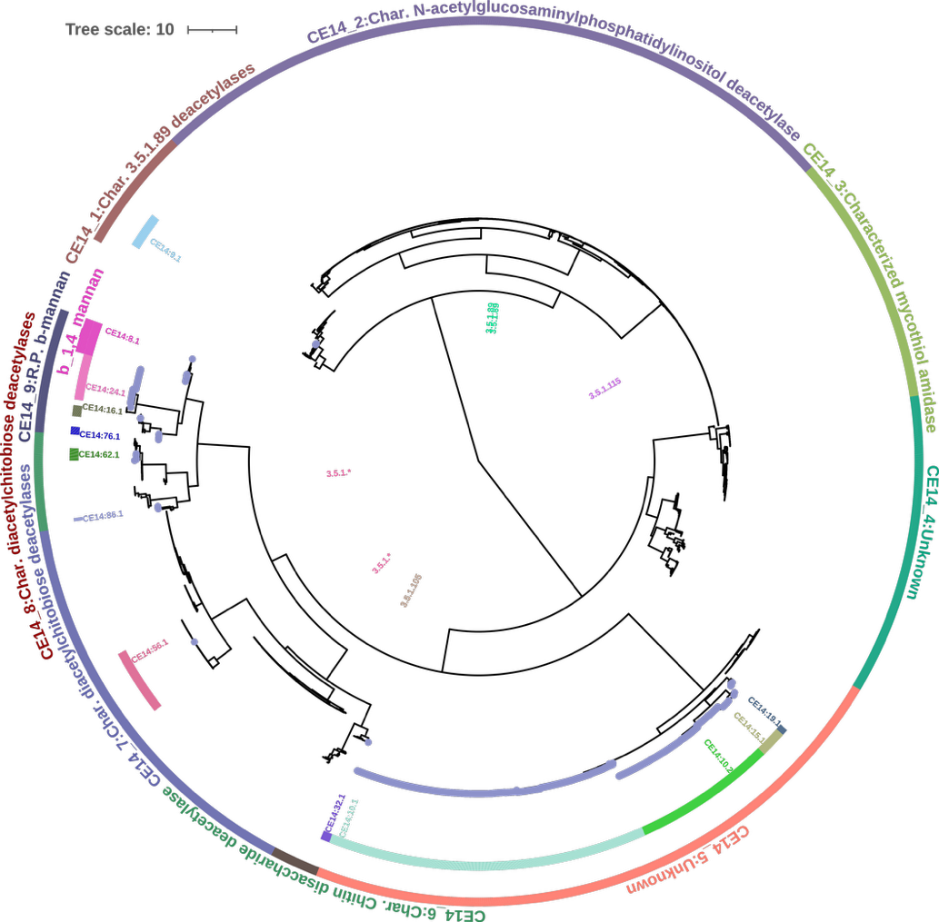
Fig. S3 Dendrogram by motif-based clustering for the CE14 family. Blue dots on the tree leaves indicate members originating from the Bacteroidota phylum. EC numbers shown represent characterized enzymes, including diacetylchitobiose deacetylase (EC 3.5.1.*), chitin disaccharide deacetylase (EC 3.5.1.105), mycothiol S-conjugate amidase (EC 3.5.1.115), and N-acetylglucosaminylphosphatidylinositol deacetylase (EC 3.5.1.89). Based on the combined insight from characterized members and reverse predicted substrates, the family has been divided into nine major clades. The only reverse prediction for this family is β-1,4-mannan. The tree with additional data labels can be viewed at: https://itol.embl.de/tree/80167202158442581754896400.
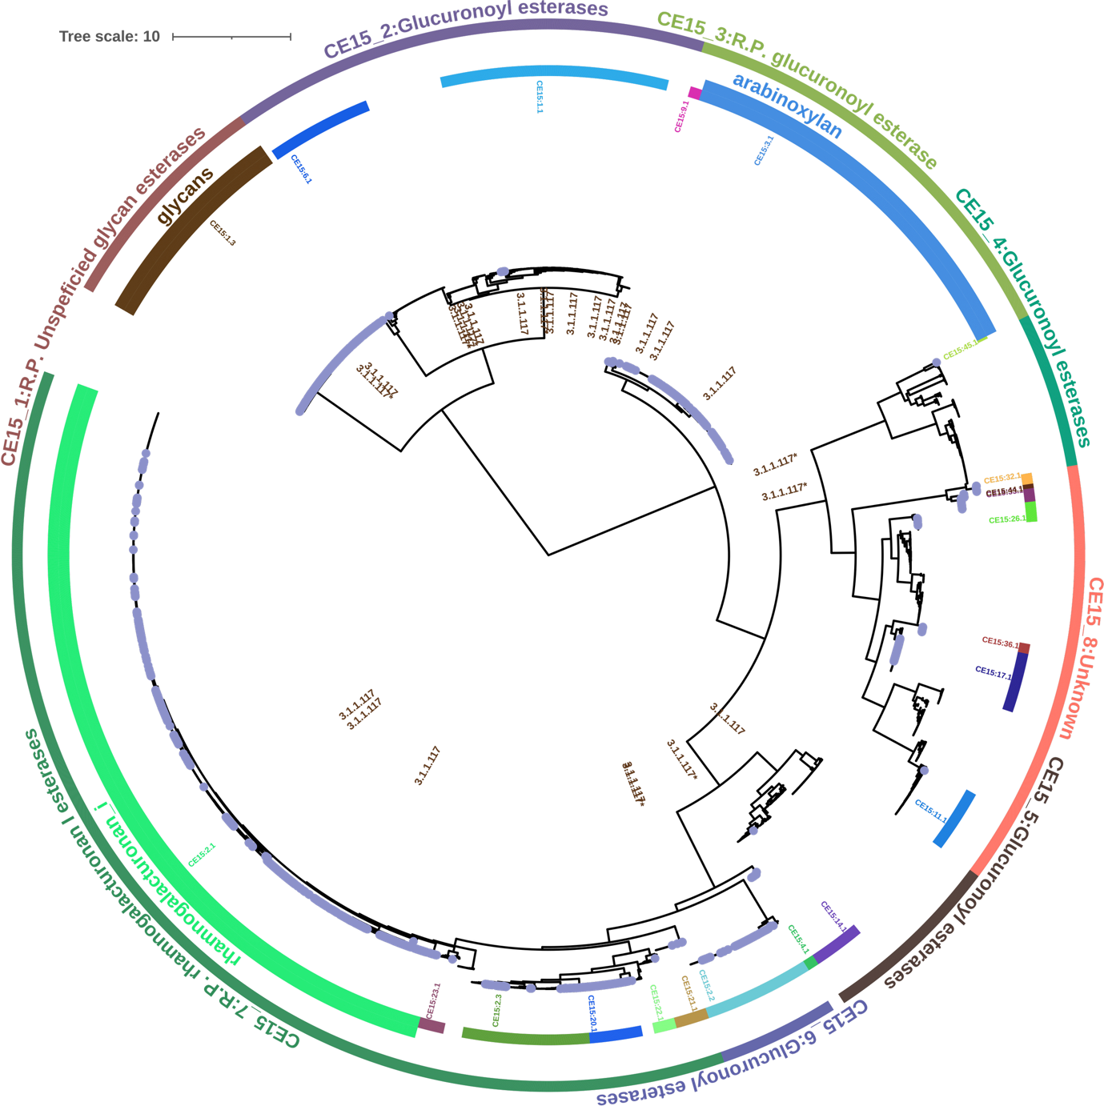
Fig. S4 - Dendrogram by motif-based clustering for the CE15 family. Blue dots on the tree leaves indicate members originating from the Bacteroidota phylum. EC numbers shown represent characterized enzymes, including 4-O-methyl-glucuronoyl esterases (EC 3.1.1.117) and feruloyl esterase (EC 3.1.1.73), the latter placed in clade CE15_1. EC numbers marked with an asterisk indicate additional references. Based on the combined insight from characterized members and reverse predicted substrates, the family has been divided into multiple clades. Reverse predictions suggest three substrate associations: glycans, arabinoxylan, and the pectin rhamnogalacturonan I. The tree with additional data labels can be viewed at: https://itol.embl.de/tree/80167202158197691754595774

