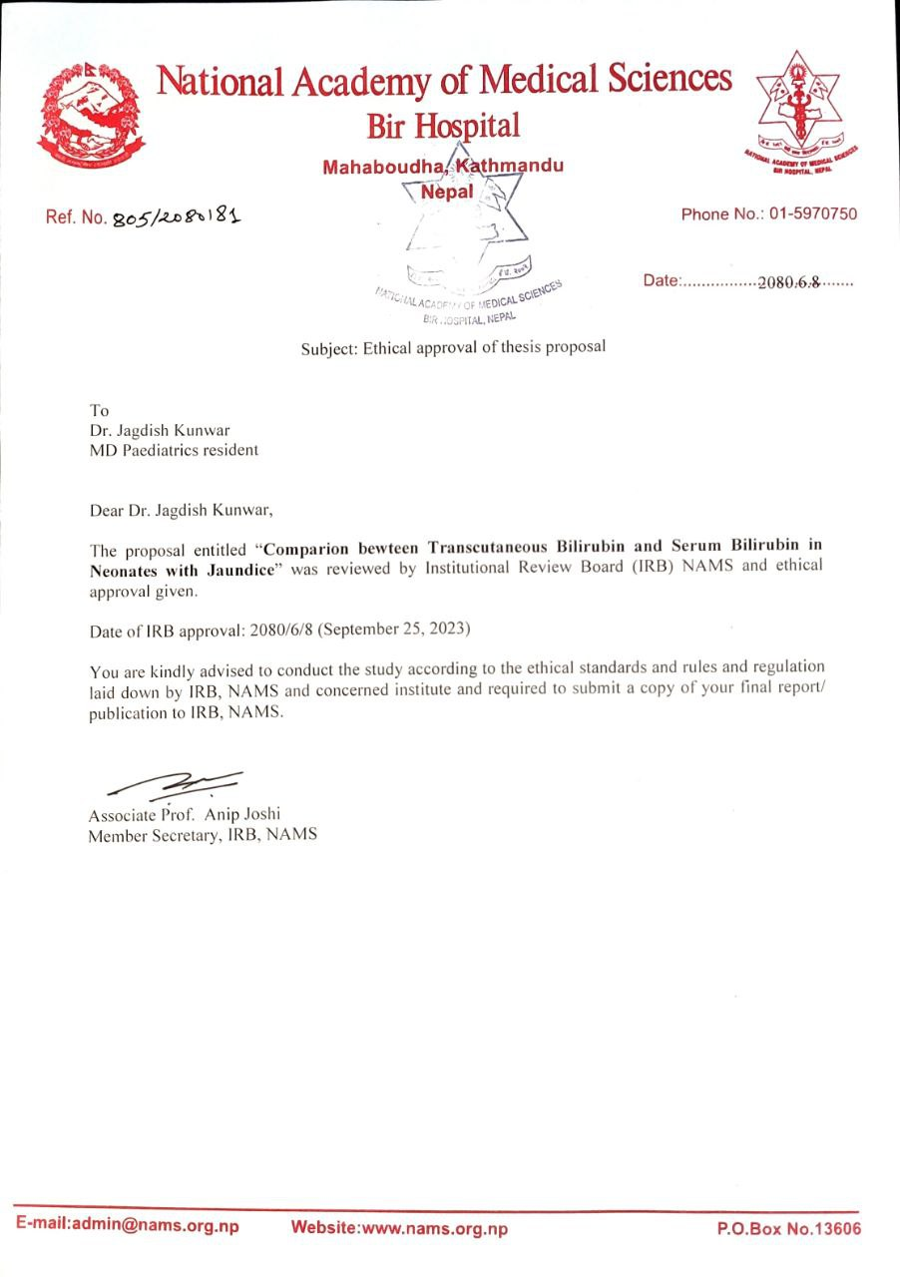

INFORMED CONSENT SHEET

I hereby willingly give my consent to participate in the research entitled “Comparison between Transcutaneous Bilirubin and Serum Bilirubin in Neonates with Jaundice” being carried out by Dr.Jagdish Kunwar. I have been fully explained about the nature of this study, its purposes, all the procedures and its implications in the future. I have had opportunity to ask questions about it and any questions that I asked have been answered to my satisfaction. I consent voluntarily to participate as participant in this research and understand that I have right to withdraw for the research at any time without in any way affecting my medical care from the hospital.
Right thumb | Left thumb
Father/Mother/Guardian
Signature:
Name:
Relation:
Address:
Date: 2080 / /

INFORMED CONSENT SHEET in Native language

सुसूचित मन्जुरीनामा
म ______________________बिरामीको अभिभावकले डॉ जगदीश कुवरले गर्न लाग्नुभएको “Comparison between Transcutaneous Bilirubin and Serum Bilirubin in Neonates with Jaundice” शिर्षकको अनुसन्धान सम्बन्धी जानकारी पत्र/पुस्तिका' सुनेर/पढेर र प्रश्नोत्तर समेत गरेर प्राप्त भयो।
यो अनुसन्धान कार्यमा मेरो सहभागिता मेरो व्यक्तिगत इच्छामा भरपर्ने र मैले चाहेको खण्डमा कुनै पनि बेला यो अनुसन्धान प्रक्रियाबाट बाहिरिन पाउने भन्ने कुरा मैले बुझेको छु। यसको लागि मैले कुनै कारण दिनुनपर्ने र त्यसबाट मैले पाउने सेवा र मेरो कानुनी अधिकारमा असर नपर्ने समेत मलाई बुझाईएकोछ।
यस अनुसन्धानको प्रतिवेदन वा सम्बन्धित प्रकाशित कृतिहरुमा मेरो र बिरामीको कुनै व्यक्तिगत परिचय खुल्ने जानकारी प्रकाशित हुने छैन भन्ने कुरा मैले बुझेको छु।
दायाँ | बायाँ
यी सबै कुराहरु जानी-बुझी, मय सअध्ययन-अनुसन्धानमा सहभागी हुन स्वेच्छाले राजी भई यो सुसूचित मन्जुरीनामामा सहिछाप गरेको छु।
अभिभावकको बुढीऔंलाको ल्याप्चे
अभिभावकको सही:

अभिभावकको नामथर:

नाता:

ठेगाना :

मिति :

PROFORMA
“Comparison between Transcutaneous Bilirubin and Serum Bilirubin in Neonates with Jaundice"
Paropakar Maternity and Women’s Hospital,
Thapathali, Kathmandu
Study No: Date Of enrollment:
Date of Admission: Hospital ID Number:
Date and Time of Birth: Age(days)/Sex:
Birth History:-
LMP:
New Ballard Scoring (<96 Hours of age):
EDD from antenatal USG in first Trimester (If LMP Not available):
Weeks of Gestation: >37 weeks ( ) 34-37 weeks ( ) 28-34 weeks ( )
SGA( ) AGA( ) LGA( )
Birth Weight (in Grams):
Low Birth Weight ( ) Normal Birth Weight ( ) Macrosomia ( )
Transcutaneous Bilirubin(mg/dl):
Reading 1 |  | Reading 2 |  | Reading 3 |  | Average |  | Average total
FH | S | FH | S | FH | S | FH | S
Total Serum Bilirubin(mg/dl):

Master Chart of Data
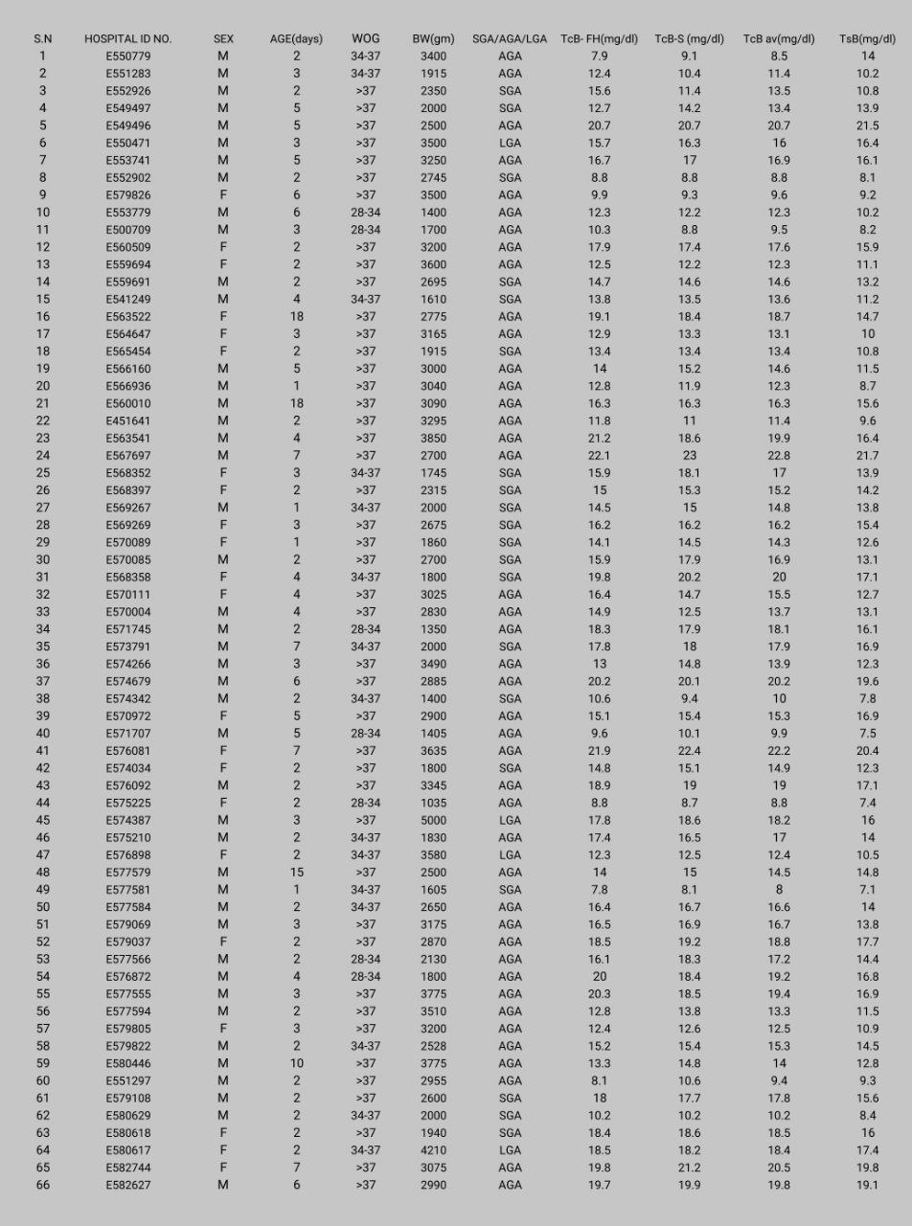
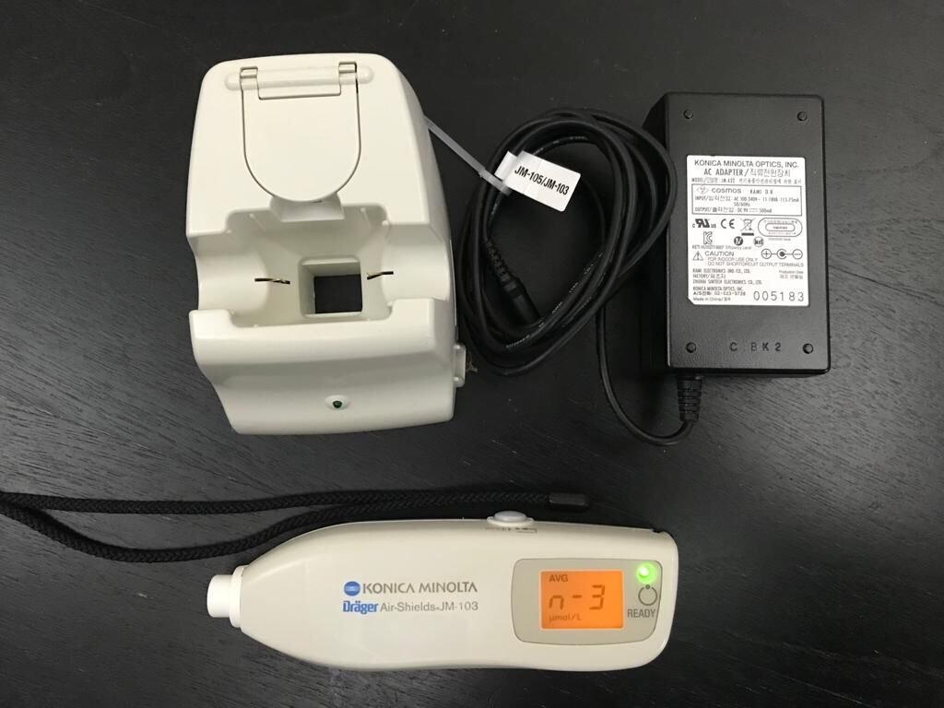
Figure: Konica Minolta Jm-103 bilirubinometer

