Supplementary Material
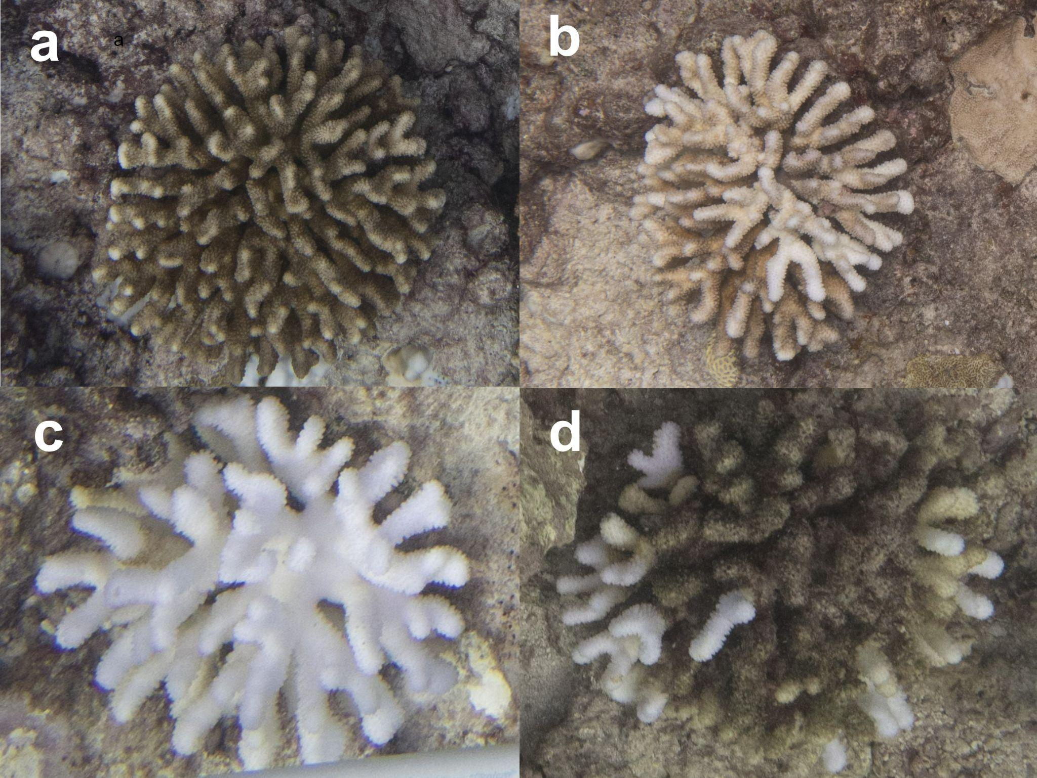
Fig S1: Reference images highlighting the different bleaching categories in Pocillopora colonies. a- Healthy; b - Pale; c- Bleached; d- Recently dead.

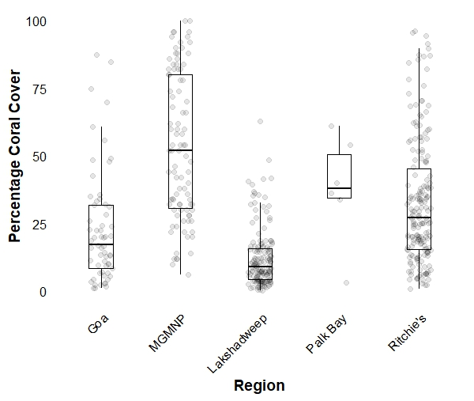

Fig S2: Percentage coral cover across regions. Coral cover was highly variable within regions

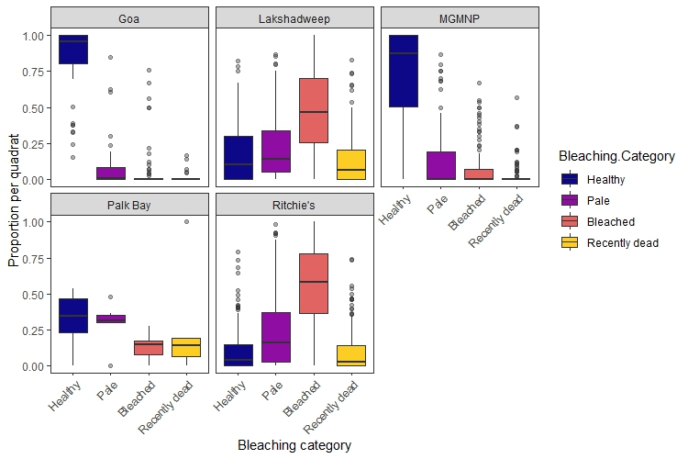

Fig S3: Proportion of coral in each bleaching category within each region.

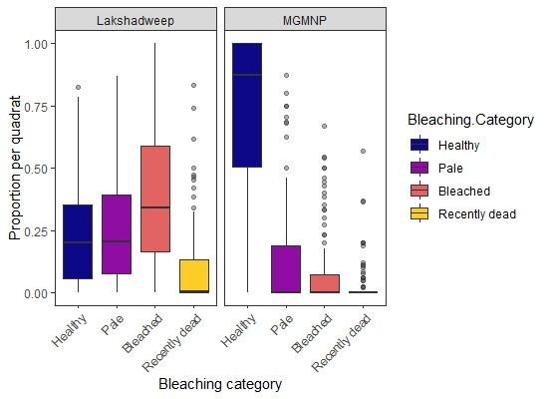

Fig S4: Proportion of coral in each bleaching category within Kavaratti and MGMNP at similar levels of heat stress. Kavaratti showed a much greater proportion of pale, bleached and recently dead coral, while coral cover in MGMNP was predominantly healthy.

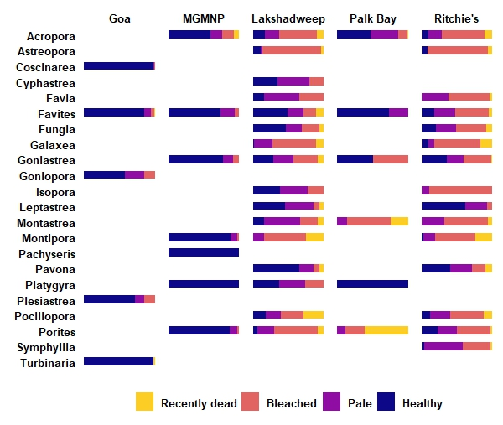
Fig S5: Proportion of health categories of each genus across regions. This graph highlights nuances such as the high mortality in Porites colonies in Palk Bay that may be obscured by the aggregation of data in the Bleaching intensity index. Bars that are missing indicate rarity (<5% quadrats) or absence of the genus from the region.

Region | Site | Depth | Date | Lat | Long | DHW
Lakshadweep | White House | 7.5 | 02-05-2024 | 10.54746 | 72.62838 | 4.27
Lakshadweep | White House | 15 | 02-05-2024 | 10.54746 | 72.62838 | 4.27
Lakshadweep | Western Ghats | 2 | 02-05-2024 | 10.55399 | 72.61416 | 4.27
Lakshadweep | Western Ghats | 7.5 | 02-05-2024 | 10.55399 | 72.61416 | 4.27
Lakshadweep | Western Ghats | 15 | 02-05-2024 | 10.55399 | 72.61416 | 4.27
Lakshadweep | Black Tangs | 7.5 | 17-05-2024 | 10.57703 | 72.63021 | 7.11
Lakshadweep | Black Tangs | 15 | 17-05-2024 | 10.57703 | 72.63021 | 7.11
Lakshadweep | Lighthouse | 7.5 | 17-05-2024 | 10.55945 | 72.64686 | 7.11
Lakshadweep | Lighthouse | 15 | 17-05-2024 | 10.55945 | 72.64686 | 7.11
Goa | Pequeno_East | 4.5 | 24-04-2024 | 15.37447 | 73.79916 | 1.29
Palk Bay | Site 1 | 3.5 | 07-06-2024 | 9.288889 | 79.2175 | 6.69
Palk Bay | Site 2 | 3.5 | 07-06-2024 | 9.305278 | 79.27056 | 6.69
Ritchie's | Pilot Reef | 10.5 | 30-05-2024 | 12.02472 | 93.04228 | 9.81
Ritchie's | Tribe Gate | 4.5 | 02-06-2024 | 12.0388 | 93.01651 | 9.81
Ritchie's | The Slope | 7 | 02-06-2024 | 12.05585 | 92.97354 | 9.84
Ritchie's | The Slope | 11 | 03-06-2024 | 12.05585 | 92.97354 | 9.84
Ritchie's | Aquarium | 7.5 | 20-05-2024 | 11.85025 | 93.02417 | 8.87
Ritchie's | Aquarium | 11 | 20-05-2024 | 11.85025 | 93.02417 | 8.87
Ritchie's | The Nursery | 7 | 20-05-2024 | 11.83512 | 93.00173 | 8.8
Ritchie's | The Nursery | 11 | 20-05-2024 | 11.83512 | 93.00173 | 8.8
Ritchie's | Fishslate | 7 | 19-05-2024 | 11.8499 | 93.045 | 8.51
Ritchie's | Fishslate | 11 | 19-05-2024 | 11.8499 | 93.045 | 8.51
MGMNP | Boat Exposed 1 | 6.5 | 08-05-2024 | 11.53444 | 92.54917 | 4.52
MGMNP | Boat Exposed 2 | 7 | 08-05-2024 | 11.52389 | 92.54917 | 4.52
MGMNP | Boat Sheltered 1 | 4.5 | 08-05-2024 | 11.52083 | 92.56972 | 4.52
MGMNP | Boat Sheltered 2 | 3.5 | 08-05-2024 | 11.54083 | 92.56139 | 4.52
MGMNP | Tarmugli Exposed 1 | 6 | 09-05-2024 | 11.60667 | 92.53333 | 4.92
MGMNP | Tarmugli Exposed 2 | 5 | 09-05-2024 | 11.56278 | 92.52889 | 4.92
MGMNP | Tarmugli Sheltered 1 | 4 | 09-05-2024 | 11.60306 | 92.55056 | 4.83
MGMNP | Tarmugli Sheltered 2 | 3.5 | 09-05-2024 | 11.57853 | 92.56339 | 4.98
Goa | ARS1 | 4 | 02-05-2024 | 15.35667 | 73.77861 | 3
Goa | ARS2 | 4 | 02-05-2024 | 15.34972 | 73.77528 | 3
Goa | ARS3 | 4 | 02-05-2024 | 15.355 | 73.77333 | 3

Table S1. A list of each of the sites along with the depths that each site was sampled at. Some sites were sampled at multiple depths resulting in a total of a total of 23 sites and 33 reefs (combination of site and depth) sampled.

Table S2a | Estimate | Std. Error | z value | P value
Intercept:RegionLakshadweep | -1.009 | 0.714 | -1.413 | 0.158
Depth | -0.031 | 0.011 | -2.893 | 0.004*
DHW | 0.255 | 0.118 | 2.169 | 0.03*
Branching_ratio | 0.036 | 0.1 | 0.362 | 0.717
RegionGoa | -1.849 | 0.501 | -3.69 | 0*
RegionMGMNP | -2.185 | 0.3 | -7.277 | 0*
RegionPalk Bay | -0.489 | 0.521 | -0.939 | 0.348
RegionRitchie's | -0.928 | 0.506 | -1.833 | 0.067

Table S2b | Estimate | Std. Error | z value | P value
(Intercept) | 0.689 | 0.227 | 3.036 | 0.002*
Depth | 0.071 | 0.017 | 4.264 | 0*
DHW | 0.136 | 0.029 | 4.630 | 0*

Table S2: Model results for the; a - conditional model and; b - dispersion model for factors influencing bleaching intensity. Depth, Region and DHW significantly influenced bleaching intensity. Meanwhile, the branching ratio seemed to have no effect on bleaching intensity. Dispersion was variable across both Depth and DHW.

