Supplementary file

Supplementary Figure 1
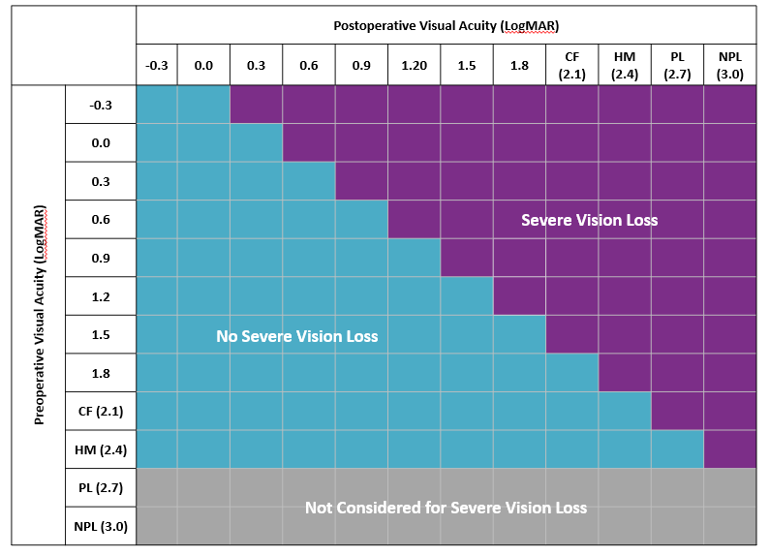

The data were recorded on either the Medisoft EMR system (Medisoft Ophthalmology, Medisoft Limited, Leeds, UK, www.medisoft.co.uk), the Open Eyes EMR system (www.openeyes.org.uk), the EPIC patient medical record system (www.epic.com) or ‘in-house’ data collection systems compliant with the National Cataract Dataset (https://www.rcophth.ac.uk/standards-publications-research/audit-and-data/clinical-data-sets/cataract-national-data-set/).

The participating centres included in this study are listed in alphabetic order, separated into the 52 English NHS Trusts, one Welsh Health Board, 76 independent sector treatment centres, two private fee-paying provider and the one centre from Guernsey.

The following 52 NHS Trusts in England:
Barts Health NHS Trust; Bolton NHS Foundation Trust; Calderdale and Huddersfield NHS Foundation Trust; Cambridge University Hospitals NHS Foundation Trust; Chesterfield Royal Hospital NHS Foundation Trust; County Durham and Darlington NHS Foundation Trust; East Sussex Healthcare NHS Trust; Epsom and St Helier University Hospitals NHS Trust; George Eliot Hospital NHS Trust; Gloucestershire Hospitals NHS Foundation Trust; Great Western Hospitals NHS Foundation Trust; Guy's and St Thomas' NHS Foundation Trust; Hampshire Hospitals NHS Foundation Trust; Harrogate and District NHS Foundation Trust; Imperial College Healthcare NHS Trust; Isle of Wight NHS Trust; James Paget University Hospitals NHS Foundation Trust; King's College Hospital NHS Foundation Trust; Leeds Teaching Hospitals NHS Trust; Liverpool University Hospitals NHS Foundation Trust; London North West University Healthcare NHS Trust; Manchester University NHS Foundation Trust; Mersey and West Lancashire Teaching Hospitals NHS Trust; Mid Cheshire Hospitals NHS Foundation Trust; Mid Yorkshire Teaching NHS Trust; Moorfields Eye Hospital NHS Foundation Trust*; North West Anglia NHS Foundation Trust; Northern Lincolnshire and Goole NHS Foundation Trust; Nottingham University Hospitals NHS Trust; Portsmouth Hospitals University NHS Trust; Royal Berkshire NHS Foundation Trust; Royal Devon University Healthcare NHS Foundation Trust; Royal Free London NHS Foundation Trust; Royal Surrey County Hospital NHS Foundation Trust; Salisbury NHS Foundation Trust; Sandwell and West Birmingham Hospitals NHS Trust; Sheffield Teaching Hospitals NHS Foundation Trust; Somerset NHS Foundation Trust; South Warwickshire University NHS Foundation Trust; The Hillingdon Hospitals NHS Foundation Trust; The Newcastle upon Tyne Hospitals NHS Foundation Trust; The Princess Alexandra Hospital NHS Trust; The Shrewsbury and Telford Hospital NHS Trust; University Hospital Southampton NHS Foundation Trust; University Hospitals Birmingham NHS Foundation Trust; University Hospitals Bristol and Weston NHS Foundation Trust; University Hospitals Coventry and Warwickshire NHS Trust; University Hospitals Dorset NHS Foundation Trust; University Hospitals Plymouth NHS Trust; West Suffolk NHS Foundation Trust; Wirral University Teaching Hospital NHS Foundation Trust; Wrightington, Wigan and Leigh NHS Foundation Trust;

The following one University Health Board in Wales:
Cwm Taf Morgannwg University Local Health Board;

The following one centre from Guernsey:
Medical specialists group Guernsey

Independent sector treatment centres:
The Stoneygate Eye Hospital;

The following six sites from Community Health and Eyecare Limited:
Accrington; Blackpool; Coventry; Leicester; Preston; Stevenage;

The following one site from Newmedica:
Northampton;

The following six sites from Optegra Eye Health Care:
Birmingham Eye Hospital; Bradford Eye Hospital; Colchester Eye Clinic; Hampshire Eye Hospital; London Eye Hospital; North London Eye Hospital;

The following two sites Optimax clinics:
Leicester; Newton Abbot;

The following eight sites from Practice Plus Group:
Barlborough; Devizes; Emersons Green; Gillingham; Ilford; Rochdale; Shepton Mallet; St. Mary's Portsmouth;

The following 52 sites from SpaMedica:
Bedford; Bexhill; Birkenhead; Birmingham; Blackpool; Bolton; Bradford; Brighton; Bristol; Bromley; Carlisle; Chelmsford; Chester; Colchester; Coventry; Derby; Doncaster; Epsom; Exeter; Gateshead; Gloucester; Haydock; Hull; Kendal; Leeds; Leicester; Liverpool; Manchester; Newark; Newcastle Under Lyme; Newton le Willows; North Tyneside; Norwich; Oldham; Oxford; Peterborough; Poole; Preston; Romford; Sheffield; Sittingbourne; Solihull; Southampton; Stockton on Tees; Telford; Truro; Wakefield; Watford; West Lancashire; Widnes; Wokingham; Wolverhampton;

The following two private fee -paying providers
Exeter Eye; SANA Private Health;

*Including Bedford Hospital NHS Trust and Croydon Health Services NHS Trust as these are part of the same governing authority for ophthalmology.

