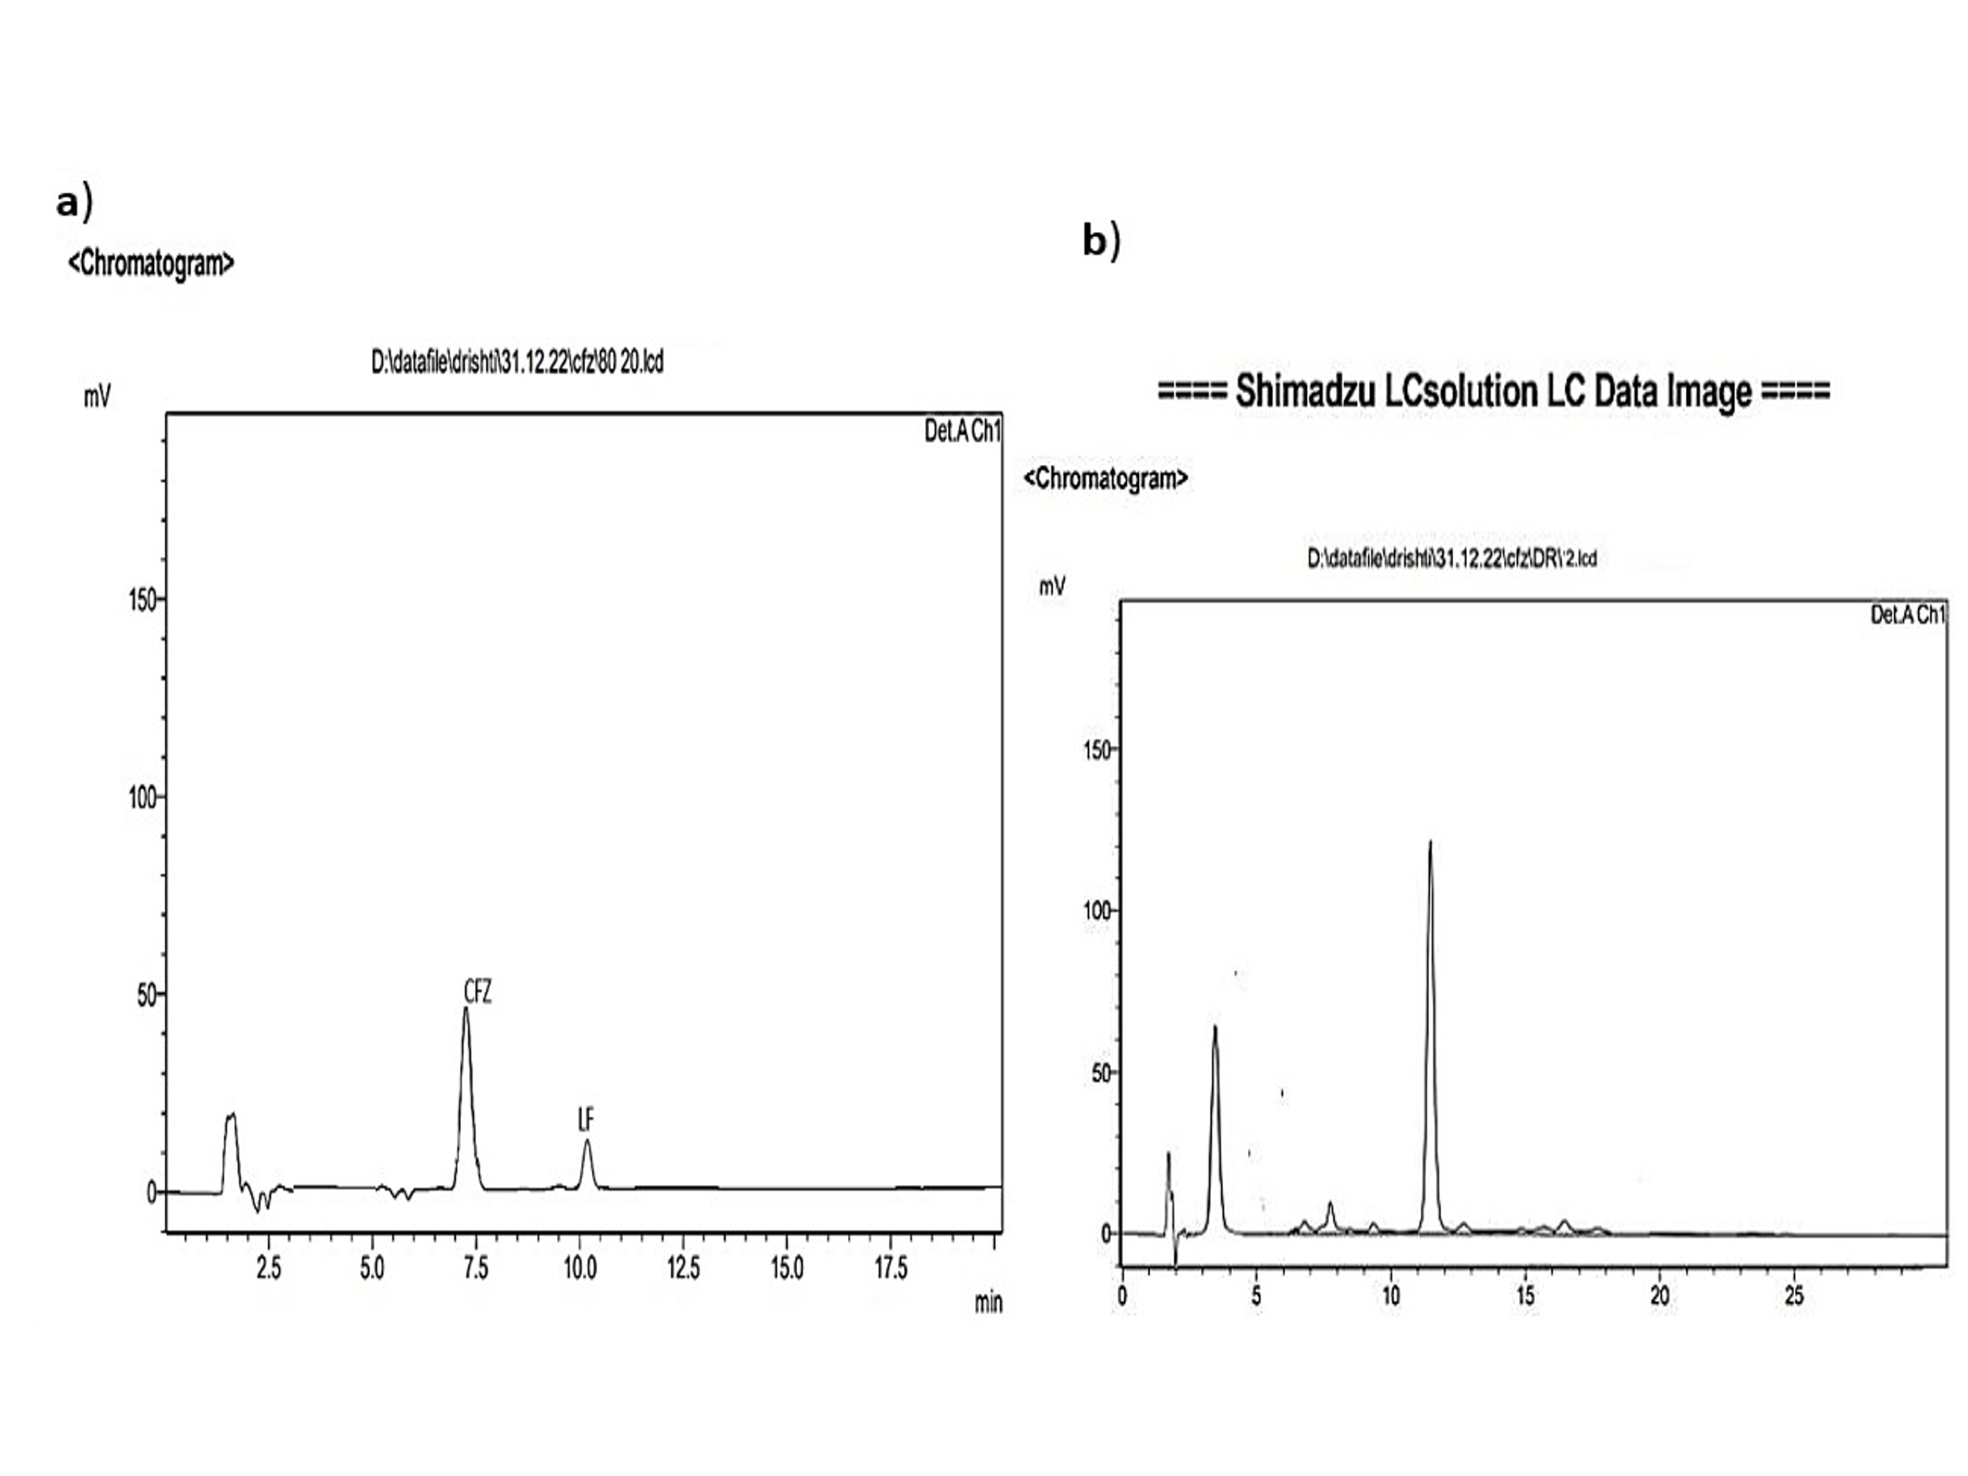Figure S1 HPLC chromatograms for determining %EE of CFZ: a) physical admixture of CFZ, and LF; b) Carfilzomib encapsulated lactoferrin nanoparticles (CFZ-LF-NPs)
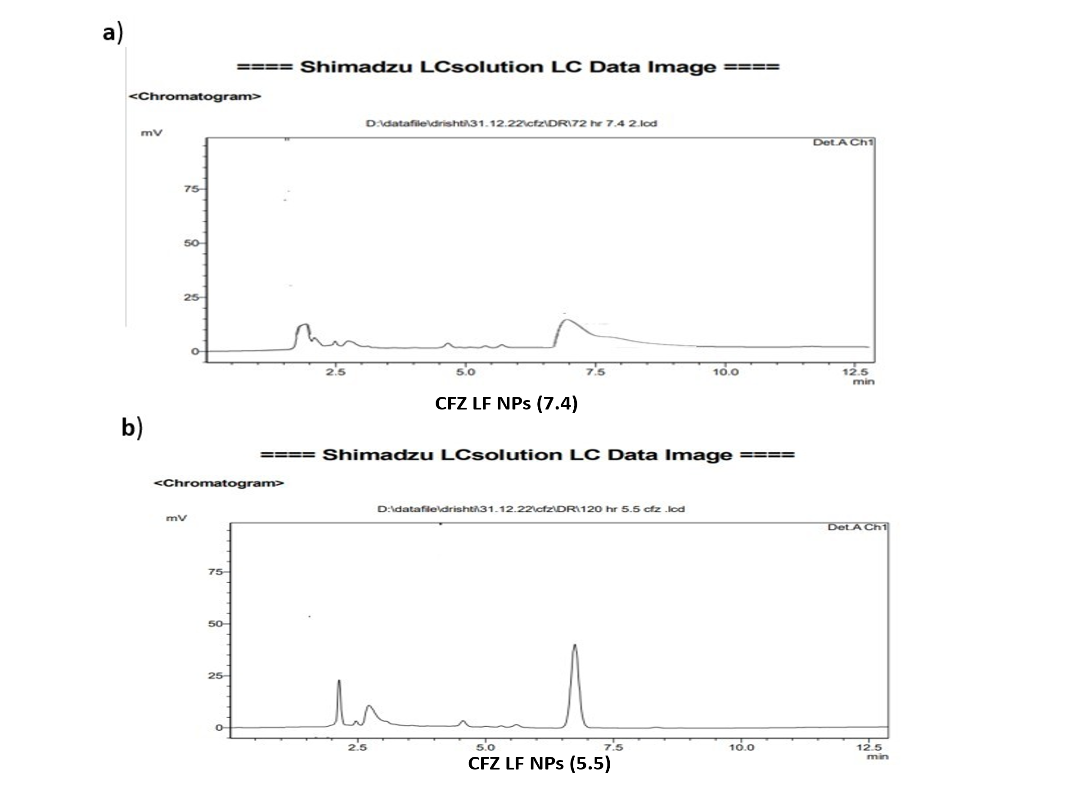
Figure S2 HPLC chromatogram of drug release samples of CFZ-LF-NPs
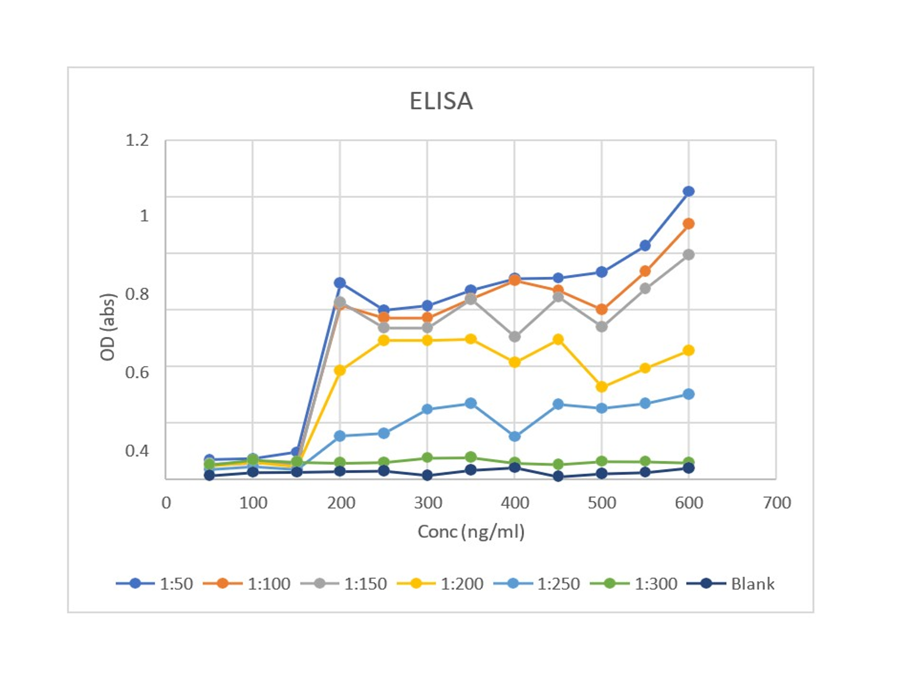
Figure S3 Optical density via ELISA plate reading to depict the percentage of Anti- Her2 conjugation
Sr.no | Parameters | CFZ-LF-NPs |  |  |  |  |  | AntiHe2-CFZ-LF-NPs
Sr.no | Parameters | Storage conditions |  |  |  |  |  | Storage conditions
Sr.no | Parameters | 4-8°C ±2°/45%±5% RH |  |  | 25°C±2°C/65±5% RH |  |  | 4-8°C ±2°/45%±5% RH |  |  | 25°C±2°C/65±5% RH
Sr.no | Parameters | 2 months | 2 months | 2 months | 2 months | 2 months | 2 months | 2 months | 2 months | 2 months | 2 months | 2 months | 2 months
1 | Physical  appearance | White | White | White | White | White | White | White | White | White | White | White | White
2 | Particle size  (nm) | 86.1±0.06 | 87.2±0.32 | 89±0.15 | 86.8±0.06 | 88.3±0.25 | 91.2±0.12 | 236±0.06 | 237.2±0.32 | 240±0.15 | 236.8±0.06 | 240.1±0.25 | 244.5±0.12
3 | %EE | 84.2 ± 0.017 | 82.1 ± 0.185 | 79.4 ± 0.447 | 84.2± 0.412 | 81.3 ± 0.146 | 79.4±1.247 | 87.3 ± 0.017 | 85.6 ± 0.185 | 82.1 ± 0.447 | 86.4± 0.412 | 82.7 ± 0.146 | 80.1±1.247
Table S1. Stability studies of CFZ-LF-NPs and AntiHe2-CFZ-LF-NPs

