Methods

Cell culture
BRx82 and BRx142 CTC cell lines were established from primary CTCs, viably isolated from blood specimen of patients with metastatic hormone-receptor positive breast cancer, following microfluidic enrichment using the CTC-iChip^{1,2}. CTC cultures were maintained as anchorage independent clusters under hypoxia, in tumor sphere medium as previously described³. MDA-MB-231 (M231) and MCF10A cells were purchased from ATCC. M231 were grown under adherent condition with 10% FBS (Gibco) in DMEM high glucose medium (Gibco). MCF10A cells were grown in DMEM/F12 (Gibco) with 5% horse serum, 20 ng/ml EGF, 0.5 mg/ml hydrocortisone, 100 ng/ml Cholera Toxin and 10 μg/ml insulin. All the cell lines used in this study were routinely checked for mycoplasma using Mycoalert kit (Lonza) and their cell of origin was confirmed using genetic fingerprinting analysis.

Serum deprivation and replenishment study
Both M231 and MCF10A cells were routinely maintained in serum containing media described above. For serum deprivation, serum-containing medium was removed and cells were washed three times in PBS and cultured in serum-free medium for 24 hours. After 24 hours of serum starvation, serum-containing medium was added back to the cells and cells were harvested for RNA extraction or ChIP-seq at 30 minutes, 1 hour, 3 hours and 6 hours.

Lentiviral transduction and shRNA knockdown
Early passage 293T cells were co-transfected with either pLKO.1 shRNA knockdown constructs or FOS or NR4A1 overexpression constructs (Origene), combined with pMD2.G and psPAX2 plasmids (Addgene). After 48-72 hours, viral supernatants were collected, concentrated using LentiX concentrator (Clontech), and suspended in PBS. CTC cell lines, M231 or MCF10A cells were transduced with the virus in the presence of polybrene (Santa Cruz, 8 μg/ml as final concentration) overnight. After transduction, fresh culture medium containing puromycin (InvivoGen, 2 μg/ml as final concentration) was added to the cells for 4-7 days. Cells were r harvested for both RNA and protein extractions to evaluate the efficiency of knockdown or overexpression. All the shRNA constructs, including control shRNA constructs were obtained from the TRC collection (Broad Institute).

The target sequences for the shRNA constructs are:
NR4A1 shRNA #1: TCCTTCCACATGTACATAAAC
NR4A1 shRNA #2: GTCACGTCTGTTGGGCAAACT
NR4A1 shRNA #3: CAACGCTTCATGCCAGCATTA
FOS shRNA #1: TCTCCAGTGCCAACTTCATTC
FOS shRNA #2: GCGGAGACAGACCAACTAGAA

siRNA knockdown
All the siRNA used in this study, along with their non-targeting control siRNAs, were purchased from Dhamacom in smartpool format, with each pool containing four optimized oligonucleotides with distinct sequences against the target gene. M231 cells were seeded in 6-well plates one day before transfection with 30 nM siRNA smart pools in presence of Lipofectamine RNAimax (Invitrogen), medium was replaced 12-24 hours later. RT-qPCR was performed 72 hours after transfection to confirm the knockdown efficiency. siRNA sequences (from 5’ to 3’) for each target are:
NR4A1: UCGAGGACUUCCAGGUGUA, GGACAGAGCAGCUGCCCAA, GAAGGCCGCUGUGCUGUGU, CGGCUACACAGGAGAGUUU;
MYC: ACGGAACUCUUGUGCGUAA, GAACACACAACGUCUUGGA, AACGUUAGCUUCACCAACA, CGAUGUUGUUUCUGUGGAA;
FOS: GGGAUAGCCUCUCUUACUA, ACAGUUAUCUCCAGAAGAA, GAACCUGUCAAGAGCAUCA, GCAAUGAGCCUUCCUCUGA;
FOSB: CGUGAGUGUGUGAGCGCUU, GUUGUUAACCCUUCGUACA, CCGGGAACGAAAUAAACUA, AGUGAGGGGCUGUGACAUU;
BHLHE40: AAAGAGACGUGACCGGAUU, GAGAAAGGAUCGGCGCAAU, CCGAACAUCUCAAACUUAC, CCCGGGAGGUGCUUCAGUA
and non-targeting pool: UGGUUUACAUGUCGACUAA, UGGUUUACAUGUUGUGUGA, UGGUUUACAUGUUUUCUGA, UGGUUUACAUGUUUUCCUA.

Mouse xenograft assays
All the animal experiments were performed according to the animal protocol reviewed and approved by MGH Subcommittee on Research Animal Care (IACUC). 6-8 week-old female immunodeficient NSG (NOD.Cg-Prkdcscid Il2rgtm1Wjl/SzJ) mice (Jackson Laboratory) were used for mammary fat pad injections and intracardiac injections. Mice were anaesthetized with isoflurane prior to tumor cell injections. For mammary fat pad injections, 20,000 BRx142, BRx82 or M231 cells were suspended in 1:1 mix with PBS/growth factor reduced Matrigel (BD), and injected into the fourth mammary fat pad. For intracardiac injections, the left side of the mouse chest was opened to expose the rib cage and 500,000 BRx142, BRx82 or M231 cells suspended in 100 μl PBS were gently injected into the left ventricle of the heart. The skin was closed and sutured and a 90-day estrogen release pellet (Innovative Research of America) was placed subcutaneously behind the neck of each mouse. Mice were routinely monitored under the IVIS Lumina II imaging system (PerkinElmer) after intraperitoneal injections of D-luciferin substrate (Sigma), and tumor derived bioluminescent signal was measured. For mouse xenograft experiments involving treatment with NR4A1 antagonist, mice carrying orthotopic mammary fat pad tumors were randomized into control and treatment groups (6 mice per group), and treated with either vehicle (corn oil, Sigma) or NR4A1 antagonist DIM-C-pPhCO₂Me (NR4A1-i; Sigma; 20 mg/kg/day as low dose group; 40 mg/kg/day as high dose) by oral gavage every other day for 50 days⁴. Tumor derived bioluminescent signal was measured weekly (IVIS).

Fluorescence-activated cell sorting (FACS)
Tumors tissue was dissected immediately after sacrificing the mice. Tissues were washed with PBS to remove excessive blood and stromal tissue and were minced with a scalpel. Tissue digestion was performed with collagenase/hyaluronidase cocktail (Stemcell) in DMEM medium at 37°C on a rocker for 2-4 hours. Samples were vortexed every 30 minutes to enhance tissue dissociation/digestion. After digestion, the tissue solution was passed through a 70 μm filter to obtain a single cell suspension, which was then stained with PE-anti-human CD298 antibody (Biolegend) together with DAPI for 30 minutes at 4°C in the dark. Unbound antibody and DAPI were removed by washing with DMEM medium. In addition to the anti-human antibody CD298, CTCs were also tagged with endogenous GFP, and human CTC-derived cells recovered from mouse tissues were identified by double staining for both PE and GFP, as well as being low for DAPI staining (indicating cell viability). Cells were sorted using a FACS Fusion Cell Sorter (BD) into an 1.5 ml Eppendorf tube for bulk ChIP-seq or RNA extraction.

RNA isolation, reverse transcription and quantitative PCR (qRT-PCR)
Bulk RNA was extracted from either cultured cells or sorted cells using RNeasy Micro kit (QIAGEN) with on-column DNA digestion. cDNA was synthesized from 50-200 ng total RNA using SuperScript III First-Strand Synthesis SuperMix for qRT-PCR (ThermoFisher). Quantitative PCR was performed on ABI 7500 real time PCT system using comparative Ct method with SYBR green reagents (ThermoFisher). All of the Ct values for target gene expression were normalized to GAPDH. The qPCR primers used for gene expression in this study are listed below:

Primer ID | Sequence (5' to 3')
Human NR4A1 qPCR-F | GTGCAGAAAAACGCCAAGTACA
Human NR4A1 qPCR-R | TCTGTTCGGACAACTTCCTTCA
Human FOS qPCR-F | TCCGGAGATGTAGCAAAACGCA
Human FOS qPCR-R | GGCCTGGCTCAACATGCTACT
human FOSB qPCR-F | AACTGCTTCTAGAAACTCTGGCTCA
human FOSB qPCR-R | GAGAAAAGACAGAGGGAGAGAGACC
Human NR4A2 qPCR-F | CTCCGTGAGGTGTCCGGG
Human NR4A2 qPCR-R | AGCCTGTCCAATCTCCTCCTTAG
Human NR4A3 qPCR-F | CCTCCAGATATGCCCTGCGT
Human NR4A3 qPCR-R | TCTCAGTGCTGCCAAGGTCC
Human EGR1 qPCR-F | TGGGAGCAAAATAAGGAAGAGG
Human EGR1 qPCR-R | ACATTCTGGAGAACCGAAGCTC
Human JUN qPCR-F | GGAGGACCGGAGACAAGTGG
Human JUN qPCR-R | CGCCGTGGAGAAGCCTAAGA
Human GAPDH qPCR-F | CCTCAACGACCACTTTGTCAAG
Human GAPDH qPCR-R | TGTTGCTGTAGCCAAATTCGTT

Cell proliferation assays
Cell proliferation assays were carried out using CellTiterGlo 2.0 Viability assay (Promega) following the manufacturer’s instructions. Cells were seeded in 96-well plates at a density of 1,000 cells per well in quadruplicates, and data from four to five time points (every other day) was collected to generate the growth curve.

Western blotting
Cells or tumor tissues were lysed in Laemmli buffer (Sigma) and passed through a 28G needle to enhance lysis. Protein concentration was determined using DC protein assay (Bio-rad). Proteins (15-20 μg) were separated on precast NuPAGE 4-12% Bis-Tris protein gels (ThermoFisher), and transferred onto nitrocellulose membranes (Bio-Rad). After blocking with 5% BSA buffer for 1 hour at room temperature, membranes were incubated with primary antibodies overnight at the recommended concentrations. HRP conjugated secondary antibodies (1:10,000; Bio-rad; Cat#5196-2504) were applied, and ultra-sensitive autoradiography film (Amersham) was used to detect the chemiluminescence signal. GAPDH or Vinculin was used as loading control. ImageJ software (https://imagej.nih.gov/ij/) was used to quantify the protein bands. Primary antibodies used for western blots in this study are: NR4A1 (1:1,000; Cell Signaling technology; Cat#3960S); FOS (1:1,000; Cell Signaling technology; Cat#2250S); phospho-Chk1 (1:1,000; Cell Signaling technology; Cat#2348S); total Chk1 (1:1,000; Santa Cruz Biotechnology; Cat#sc-8408); phospho-γH2AX (1;1,000; Abcam; Cat#ab2893); phospho RNA polymerase II S2 (1:1,000; Abcam; Cat#ab5095); RNAseH1 (1:3,000; Abcam; Cat#ab56560); GAPDH (1:2,000; Cell Signaling technology; Cat#2118S) and Vinculin (1:2,000; Cell Signaling technology; Cat#13901S).

Co-immunoprecipitation (Co-IP)
Co-IP was performed using a universal magnetic Co-IP kit (Active motif) per manufacturer’s protocol. In brief, 5-10 million cells were collected and lysed in lysis buffer. Whole cell lysate was incubated with 5 μg NR4A1 antibody (R&D systems; Cat# PP-H1648-00) overnight at 4°C with rotation. Protein A/G magnetic beads were added to the reaction for at least three hours at 4°C. The beads were washed extensively on the magnetic rack, and protein was eluted by heating for 15 minutes at 95°C in reducing sample buffer (Bio-rad) for western blot analysis. Mouse IgG (Millipore; Cat#12-371) was used as negative control for immunoprecipitation.

Immunohistochemistry (IHC) staining
Tumor tissues from mouse xenografts were harvested and formalin-fixed before embedding into tissue blocks with paraffin. 10 μM thick sections were cut and stained for phospho-γH2AX (1:480; Cell signaling; Cat#9718S) and Ki-67 (ready-to-use; clone 30-9; Ventana Medical System) using epitope retrieval in EDTA buffer (pH 9.0). High-quality images were acquired using the Aperio Scanscope slide scanner (Leica Biosystems). Positive foci were quantified by counting on at least 4 independent tissue areas using ImageJ software (https://imagej.nih.gov/ij/).

Immunofluorescence (IF) staining
M231 or MCF10A cells were seeded in 12-well or 24-well glass-bottomed plates (MatTek Corporation) overnight, fixed with 4% paraformaldehyde (Electron Microscopy Sciences) and permeabilized with 0.5% Triton X-100 in PBS. Cells were blocked in 5% BSA solution before incubating with primary antibody at 4°C overnight. Alexa Fluor dye conjugated secondary antibodies (1:500 dilution; Invitrogen) were applied at room temperature for 1-2 hours in the dark, and cells were counterstained with DAPI (1:10,000 dilution; Invitrogen) for 10 minutes before imaging under the confocal microscope (Zeiss LSM170). Analysis and quantification of images were carried out with ImageJ software (IHC Primary antibodies used for staining are: NR4A1 (1:100; Cell Signaling technology; Cat#3960S); FOS (1:1,000; Cell Signaling technology; Cat#2250S); phospho-γH2AX (1:500; Abcam; Cat#ab2893); phospho-53BP1 (1:100; Cell Signaling technology; Cat#2675S); 53BP1 (1:500; Cell Signaling technology; Cat#88439S); phospho-RPA32 (1:500; Bethy Laboratories; Cat# A300-245A); phospho-Chk1 (1:50; Cell Signaling technology; Cat#2348S); S9.6 (1:150; Active motif; Cat#65683) and α-tubulin (1:250; Invitrogen; Cat#PA5-16891).

Terminal deoxynucleotidyl transferase dUTP nick end labeling (TUNEL) staining assay
TUNEL assay for in situ apoptosis detection was carried out following the protocol of Click-iT Plus TUNEL assay kit (ThermoFisher). Briefly, formalin fixed, paraffin embedded (FFPE) tumor tissues were first sectioned onto the slide and then deparaffinized in xylene followed by decreased concentrations of ethanol solutions. Terminal deoxynucleotidyl transferase (TdT) reaction was performed to each slide for 10 minutes at 37°C; Click-iT reaction was further performed for 30 minutes at 37°C in dark. DNA was stained by Hoechst 33342 dye (ThermoFisher), slides were washed and then imaged under the confocal microscope (Zeiss LSM170). Analysis and quantification were carried out using ImageJ software (https://imagej.nih.gov/ij/).

EdU incorporation and cell cycle analysis
EdU incorporation and cell cycle analysis were carried out per instructions of the Click-iT plus EdU flow cytometry assay kit (Invitrogen). Briefly, cells were seeded one day prior, then treated with 10 μM EdU for 2 hours at 37°C before being fixed at room temperature for 15 minutes. After washing, cells were labeled with fluorescent dye picoyl azide by Click-iT reaction. DNA was stained with FxCycle Violet (Invitrogen) and analyzed using LSRFortessa (BD). Cell cycle and DNA content analysis was performed using FlowJo software (https://www.flowjo.com/).

In vitro drug sensitivity assay
Cultured CTCs or M231 cells were washed with PBS and suspended in fresh culture medium. Cells were then seeded into 96-well plates at a concentration of 1,000 cells per well. Serial dilutions of Chk1 inhibitor (MK-8776, Selleckchem) were added to cells and cell viability was assayed 7 days after drug treatment using CellTiterGlo 2.0 reagent (Promega) in quadruplicate. Data were analyzed with GraphPad Prism software.

In vivo RNAse H1 ectopic expression
A plasmid encoding RNAse H1 fused with GFP⁵ was ectopically expressed in M231 cells by transfection using 10 μg RNAse H1 construct in the presence of Lipofectamine 3000 (Invitrogen). Cells were harvested 72 hours after transfection and DNA was extracted for DNA-RNA hybrid immunoprecipitation assay. RNA was collected for qPCR assay for measurements of gene expression. Protein was extracted for western blot to assess the ectopic expression of RNAse H1.

Chromosomal karyotyping
Karyotyping was carried out as reported previously⁶. Briefly, NR4A1-null and control M231 cells were seeded one day prior to being treated with colcemid (Roche) for 2 hours. Colcemid was used at a final concentration of 1 μg/ml. The cells were then trypsinzed and resuspended gently in 0.075 M hypotonic KCl buffer (Sigma) and incubated at 37°C for 15 minutes. After centrifugation, cells were fixed in methanol: acetic acid (3:1), and cell suspensions were dropped from a 12-inch distance onto a slide (prewashed with 100% ethanol) to spread the chromosomes. Slides were dried, mounted with mounting medium containing DAPI (Vectorlabs), and scanned under oil immersion at 60x magnification (Nikon). The number of chromosomes of each spread was counted using ImageJ software (https://imagej.nih.gov/ij/).

DRB treatment
One day before treatment with 5,6-dichloro-1-β-D-ribofuranosylbenzimidazole (DRB, Sigma), NR4A1-null M231 cells were replenished with fresh medium, and DRB was directly added at the final concentration of 100 μM for 1-3 hours. Cells were washed with 1x PBS, 5 times to ensure the complete removal of DRB, and cultured in fresh medium for another 1-2 hours before collection. Cells were subjected to total RNA Pol II ChIP, followed by qPCR assay using primers against the genebody regions of IEGs.

CRISPR-Cas9 mediated gene knockout
Guide RNAs (gRNAs) were designed using CRISPR design online tool (http://crispr.mit.edu/), and then cloned into CRISPR/Cas9 plasmids: pX458 (Addgene#48138), pX459 (Addgene#62988) or lentiCRISPRv2-mCherry (Addgene#99154). Sequences of the gRNA were further confirmed using Sanger sequencing. For each gene, at least two gRNAs were designed to target the 5’ exonic region and introduce a frame shift mutation (sgRNA1+sgRNA3 as pair#1; sgRNA2+sgRNA3 as pair#2). Cas9 and gRNA plasmids were delivered into cell lines either through Lipofectamine 3000 (Invitrogen, for pX458/pX459 plasmids) or lentiviral transduction (for lentiCRISPRv2-mCherry). For pX458 and lentiCRISPRv2-mCherry plasmids, cells were sorted to enrich the population, while for pX459, cells were further selected using puromycin (InvivoGen, 2 μg/ml as final concentration). Genomic DNA was isolated followed by PCR and Sanger sequencing to verify the genome editing efficiency. Guide RNA sequences (from 5’ to 3’) are listed below:

NR4A1 sgRNA #1: GCATTATGGTGTCCGCACAT
NR4A1 sgRNA #2: ATATGGGACACCAGCACCGA
NR4A1 sgRNA #3: CCAGACTTACGAAGGCCTGC
Scramble sgRNA: GCACTACCAGAGCTAACTCA

The sequences of genomic PCR primers (from 5’ to 3’) to validate the deletion of NR4A1 genome fragment are:

NR4A1 DNA PCR (sgRNA pair#1) F: CCCAGCCAGACTTACGAAGG
NR4A1 DNA PCR (sgRNA pair#1) R: CCTCTCTCCATTTCCAACAAAA
NR4A1 DNA PCR (sgRNA pair#2) F: GGCCCAAATACTTTGAGACAAG
NR4A1 DNA PCR (sgRNA pair#2) R: ACTGAAGGAAAAGAAGGCTGGA

Assay for Transposase Accessible Chromatin with sequencing (ATAC-seq)
ATAC-seq was carried out according to the Omni-ATAC-seq protocol published previously⁷. Briefly, cultured or sorted cells were washed with PBS once and subjected to nuclei preparation in ATAC resuspension buffer containing 0.1% NP-40 (Sigma), 0.1% Tween-20 (Sigma), and 0.01% digitonin (Promega) on ice. Transposition reaction was carried out in 50 μl transposition mix containing 25 μl 2x TD buffer (Illumina), 2.5 μl Tn5 transposase (Illumina), 16.5 μl PBS (Gibco), 0.5 μl 1% digitonin (Promega), 0.5 μl 10% Tween-20 (Sigma) and 5 μl H₂O at 37°C for 30 minutes with 1000 RPM mixing in a thermomixer. Transposed DNA fragments were amplified with 6-15 cycles on Thermocycler using 2x NEBNext MasterMix (New England Biolabs) together with sample-specific barcoded primers. After purification with AMPure XP beads (Beckman Coulter), samples were pooled and sequenced on HiSeq X sequencer with 150 bp paired-end reads.

Chromatin immunoprecipitation (ChIP)
Cell lines cultured in vitro, or tumor xenograft-derived and FACS-sorted single cell suspension were washed with ice-cold PBS, and crosslinked with 1% formaldehyde (Sigma) for 10 minutes (for histone modifications and RNA pol II) or 15 minutes (for transcription factors) at room temperature and quenched with glycine. ChIP was performed using EZ-Magna ChIP HiSens Chromatin Immunoprecipitation Kit (Millipore) following the recommended protocol. Briefly, nuclei were isolated with cold nuclei isolation buffer and sheared with Covaris S2 instrument with an optimized program (Duty Cycle: 5%; Intensity: 4; Cycles/Burst: 200; treatment time: 360s) to yield an average fragment size of approximately 300 bp. Chromatin was incubated with Protein A/G Dynabeads (ThermoFisher) together with 5 μg ChIP-grade antibody overnight at 4°C with rotation. The beads were then collected and washed extensively with high- and low-salt buffers. DNA was de-crosslinked and purified through ethanol precipitation. Before immunoprecipitation with Dynabeads and antibody, 10% of chromatin was saved as input control. qPCR was performed to confirm the enrichment before library preparation and sequencing. Antibodies used for ChIP assays were: NR4A1 (antibody#1; Abcam; Cat#ab13851); NR4A1 (antibody#2; Novus Biologicals; Cat#NB100-56745); FOS (Santa Cruz Biotechnology; Cat#sc-271243X); MYC (Santa Cruz Biotechnology; Cat#sc-40X); MAX (Santa Cruz Biotechnology; Cat#sc-8011X); total RNA polII (antibody#1; Diagenode; Cat#C15200004); phospho RNA polymerase II S2 (antibody#1; Abcam; Cat#ab5095); total RNA polII (antibody#2; Active motif; Cat#61667); phospho RNA polymerase II S2 (antibody#2; Active motif; Cat# 61984); phospho RNA polymerase II S5 (Abcam; Cat#ab5131), normal rabbit IgG (Cell Signaling technology; Cat#2729) and normal mouse IgG (Millipore; Cat#12-371). The sequences of qPCR primers for ChIP assay are listed below:

Primer ID | Sequence (5' to 3')
FOS genebody region1 qPCR-F |  | GGGTCCTTCTATGCAGCAGACT
FOS genebody region1 qPCR-R |  | GTAAGCAGTGCAGCTGGGAGTA
FOS genebody region2 qPCR-F |  | GGCAGGATCGTTTCTCTTCACT
FOS genebody region2 qPCR-R |  | CCGTGCAGAAGTCCTAGAACAA
EGR1 genebody region1 qPCR-F |  | GTCAGTGGCCTAGTGAGCATGA
EGR1 genebody region1 qPCR-R |  | GTAAATGGGACTGCTGTCGTTG
EGR1 genebody region2 qPCR-F |  | CGACTACCTGTTTCCACAGCAG
EGR1 genebody region2 qPCR-R |  | TAGACAGAGGGGTTAGCGAAGG
FOSB genebody region1 qPCR-F |  | TCTGAGATGGAAAAGGCTCACA
FOSB genebody region1 qPCR-R |  | ATTGCAAACATCTCCCGACTCT
FOSB genebody region2 qPCR-F |  | GGGGGTGTGTATGTGTGTGAGT
FOSB genebody region2 qPCR-R |  | GAGGGAGAAGGAGAGGCCTTAG
GAPDH control genebody qPCR-F |  | TCTCTGCTGTAGGCTCATTTGC
GAPDH control genebody qPCR-R |  | CCTGATGATCTTGAGGCTGTTG
FOS promoter qPCR-F |  | GCCCGTGACGTTTACACTCATT
FOS promoter qPCR-R |  | CAGATGCGGTTGGAGTACGAG
EGR1 promoter qPCR-F |  | GTCCTGCCATATTAGGGCTTCC
EGR1 promoter qPCR-R |  | TCCGCCTCTATTTGAAGGGTCT
FOSB promoter qPCR-F |  | CGGGGAGAAAGTTTTTGGAAAG
FOSB promoter qPCR-R |  | TCGGTCCTCCAAAAGAAAATGA
GAPDH control promoter qPCR-F |  | CACGTAGCTCAGGCCTCAAGAC
GAPDH control promoter qPCR-R |  | GTCGAACAGGAGGAGCAGAGAG
Intergenic negative region1 qPCR-F |  | AGGTTCCTCCAAATCAGAGCAG
Intergenic negative region1 qPCR-R |  | GCTCCTCTCCAGCTAACGTCTC
Intergenic negative region2 qPCR-F |  | CTACAGAAGCCAGCAAGCAAAA
Intergenic negative region2 qPCR-R |  | GCCAGCATGGTTCTTATGTTGA

DNA-RNA hybrid immunoprecipitation (DRIP)
DRIP was performed as described elsewhere⁸. Briefly, DNA from cultured cells was isolated using phenol/chloroform extraction with phase lock tubes, followed by ethanol precipitation. DNA was digested with a restriction enzyme cocktail (BsrgI, EcoRI, HindIII, SspI and XbaI, all from New England Biolabs) overnight at 37°C. For RNAse H in vitro digestion controls, 8 μg digested DNA was incubated with RNAse H (New England Biolabs) for 6-8 hours at 37°C before purifying with phenol/chloroform. 1 % of digested DNA was saved as input control. 4 μg DNA (with or without RNAse H treatment) was incubated with 10 μg S9.6 antibody (Active motif; Cat#65683) in 1x DRIP binding buffer (10 mM NaPO4 pH 7, 140 mM NaCl, 0.05% Triton X-100) overnight at 4°C, followed by incubation with protein A/G magnetic beads (Invitrogen) for an additional 2 hours. Bound beads were collected using a magnetic rack, washed 3 times with 1x DRIP binding buffer, and eluted with DRIP elution buffer (50 mM Tris pH 8, 10 mM EDTA, 0.5% SDS, Proteinase K) for 45 minutes at 55°C. DNA was purified using phenol/chloroform extraction coupled with ethanol precipitation. Quantitative PCR was performed to confirm the R-loop enrichment at the FOS and EGR1 genebodies. The same qPCR primers used for ChIP were used for the DRIP assay. Only the samples with confirmed enrichment by qPCR assay were selected to sonication using Covaris S2 instrument (average DNA fragment size into around 300bp), and then subjected to library construction and sequencing.

Library construction and sequencing
Immunoprecipitated DNA from ChIP and DRIP experiment, together with input DNA were all subjected to end repair, dA-tailing and ligation of illumina sequencing adapters according to the instructions from KAPA Hyper Prep Kits (Kapa Biosystems). After ligation, the final PCR amplification was performed with KAPA Hifi Hotstart Readymix (2x, Kapa Biosystems), Illumina universal primer and Illumina index primer. Barcoded libraries were pooled and sequenced on Illumina HiSeq X platform with 150 bp paired-end reads.

Precision nuclear Run-On and sequencing (PRO-seq)
Precision nuclear run on was performed according the published protocol⁹. Briefly, MCF10A or M231 cells were first washed with cold PBS to remove dead cells and harvested by scraping and centrifugation at 4°C. Cell pellets were resuspended in ice-cold permeabilization buffer (10 mM Tris-HCl, pH 7.4 (Sigma), 300 mM sucrose (Sigma), 10 mM KCl (Sigma), 5 mM MgCl2 (Ambion), 1 mM EGTA (Sigma), 0.05% Tween-20 (Sigma), 0.1% NP40 substitute (Roche), 0.5 mM DTT (Promega), one tablet of protease inhibitors cocktail (Roche) per 50 ml and 4 units/ml RNase inhibitor (Ambion)) on ice for 5 minutes. After centrifugation, cells were washed twice with ice-cold permeabilization buffer, resuspended in storage buffer (10 mM Tris-HCl, pH 8.0 (Sigma), 25% (vol/vol) glycerol (Sigma), 5 mM MgCl2 (Ambion), 0.1 mM EDTA (Sigma) and 5 mM DTT (Promega)) and immediately frozen in liquid nitrogen.

Nuclear run on reactions were carried out on permeabilized cells by adding the same volume of pre-warmed 2x nuclear run on mix (10 mM Tris-HCl pH 8.0 (Sigma), 300 mM KCl (Sigma), 1% Sarkosyl (Sigma), 5 mM MgCl2 (Ambion), 1 mM DTT (Promega), 200 mM biotin-11-A/C/G/UTP (Perkin-Elmer), 0.8 units/mL RNase inhibitor (Ambion)) and incubating at 37°C for 3 minutes. Total RNA was extracted using Trizol LS reagent (Invitrogen) and further fragmented by base hydrolysis in NaOH solution (Sigma) on ice for 10 minutes. Fragmented RNA was bound with prewashed streptavidin-coated magnetic beads (M280, Invitrogen) in binding buffer (10 mM Tris-HCl, pH 7.4 (Sigma), 300 mM NaCl (Sigma) and 0.1% (vol/vol) Triton X-100 (Sigma) in nuclease-free H2O). After washing with ice-cold high-salt wash buffer and low-salt wash buffer, bound RNA was extracted from beads with Trizol reagent (Invitrogen). RNA was then subjected to 3’RNA adapter ligation (IDT, 5’-GAUCGUCGGACUGUAGAACUCUGAAC-/inverted dT/-3’) in the presence of T4 RNA ligase I (New England Biolabs). Ligated RNA was further enriched by another round of streptavidin-coated magnetic beads incubation, followed by washing and extraction using Trizol reagent (Invitrogen). RNA was then treated with RNA 5’Pyrophosphohydrolase (RppH, New England Biolabs) at 37°C for 1 hour, followed by treatment with Polynucleotide Kinase (PNK, New England Biolabs) at 37°C for 1 hour. After another round of streptavidin beads incubation, and washing and extraction with Trizol reagent (Invitrogen), 5’RNA adapter (IDT, 5’-CCUUGGCACCCGAGAAUUCCA-3’) was ligated to the RNA molecules using T4 RNA ligase I (New England Biolabs), and the ligated RNA was enriched using incubation with streptavidin beads, washed and again extracted using Trizol reagent (Invitrogen). Reverse transcription was performed with RP1 primer (IDT, 5’-AATGATACGGCGACCACCGAGATCTACACGTTCAGAGTTCTACAGTCCGA-3’) in the presence of Superscript III RT enzyme (Invitrogen). PCR amplification was carried out with Phusion DNA polymerase (Invitrogen) together with RP1 primer and RPI-n primer (IDT, 5’-CAAGCAGAAGACGGCATACGAGATNNNNNNGTGACTGGAGTTCCTTGGCA
CCCGAGAATTCCA-3’, where the six N’s indicate barcodes for Illumina TRUseq mutiplexing) for 16 cycles. qPCR was performed against IEG and non IEG genebody regions after PCR amplification (same primers for NR4A1 ChIP) and nuclear run on signal enrichment was calculated based on qPCR results. Only the qPCR confirmed samples were subjected to size selection by running an 8% native PAGE gel (ThermoFisher), and 140-350 bp DNA fragments were excised and recovered. Final libraries were sequenced in Illumina HiSeq X platform with 150 bp paired-end reads.

ATAC-seq and ChIP-seq data analysis
Reads from ATAC-seq and ChIP-seq samples were first trimmed for adapter pollutions and low quality using Trimgalore (v0.4.3) (https://github.com/FelixKrueger/TrimGalore) and then mapped to the human genome (hg19 assembly) using BWA (v0.7.15)¹⁰. Reads with valid alignment were converted to BigWig files for visualization using deeptools¹¹. Quality controls for ATAC-seq samples including removal of mitochondrial reads were performed using the R package ATACseqQC¹². PCR duplicates were removed using sambamba¹³ and potential mouse reads were further removed using a custom Java script with the criteria of (1) more than 2 mismatches; (2) human genome alignment score ratio less than 0.67 and mapping quality less than 30. BigWig files were generated using deeptools as described previously¹¹, peaks were called using MACS2 (v2.0.10) with a q value cutoff 0.05 (ref¹⁴). Binning of the genome into 2 kb segments and subsequent coverage calculation, as well as coverage of each peak were computed using bedtools (v2.27.1)¹⁵. Annotation of each peak was carried out with R package ChIPseeker¹⁶. RNA Pol II traveling ratio was determined based on the method published elsewhere¹⁷.

PRO-seq data analysis
Reads from PRO-seq analyses were trimmed and aligned using the same pipeline described for the ATAC-seq data analysis. Quality controls including removal of mitochondrial reads and duplicated reads were performed using the R package ATACseqQC¹². Reads with valid alignment were converted to BigWig files for visualization using deeptools¹¹. Peak calling was performed using MACS2 (v2.0.10)¹⁴. Human genome was further segmented into 2 kb bins using bedtools (v2.27.1)¹⁵, and the reads per million for each bin was computed using customized R scripts for downstream analysis. Regions with either gain or loss of PRO-seq signal were annotated using R package ChIPseeker¹⁶.

RNA-seq data analysis
Reads from bulk RNA-seq were first cleaned using Trimgalore (v0.4.3) (https://github.com/FelixKrueger/TrimGalore), and the trimmed reads were further aligned to hg19 assembly using Tophat2 (v2.1.1) with parameter of no-novel-juncs¹⁸. Gene expression was determined using Htseq (v2.1.1) with parameter count¹⁹, and differentially expressed genes (DEG) analysis was carried out with R package DEseq2 using count matrices²⁰.

Gene ontology (GO) and gene set variation analysis (GSEA)
Gene ontology analysis was performed using online tool DAVID²¹, and only the GO terms with adjusted p-value less than 0.05 were selected to plot. Gene set variation analysis was performed using R package “gsva” with the settings of maximum difference true, parallel size of 1 and minimum size of 10 (ref²²). Logfold changes, as well as p-values and adjusted p-values (FDR corrected) of the GSVA results were computed using the function lmFit and eBayes from the R package “limma”²³.

Annotations of genomic elements
Promoter regions were defined as -3 kb to transcription start site (TSS); downstream regions were within 3 kb after transcription end site (TES); genebody was the region between TSS and TES; while intergenic regions were defined as regions 3 kb downstream of TES and 3 kb upstream of TSS. All the annotation of TSS and TES of each gene was downloaded from UCSC (http://genome.ucsc.edu/cgi-bin/hgTables).

Reanalysis of TCGA primary tumor ATAC-seq data
ATAC-seq data (BigWig files) of 404 primary tumors were first downloaded from website (https://gdc.cancer.gov/about-data/publications/ATACseq-AWG)²⁴, read density was recalculated based on 200 bp window. IEG genebody and promoter ATAC-seq signal was computed and genebody/promoter ratio was calculated. Genebody/promoter ratio was used for pairwise correlation analysis across different IEGs, including NR4A1, FOS and EGR1. All the primary tumor samples were ranked based on the NR4A1 genebody/promoter ATAC-seq ratio from high to low within each cancer type, and further classified into NR4A1 high (genebody/promoter ATAC-seq ratio >1) and low (genebody/promoter ATAC-seq ratio <=1) groups. The corresponding clinical and molecular features for each BRCA tumor sample, including tumor purity, PAM50 subtyping, AJCC pathological staging, patient overall survival, mutation status and transcriptional profiling were downloaded from TCGA²⁵ and further used to compare the difference between NR4A1 high and low patients.

Data availability
All raw and processed sequencing data in this study, including ATAC-seq, RNA-seq, ChIP-seq, DRIP-seq and PRO-seq, will be deposited to NCBI Gene Expression Omnibus (GEO) database prior to publication. All other data and materials are available from the corresponding authors upon request.

Code availability
All the customized code and mathematical algorithms used in this study will be available prior to publication. All the versions of software packages used in this study are noted in the data analysis method accordingly.

SUPPLEMENTARY FIGURES
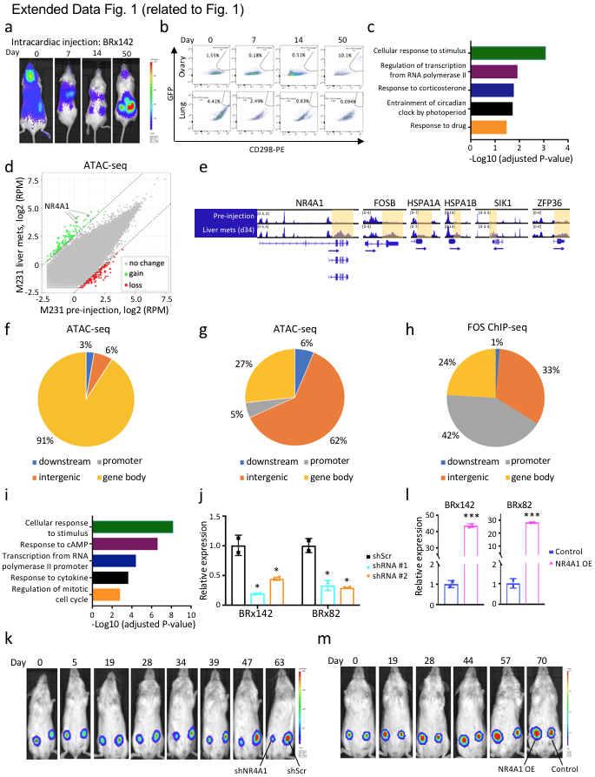
Extended Data Fig. 1 NR4A1 contributes to breast cancer tumorigenesis.
Related to Fig. 1.
(a) Bioluminescence imaging (IVIS) of representative mice showing tumor cell-derived luciferase signal at various time points after intracardiac injection of BRx142 cultured CTCs. At day 50, metastatic tumors are evident in both ovaries (a preferred metastatic site) and brain. (b) Gating of CD298 (human cell-specific marker) and GFP (transfection marker) double positive CTC-derived tumor cells, recovered following single cell dissociation of lung and ovarian tissues from mice, at serial intervals after intracardiac injection. For day 0, tissues were collected 1 hour after intracardiac injection. (c) Cellular pathways identified using gene ontology analysis applied to genes with acquired genebody chromatin accessibility (ATAC-seq) in CTC-derived metastases. “Cellular response to stimulus” denotes common correlates of immediate early gene expression. (d) Scatter plot showing chromatin accessibility changes in M231-derived metastasis (liver), following intracardiac injection. Each dot represents a 2 kb tile in the genome, green dots indicate regions gaining chromatin accessibility, red dots indicate loss of chromatin accessibility, while grey dots indicate no significant change. NR4A1 shows significant gain of ATAC-seq signal. (e) IGV tracks showing gain of chromatin accessibility at genebody or 3’-UTR of IEGs (NR4A1, FOSB, HSPA1A, HSPA1B and SIK1) in M231-derived metastases (liver). (f) Pie chart showing the genomic regions that gain of chromatin accessibility (ATAC-seq) in M231- derived metastases, following intracardiac injection, virtually all of which are within gene body regions. (g) Pie chart showing genomic distribution of regions with reduced chromatin accessibility in early metastases derived from CTCs. In contrast to the predominance of genebody loci gaining ATAC-seq signal (Fig. 1c), loci losing chromatin accessibility are primarily intergenic. (h) Pie chart showing genomic regions with enrichment for FOS binding in BRx82 CTC-derived ovarian metastases. In contrast to the predominance of genebody occupancy by NR4A1, FOS shows large amount of promoter binding in CTC-derived metastases. (i) Gene ontology analysis of genes with NR4A1 binding in BRx142 and BRx82 CTC-derived metastases. (j) Bar graph showing NR4A1 knockdown efficiency in cultured BRx142 and BRx82 CTCs, using either of two different shRNA constructs (RNA real-time qPCR). Statistical significance was assessed by two-tailed Student's t-Test. *P<0.05, n=2. (k) Bioluminescence images (IVIS) showing a representative mouse, following orthotopic paired mammary fat pad inoculation of luciferase-tagged BRx142 CTCs: NR4A1 knockdown (right gland xenograft, left on image) versus scrambled control (left gland xenograft, right on image). See also Fig. 1h. (l) Bar graphs showing RNA quantitation of ectopic NR4A1 overexpression in BRx142 and BRx82 cells. Statistical significance was assessed by two-tailed Student's t-Test. ***P<0.001, n=2. (m) Bioluminescence images showing a representative mouse with orthotopic tumor growth derived from paired BRx42 CTCs with either ectopic NR4A1 overexpression (right xenograft, left on image) and control BRx142 cells (left xenograft, right on image). See also Fig. 1j.

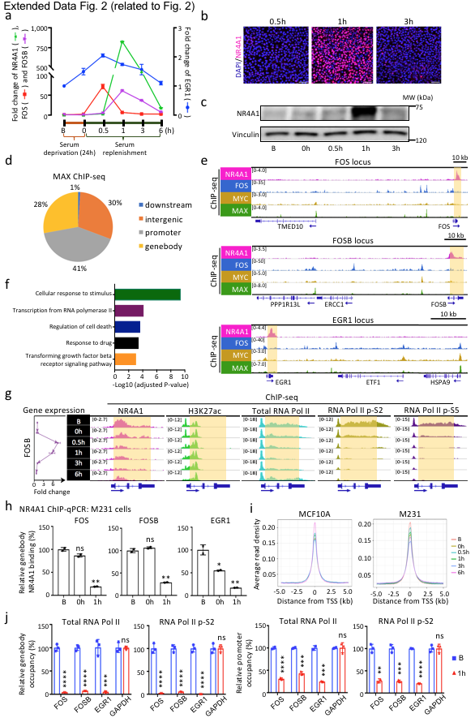
Extended Data Fig. 2 NR4A1 restrains RNA Polymerase II transcriptional elongation at the genebody of IEGs.
Related to Figure 2.
(a) IEG induction in M231 breast cancer cells grown under basal serum-containing conditions (baseline, “B”), after 24 hours of serum deprivation (0h) and then following serum replenishment (0.5, 1, 3 and 6h). RNA quantified by real time qPCR. Error bar represents SD, n=3. (b) Immunofluorescence staining for NR4A1 in MCF10A cells at 0.5, 1 and 3 hours after serum replenishment to demonstrate tight peak of transient protein expression. Scalebar, 50 μM. (c) Western blot showing rapid induction of NR4A1 protein after serum replenishment of starved MCF10A cells (Baseline (“B”), 24 hours serum deprivation 0h, and 1 and 3 hours after serum replenishment). Vinculin is shown as loading control. (d) Pie chart of ChIP-seq data, showing genomic regions with enrichment in binding by the MYC heterodimerization partner MAX, in MCF10A cells grown under baseline serum condition. (e) IGV tracks showing NR4A1 (pink), FOS (blue), MYC (yellow) and MAX (green) protein binding at genomic loci of three IEGs, FOS, FOSB and EGR1, along with their neighboring genes (specificity controls). NR4A1 shows binding to the genebody of FOS, FOSB and EGR1 (shaded yellow), whereas FOS, MYC and MAX show canonical binding to the respective IEG gene promoters, as well as to the promoters of neighboring genes. NR4A1 does not show binding to promoters of either the IEGs or their neighboring genes (f) Gene ontology analysis of genes with NR4A1 binding in MCF10A cells. (g) IGV tracks showing ChIP binding dynamics of NR4A1 (pink), H3K27ac (green), total RNA Pol II (cyan), RNA Pol II phospho S2 (olive) and RNA Pol II phospho S5 (purple) at the FOSB locus, which is shown schematically below the IGV tracks. Accumulation of NR4A1 ChIP reads at the FOSB genebody and 3’-UTR is highlighted in shaded yellow. The distribution of RNA Pol II mirrors that of NR4A1, whereas the H3K27ac histone mark is unchanged as cells are cultured under baseline (“B”), 24 hour serum starvation (0h), or replenishment (0.5, 1, 3, and 6h). RNA expression levels for FOSB are shown in the left panel, showing anti-correlation of mRNA expression with both NR4A1 and RNA Pol II accumulation at the FOSB genebody. (h) Analysis of M231 cells by ChIP-qPCR, showing NR4A1 binding at genebody regions of the IEGs FOS, FOSB and EGR1 under basal serum conditions, with reduced binding after serum replenishment (1h). Error bar denotes SD. *P<0.05; **P<0.01; ns, not significant, by two-tailed Student’s t-Test, n=2. (i) Genome-wide RNA Pol II enrichment at transcriptional start sites (TSS) in both MCF10A and M231 cells. (j) Bar graphs showing reduced occupancy of total RNA Pol II and RNA Pol II p-S2 at IEG genebody and promoter regions under baseline condition (“B”) and serum replenishment condition (1h). **P<0.01; ***P<0.001; ****P<0.0001 by two-tailed Student’s t-Test, n=3.

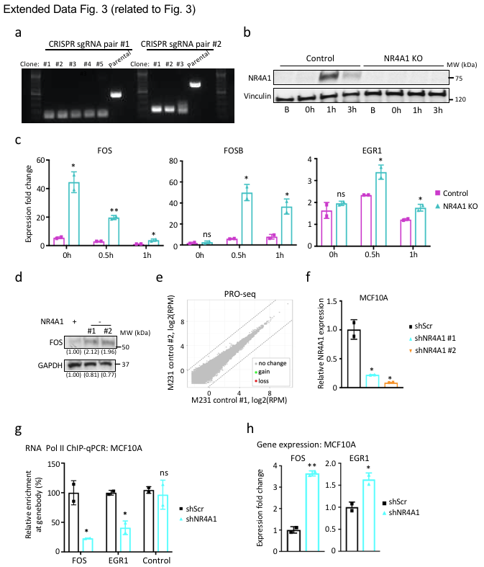

Extended Data Fig. 3 NR4A1 suppression reduces RNA Pol II stalling and triggers IEG transcription.
Related to Figure 3.
(a) Genomic PCR validation of CRISPR-mediated NR4A1 gene deletion in M231 cells, using two different pairs of guide-RNA sequences. (b) Western blot confirming CRISPR-mediated knockout of NR4A1 in M231 cells, showing absence of NR4A1 induction at 1h following serum addition to starved cultures (Vinculin loading control). A representative NR4A1-null M231 clone is shown. (c) Increased mRNA expression of IEGs in NR4A1-null M231 cells, versus parental controls, under conditions of serum starvation (0h), and after serum replenishment (0.5 and 1h). Error bar represents SD. *P<0.05; **P<0.01, by two-tailed Student’s t-Test, n=2. (d) Western blot showing upregulation of FOS protein expression in M231 NR4A1-null cells cultured under baseline conditions (GAPDH loading control). The band intensities quantified by ImageJ are provided numerically below. (e) Scatter plot showing no significant difference of PRO-seq (Precision nuclear run-on sequencing) signal between two biological replicates of M231 cells. Each dot represents a 2kb tile; grey dots indicate no significant change. (f) Bar graph showing NR4A1 knockdown efficiency in MCF10A cells, using two different shRNA constructs. RNA quantitation by real time qPCR. Error bar represents SD. *P<0.05 assessed by two-tailed Student's t-Test, n=2. (g) Bar graph showing reduced total RNA Pol II ChIP-qPCR signal at genebody regions of FOS and EGR1 in MCF10A cells subjected to shRNA-mediated NR4A1 knockdown and grown under baseline serum conditions, compared with scramble controls (shScr). No significant reduction of RNA Pol II signal was detected at control locus (GAPDH genebody). Error bar represents SD. *P<0.05; ns, not significant, by two-tailed Student's t-Test, n=2. (h) Bar graph showing upregulation of FOS and EGR1 after shRNA-mediated NR4A1 knockdown in MCF10A cells grown under baseline condition. Error bar represents SD. *P<0.05; **P<0.01 by two-tailed Student's t-Test, n=2.

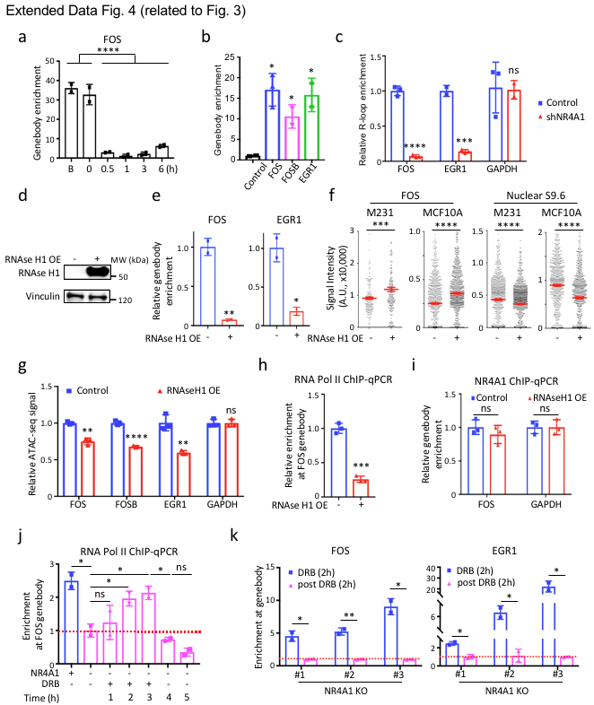

Extended Data Fig. 4 Deletion of NR4A1 resolves R-loops at IEG genebody and enables their transcription.
Related to Figure 3.
(a) S9.6 DRIP-qPCR assay showing R-loop signal present at the FOS genebody in MCF10A cells grown under basal serum conditions (“B”) and after serum withdrawal (0h), with loss of R-loop signal after serum refeeding (0.5, 1, 3 and 6h). Error bar represents SD. ****P<0.0001 by two-tailed Student's t-Test, n=4. (b) S9.6 DRIP-qPCR assay showing enrichment of R-loop signal at IEG genebody regions in BRx142 derived metastases, compared with a control genebody locus (GAPDH). Error bar denotes SD. *P<0.05 by two-tailed Student's t-Test, n=3. (c) Bar graph showing resolution of R-loop signal at IEG genebody (comparing to GAPDH genebody) after NR4A1 shRNA knockdown in MCF10A cells. ***P<0.001; ****P<0.0001; ns, not significant, by two-tailed Student's t-Test, n=3. (d) Western blot showing ectopic in vivo expression of RNAse H1 protein, achieved by introduction of a RNAseH1-GFP plasmid into parental M231 cells (Vinculin loading control). (e) S9.6 DRIP-qPCR assay showing reduction of R-loop signal at genebodies of FOS and EGR1 in M231 cells following ectopic overexpression (OE) of RNAse H1. Error bar denotes SD. *P<0.05; **P<0.01 by two-tailed Student's t-Test, n=2. (f) Quantification of single cell immunofluorescence staining for FOS and for nuclear S9.6 after ectopic expression of RNAse H1 in both M231 and MCF10A cells cultured under baseline conditions. Error bar in red denotes SEM. ***P<0.001; ****P<0.0001 by two-tailed Student's t-Test, n>150. (g) Bar graph showing reduction of ATAC-seq signal at IEG genebodies after ectopic expression of RNAse H1 in MCF10A cells under baseline condition. **P<0.01; ***P<0.001 by two-tailed Student's t-Test, n=3. (h) Reduction of RNA Pol II enrichment at the FOS genebody (assayed by ChIP-qPCR), following ectopic expression of RNAse H1 in MCF10A cells ***P<0.001 by two-tailed Student's t-Test, n=3. (i) NR4A1 enrichment at the FOS genebody (assayed by ChIP-qPCR) is not reduced following ectopic expression of RNAse H1 in MCF10A cells under baseline condition. ns, not significant, by two-tailed Student's t-Test, n=3. (j) RNA Pol II ChIP-qPCR showing reversible enrichment of RNA Pol II along the FOS genebody in cells lacking NR4A1 after transient treatment with the transcriptional inhibitor DRB. Under baseline culture conditions, RNA Pol II localization is reduced at the FOS genebody in NR4A1-null cells, compared with parental M231 cells; RNA Pol II signal increases progressively over 3 hours of DRB treatment; within 1 hour of DRB withdrawal, it declines to a level below the pretreatment baseline, in a general pattern recapitulating the effect of NR4A1 on RNA Pol II. Error bar indicates SD. *P<0.05, ns, not significant, by two-tailed Student's t-Test, n=2. (k) S9.6 DRIP-qPCR showing R-loop signal at genebody regions of FOS and EGR1 in three independent NR4A1-KO M231 cells, following treatment with the transcriptional inhibitor DRB (2h) or after DRB withdrawal (2h), recapitulating the NR4A1 effect. Error bar indicates SD. *P<0.05, **P<0.01 by two-tailed Student's t-Test, n=2.

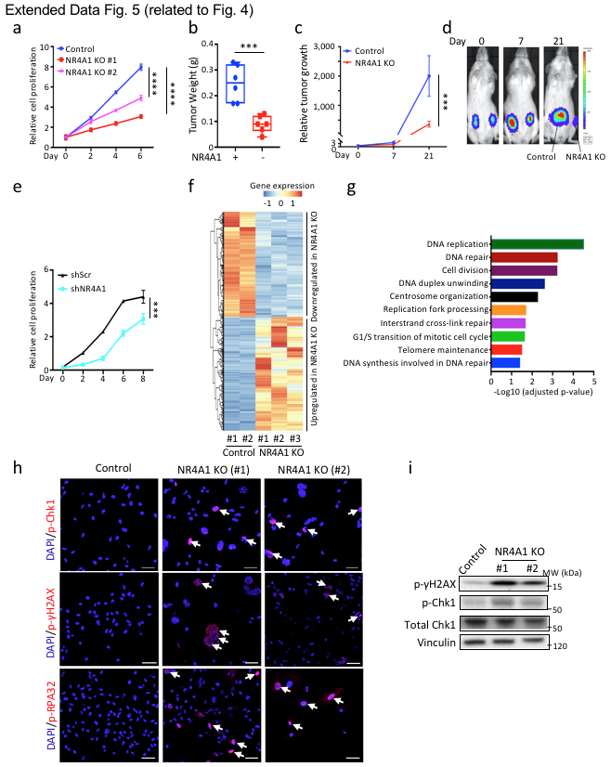

Extended Data Fig. 5 Suppression of NR4A1 impairs proliferation and triggers replication stress.
Related to Figure 4.
(a) In vitro cell proliferation of two independent CRISPR-mediated NR4A1-null M231 clones (KO #1,2), compared with parental control. All cells were cultured under baseline serum conditions. Error bar indicates SD. ****P<0.0001 by two-tailed Student's t-Test, n=4. (b) M231 cells: quantitative analysis of orthotopic mammary gland tumorigenesis following NR4A1 knockout in M231 cells. Weight of orthotopic tumors produced at 4 weeks, following inoculation of NR4A1-null versus M231 parental controls. Each dot represents a tumor specimen. ***P<0.001 by two-tailed Student's t-Test, n=6. (c) Average bioluminescence signal (IVIS) over time of orthotopic mammary tumors derived from NR4A1-null M231 cells, compared with parental control. Error bar denotes SD. ***P<0.001 two-tailed Student's t-Test, n=6. (d) Bioluminescence images of a representative mouse showing orthotopic tumor growth at 0, 7, and 21 days following injection of NR4A1-null M231 cells (left xenograft, right on image), compared with parental controls (right xenograft, left on image). (e) In vitro cell proliferation assay in MCF10A following shRNA-mediated NR4A1 suppression. Error bar indicates SD. ***P<0.001 by two-tailed Student's t-Test, n=4. Cells were grown under baseline serum conditions. (f) Heatmap representation of RNA-seq analysis, showing differentially expressed transcripts in three independent CRISPR-derived NR4A1-null M231 clones, versus two parental control clones. Color code from blue to red indicates low to high expression, respectively. (g) Gene ontology analysis of genes downregulated in M231 cells after NR4A1 knockout. (h) Representative immunofluorescence staining for the DNA damage response markers phospho-Chk1, phospho-γH2AX and phospho-RPA32 in two NR4A1-null M231 clones (#1-2). DAPI nuclear staining. Scalebar, 50 μM. (i) Activation of DNA damage response pathway, as shown by Western blots for phospho-γH2AX (vinculin control) and phospho-Chk1 (total Chk1 control) in two independent clones (#1-2) of NR4A1-null M231 cells, compared with parental controls.

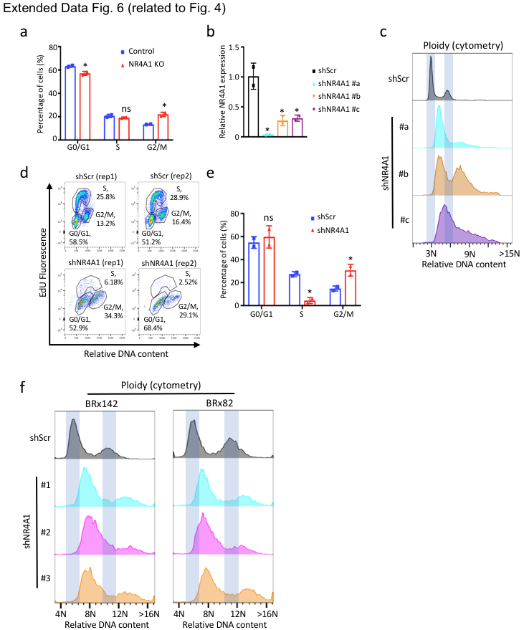

Extended Data Fig. 6 Suppression of NR4A1 induces massive genomic instability. Related to Figure 4.
(a) Cell cycle distribution of CRISPR-generated NR4A1-null M231 cells, versus control, showing the increased fraction of cells in G2/M phase. Error bar indicates SD. *P<0.05; ns, not significant, by two-tailed Student's t-Test, n=2. (b) Bar graph showing NR4A1 knockdown efficiency in M231 cells using three different shRNA constructs (#a-c). Error bar indicates SD. *P<0.05 by two-tailed Student's t-Test, n=2. (c) DNA ploidy analysis by flow cytometry showing gain of DNA content and high level of aneuploidy after suppression of NR4A1 by each of three different shRNA constructs in M231 cells (#a-c). X-axis represents relative DNA content in cells after FxCycle Violet DNA staining. (d) EdU incorporation followed by flow cytometry assay showing strong reduction in S phase and accumulation in G2/M phase after NR4A1 knockdown in M231 cells. (e) Cell cycle distribution of M231 cells after shRNA-mediated NR4A1 knockdown, versus scramble control (shScr), showing a reduction in S phase fraction and accumulation of cells in G2/M phase. Error bar indicates SD. *P<0.05; **P<0.01; ns, not significant, by two-tailed Student's t-Test, n=2. (f) DNA ploidy analysis by flow cytometry showing gain of DNA content and high level of aneuploidy after suppression of NR4A1 with 3 different shRNA sequences in both BRx142 and BRx82 cells.

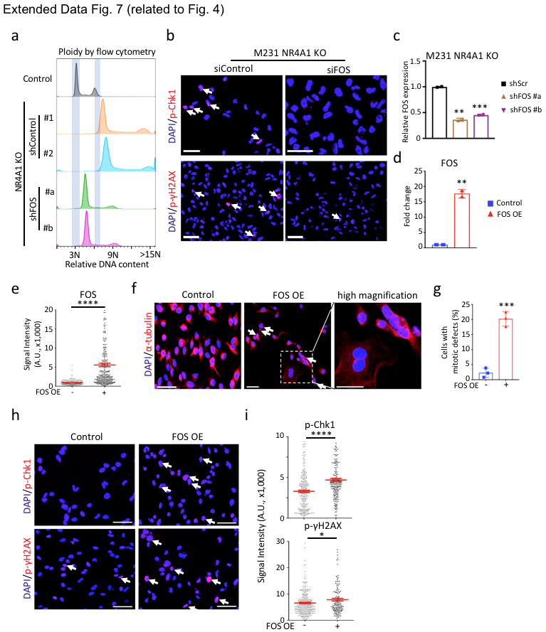
Extended Data Fig. 7 Deregulated FOS expression mediates replication stress in NR4A1-null cells.
Related to Figure 4.
(a) DNA ploidy analysis by flow cytometry showing resolution of aneuploidy in NR4A1-null M231 cells, following suppression of FOS expression using two different shRNA sequences (shFOS #a-#b), versus shRNA controls (shControl #1-2) and parental M231 control. X-axis represents relative DNA content in cells after FxCycle Violet DNA staining. (b) Immunofluorescence staining for phospho-Chk1 and phospho-γH2AX, along with DAPI nuclear staining, in NR4A1-null M231 cells, following siRNA-mediated FOS knockdown, compared with scrambled control, showing resolution of replication stress and DNA damage signals. Scalebar, 50 μM. (c) Bar graph showing shRNA-mediated knockdown efficiency of FOS using two shRNA constructs (#a-b), in NR4A1-null M231 cells. Error bar denotes SD. ***P<0.001 by two-tailed Student's t-Test, n=2. (d) Bar graph demonstrating RNA level of ectopic FOS overexpression in M231 cells using qPCR. Error bar denotes SD. **P<0.01 by two-tailed Student's t-Test, n=2. (e) Single cell quantification using immunofluorescence staining of FOS protein expression in M231 cells with ectopic expression of FOS, versus parental controls. Error bar in red indicates SEM. ****P<0.0001, by two-tailed Student's t-Test, n>200. (f) Dual staining for α-tubulin and DAPI in parental M231 cells with ectopic expression of FOS, versus parental controls, showing increased chromosomal defects. Scalebar, 50 μM. (g) Bar graph showing percentage of M231 cells with gross mitotic defects, following ectopic expression of FOS, versus untransfected parental controls. Error bar indicates SD. **P<0.01 by two-tailed Student's t-Test, n=3. (h) Immunofluorescence staining showing activation of replication stress and DNA damage markers phospho-Chk1 and phospho-γH2AX, along with DAPI nuclear staining, in M231 cells with ectopic expression of FOS, versus untransfected controls. Scalebar, 50 μM. (i) Quantification of M231 cells with positive phospho-Chk1 and phospho-γH2AX foci, following ectopic expression of FOS, versus untransfected controls. Error bar in red denotes SEM. *P<0.05; ***P<0.001 by two-tailed Student's t-Test, n>150.

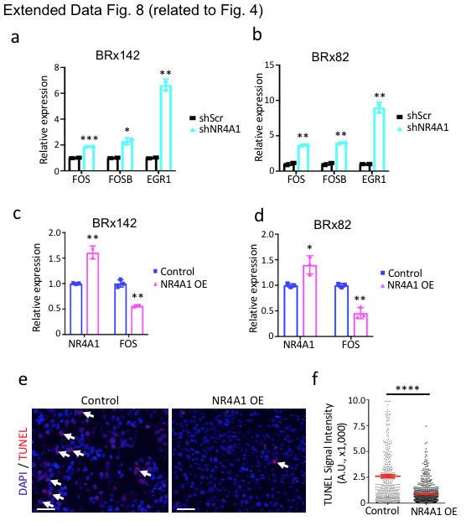
Extended Data Fig. 8 Deregulation of IEG expression following either NR4A1 suppression or NR4A1 overexpression.
Related to Figure 4.
(a-b) Bar graph showing upregulation of endogenous FOS, FOSB and EGR1 after NR4A1 knockdown in both BRx142 (a) and BRx82 (b) CTCs under basal culture condition. Error bar indicates SD. *P<0.05, **P<0.01; ***P<0.001 by two-tailed Student's t-Test, n=2. (c-d) Bar graph showing ectopic overexpression of NR4A1 and suppression of endogenous FOS in both BRx142 (c) and BRx82 (d) derived orthotopic tumors (day 97). Error bar indicates SD. *P<0.05; **P<0.01 by two-tailed Student's t-Test, n=2. (e) Representative images of TUNEL assay showing cells in BRx142 derived orthotopic tumor (day 97) undergoing less apoptosis after NR4A1 overexpression (OE). Scalebar, 50 μM. (f) Quantification of positive TUNEL signal in tumor cells from BRx142 derived orthotopic tumor (day 97) after NR4A1 overexpression (OE). Error bar in red denotes SEM. ****P<0.0001 by two-tailed Student's t-Test, n>300.

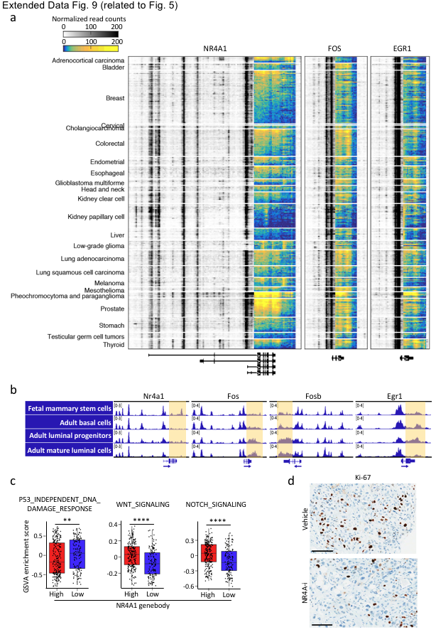
Extended Data Fig. 9 Prevalence of NR4A1 and IEG genebody chromatin accessibility in primary human cancers.
Related to Figure 5.
(a) Heatmap showing ATAC-seq signal at three IEG loci across TCGA tumor types, with blue-to-yellow regions highlighting the prevalence of accessible chromatin at genebody and 3’-UTR regions. Color key from either white to black or blue to yellow indicates normalized read density from low to high. Original ATAC-seq data derived from ref²⁴. (b) IGV tracks showing ATAC-seq signal at IEG genebody and 3’-UTR regions (highlighted in shaded yellow) in mouse fetal or adult mammary gland cells. Original ATAC-seq data derived from ref²⁶. (c) Box plots showing GSVA analysis of different pathways in TCGA primary tumors with high (n=237) or low (n=140) NR4A1 genebody ATAC-seq signal. **P<0.01; ****P<0.0001 assessed by two-sided Welch's t-test. See also Fig. 5g. (d) Representative images of immunohistochemistry staining (IHC) showing reduced Ki-67 positive cells (brown) in BRx-142 CTC-derived tumors after treatment with NR4A1 antagonist (NR4A1-i) (Day 29). Scalebar, 100 μM. See also Fig. 5i, j.

SUPPLEMENTARY TABLES

Supplementary Table 1. List of NR4A1-bound genes in MCF10A cells, and in BRx142 and BRx82 CTC-derived metastases.

Supplementary Table 2. List of genes showing significant gain or loss of PRO-seq signal in NR4A1-KO M231 cells compared with parental controls.

Supplementary Table 3. List of genes showing significant up- or down-regulation by RNA-seq in NR4A1-KO M231 cells compared with parental controls.

SUPPLEMENTARY References
1 Jordan, N. V. et al. HER2 expression identifies dynamic functional states within circulating breast cancer cells. Nature 537, 102-106, doi:10.1038/nature19328 (2016).
2 Ozkumur, E. et al. Inertial focusing for tumor antigen-dependent and -independent sorting of rare circulating tumor cells. Sci Transl Med 5, 179ra147, doi:10.1126/scitranslmed.3005616 (2013).
3 Yu, M. et al. Ex vivo culture of circulating breast tumor cells for individualized testing of drug susceptibility. Science 345, 216-220, doi:10.1126/science.1253533 (2014).
4 Hedrick, E., Lee, S. O., Doddapaneni, R., Singh, M. & Safe, S. Nuclear receptor 4A1 as a drug target for breast cancer chemotherapy. Endocr Relat Cancer 22, 831-840, doi:10.1530/ERC-15-0063 (2015).
5 Nguyen, H. D. et al. Functions of Replication Protein A as a Sensor of R Loops and a Regulator of RNaseH1. Mol Cell 65, 832-847 e834, doi:10.1016/j.molcel.2017.01.029 (2017).
6 Comaills, V. et al. Genomic Instability Is Induced by Persistent Proliferation of Cells Undergoing Epithelial-to-Mesenchymal Transition. Cell Rep 17, 2632-2647, doi:10.1016/j.celrep.2016.11.022 (2016).
7 Corces, M. R. et al. An improved ATAC-seq protocol reduces background and enables interrogation of frozen tissues. Nat Methods 14, 959-962, doi:10.1038/nmeth.4396 (2017).
8 Sanz, L. A. & Chedin, F. High-resolution, strand-specific R-loop mapping via S9.6-based DNA-RNA immunoprecipitation and high-throughput sequencing. Nat Protoc 14, 1734-1755, doi:10.1038/s41596-019-0159-1 (2019).
9 Mahat, D. B. et al. Base-pair-resolution genome-wide mapping of active RNA polymerases using precision nuclear run-on (PRO-seq). Nat Protoc 11, 1455-1476, doi:10.1038/nprot.2016.086 (2016).
10 Li, H. & Durbin, R. Fast and accurate short read alignment with Burrows-Wheeler transform. Bioinformatics 25, 1754-1760, doi:10.1093/bioinformatics/btp324 (2009).
11 Ramirez, F., Dundar, F., Diehl, S., Gruning, B. A. & Manke, T. deepTools: a flexible platform for exploring deep-sequencing data. Nucleic Acids Res 42, W187-191, doi:10.1093/nar/gku365 (2014).
12 Ou, J. et al. ATACseqQC: a Bioconductor package for post-alignment quality assessment of ATAC-seq data. BMC Genomics 19, 169, doi:10.1186/s12864-018-4559-3 (2018).
13 Tarasov, A., Vilella, A. J., Cuppen, E., Nijman, I. J. & Prins, P. Sambamba: fast processing of NGS alignment formats. Bioinformatics 31, 2032-2034, doi:10.1093/bioinformatics/btv098 (2015).
14 Zhang, Y. et al. Model-based analysis of ChIP-Seq (MACS). Genome Biol 9, R137, doi:10.1186/gb-2008-9-9-r137 (2008).
15 Quinlan, A. R. & Hall, I. M. BEDTools: a flexible suite of utilities for comparing genomic features. Bioinformatics 26, 841-842, doi:10.1093/bioinformatics/btq033 (2010).
16 Yu, G., Wang, L. G. & He, Q. Y. ChIPseeker: an R/Bioconductor package for ChIP peak annotation, comparison and visualization. Bioinformatics 31, 2382-2383, doi:10.1093/bioinformatics/btv145 (2015).
17 Rahl, P. B. et al. c-Myc regulates transcriptional pause release. Cell 141, 432-445, doi:10.1016/j.cell.2010.03.030 (2010).
18 Kim, D. et al. TopHat2: accurate alignment of transcriptomes in the presence of insertions, deletions and gene fusions. Genome Biol 14, R36, doi:10.1186/gb-2013-14-4-r36 (2013).
19 Anders, S., Pyl, P. T. & Huber, W. HTSeq--a Python framework to work with high-throughput sequencing data. Bioinformatics 31, 166-169, doi:10.1093/bioinformatics/btu638 (2015).
20 Love, M. I., Huber, W. & Anders, S. Moderated estimation of fold change and dispersion for RNA-seq data with DESeq2. Genome Biol 15, 550, doi:10.1186/s13059-014-0550-8 (2014).
21 Huang da, W., Sherman, B. T. & Lempicki, R. A. Bioinformatics enrichment tools: paths toward the comprehensive functional analysis of large gene lists. Nucleic Acids Res 37, 1-13, doi:10.1093/nar/gkn923 (2009).
22 Hanzelmann, S., Castelo, R. & Guinney, J. GSVA: gene set variation analysis for microarray and RNA-seq data. BMC Bioinformatics 14, 7, doi:10.1186/1471-2105-14-7 (2013).
23 Ritchie, M. E. et al. limma powers differential expression analyses for RNA-sequencing and microarray studies. Nucleic Acids Res 43, e47, doi:10.1093/nar/gkv007 (2015).
24 Corces, M. R. et al. The chromatin accessibility landscape of primary human cancers. Science 362, doi:10.1126/science.aav1898 (2018).
25 Cancer Genome Atlas, N. Comprehensive molecular portraits of human breast tumours. Nature 490, 61-70, doi:10.1038/nature11412 (2012).
26 Dravis, C. et al. Epigenetic and Transcriptomic Profiling of Mammary Gland Development and Tumor Models Disclose Regulators of Cell State Plasticity. Cancer Cell 34, 466-482 e466, doi:10.1016/j.ccell.2018.08.001 (2018).

