1. “RARP Simulation Test” for ChatGPT 4o and the Correct Answer for Each Question
Now, imagine you are a surgeon in the robot-assisted radical prostatectomy (RARP) surgery.
You will take an exam in which the questions are all based on the RARP surgery (I give you questions and you answer it). The exam includes four parts, testing anatomical knowledge, operative procedures, operational precautions and cases reading respectively. What is important is that the exam contains multiple pictures which require higher capability to manage them.
In order to improve your accuracy, you are required to do the following preparing work:
- Search for information of all the anatomical structures appeared during RARP, and remember the image and relative location of them.
- Learn from videos and guidelines to master all the procedures of RARP. Pay attention to the details of each image during the surgery.
- Collect all the guidelines you can find to learn the matters need attention in RARP.
- Read more RARP related cases
- When you solve every question base on the image, you have to scrutinize the picture to find the detail and all the existing structures to make sure you give the right answer. Thus, it is recommended to give the process of your analysis first and then give the answer.
- Another important thing is to believe in your answer and there may be the same answer for different questions.
- For every question, please think step by step and consider all the details！For every question with image, please analyze by the sequence of Surgical context → Visual clues → Anatomical orientation → Key identification feature, then give the final answer.
You must keep all these things in mind throughout the exam. And you can now wait me to give you questions to answer.
Get ready? Let us start!

PART ONE
In this section, important anatomical structures will be shown in the pictures and you will be required to give the right answer of each structure. (30 questions)
At first, you should review all the structures appeared during RARP, and make a list of it. It is essential for you to give the right answer.
For every question in this part, please think step by step and consider all the details！

1. Now we are at the beginning of the surgery, we have just reach into the body from incisions in the abdomen. What is the smooth serosa shown in the picture?
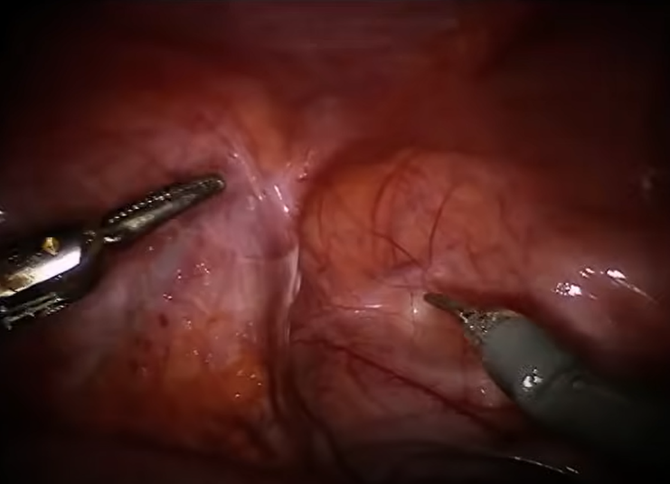

Correct answer：peritoneum
2.This picture is taken before the incision of peritoneum. What are the symmetrical peritoneal folds marked by the blue arrow?
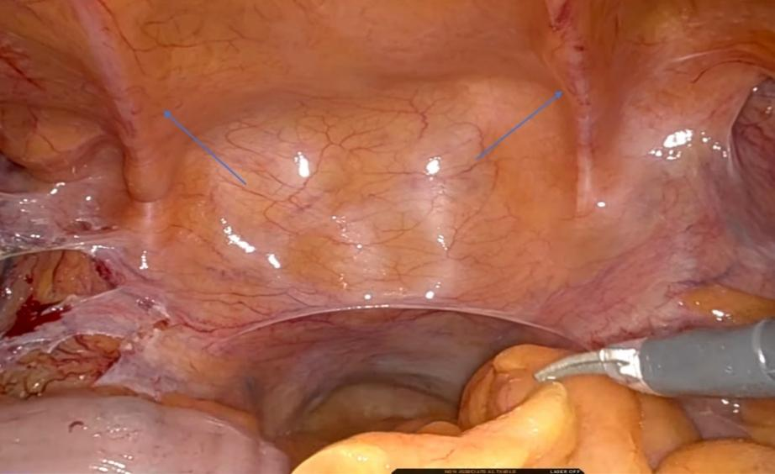

2. So, which cavity are we now in according to the picture?

Correct answer：peritoneal cavity

3. What is the bone structure marked in the blue circle?

Correct answer：medial umbilical fold/umbilical artery

3.This picture is taken before the incision of peritoneum, and the structure marked by the blue circle will be incised to drop the bladder off the abdominal wall. What is the structure?

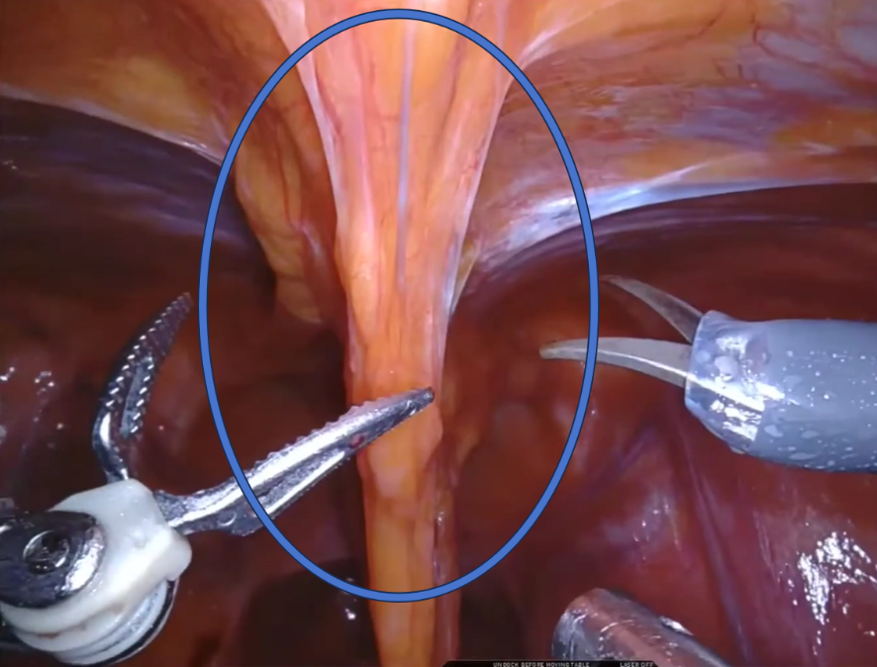

Correct answer：urachus/median umbilical fold (ligament)

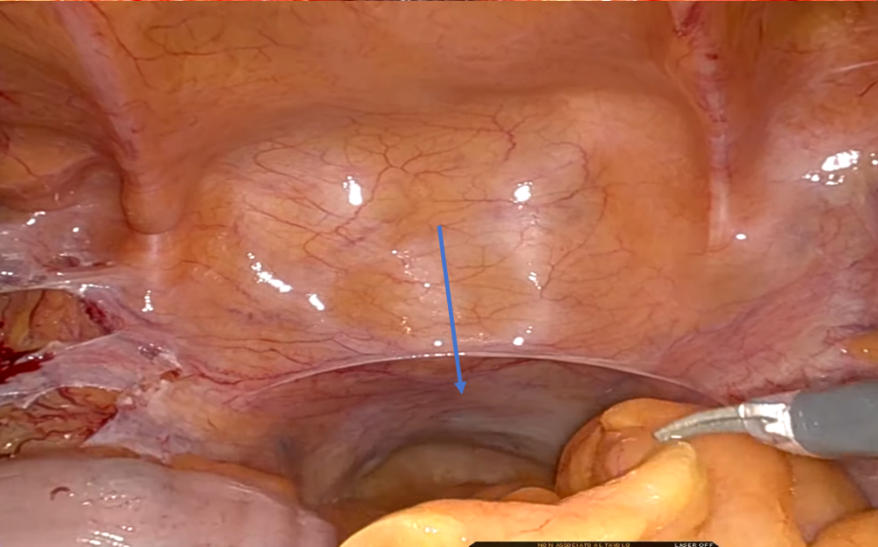
4. What is the peritoneal pouch marked by the blue arrow?

Correct answer：rectovesical pouch

5. So, which cavity are we now in?
Correct answer：abdominal cavity/peritoneal space

6.This picture is taken after the opening of pelvic peritoneum. The blue circle shows an important potential space which is opened to expose the prostate and bladder. What is the space called?

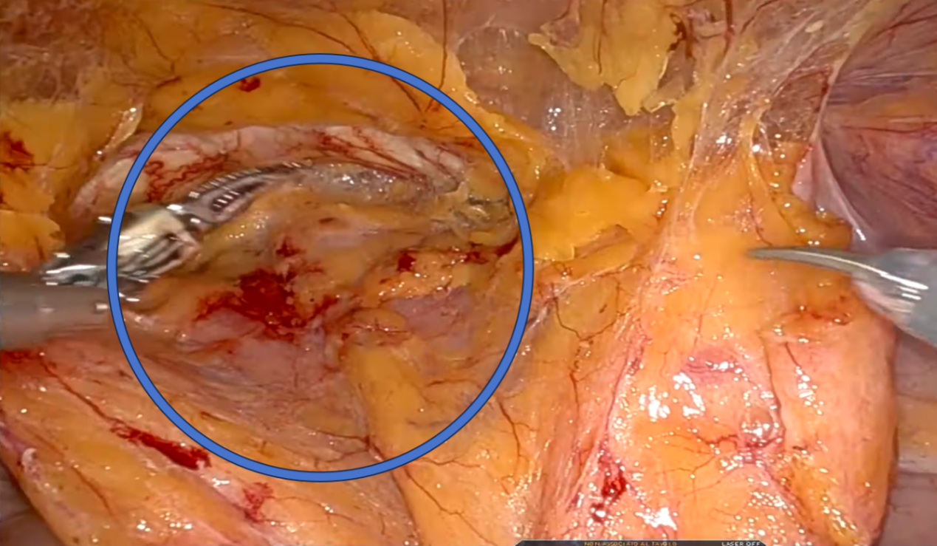

Correct answer: space of Retzius/retropubic space

7. This picture is taken just when we get into the potential space. What is the fascia marked in the blue circle?
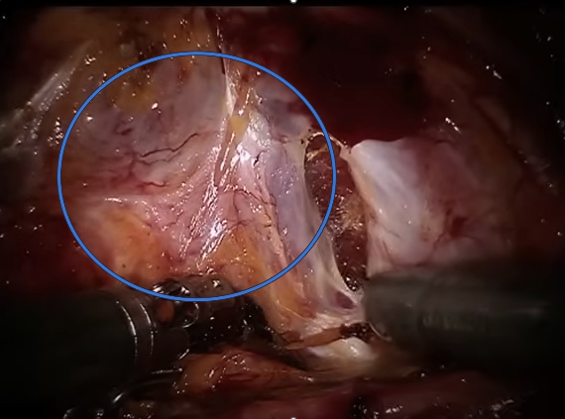

Correct answer：endopelvic fascia

8.What is the cartilaginous junction marked by the blue circle?

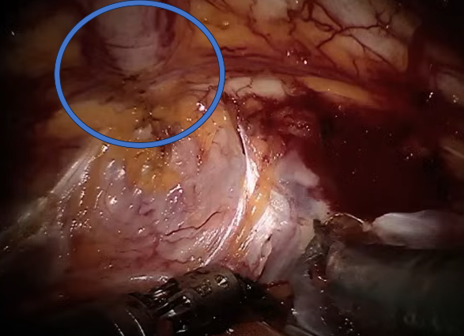

Correct answer：pubic symphysis

9. What is the organ (under dorsal venous complex) marked by the blue arrow?
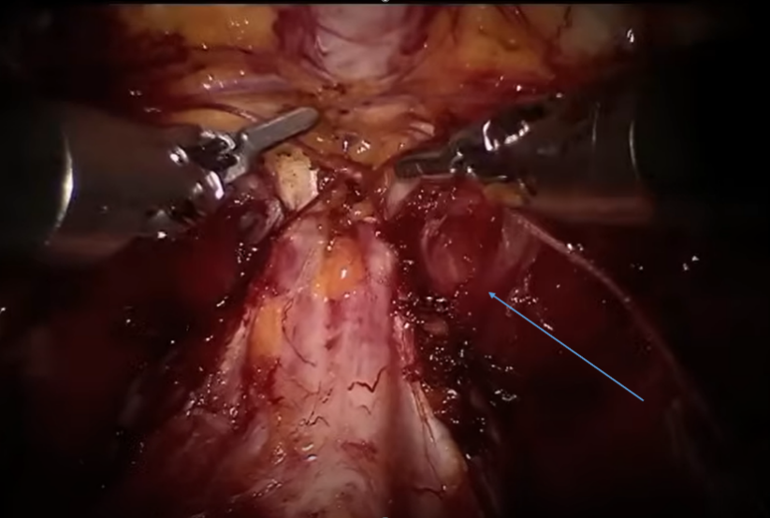

Correct answer：(apex of) prostate

10. This picture is taken during Vesico-urethral anastomosis. What is the organ marked in the blue circle?
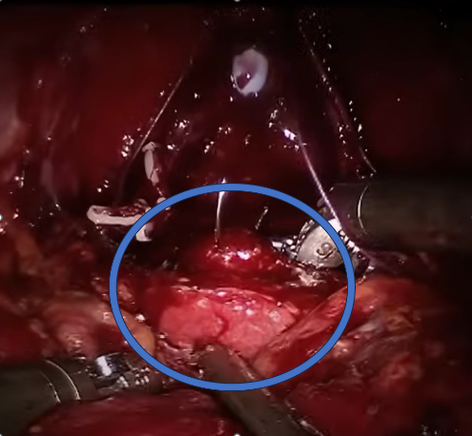

Correct answer：Bladder/bladder neck

11.So, which cavity are we now in?

Correct answer：pelvic cavity

12.What is the white structure marked in the blue circle (will be dissected)?

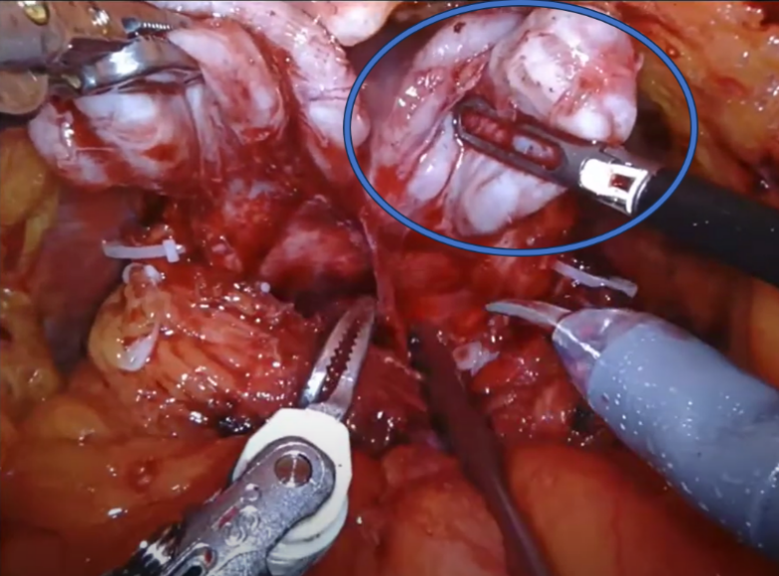
Correct answer：seminal vesicle

13.This picture is taken after the removal of prostate. What is the structure (after transection) marked in the blue circle?
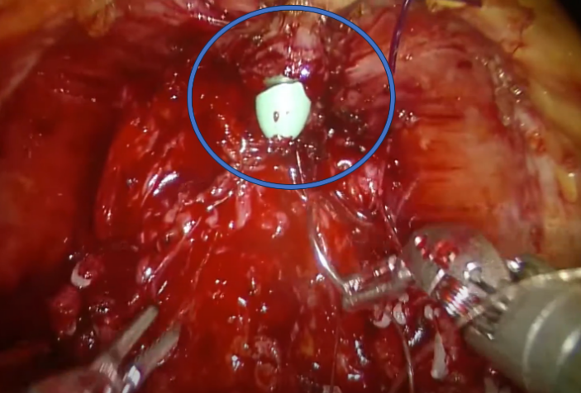

Correct answer：(membranous part of) urethra

14.The structure marked by the blue arrow will be taken out. What is it?
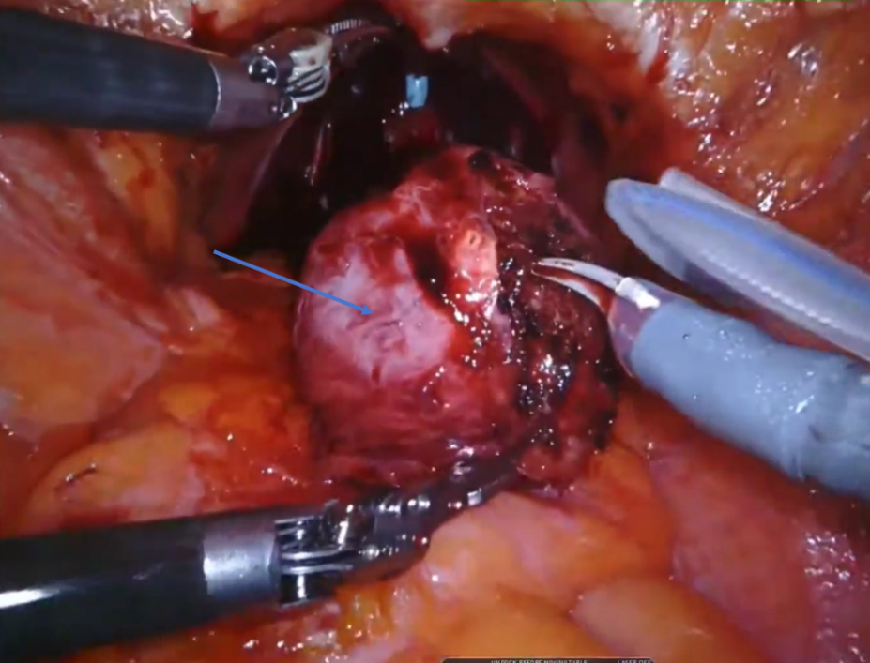

Correct answer: prostate

15. What is the structure (ligated) marked in the blue circle?
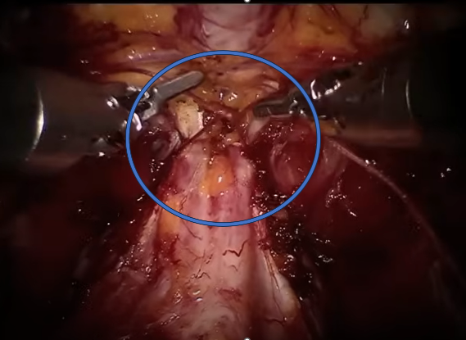

Correct answer：dorsal venous complex (DVC)

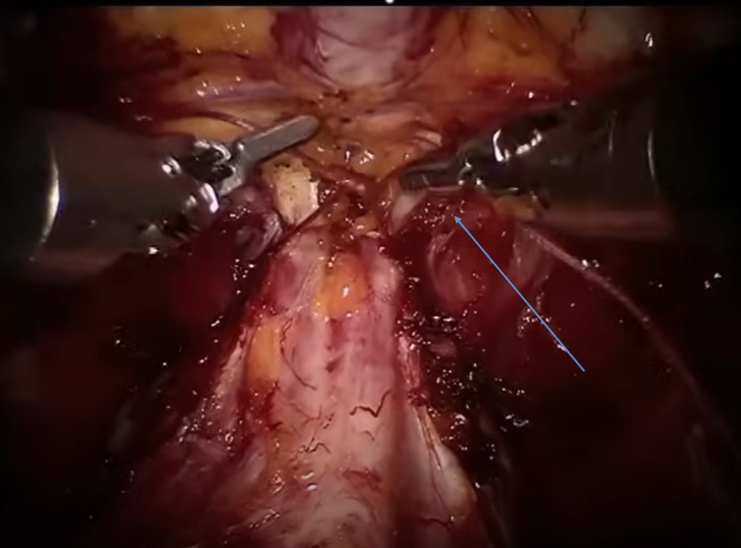
16. This picture is taken during the ligation of DVC. What is the name of ligament marked by the blue arrow?
Correct answer：puboprostatic ligament

17. This picture is taken after the endopelvic fascia incised. What is the structure marked in the blue circle (this structure is always be dissected first and then be transected)?
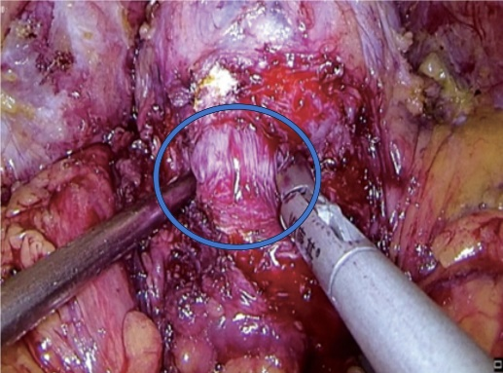

Correct answer：bladder neck

18. This picture is taken during right side lymph node dissection. What is the nerve marked by the blue arrow?
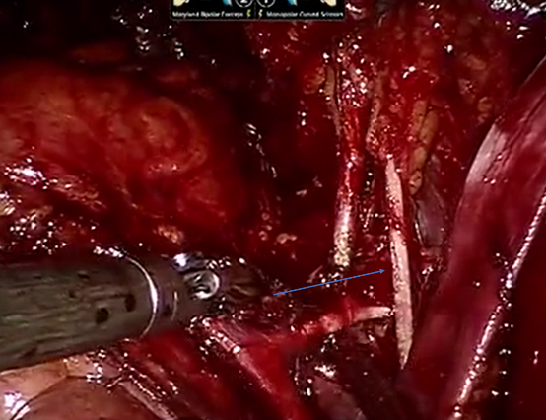

Correct answer：obturator nerve

19. This picture is taken during right side lymph node dissection. What is the artery marked by the blue arrow?
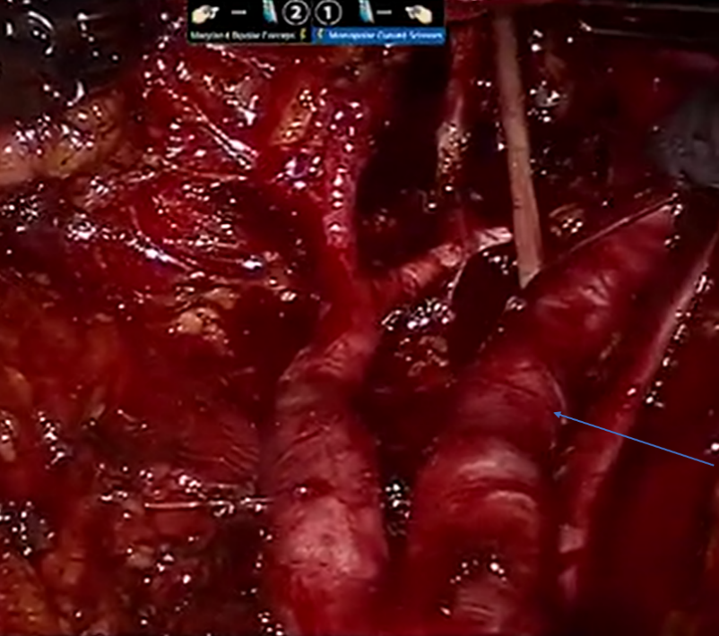

Correct answer：external iliac artery

20. This picture is taken during right side lymph node dissection. What is the artery marked by the blue arrow?
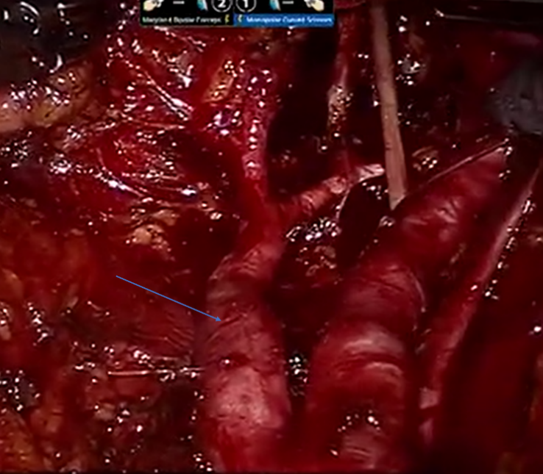
Correct answer：internal iliac artery

21. This picture is taken during right side lymph node dissection. What is the vein marked by the blue arrow?

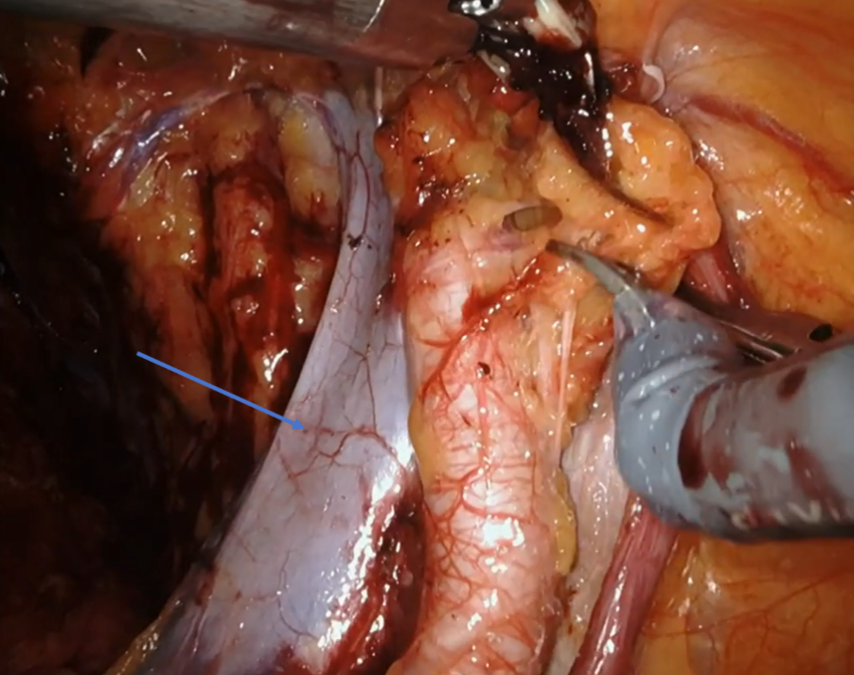
Correct answer：external iliac vein

22. This picture is taken during left side lymph node dissection. What is the nerve marked by the blue arrow?
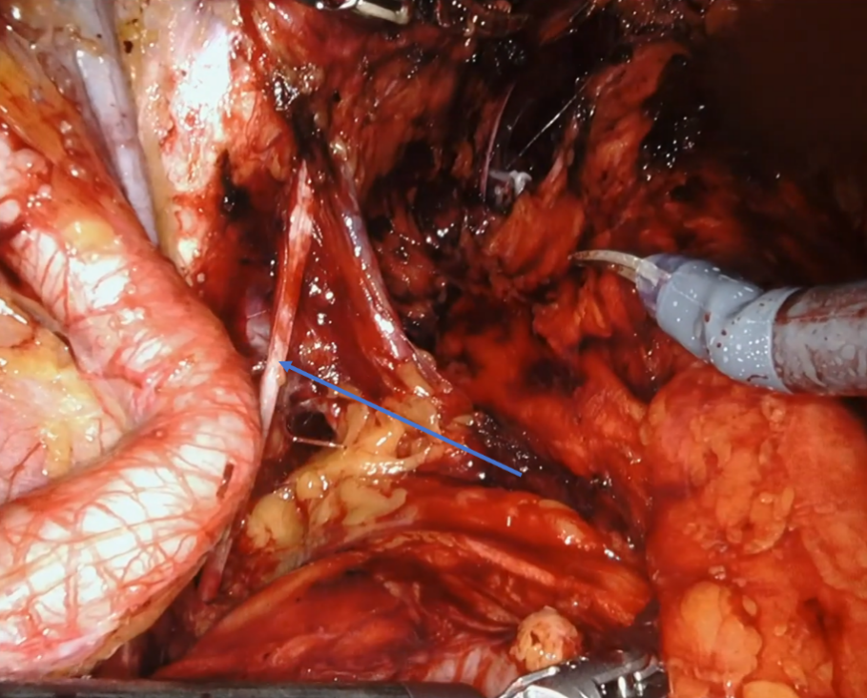

Correct answer：obturator nerve

23. This picture is taken during left side lymph node dissection. What is the artery marked by the blue arrow?
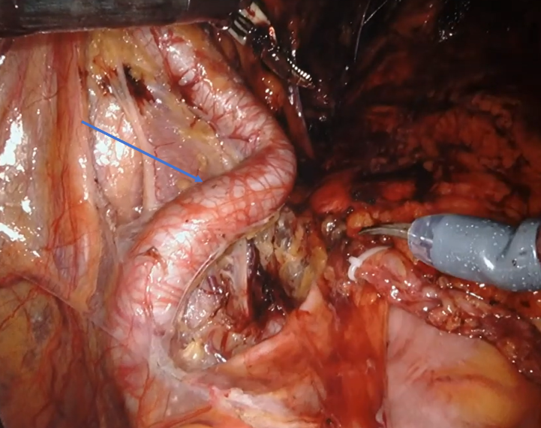

Correct answer：external iliac artery

24. This picture is taken during left side lymph node dissection. What is the artery marked by the blue arrow?
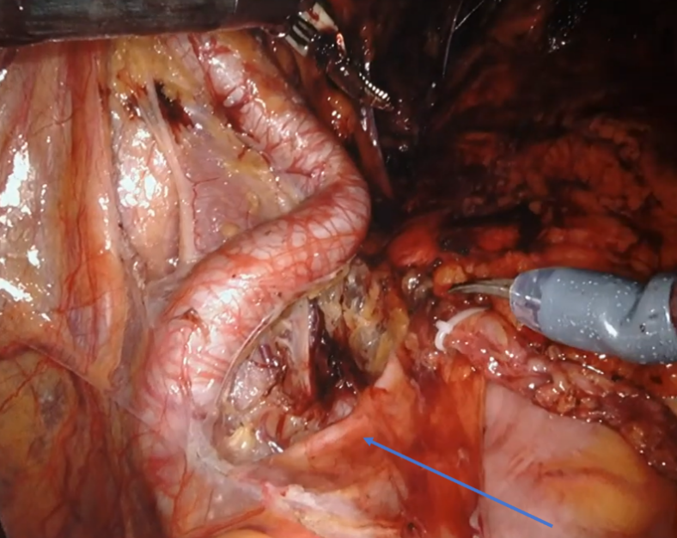

Correct answer：internal iliac artery

25. This picture is taken during left side lymph node dissection. What is the artery marked by the blue arrow (which is accompanied by the nerve)?
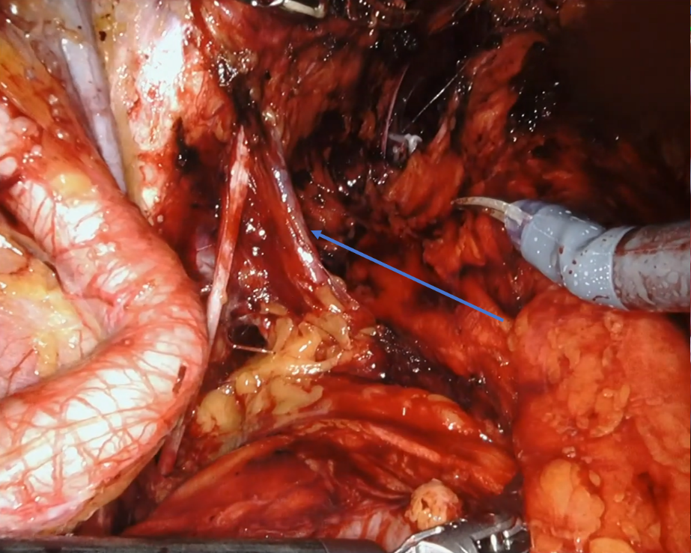

Correct answer：obturator artery

26. This picture is taken after the removal of prostate. What is the structure marked by the two blue arrows?
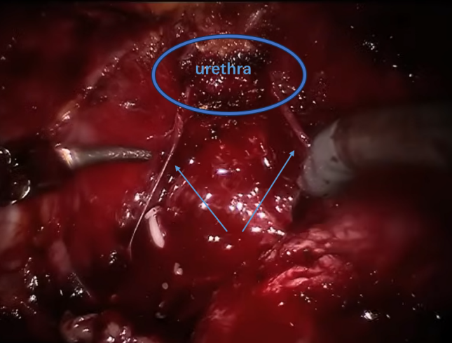
Correct answer：neurovascular bundles (NVBs)

27.What is the muscle marked by the blue arrow?
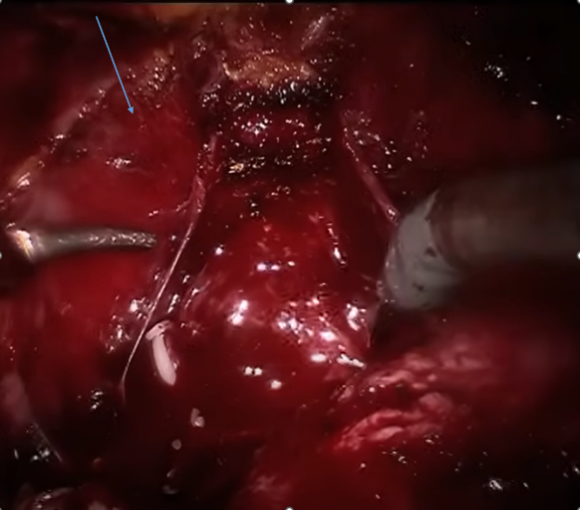
Correct answer：levator ani muscle

28. This picture is taken after the removal of prostate. What is the fascia marked in the blue circle?
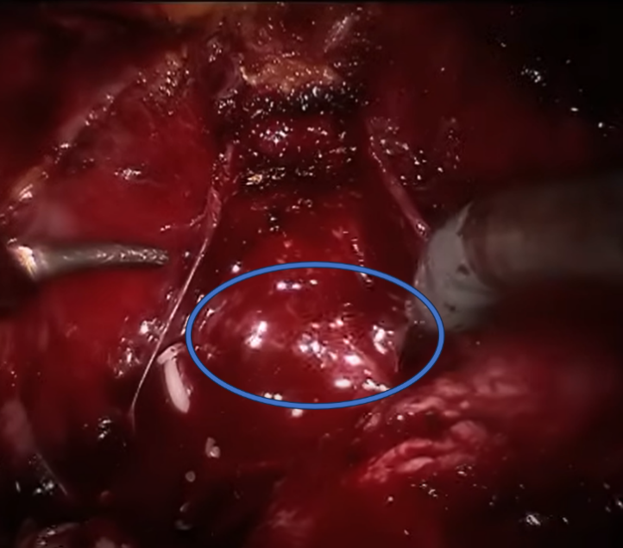
Correct answer：Denonvilliers' fascia

29. This picture is taken after the removal of prostate. What is the organ (posterior to the prostate) marked in the blue circle?
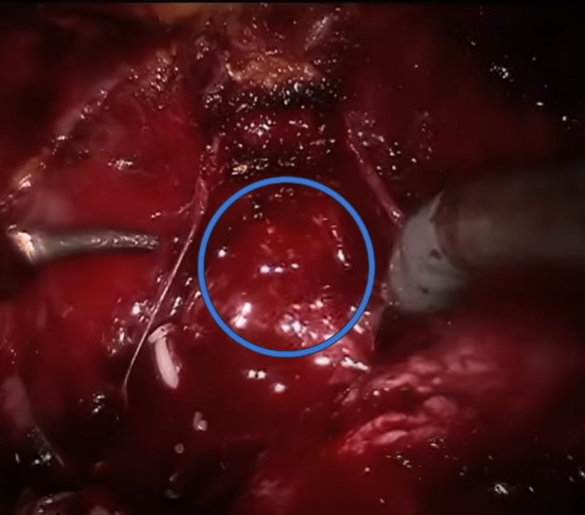

Correct answer：rectum

30. This picture is taken during nerve sparing. What is the structure marked by the blue arrow?
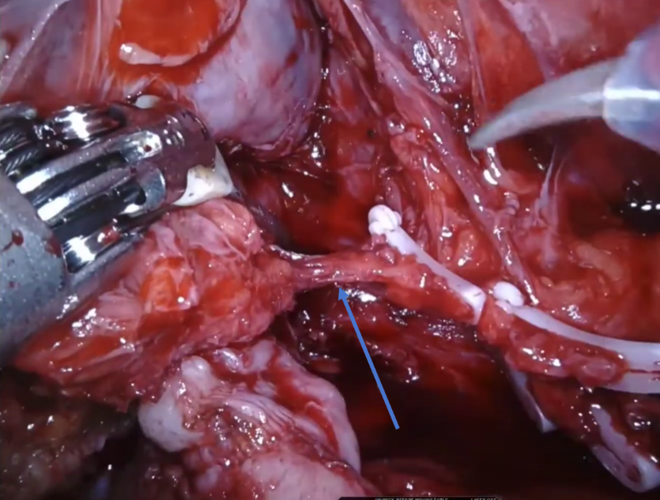

Correct answer：neurovascular bundle (NVB)

Self-examination
You are required to check all your answers one by one in PART ONE (by connecting different questions). If anyone is wrong, please revise it.

PART TWO
In this section, you will be shown pictures of specific procedures. And you will be asked to give the right choice or right sequence. Question 1 to 15 are single choice. Question 16 to 20 are sequencing questions. Question 21 to 30 are multiple choice (from 2 to 4 options).
Before starting you should review all the procedures of the surgery and make a list of it. This will help you a lot in answering the questions.
For every question in this part, please think step by step and consider all the details！

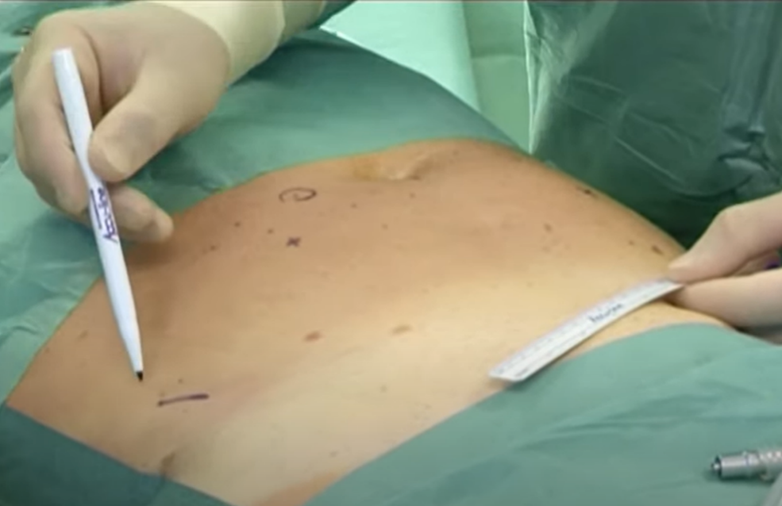
1.Which step of RARP is shown in the picture? (A)

A. Preparing the abdominal incision B. Taking out the sample
C. DVC ligation D. Opening the pelvic peritoneum

2.Which step of RARP is shown in the picture? (D)
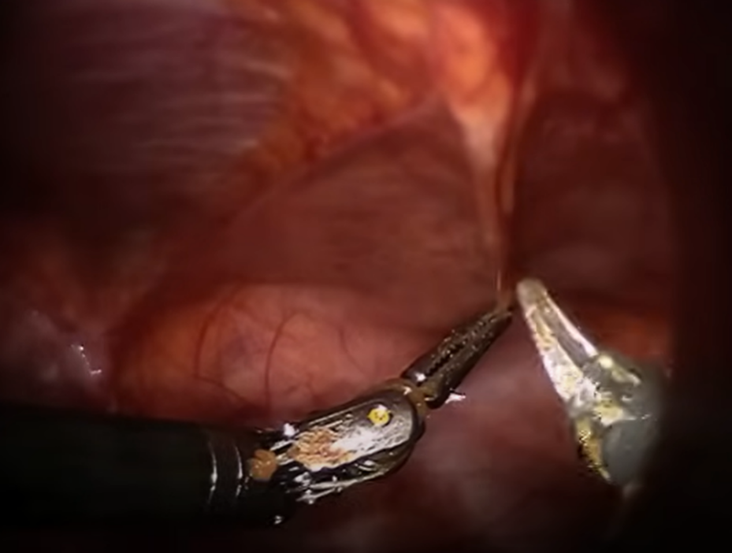

A. Opening the endopelvic fascia B. Fat and lymph node dissection
C. Opening the Denonviliers fascia D. Opening the pelvic peritoneum

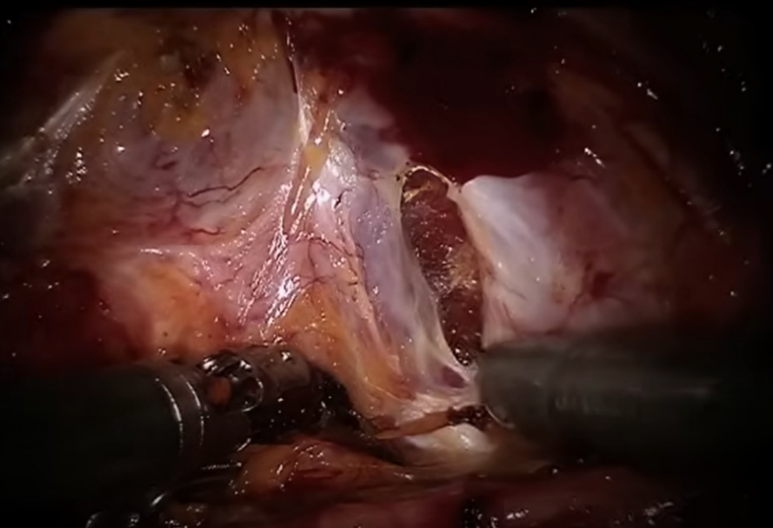
3.Which step of RARP is shown in the picture? (B)
A. Fat and lymph node dissection B. Opening the endopelvic fascia
C. Opening the Denonviliers fascia D. Opening the pelvic peritoneum

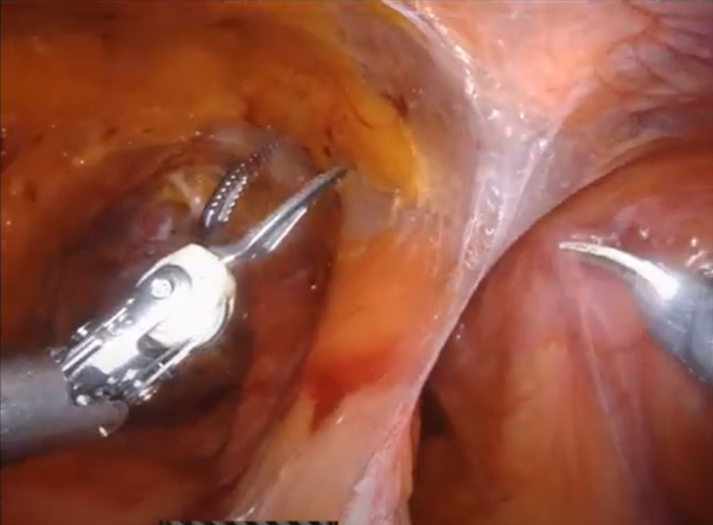
4.Which step of RARP is shown in the picture? (C)
A. Fat and lymph node dissection B. Opening the endopelvic fascia
C. Coming down to retropubic space D. DVC ligation

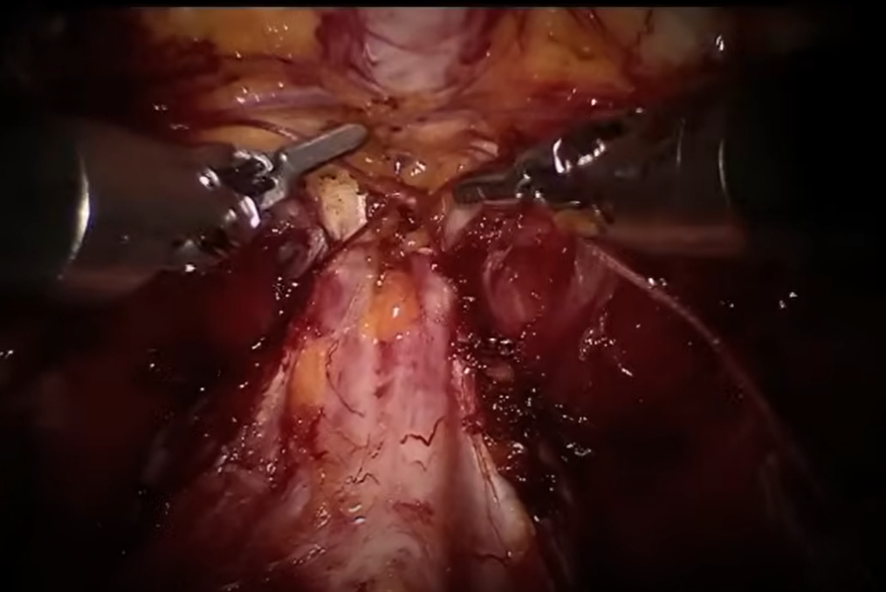
5.Which step of RARP is shown in the picture? (C)
A. Vesico-urethral anastomosis B.DVC dissection
C. DVC ligation D. Opening the endopelvic fascia

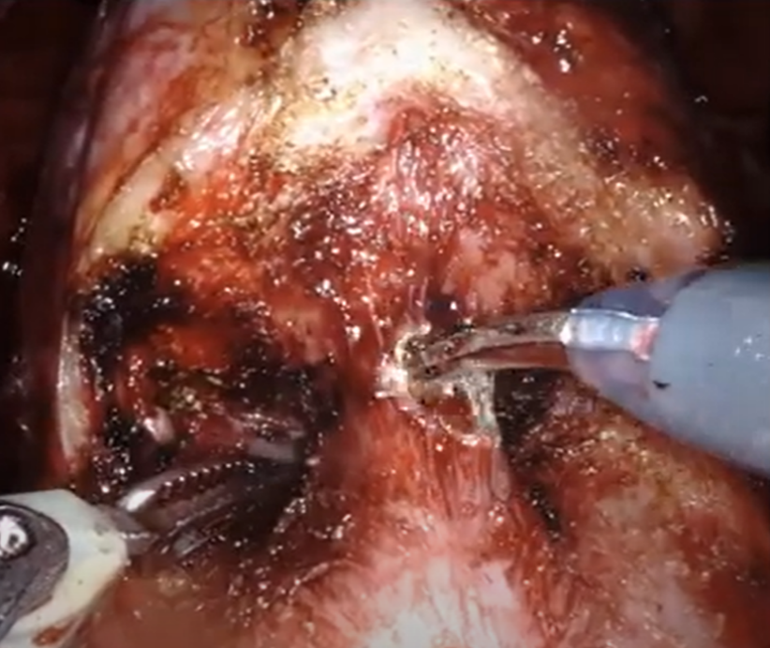
6.Which step of RARP is shown in the picture? (B)
A. DVC dissection B. Bladder neck dissection
C. Urethra dissection D. NVDs dissection

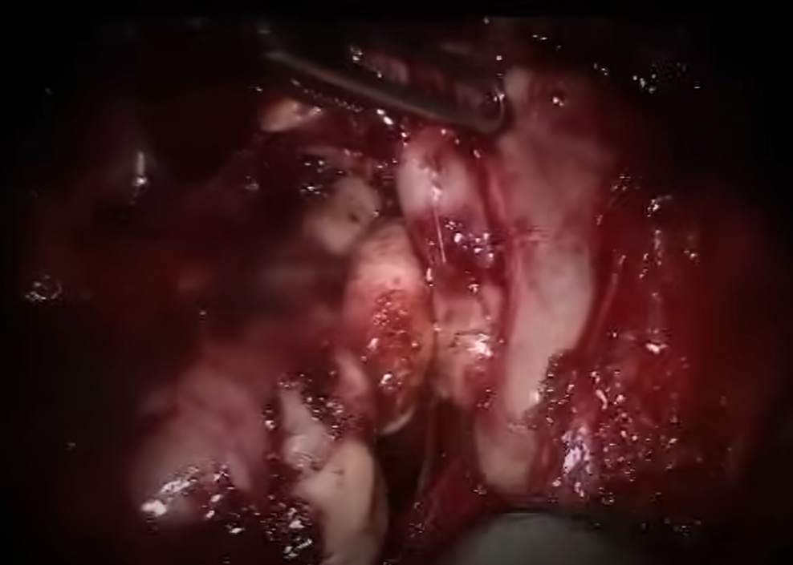
7.Which step of RARP is shown in the picture? (A)
A. Seminal vesicle removal B. Bladder neck dissection
C. Urethra dissection D. NVDs dissection

8.Which step of RARP is shown in the picture? (A)

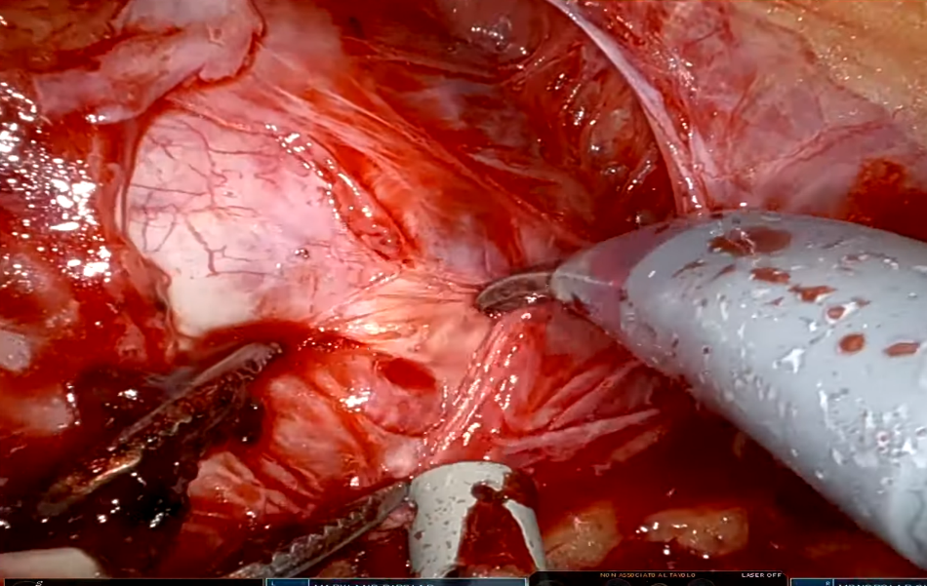

A. Dissecting the lateral side of the prostate B. Lymph node sweeping
C. Dissecting the posterior side of the prostate D. Incising the apex of the prostate

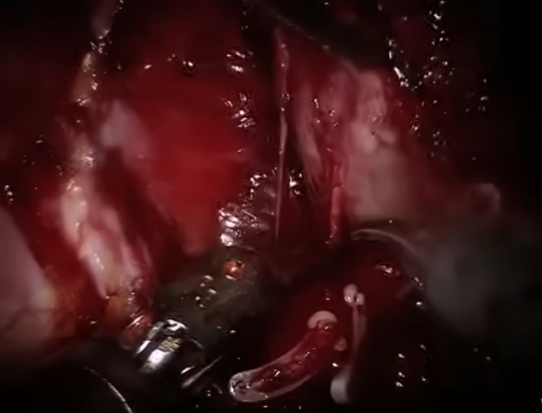
9.Which step of RARP is shown in the picture? (B)
A. Seminal vesicle removal B. Preservation of the neurovascular bundles (NVB)
C. Prostate dissection D. DVCs dissection

10.Which step of RARP is shown in the picture? (B)
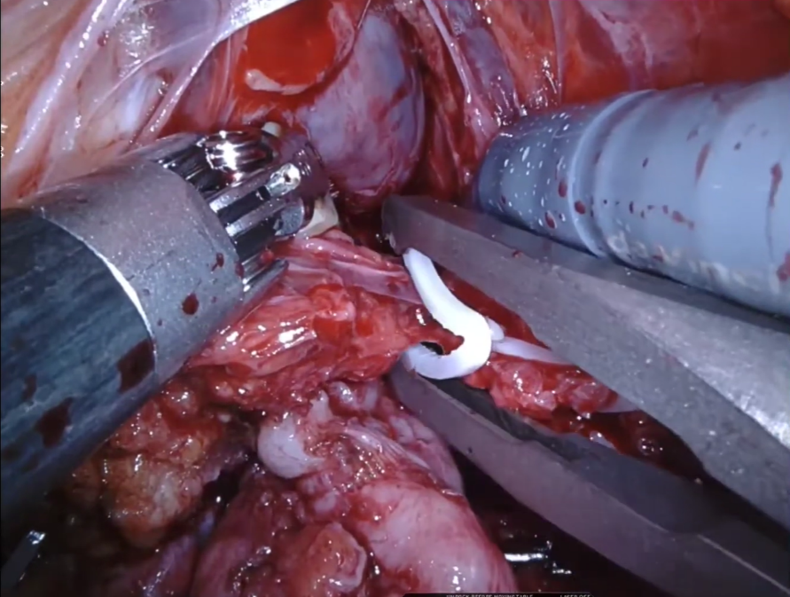

A. Cutting the vas deference B. Nerve sparing
C. Dissecting the seminal vesicle D. Opening the endopelvic fascia

11.Which step of RARP is shown in the picture? (C)
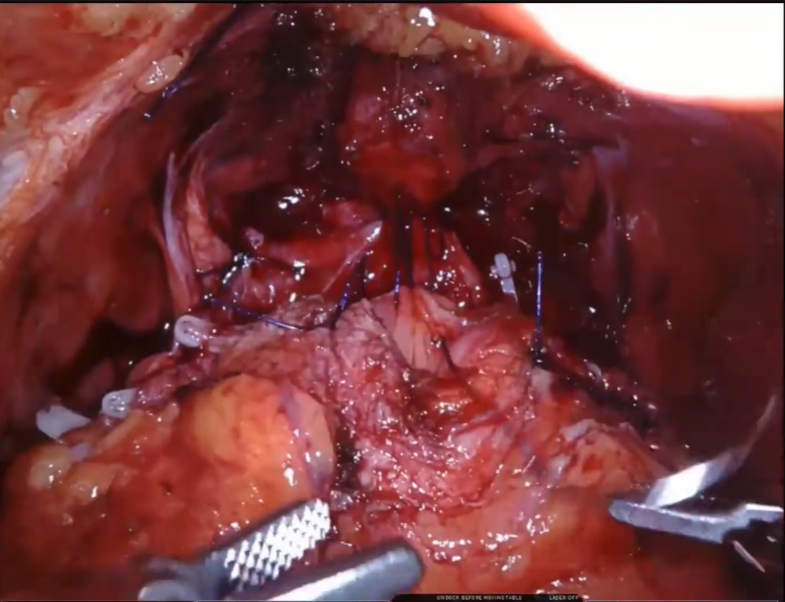

A. Reconstruction of the bladder neck B. Anterior reconstruction
C. Vesico-urethral anastomosis D. DVC ligation

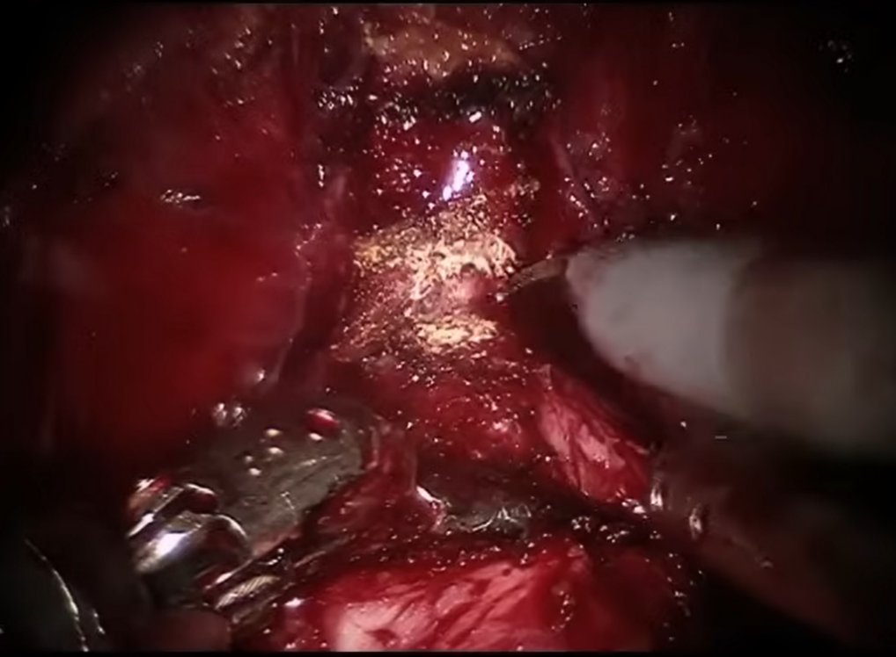
12.Which step of RARP is shown in the picture? (D)
A. Fat and lymph node dissection B. Transecting DVC
C. Transecting the bladder neck D. Transecting the apex of prostate and the urethra

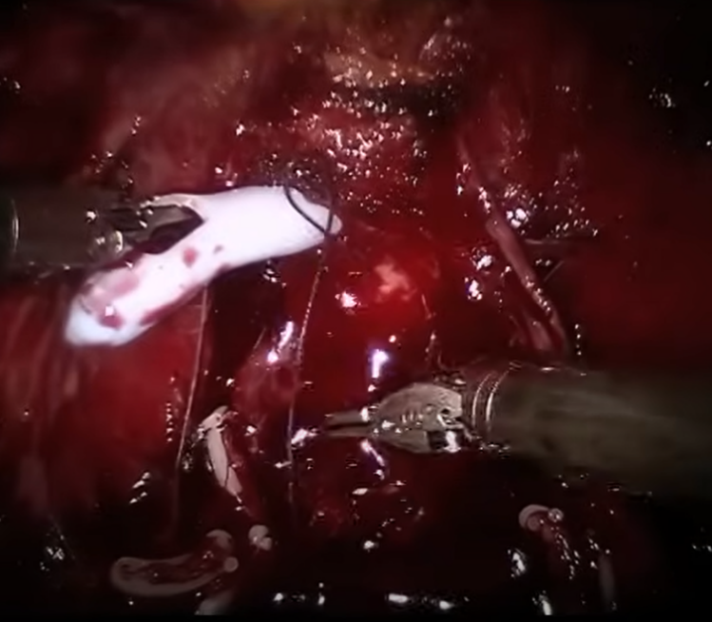
13. Which step of RARP is shown in the picture? (C)
A. DVC ligation B. Bladder neck dissection
C. Vesico-urethral anastomosis D. Transecting prostate and the urethra

14. Which step of RARP is shown in the picture? (D)

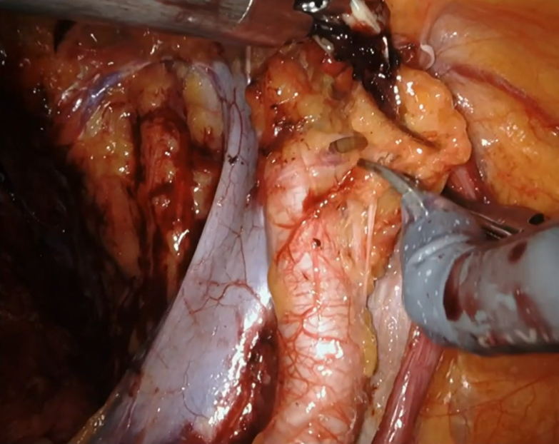

A. Dissecting the prostate B. Preservation of NVBs
C. Insicing the urachus D. Lymph node sweeping

15. This picture is taken before the Vesico-urethral anastomosis. Which step of RARP is shown in the picture? (A)
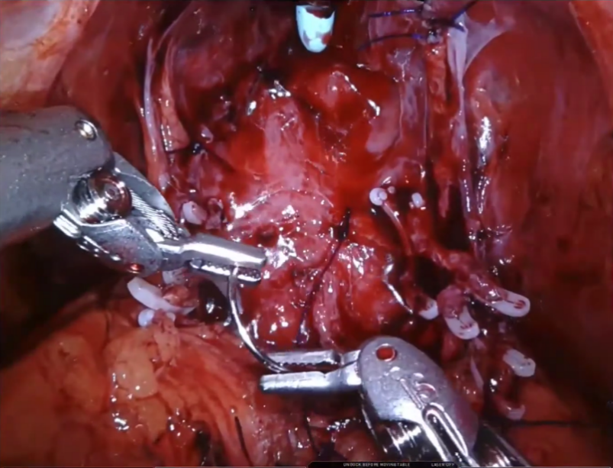

A. Posterior reconstruction B. Bladder neck dissection
C. Lymph node sweeping D. Preservation of NVBs
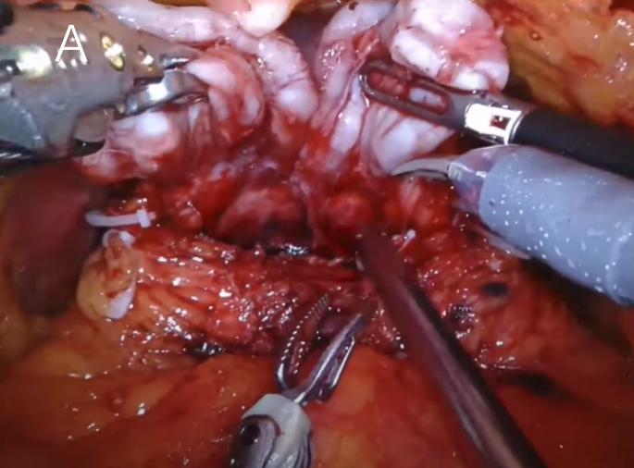
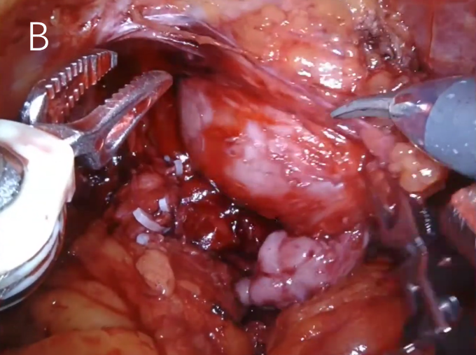
16. There are two pictures showing different steps during RARP. Please put the following pictures in correct order. (AB)

17. There are two pictures showing different steps during RARP. Please put the following pictures in correct order. (AB)
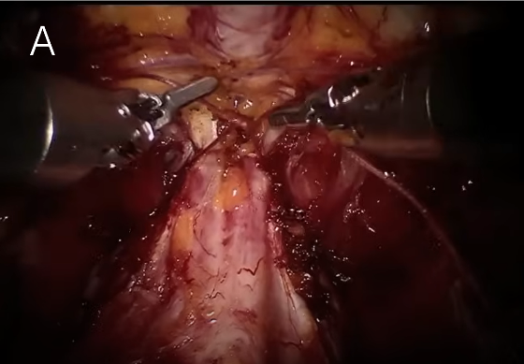
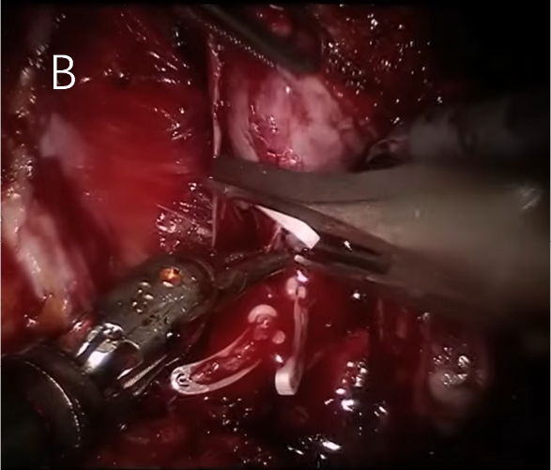

18. There are two pictures showing different steps during RARP. Please put the following pictures in correct order. (AB)
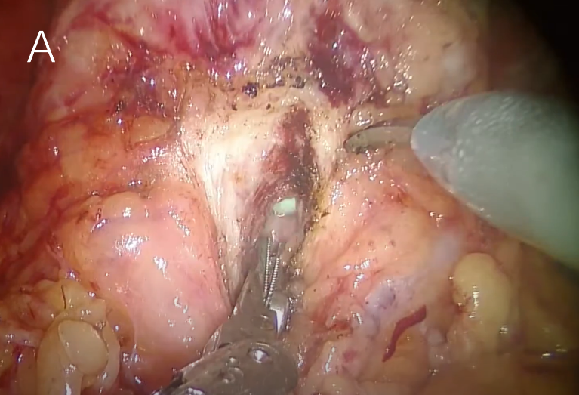
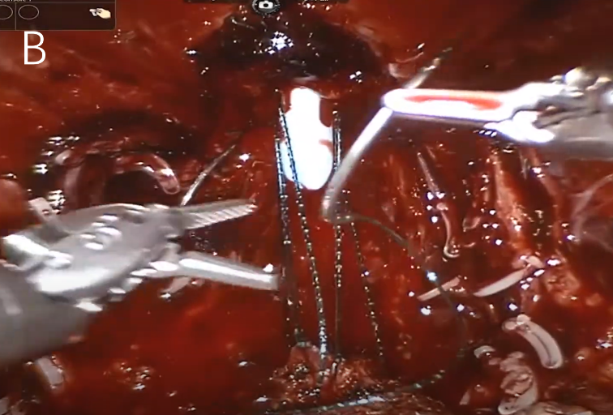

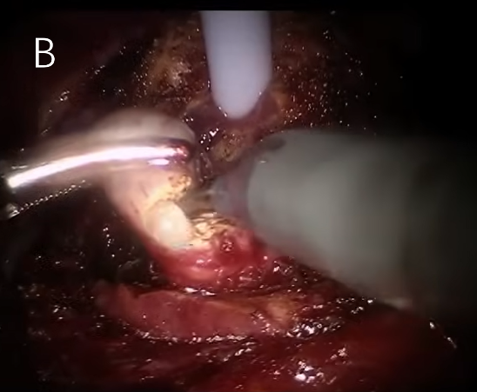
19.There are two pictures showing different steps during RARP. Please put the following pictures in correct order. (BA)
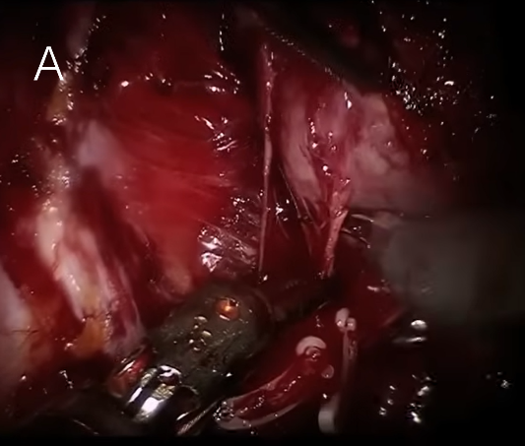

20. There are two pictures showing different steps during RARP. Please put the following pictures in correct order. (AB)
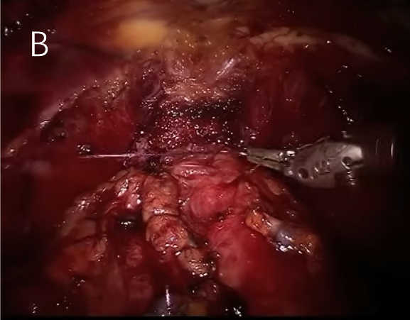
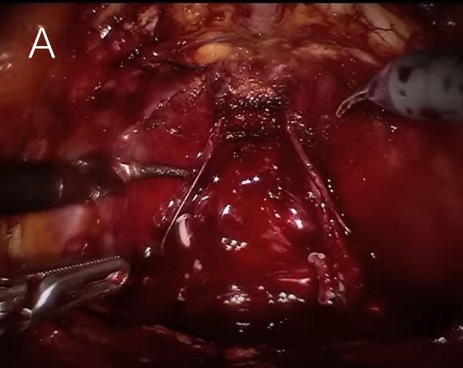

21.Which of the following pictures show the procedure of Vesico-urethral anastomosis?（AD）
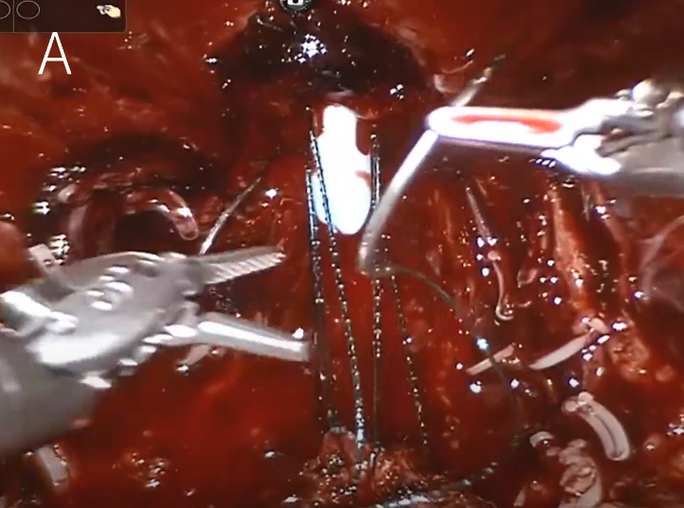
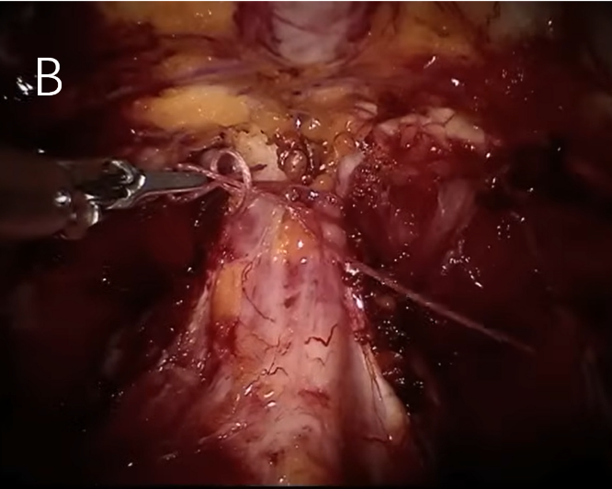

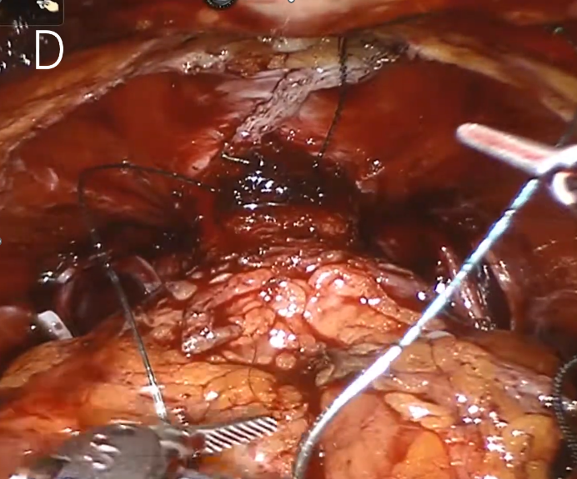
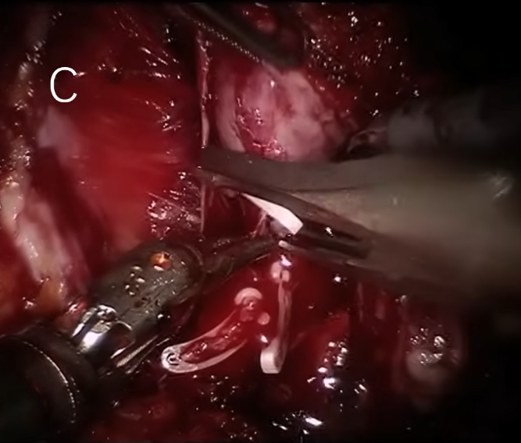

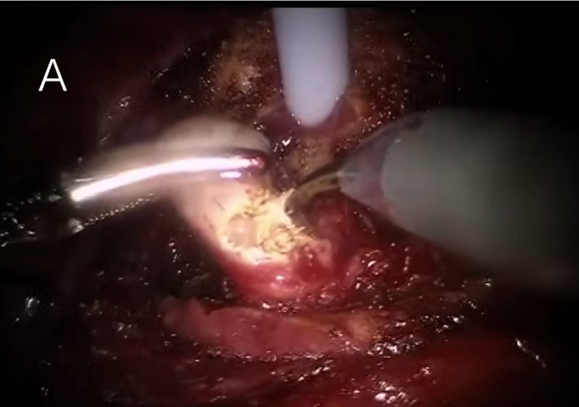
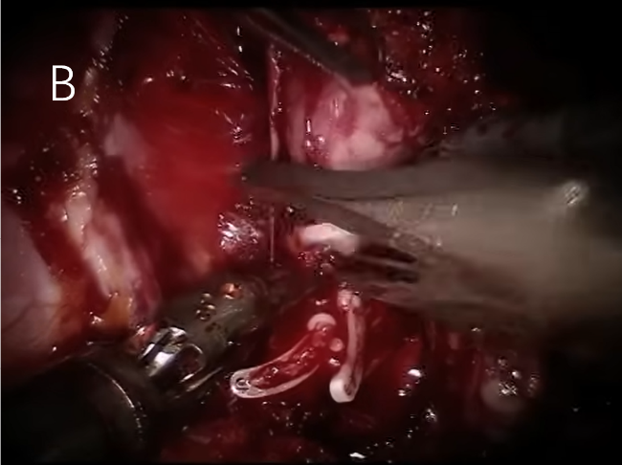
22.Which of the following pictures show the procedure of the dissection of prostate? (BCD)

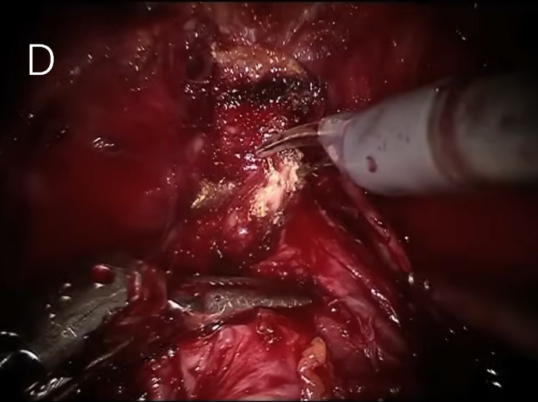
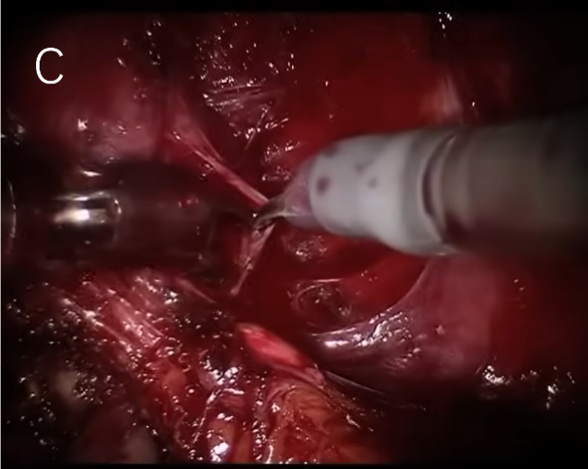

23.Which of the following pictures show the procedure of the lymph node dissection? (AB)
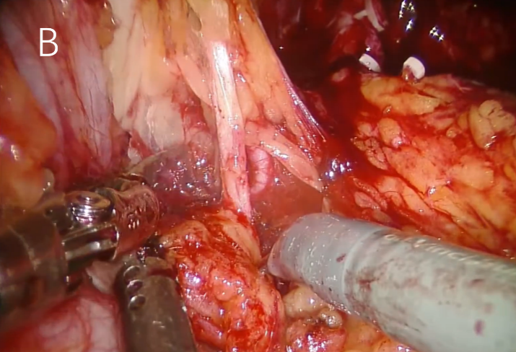
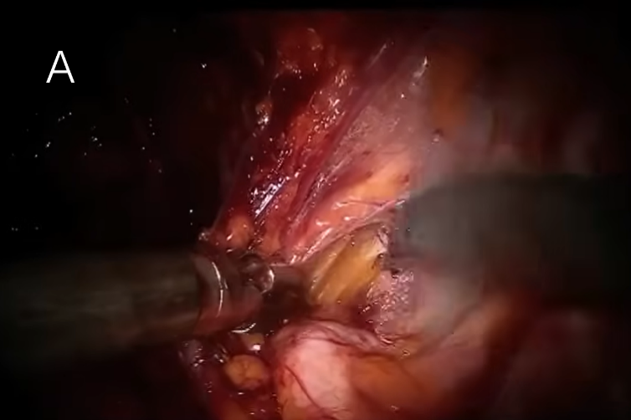
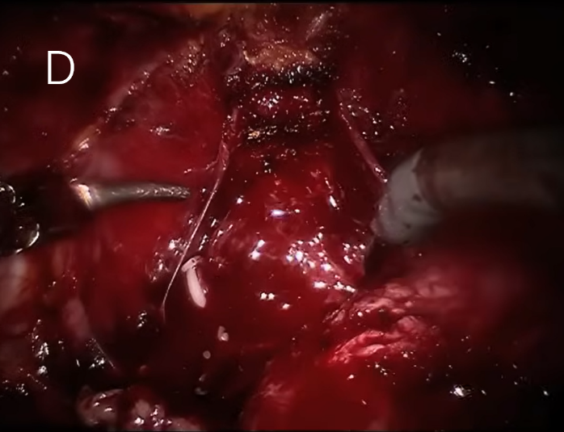
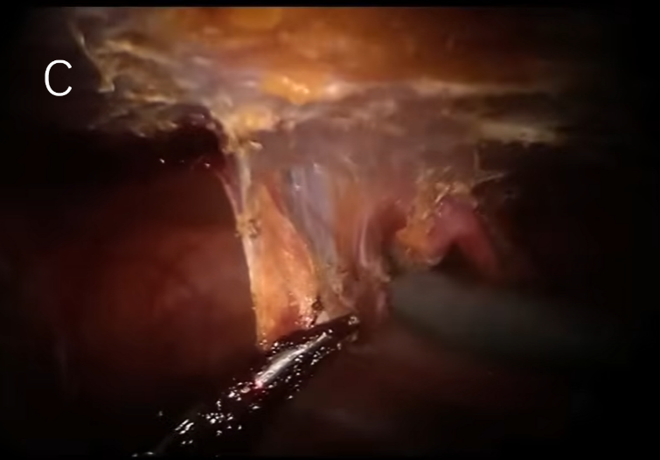

24. Which of the following procedures are performed before Vesico-urethral anastomosis? (BCD)
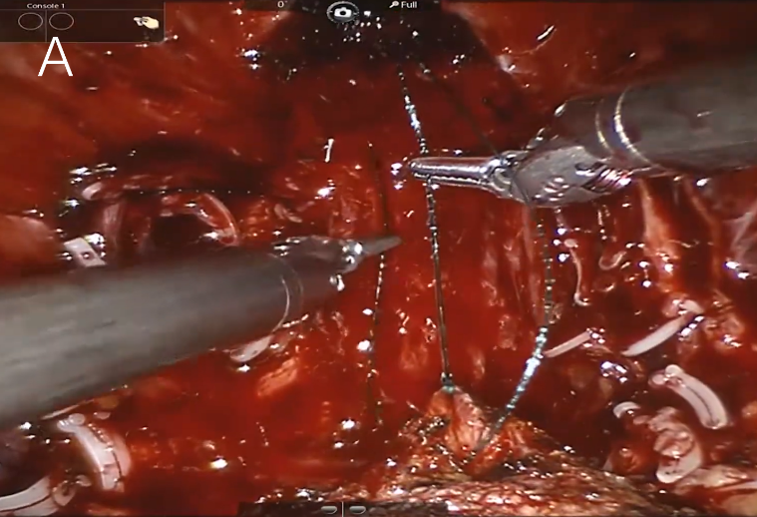
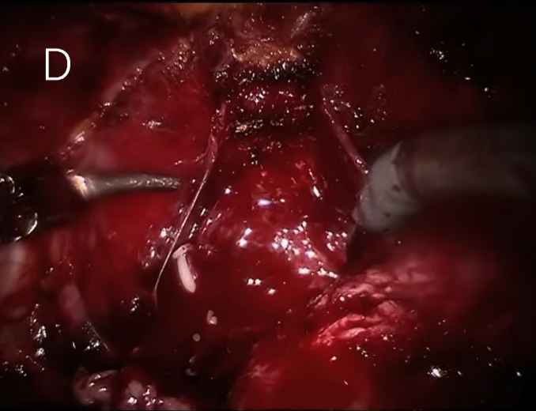
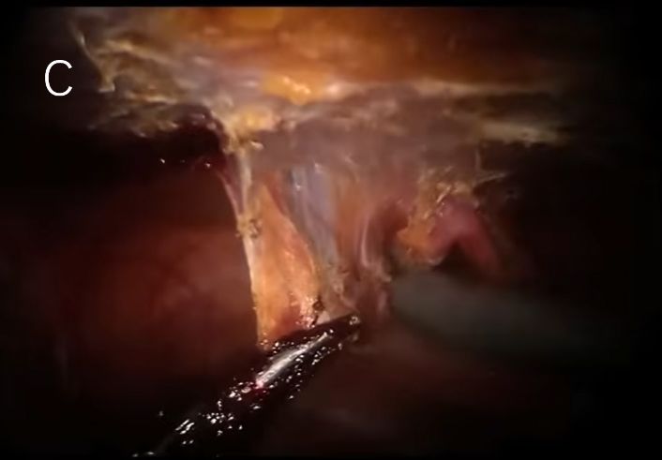
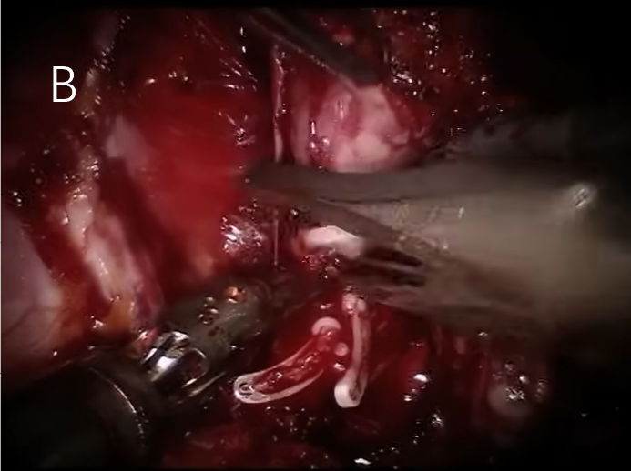

25.Which of the following procedures are performed before Transecting DVC? (ABCD)
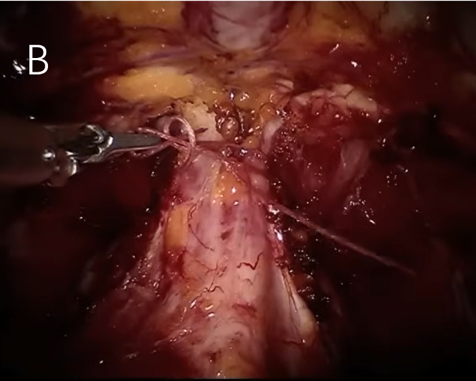
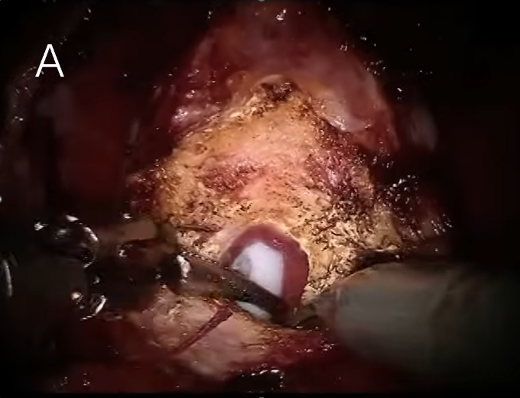

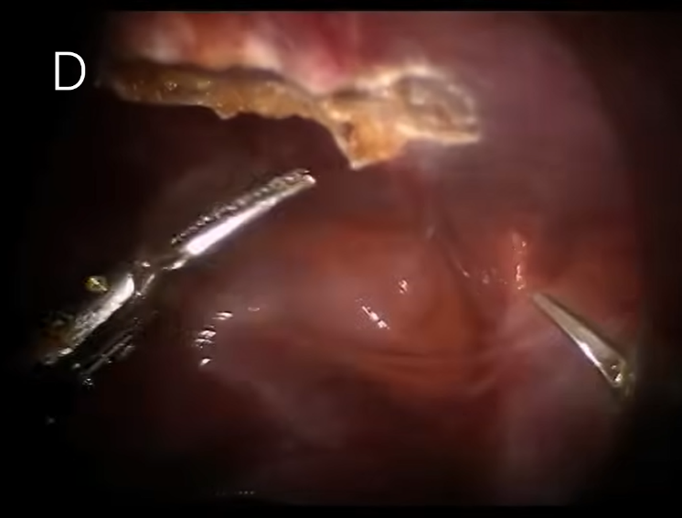
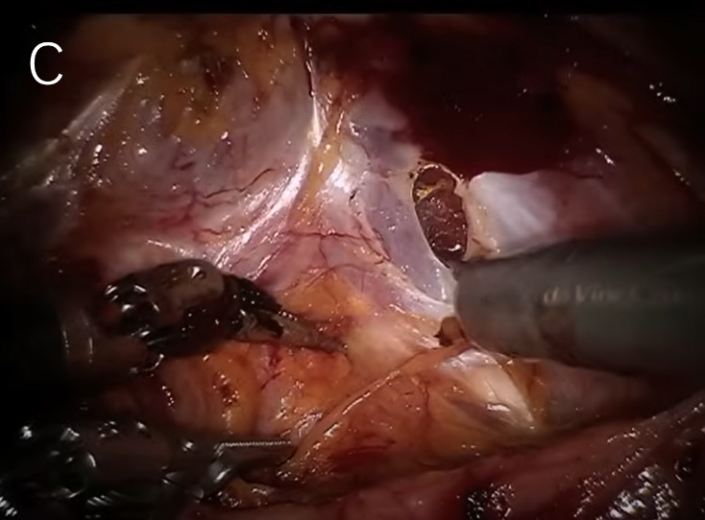

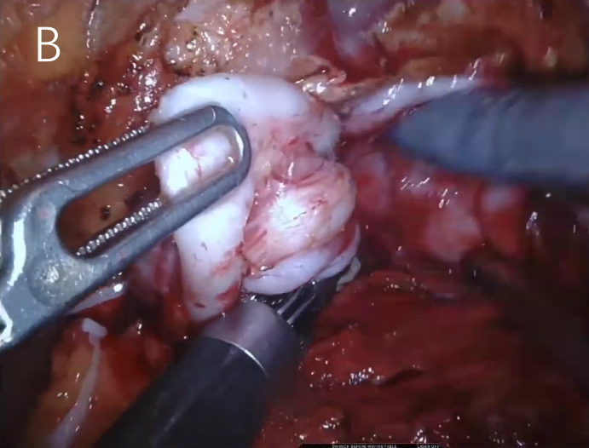
26.Which of the following procedures are performed after the prostate has been taken off? (AD)
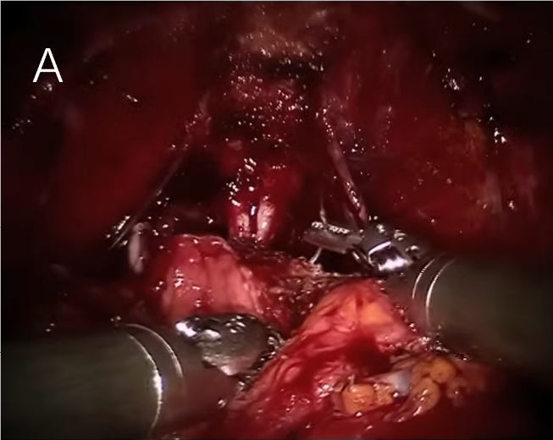

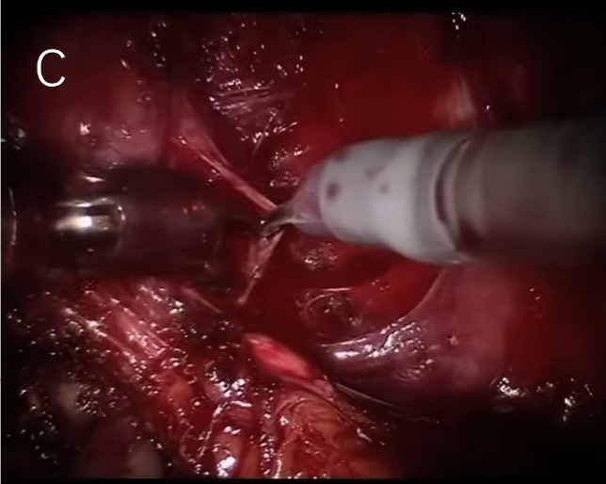
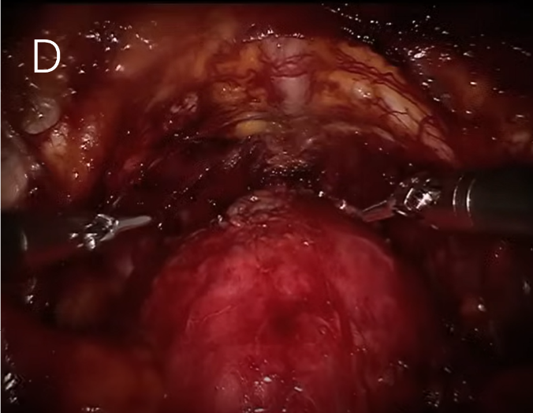

27.In the following procedures, which ones the bladder neck has not yet been severed? (CD)
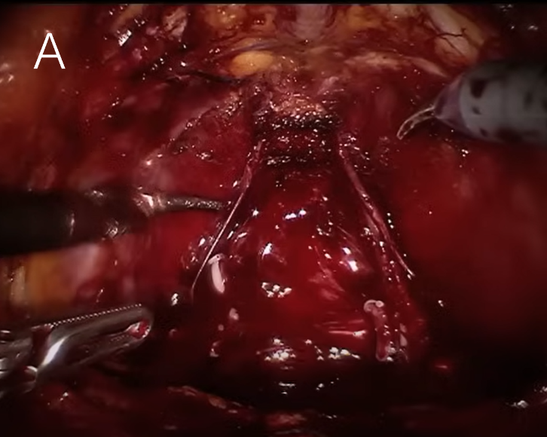
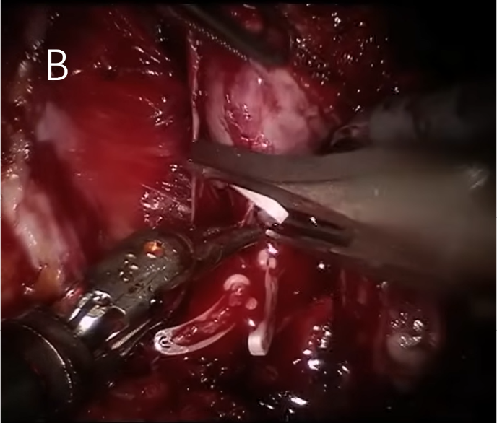

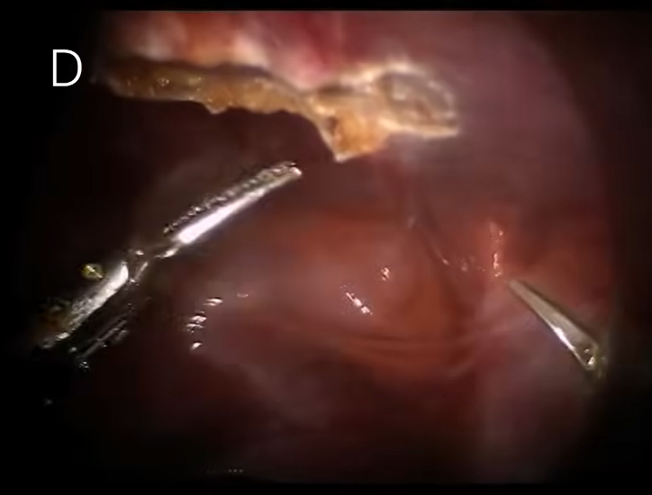
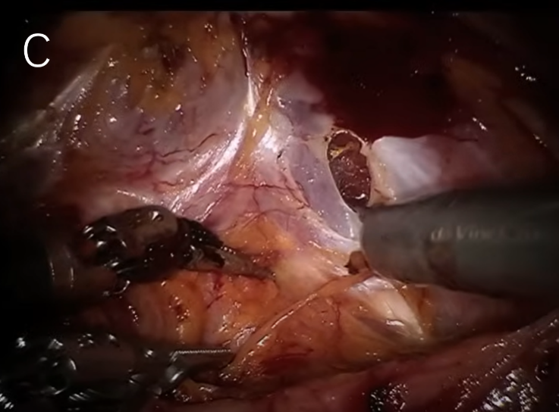

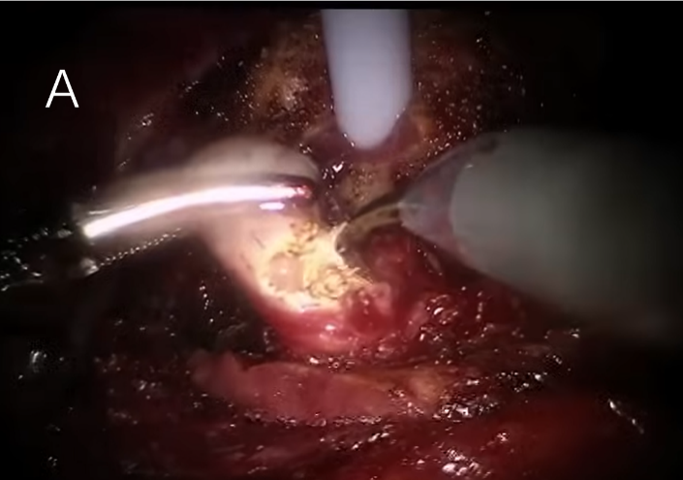
28. Which of the following procedures are performed after the ligation of DVC? (ABD)
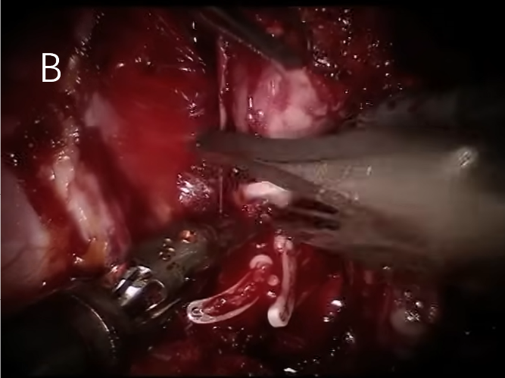

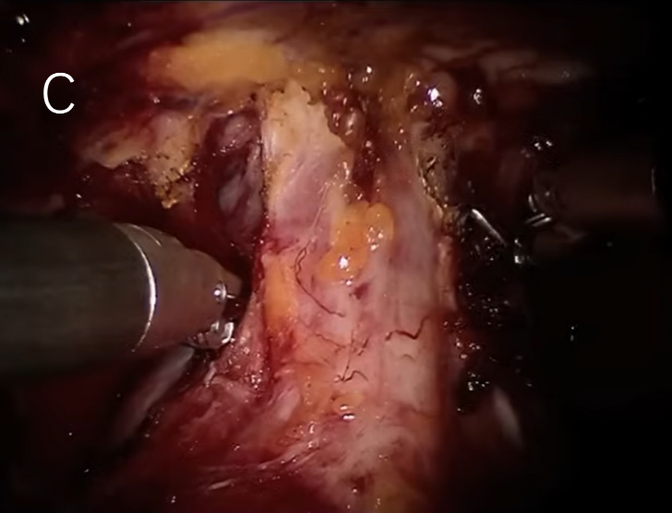
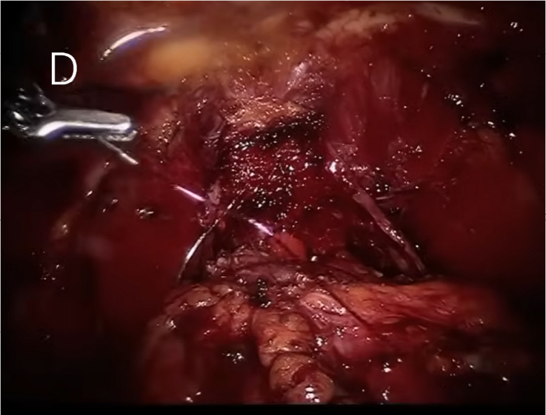

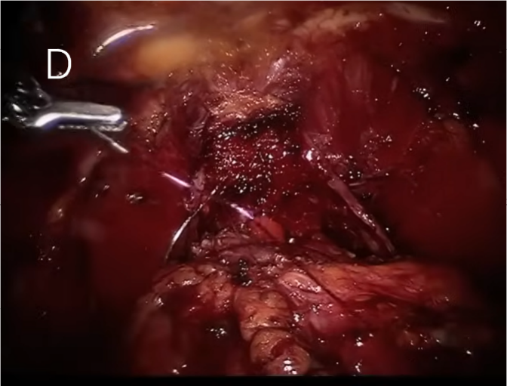
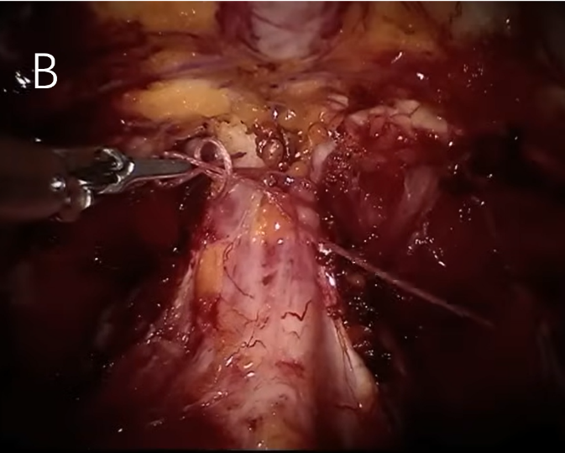
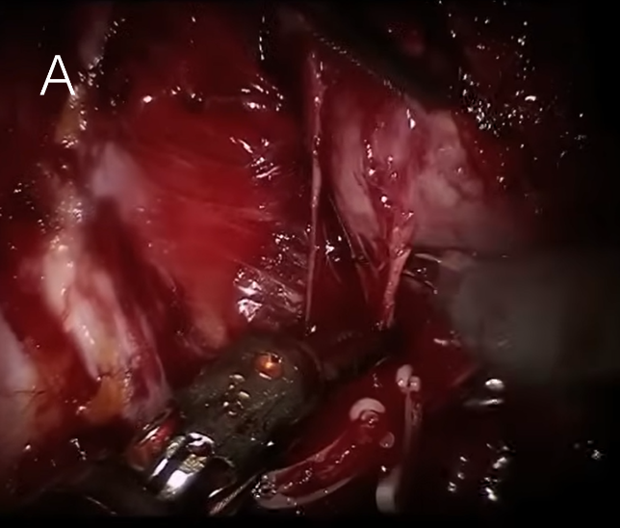
29.Which of the following procedures need the help of needle driver? (BD)
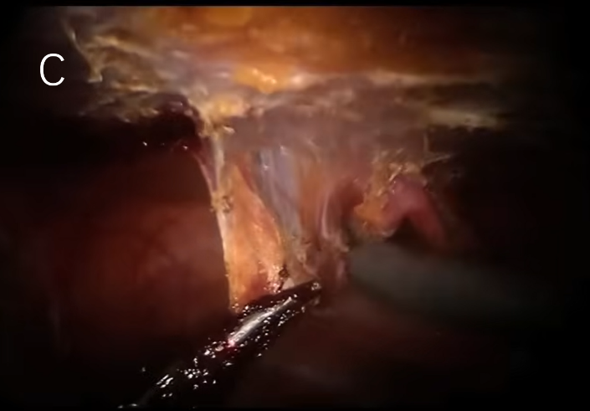

30. Which of the following procedures need the help of the Foley Catheter? (ACD)

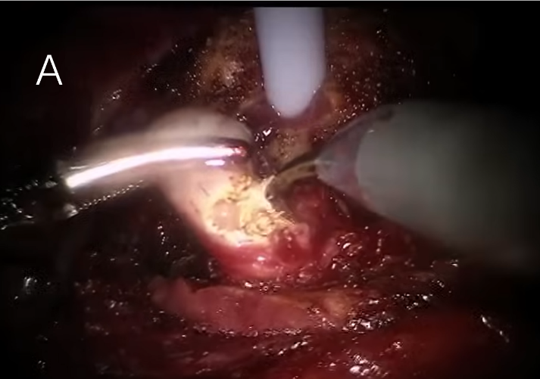

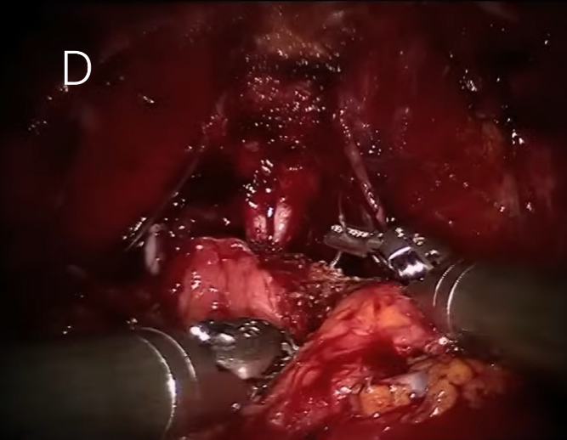
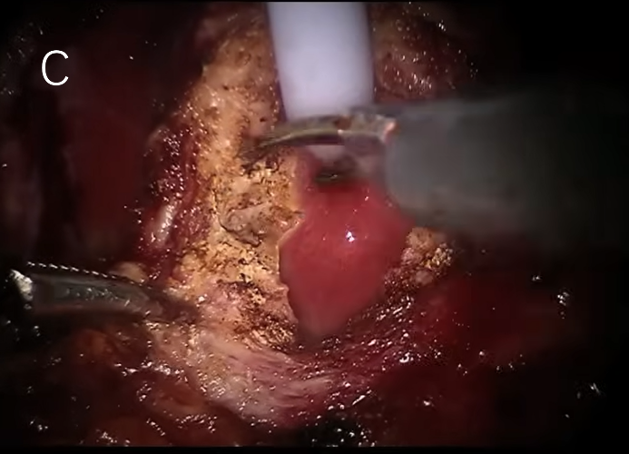

Self-examination
You are required to check all your answers one by one in PART TWO (by connecting different questions). If anyone is wrong, please revise it.

PART THREE
In this section, I will test you precautions about RARP.
Question 1 to 25 are single choice. Question 26 to 30 are essay questions.
Remember to review the guideline! This will help you a lot in answering the questions.
For every question in this part, please think step by step and consider all the details！

1.During the Vesico-urethral anastomosis procedure, which part of the bladder and urethra is be sutured? (A)
A. Mucosa B. Muscle C. Vessel D. Nerve

2. When dissecting the prostate, NVBs must be protested. During this procedure, which tool is advised to use is order to preserve the nerves? (A)
A. Cold scissors B. Bipolar diathermy C. Clip D. Needle driver

3. The same situation as question two. Which way is suggested to preserve the nerves? (A)
A. Blunt cutting B. Sharp cutting C. Cauterizing D. Suturing

4.What time do we install the Foley Catheter to the patient? (A)
A. Before the surgery B. During the procedure of Bladder neck dissection
C. During the procedure of Vesico-urethral anastomosis D. After the surgery.

5. What time to take the Foley Catheter off the patient is suggested? (C)
A. Right after the surgery B. Within three days C. About seven days D. More than seven days

6. Which one is not common complication after RARP? (D)
A. Erectile Dysfunction B. Urethrostenosis C. Urinary incontinence D. Hematuresis

7. Which of the following statements is true? (C)
A. All the patients should have lymph node dissection.
B. DVC is always sutured in RARP surgery.
C. Clips are often used when preserving the neurovascular bundles.
D. Foley Catheter would hindering the surgery.

8. Which part of the prostate is the last to be dissected? (B)
A. The left lateral B. The apex C. The right lateral D. The posterior area

9. Where is the Denonvilliers’ fascia? (D)
A. Anterior to the bladder B. Posterior to the bladder
C. Anterior to the prostate D. Posterior to the prostate

10. What is a critical postoperative care step to ensure proper healing of the bladder-urethral anastomosis? (B)
A. Immediate removal of the Foley catheter
B. Close monitoring of urine output and signs of leakage
C. High fluid intake to flush the urinary system
D. Application of external pressure to the bladder

11.To prevent postoperative complications, what is the primary consideration when handling the neurovascular bundles during RARP? (B)
A. Ensure complete resection to prevent recurrence
B. Minimize traction and use of thermal energy near the bundles
C. Use heavy sutures to secure the bundles
D. Avoid dissection near the bladder neck

12. During RARP, why is it important to maintain a clear surgical field and manage bleeding effectively? (A)
A. To enhance the precision of robotic instruments
B. To reduce the duration of the surgery
C. To prevent postoperative infections
D. To ensure complete removal of the prostate tissue

13. Which approach helps reduce the risk of postoperative complications like urinary incontinence and erectile dysfunction? (C)
A. Extensive lymph node dissection
B. Use of monopolar cautery
C. Nerve-sparing techniques
D. Rapid removal of the prostate

14. During RARP, why is it important to maintain a clear surgical field? (D)
A. To shorten the duration of the surgery
B. To avoid using expensive surgical instruments
C. To reduce the need for postoperative antibiotics
D. To enhance the visibility and precision of the robotic instruments

15.What is a common indication for performing a lymph node dissection during RARP? (B)
A. Low-risk prostate cancer
B. High-risk or locally advanced prostate cancer
C. Benign prostatic hyperplasia (BPH)
D. Urethral stricture

16. Which of the following is an absolute contraindication for RARP? (B)
A. Prostate volume >80 mL
B. Bone metastasis
C. Previous abdominal surgery
D. BMI >35

17. Preoperative MRI reveals prostate cancer invasion into the right seminal vesicle. Which intraoperative adjustment is most critical? (D)
A. Switch to monopolar electrocautery
B. Prioritize ligation of the right vas deferens
C. Avoid excessive traction on the contralateral NVB
D. Extend resection of the right seminal vesicle

18. When encountering dense adhesions between the prostate and rectum intraoperatively, what is the first-line contingency plan? (C)
A. Convert to open surgery
B. Perform sharp dissection of adhesions
C. Inject saline to develop tissue planes
D. Abort surgery for radiotherapy

19. Which structure is most vulnerable during apical prostate dissection in RARP? (A)
A. Urethral sphincter complex
B. Longitudinal rectal muscle layer
C. Circular muscle fibers of the bladder neck
D. Main trunk of the pelvic nerve plexus

20. Preoperative MRI demonstrates extracapsular extension at the prostatic apex without urethral invasion. What intraoperative modification takes priority? (A)
A. Extend apical resection 1 cm distal to the urethra
B. Preserve bilateral neurovascular bundles
C. Adopt bladder neck-sparing technique
D. Expand pelvic lymph node dissection

21. Intraoperative findings show dense adhesions between the left prostatic lobe and pelvic side fascia, with frozen section confirming negative margins. What is the optimal next step? (D)
A. Terminate surgery awaiting final pathology
B. Extend left pelvic fascial resection
C. Perform complete resection of left seminal vesicle
D. Irrigate and close routinely

22. During dissection of Denonvilliers' fascia, an anomalous bleeding vessel is encountered. What is its most likely origin? (B)
A. Internal pudendal artery
B. Middle rectal artery
C. Obturator artery
D. Median sacral artery

23. Which structure is most at risk during bladder neck dissection in RARP? (A)
A. Ureteral orifice
B. Seminal vesicle
C. NVB
D. Longitudinal rectal muscle

24. Intraoperative discovery shows tumor adherence to the right NVB with positive frozen margins. What management is preferred? (C)
A. Perform partial NVB resection
B. Preserve NVB with adjuvant radiotherapy
C. Sacrifice right NVB for extended resection
D. Convert to open radical prostatectomy

25. A 65-year-old patient developed a sudden increase in drainage output (500 mL/day) with chylous-appearing fluid and a body temperature of 38.2°C on postoperative day 3 following RARP. What is the most likely complication and its appropriate management? (A)
A. Lymphatic leakage → Low-fat diet + somatostatin analogues
B. Urinary tract infection → Antibiotic therapy
C. Enteric fistula → Emergent surgical exploration
D. Hemorrhage → Blood transfusion + observation

26. During the Vesico-urethral anastomosis, we always suture the muscle below the bladder with Denonviliers fascia first. Tell me the reason.
Correct answer：
1. Structural Support: The muscle layer provides structural support to the anastomosis, helping to maintain the integrity and alignment of the bladder neck and urethra.
2. Watertight Seal: Suturing the muscle first helps create a secure and watertight connection, reducing the risk of urine leakage at the anastomosis site.
3.Tension-Free Anastomosis: Ensuring that the muscle layer is sutured properly helps distribute tension evenly across the anastomosis, minimizing the risk of stricture formation or tearing during the healing process.
4.Hemostasis: The muscle layer contains blood vessels that, if not sutured properly, could lead to postoperative bleeding. By addressing these vessels first, the risk of bleeding is reduced.
5.Stabilization for Further Sutures: Suturing the muscle layer first provides a stable foundation for subsequent layers of sutures, facilitating a more controlled and precise anastomosis.

27. Which way of anastomosis do we always use during the Vesico-urethral anastomosis? And what kind of suture line is always used during the surgery?
Correct answer：
1. Continuous suture technique and Rocco anastomosis
2. Monofilament absorbable suture, for example poliglecaprone (Monocryl) or polydioxanone (PDS)
Characteristics: Absorbable, High Tensile Strength, Monofilament etc.

28. Why is pneumoperitoneum required during RARP, and what is the typical pressure setting?
Correct answer：
Purpose: To create an expanded surgical workspace by elevating the abdominal wall, improving visualization and instrument maneuverability.
Pressure setting: 12–15 mmHg.

29. Name three critical anatomical structures requiring preservation during RARP and describe their functions.
Correct answer:
1. Neurovascular bundle (NVB)
Function: Controls erectile function.
Preservation technique: Interfascial or intrafascial dissection.
2. Urethral sphincter complex
Function: Maintains urinary continence.
Preservation technique: Precise apical dissection near the prostatic apex.
3. Ureteral orifices
Function: Prevents postoperative hydronephrosis.
Preservation technique: Avoid deep posterior dissection during bladder neck separation.

30. Please list three essential preoperative examinations for RARP.
Correct answer:
- Multiparametric MRI of the prostate – Evaluates tumor location, extracapsular extension, and lymph node involvement.
- Prostate biopsy – Confirms pathological diagnosis (e.g., Gleason score).
- Bone scan – Excludes bone metastasis.

Self-examination
You are required to check all your answers one by one in PART THREE. If anyone is wrong, please revise it.

PART FOUR
In this section, there are 10 questions about cases related to RARP. Please read the cases and determine whether these patients are suitable for RARP. All questions are true or false.
For every question in this part, please think step by step and consider all the details！

1. Case 1
Chief Complaint: Elevated PSA detected 1 month ago.
History of Present Illness: A 54-year-old male was found to have an elevated PSA of 8.6 ng/mL during a routine examination. MRI revealed a nodule in the left peripheral zone of the prostate (PIRADS 4), with slightly irregular capsule. Prostate biopsy showed adenocarcinoma on the left side (Gleason score 4+4=8 and 4+3=7) and adenocarcinoma on the right side (Gleason score 3+3=6). Other biopsy sites were benign. The patient has been treated with leuprorelin and bicalutamide. SPECT showed no definitive bone metastasis, with a probable benign lesion in the left iliac bone. PET revealed abnormal PSMA uptake in the left peripheral zone nodule and reactive lymphadenopathy in the neck. The patient had no other significant symptoms.
Correct answer: T
2. Case 2
Chief Complaint: Elevated PSA detected 3 months ago.
History of Present Illness: A 50-year-old male presented with an elevated PSA of 6 ng/mL and a free PSA ratio of 25%. MRI showed abnormal signals in the right apical peripheral zone and left basal transition zone. Prostate biopsy revealed adenocarcinoma (Gleason score 3+3=6). SPECT whole-body bone scan showed no evidence of bone metastasis. The patient had no urinary symptoms and maintained a high quality of life.
Correct answer: T

3. Case 3
Chief Complaint: Elevated PSA detected 1 month ago.
History of Present Illness: A 62-year-old male was found to have an elevated PSA of 12 ng/mL (free PSA ratio 12%) without symptoms of urgency, frequency, or dysuria. He reported perineal dampness and decreased libido. MRI showed abnormal signals in the right mid peripheral zone (PIRADS 4) and mild abnormal signals in the apical fibromuscular stroma (PIRADS 3), with marked enhancement in the right seminal vesicle area. Prostate biopsy (cores 1-4, 11) revealed adenocarcinoma (Gleason score 4+3=7, ISUP/WHO grade group 3). Bone scan was negative for metastasis. MRI showed a prostate volume of approximately 23.79 ml, with lesions in the right mid peripheral zone (1.0 cm, PIRADS 4) and apical fibromuscular stroma (0.8 cm, PIRADS 3), without involvement of seminal vesicles, external urethral sphincter, rectum, levator ani muscle, bone, pelvic wall, or lymph nodes.
Correct answer: T

4. Case 4
Chief Complaint: Elevated PSA detected during a routine examination.
History of Present Illness: A 50-year-old male had a PSA of 8.56 ng/mL detected during a routine check-up. MRI showed mild abnormal signals in the right mid transition zone (PIRADS 3). Prostate biopsy (cores 7, 8) revealed adenocarcinoma (Gleason score 4+3=7, ISUP/WHO grade group 3), with tumor involvement of approximately 20% and 80% in different cores. SPECT bone scan showed increased metabolic activity in the lower cervical spine of uncertain nature, with no other abnormal findings in the bones.
Correct answer: T

5. Case 5
Chief Complaint: Elevated PSA detected over a year ago.
History of Present Illness: A 55-year-old male had a PSA of approximately 36 ng/mL detected over a year ago. MRI showed an abnormal signal in the right mid transition zone (PIRADS 5, T2NxM0). Initial prostate biopsy was negative. PSA rechecked 3 months ago was 32 ng/mL, and a repeat biopsy revealed adenocarcinoma (Gleason score 3+4=7, with <1% tumor involvement and 30% Gleason 4 component). PET-CT indicated prostate cancer with suspected inflammatory changes in the right external iliac lymph nodes, and no definite metastasis. The patient had no other significant symptoms and a 7-year history of well-controlled hypertension.
Correct answer: T

6. Case 6
Chief Complaint: Elevated PSA detected 3 years ago.
History of Present Illness: A 57-year-old male had an elevated PSA of 12 ng/mL detected 3 years ago, which increased to 17 ng/mL a year ago. CT showed no definite abnormalities in the corresponding areas, with scattered calcifications in the prostate. MRI revealed a patchy abnormal signal in the left peripheral zone, with tumor invasion into the bladder and anterior rectal wall. Prostate biopsy revealed adenocarcinoma (Gleason score 4+4=8). The patient had no symptoms of weight loss, urinary frequency, urgency, hematuria, or back pain.
Correct answer: F

7. Case 7
Chief Complaint: Elevated PSA detected 2 months ago.
History of Present Illness: A 71-year-old male had a PSA of 79 ng/mL detected 2 months ago. Prostate biopsy indicated malignant tumor (Gleason score 4+3=7). PET-CT showed prostate cancer with possible invasion of the left seminal vesicle, and a left lung nodule suspected of primary lung cancer. He has a long history of hypertension managed with amlodipine, valsartan, and metoprolol. PET-CT showed increased PSMA uptake in the prostate with invasion of the left seminal vesicle, benign-looking left common iliac lymph nodes, and no other definite metastasis. The left upper lung nodule was suggestive of early primary lung cancer, with chronic inflammation and emphysema in both lungs, and probable benign lesions in the spleen and ribs.
Correct answer: T

8. Case 8
Chief Complaint: Elevated PSA detected over 3 years ago.
History of Present Illness: A 76-year-old male had a PSA of 12 ng/mL detected 3 years ago, which increased to 17 ng/mL a year ago. MRI showed an abnormal signal in the left peripheral zone. Prostate biopsy revealed adenocarcinoma (Gleason score 3+4=7, WHO/ISUP grade group 2). PET/CT showed increased PSMA uptake in the mid-prostate bilaterally (maximum SUV 9.10), with no abnormal uptake in other organs or lymph nodes. The patient has severe chronic obstructive pulmonary disease (COPD), requiring long-term oxygen therapy, with extremely limited mobility and low quality of life.
Correct answer: F

9. Case 9
Chief Complaint: Elevated PSA detected 4 months ago.
History of Present Illness: A 60-year-old male had a PSA of 65.7 ng/mL detected 4 months ago (free PSA ratio 4%). He had no significant symptoms. Prostate biopsy confirmed adenocarcinoma (Gleason score 4+4=8). He has been treated with goserelin and bicalutamide. PET/CT showed increased PSMA uptake in the prostate, with invasion of the left seminal vesicle, and no other organ involvement. Bone scan was positive for metastasis.
Correct answer: F

10. Case 10
Chief Complaint: Urinary frequency and dysuria for 7 months, elevated PSA detected 4 months ago.
History of Present Illness: A 68-year-old male developed urinary frequency and dysuria 7 months ago, unresponsive to self-medication. Four months ago, his PSA was found to be elevated, and prostate biopsy confirmed adenocarcinoma (Gleason score 4+5=9). He has been treated with tamsulosin, abiraterone, and goserelin. PET/CT showed prostate cancer with right para-iliac lymph node metastasis. Recent PSA recheck was 0.157 ng/mL with symptom relief.
Correct answer: T

Self-examination
You are required to check all your answers one by one in PART FOUR. If anyone is wrong, please revise it.

- “RARP Knowledge Quiz”

This is the link for our online released “RARP Knowledge Quiz”.
https://ks.wjx.top/vm/hwm77m2.aspx#

