Supplementary Information for
Identification of intrinsic active sites in ternary CuZnTi catalysts toward low-temperature water gas shift reaction
Jian Zhang,^{#1}Pan Yin,^{#1}Ming Xu,*¹ Guoqing Cui,^{1,2} Jun Yu,¹ Ning Liu,¹ Song Hong,¹
Lirong Zheng,*³ Min Wei*¹
¹State Key Laboratory of Chemical Resource Engineering, Beijing Advanced Innovation Center for Soft Matter Science and Engineering, Beijing University of Chemical Technology, Beijing 100029, P. R. China
²State Key Laboratory of Heavy Oil Processing, China University of Petroleum, Beijing 102249, P. R. China
³Institute of High Energy Physics, the Chinese Academy of Sciences, Beijing 100049, P. R. China

# This authors contributed equally to this work.
* Corresponding authors. Tel: +86-10-64412131; Fax: +86-10-64425385.
E-mail addresses: mingxu@mail.buct.edu.cn (M. Xu); zhenglr@ihep.ac.cn (L. Zheng); weimin@mail.buct.edu.cn (M. Wei).
This file includes:
Supplementary Methods
Supplementary Discussion
Supplementary Figures 14
Supplementary Tables 5
Supplementary References

Supplementary Methods
1. N₂O titration characterization. The hydrogen pulse reduction (N₂O titration) that provides the dispersion and specific surface area of Cu species, was performed on a Micromeritics Autochem II 2920 instrument equipped with a TCD detector. Firstly, Cu/ZnTi-MMO(H300) was pretreated with Ar flow at 473 K for 0.5 h, followed by introduction of 10%H₂/Ar flow (50 mL min⁻¹) at 573 K for 1 h, and the amount of hydrogen consumption was denoted as X; Subsequently, Ar was flushed for 0.5 h and cooled down to 323 K, then a pure N₂O flow (50 mL min⁻¹) was introduced for 2.0 h, completing the process [2Cu (s) + N₂O → Cu₂O (s) + N₂)]. Finally, a successive 10%H₂/Ar flow (50 mL min⁻¹) was purged at 573 K for the reduction of surface Cu₂O to metallic Cu and the amount of H₂ consumption was denoted as Y. The dispersion degree and specific surface area of metallic Cu (D_{Cu}%) were obtained by Eq. (1) and (2).
$$D\text{Cu}\left(\%\right)=\frac{2Y}{X}×100 （1）$$
$$S_{Cu}=\frac{2N_{A}Y}{1.4×{10}^{19}M_{Cu}{Wt}_{Cu}\%} （2）$$
Where D_{Cu}(%) is defined as the ratio of exposed Cu on the surface to total Cu; S_{Cu} is the exposed Cu surface area per gram of Cu metal; M_{Cu}, Wt_{Cu}% and N_{A} are the molecular weight of Cu, mass percentages of copper species, Avogadro’s constant, respectively, 1.4×10¹⁹ is the number of copper atoms per square meter ^{[1]}.
2. XAS characterizations. In situ EXAFS at the Cu and Ti K-edge was measured on the 1W1B beamline of the Beijing Synchrotron Radiation Facility (BSRF), Institute of High Energy Physics (IHEP), Chinese Academy of Sciences (CAS), operated at 2.5 GeV at the typical energy of the storage ring with a constant current of 250 mA. The Si (111) double crystal monochromator was used. The powdered sample (60 mg) was first pressed into sheet with a diameter of 13 cm and put into a reactor cell equipped with polyimide windows. The detailed experiment was described as follows:
(1) In situ EXAFS spectra: The Cu/ZnTi-MMO catalyst was pretreated in a 5% H₂/He stream at 350 °C for 2 h at a heating rate of 5 °C min⁻¹, then a high purity He flow (50 mL min⁻¹) was introduced and slowly cooled to 25 °C for the measurement of EXAFS spectra. Cu/ZnO and Cu/ TiO₂ were reduced at 300 °C for 2 h, followed by the same treatments as the Cu/ZnTi-MMO catalyst. Finally, the EXAFS spectra were collected (as shown in Fig. 3).
(2) In situ EXAFS spectra at Cu and Ti K-edge with the introduction of reagent: The Cu/ZnTi-MMO catalyst was firstly reduced in a 5 % H₂/He stream at 350 °C for 2 h at a heating rate of 5 °C min⁻¹, followed by flowing a high purity He (50 mL min⁻¹) and cooling to 250 °C, and then EXAFS spectra at Cu and Ti K-edge were collected. Subsequently, H₂O vapor was introduced into the in situ reaction cell via a HPLC pump, and Cu and Ti EXAFS spectra were collected within 30 min. Finally, a switch to 5 volume % CO/He atmosphere was performed for the collection of Cu and Ti K-edge EXAFS spectra for another 30 min (as shown in Fig. 7A₁−A₃).
(3) Operando EXAFS spectra at Cu and Ti K-edge: The Cu/ZnTi-MMO sample was firstly reduced in a 5% H₂/He stream at 350 °C for 2 h at a heating rate of 5 °C min⁻¹, followed by flowing a high purity He (50 mL min⁻¹) and cooling to 250 °C, and then EXAFS spectra at Cu and Ti K-edge were collected. Subsequently, a mixture of CO, H₂O and He (6% CO, 25% H₂O and 69% He) was introduced into the reactor with a total flux of 100 ml min⁻¹, and then Cu K-edge EXAFS spectra were collected under stable operando conditions at 250 °C for 15 and 30 min; Ti K-edge EXAFS spectra were collected under stable operando conditions at 250 °C for 20 min (as shown in Fig. 7B₁−B3).
3. Quasi in situ XPS characterizations. Quasi in situ X-ray photoelectron spectra (XPS) and X-ray excited Auger electron spectra (XAES) were carried out on an AXIS SUPRA X-ray photoelectron spectrometer equipped with Al Kα radiation (1486.6 eV) operated at a pressure of 2 ×10⁻⁹ Torr. The sample was first reduced in a micro quartz tube reactor, and then transferred in a vacuum glove box by a transport chamber seriously preventing from air during the whole process. The contaminated carbon C 1s signal (284.6 eV) was applied to calibrate above binding energy.
4. In situ DRIFTS characterizations. In situ DRIFTS was performed in a home-made in situ reaction cell on a Bruker TENSOR II spectrometer equipped with an MCT narrow-band detector. The details of pre-treatment and test conditions are given as follows:
(1) In situ DRIFTS spectra at 25 °C: Firstly, 20 mg of the Cu/ZnTi-MMO sample was loaded into the in situ reaction cell, and then was pre-treated in a flow stream of 5% H₂/He (40 ml min⁻¹) at different temperatures (300, 350, 400 °C) for 2 h at a heating rate of 5 °C min⁻¹ and then cooled to 25 °C. Subsequently, the gas flow was switched to high purity He to collect background spectrum, followed by introduction of 5% CO/He (40 ml min⁻¹), and then DRIFTS spectra were collected until the CO adsorption signal kept stable. Cu/ZnO and Cu/ TiO₂ were reduced at 300 °C for 2 h, followed by the same treatments as the Cu/ZnTi-MMO (as shown in Fig. 4C).
(2) In situ DRIFTS spectra for Cu/ZnTi-MMO(H350) and Cu/TiO₂: The Cu/ZnTi-MMO(H350) sample (20 mg) was loaded into the in situ reactor cell, pretreated in a flow stream of 5% H₂/He (40 ml min⁻¹) at 350 °C for 2 h at a heating rate of 5 °C min⁻¹ and then cooled to 250 °C. The gas flow was switched to a high purity He to collect background spectrum. Subsequently, H₂O vapor was introduced into the in situ reaction cell via a high purity He flow for 10 min, then a switch to 5% CO/He atmosphere was performed for the collection of the time-resolved DRIFTS spectra using a 64-scan quick sweep mode with a resolution of 4 cm⁻¹ (as shown in Fig. 6).
5. TPSR-MASS characterizations. The temperature-programed surface reaction (TPSR)-MASS experiments were carried out to further explore the reaction mechanism of WGS over the Cu/ZnTi-MMO(H350) catalyst. The TPSR-MASS measurements were carried out on a Micromeritics ChemiSorb 2070 with a thermal conductivity detector (TCD). The detailed experimental process is given as follows:
In a typical CO+H₂O-TPSR process, ~100 mg of sample was sealed in a quartz tube reactor and reduced in a stream of H₂/Ar (1:9, v/v; a total flow rate of 40 ml min^{–1}) at 350 °C for 2 h at a heating rate of 5 °C min^{–1} and flushed with a high purity He for 30 min. The sample was slowly cooled to 100 °C in a He atmosphere. Then, a mixture of CO, H₂O and Ar (molar composition: 6% CO, 24% H₂O and 70% Ar) was introduced into the reactor with a total flux of 100 ml min^{–1}. The Mass signals of CO, H₂O, CO₂, and H₂ were collected within the temperature range from 100 °C to 350 °C at a heating rate of 5 °C min^{–1} (as shown in Supplementary Fig. 9A). Subsequently, CO-TPSR experiment was carried out to further investigate the catalytic mechanism of Cu/ZnTi-MMO(H350) catalyst. The sample (100 mg) was reduced in H₂/Ar (1:9, v/v; a total flow rate of 40 ml min^{–1}) at 350 °C for 2 h and flushed with a high purity He for 30 min. After a water vapor treatment at 250 °C for 15 min, the sample was slowly cooled to 120 °C in a He atmosphere. Then, 5%CO/He was introduced into the reactor and Mass signals of H₂O, CO₂, and H₂ were collected within the temperature range from 120 °C to 350 °C at a heating rate of 5 °C min^{–1} (as shown in Supplementary Fig. 9B).
6. Catalytic evaluations. The low-temperature water gas shift (WGS) reaction was performed on a continuous flow fixed-bed with a quartz reactor (inner diameter: 8 mm) at atmospheric pressure. Briefly, 0.5 g of Cu/ZnTi-MMO precursor was diluted with silicon carbide, and pretreated in a mixture gas of H₂/N₂ (2:3, v/v; a total gas flow of 100 ml min^{–1}) at 300 °C, 350 °C, 400 °C for 2 h at the ramping rate of 5 °C min^{–1}, respectively, followed by cooling to 120 °C in a high purity N₂ stream. For the reference sample, Cu/ZnO and Cu/TiO₂ were reduced in the same stream at 300 °C for 2 h. After reduction, the catalyst was exposed to the mixed gas (CO: 6%, H₂O: 25%, Ar: 69%). Meanwhile, water was introduced into the system by a HPLC pump and mixed with CO in a vaporizer maintained at 150 °C. The measurements were performed at a total gas flow of 110 mL min⁻¹, using a fixed amount of diluted catalysts to ensure the weight hourly space velocity (WHSV) maintained at 13200 mL gcat⁻¹ h⁻¹. The evaluation was carried out within temperature range from 120 °C to 350 °C. Influent and effluent gases were analyzed by online gas chromatography with a TDX-01column and TCD detector. Ar internal standard method was used to determine the composition of the outlet gas. The coefficients of CO and CO₂ were determined using standard samples. At each temperature, the collection was repeated for 3 times to obtain accurate catalyst performance. In the quantification, CO conversion was calculated based on the following formula ^{[2]}:
$${ X}_{CO}=\frac{{ [{CO}_{2}]}_{out}}{{ [{CO}_{2}]}_{out}+{ [CO]}_{out}} (3)$$
The CO conversion was kept below 15% to obtain the accurate reaction rate and TOF value ^{[2]}:
$$Reaction rate=\frac{Mol of CO converted}{mass of catalyst(g)×time(s)} (4)$$
$$TOF=\frac{Mol of CO converted}{Mol of metallic Cu surface atom×time(s)} (5)$$
As for the stability test, the catalyst was pretreated under the same conditions and exposed to the mixed gas at 250 °C for 60 h. A start/stop cycles test was carried out for five cycles. Meanwhile, the running temperature was raised to 300 °C for 1 h to evaluate catalytic performance, and then cooled to room temperature for another 1 h.

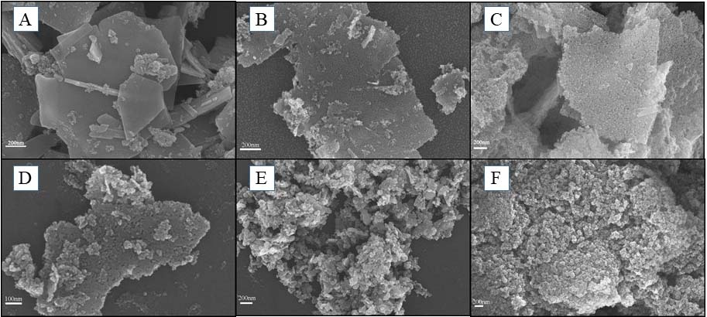
Supplementary Fig. 1 SEM images of (A) Cu/ZnTi-LDHs, (B) Cu/ZnTi-MMO(H300), (C) Cu/ZnTi-MMO(H350), (D) Cu/ZnTi-MMO(H400), (E) Cu/ZnO, (F) Cu/TiO₂.

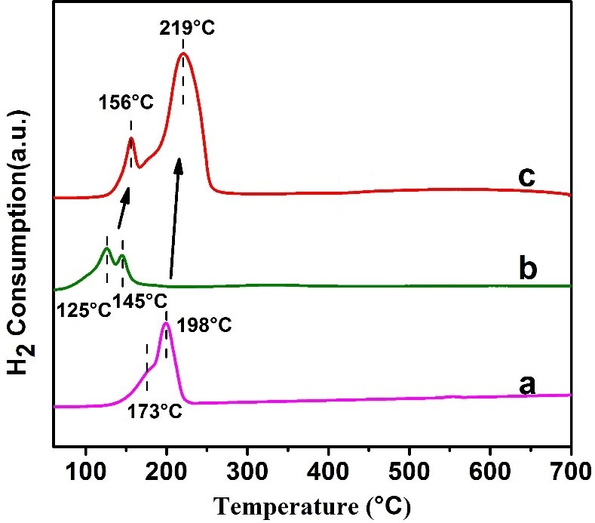
Supplementary Fig. 2 H₂-TPR profiles of (a) CuO/ZnO, (b) CuO/TiO₂, (c) CuZnTi-LDHs.

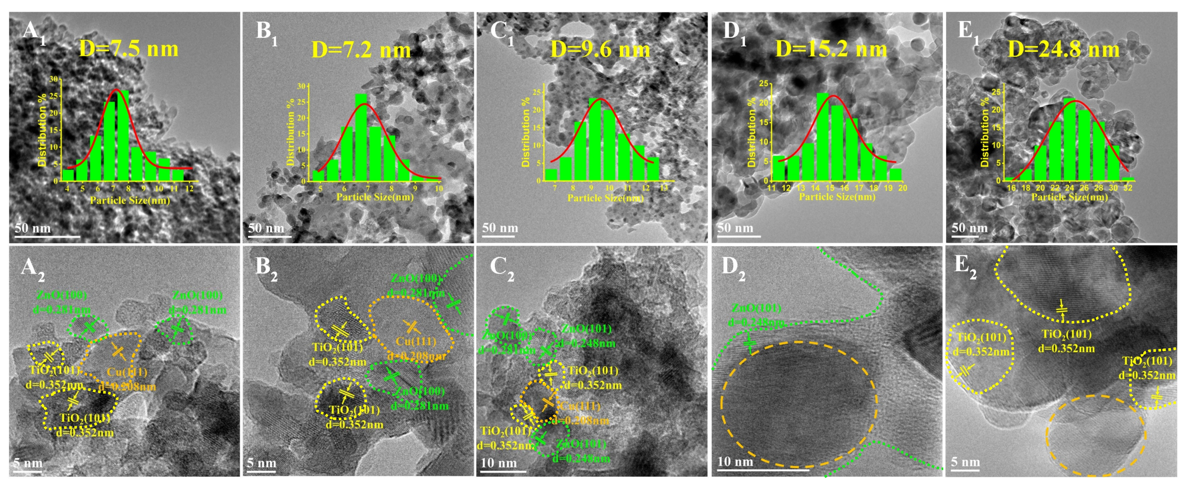
Supplementary Fig. 3 TEM and HRTEM images of (A) Cu/ZnTi-MMO(H300), (B) Cu/ZnTi-MMO(H350), (C) Cu/ZnTi-MMO(H400), (D) Cu/ZnO, (E) Cu/TiO₂.

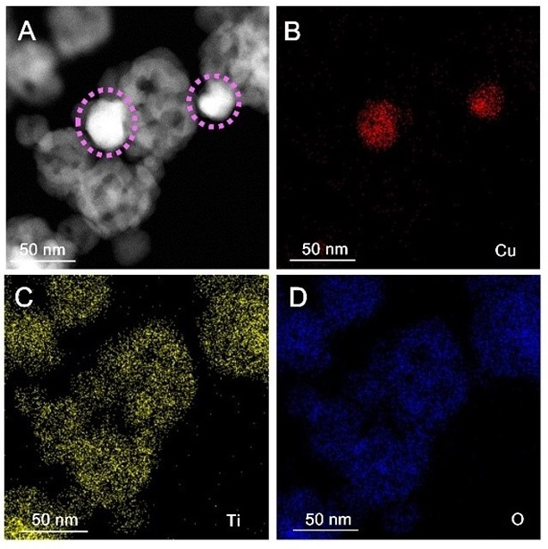
Supplementary Fig. 4 (A) Low magnification ac-HAADF-STEM image of the Cu/ZnTi-MMO(H350) sample. (B-D) Element EDS mapping images of Cu, Ti and O, respectively. Cu nanoparticles are spotted by pink circle.

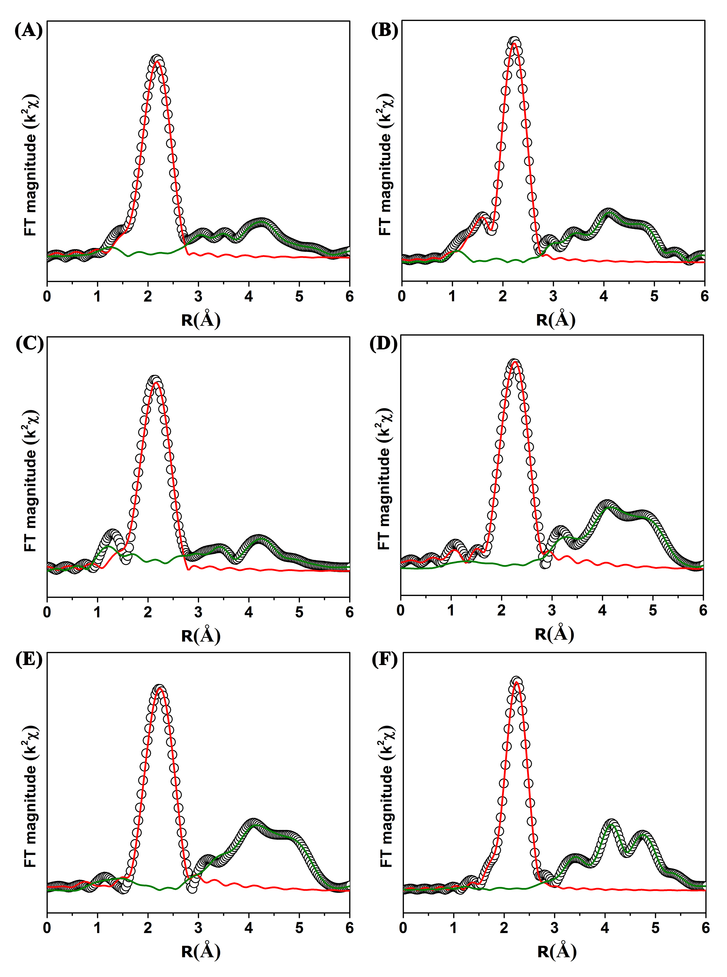
Supplementary Fig. 5 Fourier-transform EXAFS spectra and fitting at Cu K-edge for: (A) Cu/ZnTi-MMO(H300), (B) Cu/ZnTi-MMO(H350), (C) Cu/ZnTi-MMO(H400), (D) Cu/ZnO, (E) Cu/TiO₂ and (F) Cu foil, respectively. The dashed line: experimental data; the solid line: fitting curve.

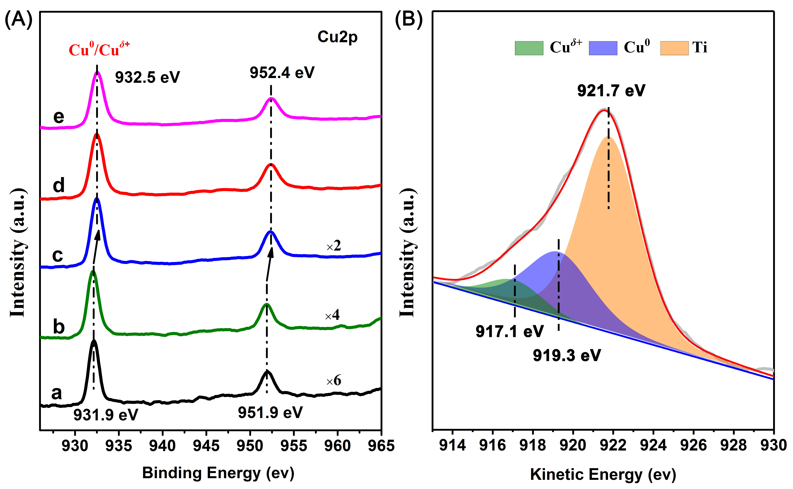
Supplementary Fig. 6 (A) Cu 2p XPS spectra of (a) Cu/ZnO, (b) Cu/TiO₂, (c) Cu/ZnTi-MMO (H300), (d) Cu/ZnTi-MMO (H350), and (e) Cu/ZnTi-MMO (H400). (B) Quasi in situ XAES spectra of Cu LMM spectra for Cu/TiO_{2.}
Supplementary Fig. 6A shows two peaks centered at ∼931.9 and ∼951.9 eV attributed to Cu 2p_{3/2} and Cu 2p_{1/2} of Cu⁰ and/or Cu^{δ+}, respectively. Moreover, Cu 2p XPS spectra of three Cu/ZnTi-MMO samples shift to higher binding energies (~0.6 eV) relative to Cu/ZnO and Cu/TiO₂ samples. As shown in Supplementary Fig. 6B, Cu LMM spectra of Cu/TiO₂ was deconvoluted into three peaks centered at 917.1, 919.3 and 921.8 eV, ^{[3]} corresponding to Cu^{δ+}, Cu⁰ species and the disturbance of Ti element.

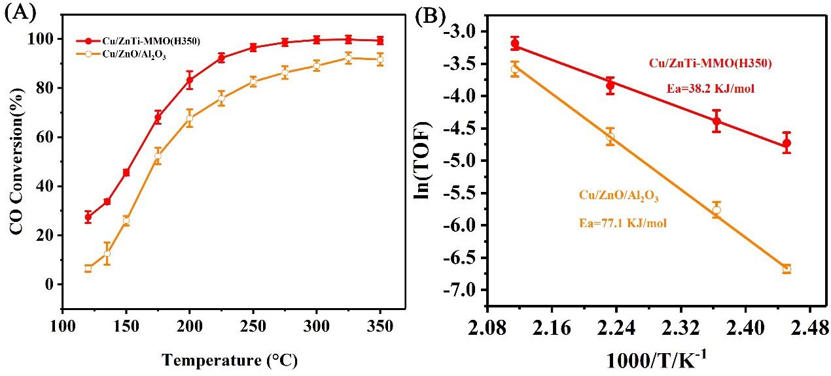
Supplementary Fig. 7 Catalytic performance for water–gas shift reaction (WGSR): (A) CO conversion as a function of reaction temperature over the Cu/ZnTi-MMO and commercial Cu/ZnO/Al₂O₃ catalyst. (B) Arrhenius plots of WGSR over the Cu/ZnTi-MMO and commercial Cu/ZnO/Al₂O₃ catalyst.

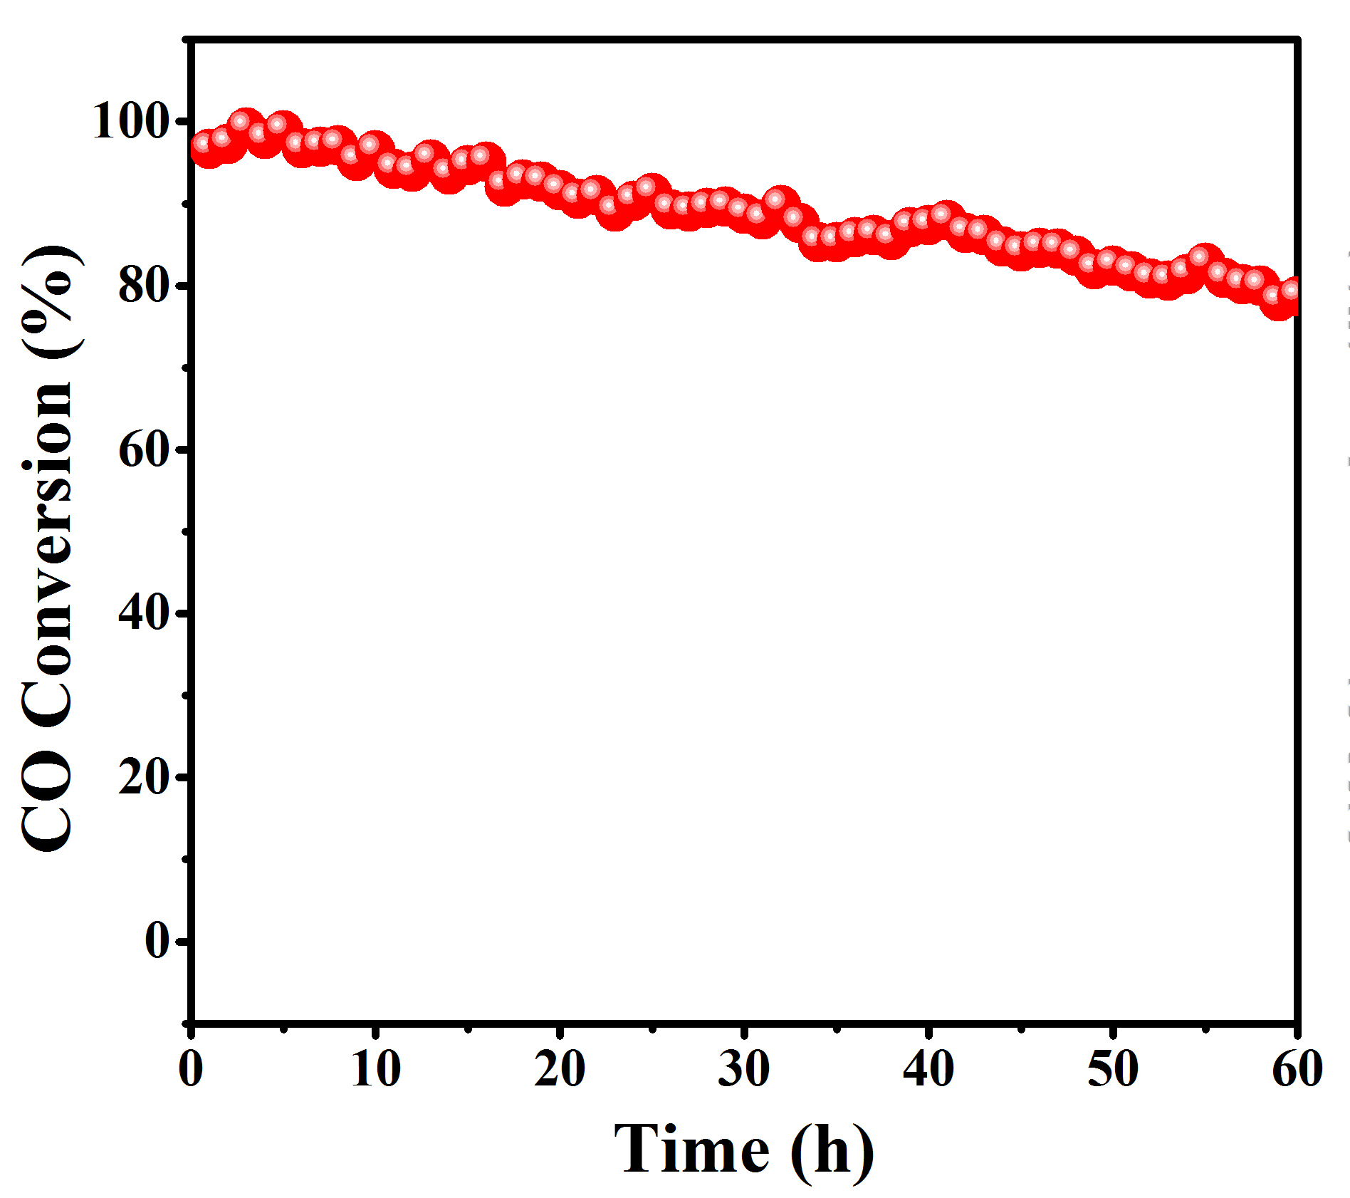
Supplementary Fig. 8 Plots of CO conversion to CO₂ vs. reaction time at 250 °C for the sample of Cu/ZnTi-MMO(H350).

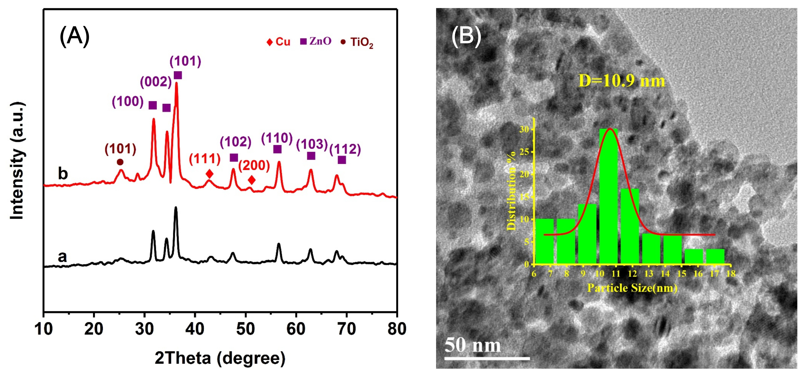
Supplementary Fig. 9 (A) XRD patterns of the Cu/ZnTi-MMO(H350) catalyst: (a) the fresh sample, (b) the used sample after 100 h stability test; (B) HRTEM image of the used sample b in (A).

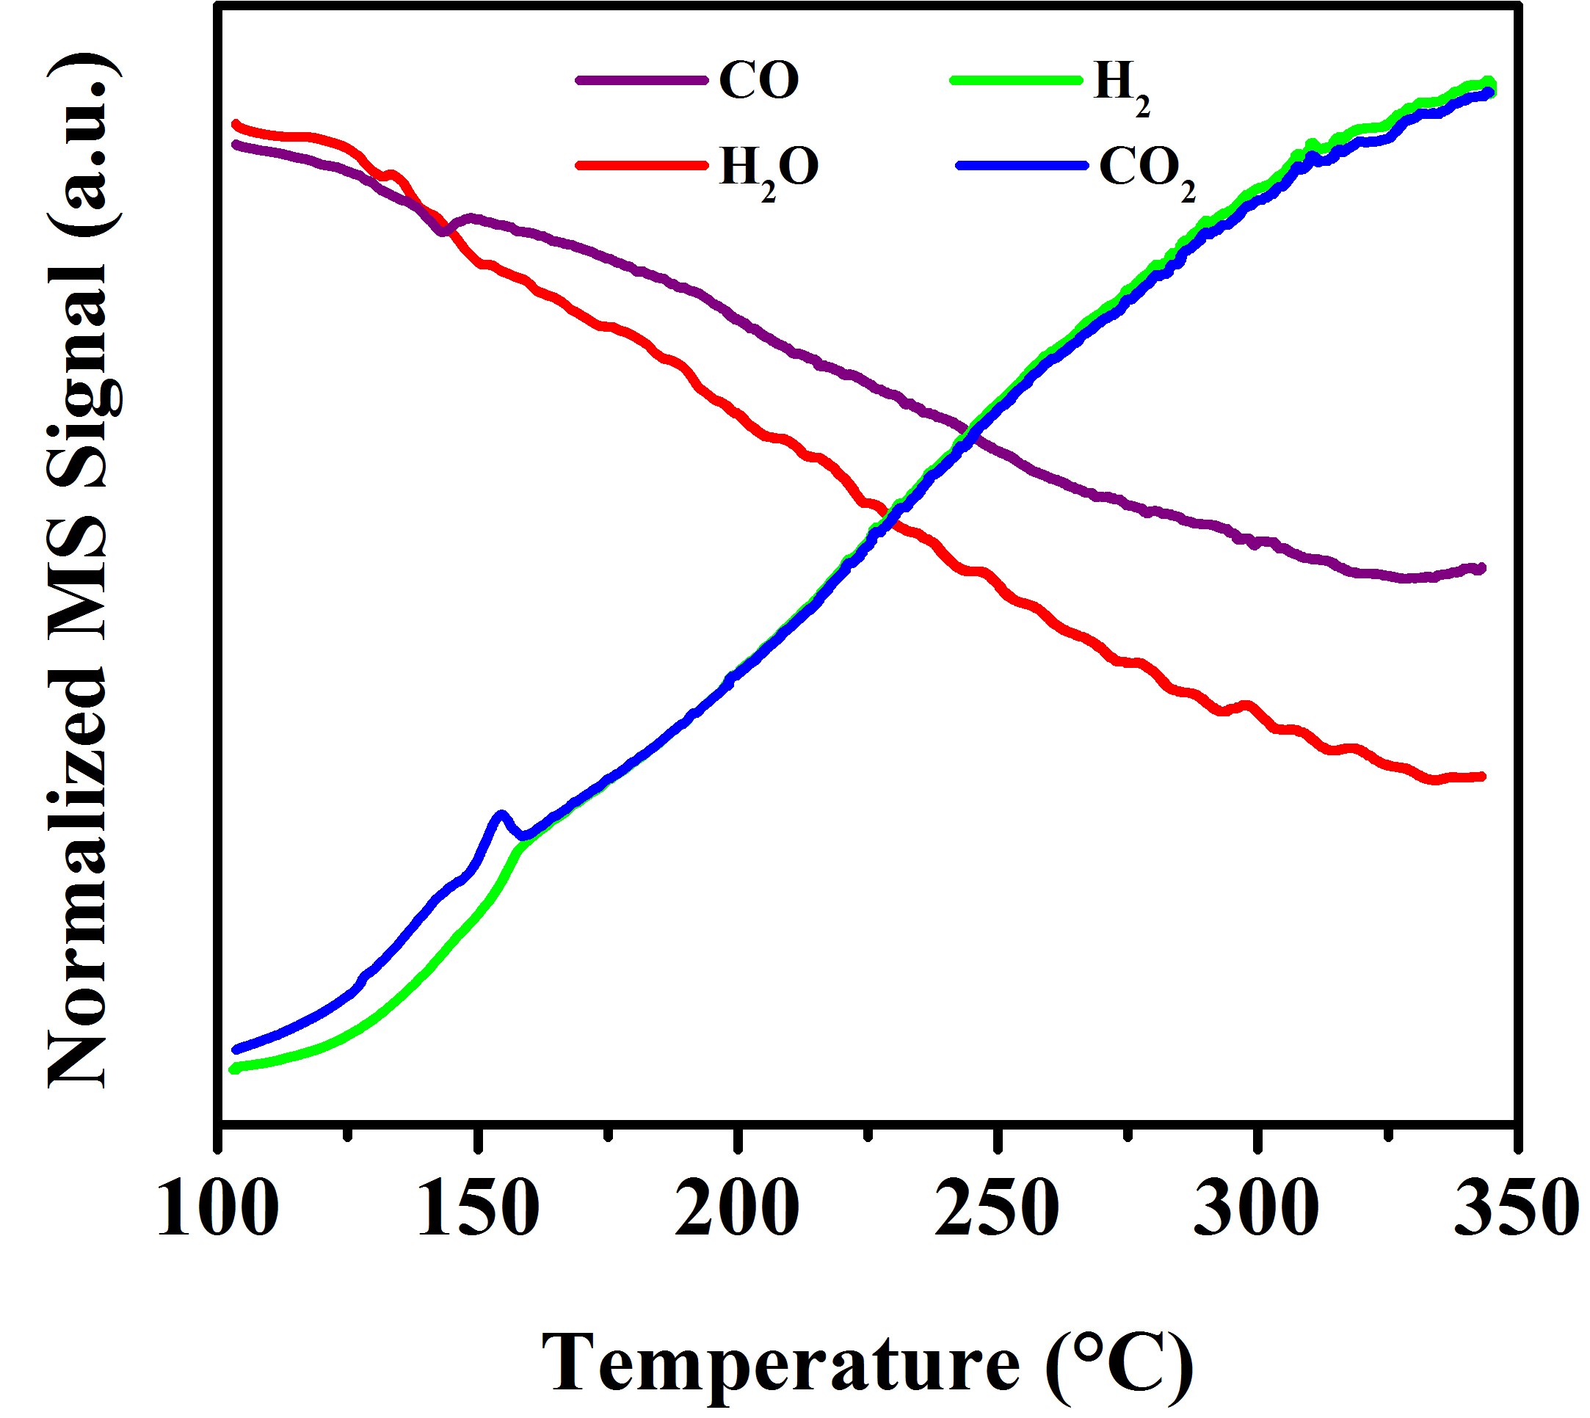
Supplementary Fig. 10 Normalized MS signals of CO, H₂O, CO₂, and H₂ during CO+H₂O-TPSR for the Cu/ZnTi-MMO(H350) catalyst.

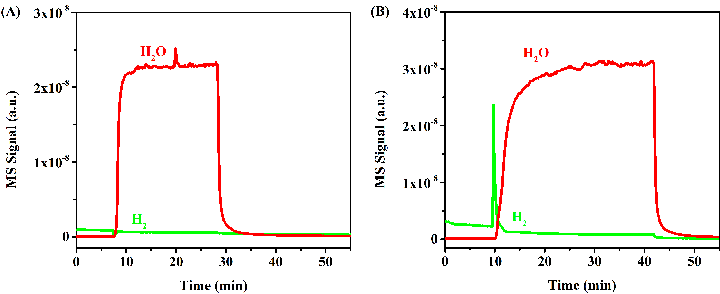
Supplementary Fig. 11 MS signals of H₂ and H₂O under water vapor treatment for the Cu/ZnTi-MMO(H350) catalyst at (A) 150 °C and (B) 250 °C for 60 min.

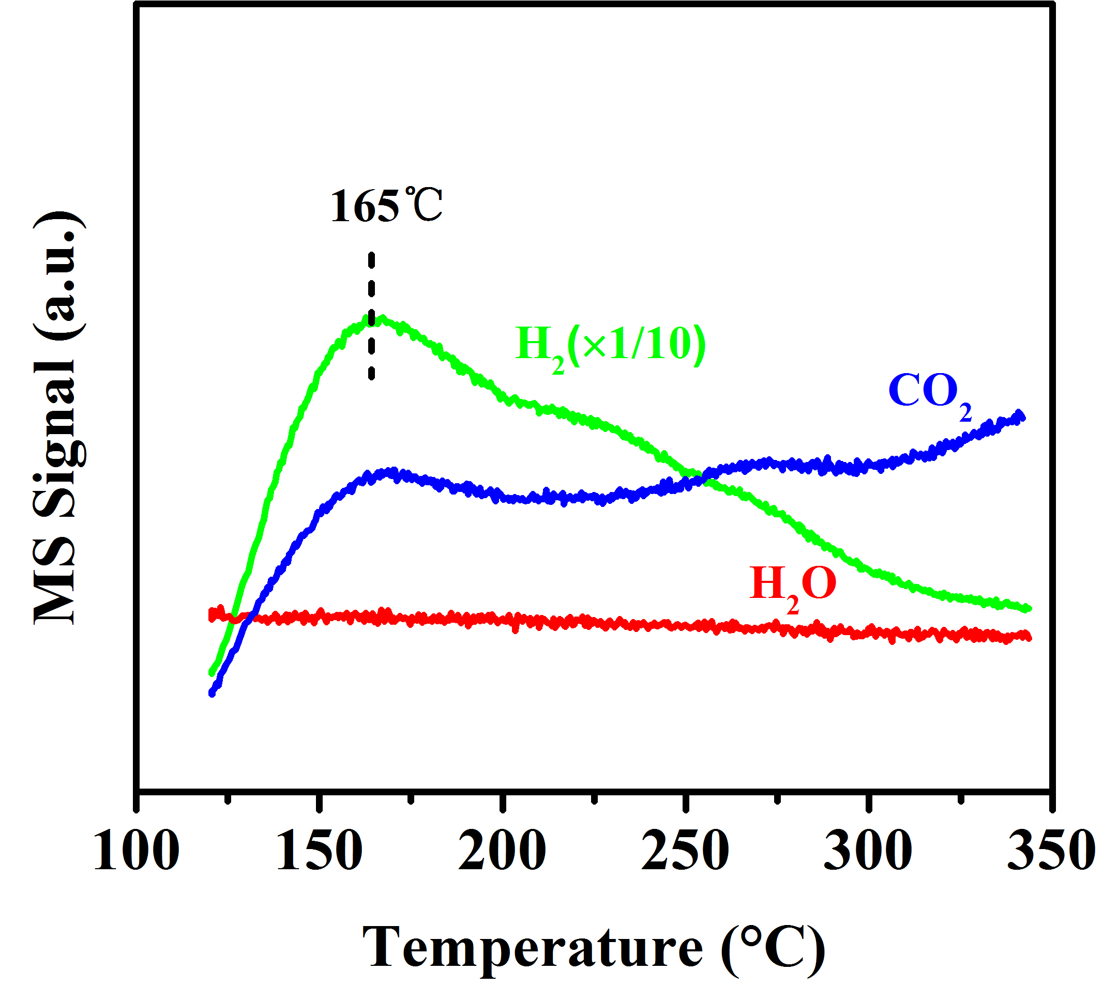
Supplementary Fig. 12 MS signals of CO₂, H₂ and H₂O during CO-TPSR for the Cu/ZnTi-MMO(H350) catalyst.

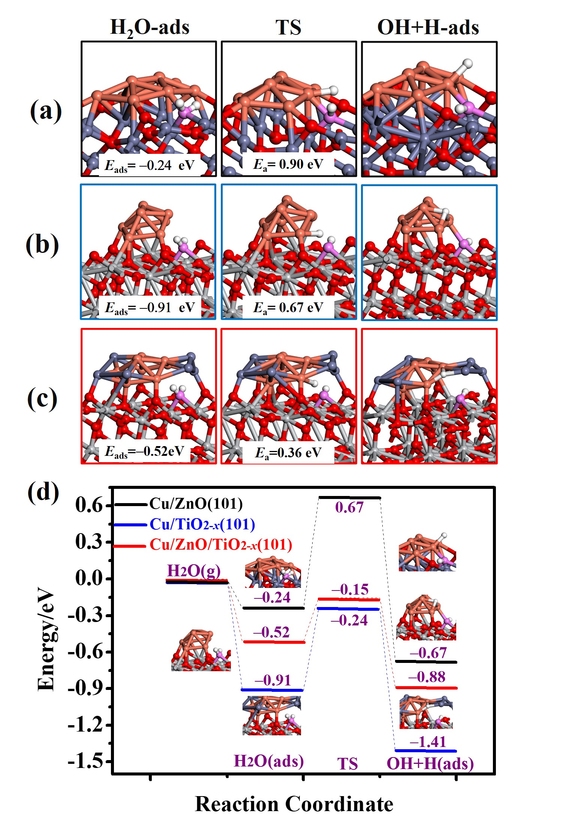
Supplementary Fig. 13 Optimized structures for various steps of water dissociation over: (a) Cu/ZnO(101) interface, (b) Cu/TiO_{2−x}(101) interface, (c) Cu/ZnO/TiO_{2−x}(101) interface. Color code: Cu, rose red; Zn, blue; Ti, gray; O atom in TiO₂, red; O atom in H₂O, pink; H, white sphere, respectively. (d) Activation barrier of water dissociation over Cu/ZnO(101) interface, Cu/TiO_{2−x}(101) interface, and Cu/ZnO/TiO_{2−x}(101) interface, respectively.

Supplementary Fig. 14 Gibbs energy profiles of R5 CO*+O* ⇌ CO₂* and R8 CO*+H* ⇌ CHO* elemental reactions as a function of temperature at the Cu/ZnO/TiO_{2−x}(101) interface.

Supplementary Table 1. Physicochemical properties of Cu-based samples
Samples | BET  surface area  (m² g⁻¹) |  | Cu species content ª  (wt.%) | Cu Crystallite size ^{b} (nm) | Mean Cu particle size ^{c} (nm) | Determined  dispersion of Cu ^{d}  (%) | Surface metallic Cu concentration ^{e}  (mmol g⁻¹)
Cu/ZnTi-MMO(H300) |  | 98.6 | 12.9 | 9.4 | 7.5 | 15.0 | 0.305
Cu/ZnTi-MMO(H350) |  | 78.2 | 14.5 | 9.0 | 7.2 | 15.4 | 0.352
Cu/ZnTi-MMO(H400) |  | 112.9 | 14.8 | 10.1 | 9.6 | 12.3 | 0.287
Cu/ZnO |  | 33.1 | 9.3 | 15.6 | 15.2 | 11.4 | 0.167
Cu/TiO₂ |  | 59.7 | 6.6 | 23.2 | 24.8 | 9.7 | 0.101
ª Cu species content was determined by inductively coupled plasma–atomic emission spectroscopy (ICP–AES). ^{b} Crystallite size was determined by XRD with the Scherrer equation. ^{c} Mean Cu particle size was obtained by TEM. ^{d-e} Metal Cu dispersion and surface metallic Cu concentration were calculated based on the results of the hydrogen pulse reduction method (N₂O titration, described in Experimental Section). ^{f} Cu dispersion was estimated based on Cu particle size measured by TEM.

Supplementary Table 2. EXAFS fitting parameters at the Cu K-edge for various samples
Sample | Shell | N ª | R (Å) ^{b} | σ² (Å²·10⁻³) ^{c} | ΔE₀ (eV) ^{d} | R factor (%)
CuZnTi-MMO(H300) | Cu-Cu | 9.7 | 2.51 | 16.5 | 2.3 | 0.4
CuZnTi-MMO(H350) | Cu-O | 0.7 | 1.90 | 4.1 | 4.9 | 0.2
CuZnTi-MMO(H350) | Cu-Cu | 6.2 | 2.54 | 9.8 | 4.6 | 0.2
CuZnTi-MMO(H400) | Cu-Cu | 9.0 | 2.50 | 16.8 | 1.0 | 0.9
Cu/ZnO | Cu-Cu | 9.1 | 2.55 | 9.5 | 5.5 | 0.5
Cu/TiO₂ | Cu-Cu | 11.9 | 2.54 | 10.4 | 4.1 | 0.7
Cu-foil | Cu-Cu | 12 | 2.54 | 8.6 | 4.2 | 0.1
ª N: coordination numbers; ^{b} R: bond distance; ^{c} σ²: Debye-Waller factors; ^{d} ΔE₀: the inner potential correction. R factor: goodness of fit. Ѕ₀² were set as 0.897/0.85 for Cu−Cu/Cu−O, which was obtained from the experimental EXAFS fit of Cu foil/CuO reference by fixing CN as the known crystallographic value and was fixed to all the samples.

Supplementary Table 3. XPS results of various samples
Samples | Cu 2p_{3/2} BE (eV) | Kinetic Energy (eV) |  |  | X_{Cu}^{δ+} (%)
Samples | Cu 2p_{3/2} BE (eV) | Cu^{δ+} |  | Cu⁰ | X_{Cu}^{δ+} (%)
Cu/ZnTi-MMO(H300) | 932.5 | 916.8 | 918.8 |  | 41.8
Cu/ZnTi-MMO(H350) | 932.5 | 917.2 | 919.1 |  | 50.0
Cu/ZnTi-MMO(H400) | 932.5 | 917.0 | 919.0 |  | 31.9
Cu/ZnO | 931.9 | 917.5 | 919.2 |  | 19.6
Cu/TiO₂ | 931.9 | 917.1 | 919.3 |  | 16.7

Supplementary Table 4. Catalytic performances of various samples toward WGSR
Samples | Surface metallic Cu concentration  (mmol g⁻¹) | Ti³⁺/(Ti³⁺+ Ti⁴⁺) ratio ª | X_{CO} ^{b}  (%) | TOF  (s⁻¹) | Reaction rate  (μmol_{CO} g_{cat}⁻¹ s⁻¹) | E_{a}  (kJ mol⁻¹)
Cu/ZnTi-MMO(H300) | 0.305 | 0.36 | 94.3 | 5.1×10⁻² | 17.1 | 49.8
Cu/ZnTi-MMO(H350) | 0.352 | 0.53 | 96.5 | 5.7×10⁻² | 19.7 | 31.6
Cu/ZnTi-MMO(H400) | 0.287 | 0.30 | 68.9 | 4.0×10⁻² | 12.0 | 50.3
Cu/ZnO | 0.167 | — | 20.3 | 1.2×10⁻² | 2.0 | 59.3
Cu/TiO₂ | 0.101 | 0.23 | 5.9 | 0.6×10⁻² | 0.6 | 29.0
ª Ti³⁺/(Ti³⁺+Ti⁴⁺) ratio was calculated from Ti 2p XPS spectra. ^{b} X_{CO} represents the CO conversion at 250 ºC.

Supplementary Table 5. Catalytic performance of various catalysts toward WGSR
Catalyst | Reaction Temperature (°C) | Reaction Condition | Reaction Rate (μmol_{CO} g_{cat}⁻¹s⁻¹) | TOF  (×10⁻² s⁻¹) | Ref.
Cu/ZnTi-MMO(H350) | 200 | 6%CO-25%H₂O-Ar | 12.0 | 3.4 | This work
Cu/ZnTi-MMO(H350) | 225 | 6%CO-25%H₂O-Ar | 15.8 | 4.5 | This work
Cu/ZnTi-MMO(H350) | 250 | 6%CO-25%H₂O-Ar | 19.7 | 5.7 | This work
CuZnAl  （40%Cu, commercial） | 200 | 6%CO-25%H₂O-Ar | 19.5 | 2.4 | This work
CeO₂/Cu | 250 | 2%CO-10%H₂O-N₂ | 17 | 5.8 | [4]
Cu/CeO₂ | 200 | 1.0%CO-3.0%H₂O-He | 4.0 | 2.8 | [5]
ZnO/c-Cu | 225 | 5% CO, 10% H₂O, balance Ar | 1.2 | — | [6]
Cu_{0.3}Fe_{0.7}O_{x} | 250 | 2%CO, 10%H₂O, balance N₂ | 12.2 | 4.7 | [7]
5Ni5Cu/CeO₂ | 350 | 7% CO, 22% H₂O, 10% CO₂, 20% H₂, balance He | 18.5 | 1.3 | [8]
Cu/ZnO/La | 230 | 7% CO, 8.5% CO₂, 23% H₂O, 37.5% H₂ and 25% N₂ | 11.7 | 1.8 | [9]
CuO₄₂–ZnO–Al₂O₃  (commercial) | 275 | 1.8% CO, 1.8% H₂O,  balance He | 11.8 | — | [10]
Ce_{0.75}Cu_{0.1}Ni_{0.15}O_{2−δ} | 240 | 1.3%CO, 35%H₂O | 2.2 | — | [11]
Cu₄Ni₁₆/CeLaO_{x} | 275 | 10%CO-20%H₂O-He | 15.6 | — | [12]
Cu_{8.9}/CeO₂ | 300 | 10%CO-20%H₂O-He | 16.7 | — | [13]
FeCrCu  (commercial) | 300 | 10%CO, 10%H₂O, 7.5%H₂, 5%CO₂, balance N₂ | 5.0 | — | [14]

References
- Gervasini, A. & Bennici, S. Dispersion and surface states of copper catalysts by temperature-programmed-reduction of oxidized surfaces (s-TPR). Appl. Catal., A 281 (1-2), 199-205 (2005).
- Xu, M. et al. TiO_{2–x}-Modified Ni Nanocatalyst with Tunable Metal-Support Interaction for Water-Gas Shift Reaction. ACS Catal. 7 (11), 7600-7609 (2017).
- Ge, H. et al. Photocatalytic Conversion of CO₂ into Light Olefins over TiO₂ Nanotube Confined Cu Clusters with High Ratio of Cu⁺. Appl. Catal., B 263, 118133 (2020).
- Yan, H. et al. Construction of Stabilized Bulk-Nano Interfaces for Highly Promoted Inverse CeO₂/Cu Catalyst. Nat Commun. 10 (1), 3470 (2019).
- Chen, A. L. et al. Structure of the catalytically active copper–ceria interfacial perimeter. Nat Catal. 2 (4), 334–341 (2019).
- Zhang, Z. et al. The most active Cu facet for low-temperature water gas shift reaction. Nat Commun. 8 (1), 488 (2017).
- Yan, H. et al. Promoted Cu-Fe₃O₄ Catalysts for Low-Temperature Water Gas Shift Reaction: Optimization of Cu Content. Appl. Catal., B 226, 182-193 (2018).
- Saw, E. T. et al. Bimetallic Ni–Cu catalyst supported on CeO₂ for high-temperature water–gas shift reaction: Methane suppression via enhanced CO adsorption. J. Catal. 314, 32-46 (2014).
- Kam, R., Selomulya, C., Amal, R. & Scott, J. The influence of La-doping on the activity and stability of Cu/ZnO catalyst for the low-temperature water–gas shift reaction. J. Catal. 273 (1), 73-81 (2010).
- Kušar, H., Hočevar, S. & Levec, J. Kinetics of the Water–Gas Shift Reaction over Nanostructured Copper–Ceria Catalysts. Appl. Catal., B 63 (3), 194-200 (2006).
- Shinde, V. M. & Madras, G. Water Gas Shift Reaction over Multi-Component Ceria Catalysts. Appl. Catal., B 123-124, 367-378 (2012).
- Lin, J.-H., Biswas, P., Guliants, V. V. & Misture, S. Hydrogen Production by Water–Gas Shift Reaction over Bimetallic Cu–Ni Catalysts Supported on La-doped Mesoporous Ceria. Appl. Catal., A 387 (1-2), 87-94 (2010).
- Thinon, O., Diehl, F., Avenier, P. & Schuurman, Y. Screening of Bifunctional Water-Gas Shift Catalysts. Catal. Today 137 (1), 29-35 (2008).
- Zhang, L., Wang, X., Millet, J.-M. M., Matter, P. H. & Ozkan, U. S. Investigation of Highly Active Fe-Al-Cu Catalysts for Water-Gas Shift Reaction. Appl. Catal., A 351 (1), 1-8 (2008).

