Supporting information

Quercetin: Silent retarder of fatty acid oxidation in breast cancer metastasis through steering of mitochondrial CPT1

Bhuban Ruidas^{1*}, Tapas Kumar Sur², Chitrangada Das Mukhopadhyay¹, Koel Sinha¹, Sutapa Som Chaudhury¹, Pramita Sharma³, Shovonlal Bhowmick⁴, Achintya Saha⁴, Rabindranath Majumder¹

¹Centre for Healthcare Science and Technology, Indian Institute of Engineering Science and Technology, Shibpur, Howrah-711103, West Bengal, India.
²Department of Pharmacology, R G Kar Medical College and Hospital, Kolkata 700004, West Bengal, India.
³Dept of Zoology, Hooghly Mohsin College affiliated to University of Burdwan, Hooghly 712101,West Bengal, India.
⁴Department of Chemical Technology, University of Calcutta, 92, A. P. C. Road, Kolkata, 700009, India.
*Correspondence: Tel: +91-8013446097, Fax: (033) 2668-2916; br.rs2015@chest.iiests.ac.in; bhubo18@gmail.com
Running Title: Quercetin seizes extensive energy supply in metastatic breast cancer.
ORCID Id:
Bhuban Ruidas:https://orcid.org/0000-0003-2062-9159
Koel Sinha:https://orcid.org/0000-0001-6534-0944
Sutapa Som Chaudhury:https://orcid.org/0000-0002-9479-3966

Extract preparation
Soxhlet extractions were performed with 80% methanol for 24 hr on a water bath to collect methanol soluble fractions (Fr). Further, a sequential extraction with petroleum ether (Fr-I), ethyl ether (Fr-II) and ethyl acetate (Fr-III) was performed separately. Fr-II and Fr-III were concentrated for flavonoids, while Fr-I was discarded as it mainly contains fatty substances. Fr-III was further hydrolyzed by refluxing with 7% H₂SO₄ (10 ml/gm plant material for 2 hr), and further extraction was repeated with ethyl acetate thrice from both the filter and filtrates. The total ethyl acetate layer, including Fr-II, was pooled down separately by neutralizing distilled water repeatedly and concentrated in vacuo [1]. Next, all the experiments were performed with these final fractions denoted as MIKA.
Spectrophotometric estimation of total flavonoids
The amount of total flavonoids present in the MIKA was determined according to aluminium chloride method [2, 3]. MIKA was dissolved in hydro-methanol (20:80) at different dilutions (0.1-10 mg/ml). 0.2 ml of MIKA solution was mixed with 0.8 ml methanol, 0.1 ml of 10% aluminium chloride, 0.1 ml of 1 (M) potassium acetate and 2.8 ml of distilled water. It was kept at room temperature for 30 min. After that, the absorbance of the reaction mixture was measured spectrophotometrically at 415 nm. The calibration curve was plotted by preparing the QT solutions at concentrations 12.5 to 100 mg/ml in hydro-methanol (20:80).
Estimation of Quercetin by HPTLC
MIKA and QT (5,7,3ʹ,4ʹ-tetrahydroxyflavonol) solution were prepared separately in hydro-methanol (20:80) at the concentration of 10 µg/ml. The samples were spotted in the form of bands with a Camagmicrolitre syringe on a pre-coated silica gel 60 F254plates (20x20cm) using CamagLinomat applicator (CAMAG Linomat 5). An automatic sample spotter of bandwidth 10mm was used. The plates were developed in a solvent system (toluene: ethyl acetate: formic acid = 4.5 : 3 : 0.2) in Camag twin trough glass chamber for 30 min. TLC plates were air-dried and densitometric scanning was performed on a Camag TLC Scanner 3 at absorbance 280 nm and operated by winCATS planar chromatography manager [4-6]. All tests were done in triplicate mode. The standard curve of QT (peak height and area) and the total amount of QT present in MIKA was determined.
Cell line preparation
All the procured cell lines were revived and cultured in Dulbecco Modified Eagles Media (DMEM) with 10% fetal bovine serum (FBS), 100 I.U./ml penicillin, 100 μg/ml streptomycin and incubated at 37°C with 5% CO₂ and 95% air till confluence state is achieved. In addition, to the constituents mentioned above, the growth medium of MCF-12F was further supplemented with 0.5 µg/ml hydrocortisone, 10 µg/ml insulin and 20 ng/ml of recombinant epidermal growth factor (EGF). All the chemicals, including DMEM and FBS were procured from HiMedia, India.
2.6 Cytotoxicity assay
MTT or 3-(4,5-dimethylthiazol-2-yl)-2,5-diphenyl tetrazolium bromide found the minimal inhibitory effect or IC₅₀ dose of QT in MDA-MB-231, MDA-MB-468, MCF-12F and 4T1 cells, respectively. Approximately, 1× 10⁴ cells of each cell line were grown separately in 96 well plates and treated with varying concentrations of QT, i.e., 0, 5, 10, 15, 20, 25, 30, 35, 40, 50 µg/ml, respectively, followed by 24 h of incubation at 37 ℃. The post-treated cells were then washed with 1X phosphate buffer saline (PBS), before the 4 h of incubation with MTT solution (1 mg/ml stock) at 37 ℃. The resulting formazan crystals were then solubilized with MTT solubilizing buffer to track the individual relative absorbance at 570 nm using a microplate reader (BioTek, USA). The final data were scrutinized in triplicate mode [7].
ROS and Intracellular antioxidant measurements
DCFDA analyses checked the intracellular ROS production. Briefly, untreated control or QT-treated cells (Based on the IC₅₀ value) were washed with ice-cold Hanks balanced salt solution (HBSS) followed by the incubation with DCFDA (10 μM) at 37 °C for 30 min. Subsequently, the cell lysates were performed with alkaline solutions to measure the fluorescence intensities were measured at excitation and emission wavelength of 485 nm and 520 nm respectively, using a microplate reader (BioTek, USA). The analysis of data was based on the triplicate mode.
Intracellular glutathione (GSH) and Nicotinamide Adenine Dinucleotide Phosphate (NADPH) are two significant antioxidants associated in mitochondrial oxidation. Post-treatment of 1×10⁴ MDA-MB-231 cells were washed in PBS and the relative GSH level by GSH-GloTM Glutathione Assay kit (Promega) were determined. To measure the relative GSH level, the post-treated cells were further incubated in a bicarbonate-free DMEM medium supplemented with 25 mM of glucose and 6 mM of glutamine at 37 °C inside a non-CO₂ incubator for 45 min. Finally, the luminescent intensities were recorded using a FLUOstar Optima plate reader.
Subsequently, the post-treated 4×10⁶ cells after 24 h incubation were washed thrice to quantify the relative NADPH levels by AmpliteTM Fluorometric NADPH Assay (AAT Bioquest, USA) kit and the data were noted using FLUOstar Optima plate reader. All the data were recorded in triplicate mode.
Mito and Glyco stress analyses
The investigation of overall oxygen consumption rate (OCR) for Mito stress and extracellular acidification rate (ECAR) for Glyco stress prediction in MDA-MB-231 cells were achieved by Seahorse XFe24 Extracellular Flux Analyzer (Seahorse Bioscience, North Billerica, MA, USA) in 24 XF well plates. Briefly, 2×10⁴ cells were seeded in the XFe24 cell culture plate for 24 h at 37 ℃ with 5% CO₂. Then, the different concentrations of QT treated cells were incubated for 12 h at 37 ℃. Before readings, the cells were washed with seahorse XF base media (Seahorse Bioscience) and incubated at 37 ℃ for 20-30 min in a non-CO₂ incubator supplemented glutamine and glucose. Finally, the procured mitochondria agitating agents (Sigma Aldrich), namely, carbonyl cyanide-4-(trifluoromethoxy)-phenylhydrazone (FCCP) and rotenone/antimycin A, are injected at the drug injection ports, by the basal measurement of OCR carried out by 20 min of calibration and equilibration in the instrument. Consequently, the data were normalized with respective protein content, which is evaluated by Lowry methods.
The measurement of ECAR was preceded by washing and replacing of XF base media supplemented with glutamine treated cells (12 h of incubation) and incubating them in a non-CO₂ incubator for 1h at 37 ℃. It is then followed by the addition of glycolysis agitating agents (Sigma Aldrich) such as glucose, oligomycin (mitochondrial respiration blocker) and 2-deoxyglucose addition at the drug injection ports respectively with 20 min of calibration and equilibration. Eventually, the data were normalized with the respective total protein content quantified by Lowry methods.
Anti-invasion and migration study
To assess the anti-migratory effect of QT, 1×10⁴ of cells (MDA-MB-231) were cultured in 24 well plates at 37 ℃ in a 5% CO₂ incubator for 24 h. The post-treated cells were further incubated at varying time intervals (0, 24, 48 h, respectively) after constructing scratches on the monolayer cells and observed the wound healing following sequential time intervals using an inverted fluorescence microscope. For anti-invasion assay, 1×10⁴ of MDA-MB-231 cells were seeded in Transwell chamber keeping the nutrients below of another chamber for overnight at 37 ºC and 5% CO₂ incubator. Non-invaded cells were stained with supplied blue dye and washed sequentially to remove death cells. Next, the invasive cells in the matrix were observed under an inverted fluorescence microscope (Olympus, Japan) and the corresponding intensities were measured using microplate reader (Biorad, India).
ELISA assay for metastatic protein expression
Active migration and invasion abilities of cancer cell are highly influenced by the over expression of matrix metalloproteinase 2, and 9 (MMP-2, MMP-9) level and also these are the key regulator of cancer metastasis [8].
Relative protein expression analyses were performed using individual matrix metalloproteinase-2 and 9 (MMP-2 and MMP-9) specific Enzyme-Linked Immunosorbent Assay (ELISA) kit (Sigma, Aldrich) following the supplier's protocol. In short, 2.5×10⁴ MDA-MB-231 cells were seeded and incubated in an ELISA microplate individually for 24 h at 37 ℃. Following this, the cells were treated and incubated with different concentrations of QT for 24 h. The treated cells were then fixed in fixing buffer after repeated wash with 1X wash buffer for a further 20 min of incubation at 37 ℃. Next, the cells were washed again with 1X wash buffer prior to 20 min of incubation with 1X quenching buffer, then substituted with a blocking buffer for 1 h of incubation at 37 ℃. The cells were then incubated with 50 µl of 1X primary antibody for 2 h at 37 ℃ followed by a repeated wash with 1X wash buffer. Primary antibody-treated cells were further washed thrice in wash buffer before incubation with 1X HRP conjugated secondary antibody for 1 h at 37 ℃. Ultimately, the cells were incubated in the dark after treating 100 µl of the 3,3',5,5'-tetramethylbenzidine (TMB) substrate for 30 min at 37 ℃ by the inclusion of 50 µl of stop solution. The data is then noted immediately at 450 nm by using a microplate reader (BioTek, USA).
RNA extraction, cDNA synthesis and gene expression analysis
The total RNA from QT treated or mock-treated MDA-MB-231 cells were extracted using Trizol reagents (Sigma Aldrich). After RNA synthesis, it was further processed to transform into cDNA by normal polymerase chain reaction (PCR, Bio-Rad, Hercules, CA, USA). Then, the individual gene expression was investigated after selecting the forward and reverse primer of desired protein (IDT technologies, Iowa, USA) using SYBR green (Thermo Fischer Scientific, USA) in qRT-PCR (Applied Biosystems, Waltham, MA,USA) immediately after RNA extraction and subsequent cDNA synthesis (PCR, Bio-Rad, Hercules, CA, USA). Relative gene expressions were calculated following the comparative CT method (ΔΔCT) and the fold changes were calculated using the formula: 2-[ΔCT (treated) – ΔCT (calibrated)]. Therefore, the ΔCT values of the targeted genes were calculated after deduction from the housekeeping gene's ΔCT value.
In-silico molecular modelling and docking studies
I-TASSER software predicted the 3D structure of CPT1 successfully and worked on submitted amino acid sequences of CPT1, retrieved from UniProt database (UniProtKB - P50416) to automatically generate high-quality model predictions for CPT1 crystal structure. The best model's best quality assessment was also checked using Very 3D available at https://saves.mbi.ucla.edu/ and structure was validated through the Ramachandran plot analysis.
Before docking execution, the modeled crystal structure of CPT1 was preprocessed employing the ‘Protein Preparation Wizard’ utility tool of the Schrödinger suite [9]. During the protein preparation step, hydrogen atoms were added to the modeled protein crystal structure, followed by appropriate bond orders and formal charges. Specifically, the protein processing step comprises terminal capping with N-methyl amide (NMA) and N-acetyl (ACE) groups. Further, the modeled protein's loop refinement was performed to rectify the invalid residues, if present in the crystal structure. The final step, modeled CPT1 crystal structure, was energetically minimized employing the OPLS3 molecular mechanics force field [10]. After successful prediction of 3D crystal structure, among the top 5 final models predicted by I-TASSER, best model protein structure was selected based on the TM-score. The restrained minimization progression was preceded until the heavy atoms' convergence achieves the root mean square deviation (RMSD) of 0.30 Å. Hence, the optimized CPT1 crystal structure was obtained for subsequent studies. Further, a docking grid file was generated for the prepared protein structure using the ‘Receptor Grid Generation’ module embedded in Schrödinger’s Maestro interface. The grid box was particularly generated around the carnitine-binding site with the conserved amino acid residues such as Tyr241, His473, Asp477, Ala478, Tyr589, Thr602, Ser685 and Ser687 or by selecting close proximity residues along the catalytic tunnel of CPT1 [11]. Thereby, above mentioned specified residues information was confined inside the rectangular grid box for grid box generation. The grid center was particularly assigned as 66.0, 16.0, -6.0 Å for the X, Y and Z coordinates, respectively. On the other hand, to generate the low-energy stereoisomers of the studied molecule with correct chirality, the polyphenolic flavonoid ligand molecule, QT was prepared energetically optimized using ‘LigPrep’ utility tool embedded in Schrödinger’s Maestro interface [12]. After successful implementation of Glide XP-docking protocol, initially all docked poses were manually inspected for binding energy score through ‘XP visualizer’ and molecular binding interaction analyses in ‘Ligand interaction diagram’ module in 2D view and further the protein–ligand interaction profiler (PLIP) tool was used to detect the details of 3D interaction profiles and binding modes between each CPT1 protein and flavonoid QT. Also, Successful execution of ‘LigPrep’ module generated all possible 3D geometry configurations for QT and the structure of QT was initially retrieved from PubChem database available at https://pubchem.ncbi.nlm.nih.gov/.
Animal experiments
Single dose toxicity
QT was tested for acute oral toxicity study following the guidelines of OECD No. 423. The test drug was given to 16 h fasted mice in the doses of 1 mg, 2 mg, 5mg, 10 mg and 25 mg per kg in progressive manner by intravenous route in a single dose and observed for 3 days. The volume was restricted to 0.1 ml/kg for each mice. The behavioral signs and symptoms were carefully observed and noted. The rates of mortality (if any) up to 14 days were recorded for the selection of 50% lethal dose of test formulation.
Selection of therapeutic dosages
On the basis of single dose acute toxicity study, two intravenous dosages i.e., 15 mg/kg and 30 mg/kg (1/5th and 2/5th of maximum studied dose) of QT (QT-15 and QT-30) were selected for therapeutic application in mice. The reference anti-tumor drug, ETO was used at the dose of 30 mg/kg (ETO-30). All test drugs were given intravenously every 3 alternative days. The volume was restricted to 0.1 ml/kg for each mice.
In-vivo anticancer assessment
For tumorigenic activity assessment, over-night fasted female mice were anesthetized and a 25µl of 4T1 cell suspension of 5x10⁴ cells were injected subcutaneously in the mammary fat pad by 25 gauge needle. After 10 days all tumor bearing mice were segregated randomly into four experimental groups (each group containing 6 animals). Then, each group were treated with 15 and 30 mg/kg of QT (QT-15 and QT-30), 30 mg/kg of ETO (ETO-30) and equal volume of PBS (0.1 ml/mice) as control dose intraperitoneally with 3 days interval and continued upto 21 days. A time-dependent tumor growth along with mice body weight, tumor weight and volume were calculated and recorded comparing with tumor control. The hemi ellipsoid nature of tumor volume (V) was calculated by the formula ½ ×LWH, where LWH denotes mean length, width and height respectively. Also, a small portion of breast tissue was processed with hematoxylin-eosin (H/E) staining for microscopic histopathological analysis. In addition, the homogenized part of breast tissue in 0.1 (M) phosphate buffer (10% w/v) was prepared to investigate the major oxidative stress parameters including lipid peroxide (LPO), superoxide dismutase (SOD), reduced glutathione (GSH) and protein following standard protocols. In addition, total cholesterol, high density lipoprotein (HDL), low density lipoprotein (LDL), very low density lipoprotein (VLDL) and triglyceride were also checked spectrophotometrically following standard protocols. To check the nontoxic effect, the liver enzymes namely serum glutamate oxaloacetate transaminase (SGOT), serum glutamate pyruvate transaminase (SGPT), alkaline phosphatase (ALP) and renal markers namely urea, creatinine level were measured spectrophotometrically using commercially available kits (Arkray, Inc., India).

Fig. S1 Molecular quantification of Quercetin. (a) HPTLC chromatogram of standard QT (b) HPTLC chromatogram of MIKA (c) Integrated spectrum of MIKA.
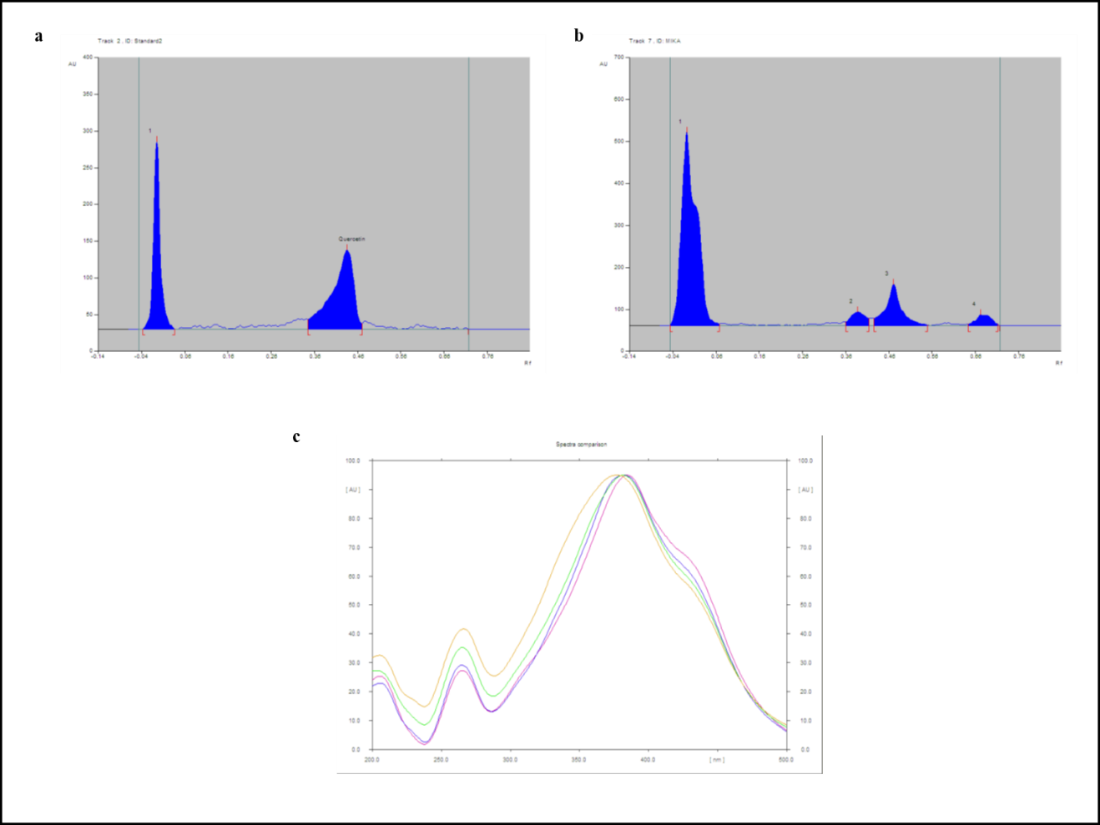

Fig S2. Cytotoxicity analysis of QT in different breast cancer cells.
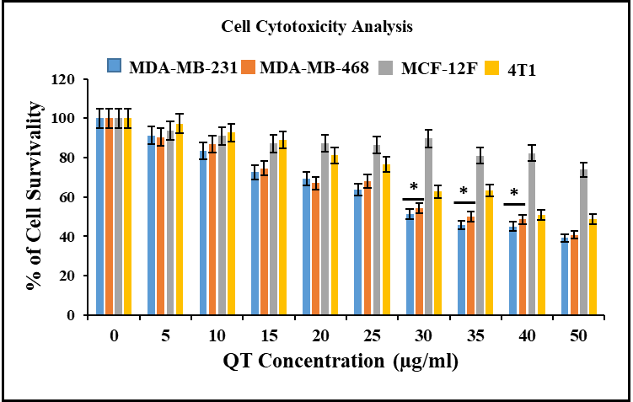

Fig. S3 Intracellular ROS and antioxidant level analysis
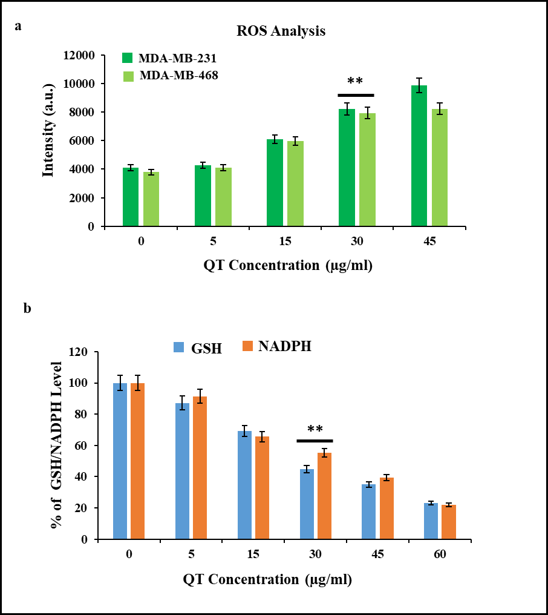
Fig. 1 Intracellular ROS and antioxidant level analysis (a) QT-triggered dose-dependent ROS generation has been depicted in MDA-MB-231 and MDA-MB-468 cell respectively (b) A dose-dependent decrease in antioxidant level (mainly GSH and NADPH) in presence of QT has been illustrated. Bar reports mean ± s.e.m, one of two experiments completed with or without human subject samples, is shown. **p<0.001

Fig. S4 QT intervened cell apoptosis analysis
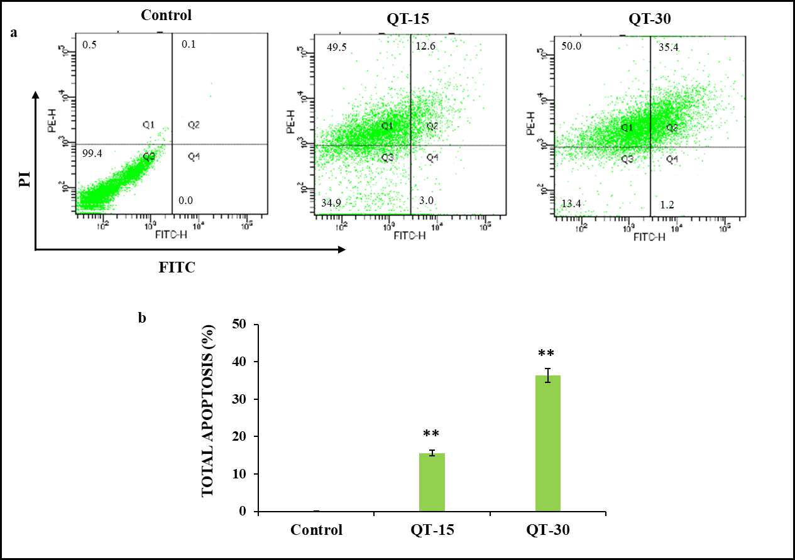
Fig. 5 QT intervened cell apoptosis analysis. Apoptotic cell induction in presence of QT-15 and QT-30 has been illustrated compared to untreated control (a). The dose-dependent increment in total apoptosis has been quantified in presence of QT-15 and QT-30 compared to untreated control (b). Bar reports mean ± s.e.m, one of two experiments completed with or without human subject samples, is shown. **p<0.001.

Fig. S5 In-vivo toxicity analysis. (a) comparative liver function, (b) kidney function in presence of QT and ETO.
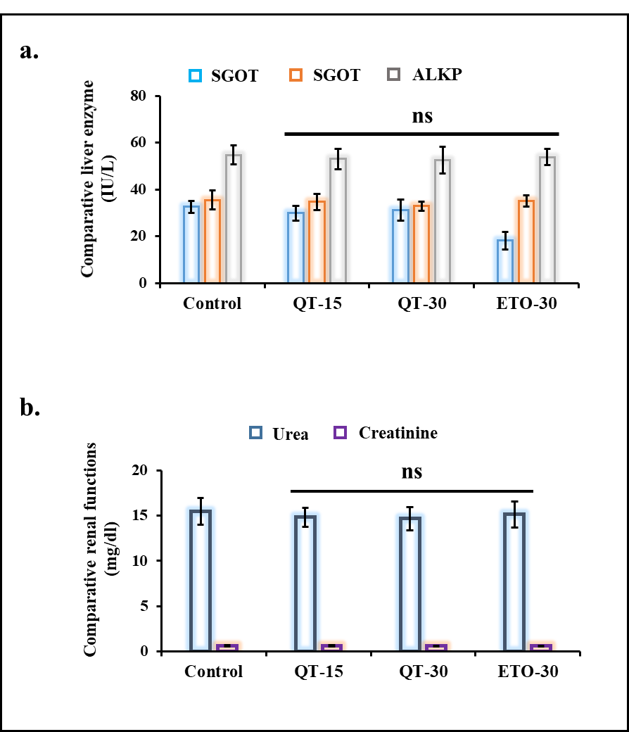

Table S1 Primers used for qRT-PCR experiments
Name of the gene | Forward primer (5’-3’) | Reverse primer (5’-3’)
FASN | TCGTGGGCTACAGCATGGT | GCCCTCTGAAGTCGAAGAAGAA
ACCα | CTGTAGAAACCCGGACAGTAGAAC | GGTCAGCATACATCTCCATGTG
CPT1A | TCCAGTTGGCTTATCGTGGTG | CTAACGAGGGGTCGATCTTGG
GAPGH | CCCCTTCATTGACCTCAACTAC | GAGTCCTTCCACGATACCAAAG

Table S2 Flavonoids and QT concentration in MIKA
Flavonoids  (µg QE/mg MIKA) | QT  (µg/mg MIKA)
132.66 ± 0.029 | 118.41 ± 0.018
N=3; Mean±SD; QE=QT equivalent; Rf value of QT 0.38; r²=0.99662;

Table S3 Acute toxicity
QT: Group | Dose  mg/kg | Dead / Total |  |  |  |  | Dead %
 |  | Day 1 | Day 2 | Day 3 | Day 7 | Day 14 Day 21
1 | 250 | 0/3 | 0/3 | 0/3 | 0/3 | 0/3 0/3 | 0
2 | 500 | 0/3 | 0/3 | 0/3 | 0/3 | 0/3 0/3 | 0
3 | 1000 | 0/3 | 0/3 | 0/3 | 0/3 | 0/3 0/3 | 0
4 | 1500 | 0/3 | 0/3 | 0/3 | 0/3 | 0/3 0/3 | 0
5 | 2000 | 0/3 | 0/3 | 0/3 | 0/3 | 0/3 0/3 | 0
N=3;

Reference
- L. Moreira, I. Araujo, T. Costa, A. Correia-Branco, A. Faria, F. Martel, E. Keating, quercetin and epigallocatechingallate inhibit glucose uptake and metabolism by breast cancer cells by an estrogen receptor-independent mechanism. Exp. Cell Res. 319, 1784-1795 (2013)
- J. B. Harbone, Phytochemical methods, 2nd edn. (Chapman and Hall, New York, 1984), pp-288
- D. Banerjee, S. Chakrabarti, A. K. Hazra, S. Banerjee, J. Ray, B. Mukherjee, Antioxidant activity and total phenolics of some mangroves in Sundarbans. African J Biotechnol. 7, 805-811 (2008)
- T. K. Sur, A. K. Hazra, D. Bhattacharyya, A. Hazra, Antiradical and antidiabetic properties of standardized extract of Sunderban mangrove Rhizophoramucronata. Pharmacognosy Res. 11, 389-394 (2015)
- C. I. Sajeeth, P. K. Manna, R. Manavalan, C. I. Jolly, Quantitative estimation of gallic acid, rutin and quercetin in certain herbal plants by HPTLC. Der ChemicaSinica, 1, 80-85 (2010)
- A. K. Hazra, B. Chakraborty, A. Mitra, T. K. Sur, A rapid HPTLC method to estimate piperine in Ayurvedic formulations containing plant ingredients of Piperaceae family. J. Ayurveda and Integrated Medicine, 10, 248-254 (2019)
- S. S. Chaudhury, A. Sannigrahi, M. Nandi, V. K. Mishra, P. De, K. Chattopadhyay, S. Mishra, J. Sil, C. D. Mukhopadhyay, A novel PEGylated block copolymer in new age therapeutics for Alzheimer disease. Mol. Neurobiol. 56, 6551-6565 (2019)
- H. Li, Z. Qiu, F. Li, C. Wang, The relationship between MMP-2 and MMP-9 expression levels with breast cancer incidence and prognosis. Oncol Lett. 14, 5865-5870 (2017)
- Protein preparation wizard, Schrödinger, (LLC, New York, NY, 2018)
- E. Harder, W. Damm, J. Maple, C. Wu, M. Reboul, J. Y. Xiang, L. Wang, D. Lupyan, M. K. Dahlgren, J. L. Knight, J. W. Kaus, D. S. Cerutti, G. Krilov, W. L. Jorgensen, R. Abel, R. A. Friesner, OPLS3: a force field providing broad coverage of drug-like small molecules and proteins. J. Chem. Theory and Computation, 12, 281-296 (2016)
- E. Lopez-Vinas, A. Bentebibel, C. Gurunathan, M. Morillas, D. de Arriaga, D. Serra, G. Asins, F. G. Hegardt, P. Gomez-Puertas, Definition by functional and structural analysis of two malonyl-CoA sites in carnitine palmitoyltransferase 1A. The J Biol. Chem. 282, 18212-18224 (2007)
- LigPrep, Schrödinger, (LLC, New York, NY, 2018)

