Supplementary Information

Theoretical Background

Signal Description
Interferometric NIRS records, at detector position $r$, optical frequency $ν=c/λ$ (c is the speed of light in vacuum and λ is the wavelength), and acquisition time $t_{d}$ (sweep index), the spectral interferogram:
$S(r,ν,t_{d})=S_{DC}(r,ν,t_{d})+2Re\left[W_{rs}\left(r,ν,t_{d}\right)\right]$, (S1)
where $S_{DC}$ is the DC offset, the sum of the sample- and reference-arm intensities, and $W_{rs}$ is the cross-spectral density function between the optical fields from the two arms. Its real part carries the spectral fringe information. The symbol $r$ marks the detector position. It is typically omitted in single-channel iNIRS (one detector) and becomes the pixel coordinate in parallel iNIRS.
After subtracting $S_{DC}$ and resampling to uniform optical frequency (k-linearization), inverse Fourier transformation with respect to $ν$ yields the mutual coherence function:
$Γ_{rs}(r, τ_{s},t_{d})={〈U_{r}^{*}\left(r,t_{s},t_{d}\right)U_{s}\left(r,t_{s}+τ_{s},t_{d}\right)〉}_{t_{s}}$, (S2)
where $U_{r}$ and $U_{s}$ are the optical fields in the reference and sample arms, $τ_{s}$ is the time-of-flight (a conjugate variable to $ν$), and ${〈∙〉}_{t_{s}}$ denotes averaging over the fast sampling time within the sweep $t_{s}.$
Using $Γ_{rs}(r, τ_{s},t_{d})$ we form the two-dimensional autocorrelation:
$G_{1}^{(iNIRS)}(r,τ_{s},τ_{d})={〈Γ_{rs}^{*}\left(r, τ_{s},t_{d}\right)Γ_{rs}\left(r, τ_{s},t_{d}+τ_{d}\right)〉}_{t_{d}}$. (S3)
with $τ_{d}$ the lag between successive sweeps (sampling step $δτ_{d}=1/f_{l}$, set by the sweep rate $f_{l}$). The measured correlation is the true TOF-resolved autocorrelation $G_{1}^{}(τ_{s},τ_{d})={〈U_{s}^{*}\left(τ_{s},t_{d}\right)U_{s}\left(τ_{s},t_{d}+τ_{d}\right)〉}_{t_{d}}$ convolved along $τ_{s}$ with the instrument response function (IRF):
$G_{1}^{(iNIRS)}\left(r,τ_{s},τ_{d}\right)=G_{1}^{}\left({r,τ}_{s},τ_{d}\right)*IRF\left(τ_{s}\right),$ (S4)
where the IRF is governed by the by the laser tuning bandwidth $Δλ$. The wider the bandwidth the narrower the IRF, and thus finer the TOF resolution.
Setting $τ_{d}=0$ gives the temporal point spread function (TPSF):
$I_{s}^{\left(iNIRS\right)}(r,τ_{s})=G_{1}^{(iNIRS)}\left(r,τ_{s},τ_{d}=0\right)$, (S5)
which equals the true distribution of times of flight (DTOF) convolved with the same IRF.
For parallel iNIRS (πNIRS), we spatially average TOF-resolved quantities:
$G_{1}^{(πNIRS)}\left(τ_{s},τ_{d}\right)={〈G_{1}^{\left(iNIRS\right)}\left(r,τ_{s},τ_{d}\right)〉}_{r},$ (S6)
$I_{s}^{\left(πNIRS\right)}\left(τ_{s}\right)={〈I_{s}^{\left(iNIRS\right)}\left(r,τ_{s}\right)〉}_{r}.$ (S7)
Integrating out TOF yields the continuous-wave limit (CW-πNIRS)$:$
${G_{1}^{(CW-πNIRS)}\left(τ_{d}\right)=\int_{0}^{∞}{dτ_{s}}G}_{1}^{(πNIRS)}\left(τ_{s},τ_{d}\right),$ (S8)
$I_{s}^{\left(CW-πNIRS\right)}=\int_{0}^{∞}{dτ_{s}}G_{1}^{(CW-πNIRS)}\left(τ_{d}=0\right).$ (S9)
Thus CW-πNIRS captures the same integrated intensity and field-autocorrelation as parallel iNIRS, but without TOF resolution. For plotting and parameter estimation, we normalize to zero lag:
$g_{1}^{(CW-πNIRS)}\left(τ_{d}\right)=\frac{G_{1}^{\left(CW-πNIRS\right)}\left(τ_{d}\right)}{G_{1}^{\left(CW-πNIRS\right)}\left(τ_{d}=0\right)},$ (S10)
$g_{1}^{(πNIRS)}\left(τ_{s}, τ_{d}\right)=\frac{G_{1}^{\left(πNIRS\right)}\left(τ_{s},τ_{d}\right)}{G_{1}^{\left(πNIRS\right)}\left({τ_{s},τ}_{d}=0\right)}.$ (S11)

Temporal IRF, TOF resolution and the sampling-limited TOF range
In iNIRS (single‑channel or parallel), the instrument response function (IRF) is set by the laser tuning bandwidth $Δλ$. For a Gaussian spectrum and a Mach–Zehnder detection geometry, the full width at half maximum (FWHM) of the temporal IRF is:
$δτ_{s}=\frac{2\sqrt{2}ln⁡(2)}{π}\frac{λ_{c}^{2}}{cΔλ}≈0.62\frac{λ_{c}^{2}}{cΔλ},$ (S12)
where $λ_{c}$ is the centre wavelength. Thus, increasing $Δλ$ sharpens the TOF resolution $δτ_{s}$ in direct proportion to $Δλ^{-1}$. So, a wider bandwidth yields finer resolution.
In a swept-source acquisition, each sweep provides N samples:
$N= f_{s}/f_{l}$, (S13)
where $f_{s}$ is the sampling rate and $f_{l}$ is the laser sweep (tuning) rate. The corresponding spectral step is $δλ≈Δλ/N$, which sets the unaliased TOF window (maximum measurable TOF):
$τ_{s,max}^{(sampling)}=\frac{λ_{c}^{2}}{cδλ}=\frac{f_{s}}{f_{l}}\frac{λ_{c}^{2}}{cΔλ}.$ (S14)
Finally, the autocorrelation-lag sampling is fixed by the sweep rate,
$δτ_{d} = \frac{1}{f_{l}}.$ (S15)
These relations expose two trade-offs:
- Bandwidth trade-off. Increasing $Δλ$ improves $δτ_{s}$ (finer depth resolution) but reduces $τ_{s,max}^{(sampling)}$.
- Speed trade-off. A faster sweep (larger $f_{l}$) improves the autocorrelation sampling interval $δt_{d} = 1/f_{l}$ needed for flow measurements but reduces $τ_{s,max}^{(sampling)}$ unless $f_{s}$ is increased proportionally. Raising $f_{s}$, however, demands wider-bandwidth electronics and faster data transfer, adding cost and complexity.
Therefore, the iNIRS operating point must balance (i) fine TOF resolution for optical-property fits, (ii) sufficient TOF range to reach cortex, and (iii) high temporal sampling for dynamic flow, and all within the constraints of laser tuning speed and electronic bandwidth.

Sampling-limited sweep-rate ceiling
To set a practical target TOF window for cortical sensitivity, we adopt the standard TD-NIRS framework under diffusion theory for a semi-infinite head. Representative analyses and measurements [16] show usable DTOF windows of 1–5 ns for adult source–detector separations (SDS). Because iNIRS typically operates at shorter SDS than TD-NIRS, enabled by its markedly narrower IRF (15–50 ps FWHM in iNIRS versus 200–500 ps in TD-NIRS), we take $τ_{s,target}≈ 1-1.5 ns$ as a design point for cortex-level sensing.
Using Eq. (S14) for the sampling-limited unaliased TOF window, we impose $τ_{s,max}^{(sampling)}≥ τ_{s,target}$ and obtain the range-limited sweep ceiling:
$f_{l}<f_{l,max}= \frac{f_{s}λ_{c}^{2}}{cΔλτ_{s,target}}.$ (S16)
Expressing $Δλ$ in pm, $τ_{s,target}$ in ns, and $f_{l,max}$ in kHz, we get:
$f_{l,max} \left[kHz\right]=\frac{K}{τ_{s,target} \left[ns\right] Δλ [pm]}, K=\frac{f_{s}λ_{c}^{2}}{c}×{10}^{18} [kHz⋅ns⋅pm]$. (S17)
Equation (S17) makes explicit that $f_{l,max}$ scales linearly with the sampling rate and quadratically with centre wavelength and decreases as $1/Δλ$. Thus, widening $Δλ$ (to sharpen $δτ_{s}$) reduces the allowable sweep rate unless $f_{s}$ is increased proportionally. At fixed $f_{s}$ and $τ_{s,target}$, halving $Δλ$ doubles $f_{l,max}$ but simultaneously doubles $δτ_{s}$ (coarser TOF resolution), reflecting the core bandwidth–range trade-off.
In our parallel-iNIRS prototype the dominant hardware limit is the camera sampling rate $f_{s}^{(πNIRS)} = 1.1 MHz$. By contrast, single-channel iNIRS typically employs a fast digitizer with $f_{s}^{(iNIRS)} = 100-125 MS/s$ but with orders of magnitude fewer detection channels. Using Eq. (S17), such a fast digitizer raises $K$ by ~100 relative to the camera, so range-limited sweep ceilings of the order of hundreds of kHz to ~1 MHz become theoretically admissible for the same $Δλ$ and $τ_{s,target}$. In practice, however, tuneable-laser mechanics and electronics rarely support such high $f_{l}$ while maintaining sweep linearity, and one must retain a minimum spectral sampling density $N_{min}$ (typically $N_{min}≥32-128$ samples across $Δλ$), imposing
$f_{l,max} \left[kHz\right]=\min\left\{\frac{K}{τ_{s,target} Δλ },\frac{f_{s}}{N_{min}}\right\}$ (S18)
Thus, even with a fast digitizer, N-density often limits $f_{l,max}$ to the tens–hundreds of kHz regime.
Figure S1 plots the sampling-limited sweep-rate ceiling $f_{l,max}$ as a function of the tuning bandwidth $Δλ$ [Eq. (S16)] for $λ_{c}=780$ and $850$ nm with $f_{s}=1.1 MHz$. The black curves follow $f_{l,max}$ for $τ_{s,target}=1 ns$ (solid) and $2 ns$ (dashed). Horizontal lines show the sampling-density caps $f_{s}/N_{min}$ for $N_{min}∈\left\{32,64,128\right\}$. Feasible operation lies below both the black curve and the relevant $N_{min}$ line. Specifically, the active limit is therefore the minimum of the range curve and the horizontal $f_{s}/N_{min}$ line. The crossover bandwidth at which the cap begins to dominate is
$Δλ_{th}(τ_{s,target})=\frac{K}{τ_{s,target}f_{s}/N_{min}}$. (S19)
For $τ_{s,target}=2 ns$ and $N_{min}=64,$ we obtain $Δλ≈65 pm$ (780 nm) and $≈77 pm$ (850 nm). For $τ_{s,target}=1 ns$ these thresholds double to $Δλ≈130 pm$ and $≈154 pm$, respectively. Thus, at narrower $Δλ$ the cap $f_{s}/N_{min}$ limits $f_{l}$ (curve above the line), whereas at wider $Δλ$ the range relation limits $f_{l}$ (curve below the line). Increasing $λ_{c}$ or $f_{s}$ raises $K$ and shifts $Δλ_{th}$ to larger bandwidths. Increasing $N_{min}$ (more conservative sampling) lowers the cap and shifts $Δλ_{th}$ left, making the cap active over a wider $Δλ$ range.
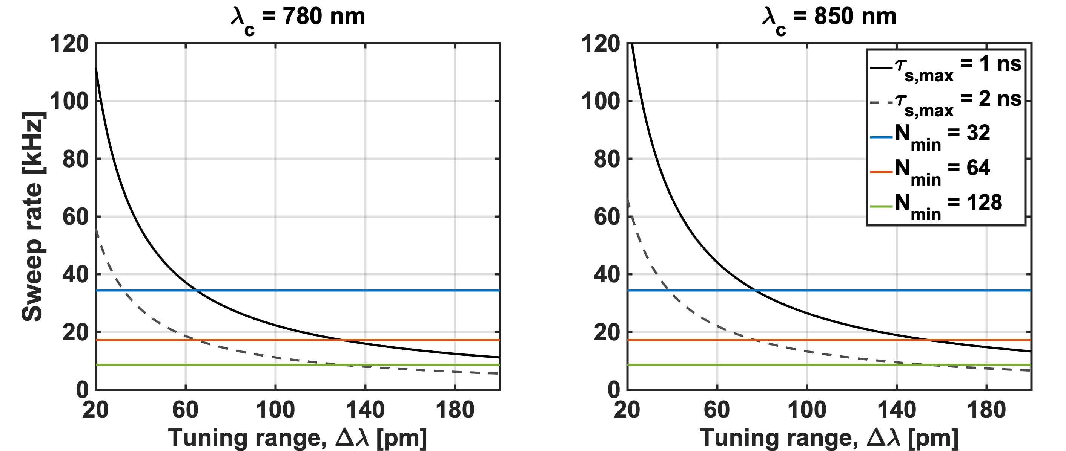
Fig. S1. Sampling-limited sweep-rate ceiling for camera-based πNIRS. Sweep-rate $f_{l}$ versus tuning bandwidth $Δλ$ for (left) $λ_{c}=780$ and (right) $850$ nm, assuming the detector sampling $f_{s}=1.1 MHz$. Black curves show the range constraint ($K/τ_{s,target} Δλ,$Eq. (S17)) with $τ_{s,target}=1 ns$ (solid) and $2 ns$ (dashed). Colored horizontal lines indicate sampling-density caps $f_{s}/N_{min}$ for $N_{min}=32$ (blue), 64 (red), and 128 (green). The feasible region lies below both the corresponding black curve and the cap. For example (right): at $Δλ≈70 pm$ the 2 ns range curve gives $f_{l,max}≈18.9 kHz$, close to the $N_{min}=64$ cap (17.2 kHz, red line). Increasing wavelength raises the curves as $f_{l,max}∝λ_{c}^{2}$; widening $Δλ$ improves TOF resolution but lowers the allowable sweep rate, illustrating the bandwidth–range trade-off.

Sweep-rate limitations imposed by decorrelation dynamics
Beyond the sampling-limited TOF window, the ability to resolve blood-flow dynamics is set by the decorrelation rate of scattered photons. According to Diffusing Wave Spectroscopy (DWS) theory, the field autocorrelation at a given photon time-of-flight, $τ_{s}$ decays exponentially in lag $τ_{d}:$
$g_{1}\left({τ_{s},τ}_{d}\right)=\exp\left[-ξ\left(τ_{s}\right)τ_{d}\right],$ (S20)
with a decay rate:
$ξ\left(τ_{s}\right)=2k^{2}αD_{B}μ_{s}^{'}cτ_{s}/n$, (S21)
where $k=2πn/λ_{c}$ is the in-medium wavenumber, $μ_{s}'$ the reduced scattering coefficient, $n$ the refractive index, and $αD_{B}$ the blood-flow index. The proportionality $ξ\left(τ_{s}\right)∝τ_{s}$ indicates that longer-path photons decorrelate faster, so deeper tissue gates require faster temporal sampling to capture their dynamics.
The sweep rate $f_{l}$ sets the autocorrelation lag step $δτ_{d}=1/f_{l}$. To adequately resolve the exponential decay, the sampling step $δτ_{d}$ must be small compared to the decay time $1/ξ(τ_{s})$. A practical criterion is
$δτ_{d}≤ \frac{1}{m ξ\left(τ_{s}\right)} ⇔ f_{l}≥ mξ(τ_{s})$, (S22)
where $m≈ 3-5$ ensures stable curve fitting. This condition defines a decorrelation-limited maximum measurable TOF,
$τ_{s,max}^{(ξ)}≈ \frac{f_{l}}{m}\frac{n}{2k^{2}αD_{B}μ_{s}^{'}c}$. (S23)
Substituting $k=2πn/λ_{c}$ yields a compact form,
$τ_{s,max}^{(ξ)}≈ \frac{f_{l}}{m}\frac{λ_{c}^{2}}{8π^{2}cnαD_{B}μ_{s}^{'}}×{10}^{12} [ns]$ (S24)
Equation (S24) provides several guidelines that are useful for experimental design. The maximum correlation time, $τ_{s,max}^{(ξ)}$, exhibits distinct scaling behavior with respect to both instrumental and tissue parameters. It increases linearly with the sampling frequency, such that a doubling of $f_{l}$ results in a twofold increase of $τ_{s,max}^{(ξ)}$. The dependence on the center wavelength $λ_{c}$ follows a quadratic relationship: for example, an increase from 780 to 1060 nm raises $τ_{s,max}^{(ξ)}$ by a factor of ${\left(\frac{1060}{780}\right)}^{2}≈ 1.85$, consistent with the reduced sensitivity of longer wavelengths to rapid decorrelation dynamics. In contrast, the reduced scattering coefficient $μ_{s}'$ contributes inversely; higher scattering shortens the accessible correlation time. For cortical tissue, where $μ_{s}^{'}≈0.9 mm^{-1}$ at 850 nm, an increase to $μ_{s}^{'}≈1.2 mm^{-1}$ reduces $τ_{s,max}^{(ξ)}$, by approximately 25%. A similar inverse relationship holds for the flow index, $αD_{B}$, where faster flow diminishes the ceiling: a twofold increase in blood flow index effectively halves the decorrelation-limited time-of-flight window.
It is convenient to define the decorrelation slope (rate per unit TOF) as
$S\left(λ_{c} \right)≡ \frac{ξ}{τ_{s}}=8π^{2}\frac{cn}{λ_{c}^{2}}αD_{B}μ_{s}^{'}×{10}^{-12} [kHz/ns]$ (S25)
Then, from Eq. (S22),
$f_{l}\left(τ_{s}\right)≈mS\left(λ_{c} \right)τ_{s}$ (S26)
Inverting Eq. (S26) gives
$τ_{s,max}^{(ξ)}≈\frac{f_{l}}{mS\left(λ_{c}\right)}.$ (S27)
This expression quantifies the largest TOF gate whose dynamics can be reliably captured at a given sweep rate, explicitly formalizing the trade-off between wavelength, scattering, flow, and sweep frequency.
The usable TOF range is now the smaller of the sampling-limited and decorrelation-limited ceilings:
$τ_{s}≤\min\left\{τ_{s,max}^{(sampling)},τ_{s,max}^{(ξ)} \right\}$. (S28)
Although a sufficiently high camera sampling rate may, in principle, support a long $τ_{s,max}^{(sampling)}$, rapid decorrelation at large $τ_{s}$ can render such measurements noise-dominated unless the sweep rate is increased to satisfy $f_{l}≥ mξ(τ_{s})$. Increasing $f_{l}$ improves sensitivity to faster dynamics but simultaneously reduces $τ_{s,max}^{(sampling)}$ unless the camera sampling frequency is proportionally raised. In practice, $f_{l}$ is bounded by laser tuning capabilities, sweep linearity, and the bandwidth and throughput limits of the detection electronics. Consequently, the optimal sweep rate must balance decorrelation resolvability and TOF coverage. Faster sweeps enhance the ability to measure rapid blood-flow changes (higher $ξ(τ_{s})$) but reduce the maximum TOF range accessible within the same sampling budget. Selecting $f_{l}$ to navigate this trade-off is thus critical for achieving quantitative, depth-resolved cerebral blood-flow measurements.
Figure S2 summarizes the constraints imposed by decorrelation dynamics on the choice of sweep rate. The left panels show how the maximum measurable TOF window is jointly limited by sampling (black and gray dashed curves) and decorrelation (colored bands), with the usable range defined by the smaller of the two ceilings. At higher sweep rates, the decorrelation ceiling increases linearly with $f_{l}$, while the sampling ceiling decreases inversely with the sweep range $Δλ$, leading to a crossover point that sets the effective operating limit. The right panels depict the complementary perspective. The minimum sweep rate required to robustly capture dynamics at a given TOF. Longer wavelengths reduce the required sweep rate owing to their quadratic scaling with $λ_{c}$, whereas larger blood-flow indices ($αD_{B}$) demand proportionally faster sweeps due to more rapid decorrelation. Likewise, wider tuning ranges $(Δλ$) tighten the sampling ceiling and thus also necessitate higher sweep rates. Together, these results highlight the intrinsic trade-off between sensitivity to fast dynamics and coverage of longer photon path lengths, emphasizing that optimal sweep-rate selection must balance these competing constraints.
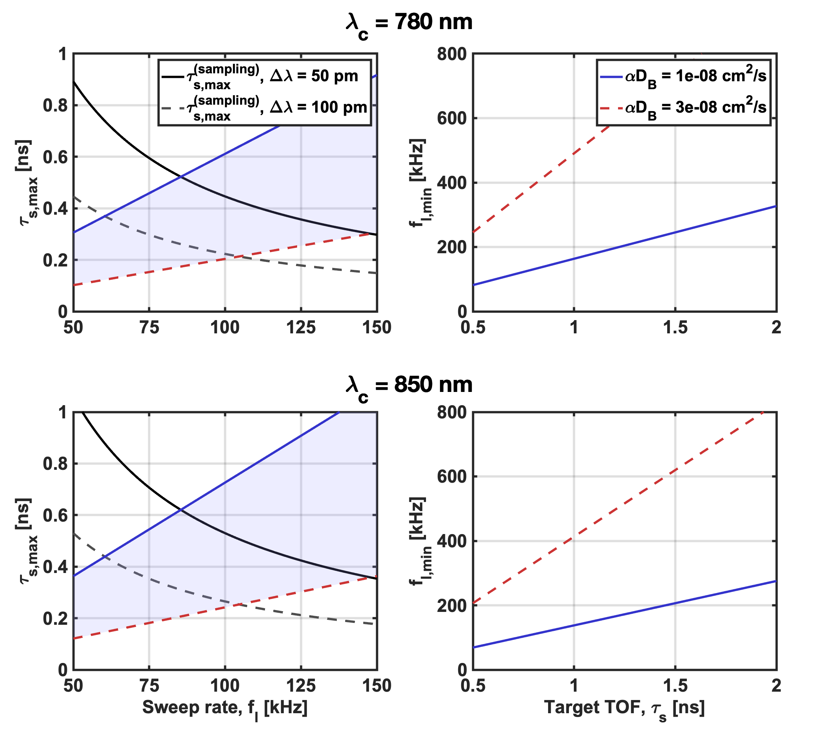
Fig. S2. Sweep rate limitations imposed by decorrelation dynamics. (Left) Maximum measurable TOF $τ_{s,max}$ versus $f_{l}$, showing the decorrelation-limited ceiling $τ_{s,max}^{(ξ)}$ [Eq. (S24)] and the sampling-limited ceiling $τ_{s,max}^{(sampling)}$ [Eq. (S14)] for representative $Δλ$. Shaded regions indicate parameter ranges for different $αD_{B}$. (Right) Minimum sweep rate required to robustly resolve a given $τ_{s}$, $f_{l,min}(τ_{s})$ [Eq. (S26)]. Longer wavelengths reduce the required $f_{l} (∝λ_{c}^{2})$, whereas larger $αD_{B}$ demands faster sweeps.

Design Considerations

Selecting operating parameters for parallel iNIRS
The dominant hardware limit in our parallel iNIRS prototype is the camera sampling. The camera sensor clocks $f_{s} = 1.1 MHz$. So, every combination of sweep bandwidth ($Δλ$) and sweep rate ($f_{l}$) must meet the required TOF resolution, TOF range, and autocorrelation lag- step without exceeding that $1.1 MHz$ ceiling.
Table S1 illustrates the trade-offs assuming $λ_{c}=785 nm$ and $f_{s}=1.1 MHz$. A wider bandwidth sharpens $δτ_{s}$ but squeezes $τ_{s,max}$. Speed row ($f_{l}$) shows that faster sweeps give finer $δt_{d}$ for flow, yet shrink $τ_{s,max}$. Any attempt to push $f_{l}$ higher or to regain TOF range would require faster, higher-bandwidth electronics.
 | Unit | High- time-of-flight resolution | Balanced | Fast-flow sensing | Extended fast-flow
Tuning bandwidth, $Δλ$ | pm | 100 | 50 | 25 | 25
Sweep rate, $f_{l}$ | kHz | 10 | 20 | 50 | 100
Time-of-flight resolution, $δτ_{s}$ | ps | 13 | 25 | 51 | 51
Sampling-limited TOF ceiling, $τ_{s,max}^{\left(sampling\right)}$ | ns | 2.3 | 2.3 | 1.8 | 0.9
Decorrelation-limited TOF ceiling, $τ_{s,max}^{\left(sampling\right)}$  $$αD_{B}=0.5×{10}^{-8}cm^{2}/s$$ | ns | 0.12 | 0.25 | 0.62 | 1.24
Decorrelation-limited TOF ceiling, $τ_{s,max}^{(ξ)}$  $$αD_{B}=1.0×{10}^{-8}cm^{2}/s$$ | ns | 0.06 | 0.12 | 0.31 | 0.62
Autocorrelation step, $δt_{d}$ | $μ$s | 100 | 50 | 20 | 10
Comments |  | Resolution-limited, decorrelation dominates | Balanced trade-off | Fast flow captured but TOF coverage reduced | Electronics-limited, sampling ceiling dominates
Table S1. Example operating points for parallel iNIRS at $λ_{c}=785 nm$ and $f_{s}=1.1 MHz$, showing the impact of sweep bandwidth and sweep rate on TOF resolution, TOF coverage, and flow sensitivity. The limiting ceiling in each configuration is shown in bold. At low sweep rates, decorrelation dynamics dominate ($τ_{s,max}^{(ξ)}$), while at high sweep rates the sampling ceiling ($τ_{s,max}^{(sampling)}$) becomes more restrictive.

Motivating the hybrid system
The parameter analysis above highlights the fundamental trade-offs in interferometric NIRS. Classical single-mode iNIRS offers sub-20 ps TOF resolution but suffers from photon starvation at centimeter-scale source–detector separations, forcing integration times >1 s and blurring fast hemodynamic responses. Conversely, parallel iNIRS (πNIRS) captures thousands of speckle modes simultaneously, dramatically improving photon throughput, yet the limited sampling rate of CMOS cameras (1.1 MHz in our setup) restricts the sweep rate to ~20 kHz. As shown in Figure S2 and Table S1, such rates fall short of resolving nanosecond-scale decorrelation dynamics, leaving default πNIRS apparently unable to resolve fast rapid cerebral blood-flow fluctuations.
To overcome these complementary bottlenecks, we engineered a hybrid interferometer architecture that shares a single swept source but distributes it across three coordinated detection paths:
- Single-mode iNIRS, digitized at 125 MS/s, providing precise wavenumber linearization, phase stability, and sub-20 ps TOF fidelity.
- Wide-field heterodyne camera arm, imaging ~2,000 speckle modes at 1.1 MHz, which boosts photon throughput and SNR through spatial averaging without requiring fiber bundles or costly detector arrays.
- Auxiliary interferometer arm, dedicated to real-time wavenumber calibration and source fluctuation monitoring, ensuring timing stability across sweeps.
By integrating these complementary detection strategies into one system, the hybrid design simultaneously achieves the high depth resolution of iNIRS, the photon throughput of πNIRS, and the timing stability necessary for fast sweeping. Joint operation enables practical sweep rates of 50–100 kHz while maintaining nanosecond TOF coverage, effectively balancing resolution, throughput, and temporal sampling. This purpose-built systems approach addresses the core hardware bottlenecks of interferometric NIRS and establishes a compact, fiber-sparse platform suited for bedside clinical monitoring of cerebral blood flow and oxygenation.

Operating regimes
For in vivo measurements of the human brain, the expected time-of-flight (TOF) distribution spans approximately 1–3 ns. Therefore, we performed numerical simulations to establish the optimal system parameters. For the calculations, the sampling frequency of 125 MS/s for reference interferometer and iNIRS subunits, the refractive index of 1.46 (RI of SMF core), and the geometrical path difference of 27 cm were assumed. The laser tuning bandwidth (here – 50 pm) constrains the allowable laser sweep frequency f_{l} to ~15–40 kHz (Fig. S3, top left). By selecting an operating frequency within this interval, for example 20 kHz, the TOF imaging window can be further tailored to the desired TOF imaging range by changing the sweep bandwidth, as illustrated in Fig. S3 (top right). However, at 20 kHz the πNIRS subunit cannot provide a fully time-resolved temporal point-spread function (TPSF) because of the limited sampling rate (Fig. S3, bottom left). Importantly, the laser tuning bandwidth Δλ not only determines the accessible TOF range, but also governs the decay rate ξ(τ_{s}), which characterizes the temporal loss of coherence in the detected light field. This decay rate encodes the dynamics of scattering particles within the tissue – such as red blood cell motion – that we aim to quantify.
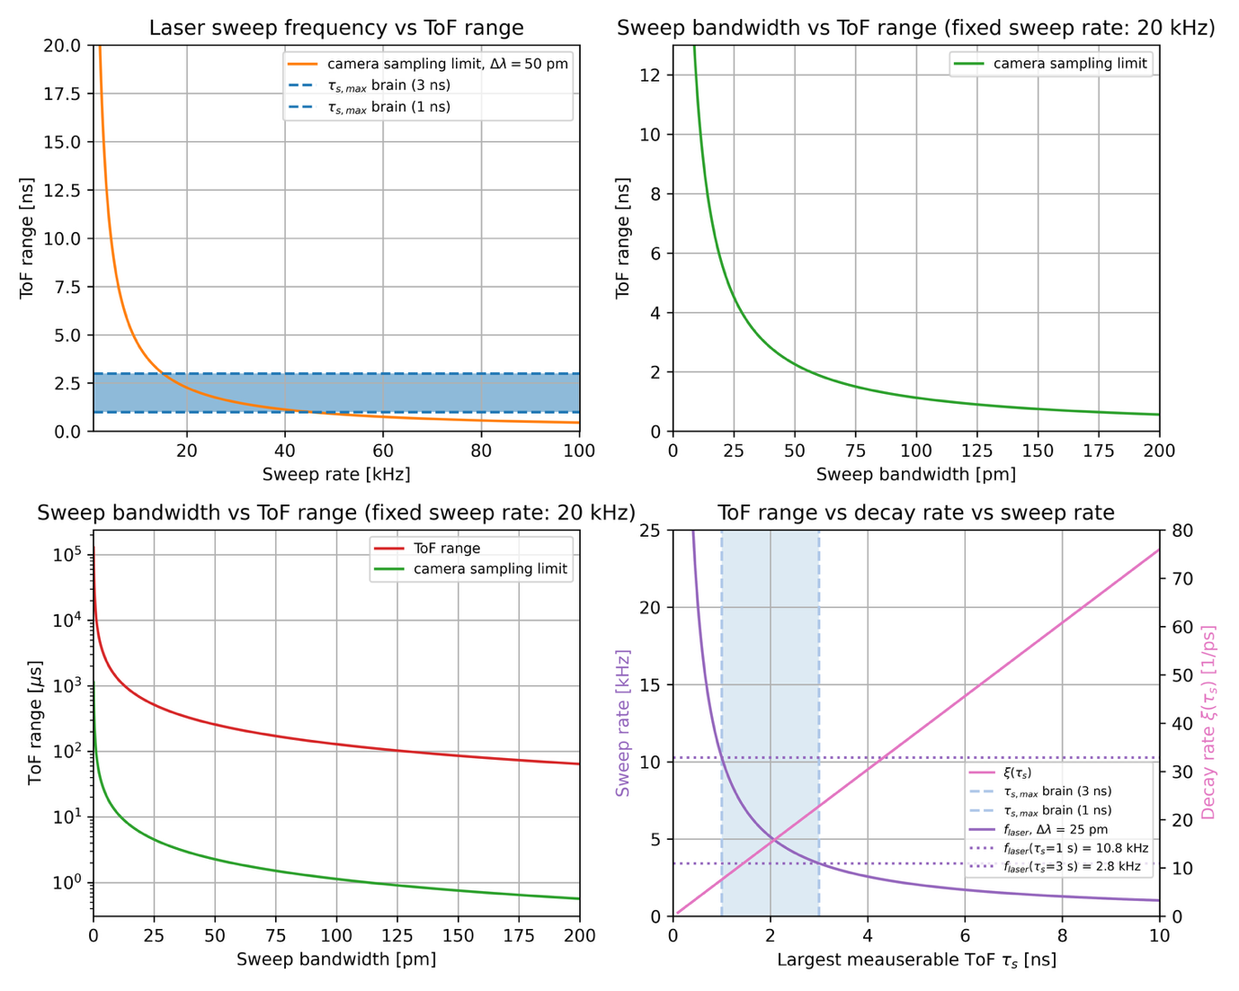
Fig. S3. Operating regimes of the hybrid interferometric NIRS system. The available laser sweep frequencies for the human brain in vivo measurements (top, left). The available TOF imaging range for the sampling frequency of 20 kHz in the function of the sweep bandwidth for iNIRS (top, right) and πNIRS (bottom, left) subunit. Laser sweep frequency and decay rate in the function of the largest measurable TOF at the sweep bandwidth of 25 pm (bottom, right).

Summary
The theoretical framework presented in this Supplement provides a unified description of interferometric NIRS that connects optical design parameters with measurable performance metrics. Starting from the field formulation of the spectral interferogram, we derived the mutual coherence function and the TOF-resolved field autocorrelation $G_{1}(τ_{s},τ_{d})$, which together define how depth information and temporal dynamics are encoded in interferometric signals. The analysis reveals that the practical performance of any iNIRS or πNIRS implementation is governed by two fundamental trade-offs: the bandwidth trade-off, linking spectral tuning range to TOF resolution and penetration depth, and the speed trade-off, linking sweep rate to the ability to sample decorrelation dynamics.
By expressing these limits through simple scaling laws and design ceilings, we provide an explicit roadmap for selecting operating points that balance TOF resolution, dynamic range, and photon throughput under real hardware constraints. The sampling- and decorrelation-limited windows derived here [Eqs. (S14)–(S28)] apply broadly to any swept-source interferometric technique, extending beyond iNIRS to full-field OCT, interferometric DWS, and emerging multi-speckle systems. Figures S1–S3 and Table S1 translate these relations into experimentally accessible parameters, enabling rapid estimation of feasible sweep frequencies, tuning ranges, and camera or digitiser requirements for a given application.
For the present study, this analysis justified the hybrid design: combining a single-mode iNIRS arm for high TOF fidelity with a parallel camera arm for photon efficiency and an auxiliary reference for stability. More generally, the framework can guide other researchers developing next-generation interferometric instruments, whether aimed at cerebral monitoring, tissue-flow mapping, or non-biological diffuse media. The equations and scaling relations derived here define the quantitative limits within which any swept-source interferometer can operate effectively, and thus serve as a practical reference for optimising performance in photon-limited, dynamic scattering environments.

