Appendix
Table A1. The English pseudoword stimuli used in the decoding task and the tasks of orthographic learning.
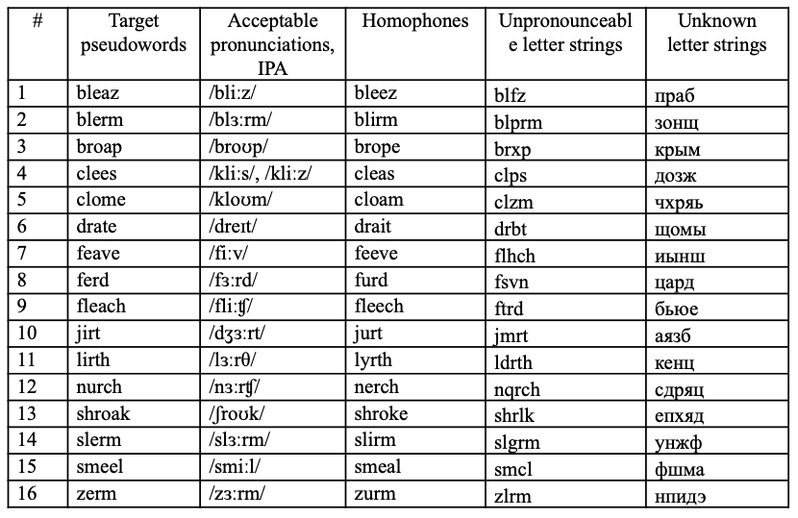
Table A2. The artificial alphabet used to create the artificial orthography (AO) and the AO word stimuli used in the decoding task and the tasks of orthographic learning.
