Additional File 2: Statistical Analysis
All 16 barriers and the bivariate distributions of rating impact and feasibility are provided in Table 2. Across ratings, feasibility received consistently higher endorsements than impact. Because of this, impact and feasibility ratings were interpreted in comparison to the average rating of impact or feasibility across barriers, rather than in terms of the original scaling from 1 (low impact/feasibility) to 4 (high impact/feasibility). This approach acknowledged that participants clearly thought the larger challenge is impact but still allowed for an interpretation of which barriers could have relatively greater impact across barriers.
Cluster analysis groupings were initially based on review of the dendrogram, which clearly showed three clusters. On examination of the response patterns by group, the three clusters appeared to represent addressable barriers (high impact and feasibility), barriers that were viewed as higher more feasible than impactful, and barriers that were viewed as more impactful than feasible.
The most actionable barrier was clearly “Team members will not know who should lead the Checklist during an intubation,” which had the highest average ratings of impact (mean = M = 2.74, standard deviation = SD = 0.82) and feasibility (M = 3.33 SD = 0.68) of any barrier, as well as minimal correlation in response ratings (0.09). The distribution of ratings of this barrier relative to all other ratings is provided in Figure A1. Another highly rated barrier was “Team will have difficulty consistently accessing/locating the Checklist for use during resuscitations,” although the rating of impact was distinctly lower (M = 2.38 SD = 0.77). There was also some negative correlation between responses, indicating not everybody agreed on the actionability (-0.21).
Figure A1: Relative Distribution of the Most Actionable Barrier
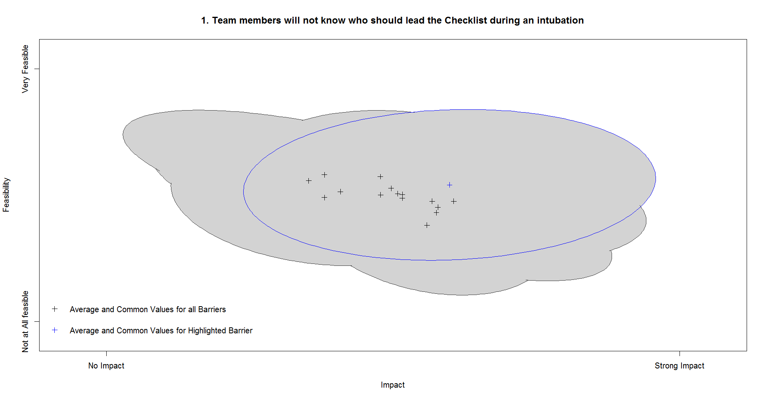

There were four other barriers which were initially grouped with these first two in the cluster analysis. Reviewing the response ratings, these other four barriers showed distinctly lower average ratings of impact and feasibility, as well as more negative correlations between responses. This suggests that these four additional barriers are on average viewed as more addressable, but the extent to which may be site specific.
There were five barriers that were grouped together as high feasibility, but low impact. The most notable barrier in this group was “Team members are unaware, or fail to acknowledge, that emergent pediatric intubation is a procedure with many risks”, which despite some distinct negative correlation between responses (-0.62) also demonstrated some of the highest ratings of feasibility (M = 3.47 SD = 0.58) paired with some of the lowest ratings of impact (M = 1.97 SD = 0.80; see Figure A2 for distribution).

Figure A2: Relative Distribution of a Feasible but not Impactful Barrier
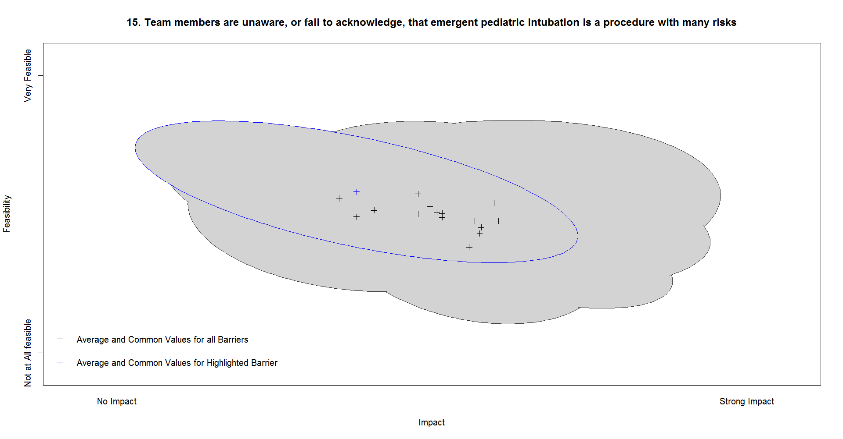

Lastly, there were five barriers identified as low impact but high feasibility. The barrier “We will have difficulty providing education/training to staff in ancillary departments that are more rarely involved in pediatric intubation in the PED (e.g. ENT, anesthesia, PICU, NICU)” stood out. While the average rating of impact was not the highest (M = 2.60), there was the least amount of variation in endorsement of any barrier (SD = 0.49) suggesting more agreement about the moderate to high relative potential impact of this barrier. This barrier also demonstrated the lowest average endorsement of feasibility of any barrier (M = 2.78, SD = 0.63) and only some negative correlation between feasibility and impact ratings (-0.29; see Figure A3 for distribution).

Figure A3: Relative Distribution of an Impactful but not Feasible Barrier
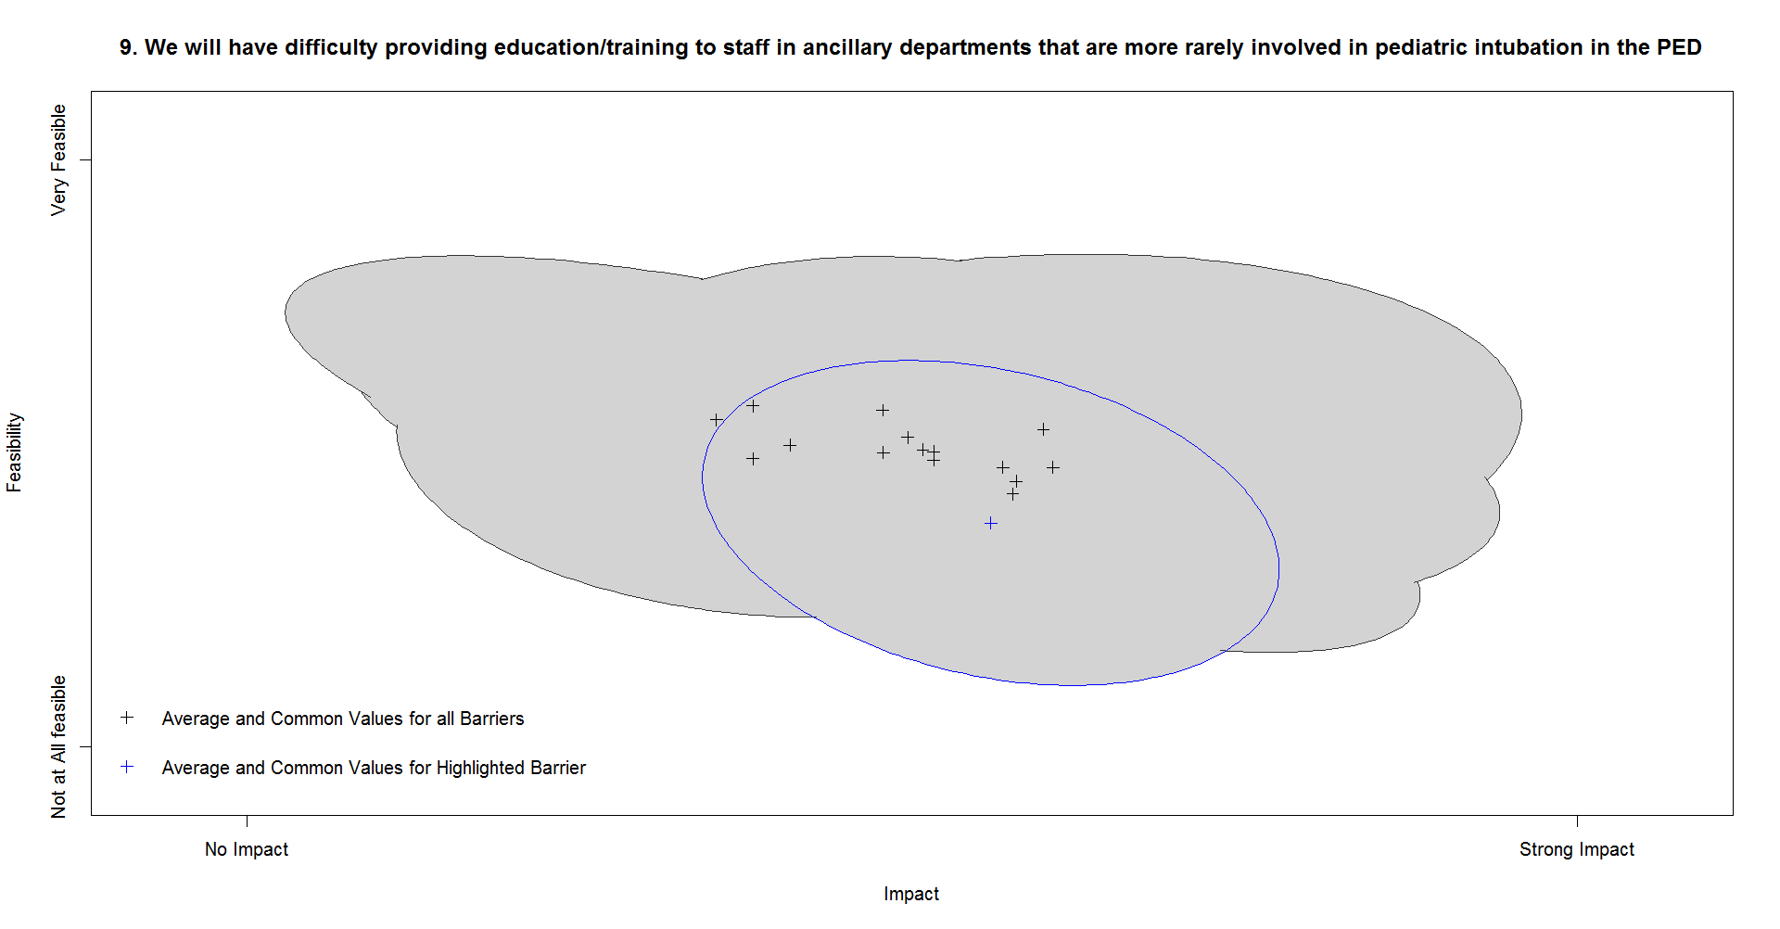

Because we had data rating feasibility and impact for each barrier, an intuitive starting place would be a scatter plot of the two. This would seem to provide a summary of how participants viewed each barrier, with the top right quadrant (high impact and high feasibility) representing the most addressable barriers. A limitation of our data collection strategy is that we only asked one question per barrier, a decision made out of concern that participants would drop off were we to have asked more questions per barrier. Because we only asked one question per barrier, there were only 16 possible responses (4 levels of feasibility by 4 levels of impact), so direct visual examination of this scatter plot did not provide meaningful information but was a grid of points without clear trends identifiable.
To overcome this limitation, we modeled responses to each pair of feasibility and impact ratings on the same barrier as bivariate normal distributions. For a standard normal distribution, the X axis represents each possible value a variable can take, and the Y axis represents the proportion of time each value is expected to be demonstrated in data with ongoing sampling. This creates the familiar bell shape, where most data are expected to be close to whatever the average is, with sloping and symmetrical probabilities of observing more extreme values based on the variance. Example distributions are plotted in Figure A4.

Figure A4: Standard univariate normal distributions
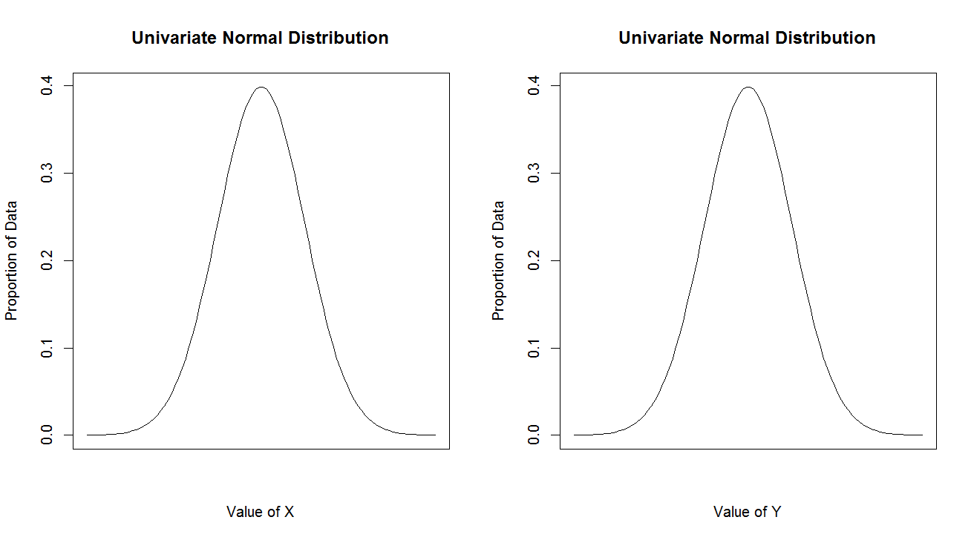

A generalization of the normal distribution, the bivariate normal distribution is like a three-dimensional bell with two X and Y axes on the bottom analogous to length and width, and one Z axis projecting vertically analogous to height. The axes on the bottom represent the values of each variable individually, and the vertical axis represents the probabilities of observing a pair of scores across both variables. A three-dimensional visualization of this distribution is provided in Figure A5.
Figure A5: Bivariate normal distributions
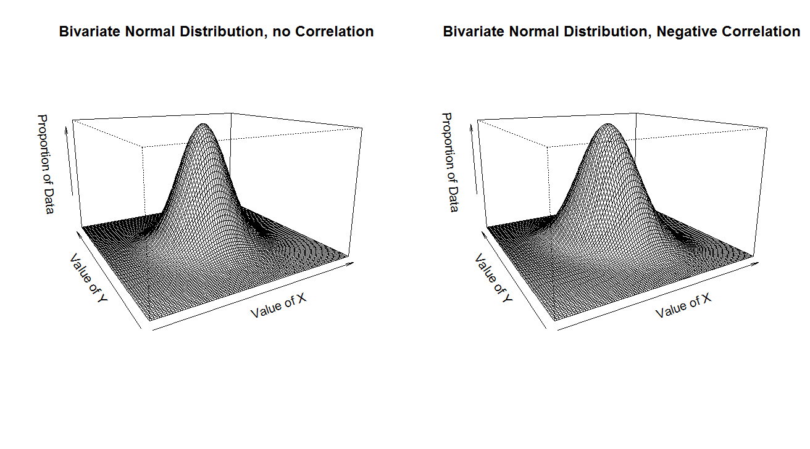
The three-dimensional density plot can be difficult to interpret; however, based on this probability density function, quantiles can be inferred, representing where most of the data are expected to be with ongoing sampling. The plot of quantiles is much more interpretable, Figure A6 plots quantiles where 90% of the data are anticipated to be as implied by the distributions in Figure A5. The shape of these quantiles can be circular if the variation in scores is similar and the correlation is minimal. If the variances for each individual variable are different, the shape of the quantiles will be an oval, and the degree of tilt will represent the magnitude and direction of correlation. Quantiles from this probability density function can visualize where most responses tended to be, mitigating the limitation of trying to plot finite response categories.

Figure A6: Quantiles of a Bivariate Normal Distribution
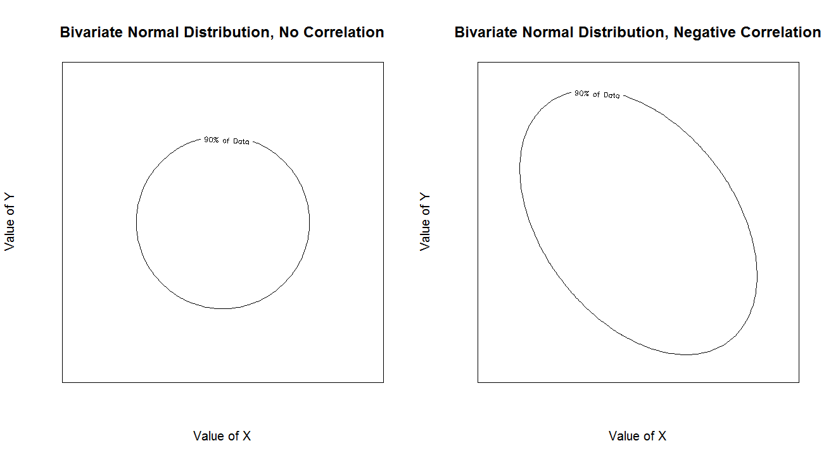
Aware that all questionnaires are inhibited by wording ambiguity, the amount of variation included in the bivariate normal models was scaled to the amount of meaningful information each rating provided as discernable from factor analysis. Factor analysis methods are common in psychometric research to identify how well individual questions represent the underlying trait they operationalize. Mathematically, this is an analysis of the correlation matrix, using linear algebra to summarize patterns of correlations between individual questions asked. If all questions represent aspects of the same underlying trait, in this case the ability to make any procedural change to introduce a new checklist, then individual responses to all questions should be highly correlated with one another. Factor analysis identifies which barriers demonstrate this property of concordant responses with other barriers, and which barriers were more unique.
The result is a loading, in this case one value for each barrier, which can be interpreted as like the average correlation between endorsement on the single barrier and all other barriers. Like correlations, a value close to zero represents minimal association, and values close to one represent strong association with all other barriers. The variance of each barrier rating was multiplied by the squared loading for each question, called the communality. Mathematically, communalities represent the percentage of variation in scores that can be attributed to the same underlying trait that presumably gives rise to scores on all variables in the analysis. This reduces the amount of variance implied in barrier rating based on how unique they were. Separate loadings were estimated for feasibility and impact.
The practical value in this approach is the direct implication for the variance in ratings of individual barriers. As an example, suppose a poorly worded barrier for which respondents did not know how to rate feasibility because they did not understand what the barrier was asking about. The variance in ratings for this barrier would be high. Some would rate the barrier as feasible, others infeasible; ultimately none of these responses are meaningful because the question was unclear. Because of the lack of understanding, this would result in proportionally low correlations between the feasibility ratings of this barrier and the feasibility ratings for other barriers, and by extension a loading closer to zero. By scaling the variance of the modeled bivariate normal distributions to the loading, it will imply much lower variance for this question, reflective of how there simply was not meaningful information to be drawn from these ratings in spite of the raw variance in scores being high.
This property can also be useful for identifying highly actionable barriers. If all respondents agree about the impact or feasibility of a single barrier above and beyond any other barrier, then the correlation between ratings of the individual barrier and all other barriers will be low. This implies a loading closer to zero, resulting in a scaled variance that is also low. By mathematically reducing the variance for ratings of this barrier, the high average endorsement of feasibility and impact will be more obvious, demonstrating that all participants agreed that the barrier is actionable. Scaling variances in this way helped to articulate the amount of information drawn from each question, highlighting the unique responses.
Based on the correlation between scores and scaled variances, the 90% quantiles of a bivariate normal distribution were constructed, to demonstrate how most respondents felt about both feasibility and impact. Figure A7 presents a visualization of what kind of distributions could be observed for an actionable barrier, versus the distribution that could be observed for a controversial barrier. An actionable barrier would have high average ratings of impact and feasibility, relatively low scaled variance in scores, and minimal correlation between ratings of impact and feasibility. This would be consistent with nearly all respondents thinking addressing the barrier would be impactful and feasible. A controversial barrier, on the other hand, would have sizable variation in ratings of both impact and feasibility, and a negative correlation between them. The values of the average endorsement of impact and feasibility would also indicate whether the barrier was generally perceived as more impactful than feasible, or vice versa.

Figure A7: Anticipated Results Patterns
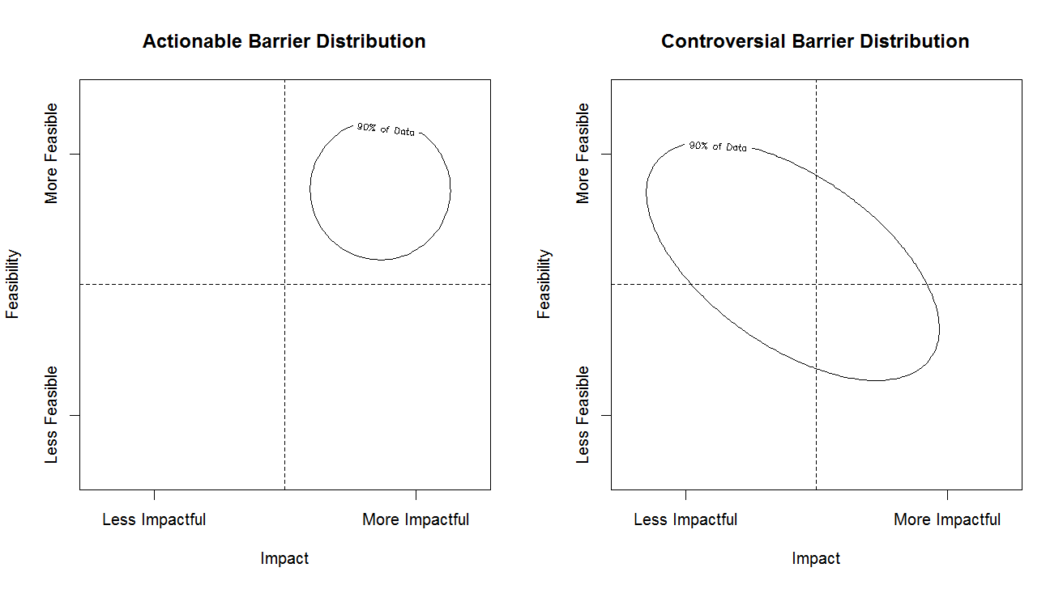
Lastly, because there were 16 barriers to consider, cluster analysis methodology was used to help identify barriers with similar assessments of feasibility. Cluster analysis groups together individual observations based on similarities and differences in the data. In this case, the data used in the cluster analysis was statistics on the bivariate normal distributions of the 16 barriers. Information on the quantiles of the bivariate normal distribution were analyzed using Ward’s algorithm to help identify which barriers tended to receive similar endorsement patterns and may represent the most actionable. This helped guide which bivariate plots to examine.

