Supplementary Information

Precise adenine base editors that exhibit minimized cytosine catalysis

Table of Contents
Supplementary Figure 1. DNA editing activities of a version of ABEmax that lacks wtTadA.
Supplementary Figure 2. DNA editing activities of selected ABE variants at four endogenous sites.
Supplementary Figure 3. DNA editing activities of various base editors in the cell lines which containing mutated sequence to mimic disease situation.
Supplementary Table 1. List of guide RNA target sequences.
Supplementary Table 2. Primers used to amplify genomic DNA or cDNAs for high-throughput sequencing.
Supplementary Table 3. List of primers used for cloning sequences encoding ABE variants.

Supplementary Figure 1. DNA editing activities of a version of ABEmax that lacks wtTadA. a Constituents of adenine base editors. Previously, both wild-type TadA protein (wtTadA) and evolved TadA protein (eTadA) were linked with partially deactivated Cas9. Recently, ABEs that lack wtTadA have been frequently used. b Two endogenous Cas9 target sequences. The selected targets in the FANCF and RNF2 genes contain both adenine and cytosine in the base editor target window. c The adenosine deaminases of four ABEs are indicated with diagrams (left). The bar graphs on the right show the substitution efficiency of each ABE at adenines and cytosines in the target windows.

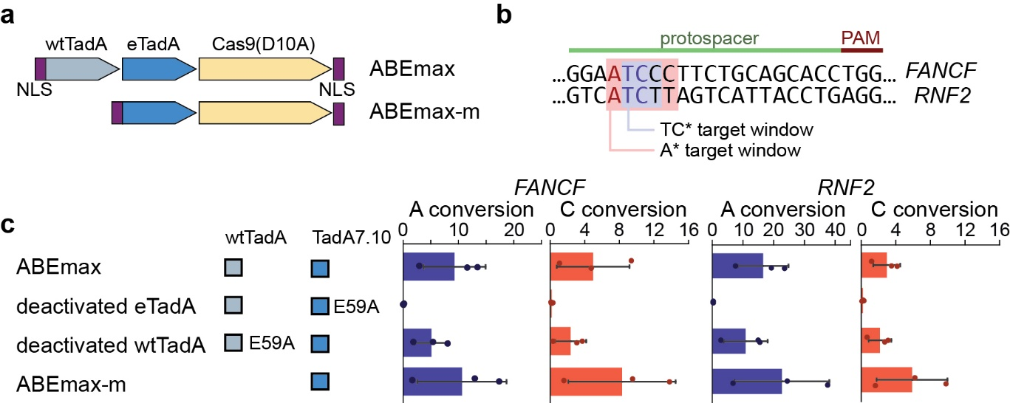

Supplementary Figure 2. DNA editing activities of selected ABE variants at four endogenous sites. a The diagrams on the left indicate the mutations in the adenosine deaminases of seven ABE variants. Base conversion efficiencies are shown in a heat map format (log₂(fold change)). b Adenine editing efficiencies relative to cytosine editing efficiencies are shown in column plots. Each column represents the mean of results from more than two independent replicates and each dot represents the data from an independent experiment. c Adenine editing efficiencies and cytosine editing efficiencies of three ABE variants are shown in column plots. Each column represents the mean of results from more than two independent replicates and each dot represents the data from an independent experiment.

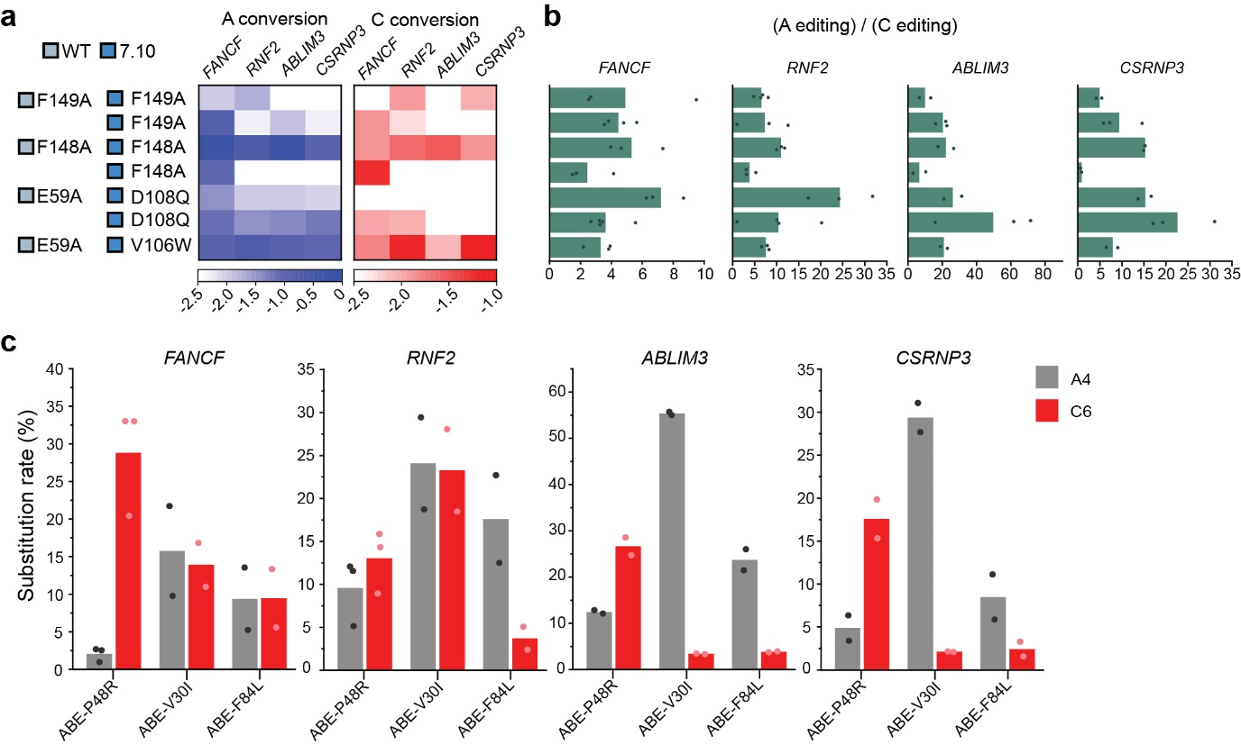

Supplementary Figure 3. DNA editing activities of various base editors in the cell lines which containing mutated sequence to mimic disease situation. a Scheme used to generate knock-in cell lines containing gene fragments that include disease-related missense mutations. Synthesized fragments are 150 base pairs in length. A Primer set was designed to amplify the mutation-bearing fragment but not the normal endogenous gene. b Four Cas9 target sequences containing TT>TC disease-related missense mutations. Target cytosine is located at position 6, counting from the 5’ end of the target sequences. Each target was inserted into the HEK293T genome as in a and edited with three base editors: CBE (AncBE4max), ABE-UGI, and ABE-P48R-UGI. The TUBB6 and PTPN11 targets showed a higher target cytosine substitution rate when cells were treated with ABE-P48R-UGI, so these two targets were deeply analyzed. The resulting data are shown in Figure 3e (TUBB6) and c (PTPN11). d Four Cas9 target sequences containing TG>TC disease-related missense mutations. Target cytosine is located at position 6, counting from the 5’ end of the target sequences. Each target was inserted into the HEK293T genome as in a and edited with three base editors: CBE (AncBE4max), ABE, and ABE-P48R. The TPO and FBN1 targets showed higher target cytosine substitution rates when cells were treated with ABE-P48R, so these two targets were intensively analyzed. The resulting data are shown in Figure 3f (TPO) and e (FBN1).

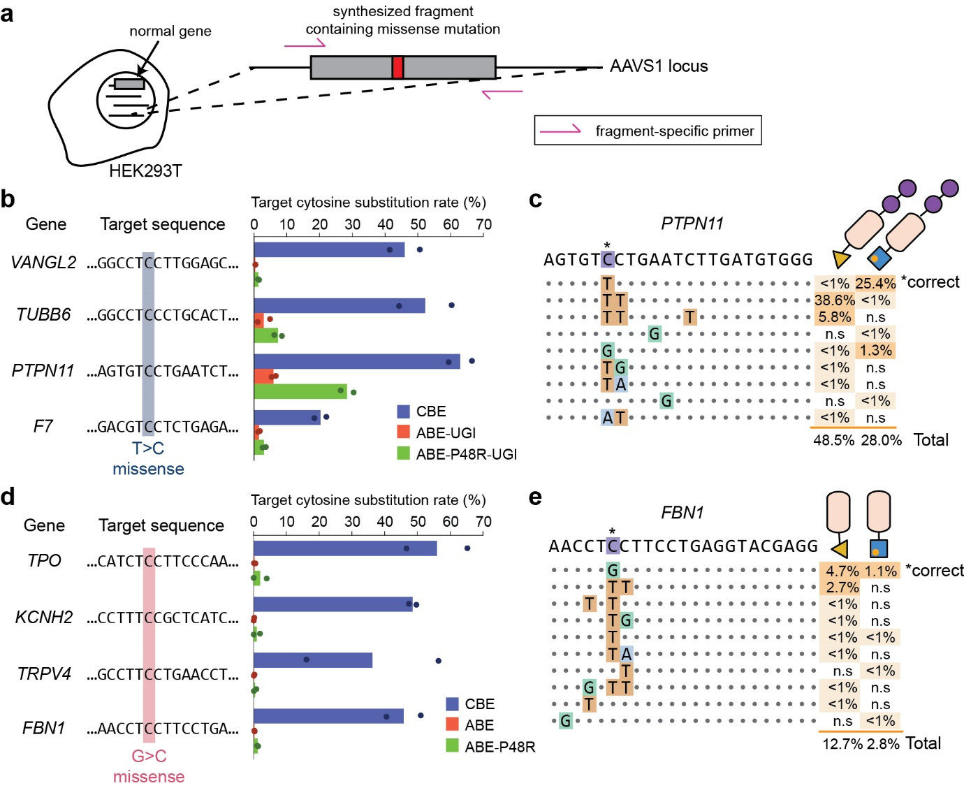

Supplementary Table 1. List of guide RNA target sequences. Protospacer adjacent motif (PAM) sequences are indicated in red. In the case of Tail_Cas9_NG, the target has a 5’-NG-3’ PAM because NG-SpCas9 was used in the experiment; in all other cases, SpCas9 was used so the targets contain 5’-NGG-3’ PAMs.
Target | Target spacer sequence with PAM
FANCF | GGAATCCCTTCTGCAGCACCTGG
RNF2 | GTCATCTTAGTCATTACCTGAGG
ABLIM3 | GTCATCCAGTGCTACCGCTGTGG
CSRNP3 | GTCATCCAGTGTAAGAGTGCTGG
Tail_Cas9_NG | CTCAGCTGGGAGGTGACTCTGGC
AAVS1_sg3 | TAAGCAAACCTTAGAGGTTCTGG
VANGL2 | GGCCTTCTTGGAGCGATACTTGG
TUBB6 | GGCCTTCCTGCACTGGTTCACGG
PTPN11 | AGTGTTCTGAATCTTGATGTGGG
F7 | GACGTTCTCTGAGAGGACGCTGG
TPO | CATCTGCTTCCCAATGAGACAGG
KCNH2 | CCTTTGCGCTCATCGCGCACTGG
TRPV4 | GCCTTGCTGAACCTGAGCAATGG
FBN1 | AACCTGCTTCCTGAGGTACGAGG

Supplementary Table 2. Primers used to amplify genomic DNA or cDNAs for high-throughput sequencing.
Primer | Primer sequence
FANCF_1F | ACCTCTTTGTGTGGCGAAAG
FANCF_1R | AAGTTCGCTAATCCCGGAAC
FANCF_DF | ACACTCTTTCCCTACACGAC GCTCTTCCGATCT AGCATTGCAGAGAGGCGTAT
FANCF_DR | GTGACTGGAGTTCAGACGTGT GCTCTTCCGATCT ATGGATGTGGCGCAGGTAG
RNF2_1F | CTGATCACCTCCCAAAGTCC
RNF2_1R | TCCATGGTTGGTGCTACATC
RNF2_DF | ACACTCTTTCCCTACACGAC GCTCTTCCGATCT GCCAACATACAGAAGTCAGGAA
RNF2_DR | GTGACTGGAGTTCAGACGTGT GCTCTTCCGATCT GTCTCAGGCTGTGCAGACAA
ABLIM3_1F | ATTCAGGGATTTGGCTTGTG
ABLIM3_1R | GGAGCTGAGCCTCCTACCTT
ABLIM3_DF | ACACTCTTTCCCTACACGAC GCTCTTCCGATCT CCCCTTCCACTTTTTCTTCC
ABLIM3_DR | GTGACTGGAGTTCAGACGTGT GCTCTTCCGATCT GGAGCTGAGCCTCCTACCTT
CSRNP3_1F | TTCATTCTCACCCAGTACAAACA
CSRNP3_1R | TGTCTTTGGATGCCCTGAAT
CSRNP3_DF | ACACTCTTTCCCTACACGAC GCTCTTCCGATCT CGGAGTTCGTGCTTTTC
CSRNP3_DR | GTGACTGGAGTTCAGACGTGT GCTCTTCCGATCT CCCTGCCCTTAATGAGTCTCT
AAVS1_left_F | TGACCAACCATCCCTGTTTT
AAVS1_right_R | ACTTCCCCTCTTCCGATGTT
VF2 | ACTCCCACTGTCCTTTCCTA
Cedit_1F | AGGCACTGGGCAGGTAAGTA
Cedit_1R | GTTGCGTCAGCAAACACAGT
Cedit_DF | ACACTCTTTCCCTACACGAC GCTCTTCCGATCT TCCACTTTGCCTTTCTCTCC
Cedit_DR | GTGACTGGAGTTCAGACGTGT GCTCTTCCGATCT TGCTGGTGCTACCTGAGATG
CCNB1IP1_DF | ACACTCTTTCCCTACACGAC GCTCTTCCGATCT AGGGTGCCTTCATGGTTAGC
CCNB1IP1_DR | GTGACTGGAGTTCAGACGTGT GCTCTTCCGATCT GCTGAGGGCCATCTGAAACA
AARS1_DF | ACACTCTTTCCCTACACGAC GCTCTTCCGATCT GCTGGATGACACCAAAATCC
AARS1_DR | GTGACTGGAGTTCAGACGTGT GCTCTTCCGATCT TGGATGAACACAAGGTTCCA
PERP_DF | ACACTCTTTCCCTACACGAC GCTCTTCCGATCT CTGTGGTGGAAATGCTCCCAAG
PERP_DR | GTGACTGGAGTTCAGACGTGT GCTCTTCCGATCT CACTCTCAGGAAGACAAGCATC
TOPRS_DF | ACACTCTTTCCCTACACGAC GCTCTTCCGATCT CCCATGGTGCCTGACTAACA
TOPRS_DR | GTGACTGGAGTTCAGACGTGT GCTCTTCCGATCT TCAGTTTTGCCCGATCTCCT

Supplementary Table 3. List of primers used for cloning sequences encoding ABE variants. These primers were used to amplify the appropriate part of ABE or CBE. The amplified PCR products were ligated via Gibson assembly.
Primer | Primer sequence
ABEmax_TadA_F | accgtcagatccgctagagatccgcggccgctaatacgactcactatagg
wtTadA_R | gtctccgcattctaaagaaatcgctcagcagggcggcgcactcgtctgcc
TadA_eTadA_F | acaagcgagtccgccacaccagagagctccggcggctcctccggaggatc
ABEmax_eTadA_R | tctcagagccagaggagcctccgctagatcctccggagtcggtggagctc
SpCas9_seq1 | tcgtccaccttggccatctc
miniABE_R | ctcgtgggaaaactccacctcagagactttccgcttcttctttgg
WT-D53E_F | cgccacgaGcctaccgcacacgcagagat
WT-D53E_R | ggtaggCtcgtggcggccgattggcctgt
eD53E_F | ctgcacgaAccaacagcccatgccgaaat
eD53E_R | tgttggTtcgtgcaggccgatggctctgt
Cas9_Bgl_R | ccaccttggccatctcgttgctgaagatctcttgcagatagcaga
WTF149A_F | gatttcGCCagaatgcggagacaggagat
WTF149A_R | cattctGGCgaaatcgctcagcagggc
eF149A_F | tatttcGCtcggatgcctagacaggtgtt
eF149A_R | catccgaGCgaaatagcacagcagggc
K20AR21A_F | ctggccGCAGCCgcacgcgatgagagggaggt
K20AR21A_R | gcgtgcGGCTGCggccagggtcagggcatgtc
V82G_F | ctgtacgGCacattcgagccttgcgtgat
V82G_R | gaatgtGCcgtacagggtggcgtcaatca
P48R_F | tggaacagaAGAatcggcctgcacgacccaac
P48R_R | caggccgatTCTtctgttccagccctcgccgatca
V30I_F | gaggtgcctATCggagccgtgctggtgctgaa
V30I_R | cacggctccGATaggcacctccctctcatcgc
V30L_F | gaggtgcctCTGggagccgtgctggtgctgaa
V30L_R | cacggctccCAGaggcacctccctctcatcgc
F84I_F | gtgacaATCgagccttgcgtgatgtgcgc
F84I_R | aggctcGATtgtcacgtacagggtggcgt
F84L_F | gtgacaCTGgagccttgcgtgatgtgcgc
F84L_R | aggctcCAGtgtcacgtacagggtggcgt
D108E_F | gtgaggGAAgcaaaaaccggcgccgcagg
D108E_R | ttttgcTTCcctcacgccaaacaccacgc
D108Q_F | gtgaggCAGgcaaaaaccggcgccgcagg
D108Q_R | ttttgcCTGcctcacgccaaacaccacgc
D108F_F | gtgaggTTCgcaaaaaccggcgccgcagg
D108F_R | ttttgcGAAcctcacgccaaacaccacgc
D108M_F | gtgaggATGgcaaaaaccggcgccgcagg
D108M_R | ttttgcCATcctcacgccaaacaccacgc
D108K_F | gtgaggAAGgcaaaaaccggcgccgcagg
D108K_R | ttttgcCTTcctcacgccaaacaccacgc
D108W_F | gtgaggTGGgcaaaaaccggcgccgcagg
D108W_R | ttttgcCCAcctcacgccaaacaccacgc
V88T_R | cgcacatGGTgcaaggctcgaatgt
TWKT_F | acattcgagccttgcACCatgtgcgccggcgccatgatcca  ctctaggatcggccgcgtggtgtttggcgtgagg
TWKT_R | gccggggtagtgcagGGTgtcTTTCCAggagcctgcggcgc  cggtttttgcgttcctcacgccaaacaccacgcg
V120T_F | GAAAgacACCctgcactaccccggc
P48K_F | aacagaAAGatcggcctgcacgacccaac
P48K_R | gccgatCTTtctgttccagccctcgccgatca
P48H_F | aacagaCATatcggcctgcacgacccaac
P48H_R | gccgatATGtctgttccagccctcgccgatca
P48E_F | aacagaGAGatcggcctgcacgacccaac
P48E_R | gccgatCTCtctgttccagccctcgccgatca
P48D_F | aacagaGACatcggcctgcacgacccaac
P48D_R | gccgatGTCtctgttccagccctcgccgatca
F148A_F | tgctatGCTtttcggatgcctagacaggt
F148A_R | ccgaaaAGCatagcacagcagggcggcac
8s-D108Q_F | gttcgcCAGgccaagacgggtgccgcagg
8s-D108Q_R | cttggcCTGgcgaacaccgaatacaactc
8e-D108Q_F | gtgaggCAGtcaaaaagaggcgccgcagg
8e-D108Q_R | ttttgaCTGcctcacgccaaacaccacgc
8eW-D108Q_F | tggagaCAGtctaaaagaggcgccgcagg
8eW-D108Q_R | tttagaCTGtctccatccaaacaccacgc
UGI_F | tgtctcagctgggaggtgacagcggcgggagcggcgggagcgggg
UGI_R | gttctttttgagccgccagacagcattttgattttgttctctccg

