Supplemental Information

Title: Characterization of dietary choline uptake by the gut microbiome reveals choline assimilating microbes and influences on host choline metabolism

Authors: Paula E. Bañuelos¹, Janine M.C. Comrie¹, Annett Richter¹, Henry H. Le¹, Sharon C. Thompson^{1,2}, Elizabeth L. Johnson^{1,2*}

Affiliations:
¹Division of Nutritional Sciences, Cornell University, Ithaca, NY, 14853, USA
²Howard Hughes Medical Institute, Ithaca, NY, 14853, USA

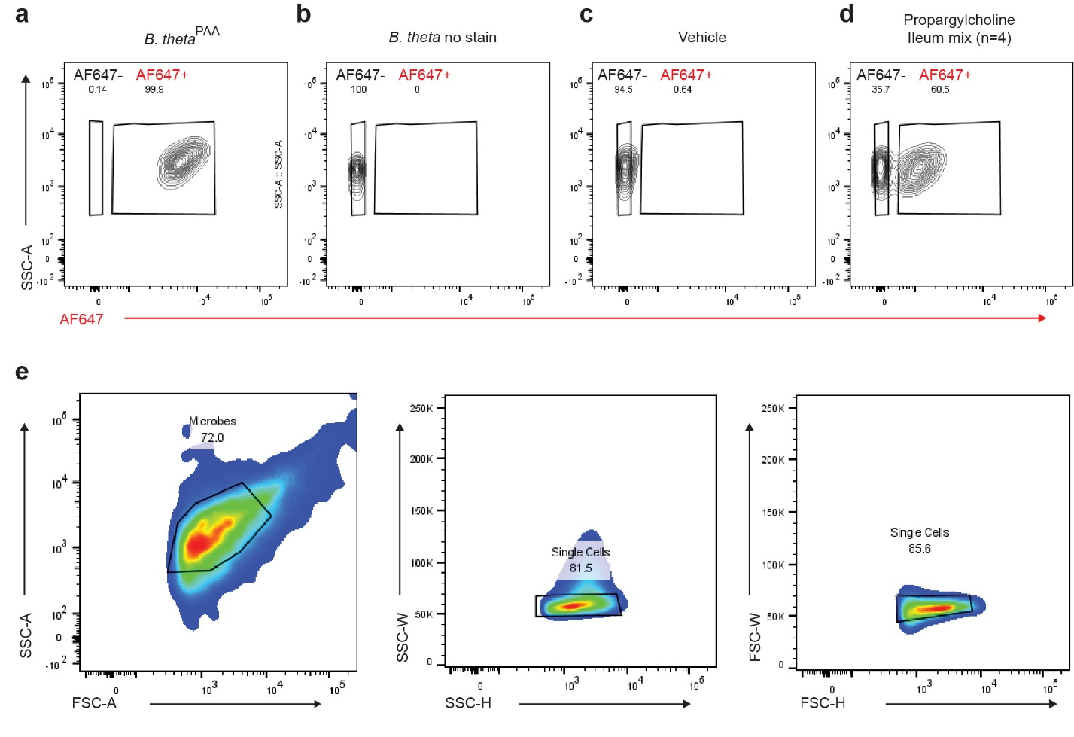
Supplemental Figure 1. Fluorescence-activated cell sorting gating strategy to identify choline-utilizing microbes from the ileum of mice. Flow cytometry plots showing the gating strategy for (a) B. theta cultures treated with palmitic acid-alkyne (PAA), referred to as B. theta^{PAA}, as a control to establish the positive gate for AF647. (b) A no-stain sample of B. theta was used to set the negative gate for AF647. (c) An ileal-microbiome sample isolated from mice gavages with a vehicle control (PBS) was used to establish the lower boundary of the gate. (d) Pooled ileum samples from four mice treated with propargylcholine. (e) Gating strategy used to sort AF647-positive bacteria for sequencing. SSC-A: Side Scatter Area, FSC-A: Forward Scatter Area. SSC-W: Side Scatter Width, SSC-H: Side Scatter Height, FSC-W: Forward Scatter Width, and FSC-H: Forward Scatter Height. AF647: fluorescence signal detected from the azide-bearing fluoroprobe (AF647-azide) used to label the choline-utilizing microbes.

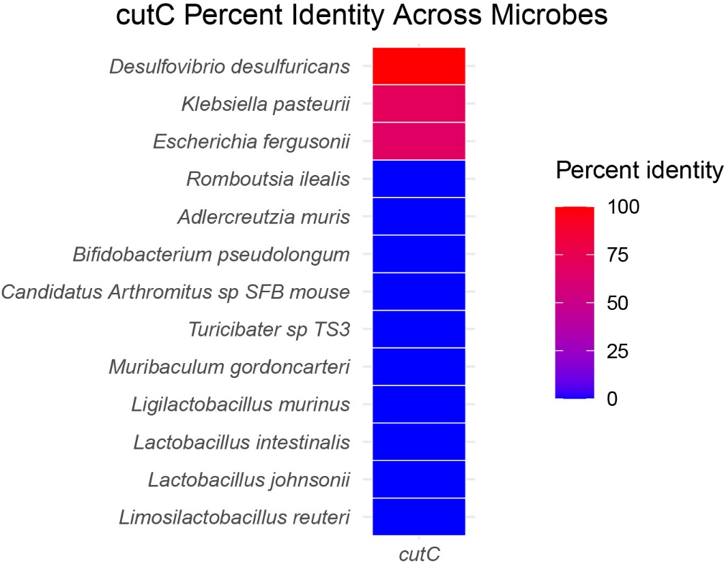
Supplemental Figure 2. Percent identity of the cutC gene across bacterial species. Heatmap showing the percent nucleotide identity of cutC homologs detected across diverse bacterial taxa using the Desulfovibrio desulfuricans strain L4 cutC gene (NCBI accession NZ_CP072608.1:2239761-2242319) as the query. Percent identity values were obtained from NCBI BLASTn searches against the bacterial nucleotide database and plotted in R using a blue-to-red color gradient, with blue representing lower identity and red representing higher identity. Each row corresponds to a bacterial species, and the single column represents the cutC gene. Microbial species are ordered by increasing similarity to the reference sequence.

Supplemental Figure 3. L. reuteri uptake of diet-derived propargylcholine in a L. reuteri monoassociated mouse model. (a) Schematic of experiment for exposing L. reuteri monoassociated germ-free mice to propargylcholine in drinking water for 3 days before measuring L. reuteri-propargylcholine interactions using click chemistry. (b) Microscopy images of ileal contents of L. reuteri monoassociated mice where diet-derived propargylcholine is detected using Alexa Fluor 647-azide (red) and bacteria are detected using a general DNA stain (DAPI – blue). (c) Flow cytometry plots demonstrating the percent AF647-azide positive (AF647+) microbes versus AF647-azide negative microbes (AF647-) in isolated intestinal contents. (d) Stool microbiome composition of L. reuteri monoassociated mice as measured by shotgun metagenomics.
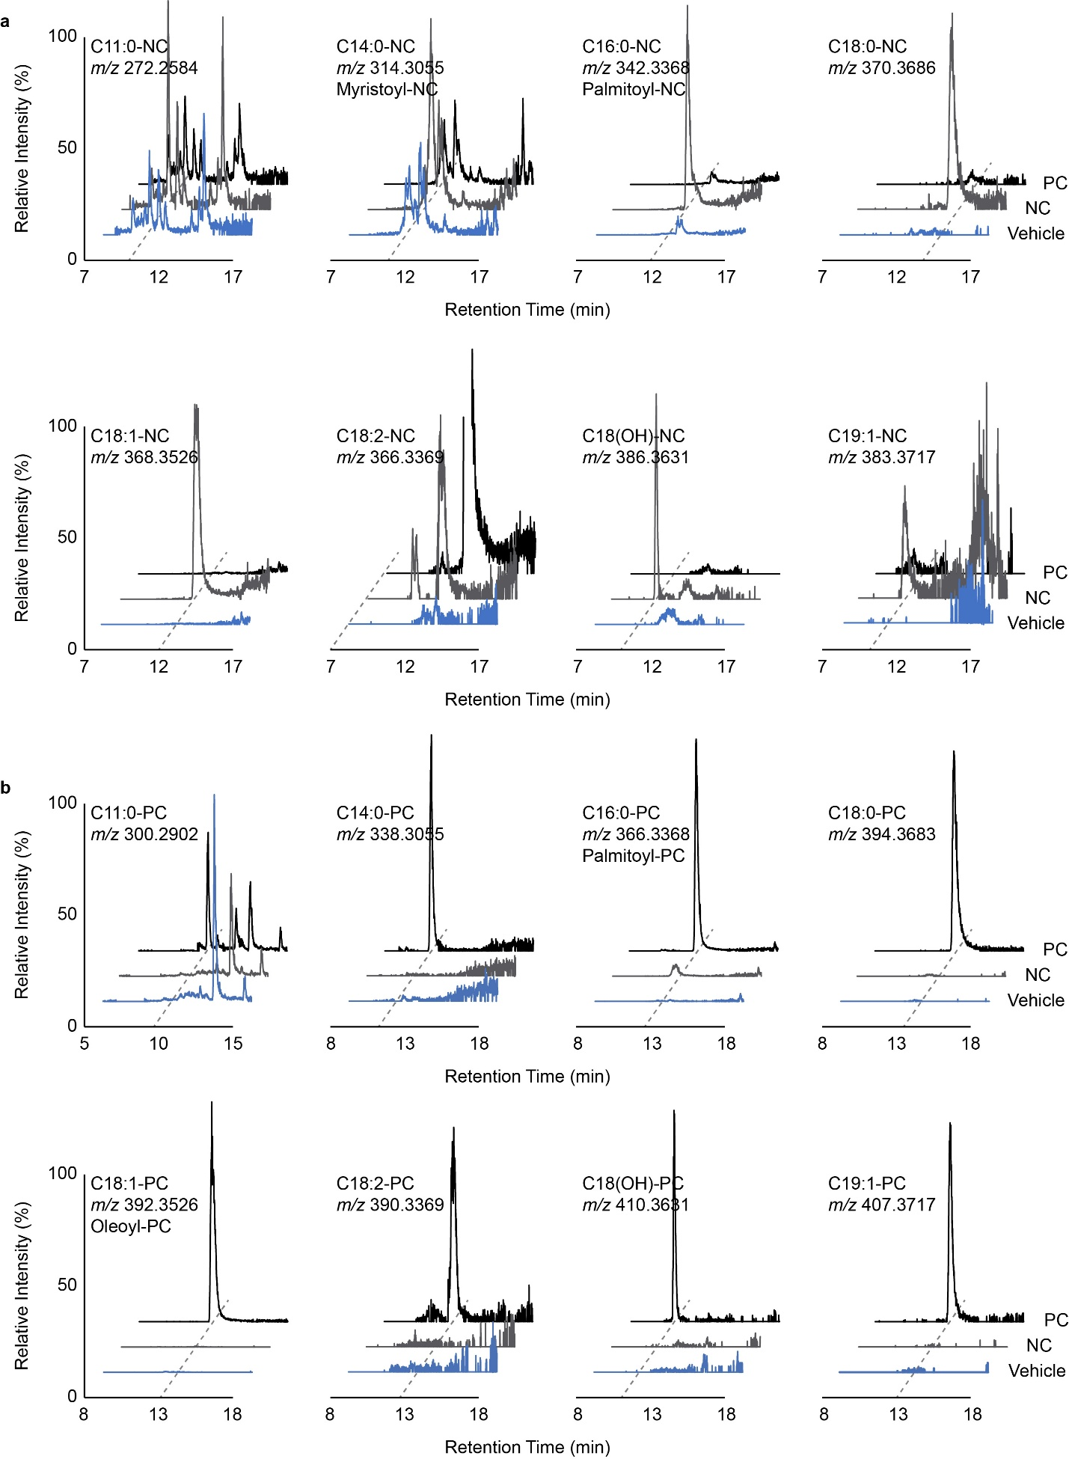
Supplemental Figure 4. Extracted ion chromatograms of metabolic features representing (a) native-choline and (b) propargylcholine containing acylcholines detected in L. reuteri cultures. Black traces represent propargylcholine treated cultures and grey traces represent choline supplemented cultures. C# represented the number of carbons in the acyl chain and the number after the colon represents the amount of unsaturations within the fatty acid. C16:0-PC and C18:1-PC were later confirmed as palmitoyl-PC and oleoyl-PC, respectively.

Supplemental Figure 5. (a) Scheme for the chemical synthesis of acyl cholines. Specifically, palmitoyl- and oleoyl-propargyl cholines are made via acyl chlorides in dry acetonitrile. (b) MS2 spectra of m/z 366 and m/z 392 from L. reuteri cultures treatment with propargyl choline, along with MS2 spectra from synthetic standards of palmitoyl- and oleoyl-propargyl cholines.

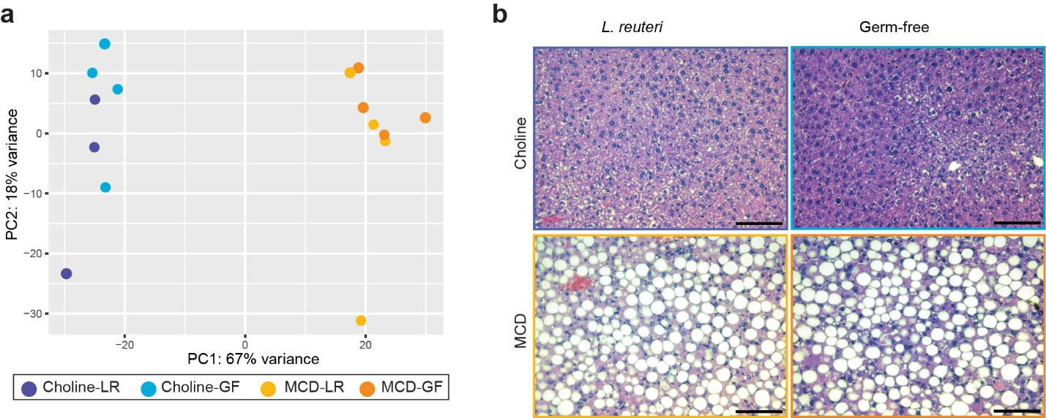
Supplemental Figure 6. (a) Principal Component Analysis (PCA) was performed on variance-stabilized transformed liver gene expression data, using the choline-LR group as the reference condition. Each point in the plot represents an individual mouse sample, with its position determined by the scores on the first two principal components (PC1 and PC2). PC1 explains 67% of the total variance, while PC2 accounts for 18%. (b) Representative brightfield images of hematoxylin and eosin (H&E) stained liver sections from mice in the four treatment groups described above. Hematoxylin stains nuclei blue, and eosin stains cytoplasm and extracellular matrix pink. Fat accumulation appears as clear round spaces within hepatocytes (white circles), indicative of hepatic lipid accumulation. Images were captured at 20X magnification. Scale bars are shown in each image. Scale bar = 100 μm.

