Tables and Figures
Supplementary Table 1. Primers and PCR conditions.
Target gene | Primer | Sequence (5’ – 3’) | Annealing Tª
16S rRNA methanogens | Met 630F | GGATTAGATACCCSGGTAGT | 62 ºC
16S rRNA methanogens | Met 803R | GTTGARTCCAATTAAACCGCA | 62 ºC
mcrA | ME3MF | ATGTCNGGTGGHGTMGGSTTYAC | 57 ºC
mcrA | ME3r’ | TCATBGCRTAGTTDGGRTAGT | 57 ºC

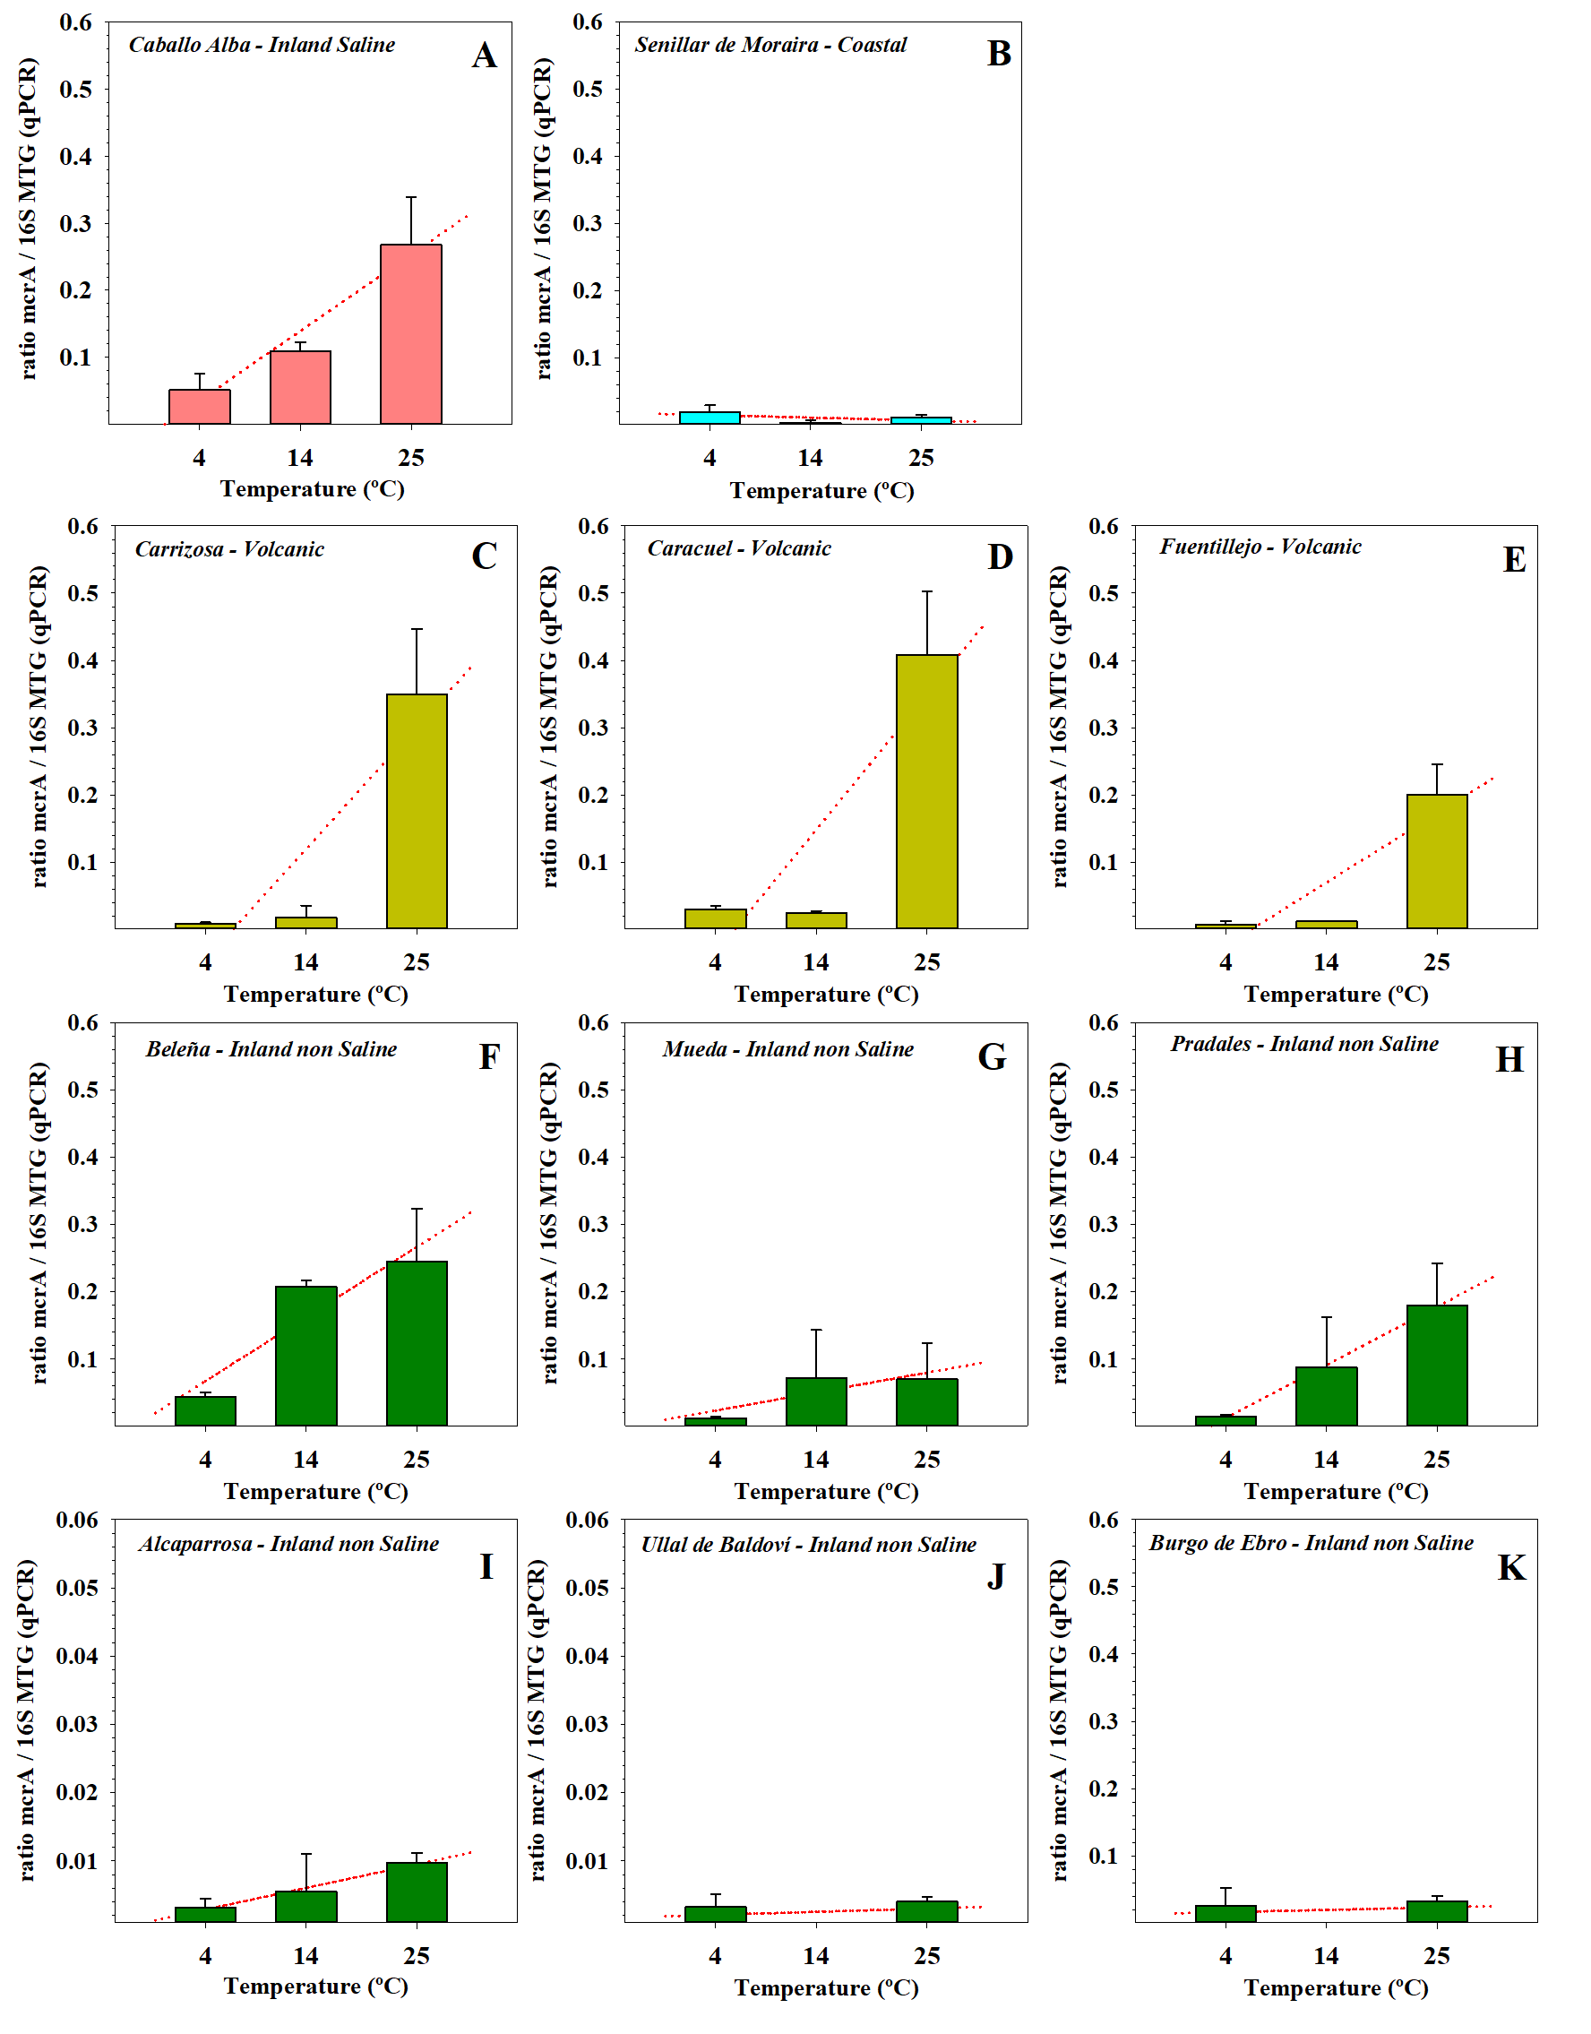

Supplementary Figure 1. A-K) Effect of temperature increase on the relationship between the amounts determined by qPCR of mcrA and 16S rRNA gene transcripts from methanogens (16S MTG). Only samples in which transcripts of both the mcrA and 16S rRNA genes of methanogens were detected were included.

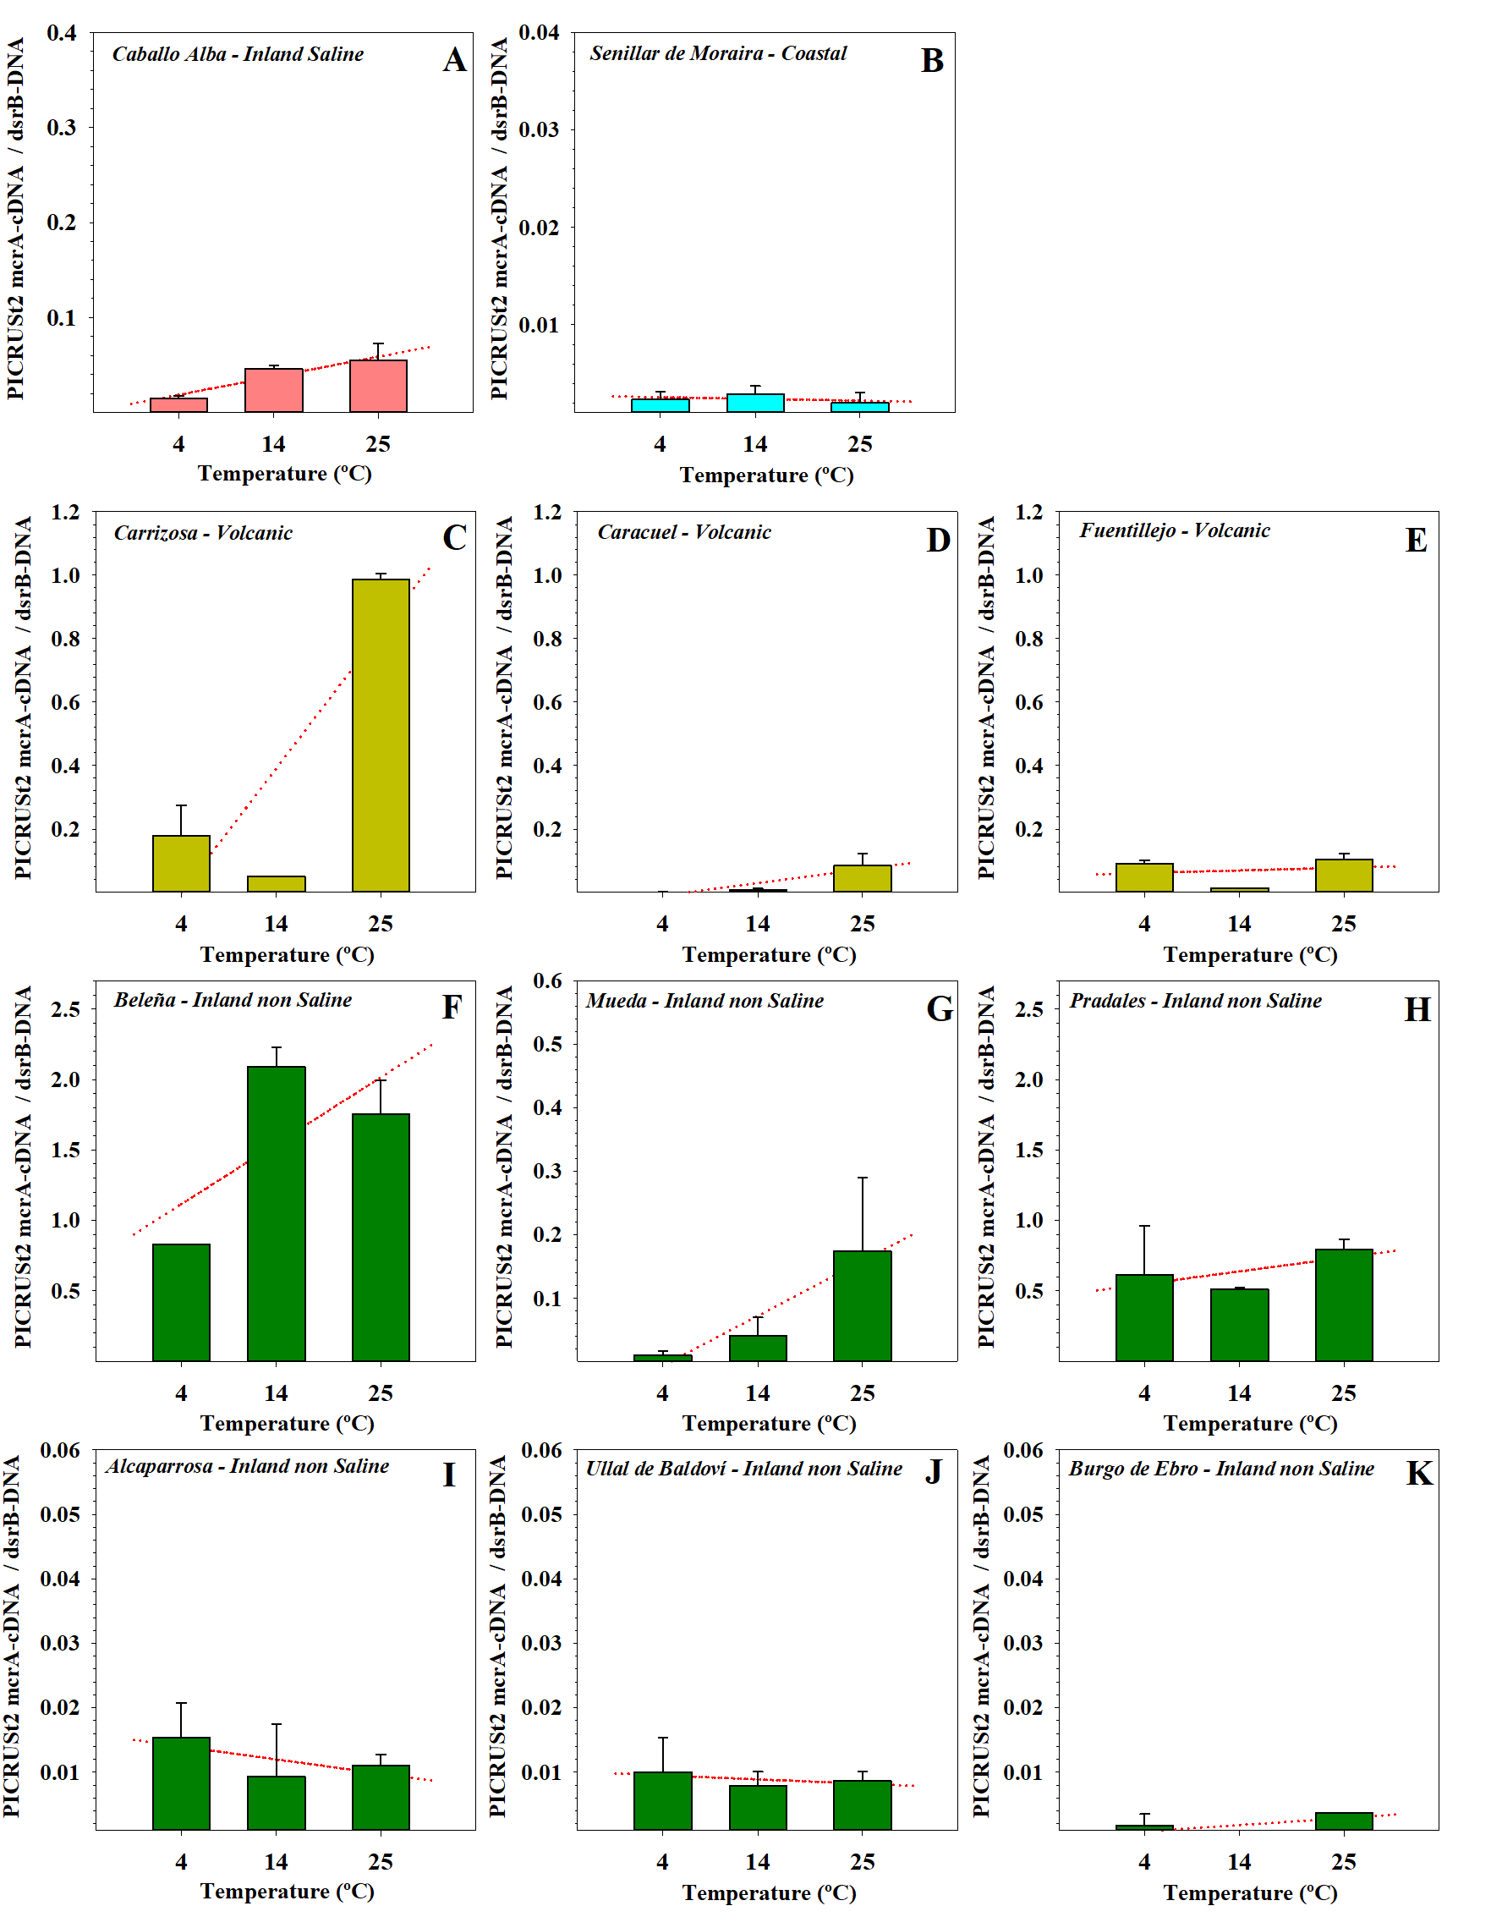
Supplementary Figure 2. A-K) Ratio between the averages per wetland of gene counts obtained with PICRUSt2 from cDNA for the mcrA gene and from DNA for the dsrB gene. These ratios were only calculated for wetlands where mcrA gene transcripts were detected by qPCR. The values of this ratio are shown for each wetland and temperature.

