Zinc triflate catalyzed solvent free synthesis of coumarins
S. S. Kale^{1, 2 †}, N. K. Dhurve^{1,3 †}, Shaikh Tanveer¹, Mohammad Ali¹, Abhijit B. Ingle^{1,4 †}, Nilesh S Shelke^{1,5}, Rohinee R. Dharamkar¹ and Hemant S. Chandak¹*
¹Department of Chemistry, G S Science, Arts and Commerce College, Khamgaon, Nandura Road, Khamgaon, 444 303, Maharashtra, India.
²Department of Chemistry, Shri Shivaji Science and Arts College Chikhli,
443 201, Maharashtra, India
³Department of Chemistry, Shri Pundlik Maharaj Mahavidyalaya Nandura Rly, 443 404, Maharashtra, India
⁴ Department of Chemistry, Dr. Ghali College, Gadhinglaj
District - Kolhapur, 416 502 Maharashtra, India.
⁵Department of Chemistry, Arts and Commerce College, Warwat Bakal, 444 202, Maharashtra, India.
Supporting Information
Contents
¹H NMR of the compound 3a S2
¹H NMR of the compound 3b S3
1H NMR of the compound 3c S4
1H NMR of the compound 3e S5
1H NMR of the compound 3f S6
Mass spectrum of the compound 3g S7
1H NMR of the compound 3j S9
1H NMR of the compound 3k S10
1H NMR of the compound 3l S11
1H NMR of the compound 3m S12

¹H NMR of the compound 3a
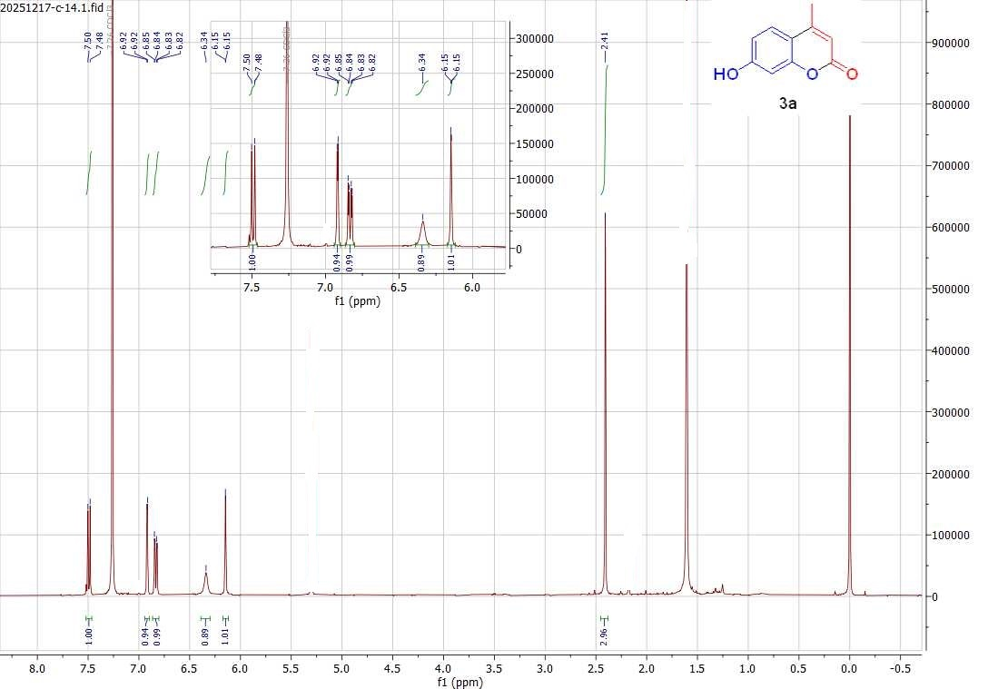

¹H NMR of the compound 3b

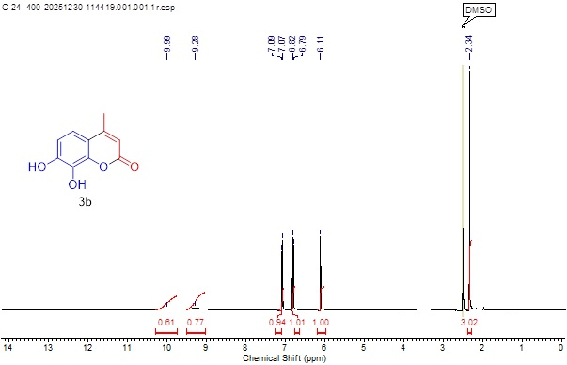

1H NMR of the compound 3c
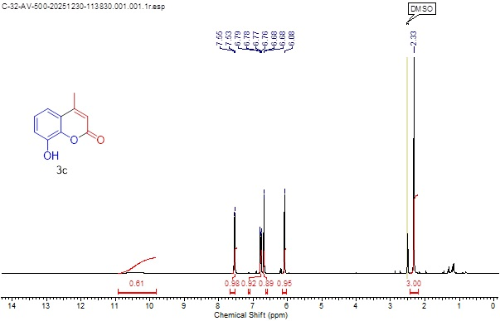

1H NMR of the compound 3e
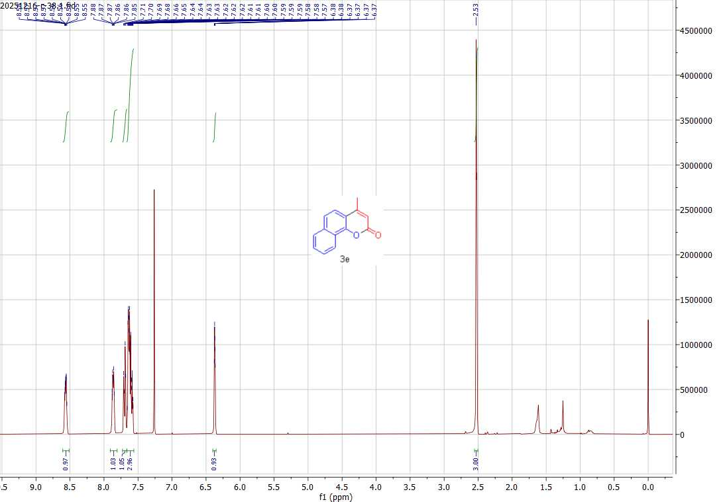

1H NMR of the compound 3f
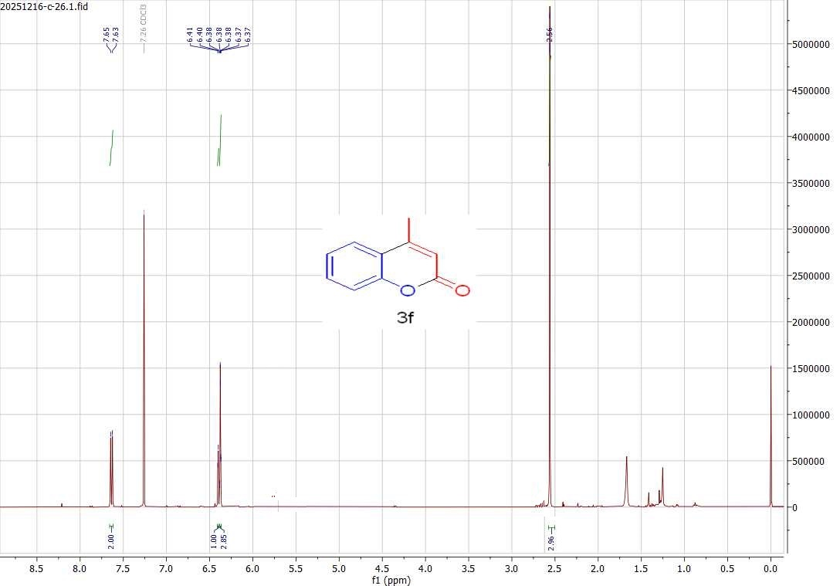

Mass spectrum of the compound 3g
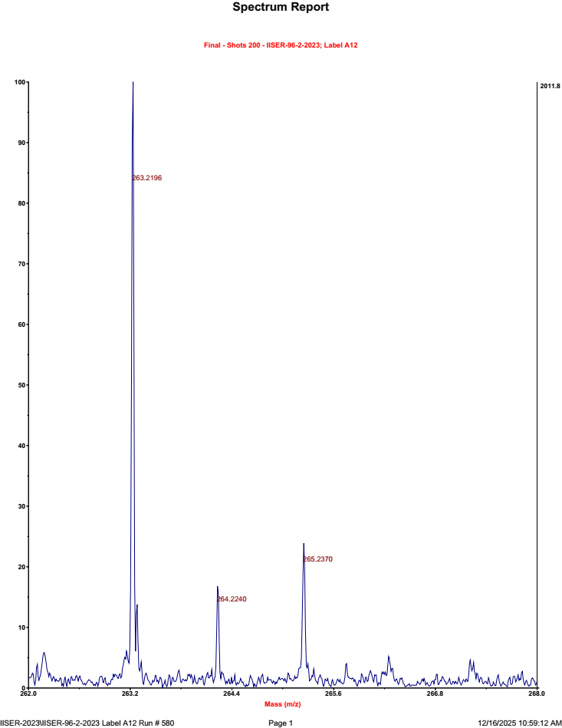
1H NMR of the compound 3i

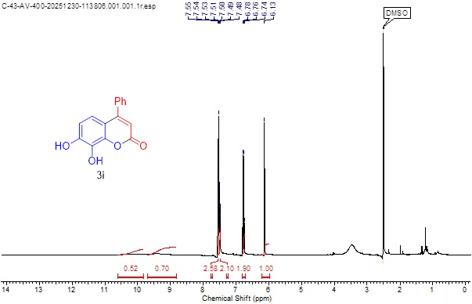

1H NMR of the compound 3j
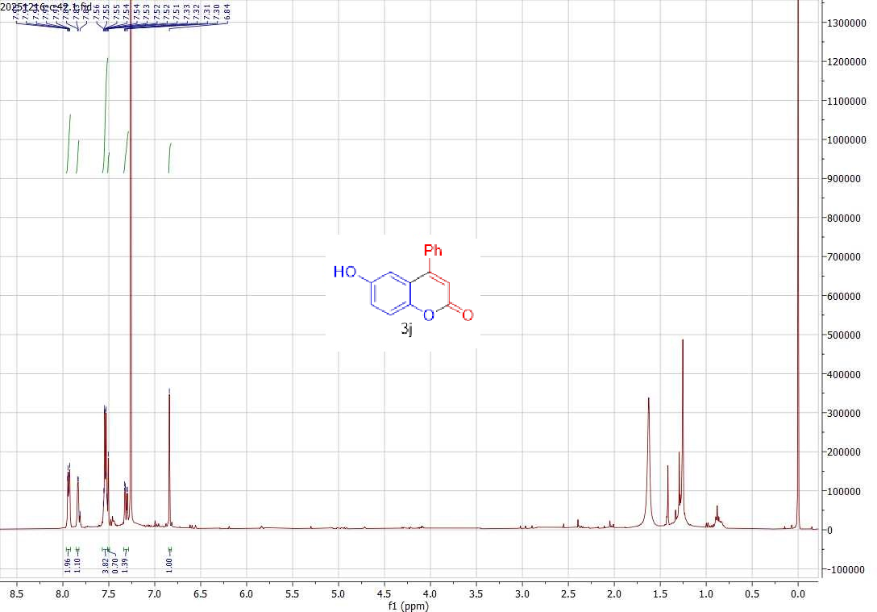

1H NMR of the compound 3k
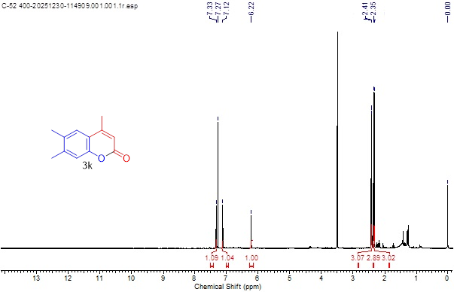

1H NMR of the compound 3l
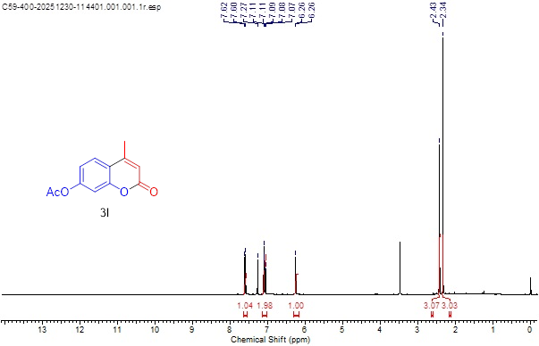

1H NMR of the compound 3m
