Table 1: Optimization of the synthesis of coumarin
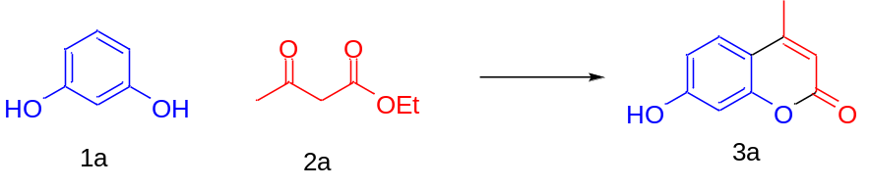
Entry | Catalyst (mol %) | Temperature (° C) | Solvent | Time (min) | Yield (%)*
1 | ZnO nano (50) | rt | Solvent free | 24 hrs | 23
2 | Zinc Triflate (50) | rt | Solvent free | 24 hrs | 42
3 | Zinc Triflate (50) | 60 | Solvent free | 60 | 65
4 | Zinc Triflate (20) | 60 | Solvent free | 60 | 73
5 | Zinc Triflate (20) | 80 | Solvent free | 30 | 92
6 | Zinc Triflate (20) | 100 | Solvent free | 10 | 76
7 | Zinc Triflate (10) | 80 | Solvent free | 20 | 92
8 | Zinc Triflate (5) | 80 | Solvent free | 20 | 84
9 | Zinc Triflate (10) | 80 | Ethanol | 240 | 19
10 | Zinc Triflate (10) | 80 | Acetonitrile | 240 | 24
Reaction condition: Resorcinol (1a) (1 mmol, 1 equiv.), ethyl acetoacetate (2a) (1 mmol, 1 equiv.), catalyst.
*- Isolated yield
Table 2: Solvent free synthesis of coumarins using Zinc triflate catalyst under optimized conditions
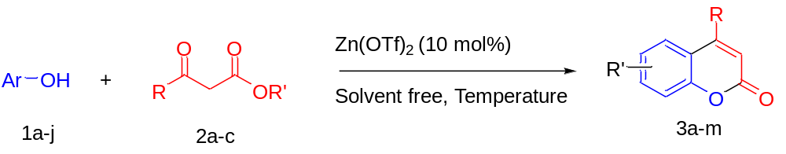
Entry | Phenol | Product | Time (min) | Temperature  (° C) | β-keto-ester, Yield (%)
 |  |  |  |  | R | R’= Me | R’=Et
1. | 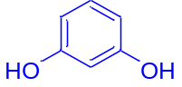 | 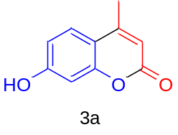 | 20 | 80 | -CH₃ | 88 | 92
2. | 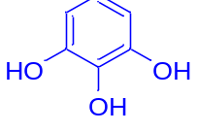 | 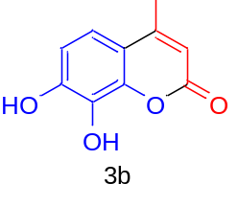 | 60 | 80 | -CH₃ | 88 | 91
3. | 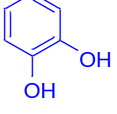 | 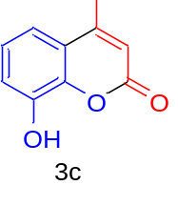 | 80 | 80 | -CH₃ | 67 | 75
4. | 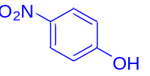 | 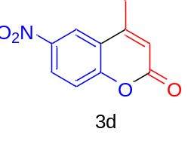 | 80 | 80 | -CH₃ | - | 72
5. | 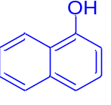 | 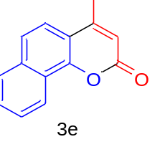 | 120 | 80 | -CH₃ | 64 | 76
6. | 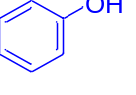 | 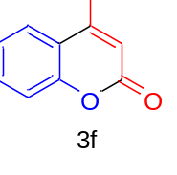 | 120 | 80 | -CH₃ | 62 | 75
7. | 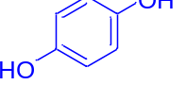 | 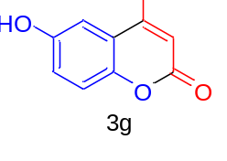 | 120 | 80 | -CH₃ | 75 | 82
8. |  | 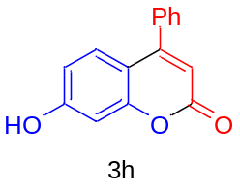 | 120 | 120 | -Ph | - | 84
9. |  | 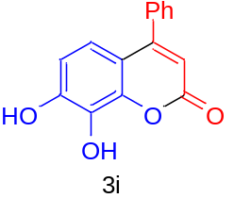 | 120 | 120 | -Ph | - | 68
10. |  | 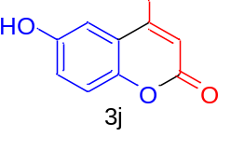 | 120 | 120 | -Ph | - | 82
11. | 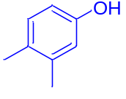 | 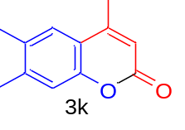 | 120 | 120 | -CH₃ | - | 68
12. | 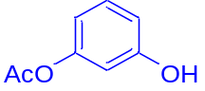 | 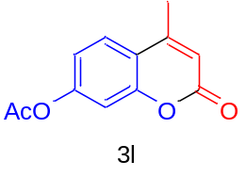 | 20 | 80 | -CH₃ | - | 71
13. | 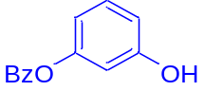 | 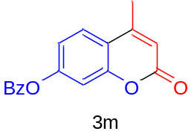 | 20 | 80 | -CH₃ | - | 67

