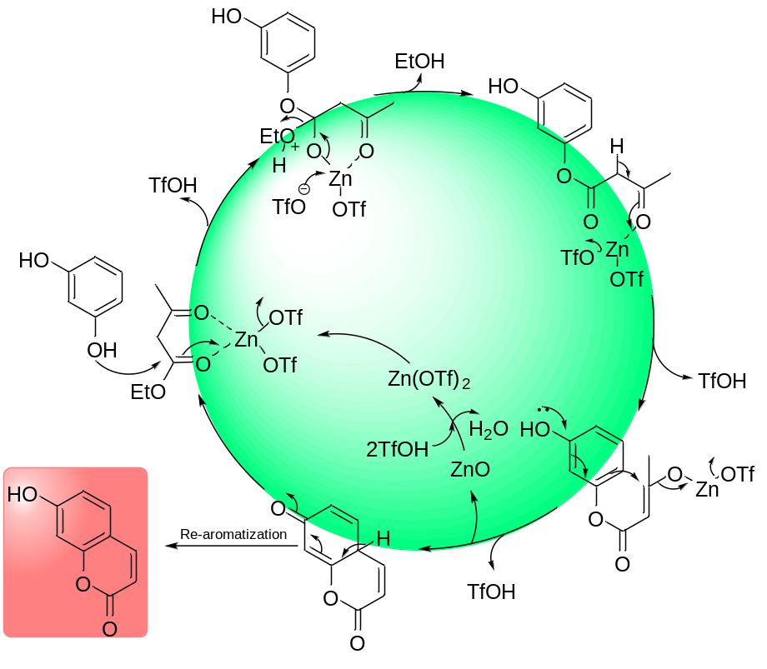
Scheme 1: Plausible mechanism for the Pechmann condensation catalyzed by Zn(OTf)₂

