Supplementary File 4: Digital Equity Ecosystem Framework (DEEF) Specification
1. Framework Overview
The Digital Equity Ecosystem Framework (DEEF) is a diagnostic and strategic tool developed through the HT-SWOT analysis of 71 empirical studies on digital education. Grounded in critical social justice theory, sociomaterial perspectives, and capability approaches, DEEF provides a multidimensional model for understanding and addressing digital inequalities in education.
Core Proposition: Digital equity cannot be reduced to access alone but must be understood as emerging from the dynamic interplay of three sociomaterially constituted dimensions: Infrastructure, Pedagogy, and Epistemology.
2. Visual Framework Representation
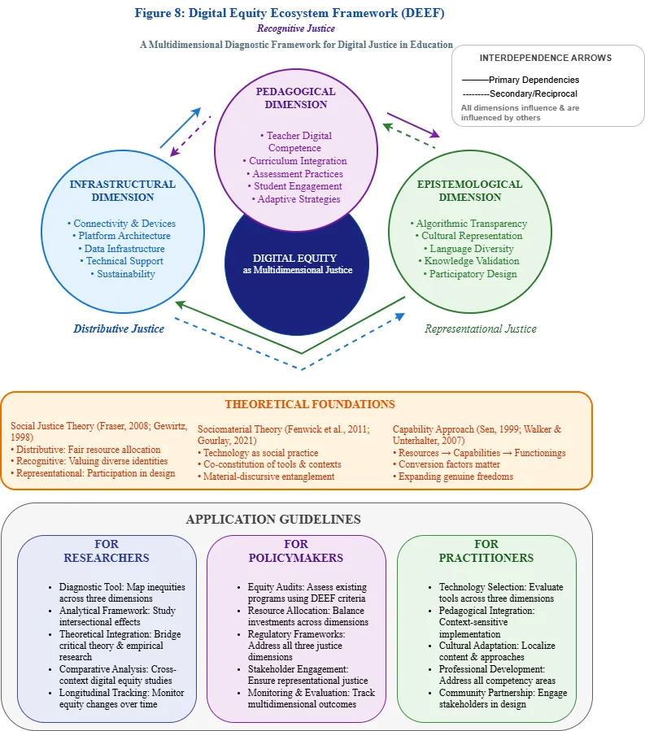
3. Detailed Framework Description
3.1. The Three Interdependent Dimensions
A. Infrastructural Dimension (Blue)
- Focus: Material and technical foundations of digital education
- Key Components:
  - Connectivity & Devices: Internet access, hardware availability, maintenance
  - Platform Architecture: System design, interoperability, accessibility features
  - Data Infrastructure: Storage, processing, security, privacy protections
  - Technical Support: Maintenance, troubleshooting, updates
  - Sustainability: Long-term viability, environmental impact, cost-effectiveness
- Justice Connection: Primarily addresses distributive justice (fair allocation of resources)
- Theoretical Basis: Sociomaterial perspective on how physical/digital infrastructures shape possibilities
B. Pedagogical Dimension (Purple)
- Focus: How technologies are embedded in teaching and learning practices
- Key Components:
  - Teacher Digital Competence: Skills, confidence, pedagogical integration
  - Curriculum Integration: Alignment with learning objectives, subject-specific adaptation
  - Assessment Practices: Formative/summative assessment, feedback mechanisms
  - Student Engagement: Motivation strategies, interaction design, personalization
  - Adaptive Strategies: Differentiation, scaffolding, support for diverse learners
- Justice Connection: Engages both distributive (access to quality pedagogy) and recognitive justice (valuing diverse learning approaches)
- Theoretical Basis: Capability approach's focus on converting resources into genuine learning opportunities
C. Epistemological Dimension (Green)
- Focus: Whose knowledge systems are encoded and validated through digital education
- Key Components:
  - Algorithmic Transparency: Understanding of AI decision-making, bias detection
  - Cultural Representation: Inclusion of diverse cultures, histories, perspectives
  - Language Diversity: Support for multiple languages, translation, localization
  - Knowledge Validation: Whose knowledge "counts," citation practices, authority structures
  - Participatory Design: Involvement of diverse stakeholders in technology development
- Justice Connection: Primarily addresses recognitive and representational justice
- Theoretical Basis: Critical social justice theory's concern with whose voices are heard and valued
3.2. Core Principles
- Interdependence: The three dimensions are not hierarchical but mutually constitutive. For example:
  - Pedagogical innovation requires infrastructural support
  - Infrastructure design reflects epistemological assumptions
  - Epistemological diversity enables richer pedagogical approaches
- Context Sensitivity: DEEF recognizes that digital equity manifests differently across contexts. What constitutes equity in a rural Global South school differs from an urban OECD university, though all three dimensions remain relevant.
- Dynamic Equilibrium: Digital equity is not a fixed state but requires ongoing negotiation and adjustment among the three dimensions as technologies and contexts evolve.

4. Application Guidelines
4.1. For Researchers
Diagnostic Applications:
- Use DEEF to map existing digital inequities in specific contexts
- Identify which dimension(s) present the most significant barriers
- Study intersectional effects (e.g., how gender inequality manifests differently across dimensions)
Analytical Frameworks:
- Structure literature reviews using the three dimensions
- Design mixed-methods studies that examine all dimensions
- Develop indicators and metrics for each dimension
Theoretical Development:
- Test and refine the framework through empirical research
- Explore relationships between dimensions in different contexts
- Integrate with other theoretical perspectives
4.2. For Policymakers
Equity Audits:
- Assess existing digital education programs using DEEF criteria
- Identify gaps and misalignments among dimensions
- Prioritize interventions based on diagnostic analysis
Resource Allocation:
- Ensure balanced investment across all three dimensions
- Avoid overemphasis on infrastructure at expense of pedagogy/epistemology
- Support integrated initiatives that address multiple dimensions simultaneously
Regulatory Frameworks:
- Develop standards and guidelines for each dimension
- Require equity impact assessments for new EdTech initiatives
- Establish accountability mechanisms across dimensions
4.3. For Practitioners (Teachers, Administrators, Technologists)
Technology Selection and Implementation:
- Evaluate potential technologies using DEEF criteria
- Consider not just technical features but pedagogical and epistemological implications
- Plan for ongoing support and adaptation across all dimensions
Professional Development:
- Address competencies in all three dimensions
- Move beyond technical skills to critical digital pedagogy
- Develop capacity for cultural adaptation and ethical implementation
Curriculum and Assessment Design:
- Integrate digital tools in pedagogically sound ways
- Ensure assessments are fair and culturally responsive
- Provide multiple pathways for demonstrating learning
5. Relation to Theoretical Foundations
5.1. Integration of Theoretical Perspectives
DEEF operationalizes three key theoretical traditions:
A. Social Justice Theory (Fraser, 2008; Gewirtz, 1998)
- Distributive Justice → Infrastructure: Fair allocation of digital resources
- Recognitive Justice → Pedagogy & Epistemology: Valuing diverse identities and knowledge systems
- Representational Justice → Epistemology: Participation in knowledge production and technology design

B. Sociomaterial Theory (Fenwick et al., 2011; Gourlay, 2021)
- Views technology not as neutral tools but as active participants in educational assemblages
- Explains how material infrastructures, pedagogical practices, and knowledge systems co-constitute each other
- Highlights the embodied, situated nature of digital education
C. Capability Approach (Sen, 1999; Walker & Unterhalter, 2007)
- Distinguishes between resources (infrastructure), capabilities (pedagogical opportunities), and functionings (actual learning achievements)
- Emphasizes conversion factors that mediate between resources and outcomes
- Provides normative foundation for evaluating whether digital education expands genuine freedoms
5.2. Contribution to Theoretical Debates
- Beyond the Digital Divide: DEEF moves beyond access-focused conceptions of digital inequality to address pedagogical and epistemological dimensions
- Integrating Critical and Sociotechnical Perspectives: Bridges critical theory's focus on power with sociotechnical studies' attention to materiality
- Linking Structure and Agency: Recognizes structural constraints while identifying spaces for transformative action
- Global-Local Tensions: Provides framework for analyzing how global technologies interact with local contexts
6. Validation and Limitations
6.1. Empirical Validation
DEEF emerged inductively from the HT-SWOT analysis of 71 empirical studies. The framework:
- Successfully categorized all identified equity issues
- Revealed patterns in how different technologies create different equity challenges
- Provided explanatory power for paradoxical findings (e.g., why increased access sometimes worsens outcomes)
6.2. Limitations and Future Development
- Complexity: Three-dimensional analysis is more complex than single-factor approaches
- Measurement Challenges: Developing valid indicators for epistemological dimension is particularly challenging
- Contextual Adaptation: Framework requires careful adaptation to different educational settings
- Evolution: As technologies evolve, new dimensions may emerge or existing ones may need redefinition
7. Conclusion
The Digital Equity Ecosystem Framework provides a comprehensive, theoretically grounded approach to understanding and addressing digital inequalities in education. By integrating infrastructural, pedagogical, and epistemological dimensions, it offers both diagnostic tools for analyzing existing inequities and strategic guidance for designing more just educational futures. DEEF represents a significant contribution to both theory and practice in digital education, bridging critical scholarship with practical implementation challenges.

