- Supplementary Information -

Nutrient stress decouples the extent and intensity of root-driven destabilization of mineral-associated organic matter
Mariela Garcia Arredondo^{1,4*}, Sherlynette Pérez Castro², Faith Aguirre Mendoza³, Glyn Mardis¹, Charlotte Koch¹, Malak M. Tfaily³, Zoe Cardon², and Marco Keiluweit^{1,5*}
¹University of Massachusetts Amherst, School of Earth & Sustainability, Amherst, MA, USA 01003
²Marine Biological Laboratory, Woods Hole, MA, USA 02543
³University of Arizona, Department of Environmental Science, Tucson, AZ, USA 85719
⁴Yale Center for Natural Carbon Capture, New Haven, CT, USA
⁵University of Lausanne, Faculty of Geosciences and Environment, 1015 Lausanne, Switzerland
*Corresponding author: Prof. Dr. Marco Keiluweit, Email: marco.keiluweit@unil.ch
Keywords: Rhizosphere; mineral-associated organic matter; nitrogen limitation; root foraging; soil carbon cycling; plant–soil feedbacks

Table S1: Mixed effects model results for individual and interactive treatment effects on important controls of MAOM destabilization. P-values < 0.05 are shown in bold.
Variable | Moisture | N Availability | Moisture: N Availability
Shoot biomass (g) | <.0001 | <.0001 | <.0001
Root biomass (g) | 0.33 | 0.001 | 0.34
Plant height (cm) | <.0001 | 0.002 | 0.55
C:N root biomass | 0.01 | <.0001 | 0.22
C:N bulk soil | 0.13 | 0.02 | 0.31
Microbial biomass nitrogen  (nmol per g soil) | 0.21 | 0.01 | 0.33
Microbial biomass carbon  (nmol per g soil) | 0.19 | 0.08 | 0.04
Total extractable Fe in rhizosphere soil  (mg g⁻¹) | 0.94 | 0.01 | 1.00

Table S2: Final soil chemical and biological values per treatment. Standard error of the mean reported in parentheses, significance at a Tukey’s HSD p < 0.05 (n=5).

Nutrient | Watering | Shoots: Roots | C:N Roots | C:N MBC | C:N Soils | pH_{i} | pH_{f} | Soil ¹³C_{f} (µmol g⁻¹ soil) | Total Extractable Fe (mg g soil⁻¹)
+N | +H₂O | 8.6 (.83) A | 50 (3.6) B | 7.3 (1.2) AB | 14 (.23) B | 4.6 (.33) A | 5.4 (.03) A | 4.6 (.17) AB | 4.7 (.15) A
+N | -H₂O | 6.6 (1.3) A | 32 (1.6) C | 6.2 (1.5) B | 13 (.13) B | - | 5.0 (.05) B | 4.7 (.11) A | 4.7 (.20) A
-N | +H₂O | 8.7 (1.6) A | 81 (7.3) A | 7.8 (1.2) AB | 15 (.69) AB | 4.7 (.33) A | 4.8 (.03) C | 4.6 (.11) AB | 4.0 (.17) A
-N | -H₂O | 7.8 (1.3) A | 76 (2.5) A | 12 (.56) A | 15 (.36) A | - | 4.8 (.03) C | 4.2 (.10) B | 4.0 (.30) A

Table S3: Compound-like classes of dissolved organic carbon compounds detected via FTICR-MS. Differences between time points are provided only within a treatment for a compound-like class denoted by capital letters at p < 0.05 level (Tukey’s HSD), if there are no letters there was no significant difference between the means, numbers in parenthesis show standard error of the means (n = 5).
Treatment | Week | Amino Sugars | Carbohydrates | Condensed Hydrocarbons | Lignin | Lipids | Proteins | Tannins | Unsaturated Hydrocarbons
+N +H₂O | 3 | 6.6 (1.3) A | 7.0 (1.0) C | 12 (1.8) B | 30 (4.9) B | 15 (3.1) A | 19 (2.6) A | 2.9 (.25) A | 7.3 (.62) A
+N +H₂O | 5 | 5.7 (1.0) AB | 12 (2.8) ABC | 14 (.75) AB | 37 (4.8) AB | 8.0 (3.7) AB | 12 (3.2) ABC | 1.4 (.38) AB | 11 (1.5) B
+N +H₂O | 6 | 3.6 (.26) AB | 14 (1.1) AB | 15 (.17) AB | 46 (1.5) A | 2.0 (.32) B | 6.4 (.34) C | 1.0 (.21) B | 13 (.55) B
+N +H₂O | 9 | 4.4 (.34) AB | 14 (2.2) AB | 12 (.78) B | 46 (1.9) A | 3.3 (1.1) B | 7.9 (1.8) C | 1.1 (.05) B | 11 (.82) B
+N -H₂O | 3 | 6.0 (1.3) | 8.3 (.73) A | 14 (2.3) | 36 (4.5) | 7.9 (1.1) | 17 (3.9) A | 2.9 (.44) | 8.4 (.87) BC
+N -H₂O | 5 | 3.9 (.32) | 14 (1.7) AB | 16 (.71) | 44 (1.7) | 2.8 (.28) | 6.1 (.73) B | 1.5 (.22) | 12 (.50) AB
+N -H₂O | 6 | 4.1 (.37) | 14 (2.5) AB | 15 (.59) | 39 (5.2) | 6.5 (4.2) | 7.9 (2.3) AB | 2.0 (.96) | 12 (.67) A
+N -H₂O | 9 | 4.4 (.14) | 16 (1.06) B | 14 (.98) | 42 (1.6) | 3.3 (.56) | 6.6 (.662) B | 1.2 (.14) | 12 (.72) A
-N +H₂O | 3 | 3.5 (.13) | 12 (1.0) | 15 (.77) | 45 (1.1) | 4.8 (.27) A | 6.9 (.39) | 1.4 (.06) A | 11 (.47) AB
-N +H₂O | 5 | 4.0 (.27) | 13 (1.5) | 15 (.56) | 44 (2.0) | 3.5 (.13) B | 6.4 (.50) | 1.6 (.15) AB | 12 (.56) A
-N +H₂O | 6 | 3.3 (.13) | 12 (.74) | 15 (.24) | 45 (.79) | 4.6 (.19) A | 6.5 (.34) | 1.7 (.13) AB | 12 (.32) AB
-N +H₂O | 9 | 4.2 (.30) | 14 (.73) | 17 (.60) | 43 (.22) | 3.3 (.20) B | 7.0 (.26) | 1.9 (.06) B | 11 (.40) B
-N -H₂O | 3 | 3.4 (.21) A | 16 (1.1) A | 16 (.75) A | 42 (1.7) | 3.2 (.26) | 5.6 (.30) A | 1.6 (.12) | 13 (.46) A
-N -H₂O | 5 | 4.3 (.57) AB | 15 (.71) AB | 15 (.30) A | 43 (1.8) | 3.1 (.30) | 6.3 (.59) AB | 1.6 (.14) | 12 (.21) A
-N -H₂O | 6 | 3.9 (.21) AB | 12 (.45) B | 16 (.30) A | 44 (1.5) | 3.5 (.20) | 6.8 (.38) AB | 1.7 (.10) | 12 (.88) A
-N -H₂O | 9 | 5.5 (.68) B | 12 (.41) B | 18 (.35) B | 38 (4.1) | 5.7 (1.9) | 9.3 (1.5) B | 1.8 (.20) | 9.3 (.13) B

Figure S1: Plant height measured at harvest. Error bars represent the standard error from the mean (n=5) with lower case letters denoting significant differences between means (p < 0.05, Tukey’s HSD).

Figure S2: Root effects on Fe mineral dissolution and DOC production. (a) Total extractable Fe in rhizosphere soil, used here as an indicator of Fe mineral disruption, shown in relation to root biomass. (b) Change in porewater DOC concentration between weeks 3 and 9 (earliest and latest sampling points) plotted against root biomass. Coefficients of determination (R²) and significance levels are shown for linear model fits; shaded gray areas indicate 95% confidence intervals. Changes in DOC concentration are expressed as ΔDOC.

Figure S3: Microbial biomass ¹³C carbon derived from soils at harvest. Error bars represent the standard error from the mean (n=5) no lower case letters denote no significant differences between means.

Figure S4: Final harvest measurements correlation plot of Pearsons correlation values. Bubbles are only present for significant correlations at p < 0.05. The closer the bubble represents the width of a line the closer the R² value is to 1. Blue denotes a positive correlation and red denotes a negative correlation. Average flux differences to a priori measurements in porewater are denoted as ∆DOC and ∆Fe fluxes ¹.

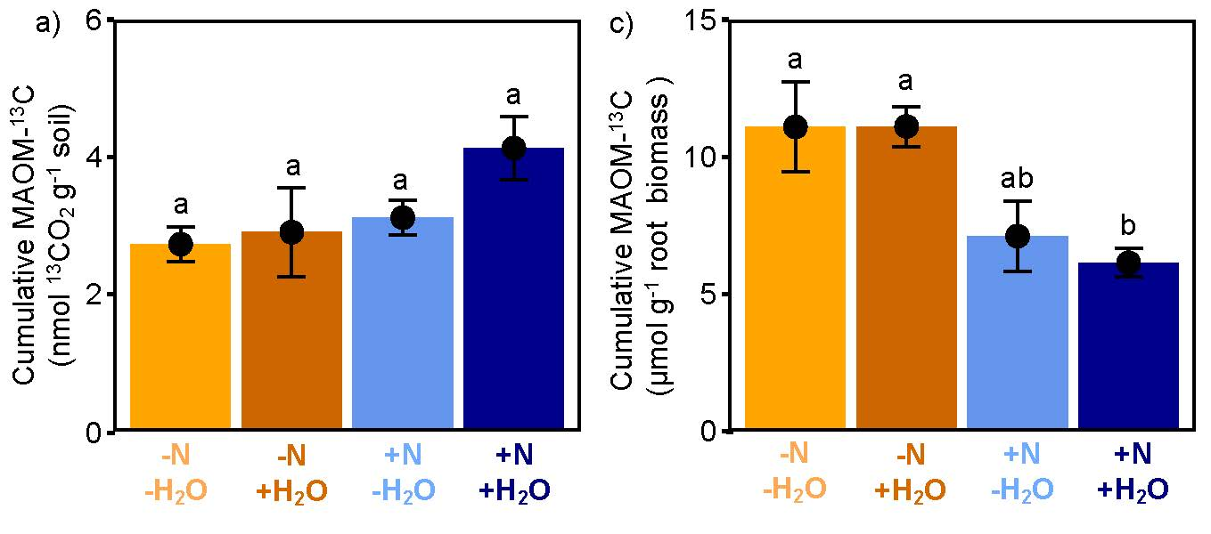 Figure S5: Cumulative root-driven MAOM destabilization
(a) Effects of nutrient and water availability on cumulative ¹³CO₂ production from ¹³C-labeled MAOM. Effects of nutrient and water availability on cumulative MAOM-¹³C per unit of root biomass. (b) Error bars represent the standard error of the mean (n = 5). Significantly different means (n = 5) are denoted by lower case letters (Tukey’s HSD, p < 0.05).

References
1. Neff, J. C. & Hooper, D. U. Vegetation and climate controls on potential CO₂ , DOC and DON production in northern latitude soils. Glob. Change Biol. 8, 872–884 (2002).

