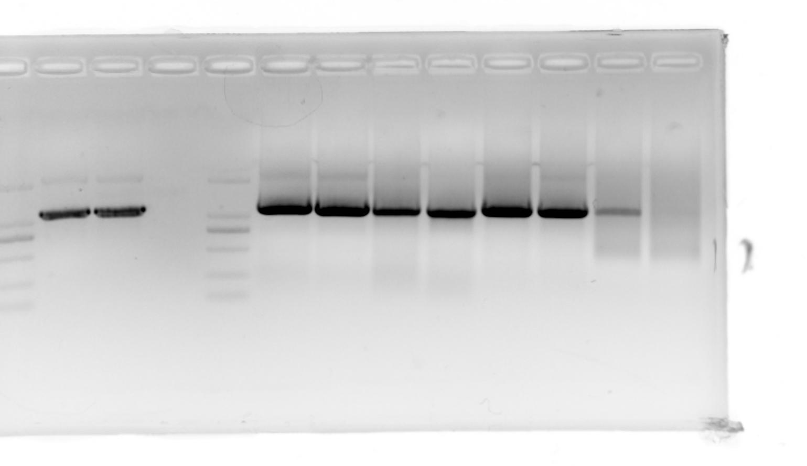
Fig. 1 the full uncropped Gels and Blots image

