Table S1 Primers used in this study
Gene Name | Primer forward sequence (5'–3') | Primer reverse sequence (5'–3')
EdSWEET1a | ATGCAGCTGATCCTCTACGC | TTGATCTTTGCCTCGCCCAT
EdSWEET1b | GGTGCCATACAACATGACGC | CGCGAAGACGAGGAAGATCA
EdSWEET2a | GGCGCTTCTGGATGACTTCT | CTGGCTTCGTCTCTCGATCC
EdSWEET2b | CAGCAGAAAGACCAGGCTGA | AGTCGGCTGGTCGAAGAAAG
EdSWEET3a | CTTTTCTCACGGCACCAAGC | TGGCTTTTGTCCCTTCGTGT
EdSWEET4 | GGAGTACATGCCCCTGTTCC | TCTGCTGCGTCGACTTGTAG
EdSWEET12 | TGATCAGGACCAAGAGCGTG | GTTGGGTGTCGCTACGAAGA
EdSWEET13 | CATTCGCCTTTGGCCTCCTA | GGAACCCCTCCCTGGATTTG
EdSWEET14 | TCGTCATGCTTGGATGGGTC | AGGGAGAGTGAGAAGGGCAT
EdSWEET15 | TCACGGCCAAGCTCTTCATT | AACTCCACGCTCTTGGTACG
EdSWEET16 | CCACGGGTTTGGTCATCTCA | TAGACATGCTCATCGTCGCC
EdSWEET17 | TAAATGGTGCAGCCCGACAT | GTAGAGCCATAGCAGCGTGT
Actin | GGGCATTCGTATTTCATAGTCAGAG | CGGTTCTTGATTAATGAAAACATCCT
EdSWEET15-F | TCTCCTTTACCCATGGTACCATGGCTTTCTTGAACATGGAAC |  |  | qRT-PCR
EdSWEET15-R | CACGGGGGACTCTAGACACTTGGACAACAGTGGC |  |  | qRT-PCR

Table S2 Physicochemical properties of EdSWEET proteins in Elymus dahuricus.
Sequence ID | Number of  Amino Acid | Molecular  Weight | Theoretical pI | Instability Index | Aliphatic Index | Grand Average of Hydropathicity
EdSWEET1a | 273 | 29603.04 | 7.58 | 24.97 | 115.68 | 0.687
EdSWEET1b | 261 | 28434.98 | 8.68 | 39.84 | 103.49 | 0.264
EdSWEET3a | 144 | 16132.4 | 9.03 | 38.09 | 106.18 | 0.613
EdSWEET2b | 231 | 25386.12 | 8.92 | 41.01 | 114.5 | 0.813
EdSWEET4 | 250 | 27365.73 | 9.32 | 37.92 | 123.56 | 0.75
EdSWEET2a | 239 | 26552.45 | 9.28 | 43.61 | 113.39 | 0.746
EdSWEET15 | 310 | 33928.34 | 7.66 | 38.74 | 117.94 | 0.689
EdSWEET14 | 296 | 32248.26 | 8.76 | 40.96 | 117.6 | 0.633
EdSWEET13 | 263 | 28369.86 | 9.03 | 34.87 | 122.28 | 0.829
EdSWEET12 | 306 | 33479.72 | 6.9 | 42 | 120.1 | 0.597
EdSWEET17 | 239 | 26085.45 | 6.69 | 40.1 | 107.32 | 0.626
EdSWEET16 | 302 | 32938.89 | 8.86 | 43.02 | 107.78 | 0.513

Table S3 Predictions of EdSWEET protein secondary structure.
Gene Name | Gene ID | α-helical structure/% | Random curl knot/% | β-turn structure/% | Extension chain/%
EdSWEET1a | Enu.ptg000015l.G1711.t1 | 51.65% | 29.67% | 2.20% | 16.48%
EdSWEET1b | Enu.ptg000034l.G180.t1 | 47.51% | 33.72% | 2.30% | 16.48%
EdSWEET2a | Enu.ptg000068l.G149.t1 | 43.51% | 33.89% | 2.51% | 20.08%
EdSWEET2b | Enu.ptg000015l.G264.t1 | 44.59% | 32.03% | 2.60% | 20.78%
EdSWEET3a | Enu.ptg000063l.G29.t1 | 44.44% | 40.28% | 0.00% | 15.28%
EdSWEET4 | Enu.ptg000042l.G217.t1 | 41.20% | 37.60% | 2.40% | 18.80%
EdSWEET12 | Enu.ptg000155l.G91.t1 | 35.95% | 47.39% | 1.31% | 15.36%
EdSWEET13 | Enu.ptg000118l.G814.t1 | 47.15% | 33.46% | 2.66% | 16.73%
EdSWEET14 | Enu.ptg000044l.G101.t1 | 35.14% | 46.96% | 1.35% | 16.55%
EdSWEET15 | Enu.ptg000026l.G350.t1 | 40.97% | 41.29% | 1.94% | 15.81%
EdSWEET16 | Enu.ptg000154l.G334.t1 | 47.68% | 33.77% | 1.99% | 16.56%
EdSWEET17 | Enu.ptg000081l.G461.t1 | 42.26% | 35.56% | 2.93% | 19.25%

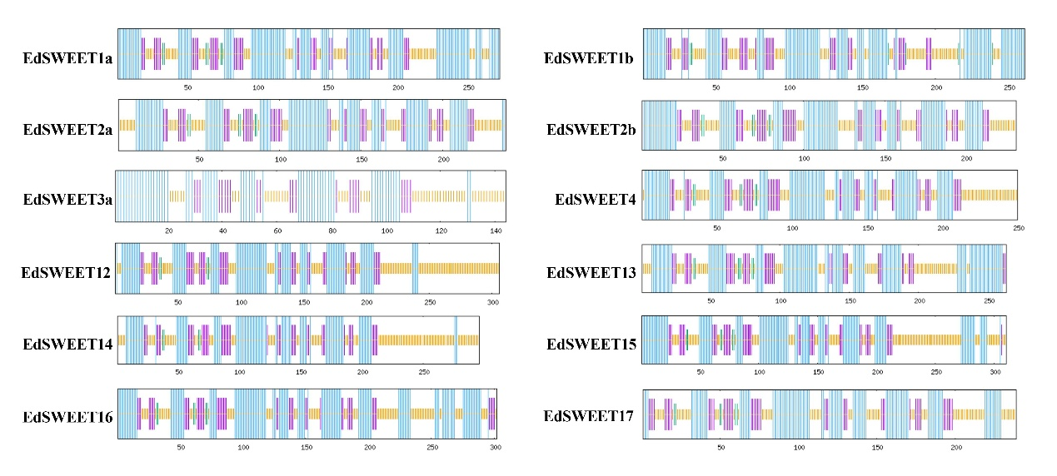
Fig.S1 Protein secondary structure encoded by EdSWEETs in Elymus dahuricus.
Note: Blue represents α- Spiral. Red indicates irregular curls.

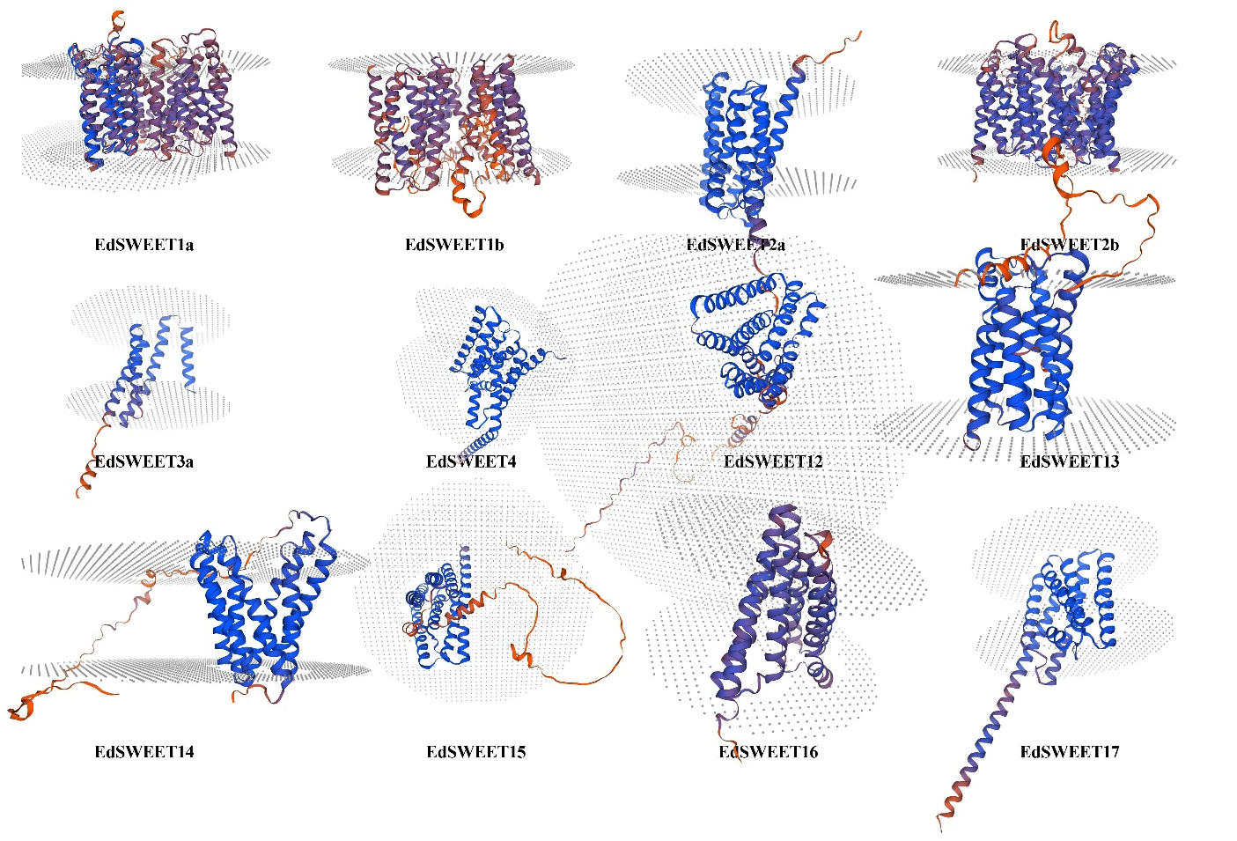
Fig. S2 Tertiary structure predictions of EdSWEET proteins. Blue indicates α-helices, green indicates β-folds, yellow indicates irregular curls, and red indicates extension chains.
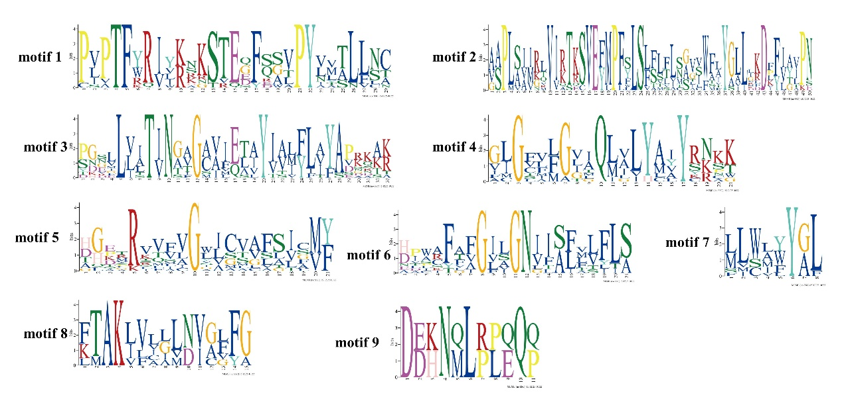
Fig.S3 Sequence marker soften motifs of EdSWEETs protein identified by MEME program.

