Table 1 Characteristics of neonates with bone and joint infections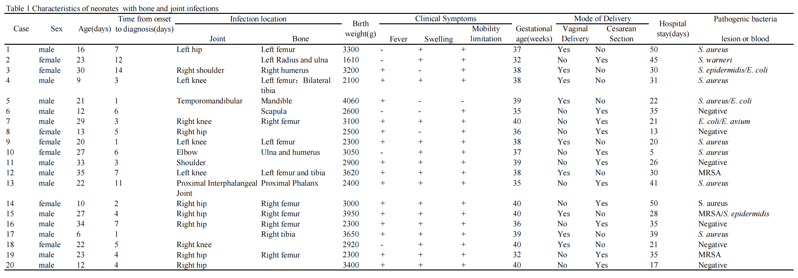

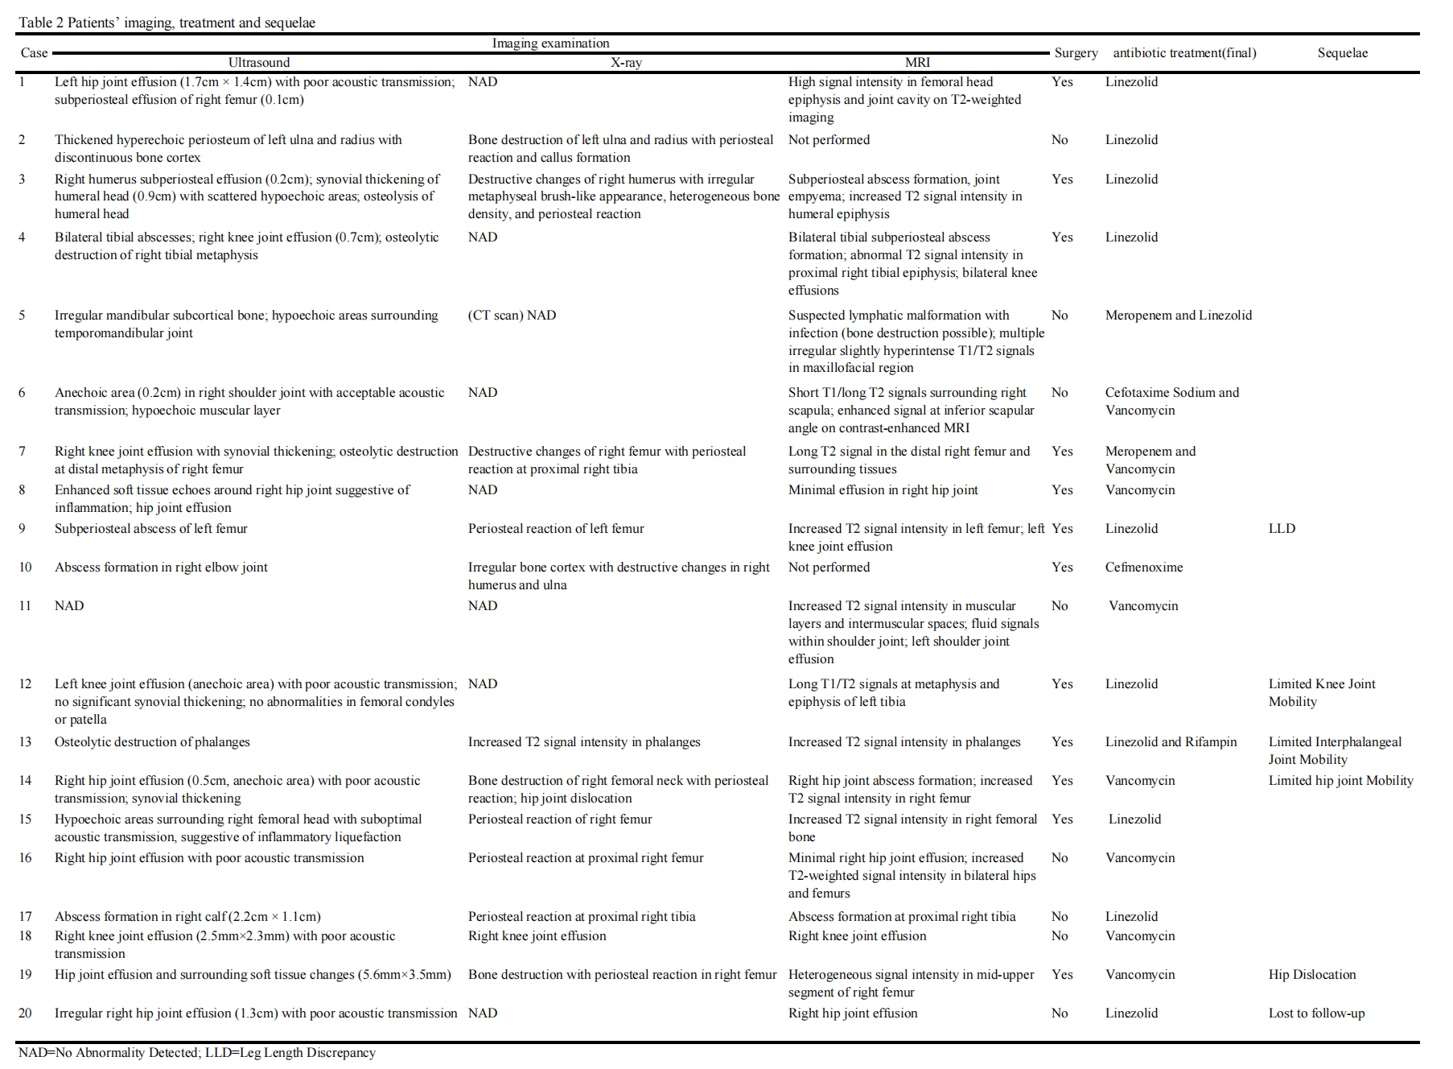
Table 2 Patients’ imaging, treatment and sequelae
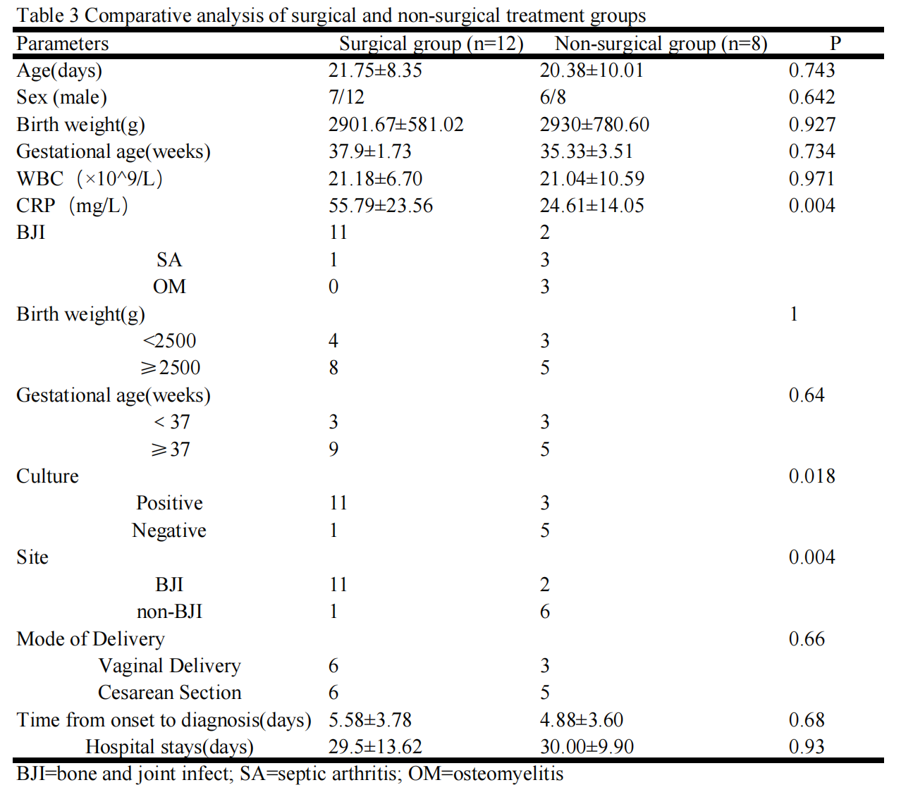
Table 3 Comparative analysis of surgical and non-surgical treatment groups

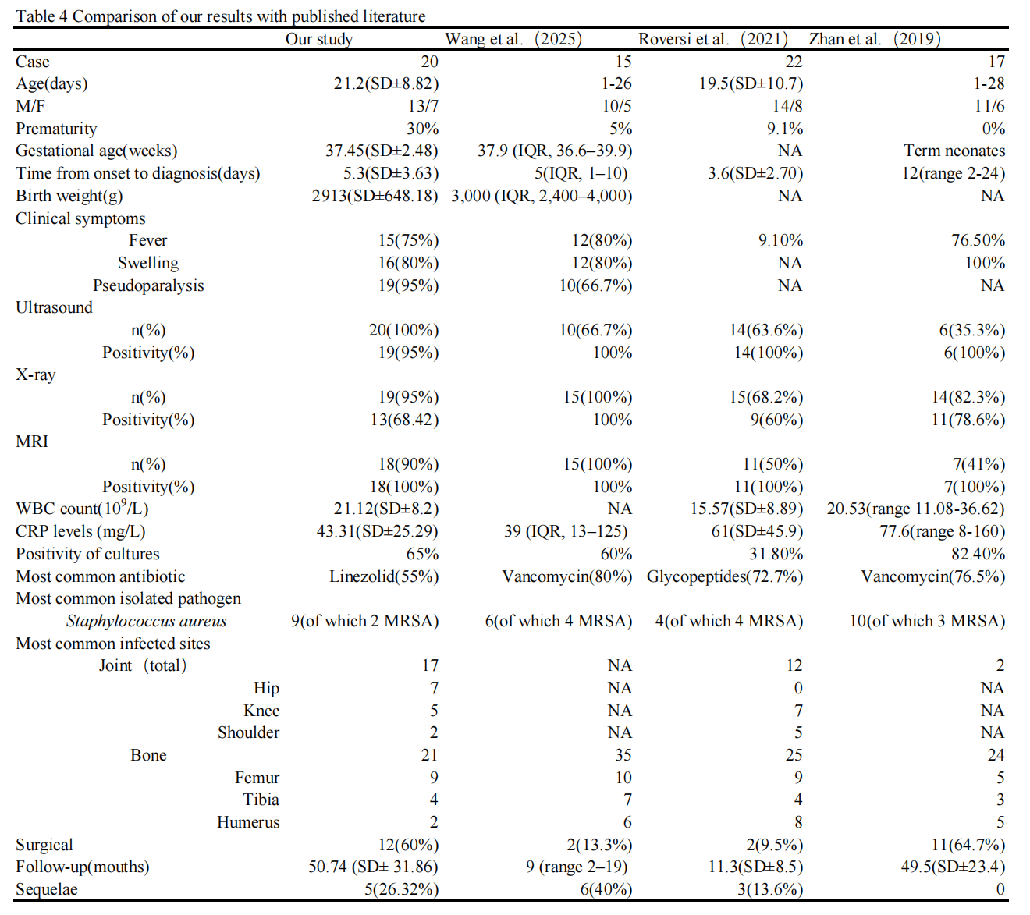
Table 4 Comparison of our results with published literature

