Supporting Information for the Article:

Bioengineered Spatially Heterogeneous Tumor Microenvironment Model Mediated by Tumor-Stromal Interactions for Multi-Drug Synergy Evaluation
You Chen^{1,2,#}, Yifan Xue^{1,2,#}, Jiahuan Yang¹, Jing Li¹, Junfeng Hu¹, Jie Liu*

¹School of Biomedical Engineering, Shenzhen Campus of Sun Yat-Sen University; Shenzhen, Guangdong, 518107, China.
2Guangdong Provincial Key Laboratory of Sensor Technology and Biomedical Instrument, Sun Yat-Sen University; Guangzhou, Guangdong, China.

# Contributed equally to this work.

* Corresponding Authors:
Prof. Jie Liu
Email: liujie56@mail.sysu.edu.cn

Fig.S1 Rheological amplitude sweep tests on two 3D cell culture matrix materials, adECM and adEMA, with an applied oscillatory strain range of 0.1-100%.

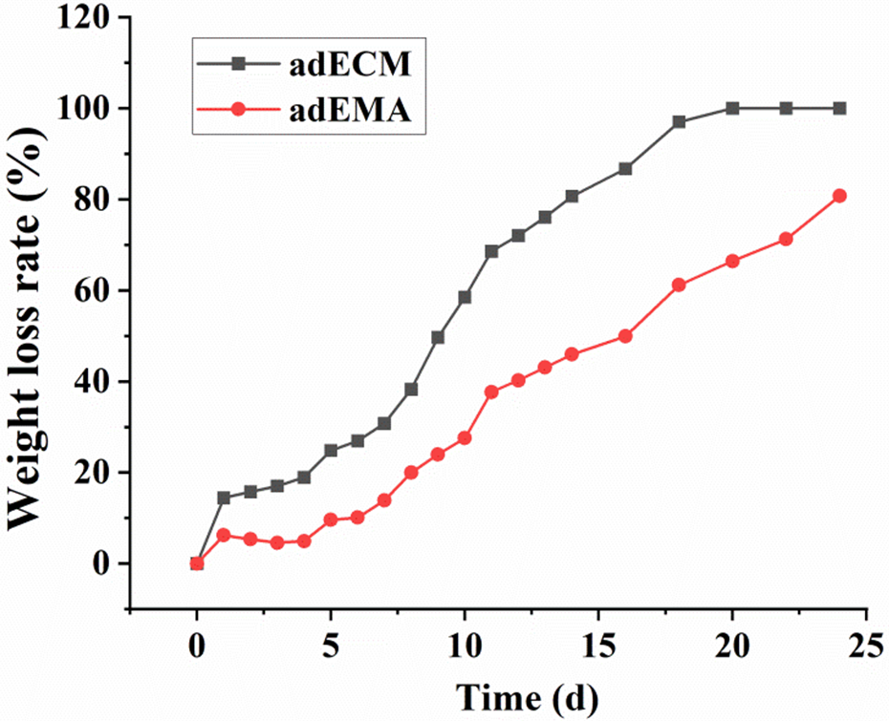
Fig.S2 Experimental results of in vitro degradation rate of two 3D cell culture matrix adECM and adEMA hydrogels.

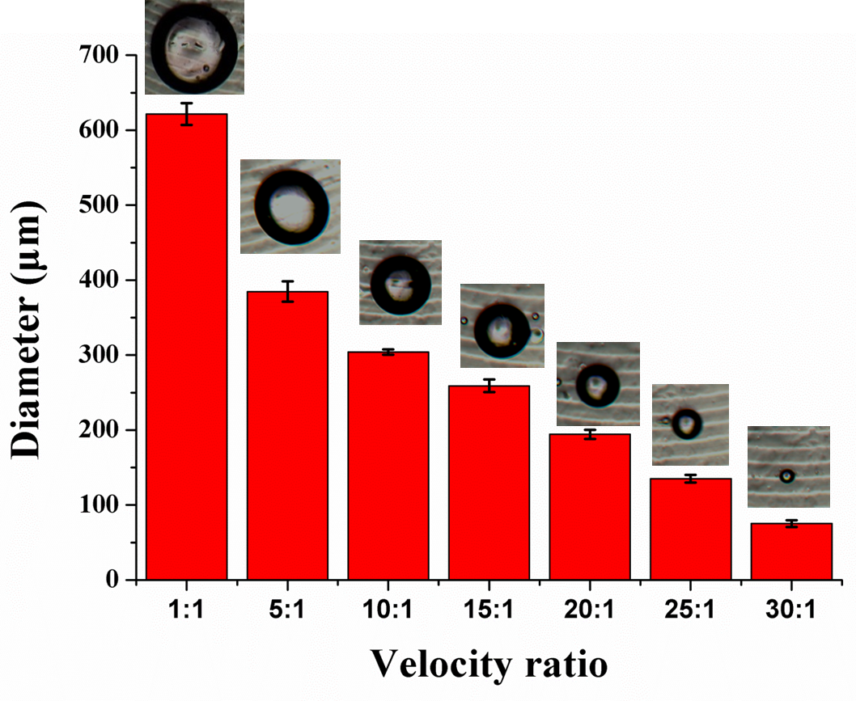
Fig.S3 The influence of different oil-water ratios on the diameter of prepared TMPs gel microspheres.
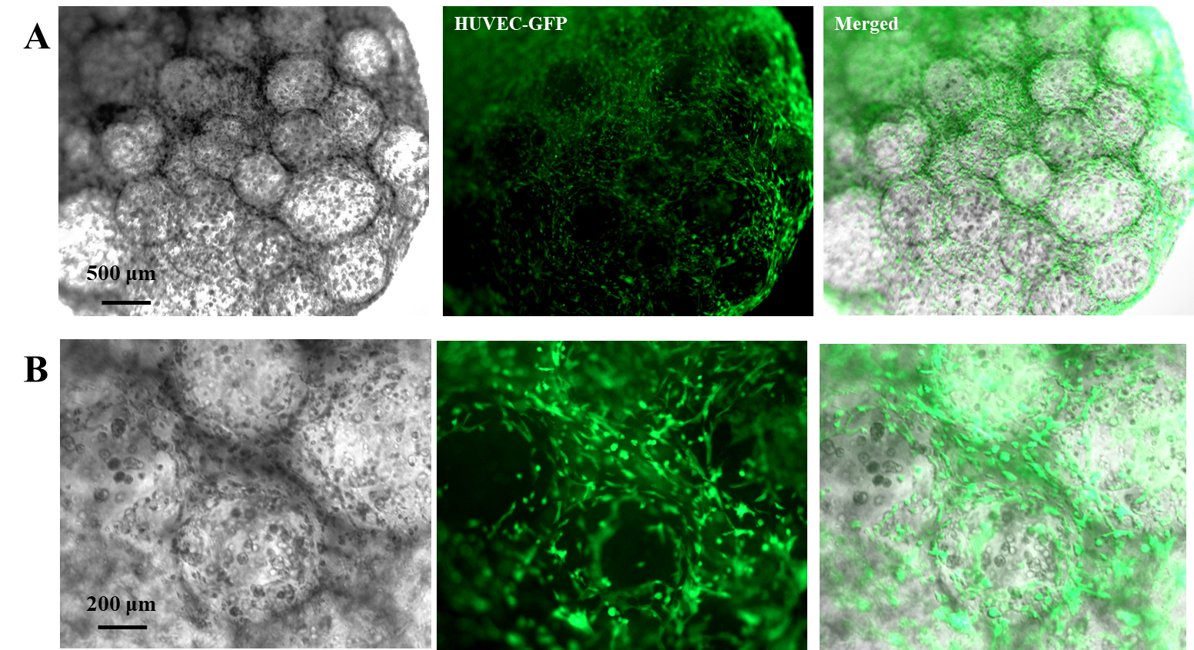
Fig.S4 Experimental results of co-culture of TMPS and UVEC-GFP cells in the MH-TMPs group after 7 days.

