Appendix A) Determining the earliest time to start RT treatment for patient i from Oncologist j
This algorithm has been developed based on queueing theory. Each linac 15-minute session and the following sessions serves each patient. Therefore, each assigned session may be considered as a server that will be busy from the first session up to the number of treatment sessions to serve each patient.
Function Z represents the triple preference measures (priority, waiting time, and due date) to weight patients in their oncologist’s waiting list for assessing the doc’s quota. The weight for the patient undergoing treatment is the highest. R shows the number of servers (or daily treatment sessions of the oncologist). This parameter specifies the number of patients for each oncologist who are scheduled in the same week, i.e., the number of patients who are using the oncologist’s quota in the same period. It is equal to the quota (v_{j}) divided by the number of days per week and the average number of required fields for the patient ($β)$. $r=1,⋯,R$ is the index of the server, and B_{r} is the number of weeks for which server r is assigned for treatment.
The following algorithm is an offline heuristic that uses queueing theory
to determine the earliest start time for RT of patient i for doctor j:
- Construct a patient list for doctor j containing all those undergoing treatment and waiting ones.
- Calculate Z_{i}=Z(q_{i},e_{i},due_{i}) for all patients in the list.
- Sort patients in the list based on decreasing Z_{i}.
- Calculate the maximum number of patients whose treatment can be done simultaneously by
$R=v_{j} /(T*β)$.
- Let B_{r} (r=1,…, R) be the week to start the RT for patient r ( that are all zero at first).
- Repeat until patient i is selected:
  - Apply greedy algorithm to select the patient from the list and assign the earliest time (Min B_{r}) for their start of treatment, and update B_{r} = B_{r}+(m/T).
- The earliest time to start treatment for patient i would be min(B_{s}+1).

Appendix B) Scheduling patients undergoing treatment
The current patients undergoing treatment whose treatment has started in previous weeks need to schedule first. This algorithm allocates the capacity to patients being treated and updates the remaining capacity of the treatment facility.
In order to respond to the random arrival of high-priority patients, we used dynamic scheduling in this article. For this purpose, the required capacity of the patients whose treatment is being performed should be allocated first. Then, the remaining capacity of the linac is calculated to decide on selecting new patients from the waiting list and starting their RT treatment. Then, the patients on the waiting list are planned according to the remaining capacity and free times of the device. We can design the capacity allocation algorithm for current patients in such a way that the patients whose treatment plans are being implemented are allocated sequentially from the first day of the next week, and the remaining capacity of the linac and the remaining quota of oncologists are determined as the output of the algorithm.
The following simple algorithm can be used :
- Record the maximum capacity of the linac and the quota of oncologists of the RT center.
- For each patient whose treatment plan is being implemented,
  - For each assigned appointment,
  - Reduce the capacity of the linac and the quota of doctors according to the number of treatment fields per session.
  - If there is a second treatment plan, check whether the second plan starts in the current planning horizon or not.
The remaining capacity of the device and the quota of doctors to plan the future time horizon will be determined at the end.

Appendix C) Quantifying multi-attribute priority class for patients
The priority class for the patient is a parameter for the proposed scheduling models as normal, priority, emergency, and pediatric. According to the procedure, the oncologist determines the priority by visiting the patient, examining the tests, and studying the profile. Every doctor can have a different opinion from the other colleagues. In unusual situations such as device failure and disease outbreak, which necessitate reducing the center's treatment capacity, the selection of priority patients becomes an important issue. According to previous studies in this field (Daitz and Moran, 2020), as well as patients' profiles and doctors' opinions, the main attributes for prioritization are the golden time criteria for patient treatment, disease staging (stage), disease grade (grade), age, physical condition, and cell growth rate. These attributes and their effects on the RT treatment are illustrated below:
- The golden time of treatment is the interval of two to four weeks from the beginning of the patient's treatment, according to the previous treatment (surgery or chemotherapy). This time interval is very important on one hand, considering the restoration of the patient's body from the previous treatment, and on the other hand, preventing the rapid growth of the tumor.
- Cancer staging helps describe where the cancer is, how far it has spread, and how it affects other parts of the body. In the staging system, tumor size, involvement of the tumor with lymph nodes, and the way the tumor spreads are used to determine the quadruple number of the stage of the disease. The higher the patient's stage number, the higher the priority. Stages one, two, and three are treatable, but stage four has no definitive treatment, and palliative treatment is prescribed.
- Different grades for cancer are determined through pathology tests to find out the type and rate of tumor proliferation. The higher the grade number of the patient, the higher the priority.
- Usually, young patients have a higher priority due to the chances of treatment and survival.
- The physical condition and physical strength of the patients are measured through the PS index. The higher the score of this test, the better the physical condition of the patient, and the priority of the patient is considered.
- Finally, the rate of cell growth is determined by the 67 KI proliferation index; the higher it is, the more dangerous the disease and the higher priority of the patient.
Table 7 can be used to quantify each of the effective attributes. Using the proposed scheme, the priority weights or priority classes can be determined to be used for the scheduling models.
Table 7: Quantifying the attribute measures into priority classes
High low priority (emergency) | with priority | medium priority | low priority | very low priority | Attributes
 | more than 4 weeks | between 3 and 4 weeks | between 2 and 3 weeks | Less than 2 weeks | Golden time interval from previous treatment
4 | 3 | 2 | 1 |  | Staging
 | 3 | 2 | 1 |  | Grading
 | between 20 and 40 | between 40 and 60 | between 60 and 80 | older than 80 years | Age
The low PS caused by this disease increases the priority for treatment, while the low PS caused by previous treatments decreases the priority and treatment effect. |  |  |  |  | performance status
 | >10 |  | <10 |  | 67 KI proliferation index

Appendix D) Weighting Procedure and Sensitivity Calibration
The multi-objective function in the patient scheduling model consists of five components: patient priority, physician quota compliance, treatment deadline adherence, patient waiting time, and linac capacity utilization. To determine the relative weights of these objectives, pairwise comparisons were conducted through interviews with the center’s oncologists. The resulting AHP computations, implemented using Expert Choice software, yielded a consistency ratio of 0.09, indicating acceptable coherence in expert judgments. Table 8 summarizes the derived weights:

Table 8 – Objectives Weights
Objective | Weight
Patient priority | 0.475
Physician quota | 0.121
Treatment deadline | 0.190
Waiting time | 0.173
Linac capacity utilization | 0.041

These weights reflect the operational priorities considered in 2021, though they may change under different policy environments. Because the objectives have different units of measurement, normalization was required. However, normalization can distort relative distances between alternatives, especially in weighted multi-objective models. To address this and to reinforce the reliability of the weights, a sensitivity-based calibration was performed.
For this purpose, a small set of representative patient profiles was extracted from real data, capturing extreme or boundary values of each criterion (Table 9). The true clinical priority of these patients, based on physicisns’ assessment, was used as a benchmark. The AHP-derived ranking was then compared with this benchmark to identify discrepancies and adjust the weights accordingly. Only criteria directly affecting the objective function were included, ensuring that the sensitivity analysis focused solely on the weight structure. Figure 2 presents the sensitivity performance charts illustrating how variations in weights influence the final prioritization outcomes.

Table 9 - Representative Patient Profiles
Patient | Physician-assigned priority* | Deviation from physician quota (%) | Deviation from treatment deadline (days) | Waiting time in queue (days) | Deviation from linac capacity (%) | Final combined priority score
1 | 4 | 0 | 5–10 | 10 | 0 | 1
2 | 4 | 20 | 5–10 | 5 | 20 | 2
3 | 2 | 0 | 10–20 | 20 | 0 | 3
4 | 2 | 20 | 10–20 | 20 | 20 | 6
5 | 4 | 20 | 10–20 | 5 | 0 | 4
6 | 4 | 0 | 2–5 | 1 | 20 | 5
7 | 2 | 0 | 5–10 | 10 | 20 | 7

This calibration procedure confirms that the final set of weights is both stable and aligned with expert expectations, ensuring that the multi-objective model reflects the clinical policies of the radiotherapy center.

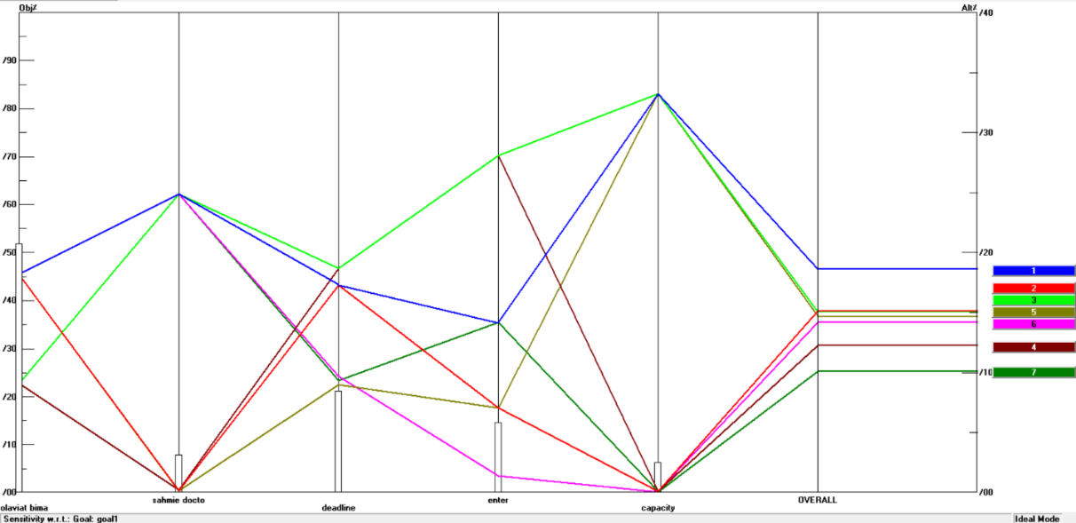

Figure 2. Sensitivity analysis chart for the extracted example

This figure justifies the adjusted objectives’ weights calibrated to match the priority structure desired by the clinical experts. For the sensitivity analysis, the targeted example presented in Table D3 was first evaluated using the initial AHP-derived weights. The resulting ranking differed from the expert-preferred ordering for patients 2, 3, 4, 5, and 6. As shown in the sensitivity chart in Figure 2, these four cases lie very close to one another with respect to the influence of the objective weights. Therefore, a minor calibration of the weights allowed us to obtain a ranking fully aligned with the clinical expert’s judgments. Once the preferred ordering was achieved through these small adjustments, the final calibrated weights were selected. The resulting weights are reported in Table 10, and the corresponding final patient scores appear in Table 11.

Table 10. Calibrated weights of the objectives
Objective | Weight
Patient priority | 0.514
Physician quota | 0.075
Treatment deadline | 0.208
Waiting time in queue | 0.143
Linac capacity compliance | 0.061

As shown in Table 10, the differences between the calibrated weights and the initial AHP weights are less than 0.05. These subtle adjustments—which refine the initial weights—enable the model’s outputs to fully align with the clinical expert’s judgments. The calibrated weights are therefore used as the final basis for running the optimization model.

Table 11. Final scores for the patients in the designed example
Patient | Final Treatment Priority | Score
1 | 1 | 18.60
2 | 2 | 15.11
3 | 3 | 15.10
4 | 6 | 12.20
5 | 4 | 14.70
6 | 5 | 14.20
7 | 7 | 10.10

As Table 11 indicates, the calibrated weights produce scores that closely match the expert’s preferred prioritization. The need for this adjustment likely reflects nuanced clinical considerations or implicit prioritization criteria that could not be fully captured through interviews alone.

Appendix E) Datasets for the test samples

Table 12: patients' attributes (sample 1)
Patient ID | Number of sessions | Under previous treatment | Due date | Waiting time | under treatment | inpatient (or emergency) | Appropriate linac | patient's preferred time | Field per session
1 | 10 | 0 | 0 | 5 | 0 | 0 | 1 or 3 | 1-2 | 1
2 | 15 | 0 | 7 | 10 | 0 | 1 | 2 | 2-3 | 2
3 | 2 | 0 | 14 | 1 | 0 | 0 | 2 or 3 | 1-2 | 3
4 | 10 | 1 | 21 | 7 | 0 | 0 | 1 | 2-3 | 1
5 | 15 | 0 | 0 | 15 | 0 | 0 | 1 | 1-2 | 2
6 | 20 | 0 | 7 | 3 | 0 | 0 | 1 or 3 | 2-3 | 3
7 | 10 | 0 | 14 | 4 | 0 | 1 | 2 | 1-2 | 1
8 | 15 | 0 | 21 | 5 | 1 | 0 | 2 | 2-3 | 2
9 | 20 | 0 | 0 | 10 | 1 | 0 | 3 | 1-2 | 3
10 | 10 | 0 | 7 | 1 | 1 | 0 | 1 | 2-3 | 1

Table 13: patients' attributes (sample 2)
Patient ID | Number of sessions | priority | Under previous treatment | Due date | Waiting time | under treatment | inpatient (or emergency) | Appropriate linac | patient's preferred time | Field per session
1 | 10 | 1 | 0 | 0 | 5 | 0 | 0 | 1 or 3 | 1-2 | 3
2 | 15 | 2 | 0 | 7 | 10 | 0 | 1 | 2 | 2-3 | 2
3 | 2 | 3 | 0 | 14 | 1 | 0 | 0 | 2 or 3 | 1-2 | 3
4 | 10 | 1 | 1 | 21 | 7 | 0 | 0 | 1 | 2-3 | 2
5 | 15 | 2 | 0 | 0 | 15 | 0 | 0 | 1 | 1-2 | 3
6 | 20 | 3 | 0 | 7 | 3 | 0 | 0 | 1 or 3 | 2-3 | 2
7 | 10 | 1 | 0 | 14 | 4 | 0 | 1 | 2 | 1-2 | 3
8 | 15 | 2 | 0 | 21 | 5 | 1 | 0 | 2 | 2-3 | 2
9 | 20 | 3 | 0 | 0 | 10 | 1 | 0 | 3 | 1-2 | 3
10 | 10 | 1 | 0 | 7 | 1 | 1 | 0 | 1 | 2-3 | 2
11 | 2 | 2 | 0 | 14 | 7 | 0 | 0 | 1 | 1 | 3
12 | 5 | 3 | 0 | 21 | 5 | 0 | 0 | 2 | 2 | 2
13 | 3 | 1 | 0 | 0 | 15 | 0 | 1 | 3 | 3 | 3
14 | 10 | 2 | 0 | 7 | 3 | 0 | 0 | 1 or 2 | 1 | 2
15 | 15 | 3 | 0 | 14 | 4 | 0 | 0 | 2 or 3 | 2 | 3
16 | 5 | 1 | 0 | 21 | 5 | 0 | 0 | 1 or 2 | 3 | 2
17 | 10 | 2 | 0 | 0 | 10 | 0 | 0 | 2 or 3 | 1 | 3
18 | 2 | 2 | 0 | 7 | 15 | 1 | 0 | 2 | 1 | 2

Performance status

