Supplementary Material

Human flourishing and suicide: A national-level analysis with 22 countries

Table of Contents
Supplementary Methods 1
Supplementary Table 1: Cook’s D values by country and outcome to assess high influence outliers 9
Supplementary Table 2: Covariates included in the stepwise backwards regression analyses 10
Supplementary Table 3: Repeated main analysis including the high influence outlier Turkey 12
Supplementary Table 4: Effect of flourishing subdomains on suicide rates in the population subgroups 12
Supplementary Table 5: Relationship between Flourishing Index and its subdomains with Suicide-adjacent constructs of Intentional Self Harm (ISH) and Depressive Disorders Prevalence and alternative measure of Suicide Mortality Rate 14
Supplementary Figure 1: Suicide mortality rate and flourishing index by subdomain including the outlier Turkey 15
Supplementary Figure 2: Suicide mortality rate and flourishing index by subgroup including the outlier Turkey 17

Supplementary Methods

Description of Data Sources

World Bank GDP per capita 2023

The World Bank GDP per capita 2023 dataset presents the average economic output per person, expressed in current U.S. dollars. The data is gathered from national accounts, providing standardized measures for evaluating economic performance and wealth inequality¹. This may be an important co-variate in assessing relationships with suicide mortality rates because economic prosperity impacts mental health through living standards, healthcare access, and social stability.

Average temperatures 2023

The average temperature dataset 2023, sourced from publicly available website Trading Economics, includes annual mean temperature measurements for countries worldwide².

World Bank Population Density 2022

The World Bank Population Density dataset from 2022 presents information on the number of individuals residing per square kilometre of land area across different countries. High-density regions often face challenges such as overcrowding, pollution, housing shortages, and strained healthcare and educational facilities. Equally, low-density areas may encounter difficulties regarding service delivery, economic integration, and connectivity³.

Education (Average Years of School) 2020

The dataset from Our World in Data on the average years of schooling in 2020 presents the state of educational attainment worldwide, representing the average number of years individuals aged 25 and above have spent in formal education⁴.

Firearms per capita 2017

The firearms per capita dataset from 2017, sourced from World Population Review, details gun ownership rates by presenting the number of privately held firearms per 100 residents in each country⁵.

Sociodemographic Index (SDI) 2021

SDI is a summary measure that identifies where countries or other geographic areas sit on the spectrum of development. Expressed on a scale of 0 to 1, SDI is a composite average of the rankings of the incomes per capita, average educational attainment, and fertility rates of all areas in the GBD study⁶.

World Health Organisation (WHO) Suicide Worldwide in 2021 – Global Health Estimates

Each year WHO member states report mortality statistics from their civil registration systems to the WHO. The WHO mortality database compiles this mortality data by age, sex and cause of death including suicide⁷. The Global Health Estimates are the WHO’s best estimates of suicide mortality rates. They have been calculated using standardised groupings and definitions to ensure cross-national comparability. The process involved taking ICD codes (X60–X84 and Y870 for suicide) and then re-allocating deaths of unknown sex/age and deaths allocated to poorly delineated codes, interpolating/extrapolating number of deaths for missing years, scaling total deaths by age and sex to WHO all-cause envelopes for 2000–2021, and using population estimates from the UN Population Division. So that the suicide mortality rates of different countries are comparable they report the age-standardised rather than non-standardised rates.

The below section has been taken directly from the Suicide worldwide in 2021: Global Health Estimates report produced by the WHO⁷.
“There are several important caveats that need to be considered when evaluating suicide mortality data. Of the WHO 183 Member States for which estimates were made for the year 2021, 86 have good-quality (labelled as high and medium quality) vital registration data that can be used directly to estimate suicide rates.
The estimated suicide rates in the other 97 Member States (which account for about 61% of global suicides) are necessarily based on modelling methods. As might be expected, good-quality vital registration systems are much more likely to be available in high-income countries. The 49 high-income countries with good vital registration data account for 99.6% of all estimated suicides in high-income countries, but the 37 low- and middle-income countries (LMICs) with good vital registration data account for only 16.3% of all estimated suicides in LMICs.
This problem of poor-quality mortality data is not unique to suicide, but given the sensitivity of suicide – and the illegality of suicidal behaviour in some countries – it is likely that under-reporting and misclassification are greater problems for suicide than for most other causes of death. Suicide registration is a complicated, multilevel procedure that includes medical and legal concerns and involves several responsible authorities that can vary from country to country.
Suicides are most commonly found misclassified, according to the codes of the 10th edition of the International Classification of Diseases and Related Health Conditions (ICD-10), as “deaths of undetermined intent” (ICD-10 codes Y10-Y34), and also as “accidents” (codes V01-X59), “homicides” (codes X85-Y09) and “unknown cause” (codes R95-R99).”

Intentional Self Harm Disability Adjusted Life Years (ISH DALYs) – Global Burden of Diseases 2021

Data from this study focussed on the disability-adjusted life years (DALYs) associated with self-harm, based on global censuses, disease registries, and surveillance systems from the Global Burden of Diseases 2021 study⁸. Bayesian hierarchical models, including Bayesian meta-regression and DisMod-MR 2.1, were employed to ensure consistent and comparable estimates across populations, age groups, genders, and regions. ISH is considerably more common than suicide and is strongly associated with suicide mortality. In some countries where suicide mortality is taboo and reported numbers may be inaccurate, ISH may be reported more accurately.

Depressive Disorder Prevalence – Global Burden of Diseases 2021

This study assessed metrics such as prevalence and incidence for depressive disorders. Data was obtained through systematic reviews, global censuses, national and subnational surveys, disease registries, and cause-of-death records. They also analysed attributable risk factors using comparative risk assessment frameworks. Bayesian hierarchical models, including Bayesian meta-regression and DisMod-MR 2.1, were employed to ensure consistent and comparable estimates across populations, age groups, genders, and regions.

Depressive disorders were defined primarily as Major Depressive Disorder (MDD) and Dysthymia. The study used the International Classification of Diseases Tenth Revision (ICD-10) for classification. MDD is characterized by sustained periods of depressed mood and diminished interest in activities, typically lasting at least two weeks. Dysthymia, a chronic, milder form of depression, involves persistent low mood but with less severe symptoms than MDD. Depressive disorders are considerably more common than suicide and is strongly associated with suicide mortality. In some countries where suicide mortality is taboo and reported numbers may be inaccurate, depressive disorder may be reported more accurately⁹.

Identification of highly influential outlier datapoints

Highly influential datapoints were identified by computing the Cook’s Distance (Cook’s D) for each of the datapoints. Cook’s D was calculated within a generalised linear model with the flourishing index as the main predictor, country median age as the only covariate and suicide mortality, Intentional Self Harm (ISH) DALYs and Depressive Disorders prevalence as the outcome variables. Cook’s D as a measure identifies highly influential data points in a regression analysis, quantifying the effect of deleting a single observation on the estimated regression coefficients. In our analysis high influence outlier datapoints were identified using a threshold of 4/n¹⁰ (i.e. 4/22 = 0.1818). The Cook’s D are summarised in the Supplementary Table 2. For the main suicide mortality analysis Turkey was identified as the high influence outlier and removed in the main analyses. For the ISH DALYs analysis Turkey was identified as high influence outliers and for the Depressive Disorders prevalence analysis Japan and Indonesia were identified as high influence outliers. For the WHO suicide mortality rate estimates

References

1. World Bank Group. GDP per capita. Country Official Statistics. https://data.worldbank.org/indicator/NY.GDP.PCAP.CD. Published 2023. Accessed July 27, 2025.
2. Trading Economics. Average Temperature by Country. https://tradingeconomics.com/country-list/temperature. Published 2023. Accessed July 27, 2025.
3. World Bank Group. Population density. https://data.worldbank.org/indicator/EN.POP.DNST. Published 2025. Accessed July 27, 2025.
4. Our World in Data. Average year of schooling. Data. https://ourworldindata.org/grapher/mean-years-of-schooling-long-run. Published 2020. Accessed July 27, 2025.
5. World Population Review. Gun Ownership by Country. Gun Ownership. https://worldpopulationreview.com/country-rankings/gun-ownership-by-country. Published 2017. Accessed July 27, 2025.
6. Institute of Health Metrics and Evaluation. Global Burden of Disease 2021. https://www.healthdata.org/sites/default/files/2024-05/GBD_2021_Booklet_FINAL_2024.05.16.pdf. Published 2022. Accessed July 27, 2025.
7. World Health Organisation (WHO). Suicide worldwide in 2021: Global Health Estimates. Global Health Estimates. https://apps.who.int/iris/rest/bitstreams/1350975/retrieve%0Ahttps://www.who.int/publications-detail-redirect/9789240026643. Published 2025. Accessed August 11, 2025.
8. Xie L, Tang L, Liu Y, Dong Z. Global burden and trends of self-harm from 1990 to 2021, with predictions to 2050. Front Public Heal. 2025;(May):1-12. doi:10.3389/fpubh.2025.1571579
9. Rong J, Wang X, Cheng P, Li D, Zhao D. Global, regional and national burden of depressive disorders and attributable risk factors, from 1990 to 2021: results from the 2021 Global Burden of Disease study. Br J Psychiatry. January 2025:1-10. doi:10.1192/bjp.2024.266
10. Altman N, Krzywinski M. Points of Significance: Analyzing outliers: Influential or nuisance? Nat Methods. 2016;13(4):281-282. doi:10.1038/nmeth.3812
11. Pritchard C, Iqbal W, Dray R. Undetermined and accidental mortality rates as possible sources of underreported suicides: population-based study comparing Islamic countries and traditionally religious Western countries. BJPsych open. 2020;6(4):e56. doi:10.1192/bjo.2020.38
12. Kanehara A, Umeda M, Kawakami N. Barriers to mental health care in Japan: Results from the World Mental Health Japan Survey. Psychiatry Clin Neurosci. 2015;69(9):523-533. doi:10.1111/pcn.12267

Supplementary Table 1: Cook’s D values by country and outcome to assess high influence outliers

Country | Cook’s D – GBD 2021 Suicide Mortality | Cook’s D – GBD 2023 Suicide Mortality | Cook’s D – WHO Suicide Mortality | Cook’s D – ISH DALYs | Cook’s D – Depressive Disorders prevalence
Argentina | 0.0019 | 0.0047 | 0.0005 | 0.0059 | 0.0225
Australia | 0.0091 | 0.0019 | 0.0063 | 0.0156 | 0.0053
Brazil | 0.0037 | 5.00E-04 | 0.003 | 0.0015 | 0
Egypt | 0.1352 | 0.0762 | 0.0519 | 0.0969 | 0.0964
Germany | 0.0011 | 0.012 | 0.0001 | 0.012 | 0.0087
Hong Kong | 0.0085 | 0.1567 | 0.0376 | 0.0507 | 0
India | 0.0406 | 0.045 | 0.0272 | 0.0704 | 0.0008
Indonesia | 0.1419 | 0.0933 | 0.1201 | 0.1205 | 0.2047*
Israel | 0.009 | 0 | 0.0072 | 0.0085 | 0.0541
Japan | 0.0254 | 0.2133* | 0.0088 | 0.0161 | 1.3303*
Kenya | 0.0701 | 0.0416 | 0.0011 | 0.0067 | 0.0596
Mexico | 0.0003 | 7.00E-04 | 0.0001 | 0.002 | 0.0013
Nigeria | 0.0024 | 0.0185 | 0.001 | 0.0045 | 0.0171
Philippines | 0.0284 | 0.0061 | 0.006 | 0.0117 | 0.0345
Poland | 0.1507 | 0.0899 | 0.0496 | 0.1415 | 0.151
South Africa | 0.0628 | 0.0614 | 0.2069* | 0.0838 | 0.0182
Spain | 0.0558 | 0.085 | 0.0434 | 0.0761 | 0.0846
Sweden | 0.0044 | 0.0124 | 0.0106 | 0.0036 | 0.0177
Tanzania | 0.0177 | 0.0014 | 0.0002 | 0 | 0.0537
Turkey | 0.492* | 0.5058* | 0.4196* | 0.3758* | 0.0004
UK | 0.0108 | 0.0182 | 0.0066 | 0.0083 | 0.0213
USA | 0.0311 | 0.0253 | 0.0267 | 0.0374 | 0.0324

Supplementary Table 1: Cook’s D values showing the degree of influence of each of the data points on the overall regression analyses. Each of the analyses included predictor variables of the flourishing index and median country age. The outcome variables were GBD suicide mortality, WHO suicide mortality, intentional self harm DALYs and Depressive Disorders prevalence. A high influence outlier was identified if the Cook’s D was greater than 0.1818 (4/22).
*>0.1818

Supplementary Table 2: Covariates included in the stepwise backwards regression analyses

Analysis | Variable | B (95%CI) | Beta | p-value
Total Population | Flourishing Index | -4.6 (-7.8, -1.4) | -0.55 | 0.0104*
Subgroups
Female | Flourishing Index | -3.2 (-5.1, -1.4) | -0.62 | 0.003**
Male | Flourishing Index | -4.4 (-9.8, 1.1) | -0.34 | 0.1336
Male | Average Temperature | -0.5 (-1, 0) | -0.56 | 0.0873
Male | Average Years of Education | 2.6 (-1, 6.1) | 0.94 | 0.1789
Male | SDI | -58.1 (-120.3, 4.2) | -1.31 | 0.0863
18 – 29 | Flourishing Index | -3.3 (-6.5, -0.1) | -0.47 | 0.0625
18 – 29 | GDP per capita | 0 (0, 0) | -0.8 | 0.1209
18 – 29 | SDI | 18.5 (-7, 44) | 0.6 | 0.1735
18 – 29 | Gun Ownership | 0.1 (0, 0.2) | 0.45 | 0.111
30 – 49 | Flourishing Index | -5.5 (-9.6, -1.4) | -0.5 | 0.0183*
30 – 49 | GDP per capita | 0 (0, 0) | -0.61 | 0.2001
30 – 49 | Average Years of Education | 2 (-0.1, 4.1) | 0.73 | 0.0791
30 – 49 | Population Density | 0 (0, 0) | -0.29 | 0.1459
30 – 49 | Gun Ownership | 0.1 (0, 0.2) | 0.34 | 0.1845
50 – 69 | Flourishing Index | -7.7 (-13.4, -2) | -0.52 | 0.0152*
70+ | Flourishing Index | -10.2 (-27.1, 6.6) | -0.27 | 0.253
70+ | GDP per capita | 0 (0, 0) | 0.62 | 0.0852
70+ | Average Temperature | -1.2 (-2.8, 0.4) | -0.47 | 0.1768
70+ | SDI | -163.8 (-280, -47.5) | -1.27 | 0.0146*
70+ | Population Density | 0 (0, 0) | 0.34 | 0.1938
Subdomains
Total Population | Flourishing Index | -4.6 (-7.8, -1.4) | -0.55 | 0.0104*
Happiness/Life Satisfaction | Happiness/Life Satisfaction | -1.9 (-5.2, 1.5) | -0.24 | 0.2894
Happiness/Life Satisfaction | Average Temperature | -0.2 (-0.4, 0.1) | -0.31 | 0.1641
Physical/Mental Health | Physical/Mental Health | -2.7 (-6, 0.7) | -0.49 | 0.1356
Physical/Mental Health | Average Temperature | -0.3 (-0.6, 0) | -0.57 | 0.0824
Physical/Mental Health | Average Years of Education | 1.6 (-0.7, 4) | 0.94 | 0.1991
Physical/Mental Health | SDI | -42.9 (-87.1, 1.2) | -1.56 | 0.0749
Meaning/Purpose | Meaning/Purpose | -4.3 (-6.8, -1.8) | -0.73 | 0.004**
Meaning/Purpose | SDI | -10.5 (-22.9, 2) | -0.38 | 0.1178
Meaning/Purpose | Gun Ownership | 0 (0, 0.1) | 0.27 | 0.1821
Character/Virtue | Character/Virtue | -2.4 (-4.9, 0) | -0.41 | 0.0634
Close social relationships | Relationships | -4 (-6.9, -1) | -0.6 | 0.0173*
Close social relationships | Average Temperature | -0.2 (-0.5, 0.1) | -0.42 | 0.1625
Close social relationships | SDI | -14.2 (-29.8, 1.4) | -0.52 | 0.0921
Financial/Material Stability | Financial Stability | -1.1 (-3, 0.9) | -0.31 | 0.2943
Financial/Material Stability | Average Temperature | -0.3 (-0.7, 0) | -0.62 | 0.0699
Financial/Material Stability | Average Years of Education | 1.7 (-0.8, 4.2) | 1 | 0.205
Financial/Material Stability | SDI | -30.3 (-72.2, 11.5) | -1.1 | 0.1749

Supplementary Table 2: Summary of generalised linear models examining the relationship between the flourishing index, flourishing index subdomains and suicide mortality rates using in the backwards stepwise regression models with the outlier country Turkey removed. This table shows the variety of different covariates included in the models. Stepwise backwards regression models considered covariates of national GDP per capita, average temperatures, average years of education, sociodemographic index (SDI), population density and numbers of guns owned per 100 persons as covariates. The first part of the table presents the total population and subgroups stratified by sex and age groups. Flourishing index and flourishing subdomain estimates accounted for complex sampling design using primary sampling units, strata and annual weights so that estimates were nationally representative.
p<0.05*
p<0.01**

Supplementary Table 3: Repeated main analysis including the high influence outlier Turkey

 | Age-adjusted model |  |  | Backwards regression model
Group | B (95%CI) | Beta | p-value | B (95%CI) | Beta | p-value
Total Population | -3.1 (-6.8, 0.7) | -0.38 | 0.1282 | -3.8 (-7.1, -0.4) | -0.47 | 0.0405*
Subgroups
Female | -2.2 (-4.5, 0) | -0.45 | 0.0669 | -2.3 (-4.2, -0.3) | -0.46 | 0.0315*
Male | -3.6 (-9.6, 2.4) | -0.29 | 0.253 | -3.2 (-8.5, 2.2) | -0.25 | 0.2582
18 – 29 | -2.8 (-6.2, 0.5) | -0.42 | 0.1145 | -2.7 (-5.6, 0.3) | -0.4 | 0.0947
30 – 49 | -3.3 (-8.2, 1.7) | -0.3 | 0.2123 | -4.5 (-8.6, -0.4) | -0.42 | 0.0473*
50 – 69 | -5.6 (-11.9, 0.8) | -0.37 | 0.1036 | -6.5 (-12.3, -0.8) | -0.44 | 0.0398*
70+ | -14.3 (-28.5, -0.1) | -0.4 | 0.0628 | -13.2 (-26.8, 0.5) | -0.36 | 0.0746
Subdomains
Happiness/Life Satisfaction | -0.4 (-3.3, 2.6) | -0.06 | 0.8014 | -0.3 (-3.4, 2.8) | -0.05 | 0.8455
Physical and Mental Health | -0.9 (-4.5, 2.7) | -0.16 | 0.6429 | -1.9 (-5.3, 1.4) | -0.36 | 0.2662
Meaning/Purpose | -3.2 (-6.1, -0.2) | -0.55 | 0.048* | -3.3 (-5.9, -0.7) | -0.57 | 0.024*
Character/Virtue | -2.7 (-6.1, 0.6) | -0.44 | 0.1303 | -2.1 (-5.2, 1) | -0.34 | 0.2035
Close social relationships | -3.7 (-7.1, -0.4) | -0.56 | 0.0422* | -3.6 (-6.6, -0.5) | -0.54 | 0.0329*
Financial/Material Stability | -0.3 (-1.9, 1.4) | -0.07 | 0.7715 | -1.1 (-3, 0.9) | -0.3 | 0.292

Supplementary Table 3: Summary of generalised linear models examining the relationship between the flourishing index and suicide mortality rates using both a simple age-adjusted model and stepwise regression models with the outlier country Turkey included. The first part of the table shows the relationship between flourishing the total population and stratified by sex and age groups. The second part of the tables shows the relationship between flourishing subdomains and suicide rates. Flourishing index and flourishing subdomain estimates accounted for complex sampling design using primary sampling units, strata and annual weights so that estimates were nationally representative. Stepwise backwards regression models considered covariates of national GDP per capita, average temperatures, average years of education, sociodemographic index (SDI), population density and numbers of guns owned per 100 persons as covariates.
p<0.05*
p<0.01**

Supplementary Table 4: Effect of flourishing subdomains on suicide rates in the population subgroups

Group | B (95%CI) | Beta | p-value
Happiness/Life-Satisfaction
Total Population | -2.2 (-5.6, 1.3) | -0.28 | 0.2321
18 – 29 | -1.8 (-5, 1.4) | -0.26 | 0.2881
30 – 49 | -2.6 (-6.9, 1.7) | -0.25 | 0.257
50 – 69 | -3.6 (-9.2, 2) | -0.28 | 0.2291
70+ | -8.9 (-23.9, 6.1) | -0.25 | 0.2616
Female | -2 (-4.1, 0.1) | -0.4 | 0.0752
Male | -1.9 (-7.1, 3.4) | -0.16 | 0.496
Physical/Mental Health
Total Population | -2.5 (-6.4, 1.4) | -0.46 | 0.2297
18 – 29 | -2 (-4.7, 0.6) | -0.47 | 0.1526
30 – 49 | -3.2 (-7.8, 1.4) | -0.42 | 0.19
50 – 69 | -5 (-11.1, 1) | -0.43 | 0.1207
70+ | -10.2 (-25.2, 4.8) | -0.28 | 0.1994
Female | -2.3 (-4.5, -0.2) | -0.71 | 0.0457*
Male | -2.3 (-8.7, 4.1) | -0.27 | 0.4852
Meaning/Purpose
Total Population | -4.6 (-7.3, -1.8) | -0.78 | 0.0047**
18 – 29 | -3 (-5.8, -0.2) | -0.61 | 0.0475*
30 – 49 | -4.9 (-8.7, -1.1) | -0.63 | 0.0201*
50 – 69 | -7.3 (-11.9, -2.6) | -0.66 | 0.0065**
70+ | -12.4 (-25.3, 0.6) | -0.38 | 0.0771
Female | -3 (-4.6, -1.3) | -0.83 | 0.0027**
Male | -5.8 (-10.5, -1.1) | -0.62 | 0.0274*
Character/Virtue
Total Population | -3.1 (-6.4, 0.2) | -0.53 | 0.0788
18 – 29 | -2.3 (-6.3, 1.6) | -0.39 | 0.2607
30 – 49 | -3.1 (-7.6, 1.4) | -0.37 | 0.1896
50 – 69 | -5.2 (-10.6, 0.3) | -0.47 | 0.078
70+ | -6.5 (-19.2, 6.2) | -0.22 | 0.331
Female | -2.3 (-4.1, -0.4) | -0.63 | 0.0294*
Male | -3.8 (-9.2, 1.7) | -0.39 | 0.1927
Close social relationships
Total Population | -4.8 (-8, -1.6) | -0.73 | 0.0088**
18 – 29 | -2.3 (-5.7, 1.1) | -0.38 | 0.2047
30 – 49 | -4.5 (-8.8, -0.3) | -0.53 | 0.0517
50 – 69 | -10.5 (-15.9, -5) | -0.86 | 0.0015**
70+ | -18.4 (-33.9, -2.8) | -0.48 | 0.0325*
Female | -2.3 (-4.5, -0.2) | -0.56 | 0.0500*
Male | -6.6 (-11.6, -1.5) | -0.65 | 0.0201*
Financial/material stability
Total Population | -0.4 (-2.1, 1.3) | -0.12 | 0.6232
18 – 29 | -1.3 (-3.1, 0.5) | -0.31 | 0.1758
30 – 49 | -0.5 (-3.1, 2.1) | -0.08 | 0.7283
50 – 69 | -0.3 (-3.4, 2.7) | -0.06 | 0.8254
70+ | -3.7 (-10.7, 3.4) | -0.26 | 0.3217
Female | -0.3 (-1.2, 0.6) | -0.14 | 0.5565
Male | -0.7 (-3.6, 2.3) | -0.11 | 0.6671

Supplementary Table 4: Summary of generalised linear models examining the relationship between the flourishing index subdomain and suicide mortality rates within age and sex subgroups. The models were adjusted only for median age and the high influence outlier country Turkey was excluded.
p<0.05*
p<0.01**

Supplementary Table 5: Relationship between Flourishing Index and its subdomains with Suicide-adjacent constructs of Intentional Self Harm (ISH) and Depressive Disorders Prevalence and alternative measure of Suicide Mortality Rate

 | Excluding outliers |  |  | Including outliers
Group | B (95%CI) | Beta | p-value | B (95%CI) | Beta | p-value
GBD 2023 estimates
Flourishing Index | -5.8 (-10.9, -0.6) | -0.43 | 0.0428* | -3.8 (-8, 0.3) | -0.35 | 0.0849
Happiness/Life Satisfaction | -1.8 (-5.9, 2.3) | -0.17 | 0.4094 | -0.8 (-4.1, 2.5) | -0.08 | 0.6558
Physical/Mental Health | -3 (-7.4, 1.3) | -0.41 | 0.1921 | -1.9 (-5.9, 2.1) | -0.26 | 0.3614
Meaning/Purpose | -4.6 (-8.4, -0.8) | -0.52 | 0.0305* | -3.5 (-6.8, -0.2) | -0.44 | 0.0497*
Character/Virtue | -2.9 (-8.2, 2.4) | -0.27 | 0.3021 | -3.3 (-7.1, 0.4) | -0.4 | 0.0931
Close social relationships | -4.3 (-8.9, 0.3) | -0.42 | 0.0818 | -3.9 (-7.7, -0.1) | -0.43 | 0.0613
Financial/Material Stability | -0.5 (-2.4, 1.3) | -0.13 | 0.5735 | -0.6 (-2.5, 1.3) | -0.12 | 0.536
WHO Age-Standardised Suicide Mortality Rate
Flourishing Index | -5.3 (-10.2, -0.5) | -0.44 | 0.0448* | -2.9 (-7.7, 1.9) | -0.25 | 0.2539
Happiness/Life Satisfaction | -2.9 (-7.2, 1.3) | -0.26 | 0.1887 | -0.6 (-4.2, 3.1) | -0.06 | 0.764
Physical/Mental Health | -3.3 (-8.1, 1.5) | -0.41 | 0.1961 | -1.2 (-5.6, 3.3) | -0.15 | 0.6144
Meaning/Purpose | -5.1 (-8.7, -1.5) | -0.6 | 0.0122* | -3.4 (-7.2, 0.3) | -0.41 | 0.09
Character/Virtue | -3.3 (-7.4, 0.8) | -0.38 | 0.1343 | -2.8 (-7, 1.4) | -0.32 | 0.211
Close social relationships | -5.1 (-9.2, -0.9) | -0.53 | 0.0284* | -3.8 (-8.1, 0.5) | -0.39 | 0.1013
Financial/Material Stability | -0.2 (-2.3, 1.9) | -0.04 | 0.8484 | 0 (-2.1, 2.1) | 0 | 0.9903
Intentional Self Harm DALYs
Flourishing Index | -228 (-416.2, -39.9) | -0.54 | 0.0288* | -139.1 (-322.3, 44.1) | -0.35 | 0.1532
Happiness/Life Satisfaction | -96.6 (-266.6, 73.4) | -0.25 | 0.28 | -20.7 (-163.5, 122.1) | -0.06 | 0.7793
Physical/Mental Health | -150.2 (-336.5, 36.1) | -0.55 | 0.1314 | -73.4 (-245.5, 98.7) | -0.28 | 0.4135
Meaning/Purpose | -193.9 (-338.4, -49.4) | -0.67 | 0.017* | -136.3 (-281.8, 9.1) | -0.48 | 0.0819
Character/Virtue | -119.2 (-284.6, 46.1) | -0.4 | 0.1746 | -103.2 (-269.3, 62.9) | -0.34 | 0.2383
Close social relationships | -191.1 (-358.5, -23.7) | -0.58 | 0.0381* | -149.1 (-318, 19.7) | -0.45 | 0.0996
Financial/Material Stability | -28.6 (-110.4, 53.1) | -0.17 | 0.5012 | -21.2 (-102.5, 60.1) | -0.12 | 0.6154
Depressive Disorders Prevalence
Flourishing Index | -905.2 (-2076.2, 265.8) | -0.36 | 0.1481 | -396.8 (-1415, 621.3) | -0.19 | 0.4543
Happiness/Life Satisfaction | -205.7 (-977.9, 566.5) | -0.13 | 0.6084 | -194.8 (-953.7, 564.1) | -0.11 | 0.6207
Physical/Mental Health | -368.9 (-1280.4, 542.5) | -0.27 | 0.4385 | -377.6 (-1297.7, 542.4) | -0.28 | 0.4311
Meaning/Purpose | -995.1 (-1844, -146.1) | -0.59 | 0.0346* | -540.7 (-1347.8, 266.4) | -0.37 | 0.2048
Character/Virtue | -425.9 (-1658.7, 806.9) | -0.21 | 0.5074 | 187.1 (-730.1, 1104.3) | 0.12 | 0.6938
Close social relationships | -1287.3 (-2355.9, -218.6) | -0.61 | 0.0304* | -563.6 (-1500, 372.8) | -0.33 | 0.2527
Financial/Material Stability | 56.8 (-341.4, 455) | 0.07 | 0.7831 | 66.9 (-369.2, 503) | 0.07 | 0.7669

Supplementary Table 5: GBD 2023 age-standardised suicide mortality rates by country per 100,000 persons, WHO estimated age-standardised suicide mortality rates by country per 100,000 persons, GBD 2021 Intentional Self Harm (ISH) national age-standardised disability adjusted life years (DALYs) per 100,000 persons and GDB 2021 Depressive Disorders national age-standardised prevalence per 100,000 persons. For GBD 2023 estimates the outliers were Japan and Turkey, for the WHO Mortality rates the identified high influence outliers were Turkey and South Africa, for the ISH DALYs it was Turkey and for Depressive Disorders prevalence they were Indonesia and Japan. All analyses included only median age of the country as a covariate.
p<0.05*
p<0.01**

Supplementary Figure 1: Suicide mortality rate and flourishing index by subdomain including the outlier Turkey

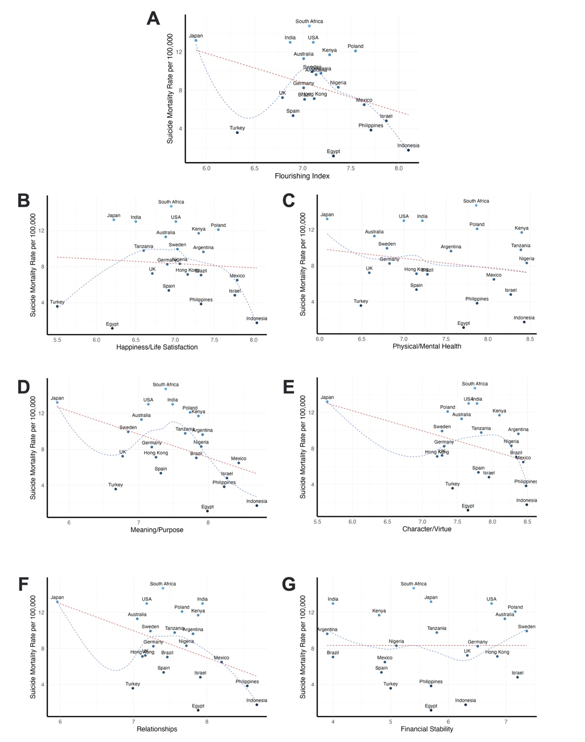

Supplementary Figure 1: Suicide mortality rate per 100,000 (y-axis) and flourishing index (x-axis) (1A) and the 6 flourishing subdomains (B – G) including the outlier Turkey. The blue line indicates the locally weighted polynomial that estimates the shape of the relationship. The red line indicates the predicted linear relationship between flourishing and suicide.

Supplementary Figure 2: Suicide mortality rate and flourishing index by subgroup including the outlier Turkey

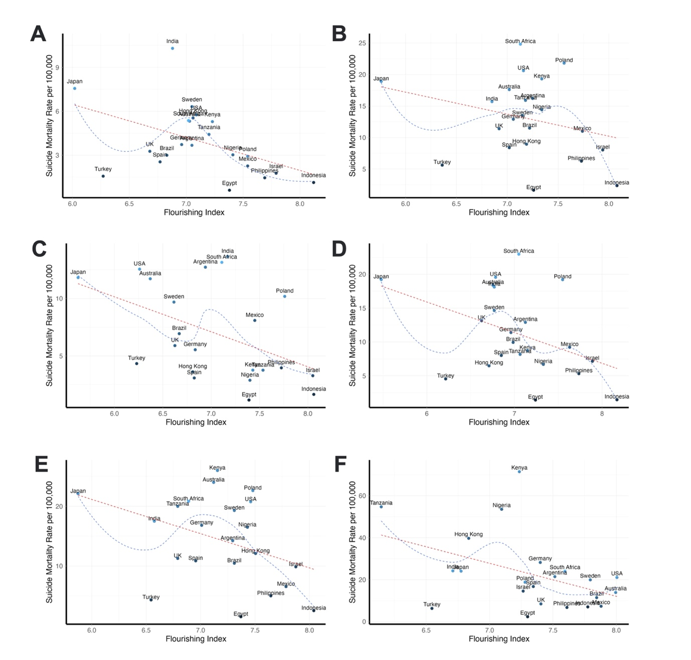

Supplementary Figure 2: Suicide mortality rate per 100,000 (y-axis) and flourishing index (x-axis) by subgroup including the outlier Turkey. A – Female; B – Male; C – 18-29; D - 30 – 49; E - 50 – 69; F - 70+. The blue line indicates the locally weighted polynomial that estimates the shape of the relationship. The red line indicates the predicted linear relationship between flourishing and suicide.

