Supplementary Information for:

The importance of dynamic cell-cell adhesions in the sorting of multicellular structures

Description of additional supplementary data
- Supplementary Figure 1-6
- Supplementary Code 1-2
Supplementary Information for:
Supplementary figure
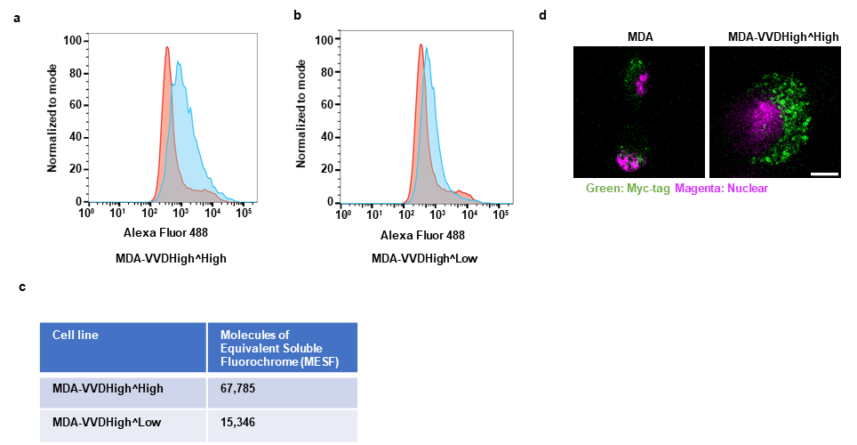
Supplementary Figure 1. Quantification of VVDHigh-PM expression on stable cell lines by using flow cytometry and immunostaining. Cells were stained with Mouse anti-Myc-tag monoclonal antibody (primary) and Goat Alexa Flour 488 anti-mouse antibody (secondary) to detect the Myc-tag fused to the VVDHigh-PM construct. The expression levels were analyzed by flow cytometry. (a) MDA-VVDHigh^High cells (blue curve) and (b) MDA-VVDHigh^Low cells (blue curve), compared to MDA cells (red curve). (c) The number of VVDHigh receptors was quantified using Quantum Alexa Fluor 488 MESF Standard Kit (Bang Laboratories) and converted into molecules of equivalent soluble fluorochrome (MESF). (d) Confocal fluorescence microscopy images of MDA and MDA-VVHigh^High cells, stained with anti-Myc-tag antibody (green) without permeabilization, and nuclear stain (SYTO™ Deep Red Nucleic Acid Stain, magenta). Confocal z-stack images were rendered using maximum intensity projection. Scale bar is 10 µm.
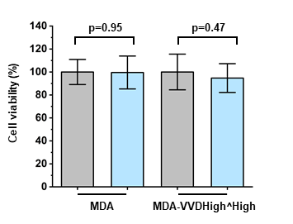
Supplementary Figure 2. Influence of blue light illumination on cell viability. Cell viability of MDA and MDA-VVDHigh^High cells after 16 h in the dark (grey) or under continuous blue-light illumination (blue) was assessed using the CellTiter-Glo 3D cell viability assay. A source data file is provided with raw data points and statistics.
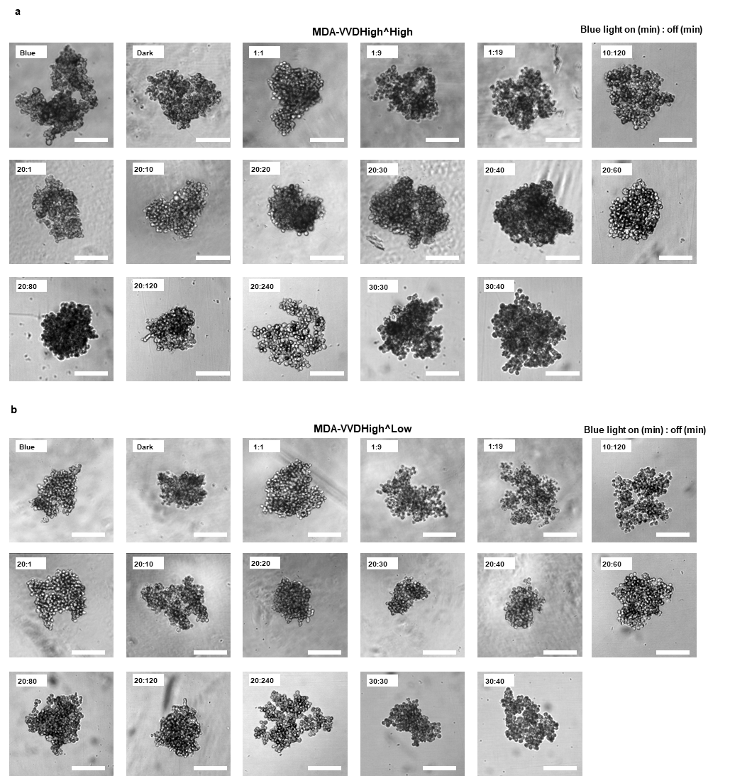
Supplementary Figure 3. Optimization of spheroid compaction under different pulsed light conditions. Bright field images of spheroid of (a) MDA-VVDHigh^High and (b) MDA-VVDHigh^Low under different blue light illumination condition. Pulsed condition indicated as x:y, where x is the on-time (in minutes) and y is the off-time (in minutes). Scale bars (a,b) are 200 µm.

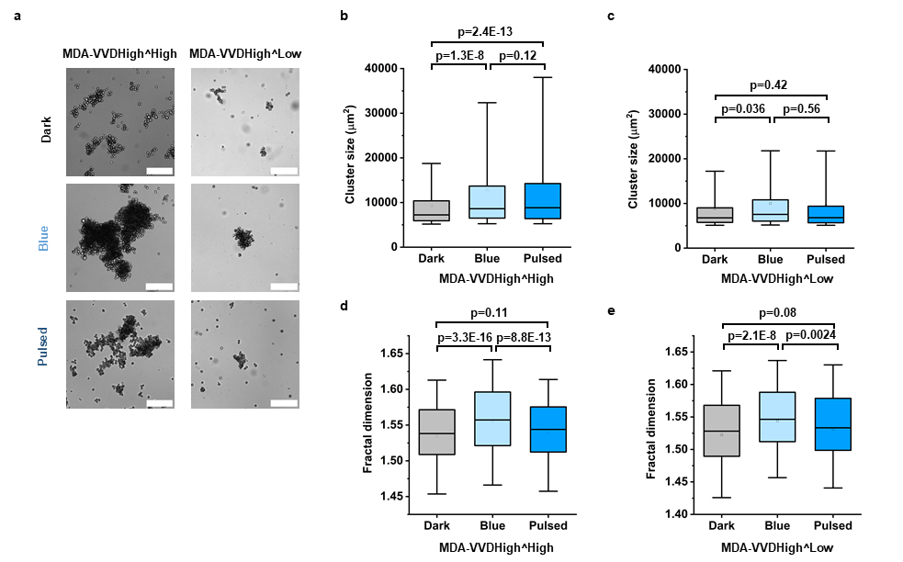
Supplementary Figure 4. Cell aggregation assay under pulsed light. (a) Bright-field images of cell aggregates formed by MDA-VVDHigh^High and MDA-VVDHigh^Low cells under dark, blue, and pulsed blue in suspension culture. Scare bar is 200 µm. (b, c) The average cluster size of (b) MDA-VVDHigh^High cells in the dark (n=868), under blue light (n=1281) and pulsed blue light (n=1107); and (c) MDA-VVDHigh^Low cells in the dark (n=653), under blue light (n=864) and pulsed blue light (n=563); (data from 3 biological replicates, one-way ANOVA with Tukey’s multiple comparisons test). (d, e) The fractal dimension of cell clusters formed by (d) MDA-VVDHigh^High cells (n=868, n=1281, and n=1107 for dark, blue and pulsed blue light) and (e) MDA-VVDHigh^Low cells (n=653, n=864, and n=563 for dark, blue and pulsed blue light; data from 3 biological replicates). Box plots show median and 25th/75th percentiles, whiskers denote 5th/95th percentiles. A source data file is provided with raw data points and statistics.

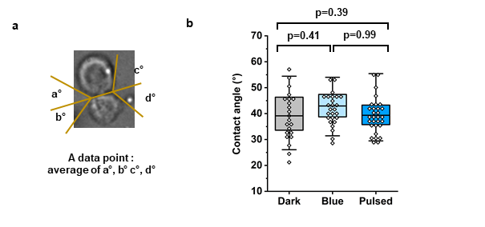
Supplementary Figure 5. Measurement of cell-cell contact angles. (a) Exemplary bright-field image showing the measurement of cell-cell contact angles. The average of the four measured angels per cell-cell interface was used to generate a single data point. (b) Cell-cell contact angle of MDA cells in the dark (n=22), under blue light (n=26), and pulsed blue light (n=30). Data from 2 biological replicates. A source data file is provided with raw data points and statistics.
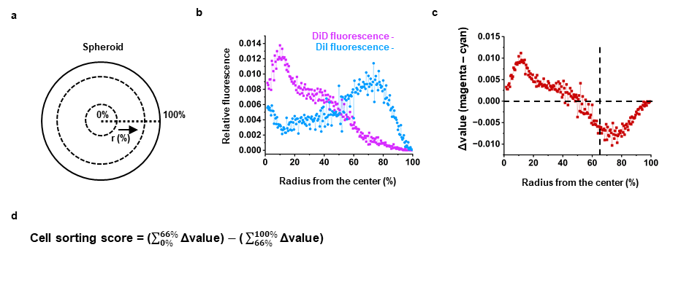
Supplementary Figure 6. Quantification of cell sorting using fluorescence penetration. (a) Schematic of the radial segmentation used for analysis, in which each spheroid was divided into concentric rings from the center (0%) to the periphery (100%). The region of interest (ROI) in spheroids were generated by using bright field images with “Find edge” and “Threshold” plugin in ImageJ. (b) Example profiles showing normalized magenta (DiD) and cyan (DiI) fluorescence across the radial axis. (c) Difference between normalized magenta and cyan fluorescence (Δ value = magenta curve – cyan curve) at each radial position. The dashed line marks the 66% radius threshold used to separate the inner and outer regions. (d) Cell sorting score calculation. The integral of Δ value from 0–66% (inner region) minus the integral from 66–100% (outer region) yields the final cell sorting score.

Supplementary Code 1. Spheroid penetration

function spheroids_penetration_profile () {
//getting the position of drawn ellipse
roiManager("Add");
//calculating of the ellipse center

//resolution of profile (the number of nested circles)
n=201;
//initialization of arrays, set-up suitable value
a=newArray(n);
s=newArray(n);
s1=newArray(n);
a1=newArray(n);
ss=newArray(n);
//calculation of increments
si=1/n;
//calculation of total fluorescence signal and pixels area from each nested circle
for (i=n; i>=1; i-=1){
scalefactor = si*(i-1);
scaletext="x="+d2s(scalefactor, 3)+" y="+d2s(scalefactor, 3)+" centered";
run("Scale... ", scaletext);
getStatistics(area, mean);
roiManager("Select", 0);
s[i-1]=mean*area;
a[i-1]=area;
}
//calculation of total intensity and area of the rims (between circles)
for (i=n-1; i>=1; i-=1){
s1[i]=s[i]-s[i-1];
a1[i]=a[i]-a[i-1];
}
//calculation of mean fluorescence intensity of the rims
s1[0]=s[0];
a1[0]=a[0];
for (i=n-1; i>=0; i-=1){
ss[i]=s1[i]/a1[i];
}
//plotting of the result profile
Plot.create("","r","Int",ss);
//roiManager("Delete");
};
run("8-bit"); //set 8-bit
spheroids_penetration_profile (); //perform spheroid penetration function

Supplementary Code 2. Spheroid vector plot for matlab
function rho = ColoredVectorsHighRes(u, v)
clc
[L, W] = size(u);
[~, rho] = cart2pol(u, v);

% Remove small vectors
mask = rho >= 3e-9;
u(~mask) = 0;
v(~mask) = 0;
rho(~mask) = 0;

% Normalize
Rmax = max(rho(:));
norm_rho = rho / Rmax;

% Create grid
[X, Y] = meshgrid(1:W, 1:L);

% Create figure with high-quality settings
f = figure('Color', 'k', 'InvertHardcopy', 'off');
set(f, 'Position', [100 100 1000 1000]);

hold on

% Color mapping similar to original style
for i = 1:L
for j = 1:W
if rho(i,j) >= 3e-9
c = norm_rho(i,j);
R = (abs(1 - 2*(1 - c)) + (1 - 2*(1 - c))) / 2;
G = -abs(2 * c - 1) + 1;
B = (abs(1 - 2 * c) + (1 - 2 * c)) / 2;
color = [R, G, B];
q = quiver(j, i, u(i,j), v(i,j), 0, ...
'Color', color, 'LineWidth', 4, 'MaxHeadSize', 7);
end
end
end
axis equal off
hold off
end

