Supplementary Information

Title: Near-atomic size highly positive silver nanoparticles are bactericidal targeting cell wall and adherent fimbriae expression

Lok R. Pokhrel^{1,2,*}, Zachary L. Jacobs³, Dmitriy Dikin⁴, Shaw M. Akula⁵
¹Department of Public Health, The Brody School of Medicine, East Carolina University, Greenville, NC, USA.
²Department of Health Education and Promotion, College of Health and Human Performance, East Carolina University, Greenville, NC, USA.
³School of Law, University of California, Berkeley, Berkeley, CA, USA.
⁴Department of Mechanical Engineering, College of Engineering, Temple University, Philadelphia, PA, USA.
⁵Department of Microbiology and Immunology, The Brody School of Medicine, East Carolina University, Greenville, NC, USA.

*Correspondence: LR Pokhrel, Phone: 252-737-5587; Email: pokhrell18@ecu.edu.

Table S1. Representative protocol for the purification of AgNPs using the Tangential Flow Filtration (TFF) system.

Purification of unclean AgNPs | Electrical Conductivity (µS/cm)
Started Volume = 500 ml | 1095
Ended Volume = 70 ml | 1162
Volume increased to 500 ml adding Milli-Q water | 185
Ended Volume = 100 ml | 283
Volume increased to 500 ml adding Milli-Q water | 36
Ended Volume = 75 ml | 68
Volume increased to 500 ml adding Milli-Q water | 11
Ended Volume = 150 ml | 20
Volume increased to 500 ml adding Milli-Q water | 10*

* obtained as purified AgNPs suspension with electrical conductivity of 10 µS/cm.

Table S2. Impact of incubation time (72 h) and temperature (35 °C) on the stability of nanoparticles in the carrier medium, i.e., moderately hard water (MHW), evaluated by measuring average hydrodynamic diameter (HDD) and zeta potential.
Parameters | Citrate-AgNPs |  | NH₂-AgNPs
Parameters | Pre-incubation | Post-incubation | Pre-incubation | Post-incubation
HDD ± SD (nm)* | 11.0 ± 0.7 | 11.2 ± 1.3 | 4.3 ± 0.8 | 5.1 ± 0.3
Zeta potential (mV) | -23.47 | -18.41 | +41.6 | +39.2
* Volume weighted hydrodynamic diameter (HDD) measured using DLS, and all size measurements were 100% by volume.

Table S3 General linear model showing significant association between E. coli cell length and diameter (top table), followed by model parameters (bottom table).
Dependent Variable: Cell Length
Source | Type III Sum of Squares |  | df |  | Mean Square |  |  | F | Sig.
Model | 2006.904ª |  | 1 |  | 2006.904 |  |  | 1386.473 | .000
Diameter | 2006.904 |  | 1 |  | 2006.904 |  |  | 1386.473 | .000
Error | 396.612 |  | 274 |  | 1.447
Total | 2403.516 |  | 275
a. R Squared = .835 (Adjusted R Squared = .834)
b. Computed using alpha = .05
Parameter | B | Std. Error |  | t |  | Sig. | 95% Confidence Interval
 |  |  |  |  |  |  | Lower Bound |  |  | Upper Bound
Diameter | 2.924 | .079 |  | 37.235 |  | .000 | 2.769 |  |  | 3.079
a. Computed using alpha = .05

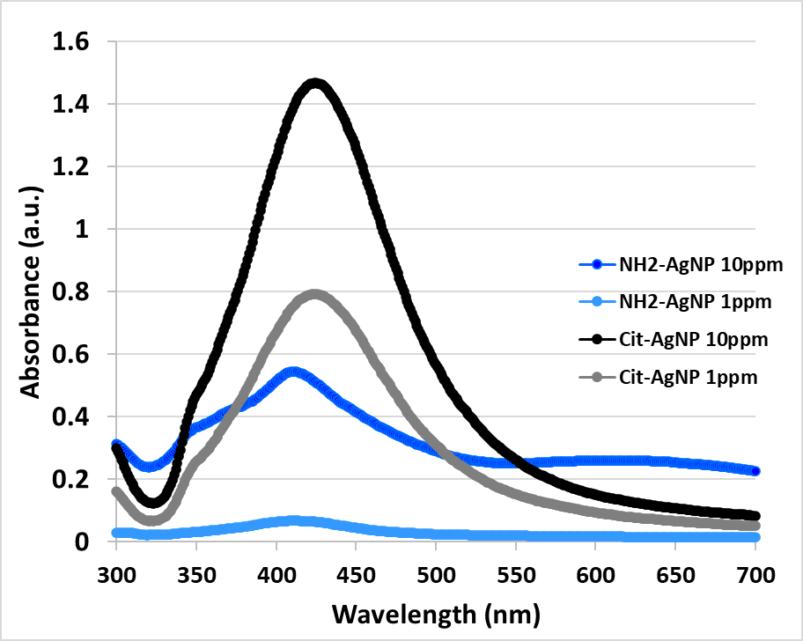
Fig. S1. UV-Visible spectra of purified NH₂-AgNPs (1 µg/mL and 10 µg/mL) and Citrate-AgNPs (1 µg/mL and 10 µg/mL) used in this study showing no change in localized surface plasmon resonance (λ_{max}) of both the AgNPs with dilution in Milli-Q water.

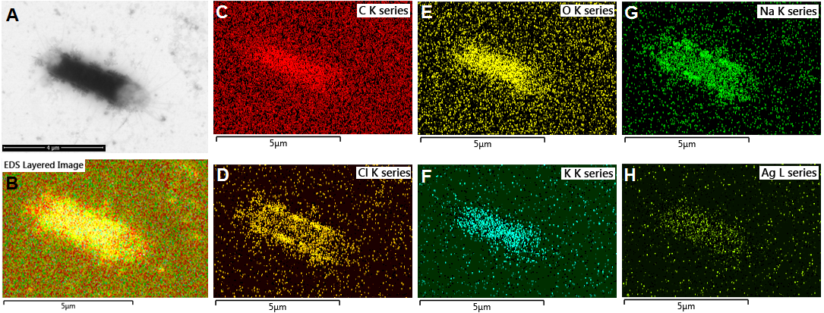
Fig. S2. Energy dispersive spectroscopy (EDS) elemental mapping of silver and other background elements (C, O, Na, Cl, and K) on the E. coli surfaces upon exposure to 10 µg/mL Citrate-AgNPs for 72 h. Scale bar denotes 5 µm for all images, except for A (scale bar = 4 µm).

