Title: Evaluating the role of burrowing sea urchins as agents of coral reef bioerosion
Journal Name: Coral Reefs (Journal of the International Coral Reef Society)
Author names - Siddhi Jaishankar^{1,3}, Radhika Nair^{1,3}, Mayukh Dey³, Wenzel Pinto³, Teresa Alcoverro^{2,3} , Rohan Arthur^{3,2}
Affiliations:
¹ National Centre for Biological Sciences, Tata Institute of Fundamental Research, Bellary Road, Bangalore 560065, Karnataka, India
² Centre d’Estudis Avançats de Blanes (CSIC), c/Acc Cala St. Francesc 14, 17300 Blanes, Spain
³ Nature Conservation Foundation, 1311 Amritha, 12th Cross, Vijayanagar 1st Stage, Mysore 570017, Karnataka, India
Corresponding author- Siddhi Jaishankar
Corresponding author mail- siddhi.jaishankar@gmail.com
ORCID ID: 0009-0005-3042-2786

Table S1: Indicators of anthropogenic nutrient input at studied islands.
Island name | Human population | No. of Septic Tanks | Percentage turf algae | Ranking (in terms of anthropogenic nutrient input)
Kavaratti | 11,221 | 2,414 | 11.70 | High
Agatti | 7,566 | 1,279 | 10.63 | Medium
Kadmat | 5,404 | 899 | 1.38 | Low
Bangaram | 0 | 0 | 0.26 | Very low

Data: Human population (Census of India 2011); No. of Septic Tanks (Department of Environment, Forests and Climate Change, Lakshadweep); macroalgal cover: see methods section in main article)

Table S2: List of fish species observed approaching or attacking sea urchins during assays

S. No | Common name | Scientific name | Family | Predation observed
1. | Orange-striped triggerfish | Balistapus undulatus | Balistidae | Yes
2. | Jansen’s wrasse | Thalassoma jansenii | Labridae | Yes
3. | Checkerboard wrasse | Halichoeres hortulanus | Labridae | Yes
4. | Crescent/Moon wrasse | Thalassoma lunare | Labridae | No
5. | Indian triggerfish | Melichthys indicus | Balistidae | No

Table S3: Multicollinearity check (VIF) and performance

Term | VIF | VIF_CI_low | VIF_CI_high | SE_factor | Tolerance | Tolerance_CI_low | Tolerance_CI_high
Predator biomass | 1.051767 | 1.005013 | 1.534540 | 1.025557 | 0.9507810 | 0.6516612 | 0.9950117
Aspect | 1.042411 | 1.002576 | 1.698379 | 1.020985 | 0.9593143 | 0.5887969 | 0.9974311
Island | 1.388976 | 1.235786 | 1.641695 | 1.178548 | 0.7199547 | 0.6091265 | 0.8092018
Rugosity | 1.126428 | 1.042708 | 1.374266 | 1.061333 | 0.8877622 | 0.7276613 | 0.9590417
Available Substrate | 1.297992 | 1.165754 | 1.535729 | 1.139295 | 0.7704207 | 0.6511567 | 0.8578138
Depth | 1.147043 | 1.056085 | 1.385512 | 1.071001 | 0.8718070 | 0.7217550 | 0.9468931

All VIF values are close to 1, hence the model appears to be healthy in terms of multicollinearity. Additionally, the standard errors (SE_factor column) are only slightly inflated, indicating that our confidence intervals and p-values remain reliable.

Table S4: Generalised linear model output for urchin bioerosion potential
 | Estimate | Standard Error | z value | Pr(>|z|)
Intercept: Agatti | 6.608 | 0.370 | 17.852 | < 2e⁻¹⁶ | ***
Predator biomass | 0.032 | 0.059 | 0.543 | 0.5874
Aspect: West | -0.677 | 0.117 | -5.779 | 7.51e⁻⁹ | ***
Bangaram | 0.465 | 0.181 | 2.572 | 0.0101 | *
Kadmat | -0.053 | 0.176 | -0.303 | 0.7615
Kavaratti | 1.923 | 0.185 | 10.388 | < 2e⁻¹⁶ | ***
Structural Complexity | -1.563 | 0.250 | -6.250 | 4.1e⁻¹⁰ | ***
Available Substrate | 0.215 | 0.065 | 3.303 | 0.0010 | ***
Depth | -0.013 | 0.061 | -0.220 | 0.8259
Signif. codes: 0 <= '***' < 0.001 < '**' < 0.01 < '*' < 0.05
(Dispersion parameter for Negative Binomial (1.0536) family taken to be 1)
Null deviance: 633.6 on 293 degrees of freedom
Residual deviance: 336.6 on 285 degrees of freedom

Fig. S3 Ivlev’s electivity index (Mean SE) per substrate for E. molaris

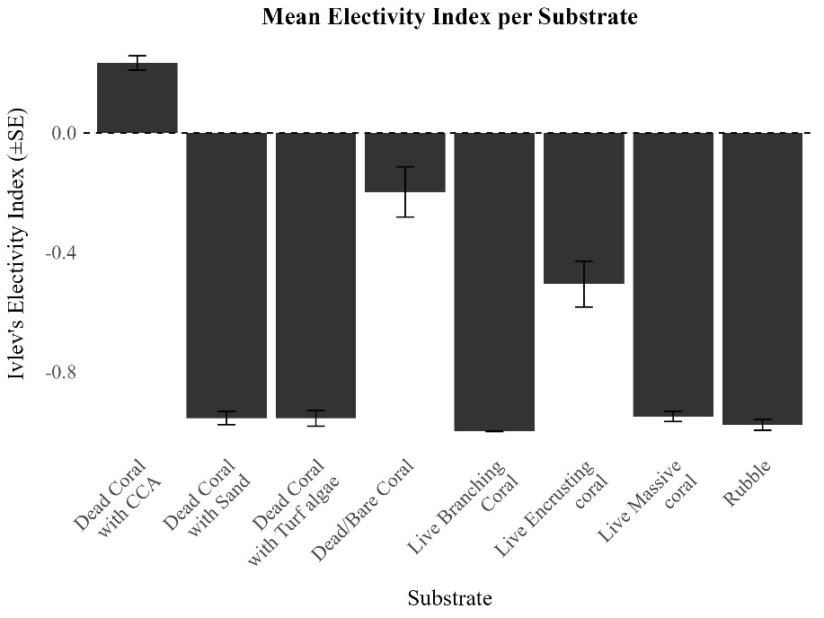

There was a clear preference for Dead Coral with CCA [E = 0.23 0.02 (SE)]. All other substrate types showed negative electivity values, indicating avoidance. The strongest avoidance was observed for Branching Coral [E = -0.99 0.001 (SE)], Rubble [E = -0.98 0.02 (SE)], Dead coral with Turf Algae [E = -0.96 0.02 (SE)], and Dead Coral with Sand [E = -0.95 0.02 (SE)]. Moderate avoidance was seen for Live Massive Coral [E = -0.95 0.02 (SE)], Live Encrusting Coral [E = -0.51 0.08 (SE)], and Dead/Bare Coral [E = -0.19 0.08 (SE)].

Fig S4. Urchin Test Diameter and Burrow Diameter
