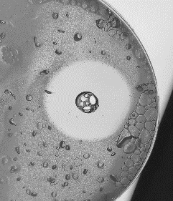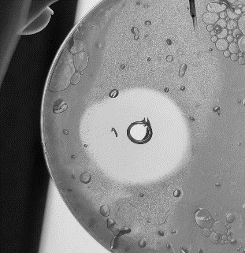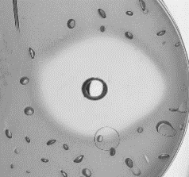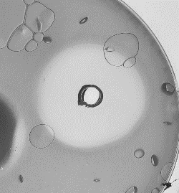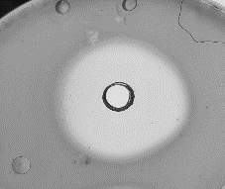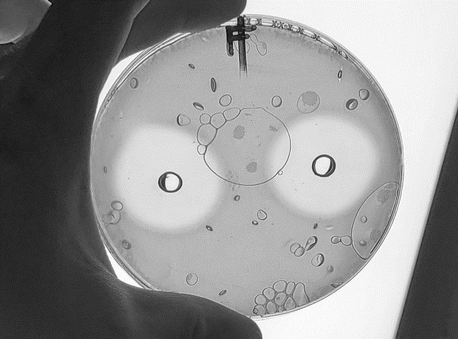
A
B
C
D
E
F
Supplementary Fig. 1. Growth inhibition of representative C. perfringens and C. difficile strains by B. subtilis BSC35 CFS in well diffusion assay. CFS was prepared from cultures grown in TSB (A–C) or optimized F4 medium (D–F). Indicators: C. perfringens 17-069 (A, D), C. difficile UK001 (B, E), and C. difficile R017/ATCC 43598 (C, F). Clear inhibition zones indicate antibacterial activity of BLIS BSC35.

