SUPPLEMENTARY MATERIALS
1. Materials and Methods
2. Figures S1 to S10
3. Tables S1 to S11
4. References (1-18)
1. MATERIALS AND METHODS
Patient cohorts. Investigations were approved by the local Research Ethics Committees. All patients gave informed written consent. A total of 136 patients were included in the study; all patients underwent cardiac surgery (coronary artery bypass or valve repair/replacement) in the John Radcliffe hospital at Oxford; ethical approval by the South Central-Berkshire B Research Ethics Committee (REF #18/SC/0404). Detailed patient characteristics are shown in (table S2). Right and left atrial biopsies were collected during cardiac surgery, mostly before or shortly after (for LAA samples) cardiopulmonary bypass and immediately processed for cell isolation (described below) or snap-frozen until use in other experiments (e.g., mRNA expression and immunoblotting), as previously described (1).
Animals. Animal breeding, handling and experimental work were carried out in two centres, BCM (USA) and the University of Oxford according to the local home office standards. All animal work was performed in accordance with the UK Home Office Animals (Scientific Procedures) Act 1986 incorporating Directive 2010/63/EU of the European Parliament, and in accordance with NIH guidelines. Animals were kept in pathogen-free cages with controlled temperature and humidity. The total number of mice used in all animal studies was 175 consisting of 66 of Lkb1-aKD and 109 of miR-31/Cre mice. Animals of both sexes were used in the experiments.
Generation of Lkb1-aKD mice. The Lkb1-aKD mice were generated as previously described (1, 2). Briefly, AAV9-ANF-Cre was injected into 2-5 days old Lkb1^{FL/FL} pups (5x10¹¹ GC, s.c. injections) generating atrial specific knockdown of Lkb1 (Lkb1-aKD). Based on our previous studies (1, 2), these mice develop ectopic activities from week 5-6 that can be detected by surface ECGs. The 15-minute surface ECGs were performed to confirm ectopic activity and/or the onset of AF (from week 8 onwards). These mice were then treated with NC- or miR-31/CT-TSB either at 8 weeks or 20 weeks (for the MRI cohort).
Generation of miR31/Cre mice. The miR31/Cre mice were generated using a PhiC31 integrase mediated cassette exchange system (fig. S2). Pre-miR31-Inv transgenic mice were generated using PhiC31 integrase that catalyses unidirectional recombination between specific sequences and is used for insertion of transgenic constructs into defined genomic locations (3). Consequently, pre-miR31-Inv heterozygous mice carry a single copy of the pre-miR31-Inv transgene at the Gt(ROSA26)Sor locus, which has benefits including that miR-31 dosage is more predictable and closer to endogenous levels, and that dosage can be doubled in homozygous animals if needed. In addition, this approach avoids the random insertion of transgenes that can otherwise disrupt endogenous gene expression by causing unintended mutations.

A 550 bp region of the mouse genome encoding the miR-31 sequence was amplified from mouse ES cell DNA and cloned upstream of an eGFP expression cassette and together this was cloned into an integrase mediated cassette exchange vector. The vector was transfected into RS-PhiC31 ES cells, which contain a modified Gt(ROSA26)Sor locus expressing PhiC31 integrase. The PhiC31 integrase system then catalyses the unidirectional insertion of inverted miR31/eGFP transgenic constructs between specific attB and attP sequences at the modified Gt(ROSA26)Sor locus (3). Recombinant clones were obtained which harbour an inverted transgene and injected into blastocysts. Chimeras were then generated which were crossed with C57BL/6J mice to obtain F1 heterozygotes. Once heterozygotes caring the inverted miR31/eGFP transgene were generated, these mice were then crossed with the tamoxifen inducible fibroblast specific Col1a2-Cre-ER(T) mouse strain (4). Mice carrying both transgenes were treated (intraperitoneally) with 2 mg tamoxifen/ 30 g mouse (tamoxifen was dissolved in corn oil) for seven consecutive days and compared to wild-type vehicle controls. Induced Cre activity results in inversion of the miR31/GFP transgene linking it to the CAG promoter leading to over expression of miR-31. The Col1a2-Cre-ER(T) transgenic mouse strain was generated by pro-nuclear injection, which results in random integration of the transgenic allele by homologous recombination at varying copy number (5). Therefore, Col1a2-Cre-ER(T) mouse colonies were maintained by crossing hemizygous with wild type mouse strains to control for Cre gene inheritance and expression level.

For the animal studies, we used twelve- and twenty-four-week (for the MRI-TSB study) old mice. Mice were age and sex matched in each experiment. Mice were compared to the respective control littermates; females and males were analysed separately for some experiments (depicted in the figures and figure legends). All animal work was performed in accordance with the local (Baylor College of Medicine and Oxford University) Animal Care and Ethics Committee guidance and in accordance with NIH guidelines.

Transgenic approaches for analysing miRNA function involve driving either short hairpin RNAs (shRNA) or endogenous primary transcripts (pri-miRNA) from ubiquitous, tissue-specific or inducible promoters (6). Such approaches, however, rely upon random insertion of the expression construct into the genome, and at variable copy number, necessitating careful analysis of multiple, and individual founder lines. Problems associated with random integration can be avoided by relying on targeted transgenic approaches where transgenic constructs are integrated into safe-harbour loci, for example Gt(ROSA)26Sor locus, known to be permissive for transgenic expression and where integration of a transgene is not associated with any detrimental phenotype. To provide further flexibility, targeted transgenic shRNA systems have been engineered with Cre recombinase switches, which allow tissue specific control of expression through the introduction of a tissue-specific Cre recombinase transgene.
With respect to transgenic expression of endogenous miRNAs, a Cre recombinase dependent inversion strategy has been reported which allows tissue-specific expression of pri-miRNA (7). Initially the miRNA is incorrectly oriented relative to its promoter, but through the use of heterotypic lox sites, the act of Cre recombinase inverts the pri-mRNA, allowing its correct expression. Here we combine this Cre-inversion strategy with a PhiC31 integrase (fig. S7) mediated cassette exchange at the Gt(ROSA)26Sor locus (3) to allow reliable conditional expression of an endogenous miRNA.
A synthetic linker containing the attB sites, necessary for PhiC31 integrase mediated targeted integration, flanking an inverted array of loxP and lox2272 sites, necessary for the Cre-recombinase dependent inversion, together with a polylinker of restriction enzyme sites to facilitate the downstream cloning, was generated and cloned into a standard plasmid vector. Into this vector, an open reading frame for the neomycin phosphotransferase gene, with a polyadenylation signal was cloned immediately downstream of the 5’ loxP and lox2272 sites. A ~450 bp region of genomic sequence encompassing the human miR31 gene was amplified from human genomic DNA using the primers (5’- TCTAGAGGCTGTATTCATCGTTGTCAG-3’ and 5’- GGATCCCAGCCAAGAACATCCCCAAAAGG-3) and cloned downstream of this neomycin selection cassette via XbaI and BamHI restriction sites which were incorporated into the 5’ ends of the PCR primers. Lastly, an eGFP open reading frame with a rabbit beta-globin polyadenylation signal, derived from a standard eGFP expression vector (pCX-eGFP) was cloned downstream of the miR31 fragment via unique BamHI and HindIII sites.
Five µg of the completed vector was electroporated into 1 × 10⁶ RS-PhiC embryonic stem cells, a C57BL/6N JM8F6 derived line (3), using the Neon transfection system (#NEON18SK, Life Technologies, Carlsbad, CA, USA) (3 × 1400 V, 10 ms), and selected in 210 µg/ml G418 for 7 days. Resistant colonies were isolated, expanded and screened for correct cassette exchange at the Gt(ROSA)26Sor locus using primers CAG-F (5′-CAGCCATTGCCTTTTATGGT-3) and ExNeo2 (5′-GTTGTGCCCAGTCATAGCCGAATAG-3′) to verify the 5’ integration event and GFP-NR3 (5′- GCACTAGTTCTAGAGCGATCCCC-3’) and 3HR-R1 (5′-CGGGAGAAATGGATATGAAGTACTGGGC-3′) to verify the 3’ integration event. Recombinant ES cells were injected into albino C57BL/6J blastocysts, and the resulting chimeras were bred with albino C57BL/6J mice to confirm germline transmission.
Isolation and culture of primary human atrial cardiofibroblasts (ACFs). Human ACFs were isolated and cultured from atrial biopsies obtained from patients who underwent cardiac surgery. Tissue biopsies were cut into small (2-3 mm³) pieces and repeatedly digested using 4 mg/ml collagenase II and trypsin (0.0625%), as previously described (1). Cells were washed twice with sterile phosphate-buffered saline (PBS) and plated onto 6-well plates in FBM-3 medium (#CC-3131, Lonza) containing 10% fetal bovine serum (FBS) and a supplement pack (#CC-4525, Lonza) and kept in a humidified atmosphere at 37 °C and 5% CO2. The medium was renewed every 2–3 days. At ~80–90% confluence, cells were passaged using a standard trypsinisation method. For the experiments with TGFβ1 stimulation, we used commercially available donors of human primary atrial fibroblasts (#CC-2903, Lonza), which were maintained and cultured in the same medium as outlined above. All experiments were carried out at cell passage (P3-P4), to minimise effects of culture-induced dedifferentiation, and cells were cultured in serum-free media for 16 hours before intervention and treatment, unless specified otherwise.
Isolation and culture of mouse atrial and ventricular cardiomyocytes and fibroblasts. Ventricular and atrial cardiomyocytes and fibroblasts were isolated from miR31/Cre and Cre/WT mice using previously described protocol (1, 7, 8) using enzymatic digestion and mechanical dissociation of the cardiac tissue. Ventricular and atrial samples were gently cut into small (~1mm) pieces and washed twice in LCS (NaCl 120 mM, KCl 1.2 mM, KH₂PO₄ 10 mM, MgCl₂ 1.2 mM, Glucose 10 mM, HEPES 10 mM, Taurine 20 mM) for 10 minutes in a shaking water-bath at 37°C. After each wash the mixture was passed through a sterile gauze filter and the supernatant was discarded. Samples were then incubated twice with LCS containing collagenase (type II, 305 IU/ml, Worthington) and protease (Type XIV, ≥3.5 units/mg, Sigma) gassed with 100% O₂, for 12 minutes as above and the mixture was passed through a sterile gauze filter; the supernatant was discarded. Thereafter, samples were incubated as above with LCS containing collagenase only, gassed with 100% O_{2,} for 15 minutes and the mixture (containing isolated cell) was then passed through a sterile gauze filter and collected; this process was repeated 4-6 times, with the supernatant collected and pooled with that of prior steps. Cardiomyocytes were collected from the pooled supernatant after a 5-minute centrifugation period at 700 rpm (rotor – Eppendorf, 07/23, 5702/R, A-4-38, max 4400 rpm). Fibroblasts were collected by the supernatants centrifugation at 1,300 rpm for 3 minutes and cultured in FBM (Lonza) containing 20% FBS (Lonza).
Sources of other human cells. In addition to the human primary cells, we also used HEK293 cells (#CRL-1573, ATCC) cultured and maintained according to the manufacturer’s instruction.
Transfection of primary human atrial cardiofibroblasts (ACFs). Human ACFs were transfected with miR-31-5p mimic, miR-31-5p inhibitor, or respective negative controls (NC-mimic, NC-inhibitor), or with miR-31/CTR-TSB and NC-TSB as previously described (7). Specifically, blockade of miR-31-5p/CTR interaction was achieved with 25 or 50 nM of antisense miRCURY LNA™ (locked nucleic acid) miRNA Power Target Site Blocker (TSB; #339199, Qiagen) G*G*G*C*A*A*G*A*G*G*T*A*A*T*C*T, or miRCURY antisense LNA™ Power Target Site Blocker negative control A (NC-TSB, #339199, Qiagen) A*C*G*T*C*T*A*T*A*C*G*C*C*C*A; LNA is not shown, as this information is proprietary. Cells were transfected using Lipofectamine RNAiMAX transfection reagent (#13778030, Invitrogen) in antibiotic-deprived FBM-3 medium containing 2 % FBS (Lonza).
Inhibition or overexpression of miR-31-5p was achieved by miRIDIAN miR-31-5p inhibitor (or NC-inhibitor) or mimic (or NC-mimic), respectively (all from Dharmacon: #IH-300507-06, IN-001005-01, C-300507-05 and CN-001000-01), using lipofectamine RNAiMAX transfection reagent (#13778030, Invitrogen) diluted in Opti-MEM medium (#31985062, Gibco), as described (7). Efficient knockdown and overexpression was confirmed by real-time qPCR and visually by using the miRIDIAN Dy547-labeled transfection control (for experiments with miR-31-5p mimic or inhibitor).
Western blots. Immunoblotting in human and murine atrial homogenates and in human ACFs was performed as described previously (1). Briefly, tissue or cell samples were lysed in RIPA buffer or CelLytic M cell lysis reagent, electrophoresis was performed using pre-cast 4-12% NuPAGE gels (#NP0335BOX, Invitrogen) and MOPS SDS running buffer (#NP0001, Invitrogen) at 150V. Proteins were transferred onto 0.2 µm nitrocellulose membrane (#1620112, Bio-Rad) using transfer buffer (#NP0006, Invitrogen). Immunodetection of the primary antibodies was performed using anti-IgG HRP-conjugated secondary antibodies (table S7). Membranes were developed using a ChemiDoc System (BioRad, UK) and analysed with ImageJ software (v.1.52a) or Image Lab 6.1 (Bio-Rad). For stripping, nitrocellulose membranes were submerged in Restore PLUS Striping buffer (#46430, Thermo Scientific). The target protein and a loading control were always run on the same membrane.
Colorimetric assays. Quantification of total secreted collagen in the cell culture supernatant was performed using a Sirius Red collagen detection kit (#9049, Chondrex) as previously described (1). The amount of total collagen in murine atrial lysates was quantified by colorimetric detection of hydroxyproline using a Quickzyme total collagen assay kit (#QZBTOTCOL1, lot 0795, QuickZyme Biosciences).
Scratch wound migration assay. Human ACFs migration was determined using in vitro scratch wound assays as previously described (1). Scratch wound assay was performed on confluent monolayers of cells (following 24-hour transfection with miR-31-5p mimic, miR-31-5p inhibitor, or respective negative controls) using chambers with 2 well silicone insert with a defined cell-free gap (#80206, Ibidi). Briefly, 5 x10³ cells were seeded into each chamber in 70 µl of complete medium (with 10% FBS, as described above). When cells attached and reached ~95% confluency, they were synchronised in serum-free medium for 16 hours, which was followed by the chamber insert removal; cells were monitored at different time points as depicted in corresponding figures. Changes in the wound area were imaged at the defined time points and quantified using ImageJ software.
Scar-in-a-jar assay. Collagen 1 accumulation by fibroblasts was assessed using a scar-in-a-jar assay as in our previous work (1). Briefly, transfected with miR-31-5p mimic, miR-31-5p inhibitor, or respective controls) cells were plated at 7000 cells/well overnight in FBM-3 medium containing 10% FBS and supplement pack. The next morning, cells were starved in serum-free medium for ~1 hour and cultured for the next 72 hours in 0.5% FBS, 100 µM ascorbic acid (#A8960, Sigma-Aldrich), 37.5 mg/ml FICOLL 400 (#F4375, Sigma-Aldrich) containing medium. After 72 hours cells were fixed with ice-cold 100% MeOH for 10 minutes, washed 3 times with PBS and blocked with 3% bovine serum albumin (BSA) at room temperature for 1 hour. Following an overnight incubation at 4ºC with primary (anti-Collagen 1 (#C4526) and anti-fibronectin (#F3648), Sigma-Aldrich) antibodies and multiple washing steps, the secondary (#A-11001 and #A-21245, Life Technologies) antibodies and a fluorescent Hoechst solution (nuclear stain) were added for 1.5 hours. After washing steps (with PBS), imaging of cells using 10x objective and 9 field per well was performed using Operetta software.
Assessment of cell proliferation. Cell proliferation at a single time point was assessed by ELISA using BrDU (5-Bromo-2´-Deoxyuridine) DNA-binding probe (#QIA58, Sigma-Aldrich) according to the manufacturer’s instructions and previously described (1). Briefly, human ACFs were plated in a sterile 96-well plate in a medium (FBM-3) containing 10% FBS and supplement pack. Cells were incubated overnight with BrdU (kit component No. JA1595) and fixed the next morning with the Fixative/Denaturing Solution (kit component No. JA1598). Anti-BrdU antibody (kit component No. JA1599) diluted 1:100 in antibody diluent (kit component No. JA1604) was added in each well and incubated for 1 hour at room temperature, followed by 3x washes with a wash buffer (kit Component No. JA1617) before 30 minutes incubation of cells with peroxidase goat anti-mouse IgG (kit component No. JA1618) reconstituted with conjugate diluent (kit component No. JA1615) followed by three more washes with wash buffer and ionised water. Cells were then incubated for 15 minutes in the dark at room temperature with the substrate solution and then with the stop solution. Spectrophotometric detection was performed at a wavelength of 450 nm.
Assessment of gene expression with Real-Time Quantitative Polymerase Chain Reaction (qPCR). As previously described (1, 7), atrial tissue samples were homogenised using an electric homogeniser Polytron with an appropriate lysis buffer. Total RNA was extracted with Nucleospin RNA II kit (#740955.250, Macherey-Nagel) following manufacturer’s instruction. Complementary DNA (cDNA) was synthesised from 250 ng of RNA with high-capacity cDNA reverse transcription kit (#4368814, Thermofisher Scientific) according to the manufacturer’s protocol. Total RNA from human ACFs was extracted with mirVana miRNA isolation kit (#AM1561, Invitrogen). cDNA was synthesised from 100 ng RNA using QuantiTect Rev. Transcription Kit (#205313, Qiagen). For miR-31-5p/3p reverse transcription (RT), the TaqMan MicroRNA Reverse Transcription Kit (#4366596, Applied Biosystems) and TaqMan MicroRNA assay RT primers were used.
Real-time qPCR was performed with TaqMan fast advanced master mix (#4444557, Thermofisher Scientific) or Power SYBR Green PCR master mix (#4367659, Thermofisher Scientific) accordingly. The gene and miR-31 expression in human samples was assessed using TaqMan gene expression assays or TaqMan MicroRNA assay (table S8, S9). To assess gene and miR-31 expression in murine samples, the TaqMan probes or TaqMan MicroRNA assay and primers (table S8, S10, S11) were used.
Each reaction was performed in duplicate (in human samples) or single repeats (in murine samples) using QuantStudio 7 Flex Real-Time PCR System and ABI 7900HT Detection System (Applied Biosystems), or QuantStudio 5 (Applied Biosystems). Relative quantification was obtained by using the comparative threshold cycle method (2^{-ΔCt}) and expression of the target gene was normalised to GAPDH, RS18 or RLPR7 (for gene targets), or to U6 snRNA (for miR-31 expression) as indicated in each figure; some data were expressed as a fold change (fc) of the respective control group (depicted in the figures).
RNA-binding protein immunoprecipitation (RIP) with Ago2 in human ACFs. Human ACFs from patients with persAF were transfected with miR-31/CTR-TSB or NC-TSB (25 nM) for 24 hours. The RIP assay was performed using the Magna RIP kit (#17-700, Sigma-Aldrich) as previously described (7). In brief, cells were washed in ice-cold PBS (two times) and lysed in 100 µl complete RIP lysis buffer. Magnetic beads were conjugated with 5 µg of anti-Ago2 antibody (#ab32381, Abcam) and subsequently incubated with the RIP lysates overnight at 4°C with rotation. Immunoprecipitates were purified and kept overnight at -80°C to precipitate the RNA and resuspended in RNase-free water. RNAs were subjected to RT-qPCR to measure the CALCR mRNA and miR-31 levels. CALCR gene expression was normalised to miR-31 and quantified using the comparative threshold cycle method (2^{-ΔCt}).
Transcription inhibition with actinomycin D. Human ACFs from patients in sinus rhythm were transfected with 25 nM of miRIDIAN miR-31-5p mimic or NC-mimic (table S8) for 24 hours and then treated with 5 μg/ml actinomycin D (#A9415, Sigma-Aldrich) for ~8.5 hours. Levels of CALCR (qPCR) are shown as percentage of the respective mRNA (2^{-ΔCt}) at 0 hour, normalising to GAPDH as the housekeeping gene.
Dual-Glo firefly luciferase reporter assay in HEK293 cells. The reporter construct was generated using the pmirGLO Dual-Luciferase miRNA Target Expression Vector (#E1330, Promega, Madison, WI, USA). The whole length (1869 bp) of CALCR 3′UTR containing predicted binding sites for all miRs under investigation were cloned into pmirGLO Dual-luciferase vector (fig. S8) using T4DNA ligase cloning with NheI and Xho1 restriction sites, plasmid DNA was transformed into DH10β Ca²⁺ competent E. coli and maxi-prepped using a Qiagen kit manufacturer’s protocol.
HEK293T cells were co-transfected with a reporter construct (250 ng) and a respective miRIDIAN miR-31, -34c, -30d, and -24a mimic (a double-stranded sequence of RNA oligonucleotides), and respective inhibitors, or mimic /inhibitor negative controls (negative control #1, 10 nM, Dharmacon, Lafayette, CO, USA) using a polyethylenimine transfection reagent (Invitrogen) in antibiotic-free Dulbecco’s modified Eagle’s medium containing 2% FBS. The firefly/renilla signal was assessed using Dual-Glo® Luciferase Assay System (# E2920, Promega, Madison, WI, USA) as per manufacturer’s instruction. The data were expressed as a ratio firefly/renilla.
Histological assessment of cardiac fibrosis with Masson’s trichrome staining in mice. Staining for collagen was performed using Masson’s trichrome staining as described before (1). Briefly, freshly excised hearts were arrested in diastole with 1M/L KCl, fixed in 10% buffered formalin, embedded in paraffin and cut into 6 µM sections for Masson’s trichrome staining in miR-31/Cre and control mice. Sections were imaged at 20x, 10x and 4x magnification using Image-Pro 7.0 and ZEISS Axio Observer; analysis of the myocardial collagen content was carried out using ImageJ software. All experiments and analysis were performed blinded.
In vivo miR-31/CTR-TSB administration in mice. Blockade of the miR-31/CTR interaction was achieved with antisense miRCURY LNA miRNA Power TSB (#339202, Qiagen) G*G*G*C*A*A*G*A*G*G*T*A*A*T*C*T, or NC-TSB (#339202, Qiagen); LNA is not shown, as this information is proprietary. Lkb1-aKD mice were treated with negative- or miR-31/CTR-TSB at either 8-weeks (young cohort) or 20-weeks (older, MRI cohort) of age at doses of 20 mg/kg TSB was injected per mouse intraperitoneally, 2 (younger mice) or 3 (older mice) injections/week for 3 weeks. A 5 µg/µl solution was prepared in sterile saline and following formula was used to calculate volume to be injected: volume to be injected (µl) = 20 x mouse weight (g) / 5.
Sandwich hybridization assay for LNA-TSB. A sandwich hybridization assay was performed using a biotinylated LNA-capture probe complementary to half of the LNA-miR-31/CTR-TSB to capture the LNA-TSB on streptavidin-coated magnetic beads as described before (15). Briefly, total RNA was extracted from homogenized tissues using phenol:chloroform:isoamyl alcohol extraction method. A 2 pM of biotinylated probe (CALCRMIRPROBE1, Qiagen, Hilden, Germany) was added to the plate. After 30 min incubation at room temperature, the plate was washed and 100 ul of diluted extract was added to the plate, followed by a 30-minute incubation at room temperature and washes. Next, 2 pM of DIG-coupled complementary probe (CALCRMIRPROBE2, Qiagen, Hilden, Germany) was added to the plate, followed by a 30-minute incubation at room temperature and washes. The captured LNA-TSBs were detected using the HRP-conjugated anti-DIG antibody (#11633716001, Roche, Basel, Switzerland) and detected at 450 nm using a standard plate reader.
MRI in mice. Mice underwent MRI imaging at two time points, before miR31/CTR-TSB or NC-TSB treatment and 3.5 weeks later. All MRI imaging data were acquired using a Bruker (city, state, country) Biospec 9.4 T, 20 cm bore, AV NEO/Paravision 360 at the Small Animal Imaging Facility at Texas Children Hospital. Mice were induced with 5% isoflurane mixed with oxygen and then maintained on 0.5% - 2% isoflurane during imaging. Mice were kept warm utilizing an MRI compatible heating system by SA Instruments and respiration rate and temperature were continuously monitored during image acquisition MRI compatible INC system (SA Instruments, Stony Brook, NY, USA). To assess fibrosis, mice were imaged twice during each imaging session: before and after injection with a T₁ collagen binding MRI contrast agent at 4 ml/kg that detects fibrosis, developed by Peter Caravan’s group (9-13) (#EP3533, Collagen Medical LLC, Belmont, MA). After 2 scout scans to obtain coronal axis 4-chamber and 2-chamber view images, high resolution axial retrospectively gated cine images were obtained using a Cine Brightblood Intragate Fast low angle shot (FLASH) sequence and imaging parameters: TR/TE=5.0/1.6 msec; flip angle=15° matrix size=30 × 30 mm²; field of view (FOV)=256×256 mm²; 5 slices with a slice thickness of 1.0 mm; number of averages - 2. Next, retrospectively gated Cine black-blood Intragate FLASH sequence with the following scanning parameters were acquired: TR/TE=5.0/1.9 msec; flip angle=20°; matrix size=30 × 30 mm2; FOV=128 × 128 mm²; 5 slices with a slice thickness of 1.0 mm; number of averages - 4; tagging resolution of 0.3 mm with 0.6 mm separation; and tag time - 16.24 msec. Black blood images were analysed using the OsiriX software (Pixmeo SARL, Bernes, Switzerland); atria were segmented and signal intensities measured before and after the injection of the contrast agent. The % change in signal was recorded and compared between the groups at the different time points. On the images, the orange lines span the area where 5 slices (each 1 mm thick) total were acquired to make ensure coverage of the atria. The three green lines position is as indicated: the outer two green lines correspond to the edges of the 1 mm slice taken through the coronal view, the middle green line is the center of the 1 mm slice, the middle green line goes through the center of slice 1 corresponding to the orange line at the bottom. Orange line (top part of the image) corresponds to the center of slice 5. The other slices do not have orange lines but since they are 1 mm thick, the green lines show which area of the coronal view they span. The correlation of atrial fibrosis measured by MRI and histological assessment with Masson’s trichrome staining is shown in (fig. S9).
Transthoracic echocardiography. Echo in Lkb1-aKD mice (Houston site). Mice were anesthetized with isoflurane (1.5%-2% in 100% oxygen). Following hair removal from the chest area using Nair cream, the animals were placed on a heated platform to maintain the body temperature within a range of 36.5-37.5°C, monitored using a rectal probe. Ultrasound echocardiography was then performed using the Visual Sonics Vevo F2 system with a 57 MHz probe (FujiFilm VisualSonics, Toronto, ON, Canada). ECG readings were continuously observed throughout the procedure. Cardiac short-axis B-mode and M-mode images were obtained to assess ventricular dimensions and systolic function. The short-axis images were analysed using Vevo LAB software to evaluate systolic function parameters. Additionally, cardiac long-axis B-mode images were captured to visualize the left atrium, and these images were subsequently analysed to measure the left atrial area. Mice were monitored until they regained consciousness before being returned to their original cages.
Echo in miR31/Cre mice (Oxford site). Echocardiographic images were acquired with the VisualSonics Vevo 2100 system fitted with an ultra-high frequency MS-550D MicroScan transducer (22-55 MHz) for miR31/Cre mice. Parasternal short and long axis images were obtained at mid-papillary level, mice were then recovered from anaesthesia in a heated incubator. Image analysis was blinded between control and treatment groups and performed on Vevo Lab, Edition 1.7.1, Imaging System (VisualSonics, Toronto, ON, Canada). Short axis B-mode images from 3-5 cardiac cycles were averaged and used to estimate left ventricular epicardial end diastolic area (LV-Epi-EDA) and endocardial end diastolic (LV-Endo-EDA) and end systolic area (LV-Endo-ESA). LV Endo EDA measurements are used as a surrogate for left ventricular end-diastolic volume (LVEDV) and hence dilation. Further, myocardial cross-sectional area (myoCSA) was calculated as a measure of hypertrophy (as it is a surrogate for LV mass), as well as fractional area change (FAC %), as a measure of ejection fraction:
$$MyoCsa \left({mm}^{2}\right)= LVEpiEDA- LVEndoEDA$$

$$FAC \%= \frac{LVEndoEDA - LVEndoESA }{LVEndoEDA} ×100$$
Echo measurements were comparable between two experimenters who independently carried out echocardiography in the same mice (fig. S10).
In vivo transesophageal burst pacing in miR31/Cre and WT/Cre mice. AF inducibility in miR31/Cre and WT/Cre mice was assessed with transesophageal burst pacing as described previously (7, 14). Briefly, mice were anaesthetised with isoflurane (2%) and an octapolar catheter (CIB'er MOUSE EP CATHETER, World precision instruments, city, state, USA) was advanced into the oesophagus to capture the atria and deliver electrical stimulation. Intradermal electrodes were implanted to monitor ECG signals throughout. All electrical signals were pre amplified and recorded using Spike2 software (version 7.09). Each burst was composed of 40 external stimulations at 1.5 times the threshold for atrial capture, starting from a cycle length of 60ms and decreasing at each successive burst by 2 ms, to a cycle length of 10 ms. Each series of 25 burst was repeated in triplicate per mouse. An AF episode was defined as a period of rapid irregular rhythm lasting at least 2 seconds. If one or more bursts in the series of burst evoked an arrhythmia/AF episode, AF was considered to be inducible. AF duration was defined as the mean duration of all induced AF episodes. The experimenters were blinded to the genotype throughout the protocol and analysis.
Telemetry studies. Telemetry studies were performed as described previously (14). Briefly, telemeters (Indus Instruments Inc., Webster, TX, USA) were implanted subcutaneously in Lkb1-aKD mice at 4 weeks of age and mice were allowed to recover for 2 weeks. Mice were anaesthetised with isoflurane (2-3%) during telemeters implantation. For analgesia we used a combination of 1 mg/kg SR Buprenorphine and 4 mg/kg SR Meloxicam for up to 5 days post-surgery. Twenty four-hour ECGs were recorded once a week beginning at week 6. AF was defined as a lack of P-waves and irregularly irregular R-R intervals for >10 seconds. AF burden was calculated as time spent in AF vs total time analysed.
RNA sequencing: sample processing and analysis. Total RNA was extracted from human ACF (hACF) cultures using mirVana miRNA Isolation Kit (#AM1560, Thermo, Invitrogen, Waltham, MA, USA), as above. For SR-ACF miR-31 mimic dataset, RNA samples were treated with RNase-Free DNase Set (79254. Qiagen, Hilden, Germany) whereby 5 µL of Buffer RDD was added to each sample followed by 1.25 µL of DNase I stock solution (2.7 Kunitz units / μL). RNA clean-up was then performed by precipitating RNA with 1.25 volumes 100% ethanol which was then applied to fresh mirVana miRNA Isolation Kit columns (AM1560, Thermo, Invitrogen, Waltham, MA, USA) that were then washed as above before eluting clean RNA. Sample replicates with 260/230 and 260/280 NanoDrop spectrophotometric absorbance ratios of ~2 were selected. 750 ng of RNA per sample was made up in 30 µL nuclease-free water which was then used for RNA-seq transcriptional profiling which was performed as a service at the genomic core facility of the Wellcome Centre for Human Genetics (Oxford). Total RNA quantity and integrity were assessed there using Quant-IT RiboGreen RNA Assay Kit (# R11490, ThermoFisher, Invitrogen, Waltham, MA, USA) and Tapestation system (Agilent, Santa Clara, CA, USA). Samples were then normalised to 100 ng. RNA was enriched for protein encoding mRNA transcripts by using polyadenosine oligonucleotides conjugated to magnetic beads with NEBNext Magnetic Isolation Module (#E7490, company, New England Biolabs, Ipswich, MA, USA). Generation of double stranded cDNA and library construction were performed with NEBNext Ultra II Directional RNA Library Prep Kit (# E7760L, Illumina, San Diego, CA, USA) with their own adapters and barcode tags (dual indexing, based on previous report (15). The concentrations used to generate the multiplex pool were determined by Picogreen. The final size distribution of the pool was determined using a Tapestation (Agilent, Santa Clara, CA, USA), and quantification was determined by Qubit (Thermo, Invitorgen, Waltham, MA, USA) before sequencing on an Illumina NovaSeq6000 as 150bp paired end.
For the persAF-ACF miR-31-5p inhibitor dataset, RNA samples were quantified using Qubit 4.0 Fluorometer (Life Technologies, Carlsbad, CA, USA) and RNA integrity was checked with RNA Kit on Agilent 5300 Fragment Analyzer (Agilent Technologies, Palo Alto, CA, USA).
RNA sequencing libraries were prepared using the NEBNext Ultra II RNA Library Prep Kit for Illumina following manufacturer’s instructions (NEB, Ipswich, MA, USA). Briefly, mRNAs were first enriched with Oligo(dT) beads. Enriched mRNAs were fragmented for 15 minutes at 94°C. First strand and second strand cDNA was subsequently synthesized. cDNA fragments were end repaired and adenylated at 3’ends, and universal adapters were ligated to cDNA fragments, followed by index addition and library enrichment by limited-cycle PCR. Sequencing libraries were validated using NGS Kit on the Agilent 5300 Fragment Analyzer (Agilent Technologies, Palo Alto, CA, USA), and quantified by using Qubit 4.0 Fluorometer (Invitrogen, Carlsbad, CA).
The sequencing libraries were multiplexed and loaded on the flowcell on the Illumina NovaSeq instrument according to manufacturer’s instructions. The samples were sequenced using a 2x150 Pair-End (PE) configuration v1.5. Image analysis and base calling were conducted by the NovaSeq Control Software v1.7 on the NovaSeq instrument. Raw sequence data (.bcl files) generated from Illumina NovaSeq was converted into fastq files and de-multiplexed using Illumina bcl2fastq program version 2.20. One mismatch was allowed for index sequence identification. Paired-end 150 bp reads were trimmed with Trim Galore! (v0.6.7) (https://www.bioinformatics.babraham.ac.uk/projects/trim_galore/) and checked for quality using FastQC (v0.12.1) (https://www.bioinformatics.babraham.ac.uk/projects/fastqc/). Reads were then aligned to the human genome (GRCh38.p14) using HISAT2 (16) (v2.2.1) with an average of 95% of reads aligned uniquely using default parameters. Gene counts were determined by the number of uniquely aligned, unambiguous reads using Subread: featureCounts (17) (v1.6.4) and annotated with GRCH38.111. Approximately 78% of reads in each sample were successfully assigned to genes. Raw counts were loaded into R (v4.4.0) and pre-filtering was performed to keep only genes with a count of at least 10 in a minimal number of samples. Differential expression (DE) analysis was performed using DESeq2. The resulting count values were used for library size normalization, log2 transformation and downstream analysis. Statistically significant DEGs were determined by a Benjamini-Hochberg adjusted p-value < 0.05 and Log2FoldChange >1 or <-1 (for SR mimic dataset) and Log2FoldChange >0.585 or <-0.585 (for AF inhibitor dataset) Functional enrichment analysis of significant DEGs were performed using clusterProfiler (v4.12.0) (18) in R. Additional plots were generated using in-house R scripts (available upon request). RNA sequencing data will be deposited in a data repository for RNAseq.
Statistical analysis. The data distribution was tested by Kolmogorov-Smirnov or Shapiro-Wilk tests (as indicated in figure legends). The unpaired or paired Student’s t test was used in two-group comparisons of the normally distributed data. Multiple groups of normally distributed data of similar variance were compared by one-way or two-way ordinary or repeated measures ANOVA with Holm-Sidak’s or Sidak’s correction. When the normality assumption was not met the data were analysed by Mann-Whitney or Wilcoxon test - for independent or paired comparisons between 2 groups, respectively – or Kruskal-Wallis with Dunn’s correction - for multiple group comparisons. Categorical variables were compared by Fisher’s exact test. All statistical analysis was performed using GraphPad Prism v7, v6.04, v9.0 and v10 software. A value of P < 0.05 was considered statistically significant. Pearson’s correlation test was used to test correlation between 2 normally distributed variables.

2. FIGURES (S1-S10)
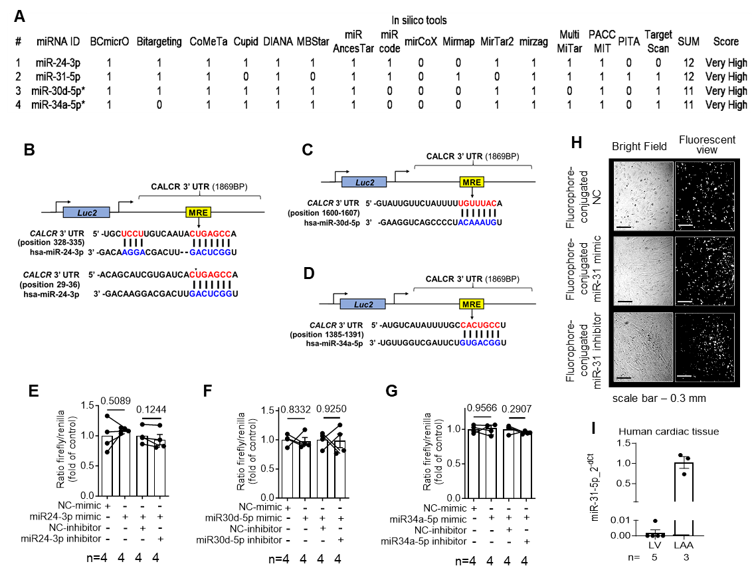

Fig. S1. MiR-31-5p regulates the function of human ACF. (A) List of the top miRs predicted (by mirDIP https://ophid.utoronto.ca/mirDIP/ tool) to bind human CTR mRNA (CACLR). (B-D) Schematic diagrams of the constructs used in the reporter assay for hsa-miR-24-3p, - 30d-5p, and -34a-5p; binding sites are shown in blue-red font; MRE, miRNA response element. (E-G) Reporter assay in HEK293 cells co-transfected (24 hours) with mimic for hsa-miR-24-3p, - 30d-5p, and -34a-5p and a construct contacting CTR-mRNA 3’UTR). (H) Representative bright field and fluorescence images of hACFs 24-hour post-transfection with fluorophore-conjugated oligonucleotides. (I) Expression levels (qPCR) of miR-31-5p in human ventricular and atrial myocardium. Data are expressed as mean ± SEM. P-values are calculated by paired t test; fc, fold change of control group; n, individual donors.
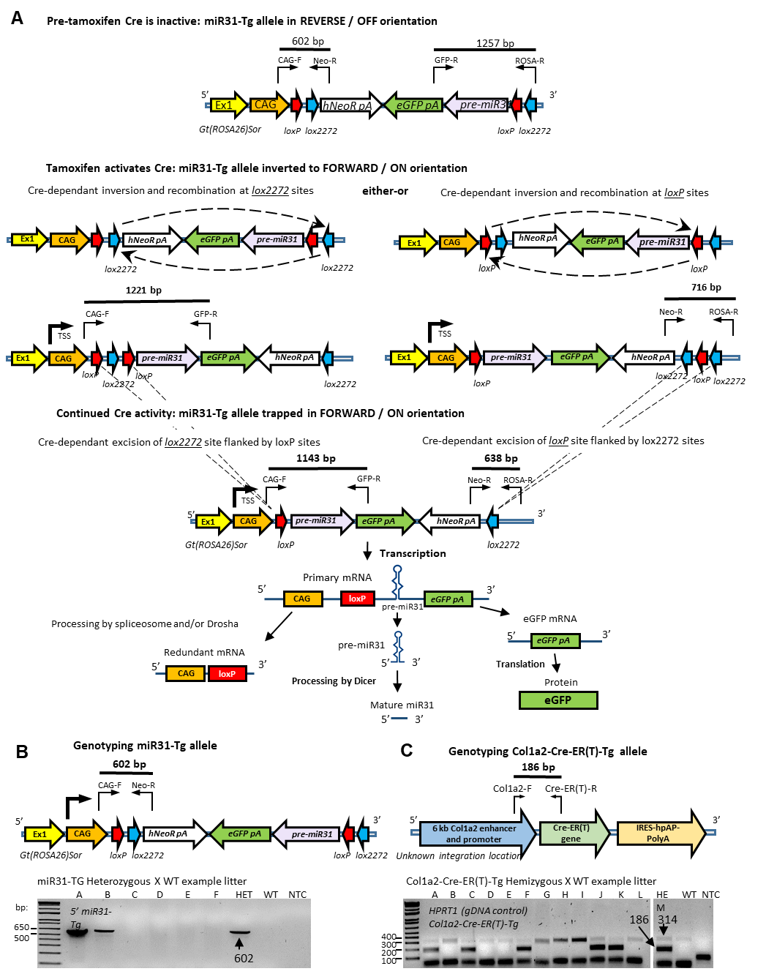

Fig. S2. Principle of Cre-recombinase dependent inversion switch at the targeted Gt(ROSA26)Sor locus and breading strategy to maintain separate miR31-Tg and Col1A2-Cre-ER(T)-Tg colonies. (A) In the nascent state, the transgenic construct containing the pre-miR-31 sequence sits inverted with respect to the CAG promoter and is flanked by two pairs of opposing loxP variants. Following tamoxifen treatment and Cre activation, recombination occurs between opposing pairs of variant loxP sites of the same type (loxP or lox2272) and causes the intervening sequence to be inverted and linked to the CAG promoter allowing transcription. Inversion occurs in either of two possible ways and following inversion, Cre excises the short sequence separating parallel loxP sites thereby trapping the entire construct in the forward orientation and inhibiting repeated flipping. The primary mRNA transcript contains CAG and loxP (now redundant), pre-miR-31 and eGFP sequences. Processing by the spliceosome and/or Drosha liberates eGFP mRNA and pre-miR31, processed by Dicer, to generate mature miR-31. Genotyping amplicon lengths are depicted and used to track the progress of the miR-31-Tg allele from its nascent to inverted and trapped states. (B) Schematic shows the miR-31-Tg allele, primer binding sites and genotyping amplicon length (602 bp). miR31-Tg colonies were maintained by crossing with WT mice, an example litter is shown with mouse pups labelled A-F. Heterozygous (HET), wild type (WT) and no-template (NTC) controls were used. (C) Col1A2-Cre-ER(T) colonies were maintained by breeding hemizygous (HEM) with WT mice and the schematic shows the randomly integrated Col1a2-Cre-ER(T) transgene with primer binding sites and amplicon length (186 bp). Genotyping PCR was performed on an example litter of pups A-L and done as a multiplex with additional primers recognising the WT Hprt1 gene (314 bp) to validate presence of genomic DNA.
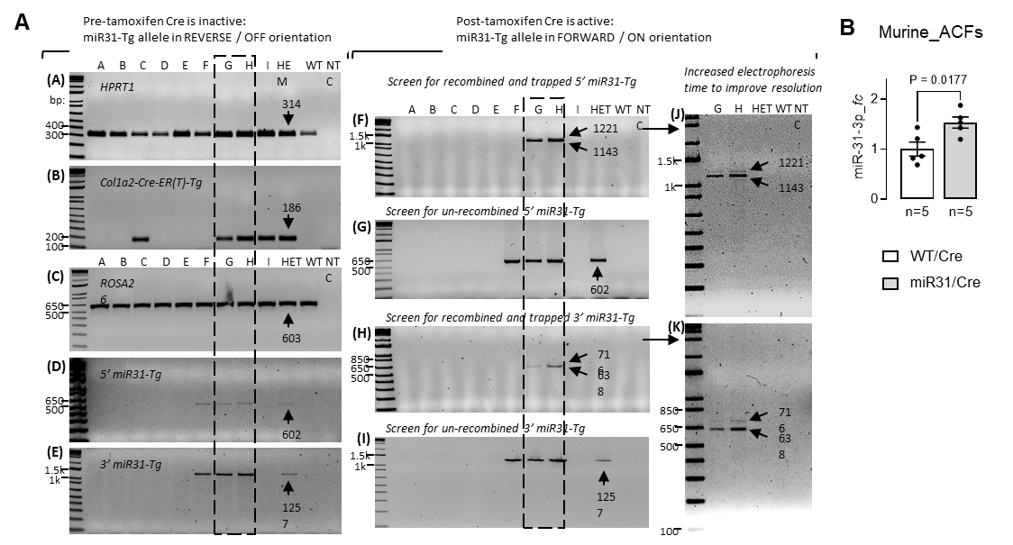
Fig. S3. PCR validation of miR31-Tg allele inversion and trapping following tamoxifen treatment. (A) Heterozygous miR31-Tg and hemizygous Col1A2-Cre-ER(T) mice were crossed and ear gDNA samples were assessed before (left gels) and after (middle-right gels) tamoxifen treatment for littermates (A–I). (A) validates presence of genomic DNA with endogenous HPRT1 gene amplicon (314 bp), (B) Col1A2-Cre-ER(T) gene amplicon (186 bp), (C) WT ROSA26 allele (603 bp), (D) 5’ end of the nascent miR31-Tg (602 bp), (E) 3’ end of miR31-Tg (1257 bp). Littermates G and H (left dotted box) showed presence of both transgenes. (F) Following tamoxifen treatment the 5’ end of the miR31-Tg allele was screened for inversion (1221 bp) and trapping (1143 bp). (G) Shows remaining un-recombined 5’ miR31-Tg (602 bp). (H and I) shows 3’ miR31-Tg recombination (716 bp), trapped (638 bp) and remaining un-recombined (1257 bp). Only littermates G and H carry both transgenes and demonstrate the tamoxifen-inducible inversion switch (right dotted box). (J and K) show samples littermates G and H re-run and electrophoresed for 30 minutes longer to better resolve and visualise band doublets at both the 5’ and 3’ ends of the miR31-Tg. Heterozygous (HET), hemizygous (HEM), wild type (WT) and no-template (NTC) controls were used. (B) miR-31-3p expression in atrial fibroblasts (ACFs) in miR31/Cre and WT/Cre control mice. Data are expressed as mean ± SEM. P-value is calculated by unpaired t test; fc, fold change of control group; n, individual biological donors.

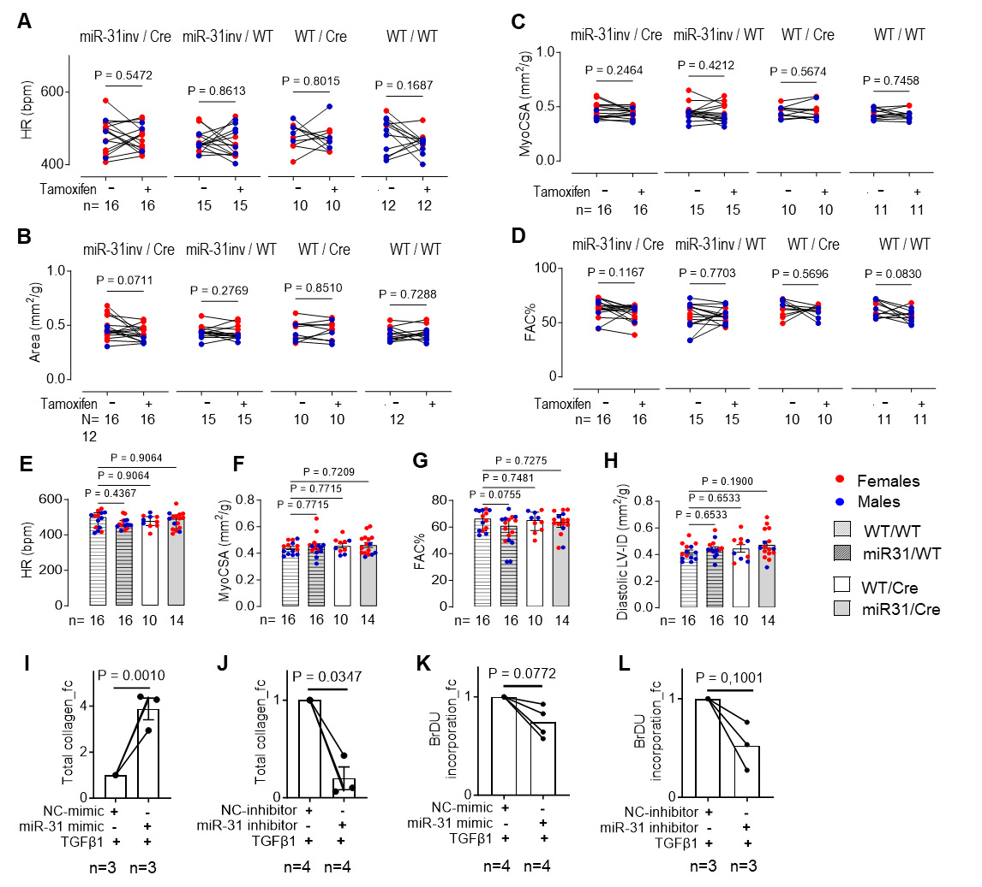
Fig. S4. Effect of tamoxifen administration on cardiac function and body weight in mice. (A) Heart rate (HR) is unchanged in mice of all four genotype variations following intraperitoneal tamoxifen administration. (B-D) Select echocardiographic parameters are not altered by tamoxifen administration regardless of genotype. (E-H) Select echocardiographic parameters are not altered by transgene (prior to induction by tamoxifen administration). (I-L) Effect of miR-31 mimic and miR-31 inhibitor or respective NC controls on 72-hour TGFβ1-stimulated total collagen production (I-J), and 24-hour cell proliferation (K-L) of hACFs. Data are expressed as mean ± SEM, except as median with IQR in (B - miR-31inv/Cre; C - for miR-31inv/WT; D – for miR-31inv/Cre and WT/WT; E). P-values calculated by paired t test (A; B, except ‘miR-31inv/Cre’; C, except ‘miR-31inv/WT’; D, except ‘miR-31inv/Cre’ and ‘WT/WT’; i-l), Wilcoxon test (B - miR-31inv/Cre; C - for miR-31inv/WT; D – for miR-31inv/Cre and WT/WT), Kruskal-Wallis (E), one-way ANOVA with Holm-Sidak’s test (F-H); fc, fold change of control group; n, individual biological donors. FAC: fractional area change; myocardial cross sectional area.
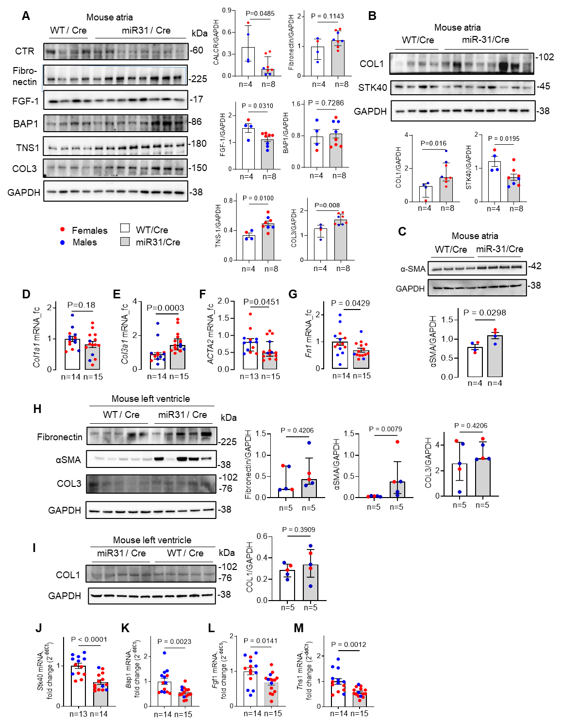
Fig. S5. Validation of miR-31-5p targets in miR31/Cre mice in the atrial and ventricular myocardium. (A-C) Effect of fibroblast-targeted miR-31 overexpression in female and male mice on protein content (Western blots) of CTR, fibronectin, FGF-1, BAP1, TNS1, collagen 3 (COL3), collagen 1(COL1), STK40 and αSMA in atrial tissue. (D-G) Effect of fibroblast-targeted miR-31 overexpression in female and male mice on mRNA levels of collagen 1, collagen 3, αSMA (encoded by ACTA2) and fibronectin.in atrial tissue. (J-M) Effect of fibroblast-targeted miR-31-5p overexpression in mice on gene expression of selected previously validated miR-31-5p targets, FGF-1, BAP1, STK40, and TNS-1 in atrial tissue. Data are expressed as mean ± SEM, except A (CALCR, COL3), B (COL1), F, C, H – expressed as median with IQR. P-values calculated by unpaired t test, except in A (CALCR, COL3), B (COL1), F, C, H –by Mann Whitney test; fc, fold change of control group; n, individual donors.

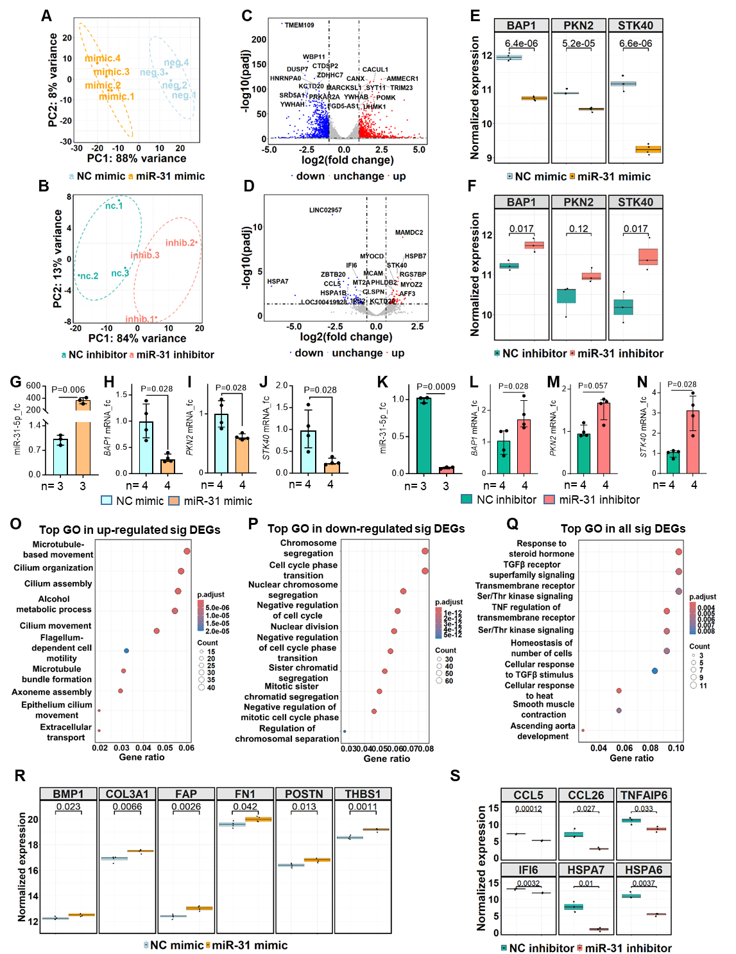

Fig. S6. MiR-31-5p alters transcriptional programme in human atrial cardiofibroblasts (hACFS). (A-F) Principal component analysis of the variances between hACFs from SR patients transfected with miR-31-5p mimic (A) vs non-targeting control (NC) mimic, and AF-hACFs transfected with miR-31-5p inhibitor (B) vs NC-inhibitor. (C-D) Volcano plots showing the distribution of gene expression changes in miR-31 mimic (c) and miR-31 inhibitor (d) groups vs respective negative controls. Red dots - significantly up-regulated differentially expressed genes (DEGs); adjusted p-value <0.05 and log2FoldChange (FC) >1 (mimic) or 0.585 (inhibitor), blue dots - significantly down-regulated DEGs; grey dots - non-significant DEGs. (E-F) Expression (RNAseq) of BAP1, PKN2, and STK40 in miR31-mimic (e) and –inhibitor (f) groups vs respective NC. (G-N) Effect of miR-31-5p mimic (G) and inhibitor (K) transfection on gene expression (qPCR) of previously validated miR-31-5p targets, BAP1, PKN2 and STK40 in human atrial cardiofibroblasts (hACFs) from control patients in SR (G-J) or persAF (K-N). (O-Q) Dot plot of the top 10 enriched Gene Ontology (GO) biological processes (BPs) in significantly up-regulated (O) and down-regulated (P) DEGs comparing miR-31-5p mimic to NC-mimic, as well as all significant DEGs (Q) comparing miR-31-5p inhibitor to NC-inhibitor. X-axis corresponds to gene ratio (that is, the number of genes in the input list annotated in the given GO term) and Y-axis corresponds to the name of enriched BP. Dot color indicates the adjusted p-value. (R-S) Normalized expression of profibrotic genes with significant difference between miR-31 mimic and NC mimic (R), or between miR-31 inhibitor vs NC-inhibitor (S). Ellipses in (A) indicates 95% confidence intervals based on multivariate T distribution; ellipses in (B) were estimated using the Khachiyan algorithm to demonstrate group clustering. Normalization (E, F, R, S) was performed with DESeq2 (v1.44.0) using size factors, followed by log2 transformation. Data in (C, D) and (O-Q) are adjusted for multiple testing using the Benjamini-Hochberg FDR method. GO analysis used clusterProfiler (v4.12.3) with the human genome background. P-values were calculated by unpaired t test (E, F, R, S), otherwise Mann-Whitney (G-N); fc, fold change of control group; n, individual donors.

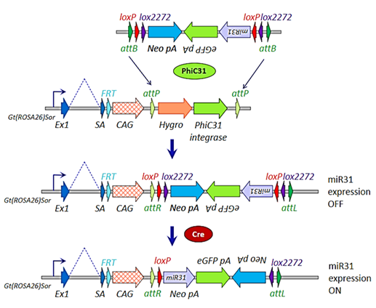
Fig. S7. Schematic representation of phi integrase system used in generation of miR31/Cre mice. Pre-miR31-Inv transgenic mice were generated using PhiC31 integrase that catalyses unidirectional recombination between specific sequences used for insertion of transgenic constructs into defined genomic locations.
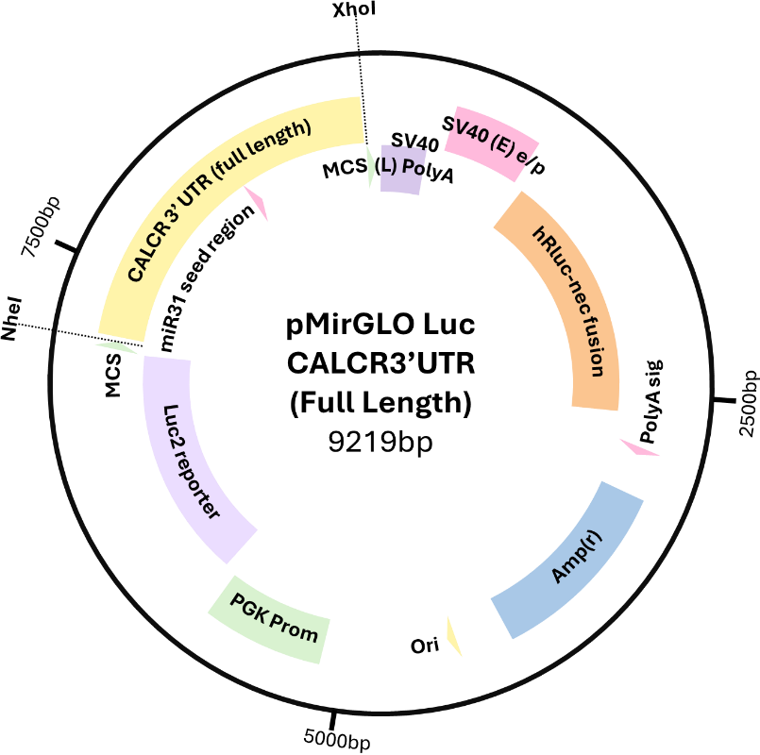
Fig. S8. Schematic map of the construct used in reporter assay depicting pmiRGLO vector with a full length CALCR-3’UTR insert.

Fig. S9. Pearson correlation between atrial fibrosis assessed by MRI and histology (with Masson’s trichrome staining). Data collected from atrial-Lkb1-KD mice and plotted using simple linear regression test.

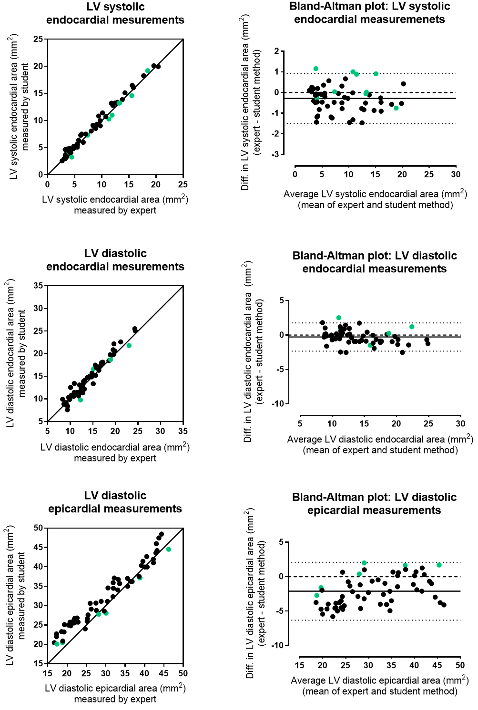
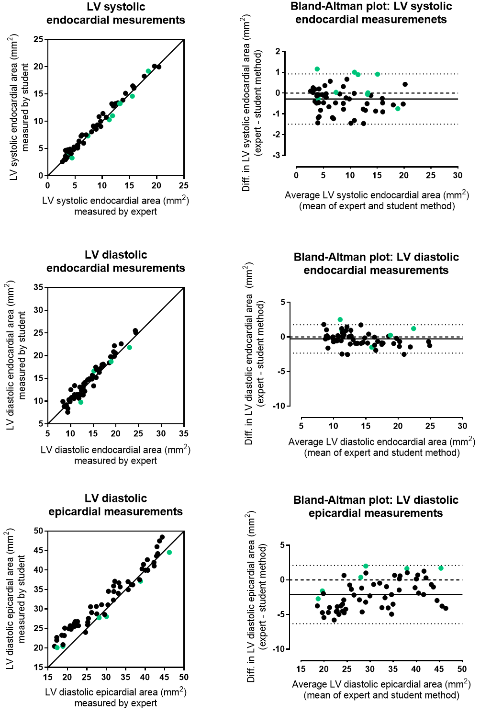
A

B

Fig. S10. Pearson’s correlation for inter-experimenter reproducibility of selected echo parametes. Data points obtained by two independent experimenters shown by black and green dots.

3. TABLES (S1-S11)
Table S1. A screen list of the PubMed published reports (doi) on the altered miRs in atrial fibrillation.
https://doi.org/10.1016/j.jjcc.2019.05.018
https://doi.org/10.1093/europace/euad047
https://doi.org/10.1093/europace/euad048
https://doi.org/10.1093/europace/euad048
https://doi.org/10.1016/j.jjcc.2019.05.018
https://doi.org/10.7717/peerj.16604
https://doi.org/10.1007/978-1-0716-3346-5_24
https://doi.org/10.1016/j.jjcc.2019.05.018
https://doi.org/10.7717/peerj.16604
https://doi.org/10.7717/peerj.16604
https://doi.org/10.1093/europace/euad047
https://doi.org/10.7717/peerj.16604
https://doi.org/10.1016/j.jjcc.2019.05.018
https://doi.org/10.1016/j.jjcc.2019.05.018
https://doi.org/10.1093/europace/euad047
https://doi.org/10.1016/j.jjcc.2019.05.018
https://doi.org/10.1093/europace/euad047
https://doi.org/10.7717/peerj.16604
https://doi.org/10.1093/europace/euad047
https://doi.org/10.7717/peerj.16604
https://doi.org/10.1093/europace/euad047
https://doi.org/10.7717/peerj.16604
https://doi.org/10.1093/europace/euad047
https://doi.org/10.1007/978-1-0716-3346-5_24
https://doi.org/10.1016/j.jjcc.2019.05.018
https://doi.org/10.7717/peerj.16604
https://doi.org/10.1093/europace/euad047
https://doi.org/10.7717/peerj.16604
https://doi.org/10.1016/j.jjcc.2019.05.018
https://doi.org/10.1016/j.jjcc.2019.05.018
https://doi.org/10.1016/j.jjcc.2019.05.018
https://doi.org/10.7717/peerj.16604
https://doi.org/10.1093/europace/euad047
https://doi.org/10.1007/978-1-0716-3346-5_24
https://doi.org/10.7717/peerj.16604
https://doi.org/10.1093/europace/euad047
https://doi.org/10.1016/j.jjcc.2019.05.018
https://doi.org/10.1093/europace/euad048
https://doi.org/10.7717/peerj.16604
https://doi.org/10.7717/peerj.16604
https://doi.org/10.1016/j.jjcc.2019.05.018
https://doi.org/10.3389/fcvm.2023.1128708
https://doi.org/10.1093/europace/euad048
https://doi.org/10.1093/europace/euad047
https://doi.org/10.1016/j.jjcc.2019.05.018
https://doi.org/10.7717/peerj.16604
https://doi.org/10.7717/peerj.16604
https://doi.org/10.3389/fcvm.2023.1128708
https://doi.org/10.3389/fcvm.2023.1128708
https://doi.org/10.1093/europace/euad047
https://doi.org/10.1093/europace/euad047
https://doi.org/10.1093/europace/euad047
https://doi.org/10.1093/europace/euad047
https://doi.org/10.7717/peerj.16604
https://doi.org/10.7717/peerj.16604
https://doi.org/10.1016/j.jjcc.2019.05.018
https://doi.org/10.7717/peerj.16604
https://doi.org/10.1007/978-1-0716-3346-5_24
https://doi.org/10.1007/978-1-0716-3346-5_24
https://doi.org/10.1093/europace/euad047
https://doi.org/10.7717/peerj.16604
https://doi.org/10.7717/peerj.16604
https://doi.org/10.1093/europace/euad047
https://doi.org/10.1016/j.jjcc.2019.05.018
https://doi.org/10.7717/peerj.16604
https://doi.org/10.1016/j.jjcc.2019.05.018
https://doi.org/10.1016/j.jjcc.2019.05.018
https://doi.org/10.1093/europace/euad047
https://doi.org/10.1093/europace/euad047
https://doi.org/10.7717/peerj.16604
https://doi.org/10.7717/peerj.16604
https://doi.org/10.7717/peerj.16604
https://doi.org/10.1016/j.jjcc.2019.05.018
https://doi.org/10.3389/fcvm.2023.1128708
https://doi.org/10.1093/europace/euad047
https://doi.org/10.7717/peerj.16604
https://doi.org/10.7717/peerj.16604
https://doi.org/10.1016/j.jjcc.2019.05.018
https://doi.org/10.1007/978-1-0716-3346-5_24
https://doi.org/10.1093/europace/euad047
https://doi.org/10.1016/j.jjcc.2019.05.018
https://doi.org/10.1093/europace/euad047
https://doi.org/10.1016/j.jjcc.2019.05.018
https://doi.org/10.1016/j.jjcc.2019.05.018
https://doi.org/10.7717/peerj.16604
https://doi.org/10.1007/978-1-0716-3346-5_24
https://doi.org/10.1007/978-1-0716-3346-5_24
https://doi.org/10.1093/europace/euad047
https://doi.org/10.1007/978-1-0716-3346-5_24
https://doi.org/10.1016/j.jjcc.2019.05.018
https://doi.org/10.1016/j.jjcc.2019.05.018
https://doi.org/10.3389/fcvm.2023.1128708
https://doi.org/10.1016/j.jjcc.2019.05.018
https://doi.org/10.7717/peerj.16604
https://doi.org/10.3389/fcvm.2023.1128708
https://doi.org/10.7717/peerj.16604
https://doi.org/10.1093/europace/euad047
https://doi.org/10.7717/peerj.16604
https://doi.org/10.3390/genes13010011
https://doi.org/10.1016/j.jjcc.2019.05.018
https://doi.org/10.1007/978-1-0716-3346-5_24
https://doi.org/10.3389/fcvm.2023.1128708
https://doi.org/10.1093/europace/euad047
https://doi.org/10.3389/fcvm.2023.1128708
https://doi.org/10.1016/j.jjcc.2019.05.018
https://doi.org/10.1093/europace/euad047
https://doi.org/10.1007/978-1-0716-3346-5_24
https://doi.org/10.1093/europace/euad047
https://doi.org/10.1016/j.jjcc.2019.05.018
https://doi.org/10.1007/978-1-0716-3346-5_24
https://doi.org/10.1093/europace/euad047
https://doi.org/10.7717/peerj.16604
https://doi.org/10.1093/europace/euad047

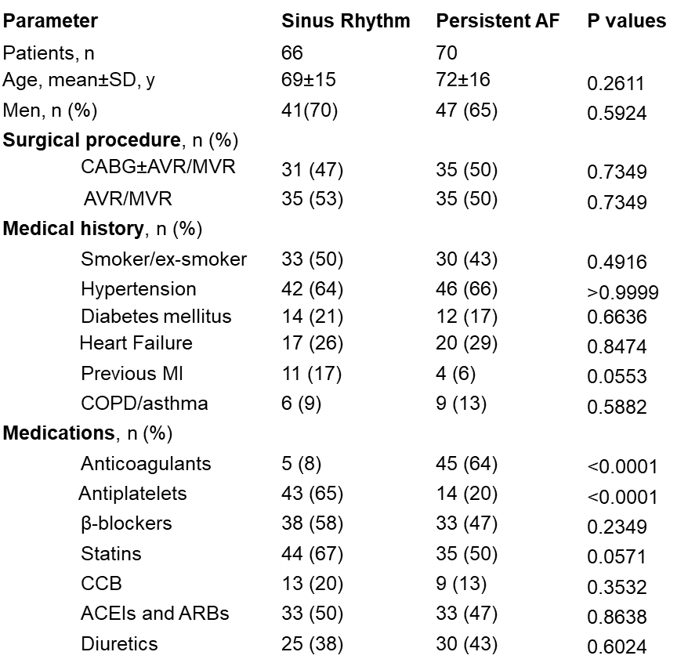
Table S2. Clinical characteristics of patients in sinus rhythm or persistent AF.

ACEI, angiotensin-converting enzyme inhibitor; ARB, angiotensin II receptor blocker; AVR, aortic valve replacement; CABG, coronary artery bypass surgery; CCB, Calcium channel blocker; COPD, chronic obstructive pulmonary disease; MI, myocardial infarction; MVR/AVR, mitral/aortic valve replacement/repair. The Fisher’s exact test was used to compare gender, surgical procedures, smoking status and medical history between groups. The unpaired t test was used to compare age.

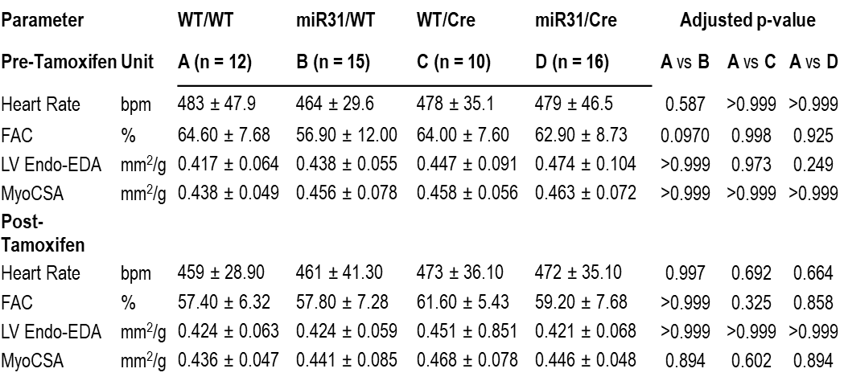
Table S3. In vivo echocardiographic parameters in WT/WT mice vs other relevant genotypes, at baseline (pre-tamoxifen) vs miR-31 induction (post-tamoxifen).

LV Endo Endo-EDA and MyoCSA adjusted to a total body weight. Data are expressed as mean ± SD (passed KS test), otherwise as median ± IQR. FAC: fractional area change; LV Endo-EDA: left ventricular endocardial end diastolic area; MyoCSA: myocardial cross sectional area. P-values were calculated by one-way ANOVA with Dunnett’s correction for parametric data, except for the HR, LV End-EDA, and MyoCSA in (D) group in pre-tamoxifen comparisons, and in FAC in (D), and LV Endo-EDA in (B) groups respectively which were analysed by Kruskal-Wallis with Dunn’s correction in post-tamoxifen comparisons.

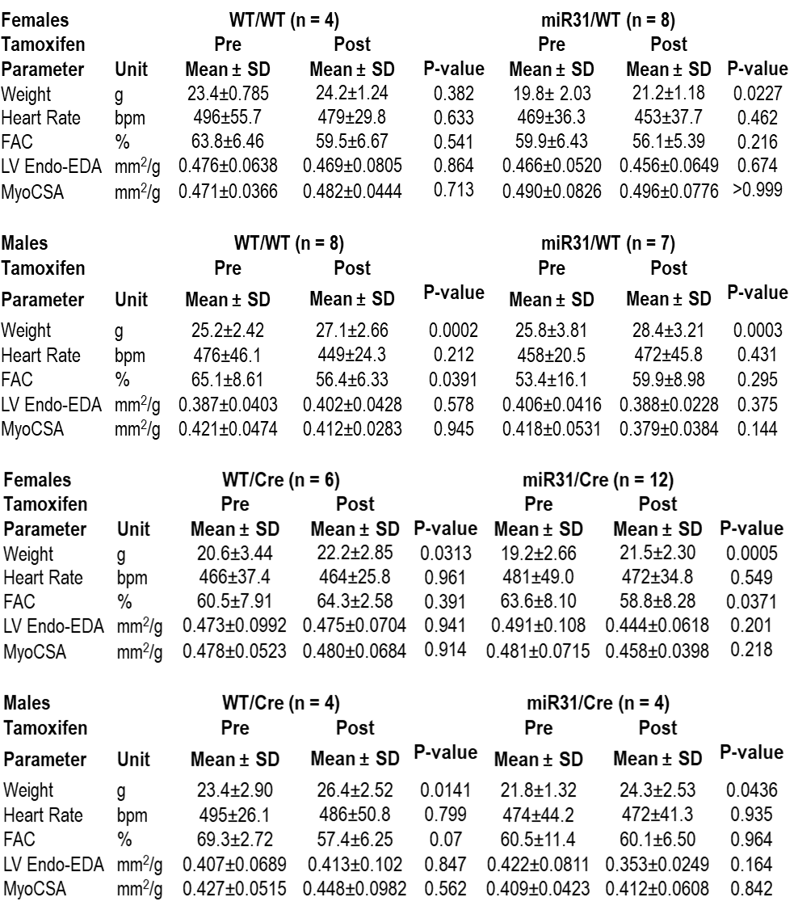
Table S4. Comparison of the in vivo echocardiographic parameters pre- and post-tamoxifen within each genotype, separated by sex.
Effects of tamoxifen on echocardiographic readouts in genotype groups organised by gender. Data are expressed as mean ± SD. FAC: fractional area change; LV Endo-EDA: left ventricular endocardial end diastolic area; MyoCSA: myocardial cross sectional area. P-values were calculated by paired t test, except LV-Endo-EDA and MyoCSA measurements in the miR31/WT group in females - by paired Wilcoxon test.

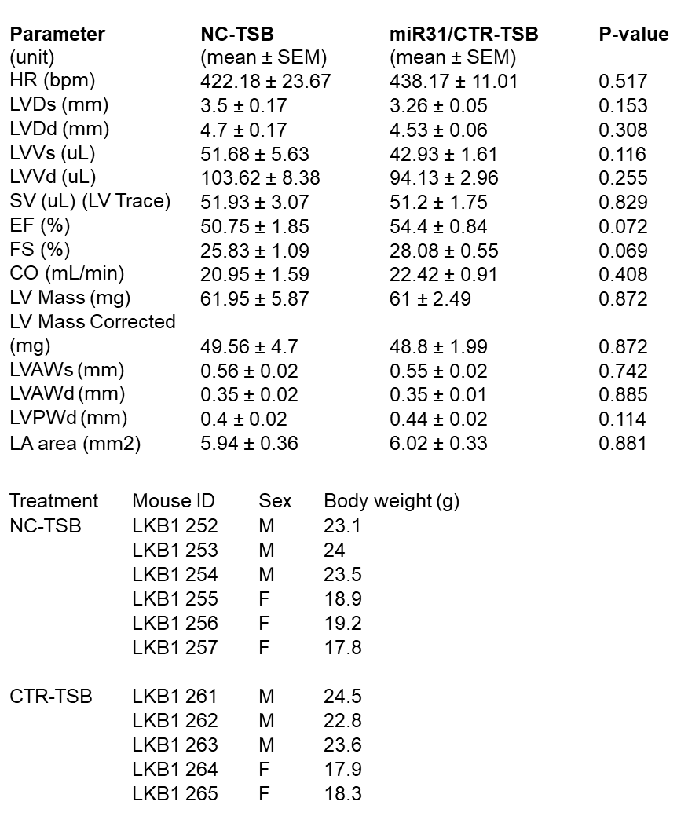
Table S5. In vivo echocardiographic parameters (A) and sex/body weight (B) of 12-week-old Lkb1-aKD mice post-treatment with miR31/CTR-TSB or TSB negative control (NC-TSB).
B
A
HR, heart rate; LVDs, left ventricular diameter at systole; LVDd, left ventricular diameter at diastole; LVVs, left ventricular volume at systole; LVVd, left ventricular volume at diastole; SV, stroke volume; EF, ejection fraction; FS, fractional shortening; CO, cardiac output; LVAWs, left ventricular anterior wall thickness at systole; LVAWd, left ventricular anterior wall thickness at diastole; LVPWd, left ventricular posterior wall thickness at diastole. P-values were calculated by unpaired t test.
Table S6. The univariate logistic regression analysis (by R software) for miR-31 and other confounding factors with AF as an outcome.
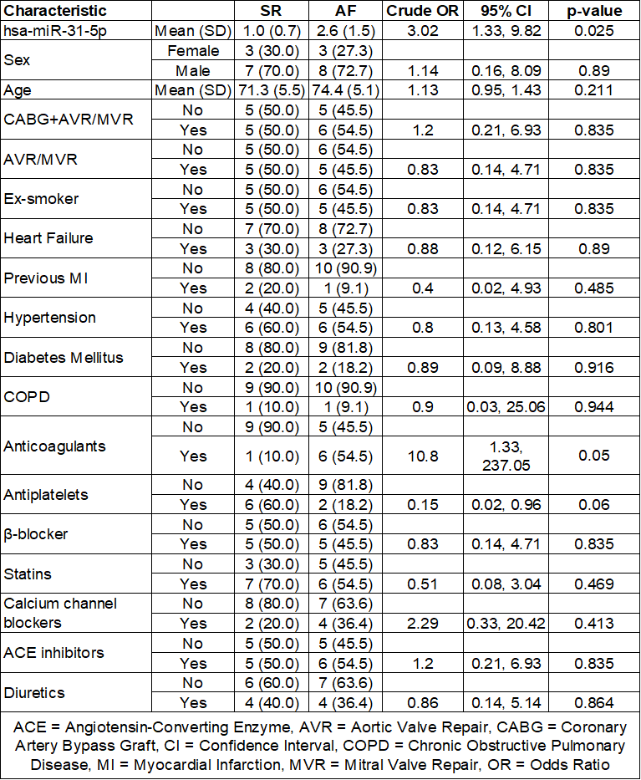

Table S7. Antibodies used in the study.
Antibodies (name) | Supplier | Cat#
Primary antibodies
Anti-BAP1 | Cell Signalling | 13187S
Anti-CALCR | Bio-Rad  Bio-Rad | AHP635  AHP3115
Anti-COL1 | Merck | 234167
Anti-COL3A1 | Novus Biologicals | NBP2-15946
Anti-FGF1 | Abcam | ab207321, clone EPR19989
Anti-FLNA | Merck | MAB1680-C
Anti-FN1 | Sigma | F3648
Anti-GAPDH, HRP-conjugated | Sigma | G9295
Anti-αSMA | Sigma | A5228
Anti-STK40 | Novus Biologicals | NBP1-33391
Anti-TNS1 | Novus Biologicals | NBP1-84129
Secondary antibodies
HRP-conjugated Anti-IgG secondary antibody (Anti rabbit (H+L) IgG | Promega | W4011
HRP-conjugated Anti-IgG secondary antibody (Anti mouse (H+L) IgG | Promega | W4021
Fluorophore-conjugated antibodies
Chicken anti-Mouse IgG (H+L) Cross-Adsorbed Secondary Antibody, Alexa Fluor™ 594 | Invitrogen | A-21201
Donkey anti-Rabbit IgG (H+L) Highly Cross-Adsorbed Secondary Antibody, Alexa Fluor™ 488 | Invitrogen | A-21206

Table S8. Oligonucleotides used in the study.

Oligonucleotide (name) | Supplier | Identifier
miRIDIAN microRNA Human hsa-miR-31-5p mimic | Dharmacon | C-300507-05
miRIDIAN microRNA Human hsa-miR-24-3p mimic | Dharmacon | C-300496-05
miRIDIAN microRNA Human hsa-miR-30d-5p mimic | Dharmacon | C-300543-03
miRIDIAN microRNA Human hsa-miR-34a-5p mimic | Dharmacon | C-300551-07
miRIDIAN microRNA Human hsa-miR-31-5p inhibitor | Dharmacon | IH-300507-06
miRIDIAN microRNA Human hsa-miR-24-3p inhibitor | Dharmacon | IH-300497-05
miRIDIAN microRNA Human hsa-miR-30d-5p inhibitor | Dharmacon | IH-300543-05
miRIDIAN microRNA Human hsa-miR-34a-5p inhibitor | Dharmacon | IH-300551-08
miRIDIAN microRNA Mimic Negative Control #1 | Dharmacon | CN-001000-01
miRIDIAN microRNA Hairpin Inhibitor Negative Control #1 | Dharmacon | IN-001005-01

Table S9. Human TaqMan assays (primers) used in qPCR.
Gene symbol | Identifier
ACTA2 | Hs00426835_g1
BAP1 | Hs01109276_g1
CALCR | Hs01016882_m1
COL1A1 | Hs00164004_m1
FLNA | Hs00924645_m1
FN1 | Hs01549976_m1
GAPDH | Hs02786624_g1
HPRT1 | Hs02800695_m1
MPRS18A | Hs01026310_m1
PKN2 | Hs00178944_m1
STK40 | Hs008894269_m1
hsa-miR-31 | 002279
U6 snRNA | 001973

Table S10. Mouse TaqMan gene expression assays.
Gene symbol | Identifier
Acta2 | Mm00725412_s1
Bap1 | Mm00550845_m1
Calcr | Mm00432282_m1
Col1a1 | Mm00801666_g1
Col3a1 | Mm00802300_m1
Fgf1 | Mm00438906_m1
Fn1 | Mm01256744_m1
Gapdh | Mm99999915_g1
Hprt1 | Mm03024075_m1
Stk40 | Mm00512134_m1
Tns1 | Mm00452886_m1
mmu-miR-31 | 000185
mmu-miR-31* | 002495
U6 snRNA | 001973

Table S11. A list of qPCR primers for mouse gene expression.
RPL7 F | GAAGCTCATCTATGAGAAGGC
RPL7 R | AAGACGAAGGAGCTGCAGAAC
Calcr F | AAGTGCCATTAGAGCGCCTT
Calcr R | TCCGCCTTTTCACTCTGGAC
LKB1 F | CCGCCTGCTCCATATTTCCA
LKB1 R | TCGCTGTCTTTGGGTTGGTT
nNOS F | CGGGTGTCGACAATCCAAGA
nNOS R | CGTGTGTGTCCCCGTTTAGT
DMD F | TAAGCTACTGCGCCAACACA
DMD R | GGTGGGGTTCGTATGCAAGA
STK40 F | AAAGAGAGCAGGACCGTTCG
STK40 R | CCGGACCACGTCGTAGAAAA
BAP1 F | GACGAGGAGTGGACAGATAAAG
BAP1 R | TACATTTGCTGGGAGGACTATG
Col 1 F | GCTCCTCTTAGGGGCCACT
Col 1 R | CCACGTCTCACCATTGGGG
Col 3 F | CTGTAACATGGAAACTGGGGAAA
Col 3 R | CCATAGCTGAACTGAAAACCACC
Sma F | GTCCCAGACATCAGGGAGTAA
Sma R | TCGGATACTTCAGCGTCAGGA

4. REFERENCES
1. Moreira, L.M., et al. Paracrine signalling by cardiac calcitonin controls atrial fibrogenesis and arrhythmia. Nature 587, 460-465 (2020).
2. Hulsurkar, M.M., et al. Atrial-Specific LKB1 Knockdown Represents a Novel Mouse Model of Atrial Cardiomyopathy With Spontaneous Atrial Fibrillation. Circulation 144, 909-912 (2021).
3. Dolatshad, H., et al. A versatile transgenic allele for mouse overexpression studies. Mamm Genome 26, 598-608 (2015).
4. Zheng B, Zhang Z, Black CM, de Crombrugghe B, Denton CP. Ligand-dependent genetic recombination in fibroblasts : a potentially powerful technique for investigating gene function in fibrosis. Am J Pathol. 2002 May;160(5):1609-17. doi: 10.1016/S0002-9440(10)61108-X.
5. Palmiter, R. & Brinster, R. Germ-line transformation of mice. Annual review of genetics 20, 465-499 (1986).
6. Kunath, T., et al. Transgenic RNA interference in ES cell-derived embryos recapitulates a genetic null phenotype. Nat Biotechnol 21, 559-561 (2003).
7. Reilly, S., et al. Up-regulation of miR-31 in human atrial fibrillation begets the arrhythmia by depleting dystrophin and neuronal nitric oxide synthase. Science translational medicine 8, 340ra374 (2016).
8. Jansen HJ, Rose RA. Isolation of Atrial Myocytes from Adult Mice. J Vis Exp. 2019 Jul 25;(149). doi: 10.3791/59588. PMID: 31403612.
9. Hildebrandt-Eriksen, E.S., et al. A locked nucleic acid oligonucleotide targeting microRNA 122 is well-tolerated in cynomolgus monkeys. Nucleic Acid Ther 22, 152-161 (2012).
10. Moon, B.F., et al. Simultaneous Positron Emission Tomography and Molecular Magnetic Resonance Imaging of Cardiopulmonary Fibrosis in a Mouse Model of Left Ventricular Dysfunction. J Am Heart Assoc 13, e034363 (2024).
11. Murphy, A.P., et al. Noninvasive quantification of fibrosis in skeletal and cardiac muscle in mdx mice using EP3533 enhanced magnetic resonance imaging. Magn Reson Med 81, 2728-2735 (2019).
12. Spuentrup, E., et al. Molecular magnetic resonance imaging of myocardial perfusion with EP-3600, a collagen-specific contrast agent: initial feasibility study in a swine model. Circulation 119, 1768-1775 (2009).
13. Desogere, P., Montesi, S.B. & Caravan, P. Molecular Probes for Imaging Fibrosis and Fibrogenesis. Chemistry 25, 1128-1141 (2019).
14. Verheule, S., et al. Increased vulnerability to atrial fibrillation in transgenic mice with selective atrial fibrosis caused by overexpression of TGF-beta1. Circ Res 94, 1458-1465 (2004).
15. Lamble S, Batty E, Attar M, Buck D, Bowden R, Lunter G, Crook D, El-Fahmawi B, Piazza P. Improved workflows for high throughput library preparation using the transposome-based Nextera system. BMC Biotechnol. 2013 Nov 20;13:104. doi: 10.1186/1472-6750-13-104.
16. Kim D, Paggi JM, Park C, Bennett C, Salzberg SL. Graph-based genome alignment and genotyping with HISAT2 and HISAT-genotype. Nat Biotechnol. 2019 Aug;37(8):907-915. doi: 10.1038/s41587-019-0201-4. Epub 2019 Aug 2.
17. Liao, Y., Smyth, G.K. & Shi, W. The Subread aligner: fast, accurate and scalable read mapping by seed-and-vote. Nucleic Acids Res 41, e108 (2013).
18. Yu, G., Wang, L.G., Han, Y. & He, Q.Y. clusterProfiler: an R package for comparing biological themes among gene clusters. OMICS 16, 284-287 (2012).

