Supplementary information
Supplementary Table S1. List of all H2A.Z cancer mutations
Supplementary Table S2. List of H2A.Z mutations, the yeast equivalents, and the structural features they mapped to in this study
Supplementary Table S3. ChIP-seq read information
Supplementary Table S4. ChIP-seq spike-in normalization scaling factors
Supplementary Table S5. H2A.Z peaks identified by ChIP-seq for wild type and the mutants
Supplementary Table S6. Plasmids used in this study
Supplementary Table S7. Primers used in this study
Supplementary Table S8. Yeast strains used in this study
Supplementary Table S9. Synthetic gene sequences used in Gateway cloning
Supplementary Figure S1. Summary of growth defects and H2A.Z protein levels in yeast mutant strains
Supplementary Figure S2. Chromatin association of H2A.Z mutants that did not impair yeast growth
Supplementary Figure S3. Pearson correlation coefficients comparing all ChIP-seq IP samples
Supplementary Figure S4. UpSet plot showing the overlap in H2A.Z ChIP-seq peak across wild type and mutants
Supplementary Figure S5. Growth phenotypes of H2A.Z mutants with and without swr1Δ
Supplementary Figure S6. H2A.Z mutants did not affect ALD5 transcription
Supplementary Figure S7. The L101W and L104R mutants were predicted to induce long-range allosteric effects on the nucleosome structure
Supplementary Figure S8. Residue-level allosteric profiles for the L101W and L104R mutations across multiple nucleosome structures
Supplementary Figure S9. The S103Y mutation was predicted to induce long-range allosteric effects on the nucleosome structure
Supplementary Figure S10. Comparison of DNA binding free energy in wild type and H2A.Z mutants
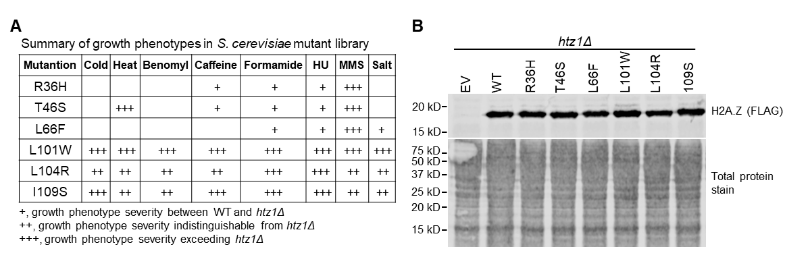
Supplementary Figures

Supplementary Figure S1. Summary of growth defects and H2A.Z protein levels in yeast mutant strains
(A) Summary of growth defects observed for R36H, T46S, L66F, L101W, L104R, and I109S H2A.Z mutant strains under the indicated conditions.
(B) Representative immunoblot showing whole-cell extracts from wild type and the indicated mutants. The htz1Δ strain carrying an empty vector (EV) served as a negative antibody control. Total protein stain was used as a loading control.
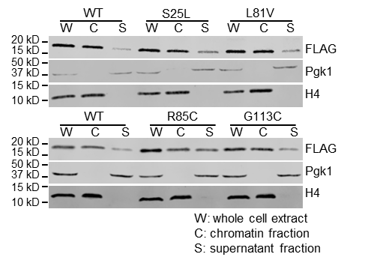

Supplementary Figure S2. Chromatin association of H2A.Z mutants that did not impair yeast growth
Chromatin association assays in the indicated H2A.Z cancer histone mutations. Whole-cell extracts (W) were separated into chromatin (C) and soluble (S) (non-chromatin) fractions and analyzed by immunoblotting. FLAG antibodies detected H2A.Z, while H4 and Pgk1 were used as controls for the chromatin and soluble fractions, respectively.
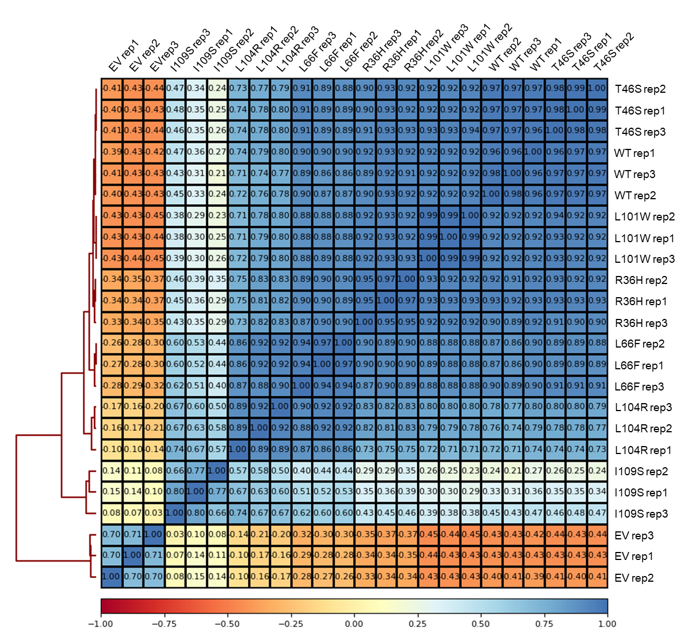
Supplementary Figure S3. Pearson correlation coefficients comparing all ChIP-seq IP samples
Pearson correlation coefficients were calculated using normalized ChIP-seq read counts binned at 100 bp resolution for each sample pair.
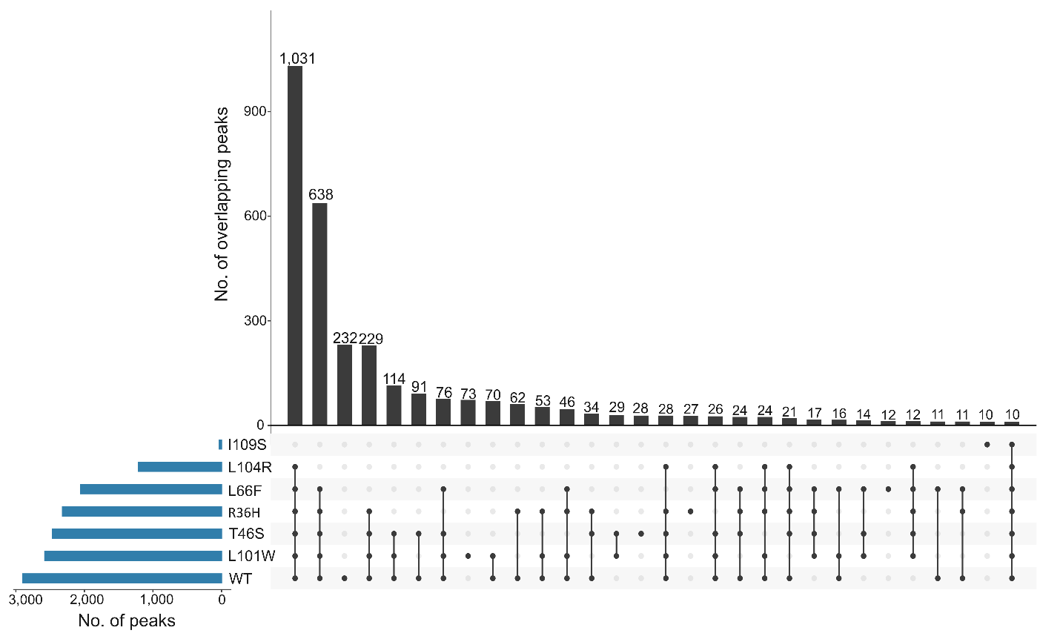
Supplementary Figure S4. UpSet plot showing the overlap in H2A.Z ChIP-seq peak across wild type and mutants
The UpSet plot was generated using Intervene (0.6.5)[137] and shows the overlap of reproducible peaks across the samples. Horizontal blue bars show the total number of peaks per sample. Vertical black columns indicate the number of peaks shared among the samples indicated by connecting dots below. Only the 30 largest intersections are shown.
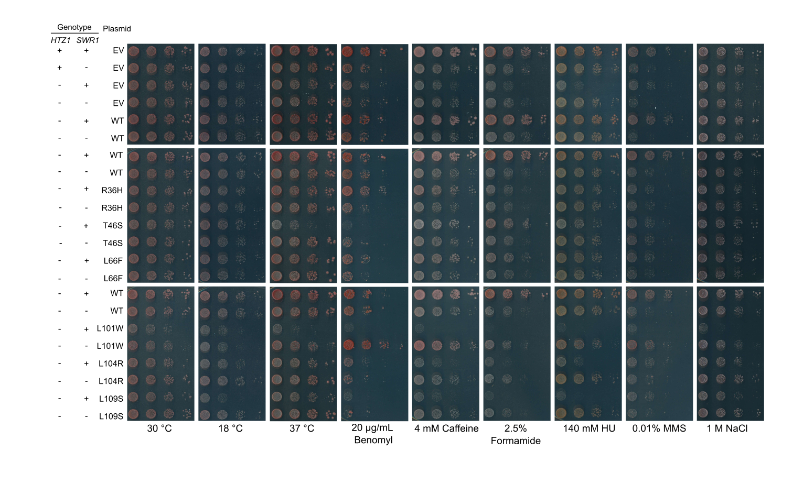
Supplementary Figure S5. Growth phenotypes of H2A.Z mutants with and without swr1Δ
Representative image from three biological replicates showing 10-fold serial dilutions of the indicated strains in the indicated conditions. Strains carrying the wild-type (WT) plasmid or empty vector (EV) serve as positive and negative controls, respectively.
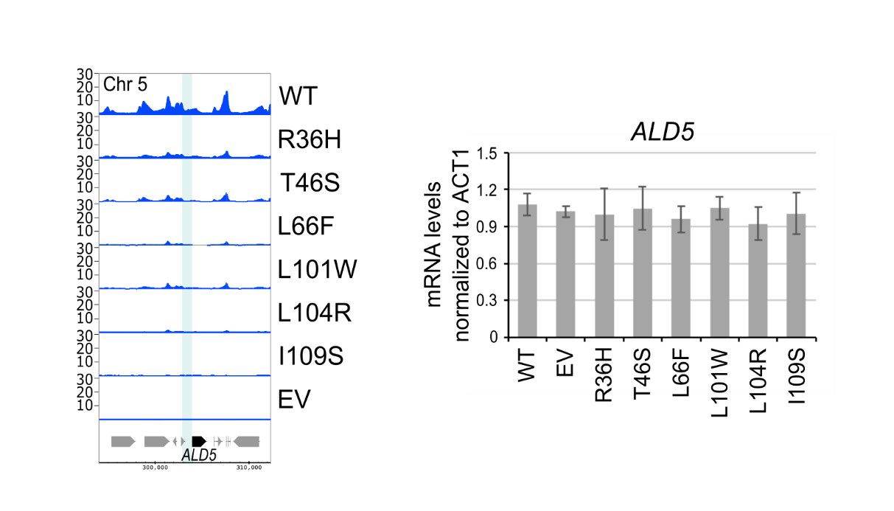

Supplementary Figure S6. H2A.Z mutants did not affect ALD5 transcription
(Left) Genome tracks showing H2A.Z spike-in normalized ChIP-seq signal at the ALD5 locus. The Y-axis values indicate the mean number of normalized reads per 10 bp. The ALD5 gene is shown at the bottom, with its promoter region highlighted in teal (left panel). (Right) ALD5 is an HTZ1-independent gene. ALD5 mRNA levels measured using RT–qPCR and normalized to ACT1. Bars represent the mean and error bars represent standard deviations from three biological replicates. Statistical significance was assessed using unpaired two-tailed Student’s t-tests. p-values are denoted as follows: *P < 0.05, **P < 0.01.
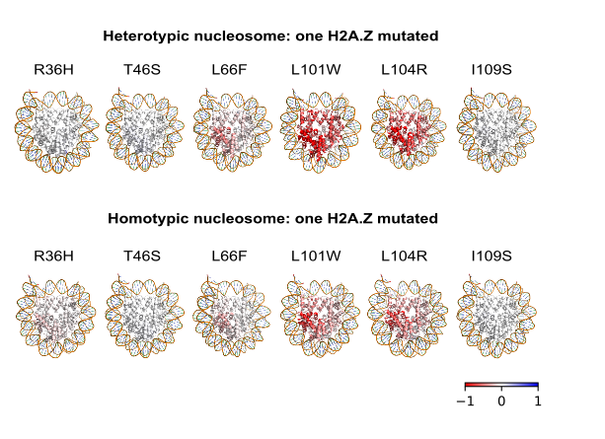

Supplementary Figure S7. The L101W and L104R mutants were predicted to induce long-range allosteric effects on the nucleosome structure
Nucleosome structures depicting per-residue average allosteric modulation (Δh) effect induced by the indicated cancer mutations. Mutations were introduced into only one copy of H2A.Z in both the homotypic and heterotypic structures. Values of |Δh| ≥ 0.6 kcal/mol are considered significant. Residues with negative Δh values are colored red, indicating suppressed conformational changes, whereas residues with positive Δh values are colored blue and indicate enhanced conformational changes. Average allosteric effects were calculated using PDBs 5B33, 3WA9, 3WAA, and 1F66 for the homotypic structures. For the heterotypic structures, PDBs 5B31 and 5B32 were used. The average effects are displayed on PDB 5B31 for the heterotypic structures, and on PDB 5B33 for the homotypic structures.
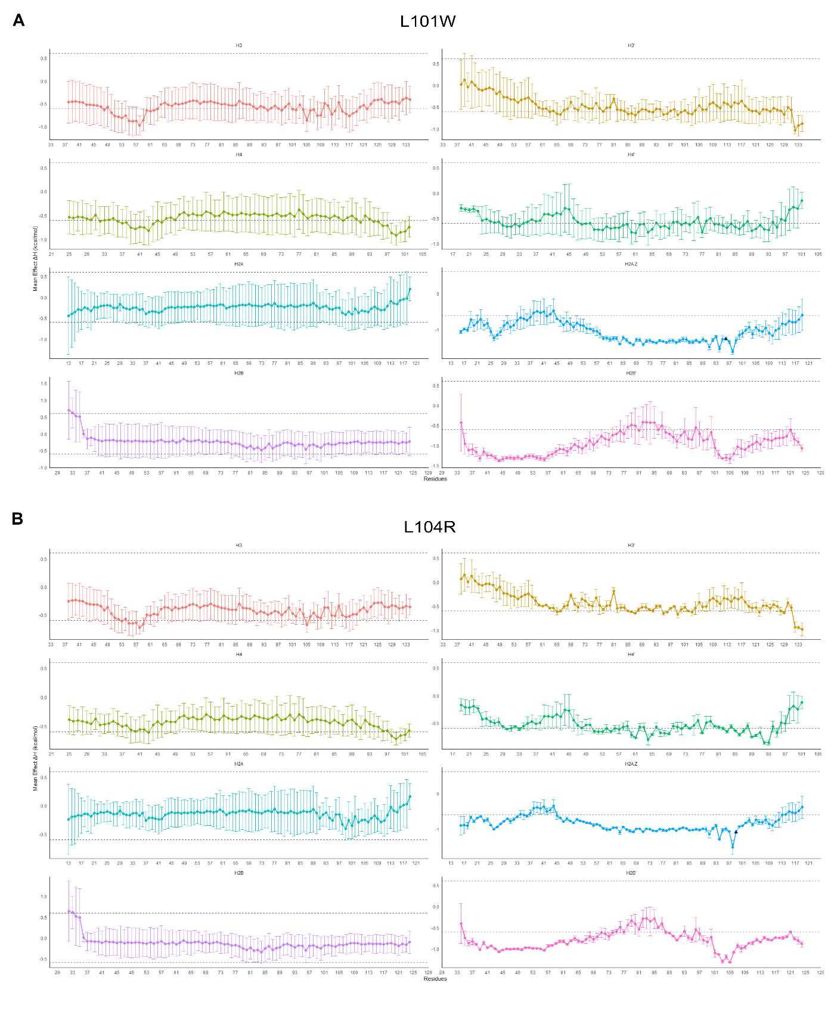
Supplementary Figure S8. Residue-level allosteric profiles for the L101W and L104R mutations across multiple nucleosome structures
Line plots showing the average residue-level allosteric free-energy changes (Δh) predicted by AlloSigMA for two H2A.Z mutations, L101W and L104R. Each mutation was introduced individually into each available heterotypic H2A/H2A.Z nucleosome structure (PDB 5B31 and PDB 5B32). Each panel shows an individual histone protein, with the histone residues on the x-axis and the average allosteric values on the y-axis. The mutation site is indicated by a triangle on the H2A.Z protein sequence. H3’, H4’, and H2B’ denote the histone closest to the mutated H2A.Z protein. The standard deviation is shown as error bars. The dashed black lines represent the significance threshold of |Δh| ≥ 0.6 kcal/mol.
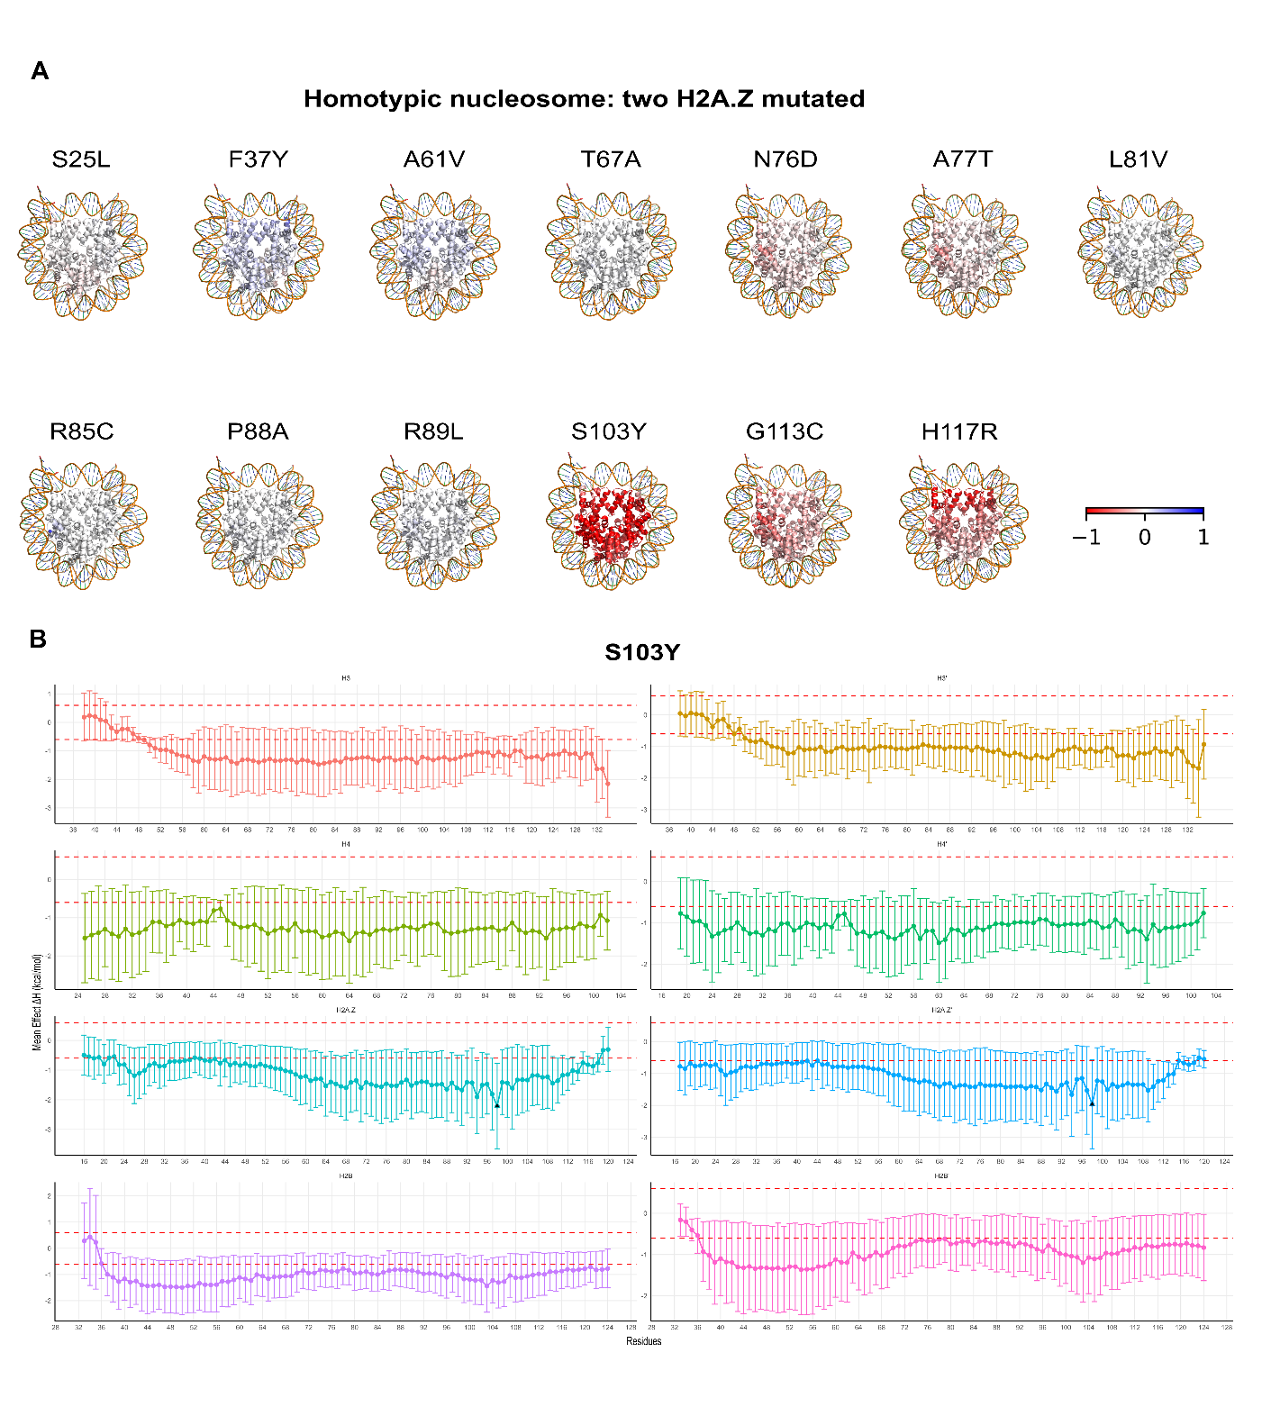
Supplementary Figure S9. The S103Y mutation was predicted to induce long-range allosteric effects on the nucleosome structure
(A) Nucleosome structures depicting per-residue average allosteric modulation (Δh) induced by the indicated cancer mutations. Mutations were introduced into both copies of H2A.Z. Values of |Δh| ≥ 0.6 kcal/mol are considered significant. Average allosteric values from the available homotypic H2A.Z structures (PDBs 5B33, 3WA9, 3WAA, and 1F66) were calculated and are mapped onto PDB 5B33 to visualize the overall effects. A red-white-blue colour scale is used to indicate Δh values; residues with positive Δh values are coloured blue (indicating an increase in local dynamics) and residues with negative Δh values are coloured red (indicating a decrease in local dynamics).
(B) Allosteric modulation profile for the S103Y mutation, which was found to produce strong allosteric effects similar to L101W and L104R. Residues with |Δh| ≥ 0.6 kcal/mol and a distance of at least 11 Å between the mutation sites are considered significant. For each histone protein, the residues are plotted on the x-axis, and the average allosteric effect is on the y-axis. The error bars represent the standard deviation. The mutation sites are indicated by a triangle on the H2A.Z protein sequence. The dashed red lines represented the significance threshold of |Δh| ≥ 0.6 kcal/mol.
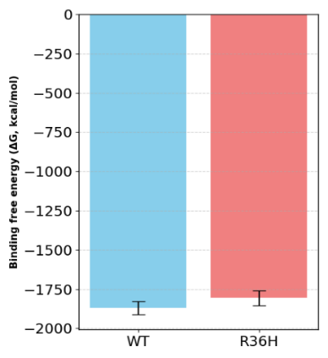
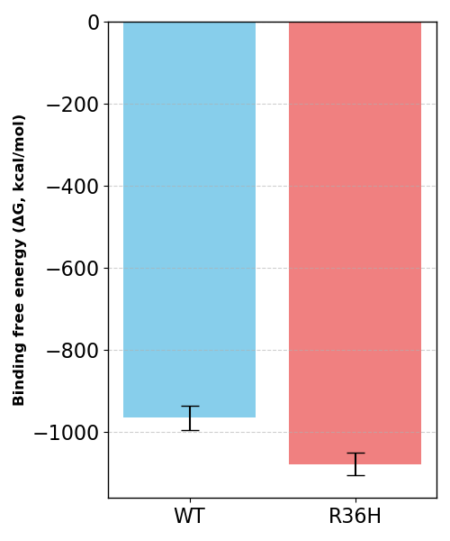
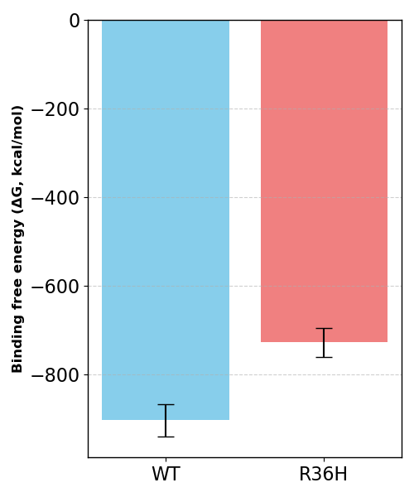
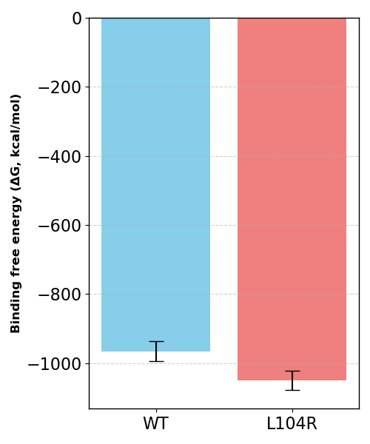
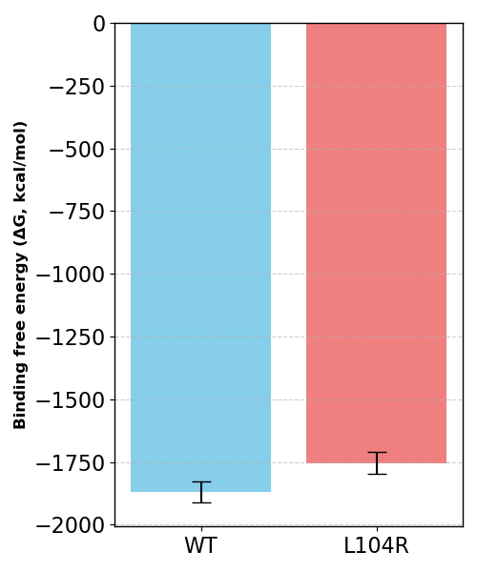
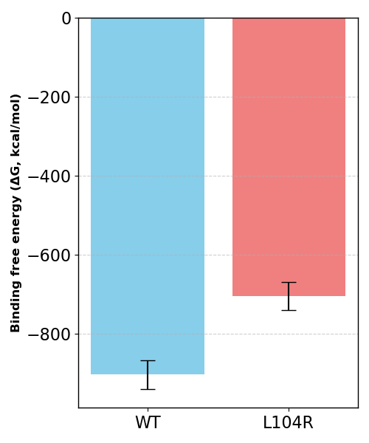
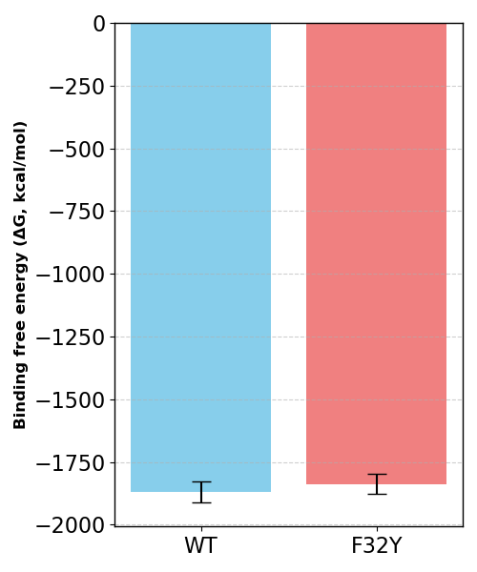
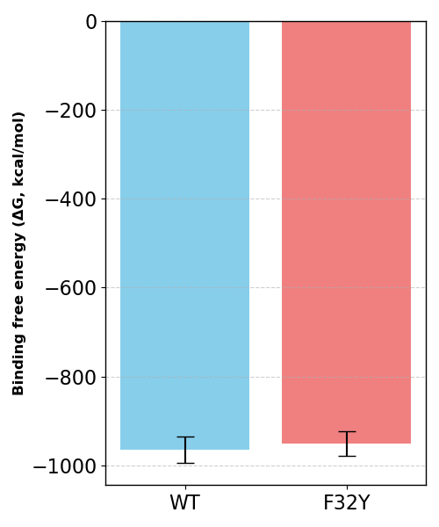
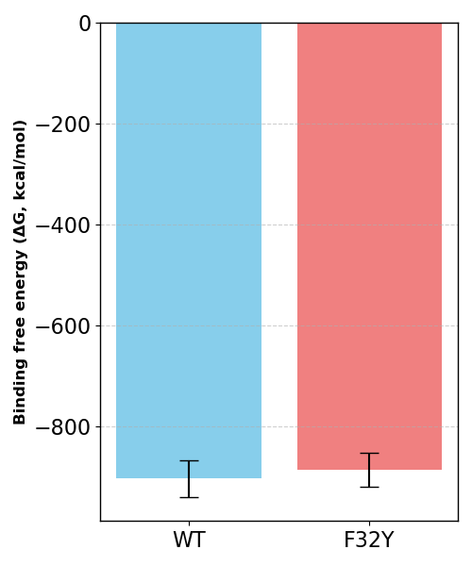
A
H3/H4 tetramer-DNA
Histone octamer-DNA
H2A.Z/H2B two dimers-DNA
B
Histone octamer-DNA
H2A.Z/H2B two dimers-DNA
C
Histone octamer-DNA
H2A.Z/H2B two dimers-DNA
H3/H4 tetramer-DNA
H3/H4 tetramer-DNA
Supplementary Figure S10. Comparison of DNA binding free energy in wild type and H2A.Z mutants
(A) Graphs showing binding free energy between H2A.Z/H2B dimers (left), the histone octamer (middle), and the H3/H4 tetramer (right), with DNA in wild type and the R36H mutant. Values were calculated using the MM/GBSA method.
(B) Binding free energy between H2A.Z/H2B dimers (left), the histone octamer (middle), and the H3/H4 tetramer (right) with DNA in wild type versus the L104R mutant.
(C) Binding free energy between H2A.Z/H2B dimers (left), the histone octamer (middle), and the H3/H4 tetramer (right) with DNA in wild type and the F32Y mutant.

